4th Sunday after Epiphany
February 1st, 2026

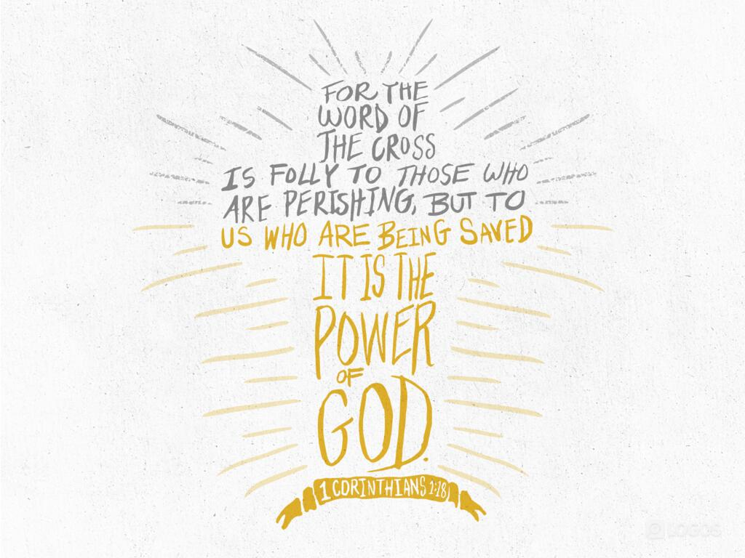

Messiah Lutheran Church
Sartell, MN
www.messiahsartell.com
320-252-5883
Prayer Before Entering
Please take this time to focus on our purpose in gathering and join in prayer before our service begins. Blessed Lord, You have caused all Holy Scriptures to be written for our learning. Grant that we may so hear them, read, mark, learn, and inwardly digest them that, by patience and comfort of Your holy Word, we may embrace and ever hold fast the blessed hope of everlasting life; through Jesus Christ, our Lord.

As We Gather
“I am a fool.” Maybe you have said that to yourself after a thoughtless word or action. Foolishness is not generally seen as a positive attribute. But Paul reminds his Corinthian readers and us that we are called to a certain special foolishness in Christ. “But God chose what is foolish . . . ; God chose what is weak . . . ; God chose what is low” (1 Corinthians 1:27–28). God chose to make Himself known to us not through the wisdom of the world, not through the scholars and academics, but through the Cross of Christ. When the world sees the cross it sees a foolish man who died for nothing, but for believers we see God's love, wisdom, and power to save us from our sins and from death itself. Let us gladly be called fools for the sake of Christ.

425 When I Survey the Wondrous Cross

Stand

The sign of the cross may be made by all in remembrance of their Baptism.

P In the name of the Father and of the T Son and of the Holy Spirit.
C Amen.

P Our help is in the name of the Lord,
C who made heaven and earth.

P If You, O Lord, kept a record of sins, O Lord, who could stand?
C But with You there is forgiveness; therefore You are feared.

P Since we are gathered to hear God’s Word, call upon Him in prayer and praise, and receive the body and blood of our Lord Jesus Christ in the fellowship of this altar, let us first consider our unworthiness and confess before God and one another that we have sinned in thought, word, and deed, and that we cannot free ourselves from our sinful condition. Together as His people let us take refuge in the infinite mercy of God, our heavenly Father, seeking His grace for the sake of Christ, and saying:
C God, be merciful to me, a sinner.

Silence for reflection on God’s Word and for self-examination.

C Almighty God, have mercy upon us, forgive us our sins, and lead us to everlasting life. Amen.

P Almighty God in His mercy has given His Son to die for you and for His sake forgives you all your sins. As a called and ordained servant of Christ, and by His authority, I therefore forgive you all your sins in the name of the Father and of the T Son and of the Holy Spirit.

C Amen.

Introit Psalm 1:1–5; antiphon: v. 6
P For the Lord knows the way of the righteous,
but the way of the wicked will perish.
C Blessèd is the man who walks not in the counsel of the wicked,
nor stands in the way of sinners, nor sits in the seat of scoffers;
P but his delight is in the law of the Lord,
and on his law he meditates day and night.
C He is like a tree planted by streams of water that yields its fruit in its
season, and its leaf does not wither.
In all that he does, he prospers.
P The wicked are not so,
but are like chaff that the wind drives away.
C Therefore the wicked will not stand in the judgment,
nor sinners in the congregation of the righteous.
All: Glory be to the Father and to the Son
and to the Holy Spirit;
as it was in the beginning,
is now, and will be forever. Amen.
P For the Lord knows the way of the righteous,
but the way of the wicked will perish.

Kyrie
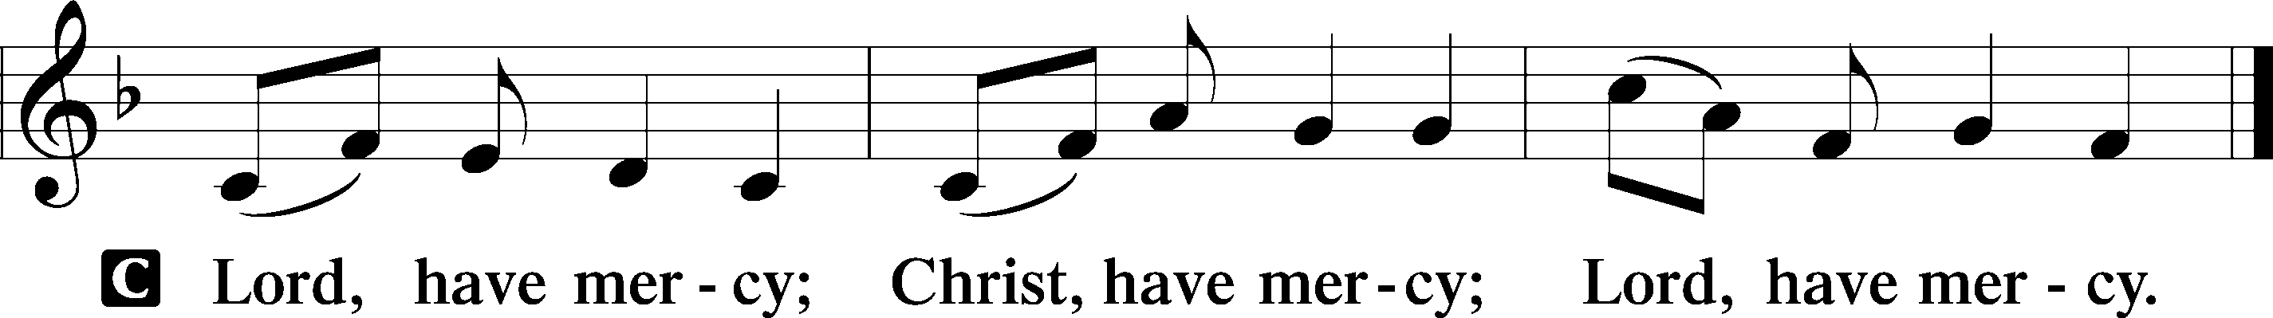

Gloria in Excelsis
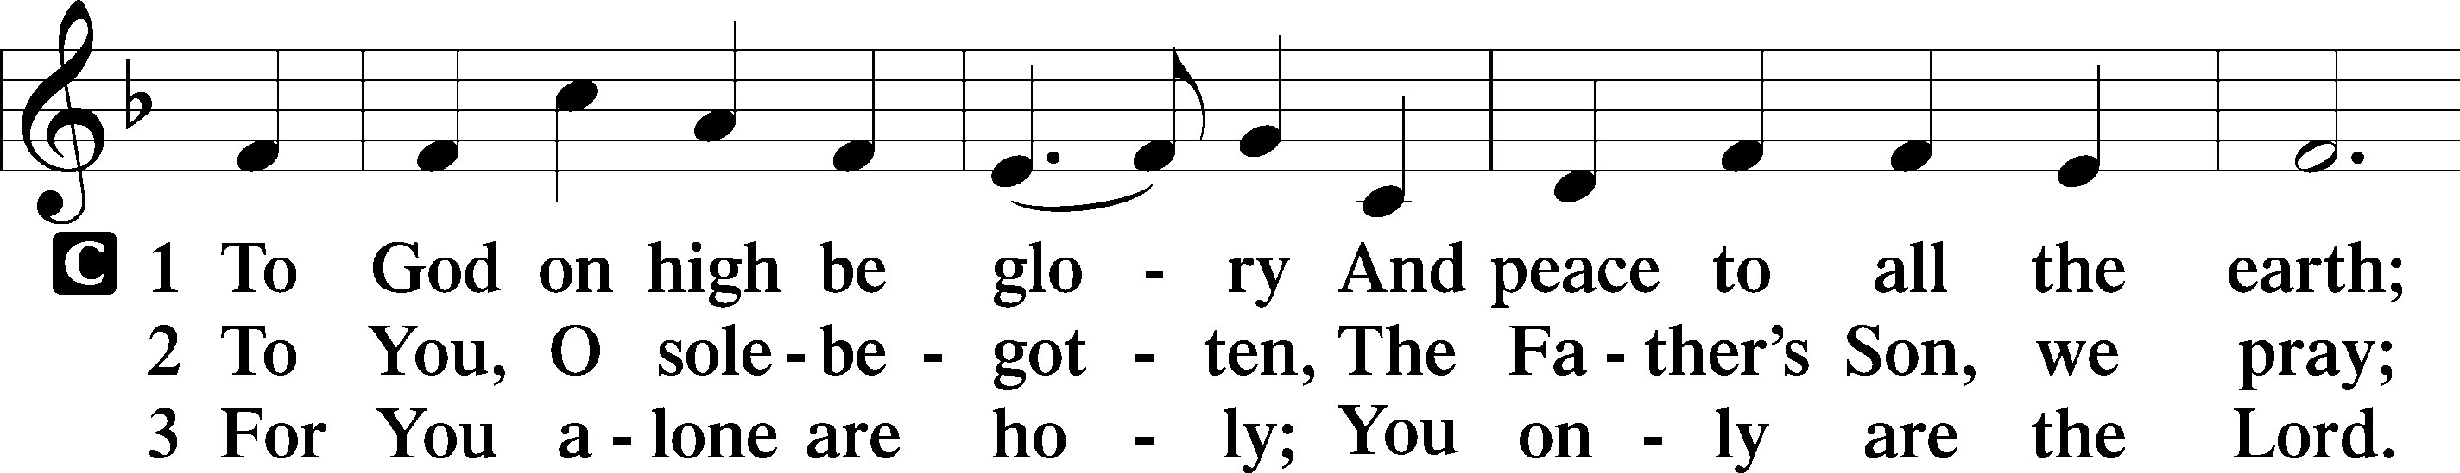
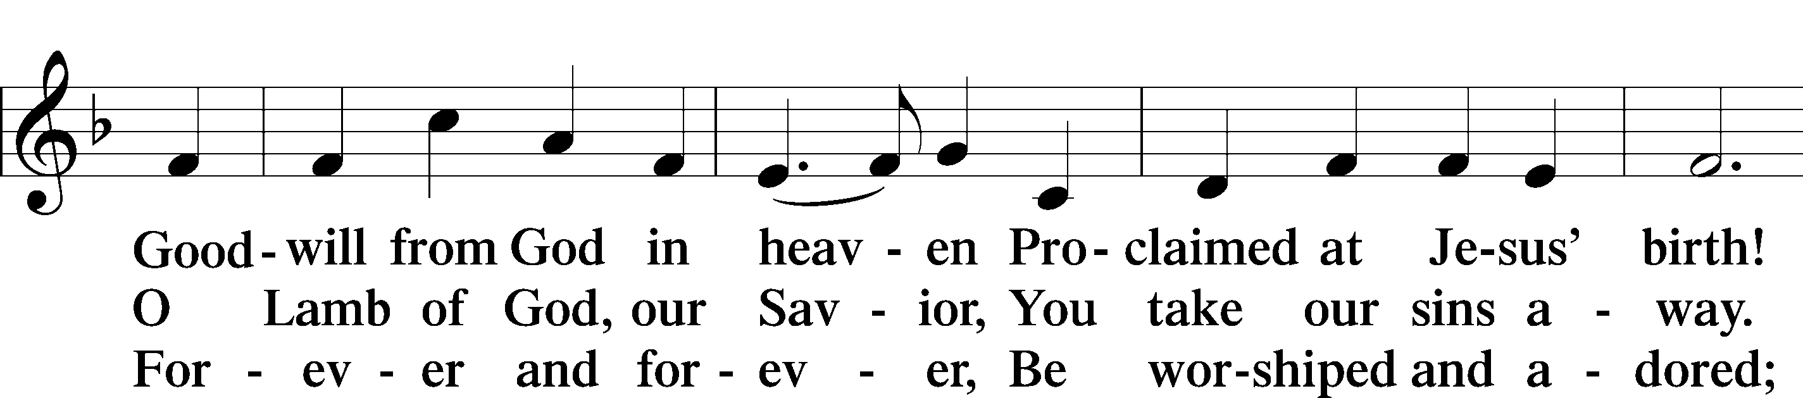
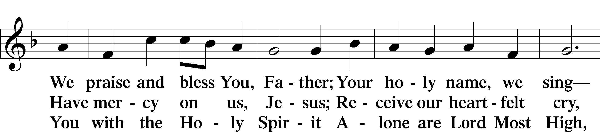
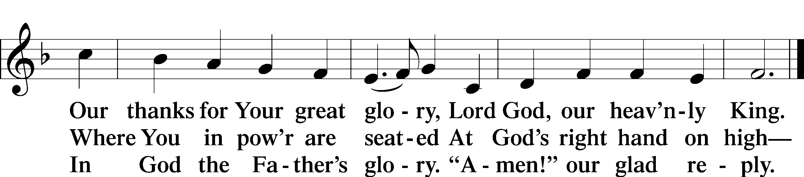

Salutation and Collect of the Day
P The Lord be with you.
C And also with you.

P Let us pray.
Almighty God, You know we live in the midst of so many dangers that in our frailty we cannot stand upright. Grant strength and protection to support us in all dangers and carry us through all temptations; through Jesus Christ, Your Son, our Lord, who lives and reigns with You and the Holy Spirit, one God, now and forever.

C Amen.

Sit
Old Testament Reading Micah 6:1–8
1Hear what the Lord says: Arise, plead your case before the mountains, and let the hills hear your voice. 2Hear, you mountains, the indictment of the Lord, and you enduring foundations of the earth, for the Lord has an indictment against his people, and he will contend with Israel. 3“O my people, what have I done to you? How have I wearied you? Answer me! 4For I brought you up from the land of Egypt and redeemed you from the house of slavery, and I sent before you Moses, Aaron, and Miriam. 5O my people, remember what Balak king of Moab devised, and what Balaam the son of Beor answered him, and what happened from Shittim to Gilgal, that you may know the saving acts of the Lord.” 6“With what shall I come before the Lord, and bow myself before God on high? Shall I come before him with burnt offerings, with calves a year old? 7Will the Lord be pleased with thousands of rams, with ten thousands of rivers of oil? Shall I give my firstborn for my transgression, the fruit of my body for the sin of my soul?” 8He has told you, O man, what is good; and what does the Lord require of you but to do justice, and to love kindness, and to walk humbly with your God?

A This is the Word of the Lord.
C Thanks be to God.

Epistle 1 Corinthians 1:18–31
18The word of the cross is folly to those who are perishing, but to us who are being saved it is the power of God. 19For it is written, “I will destroy the wisdom of the wise, and the discernment of the discerning I will thwart.” 20Where is the one who is wise? Where is the scribe? Where is the debater of this age? Has not God made foolish the wisdom of the world? 21For since, in the wisdom of God, the world did not know God through wisdom, it pleased God through the folly of what we preach to save those who believe. 22For Jews demand signs and Greeks seek wisdom, 23but we preach Christ crucified, a stumbling block to Jews and folly to Gentiles, 24but to those who are called, both Jews and Greeks, Christ the power of God and the wisdom of God. 25For the foolishness of God is wiser than men, and the weakness of God is stronger than men.
26For consider your calling, brothers: not many of you were wise according to worldly standards, not many were powerful, not many were of noble birth. 27But God chose what is foolish in the world to shame the wise; God chose what is weak in the world to shame the strong; 28God chose what is low and despised in the world, even things that are not, to bring to nothing things that are, 29so that no human being might boast in the presence of God. 30He is the source of your life in Christ Jesus, whom God made our wisdom and our righteousness and sanctification and redemption. 31Therefore, as it is written, “Let the one who boasts, boast in the Lord.”

A This is the Word of the Lord.
C Thanks be to God.

Stand

Alleluia and Verse
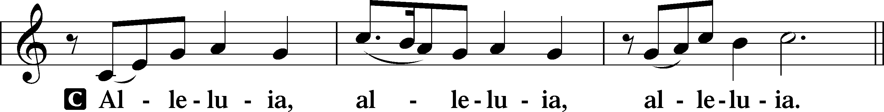
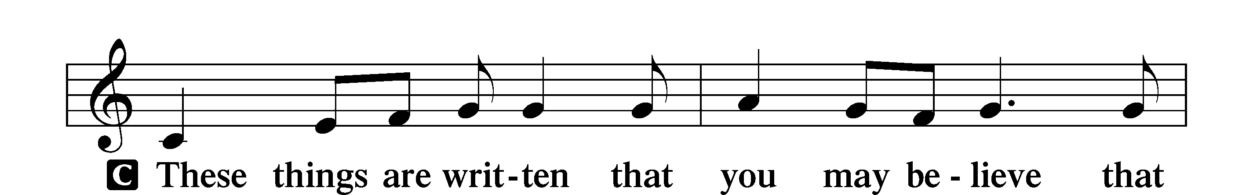
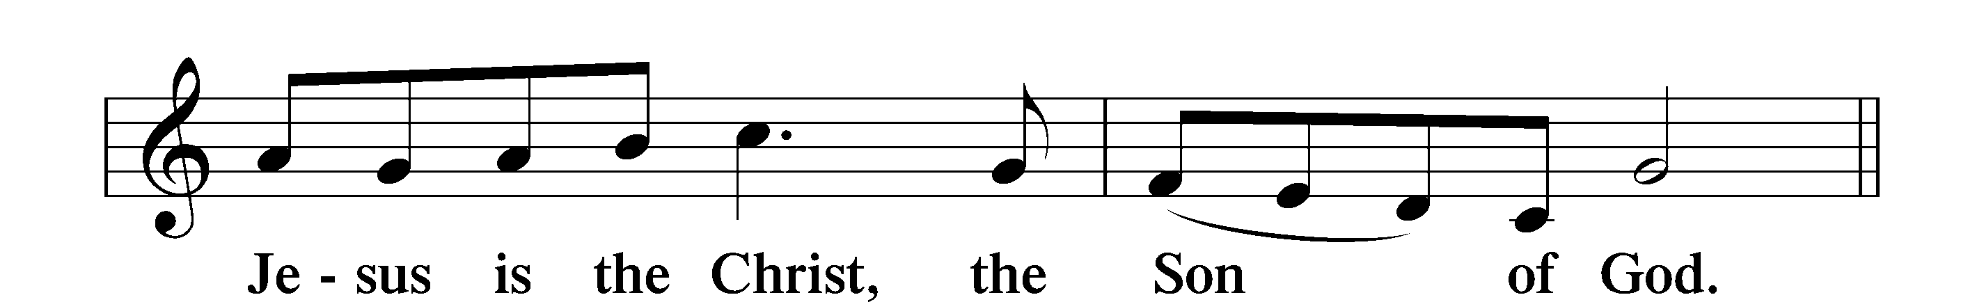
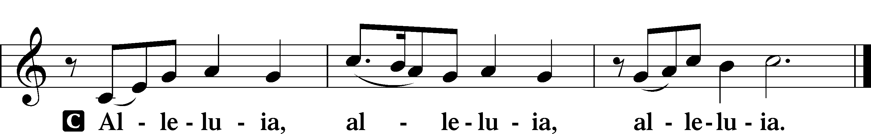

Holy Gospel Matthew 5:1–12
P The Holy Gospel according to St. Matthew, the fifth chapter.
C Glory to You, O Lord.

1Seeing the crowds, [Jesus] went up on the mountain, and when he sat down, his disciples came to him.
2And he opened his mouth and taught them, saying:
3“Blessed are the poor in spirit, for theirs is the kingdom of heaven.
4“Blessed are those who mourn, for they shall be comforted.
5“Blessed are the meek, for they shall inherit the earth.
6“Blessed are those who hunger and thirst for righteousness, for they shall be satisfied.
7“Blessed are the merciful, for they shall receive mercy.
8“Blessed are the pure in heart, for they shall see God.
9“Blessed are the peacemakers, for they shall be called sons of God.
10“Blessed are those who are persecuted for righteousness’ sake, for theirs is the kingdom of heaven.
11“Blessed are you when others revile you and persecute you and utter all kinds of evil against you falsely on my account. 12Rejoice and be glad, for your reward is great in heaven, for so they persecuted the prophets who were before you.”

P This is the Gospel of the Lord.
C Praise to You, O Christ.

Apostles’ Creed
C I believe in God, the Father Almighty,
maker of heaven and earth.
And in Jesus Christ, His only Son, our Lord,
who was conceived by the Holy Spirit,
born of the virgin Mary,
suffered under Pontius Pilate,
was crucified, died and was buried.
He descended into hell.
The third day He rose again from the dead.
He ascended into heaven
and sits at the right hand of God the Father Almighty.
From thence He will come to judge the living and the dead.

I believe in the Holy Spirit,
the holy Christian Church,
the communion of saints,
the forgiveness of sins,
the resurrection of the body,
and the life T everlasting. Amen.

Sit

427 In the Cross of Christ I Glory

Sermon

Offering. We generously give our offerings to the LORD out of thanksgiving for His generosity of forgiveness, life, and salvation in Christ (2 Corinthians 9:8). We believe that our offerings are not only to support the proclamation of the Gospel here and around the world, but also to help us all grow in faith and trust in Him (2 Corinthians 9:7). We have placed an offering plate in the narthex so you are able to freely give back to Him as you are able. To Him be all the glory!

Stand

Prayer of the Church

Lord’s Prayer

Benedicamus
A Let us bless the Lord.
C Thanks be to God.

Benediction
P The Lord bless you and keep you.
The Lord make His face shine on you and be gracious to you.
The Lord look upon you with favor and T give you peace.

C Amen.

837 Lift High the Cross sts. ref–6

Announcement

Join us for Scout Sunday at Messiah, Feb. 8! The Scouts would like to serve our congregation treats/refreshments after worship on Sunday, Feb. 8. Scouts from a variety of their dens aged kindergarten through 5th grade along with their leaders are available to serve. There will be information about their program and some of the fun things they do! Join us!

