4th Sunday of Easter
April 21st, 2024

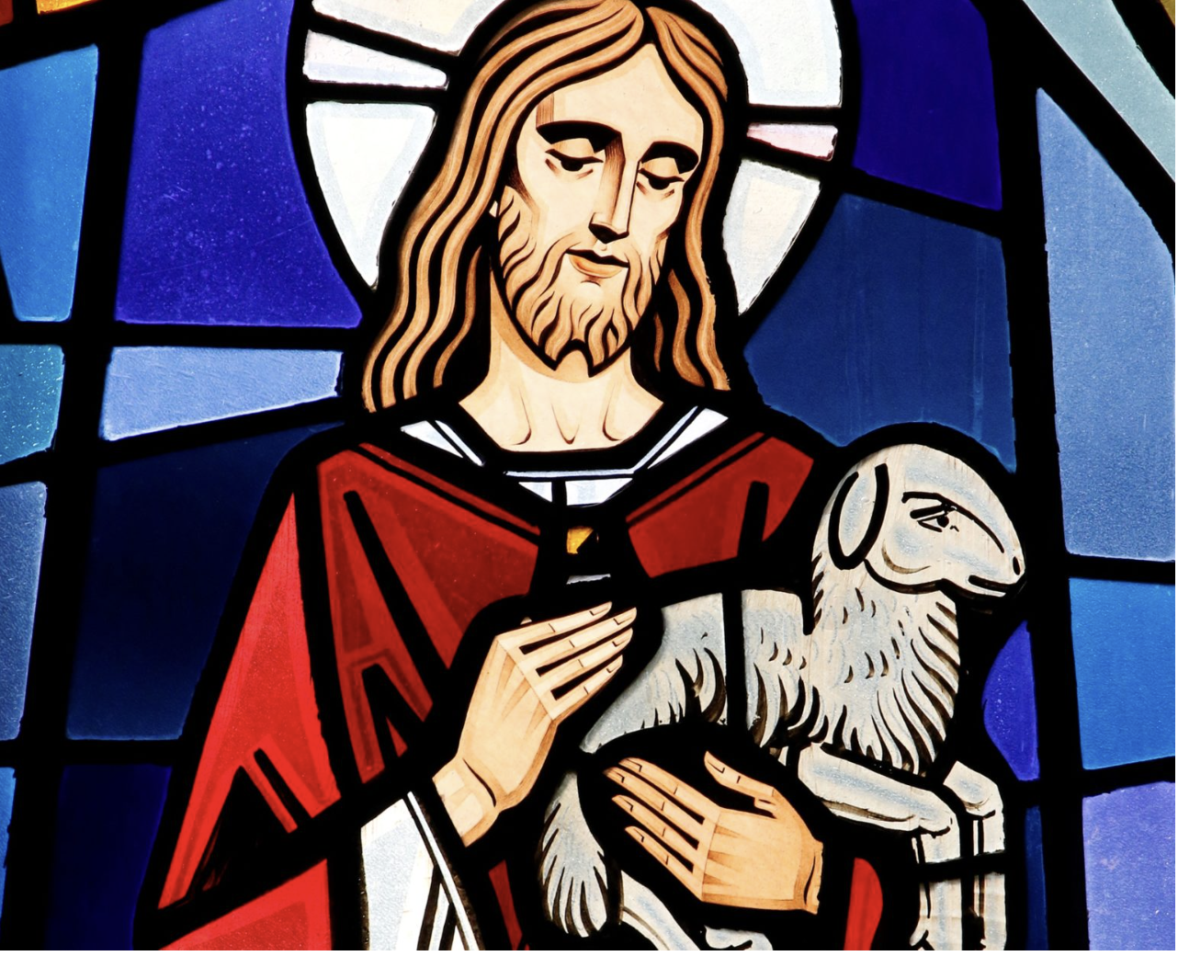

Messiah Lutheran Church
Sartell, MN
www.messiahsartell.com
320-252-5883

Welcome in the name of Christ. Our mission is simply stated, “Growing in Christ; Sharing His love.” Everything we do at Messiah is centered on receiving the gifts that Christ gives and sharing His love in service to those in our homes, at work, and our neighborhoods.

The apostle Paul tells us, “For I have decided to know nothing among you except Jesus Christ and Him Crucified. (I Corinthians 2:2).” Our goal is to preach this truth of forgiveness, life, and salvation in Christ to sinners by His Word. The LORD bless our time of worship and may His Holy Spirit help us grow in faith in Christ and love towards others.

Prayer Upon Entering
Please take this time to focus on our purpose in gathering and join in prayer before our service begins. Blessed Lord, You have caused all Holy Scriptures to be written for our learning. Grant that we may so hear them, read, mark, learn, and inwardly digest them that, by patience and comfort of Your holy Word, we may embrace and ever hold fast the blessed hope of everlasting life; through Jesus Christ, our Lord.

As We Gather
Of all the animals that could have been used to portray humanity, does it feel strange to be called a sheep? After all, it is not the most honorable creature. There are no defense mechanisms to escape a predator, no intimidating roar, and limited ability to fend for one’s self when it comes to seeking nourishment, water, and safety. Yet these things reveal the point we are called to understand. It may not be good to be a sheep on our own, but it is great to be a sheep with a Good Shepherd to care for the flock. Jesus is our perfect shepherd who protects and defends, feeds and nourishes, leads and provides all we need in this body and life. Together as His flock, we are blessed to follow Him as by His Word and Means of Grace He leads us to streams of living water and paths of righteousness for His name’s sake.

740 I Am Jesus’ Little Lamb

Stand

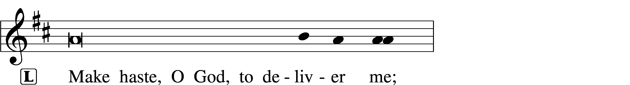
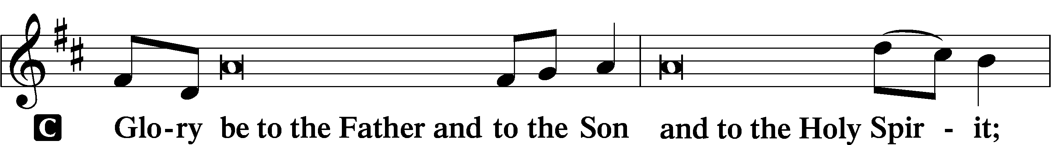
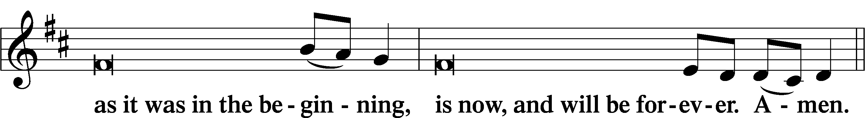
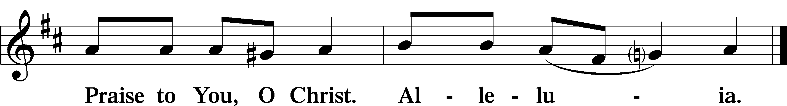
Psalmody
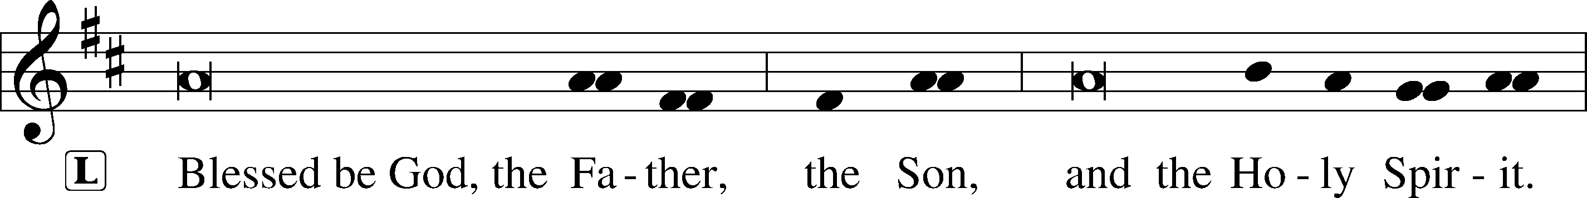
Venite
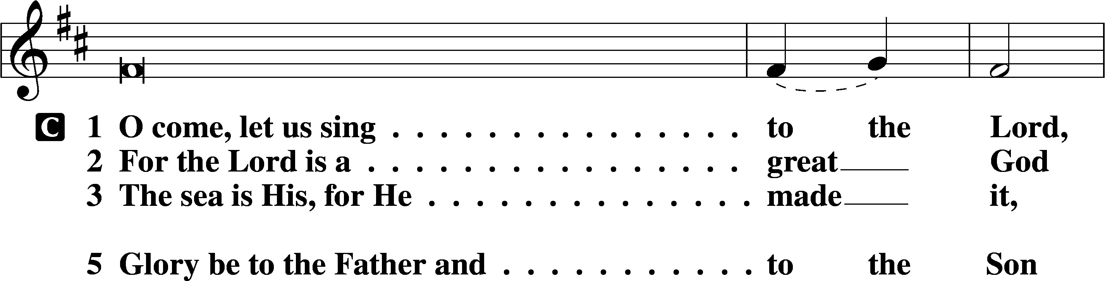
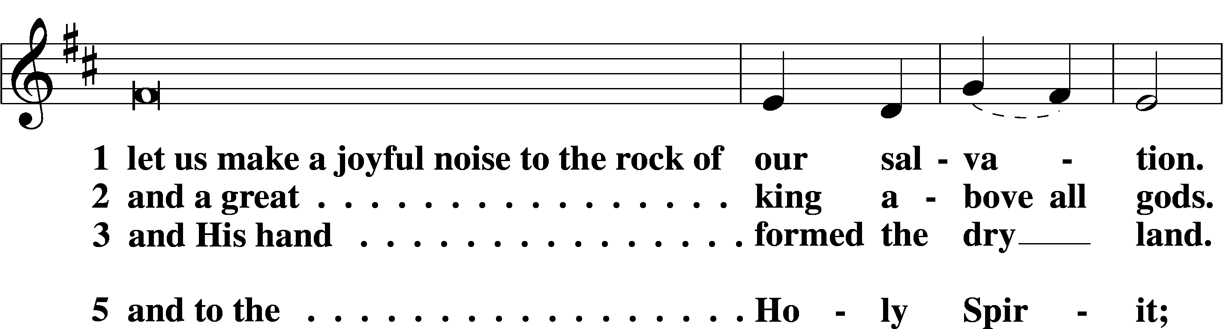
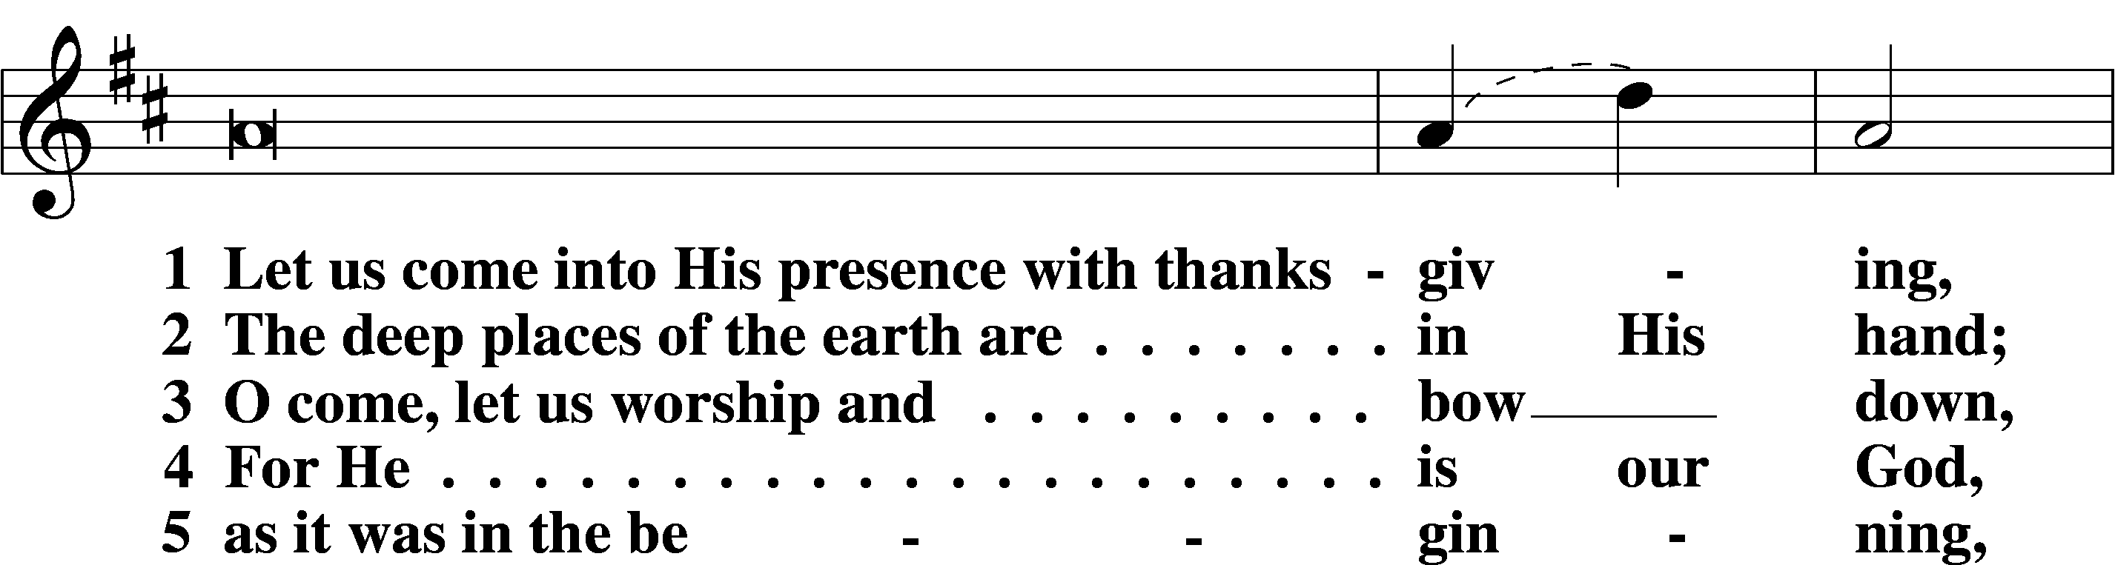
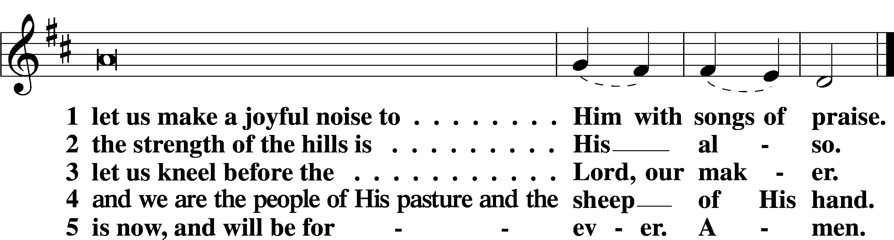

Sit

710 The Lord’s My Shepherd, I’ll Not Want

Reading Acts 4:1–12
L A reading from Acts, chapter 4.

1As they were speaking to the people, the priests and the captain of the temple and the Sadducees came upon them, 2greatly annoyed because they were teaching the people and proclaiming in Jesus the resurrection from the dead. 3And they arrested them and put them in custody until the next day, for it was already evening. 4But many of those who had heard the word believed, and the number of the men came to about five thousand.
5On the next day their rulers and elders and scribes gathered together in Jerusalem, 6with Annas the high priest and Caiaphas and John and Alexander, and all who were of the high-priestly family. 7And when they had set them in the midst, they inquired, “By what power or by what name did you do this?” 8Then Peter, filled with the Holy Spirit, said to them, “Rulers of the people and elders, 9if we are being examined today concerning a good deed done to a crippled man, by what means this man has been healed, 10let it be known to all of you and to all the people of Israel that by the name of Jesus Christ of Nazareth, whom you crucified, whom God raised from the dead—by him this man is standing before you well. 11This Jesus is the stone that was rejected by you, the builders, which has become the cornerstone. 12And there is salvation in no one else, for there is no other name under heaven given among men by which we must be saved.”

L O Lord, have mercy on us.
C Thanks be to God.

Reading 1 John 3:16–24
L A reading from 1 John, chapter 3.

16By this we know love, that he laid down his life for us, and we ought to lay down our lives for the brothers. 17But if anyone has the world’s goods and sees his brother in need, yet closes his heart against him, how does God’s love abide in him? 18Little children, let us not love in word or talk but in deed and in truth.
19By this we shall know that we are of the truth and reassure our heart before him; 20for whenever our heart condemns us, God is greater than our heart, and he knows everything. 21Beloved, if our heart does not condemn us, we have confidence before God; 22and whatever we ask we receive from him, because we keep his commandments and do what pleases him. 23And this is his commandment, that we believe in the name of his Son Jesus Christ and love one another, just as he has commanded us. 24Whoever keeps his commandments abides in him, and he in them. And by this we know that he abides in us, by the Spirit whom he has given us.

L O Lord, have mercy on us.
C Thanks be to God.

Reading John 10:11–18
L A reading from John, chapter 10.

11[Jesus said:] “I am the good shepherd. The good shepherd lays down his life for the sheep. 12He who is a hired hand and not a shepherd, who does not own the sheep, sees the wolf coming and leaves the sheep and flees, and the wolf snatches them and scatters them. 13He flees because he is a hired hand and cares nothing for the sheep. 14I am the good shepherd. I know my own and my own know me, 15just as the Father knows me and I know the Father; and I lay down my life for the sheep. 16And I have other sheep that are not of this fold. I must bring them also, and they will listen to my voice. So there will be one flock, one shepherd. 17For this reason the Father loves me, because I lay down my life that I may take it up again. 18No one takes it from me, but I lay it down of my own accord. I have authority to lay it down, and I have authority to take it up again. This charge I have received from my Father.”

L O Lord, have mercy on us.
C Thanks be to God.

Responsory
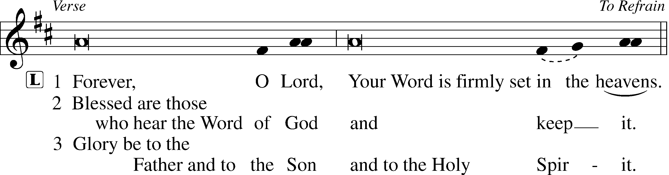
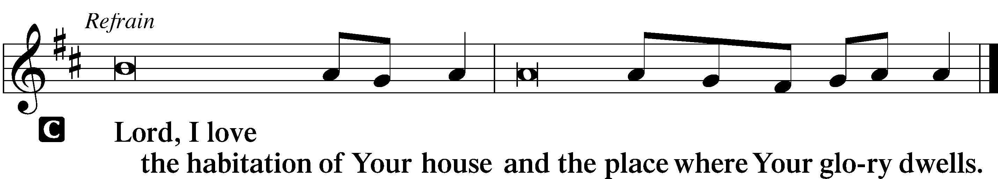

Sermon: I Am the Good Shepherd, John 10:11-18

Canticle
Stand

Te Deum
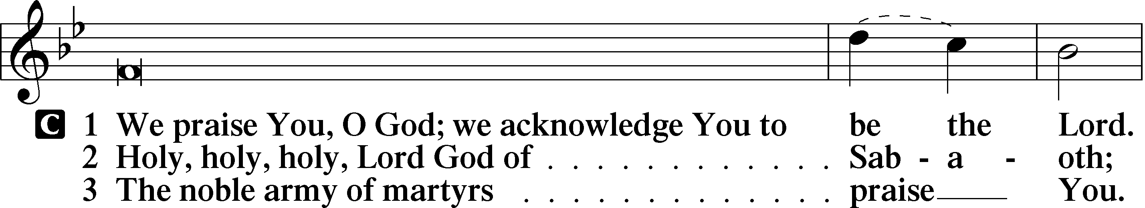
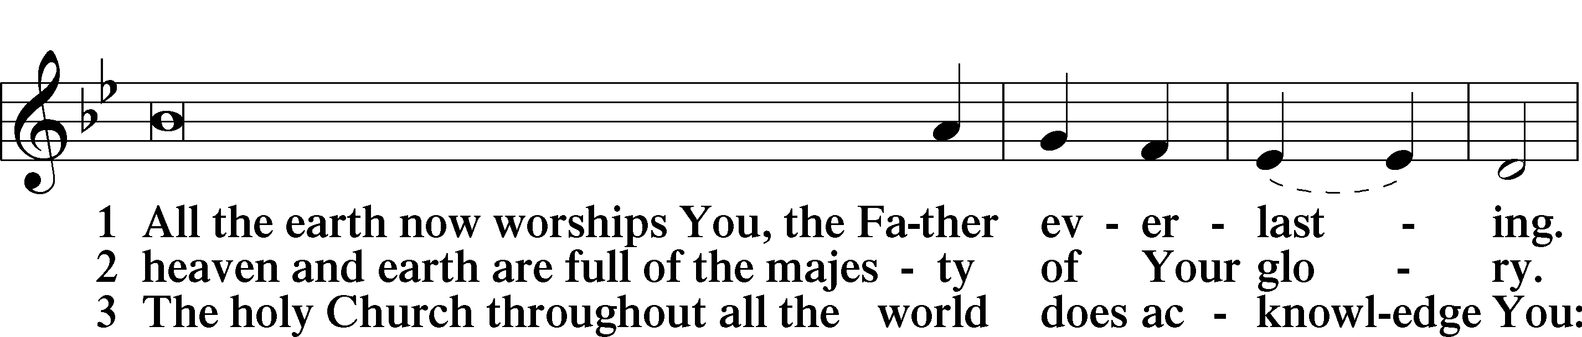
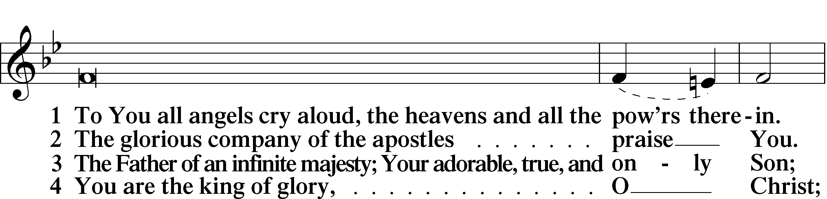
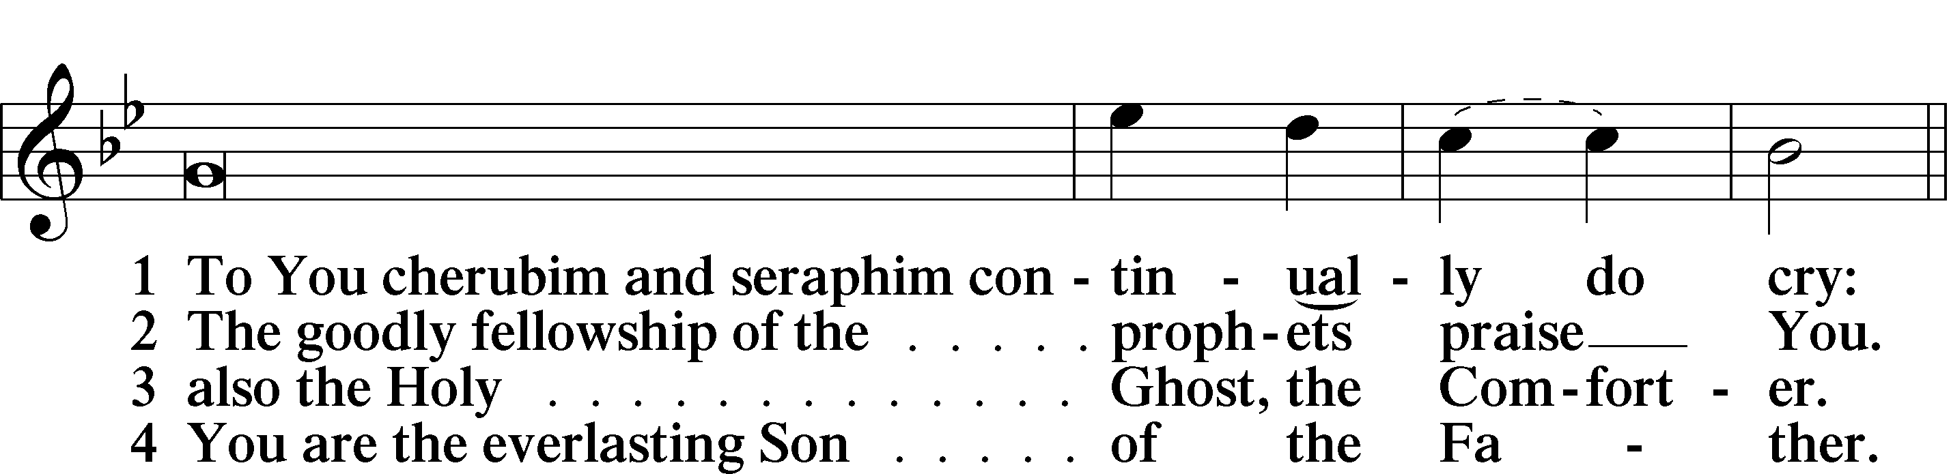
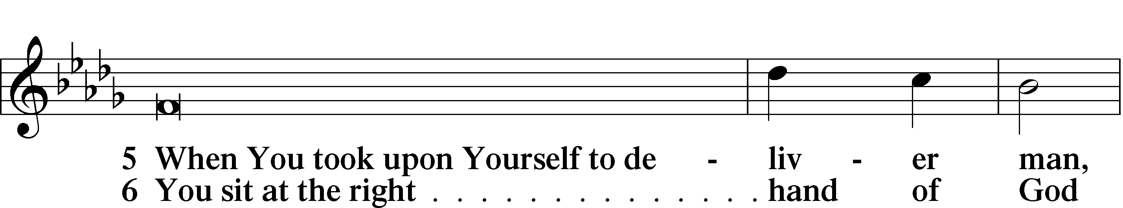
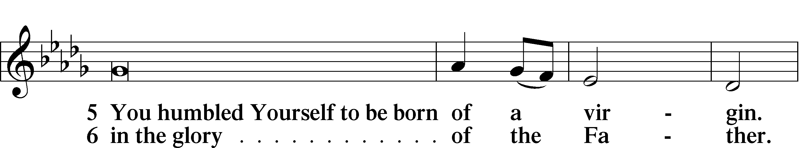
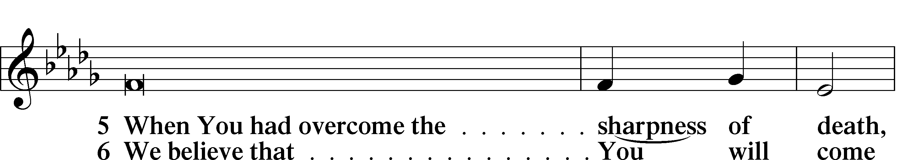
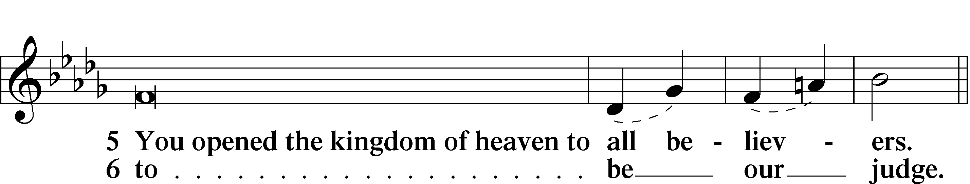
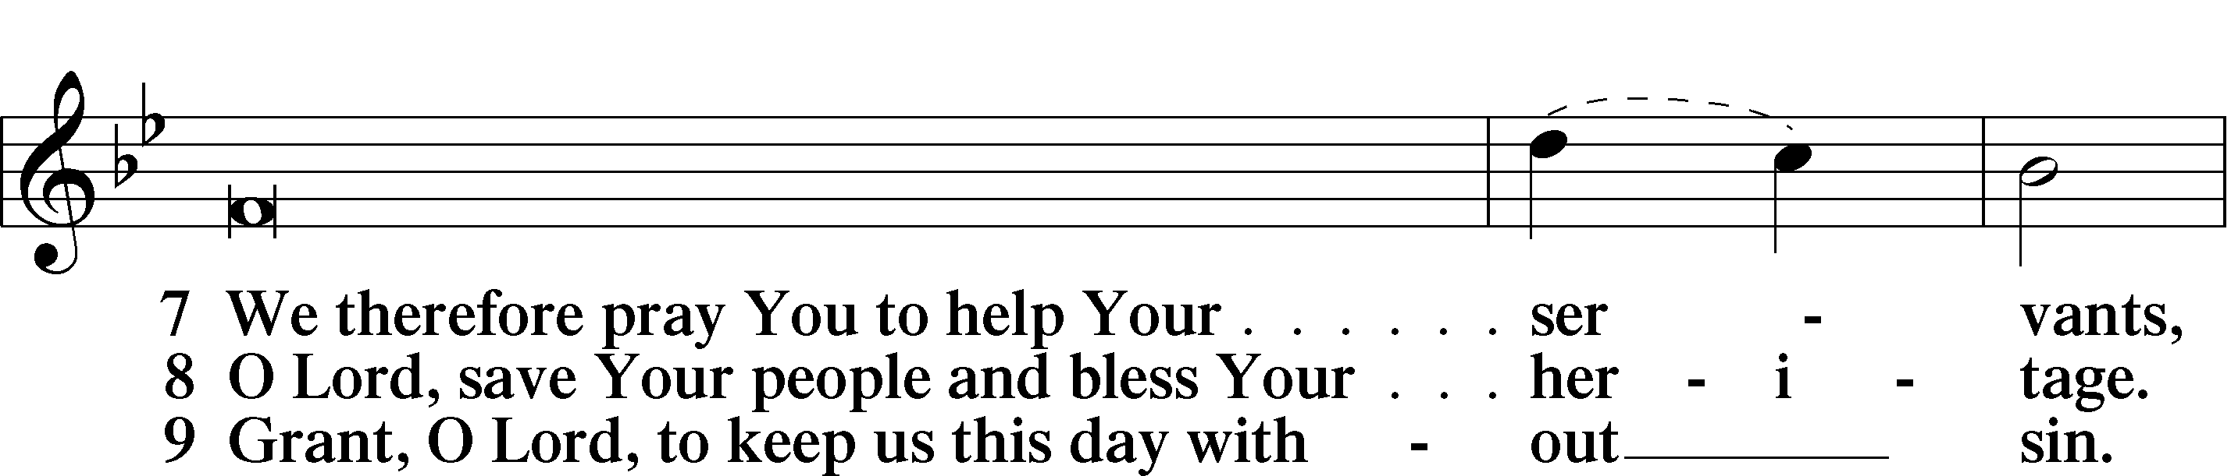
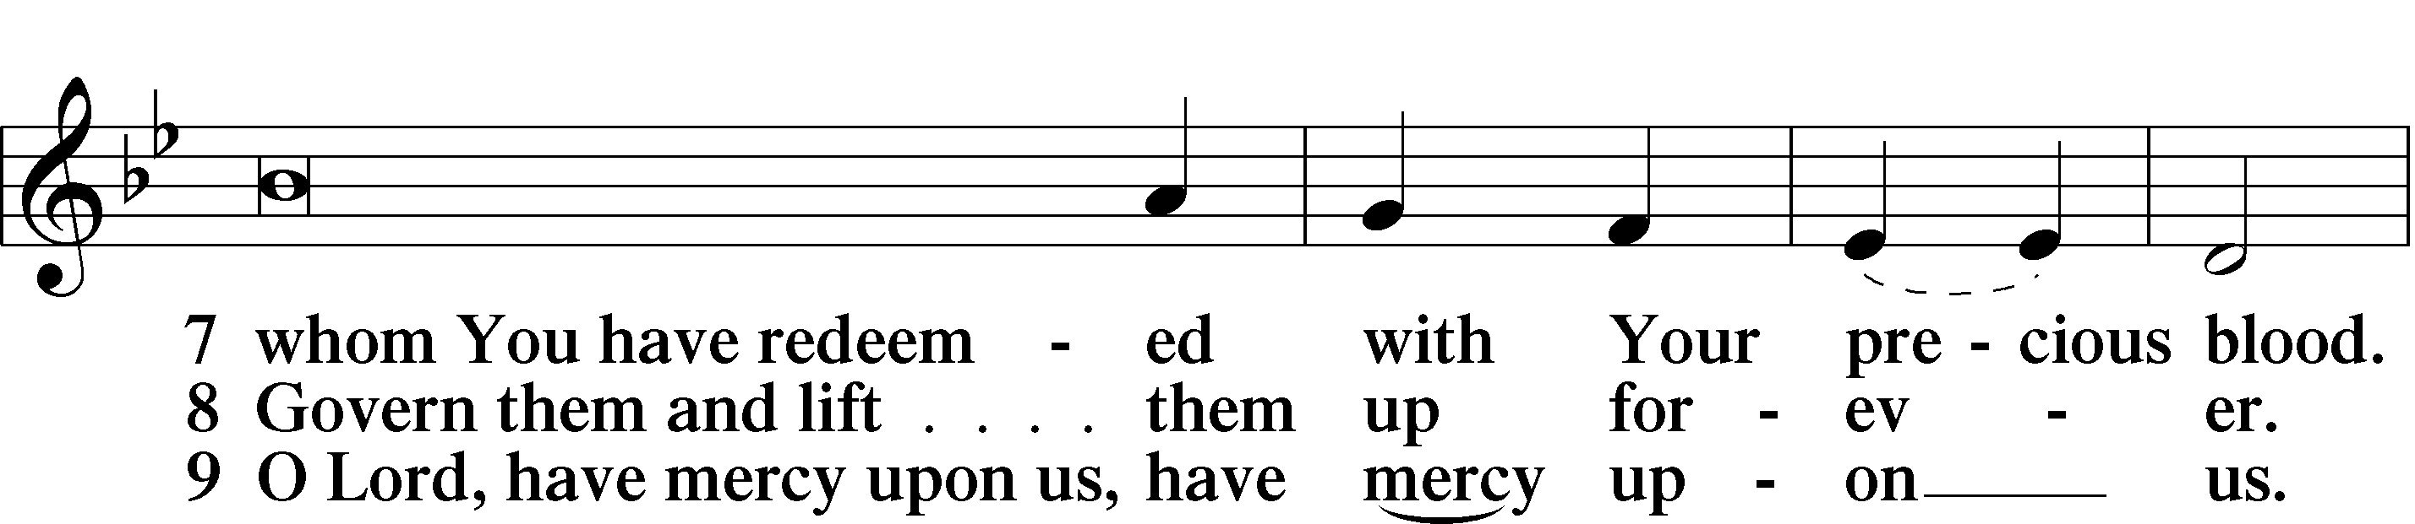
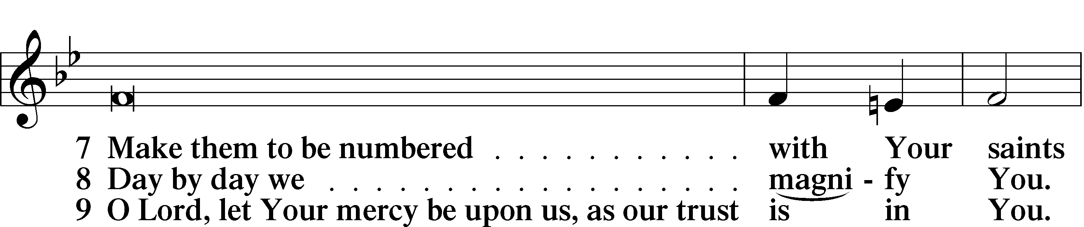
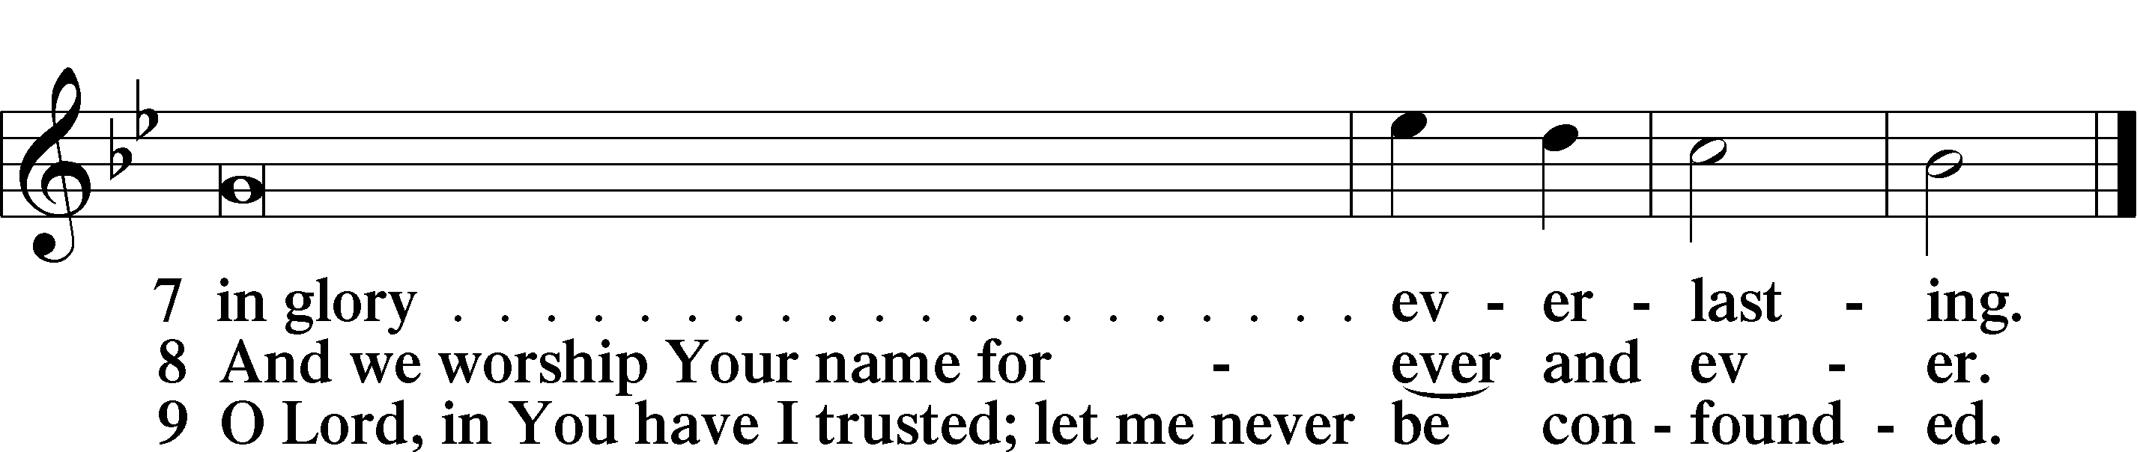
Sit

Offering We generously give our offerings to the LORD out of thanksgiving for His generosity of forgiveness, life, and salvation in Christ (2 Corinthians 9:8). We believe that our offerings are not only to support the proclamation of the Gospel here and around the world, but also to help us all grow in faith and trust in Him (2 Corinthians 9:7). We have placed an offering plate in the narthex so you are able to freely give back to Him as you are able. To Him be all the glory!

Service of Prayer

Stand

Kyrie
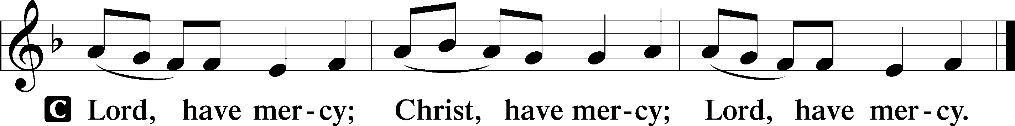

Lord’s Prayer
C Our Father who art in heaven,
hallowed be Thy name,
Thy kingdom come,
Thy will be done on earth
as it is in heaven;
give us this day our daily bread;
and forgive us our trespasses
as we forgive those
who trespass against us;
and lead us not into temptation,
but deliver us from evil.
For Thine is the kingdom
and the power and the glory
forever and ever. Amen.

Collects

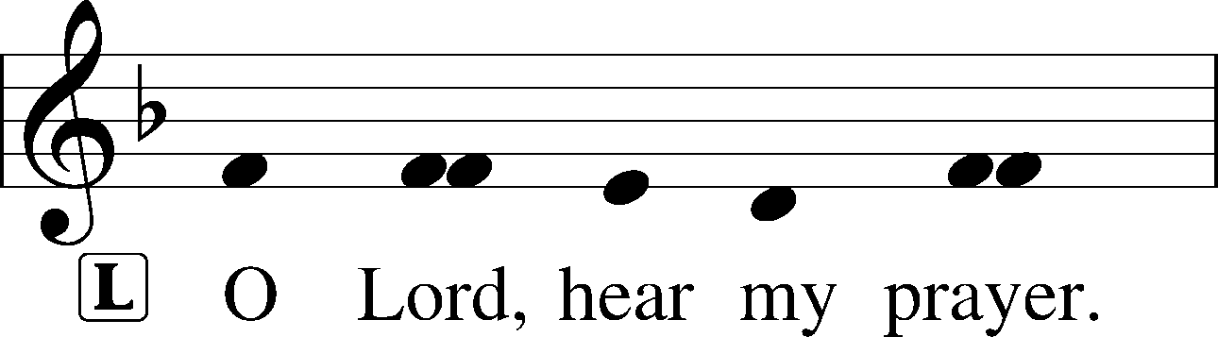
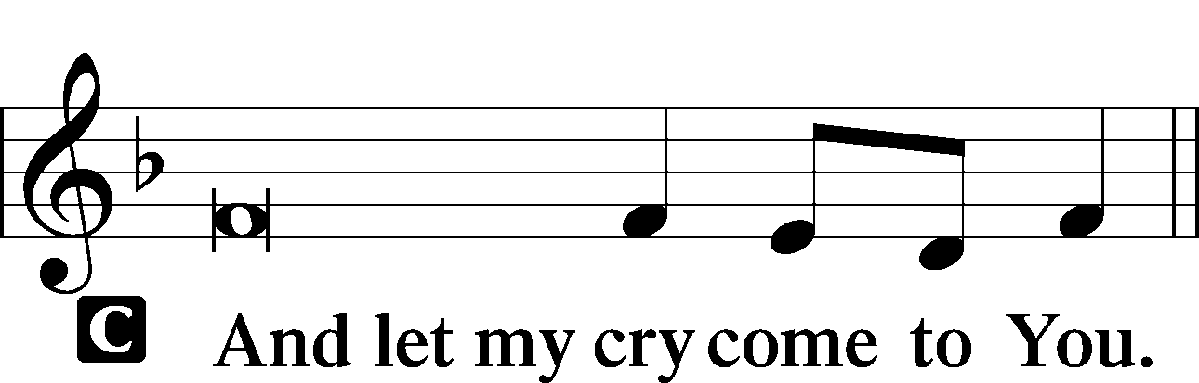

Collect of the Day
Almighty God, merciful Father, since You have wakened from death the Shepherd of Your sheep, grant us Your Holy Spirit that when we hear the voice of our Shepherd we may know Him who calls us each by name and follow where He leads; through the same Jesus Christ, Your Son, our Lord, who lives and reigns with You and the Holy Spirit, one God, now and forever.
C Amen.

Prayers of the church

Collect for Grace
L O Lord, our heavenly Father, almighty and everlasting God, You have safely brought us to the beginning of this day. Defend us in the same with Your mighty power and grant that this day we fall into no sin, neither run into any kind of danger, but that all our doings, being ordered by Your governance, may be righteous in Your sight; through Jesus Christ, Your Son, our Lord, who lives and reigns with You and the Holy Spirit, one God, now and forever.
C Amen.

Benedicamus
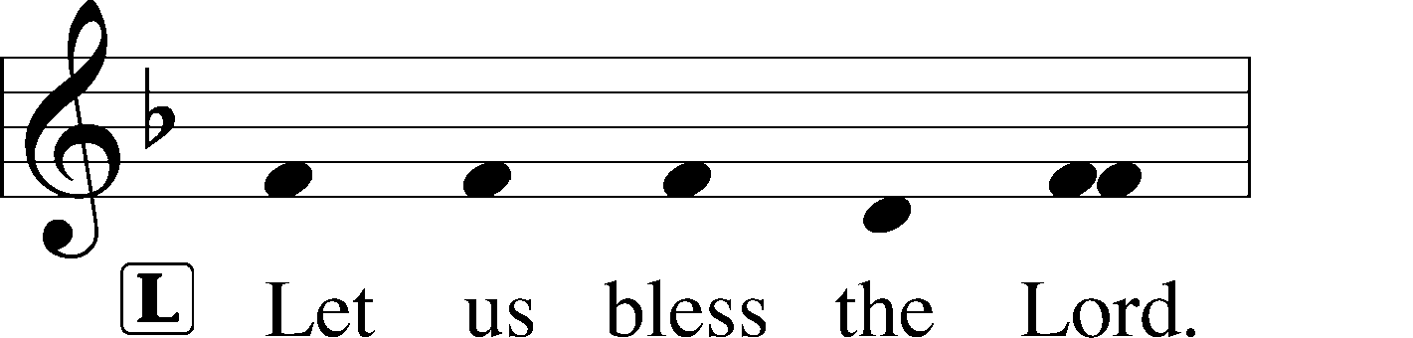
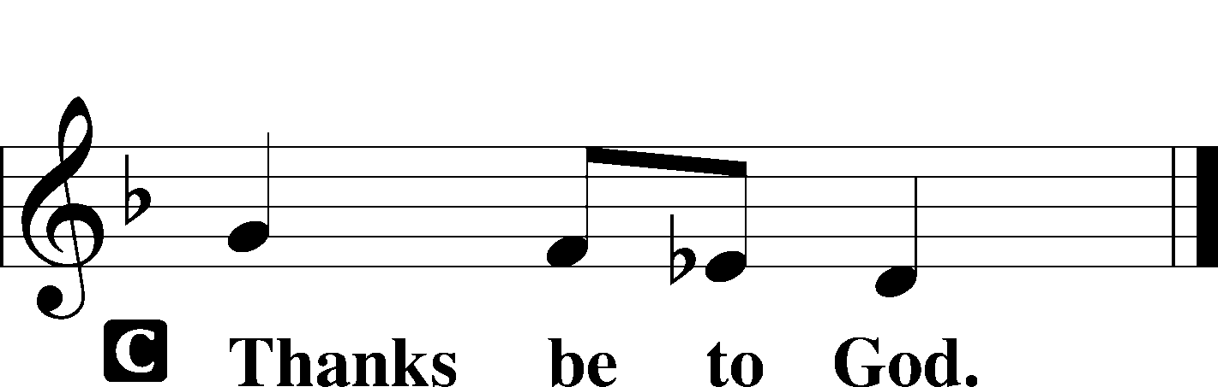

Benediction
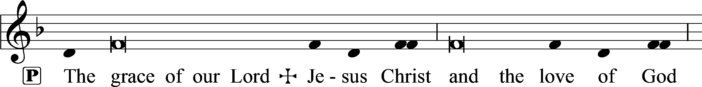
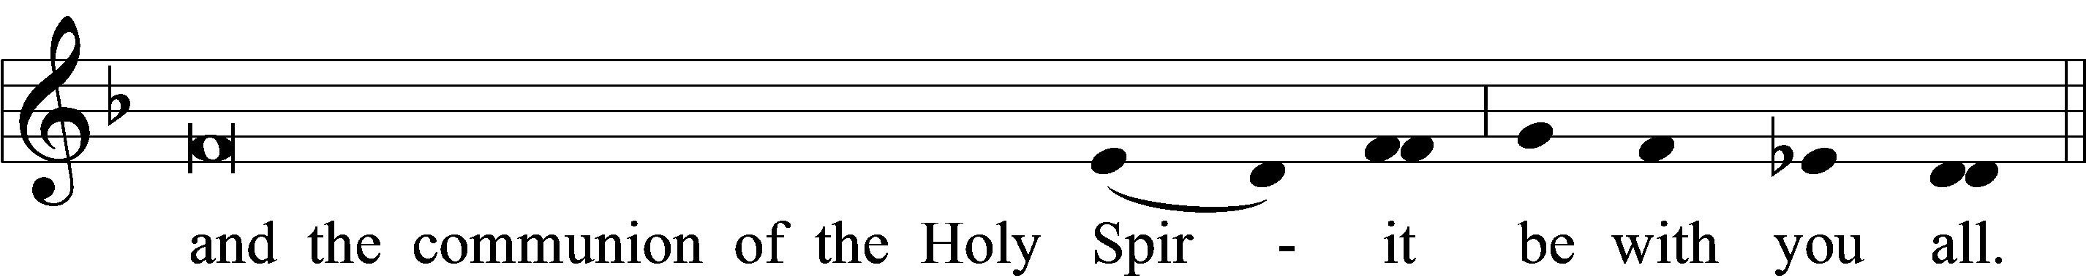

711 Savior, like a Shepherd Lead Us

Acknowledgments
Matins from Lutheran Service Book
Unless otherwise indicated, Scripture quotations are from the ESV® Bible (The Holy Bible, English Standard Version®), copyright © 2001 by Crossway, a publishing ministry of Good News Publishers. Used by permission. All rights reserved.
Created by Lutheran Service Builder © 2023 Concordia Publishing House.

Announcements

SPRING CLEANUP will be held Saturday, April 27 from 9:00 a.m.-noon. We will be cleaning inside and outside of the church. Please bring rakes and leaf blowers if you have them. We are hoping for beautiful weather and a fun morning of making Messiah beautiful. Thank you for joining us!

SUMMER MOWERS: If you are interested in being a mower
for the summer, please contact Doug Tanner.

For the Kids

