Eighth Sunday After Pentecost
July 19th, 2026

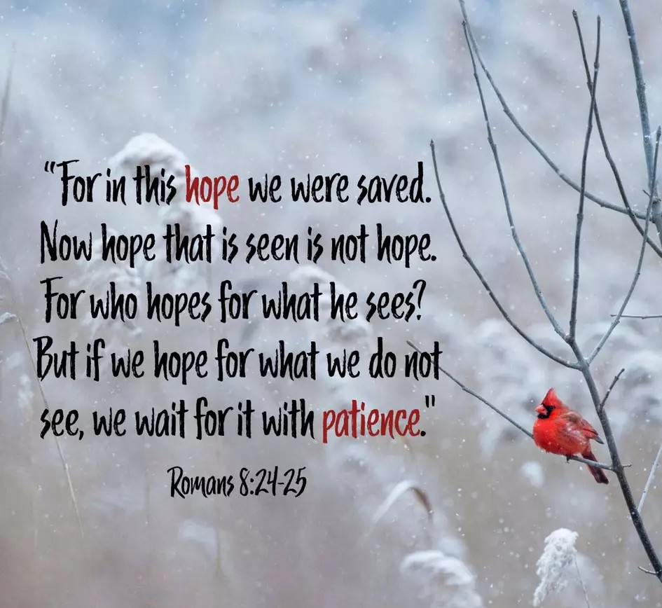

Messiah Lutheran Church
Sartell, MN
www.messiahsartell.com
320-252-5883
Prayer Before Entering
Please take this time to focus on our purpose in gathering and join in prayer before our service begins. Blessed Lord, You have caused all Holy Scriptures to be written for our learning. Grant that we may so hear them, read, mark, learn, and inwardly digest them that, by patience and comfort of Your holy Word, we may embrace and ever hold fast the blessed hope of everlasting life; through Jesus Christ, our Lord.

As We Gather
As we come to worship today, we bring with us the aches and struggles of life in a broken world. Romans 8 reminds us that this suffering is real, but it is not the end of the story. Jesus has already won the victory through His death and resurrection, and one day He will make all things new. Until then, the Holy Spirit holds us up, prays for us when we do not have the words, and keeps our hope fixed on Christ. So today we worship with thankful hearts, trusting that the glory God has promised is far greater than anything we face now.

575 My Hope Is Built on Nothing Less

Stand

The sign of the cross may be made by all in remembrance of their Baptism.

P In the name of the Father and of the T Son and of the Holy Spirit.
C Amen.

P Our help is in the name of the Lord,
C who made heaven and earth.

P If You, O Lord, kept a record of sins, O Lord, who could stand?
C But with You there is forgiveness; therefore You are feared.

P Since we are gathered to hear God’s Word, call upon Him in prayer and praise, let us first consider our unworthiness and confess before God and one another that we have sinned in thought, word, and deed, and that we cannot free ourselves from our sinful condition. Together as His people let us take refuge in the infinite mercy of God, our heavenly Father, seeking His grace for the sake of Christ, and saying:
C God, be merciful to me, a sinner.

Silence for reflection on God’s Word and for self-examination.

C Almighty God, have mercy upon us, forgive us our sins, and lead us to everlasting life. Amen.

P Almighty God in His mercy has given His Son to die for you and for His sake forgives you all your sins. As a called and ordained servant of Christ, and by His authority, I therefore forgive you all your sins in the name of the Father and of the T Son and of the Holy Spirit.

C Amen.

Introit Psalm 86:11–15; antiphon: v. 6
P Give ear, O Lord, to my prayer;
listen to my plea for grace.
C Teach me your way, O Lord, that I may walk in your truth;
unite my heart to fear your name.
P I give thanks to you, O Lord my God, with my whole heart,
and I will glorify your name forever.
C For great is your steadfast love toward me;
you have delivered my soul from the depths of Sheol.
P O God, insolent men have risen up against me; a band of ruthless men
seek my life,
and they do not set you before them.
C But you, O Lord, are a God merciful and gracious,
slow to anger and abounding in steadfast love and faithfulness.
All: Glory be to the Father and to the Son
and to the Holy Spirit;
as it was in the beginning,
is now, and will be forever. Amen.
P Give ear, O Lord, to my prayer;
listen to my plea for grace.

Kyrie
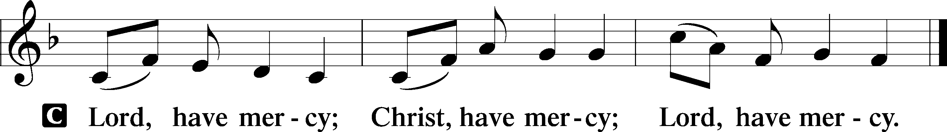

Gloria in Excelsis
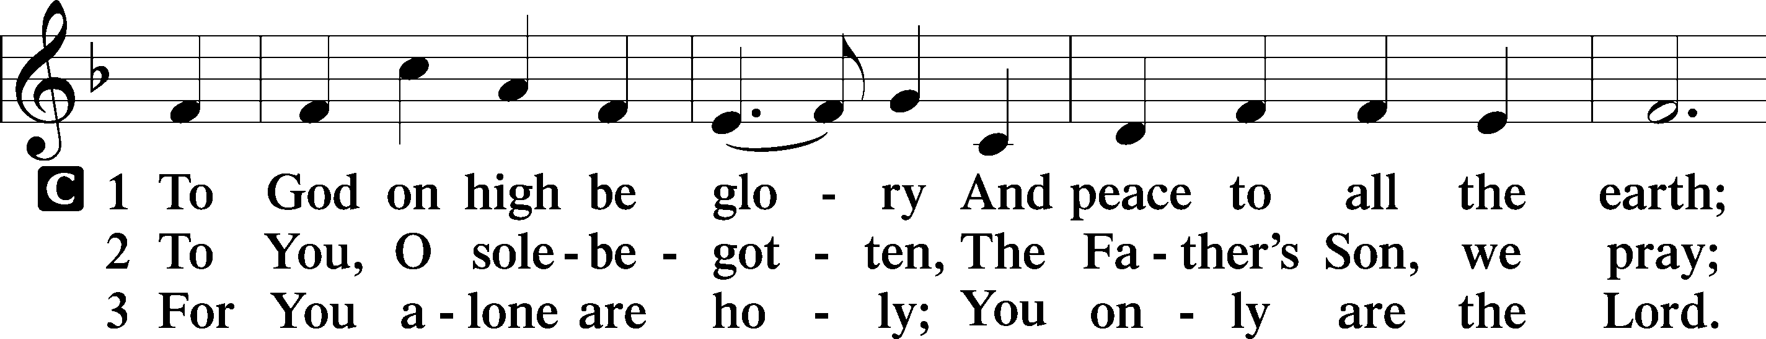
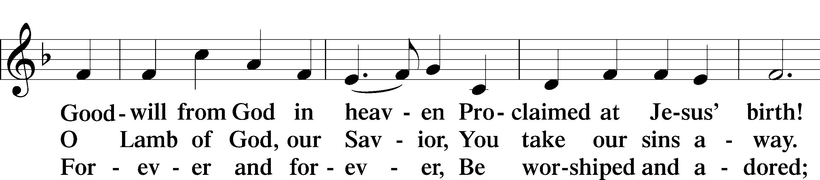
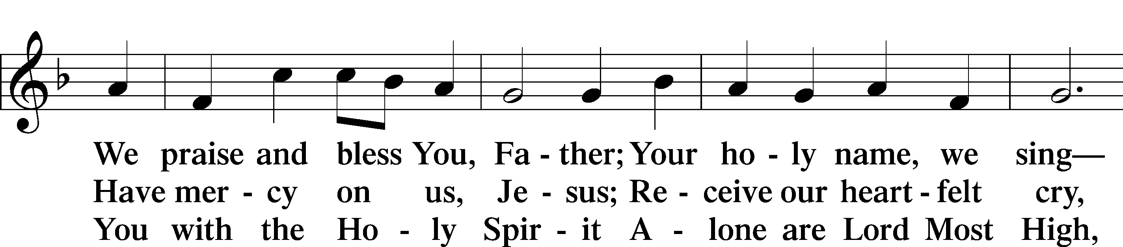
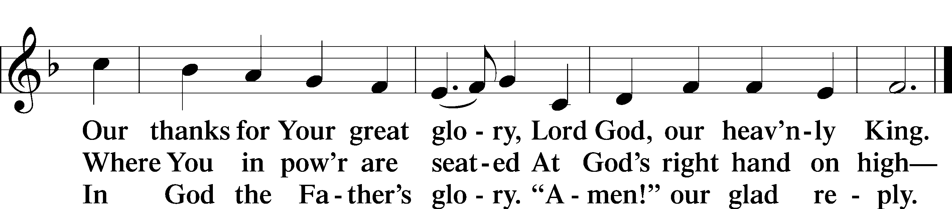

Salutation and Collect of the Day
P The Lord be with you.
C And also with you.

P Let us pray.
O God, so rule and govern our hearts and minds by Your Holy Spirit that, ever mindful of Your final judgment, we may be stirred up to holiness of living here and dwell with You in perfect joy hereafter; through Jesus Christ, Your Son, our Lord, who lives and reigns with You and the Holy Spirit, one God, now and forever.

C Amen.

Sit

Old Testament Reading Isaiah 44:6–8
6Thus says the Lord, the King of Israel
and his Redeemer, the Lord of hosts:
“I am the first and I am the last;
besides me there is no god.
7Who is like me? Let him proclaim it.
Let him declare and set it before me,
since I appointed an ancient people.
Let them declare what is to come, and what will happen.
8Fear not, nor be afraid;
have I not told you from of old and declared it?
And you are my witnesses!
Is there a God besides me?
There is no Rock; I know not any.”

A This is the Word of the Lord.
C Thanks be to God.

Epistle Romans 8:18–27
18For I consider that the sufferings of this present time are not worth comparing with the glory that is to be revealed to us. 19For the creation waits with eager longing for the revealing of the sons of God. 20For the creation was subjected to futility, not willingly, but because of him who subjected it, in hope 21that the creation itself will be set free from its bondage to decay and obtain the freedom of the glory of the children of God. 22For we know that the whole creation has been groaning together in the pains of childbirth until now. 23And not only the creation, but we ourselves, who have the firstfruits of the Spirit, groan inwardly as we wait eagerly for adoption as sons, the redemption of our bodies. 24For in this hope we were saved. Now hope that is seen is not hope. For who hopes for what he sees? 25But if we hope for what we do not see, we wait for it with patience.
26Likewise the Spirit helps us in our weakness. For we do not know what to pray for as we ought, but the Spirit himself intercedes for us with groanings too deep for words. 27And he who searches hearts knows what is the mind of the Spirit, because the Spirit intercedes for the saints according to the will of God.

A This is the Word of the Lord.
C Thanks be to God.

Stand

Alleluia and Verse
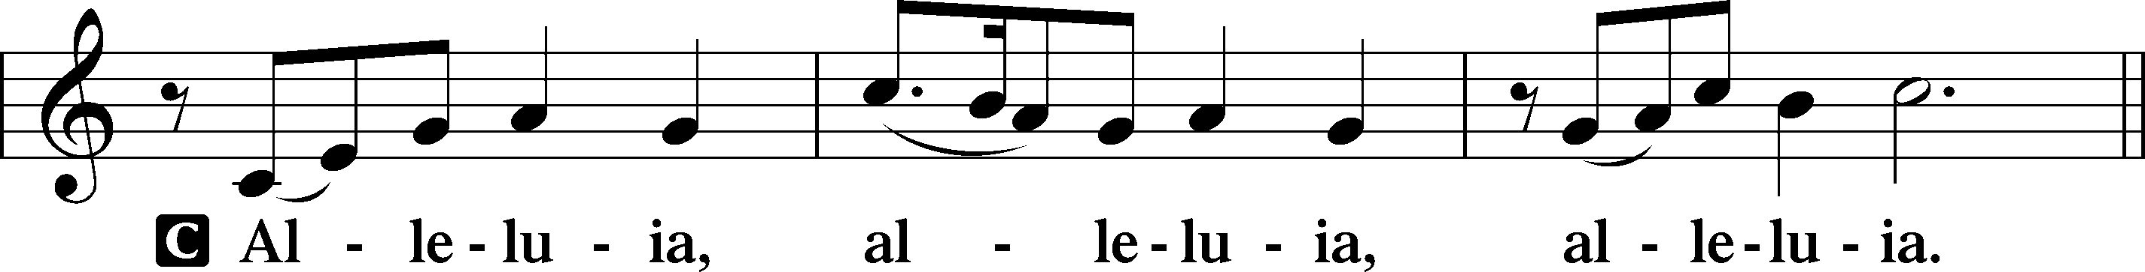
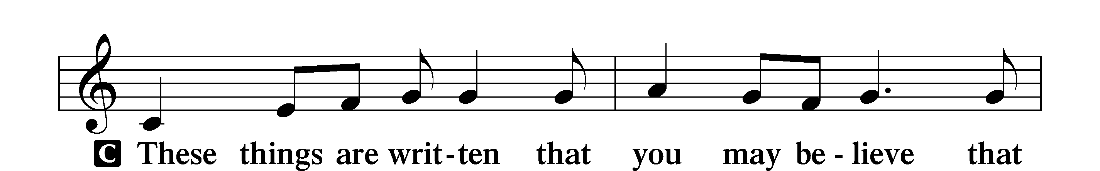
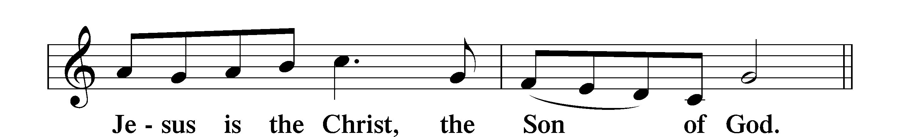
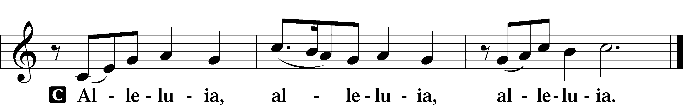

Holy Gospel Matthew 13:24–30, 36–43
P The Holy Gospel according to St. Matthew, the thirteenth chapter.
C Glory to You, O Lord.

24[Jesus] put another parable before them, saying, “The kingdom of heaven may be compared to a man who sowed good seed in his field, 25but while his men were sleeping, his enemy came and sowed weeds among the wheat and went away. 26So when the plants came up and bore grain, then the weeds appeared also. 27And the servants of the master of the house came and said to him, ‘Master, did you not sow good seed in your field? How then does it have weeds?’ 28He said to them, ‘An enemy has done this.’ So the servants said to him, ‘Then do you want us to go and gather them?’ 29But he said, ‘No, lest in gathering the weeds you root up the wheat along with them. 30Let both grow together until the harvest, and at harvest time I will tell the reapers, Gather the weeds first and bind them in bundles to be burned, but gather the wheat into my barn.’” . . .
36Then he left the crowds and went into the house. And his disciples came to him, saying, “Explain to us the parable of the weeds of the field.” 37He answered, “The one who sows the good seed is the Son of Man. 38The field is the world, and the good seed is the children of the kingdom. The weeds are the sons of the evil one, 39and the enemy who sowed them is the devil. The harvest is the close of the age, and the reapers are angels. 40Just as the weeds are gathered and burned with fire, so will it be at the close of the age. 41The Son of Man will send his angels, and they will gather out of his kingdom all causes of sin and all law-breakers, 42and throw them into the fiery furnace. In that place there will be weeping and gnashing of teeth. 43Then the righteous will shine like the sun in the kingdom of their Father. He who has ears, let him hear.”

P This is the Gospel of the Lord.
C Praise to You, O Christ.

Apostles’ Creed
C I believe in God, the Father Almighty,
maker of heaven and earth.
And in Jesus Christ, His only Son, our Lord,
who was conceived by the Holy Spirit,
born of the virgin Mary,
suffered under Pontius Pilate,
was crucified, died and was buried.
He descended into hell.
The third day He rose again from the dead.
He ascended into heaven
and sits at the right hand of God the Father Almighty.
From thence He will come to judge the living and the dead.
I believe in the Holy Spirit,
the holy Christian Church,
the communion of saints,
the forgiveness of sins,
the resurrection of the body,
and the life T everlasting. Amen.
Sit

770 What a Friend We Have in Jesus

Sermon

Offering. We generously give our offerings to the LORD out of thanksgiving for His generosity of forgiveness, life, and salvation in Christ (2 Corinthians 9:8). We believe that our offerings are not only to support the proclamation of the Gospel here and around the world, but also to help us all grow in faith and trust in Him (2 Corinthians 9:7). We have placed an offering plate in the narthex so you are able to freely give back to Him as you are able. To Him be all the glory!

Stand

Prayer of the Church

Lord’s Prayer

Benedicamus
A Let us bless the Lord.
C Thanks be to God.

Benediction
P The Lord bless you and keep you.
The Lord make His face shine on you and be gracious to you.
The Lord look upon you with favor and T give you peace.
C Amen.

769 Eternal Spirit of the Living Christ

Announcement

It’s time to update the directory! There should be a form in your church mailbox and there are extra forms on the table in the Narthex. Please fill
out and return to me even if you don’t think there have been any changes as
I would like to verify everyone’s contact information. Thank you to all
those that have turned them in already! About 50 percent of the members have turned theirs in. Please keep the forms coming!

~Tara, Secretary

