Fourth Sunday After Pentecost
June 21st, 2026

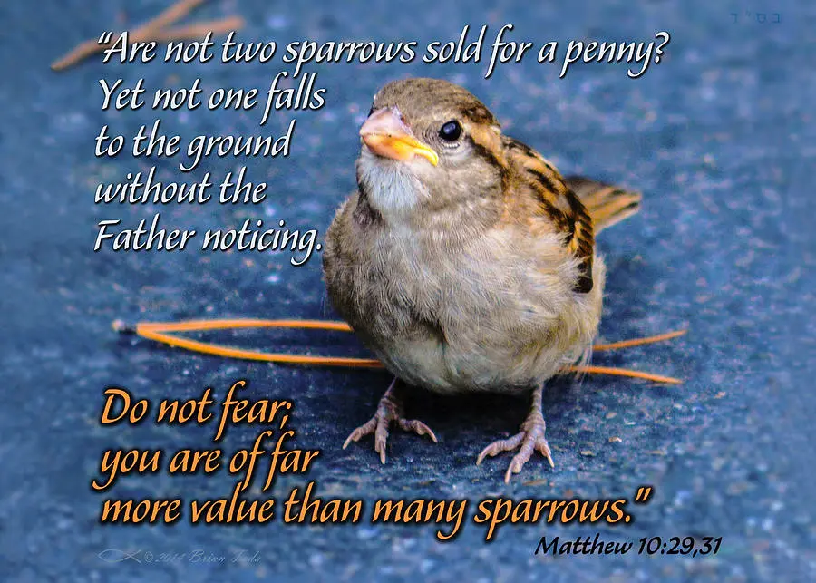

Messiah Lutheran Church
Sartell, MN
www.messiahsartell.com
320-252-5883
Prayer Before Entering
Please take this time to focus on our purpose in gathering and join in prayer before our service begins. Blessed Lord, You have caused all Holy Scriptures to be written for our learning. Grant that we may so hear them, read, mark, learn, and inwardly digest them that, by patience and comfort of Your holy Word, we may embrace and ever hold fast the blessed hope of everlasting life; through Jesus Christ, our Lord.

As We Gather
Polls tell us that many of us live in fear and struggle with depression. Jesus calls us not to be afraid—not because we have no enemies but because He is stronger than them all. God knows the score—from every bird that falls from the sky to every hair on our head. He has invested His love and mercy in us in Christ and will not turn away from us. This promise is sure. Because of this, we can surrender our fears of being known as His children. Everyone who confesses Him on earth, Christ will confess him before His Father in heaven. From this promise comes the strength to live the new life given to us in our Baptism and to make known what Christ has done by His death and resurrection—for us and for all the world. We are called to judge not by the times but by the promises of God. Neither will He disappoint us nor will He forsake us.

605 Father Welcomes

Stand

The sign of the cross may be made by all in remembrance of their Baptism.

P In the name of the Father and of the T Son and of the Holy Spirit.
C Amen.

P Our help is in the name of the Lord,
C who made heaven and earth.

P If You, O Lord, kept a record of sins, O Lord, who could stand?
C But with You there is forgiveness; therefore You are feared.

P Since we are gathered to hear God’s Word, call upon Him in prayer and praise, let us first consider our unworthiness and confess before God and one another that we have sinned in thought, word, and deed, and that we cannot free ourselves from our sinful condition. Together as His people let us take refuge in the infinite mercy of God, our heavenly Father, seeking His grace for the sake of Christ, and saying:
C God, be merciful to me, a sinner.

Silence for reflection on God’s Word and for self-examination.
C Almighty God, have mercy upon us, forgive us our sins, and lead us to everlasting life. Amen.

P Almighty God in His mercy has given His Son to die for you and for His sake forgives you all your sins. As a called and ordained servant of Christ, and by His authority, I therefore forgive you all your sins in the name of the Father and of the T Son and of the Holy Spirit.

C Amen.

Introit Psalm 56:3–4, 10–11; antiphon: v. 13
P For you have delivered my soul from death, yes, my feet from falling,
that I may walk before God in the light of life.
C When I am afraid,
I put my trust in you.
P In God, whose word I praise, in God I trust; I shall not be afraid.
What can flesh do to me?
C In God, whose word I praise,
in the Lord, whose word I praise,
P in God I trust; I shall not be afraid.
What can man do to me?
All: Glory be to the Father and to the Son
and to the Holy Spirit;
as it was in the beginning,
is now, and will be forever. Amen.
P For you have delivered my soul from death, yes, my feet from falling,
that I may walk before God in the light of life.

Kyrie
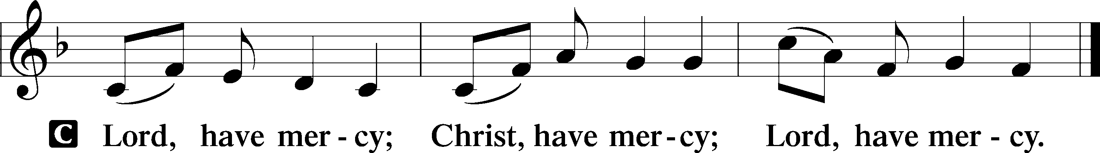

Gloria in Excelsis
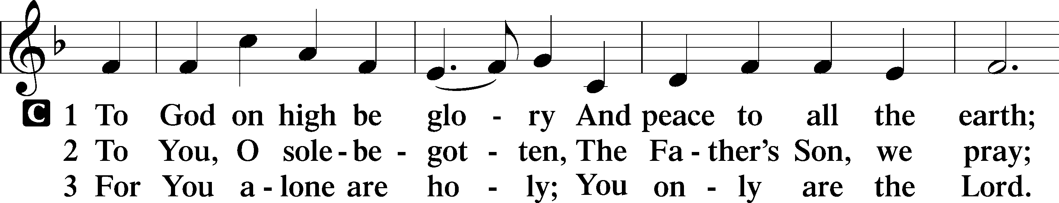
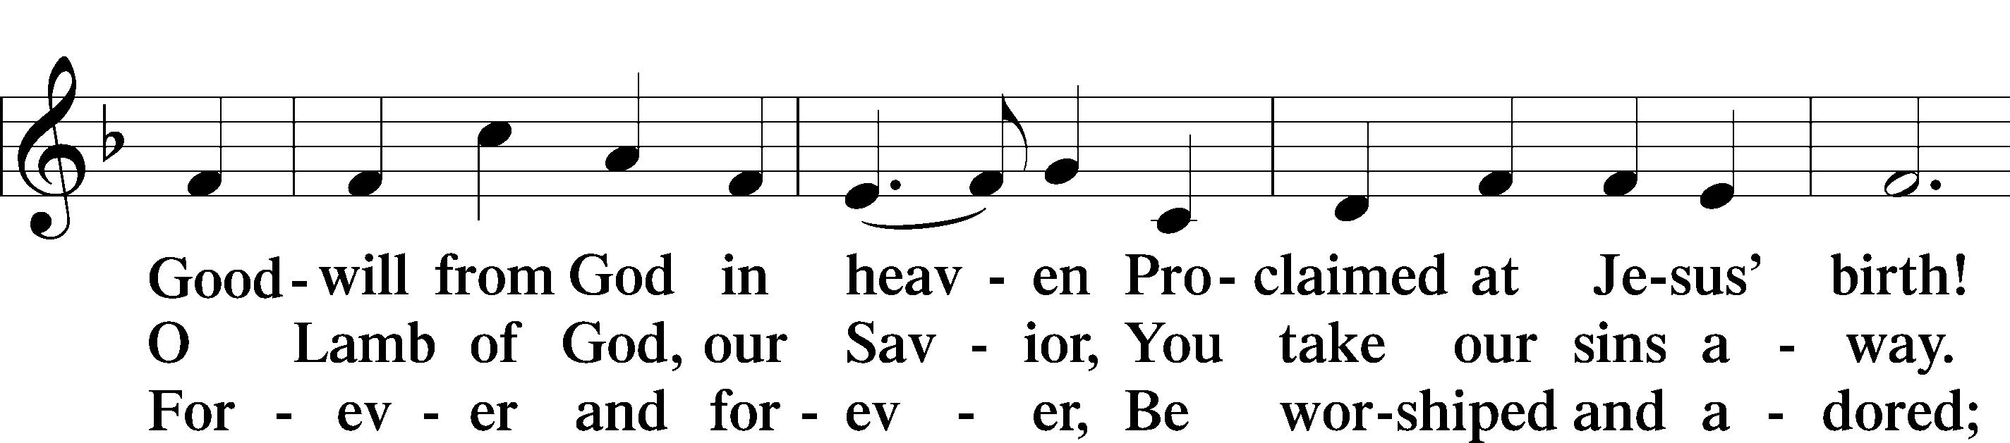
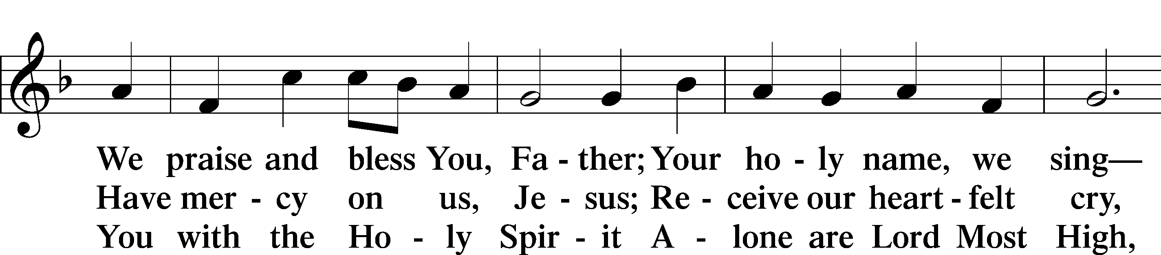
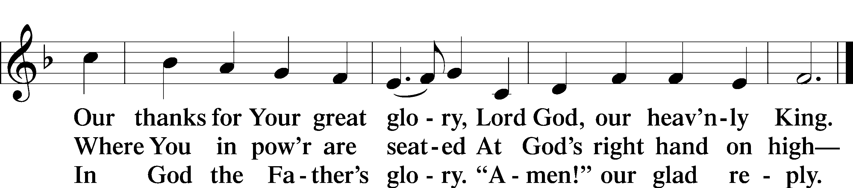

Salutation and Collect of the Day
P The Lord be with you.
C And also with you.

P Let us pray.
O God, because Your abiding presence always goes with us, keep us aware of Your daily mercies that we may live secure and content in Your eternal love; through Jesus Christ, Your Son, our Lord, who lives and reigns with You and the Holy Spirit, one God, now and forever.

C Amen.

Sit
Old Testament Reading Jeremiah 20:7–13
7O Lord, you have deceived me, and I was deceived; you are stronger than I, and you have prevailed. I have become a laughingstock all the day; everyone mocks me. 8For whenever I speak, I cry out, I shout, “Violence and destruction!” For the word of the Lord has become for me a reproach and derision all day long. 9If I say, “I will not mention him, or speak any more in his name,” there is in my heart as it were a burning fire shut up in my bones, and I am weary with holding it in, and I cannot. 10For I hear many whispering. Terror is on every side! “Denounce him! Let us denounce him!” say all my close friends, watching for my fall. “Perhaps he will be deceived; then we can overcome him and take our revenge on him.” 11But the Lord is with me as a dread warrior; therefore my persecutors will stumble; they will not overcome me. They will be greatly shamed, for they will not succeed. Their eternal dishonor will never be forgotten. 12O Lord of hosts, who tests the righteous, who sees the heart and the mind, let me see your vengeance upon them, for to you have I committed my cause. 13Sing to the Lord; praise the Lord! For he has delivered the life of the needy from the hand of evildoers.

A This is the Word of the Lord.
C Thanks be to God.

Epistle Romans 6:12–23
12Let not sin therefore reign in your mortal bodies, to make you obey their passions. 13Do not present your members to sin as instruments for unrighteousness, but present yourselves to God as those who have been brought from death to life, and your members to God as instruments for righteousness. 14For sin will have no dominion over you, since you are not under law but under grace.
15What then? Are we to sin because we are not under law but under grace? By no means! 16Do you not know that if you present yourselves to anyone as obedient slaves, you are slaves of the one whom you obey, either of sin, which leads to death, or of obedience, which leads to righteousness? 17But thanks be to God, that you who were once slaves of sin have become obedient from the heart to the standard of teaching to which you were committed, 18and, having been set free from sin, have become slaves of righteousness. 19I am speaking in human terms, because of your natural limitations. For just as you once presented your members as slaves to impurity and to lawlessness leading to more lawlessness, so now present your members as slaves to righteousness leading to sanctification.
20When you were slaves of sin, you were free in regard to righteousness. 21But what fruit were you getting at that time from the things of which you are now ashamed? The end of those things is death. 22But now that you have been set free from sin and have become slaves of God, the fruit you get leads to sanctification and its end, eternal life. 23For the wages of sin is death, but the free gift of God is eternal life in Christ Jesus our Lord.

A This is the Word of the Lord.
C Thanks be to God.

Stand

Alleluia and Verse
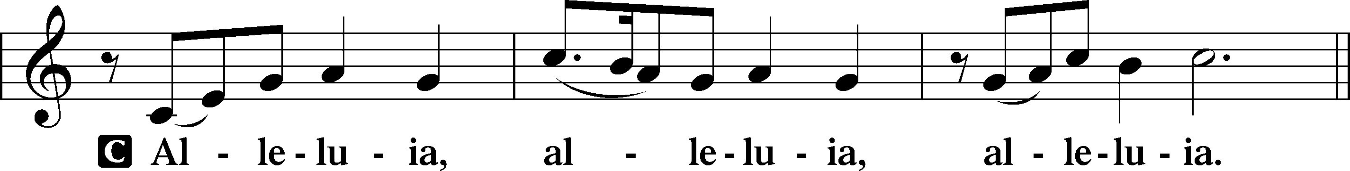
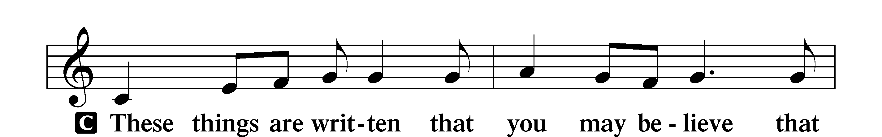
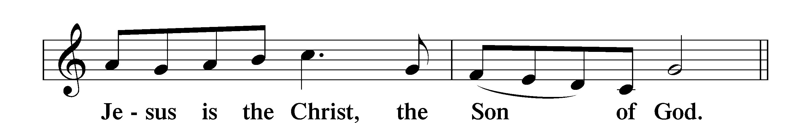
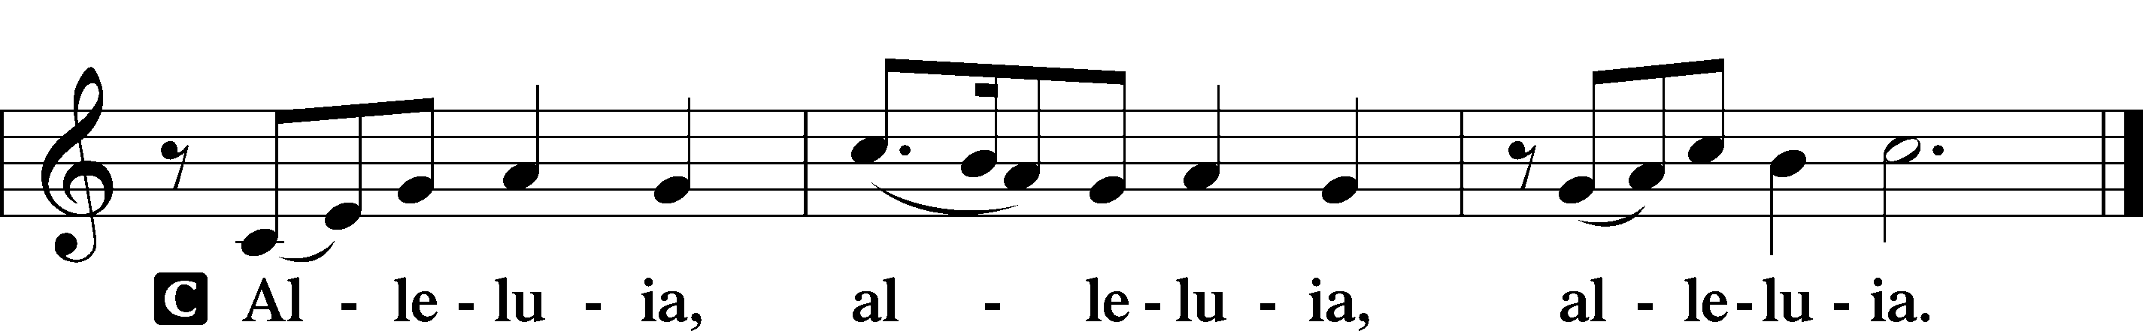

Holy Gospel Matthew 10:5a, 21–33
P The Holy Gospel according to St. Matthew, the tenth chapter.
C Glory to You, O Lord.

5These twelve Jesus sent out, instructing them, . . .
21“Brother will deliver brother over to death, and the father his child, and children will rise against parents and have them put to death, 22and you will be hated by all for my name’s sake. But the one who endures to the end will be saved. 23When they persecute you in one town, flee to the next, for truly, I say to you, you will not have gone through all the towns of Israel before the Son of Man comes.
24“A disciple is not above his teacher, nor a servant above his master. 25It is enough for the disciple to be like his teacher, and the servant like his master. If they have called the master of the house Beelzebul, how much more will they malign those of his household.
26“So have no fear of them, for nothing is covered that will not be revealed, or hidden that will not be known. 27What I tell you in the dark, say in the light, and what you hear whispered, proclaim on the housetops. 28And do not fear those who kill the body but cannot kill the soul. Rather fear him who can destroy both soul and body in hell. 29Are not two sparrows sold for a penny? And not one of them will fall to the ground apart from your Father. 30But even the hairs of your head are all numbered. 31Fear not, therefore; you are of more value than many sparrows. 32So everyone who acknowledges me before men, I also will acknowledge before my Father who is in heaven, 33but whoever denies me before men, I also will deny before my Father who is in heaven.”

P This is the Gospel of the Lord.
C Praise to You, O Christ.

Apostles’ Creed
C I believe in God, the Father Almighty,
maker of heaven and earth.
And in Jesus Christ, His only Son, our Lord,
who was conceived by the Holy Spirit,
born of the virgin Mary,
suffered under Pontius Pilate,
was crucified, died and was buried.
He descended into hell.
The third day He rose again from the dead.
He ascended into heaven
and sits at the right hand of God the Father Almighty.
From thence He will come to judge the living and the dead.
I believe in the Holy Spirit,
the holy Christian Church,
the communion of saints,
the forgiveness of sins,
the resurrection of the body,
and the life T everlasting. Amen.

Sit

659 Lord of Our Life

Sermon

Offering. We generously give our offerings to the LORD out of thanksgiving for His generosity of forgiveness, life, and salvation in Christ (2 Corinthians 9:8). We believe that our offerings are not only to support the proclamation of the Gospel here and around the world, but also to help us all grow in faith and trust in Him (2 Corinthians 9:7). We have placed an offering plate in the narthex so you are able to freely give back to Him as you are able. To Him be all the glory!

Stand

Prayer of the Church

Lord’s Prayer

Benedicamus
A Let us bless the Lord.
C Thanks be to God.

Benediction
P The Lord bless you and keep you.
The Lord make His face shine on you and be gracious to you.
The Lord look upon you with favor and T give you peace.
C Amen.

725 Children of the Heavenly Father

Announcements

Happy Father’s Day!

It’s time to update the directory! There should be a form in your church mailbox and there are extra forms on the table in the Narthex. Please fill out and return to me even if you don’t think there have been any changes as I would like to verify everyone’s contact information. Thank you!

~Tara, Secretary

