The Day of Pentecost
May 24th, 2026

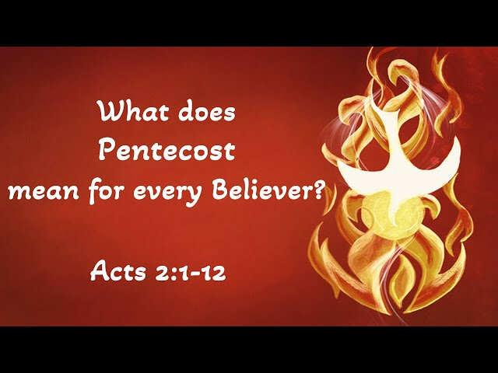

Messiah Lutheran Church
Sartell, MN
www.messiahsartell.com
320-252-5883
Prayer Before Entering
Please take this time to focus on our purpose in gathering and join in prayer before our service begins. Blessed Lord, You have caused all Holy Scriptures to be written for our learning. Grant that we may so hear them, read, mark, learn, and inwardly digest them that, by patience and comfort of Your holy Word, we may embrace and ever hold fast the blessed hope of everlasting life; through Jesus Christ, our Lord.

As We Gather
Pentecost proves for God’s people that Jesus remains at work in our midst. As we read the story of Pentecost in Acts 2, we see that the ascension departure of Jesus some ten days beforehand is not the end of His work in this world. Far from it! Jesus continues His saving work through the Spirit, whom He poured out upon the lives of His earliest followers. This same Spirit of Jesus enables us to carry His message into all the world. We are the messengers who spread the Good News of Him who was crucified for us, who rose again, who reigns on high, and who will one day return to this world in His full, heavenly glory. We listen to His message today as the Spirit brings it into our midst and are assured that as we are brought to faith in Christ, we receive the fullness of who we’ve been called to be.

Opening: Children’s Choir

Stand

The sign of the cross may be made by all in remembrance of their Baptism.

P In the name of the Father and of the T Son and of the Holy Spirit.
C Amen.

P Our help is in the name of the Lord,
C who made heaven and earth.

P If You, O Lord, kept a record of sins, O Lord, who could stand?
C But with You there is forgiveness; therefore You are feared.

P Since we are gathered to hear God’s Word, call upon Him in prayer and praise, and receive the body and blood of our Lord Jesus Christ in the fellowship of this altar, let us first consider our unworthiness and confess before God and one another that we have sinned in thought, word, and deed, and that we cannot free ourselves from our sinful condition. Together as His people let us take refuge in the infinite mercy of God, our heavenly Father, seeking His grace for the sake of Christ, and saying:
C God, be merciful to me, a sinner.

Silence for reflection on God’s Word and for self-examination.

C Almighty God, have mercy upon us, forgive us our sins, and lead us to everlasting life. Amen.

P Almighty God in His mercy has given His Son to die for you and for His sake forgives you all your sins. As a called and ordained servant of Christ, and by His authority, I therefore forgive you all your sins in the name of the Father and of the T Son and of the Holy Spirit.

C Amen.

Introit Psalm 104:24, 27–28, 30; antiphon: Liturgical Text
P Come, Holy Spirit, fill the hearts of the faithful,
and kindle in them the fire of your love. Alleluia.
C O Lord, how manifold are your works! In wisdom have you made
them all;
the earth is full of your creatures.
P These all look to you,
to give them their food in due season.
C When you give it to them, they gather it up;
when you open your hand, they are filled with good things.
P When you send forth your Spirit, they are created,
and you renew the face of the ground.
All: Glory be to the Father and to the Son
and to the Holy Spirit;
as it was in the beginning,
is now, and will be forever. Amen.
P Come, Holy Spirit, fill the hearts of the faithful,
and kindle in them the fire of your love. Alleluia.

Kyrie
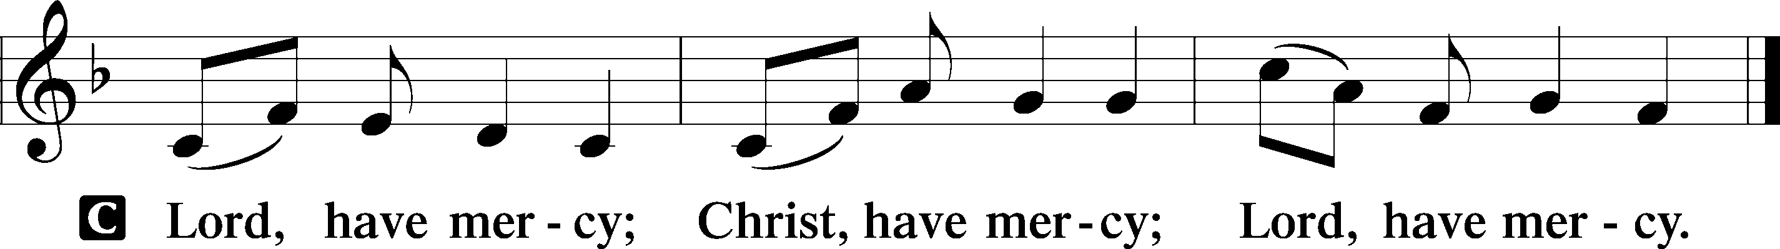
Gloria in Excelsis
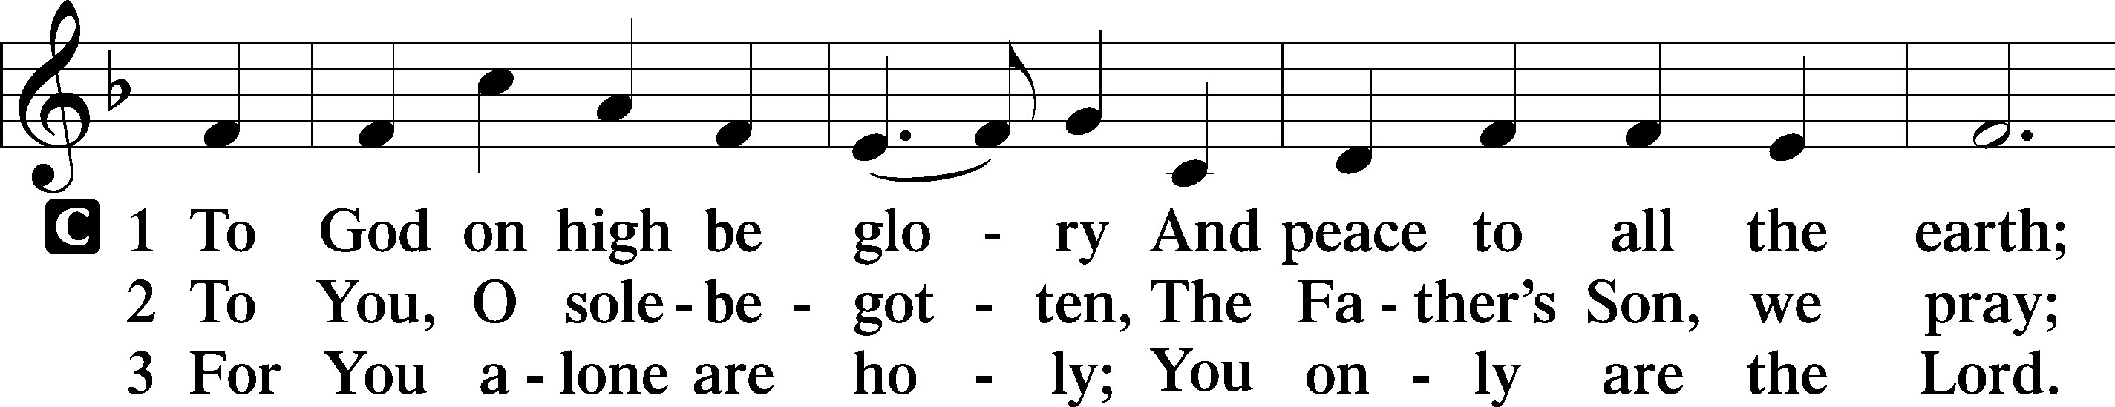
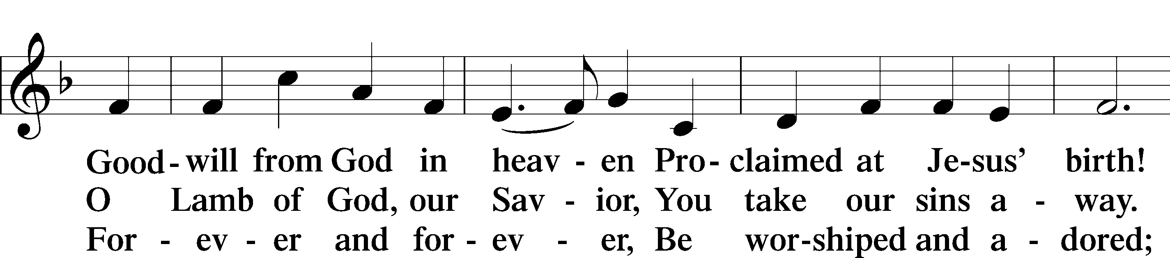
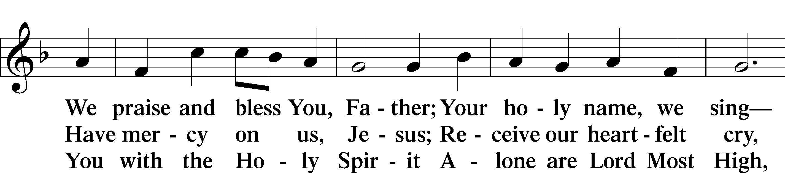
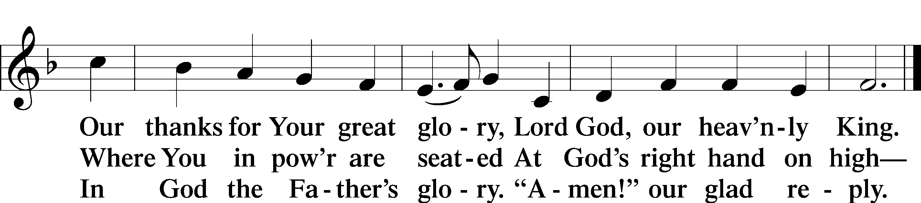

Salutation and Collect of the Day
P The Lord be with you.
C And also with you.

P Let us pray.
O God, on this day You once taught the hearts of Your faithful people by sending them the light of Your Holy Spirit. Grant us in our day by the same Spirit to have a right understanding in all things and evermore to rejoice in His holy consolation; through Jesus Christ, Your Son, our Lord, who lives and reigns with You and the Holy Spirit, one God, now and forever.

C Amen.

Sit
Old Testament Reading Numbers 11:24–30
24Moses went out and told the people the words of the Lord. And he gathered seventy men of the elders of the people and placed them around the tent. 25Then the Lord came down in the cloud and spoke to him, and took some of the Spirit that was on him and put it on the seventy elders. And as soon as the Spirit rested on them, they prophesied. But they did not continue doing it.
26Now two men remained in the camp, one named Eldad, and the other named Medad, and the Spirit rested on them. They were among those registered, but they had not gone out to the tent, and so they prophesied in the camp. 27And a young man ran and told Moses, “Eldad and Medad are prophesying in the camp.” 28And Joshua the son of Nun, the assistant of Moses from his youth, said, “My lord Moses, stop them.” 29But Moses said to him, “Are you jealous for my sake? Would that all the Lord’s people were prophets, that the Lord would put his Spirit on them!” 30And Moses and the elders of Israel returned to the camp.

A This is the Word of the Lord.
C Thanks be to God.

Second Reading Acts 2:1–21
1When the day of Pentecost arrived, they were all together in one place. 2And suddenly there came from heaven a sound like a mighty rushing wind, and it filled the entire house where they were sitting. 3And divided tongues as of fire appeared to them and rested on each one of them. 4And they were all filled with the Holy Spirit and began to speak in other tongues as the Spirit gave them utterance.
5Now there were dwelling in Jerusalem Jews, devout men from every nation under heaven. 6And at this sound the multitude came together, and they were bewildered, because each one was hearing them speak in his own language. 7And they were amazed and astonished, saying, “Are not all these who are speaking Galileans? 8And how is it that we hear, each of us in his own native language? 9Parthians and Medes and Elamites and residents of Mesopotamia, Judea and Cappadocia, Pontus and Asia, 10Phrygia and Pamphylia, Egypt and the parts of Libya belonging to Cyrene, and visitors from Rome, 11both Jews and proselytes, Cretans and Arabians—we hear them telling in our own tongues the mighty works of God.” 12And all were amazed and perplexed, saying to one another, “What does this mean?” 13But others mocking said, “They are filled with new wine.”
14But Peter, standing with the eleven, lifted up his voice and addressed them, “Men of Judea and all who dwell in Jerusalem, let this be known to you, and give ear to my words. 15For these men are not drunk, as you suppose, since it is only the third hour of the day. 16But this is what was uttered through the prophet Joel: 17“‘And in the last days it shall be, God declares, that I will pour out my Spirit on all flesh, and your sons and your daughters shall prophesy, and your young men shall see visions, and your old men shall dream dreams; 18even on my male servants and female servants in those days I will pour out my Spirit, and they shall prophesy. 19And I will show wonders in the heavens above and signs on the earth below, blood, and fire, and vapor of smoke; 20the sun shall be turned to darkness and the moon to blood, before the day of the Lord comes, the great and magnificent day. 21And it shall come to pass that everyone who calls upon the name of the Lord shall be saved.’”

A This is the Word of the Lord.
C Thanks be to God.

Stand

Alleluia and Verse
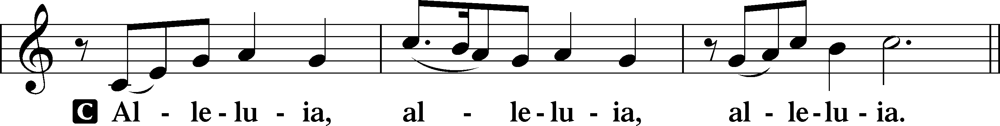
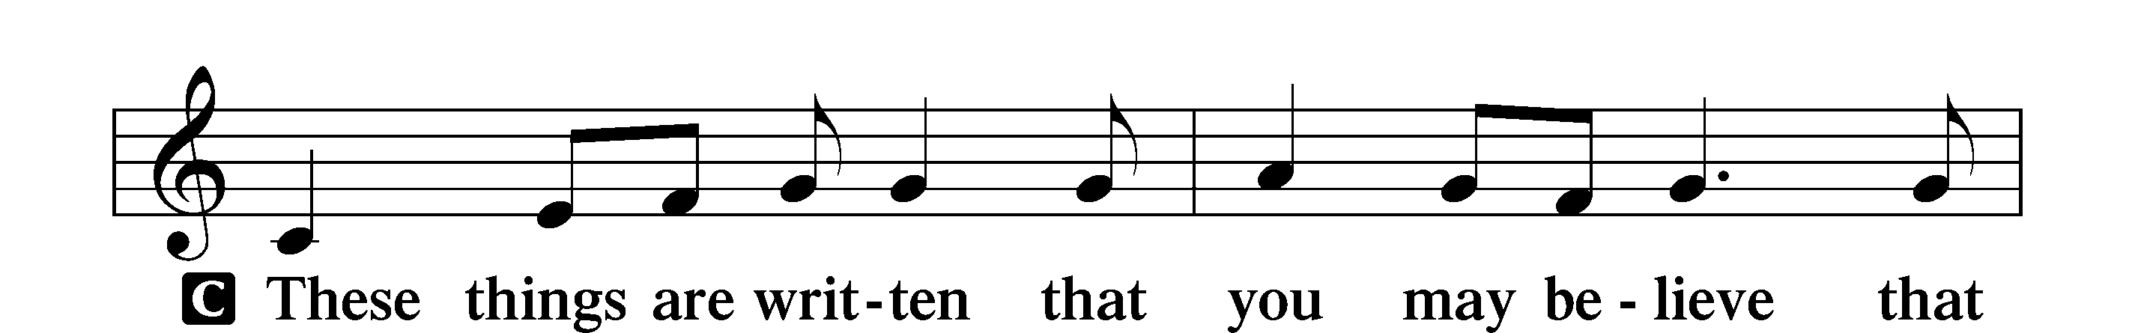
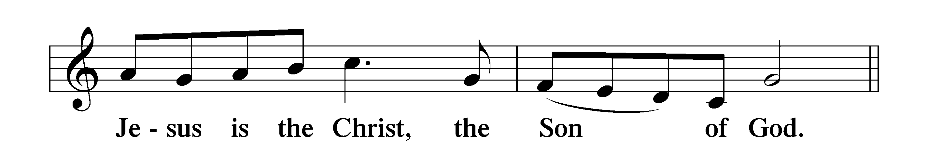
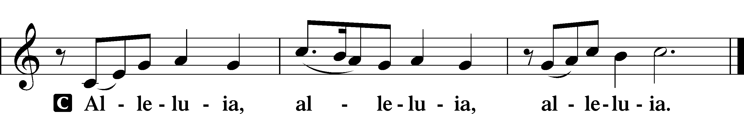

Holy Gospel John 7:37–39
P The Holy Gospel according to St. John, the seventh chapter.
C Glory to You, O Lord.

37On the last day of the feast, the great day, Jesus stood up and cried out, “If anyone thirsts, let him come to me and drink. 38Whoever believes in me, as the Scripture has said, ‘Out of his heart will flow rivers of living water.’” 39Now this he said about the Spirit, whom those who believed in him were to receive, for as yet the Spirit had not been given, because Jesus was not yet glorified.

P This is the Gospel of the Lord.
C Praise to You, O Christ.

Nicene Creed
C I believe in one God,
the Father Almighty,
maker of heaven and earth
and of all things visible and invisible.

And in one Lord Jesus Christ,
the only-begotten Son of God,
begotten of His Father before all worlds,
God of God, Light of Light,
very God of very God,
begotten, not made,
being of one substance with the Father,
by whom all things were made;
who for us men and for our salvation came down from heaven
and was incarnate by the Holy Spirit of the virgin Mary
and was made man;
and was crucified also for us under Pontius Pilate.
He suffered and was buried.
And the third day He rose again according to the Scriptures
and ascended into heaven
and sits at the right hand of the Father.
And He will come again with glory to judge both the living and the dead,
whose kingdom will have no end.

And I believe in the Holy Spirit,
the Lord and giver of life,
who proceeds from the Father and the Son,
who with the Father and the Son together is worshiped and glorified,
who spoke by the prophets.
And I believe in one holy Christian and apostolic Church,
I acknowledge one Baptism for the remission of sins,
and I look for the resurrection of the dead
and the life T of the world to come.

Amen.

Sit

503 O Day Full of Grace

Sermon

Offering. We generously give our offerings to the LORD out of thanksgiving for His generosity of forgiveness, life, and salvation in Christ (2 Corinthians 9:8). We believe that our offerings are not only to support the proclamation of the Gospel here and around the world, but also to help us all grow in faith and trust in Him (2 Corinthians 9:7). We have placed an offering plate in the narthex so you are able to freely give back to Him as you are able. To Him be all the glory!

Stand

Prayer of the Church

Holy Communion is celebrated in the belief and glad confidence that our Lord gives us not only bread and wine, but the body and blood of Christ from the cross, for us Christian to eat and drink for the forgiveness of sins (Matthew 26:28). Because we are called to examine ourselves before receiving the Lord’s Supper (I Corinthians 11:28-29), we encourage you to consider the questions on pages 329-330 in the hymnal. We also believe that when we commune, we are confessing our unity with the community we join (I Corinthians 10:17). If you desire to commune with us for the first time or have questions, our pastor is happy to speak with you.

Preface
P The Lord be with you.
C And also with you.
P Lift up your hearts.
C We lift them to the Lord.

P Let us give thanks to the Lord our God.
C It is right to give Him thanks and praise.
P It is truly good, right, and salutary that we should at all times and in all places give thanks to You, O Lord, holy Father, almighty and everlasting God, for the countless blessings You so freely bestow on us and all creation. Above all, we give thanks for Your boundless love shown to us when You sent Your only-begotten Son, Jesus Christ, into our flesh and laid on Him our sin, giving Him into death that we might not die eternally. Because He is now risen from the dead and lives and reigns to all eternity, all who believe in Him will overcome sin and death and will rise again to new life. Therefore with angels and archangels and with all the company of heaven we laud and magnify Your glorious name, evermore praising You and saying:

Sanctus
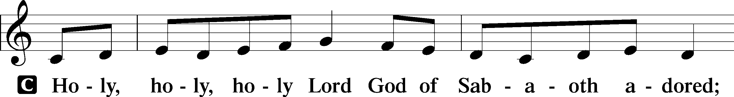
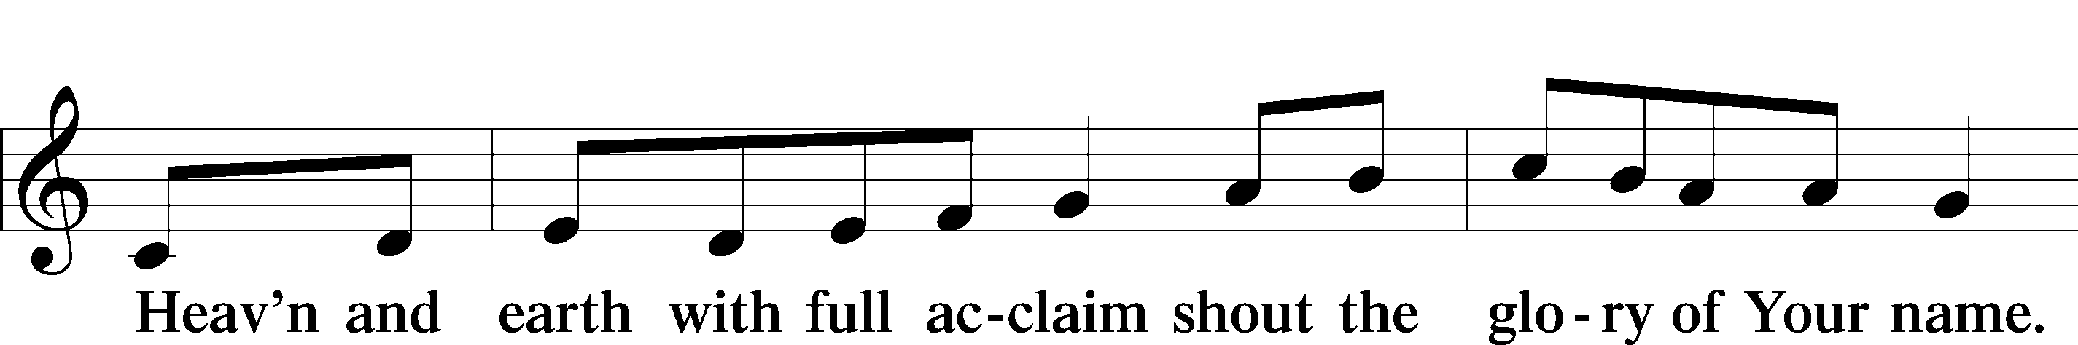
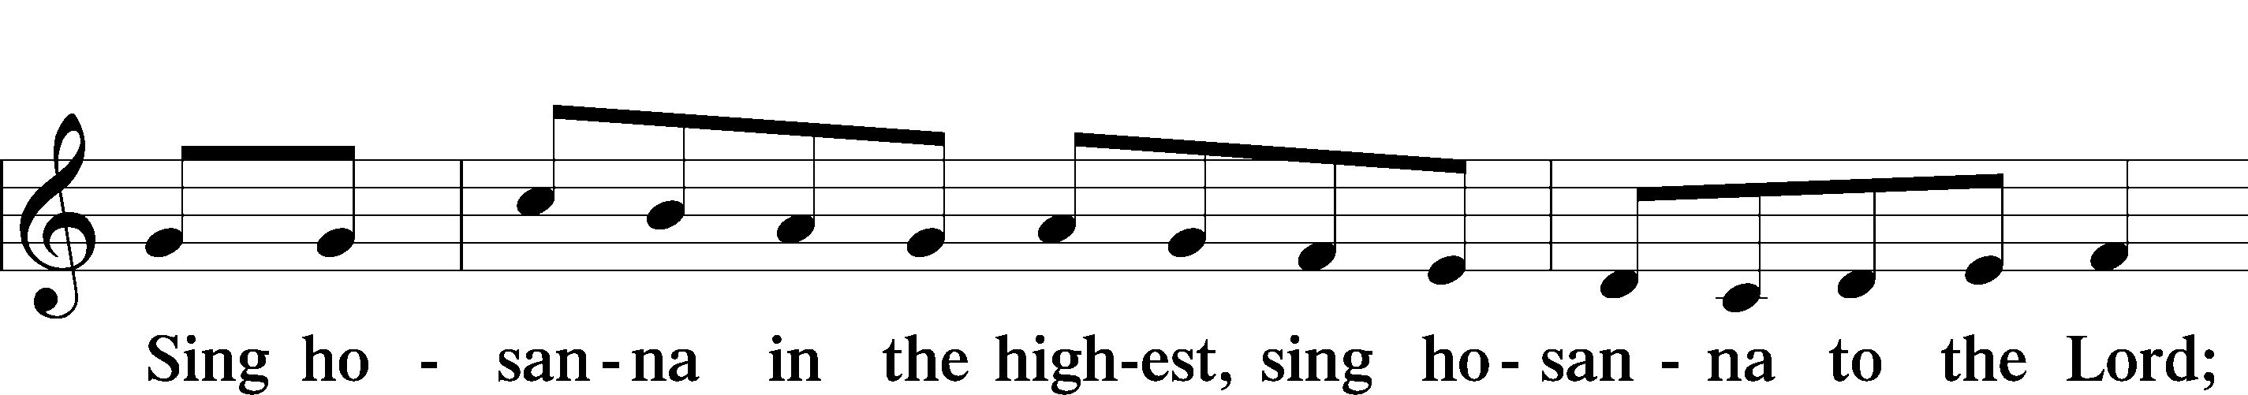
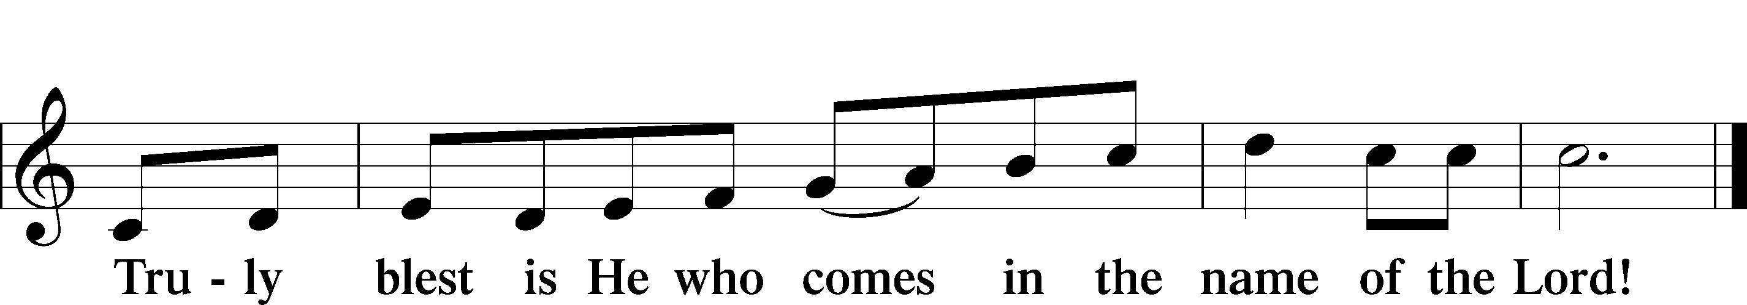

Prayer of Thanksgiving
P Blessed are You, O Lord our God, king of all creation, for You have had mercy on us and given Your only-begotten Son that whoever believes in Him should not perish but have eternal life.

In these last days, You have poured out Your Holy Spirit on Your Church that Your sons and daughters might proclaim the wonders of Your salvation in Christ Jesus, our Lord.
Pour out Your Holy Spirit upon Your gathered people that, faithfully eating and drinking the body and blood of Your Son, we may go forth to proclaim His salvation to the ends of the earth.

Hear us as we pray in His name and as He has taught us:

Lord’s Prayer

The Words of Our Lord

Pax Domini
P The peace of the Lord be with you always.
C Amen.

Agnus Dei
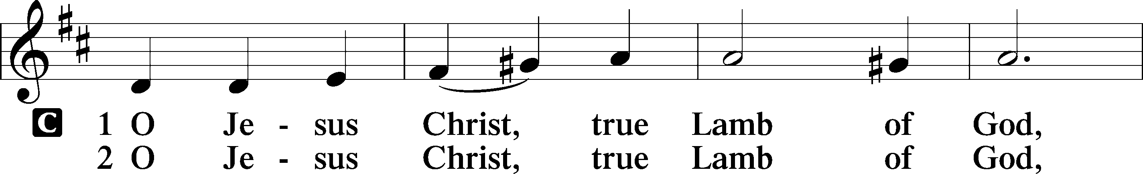
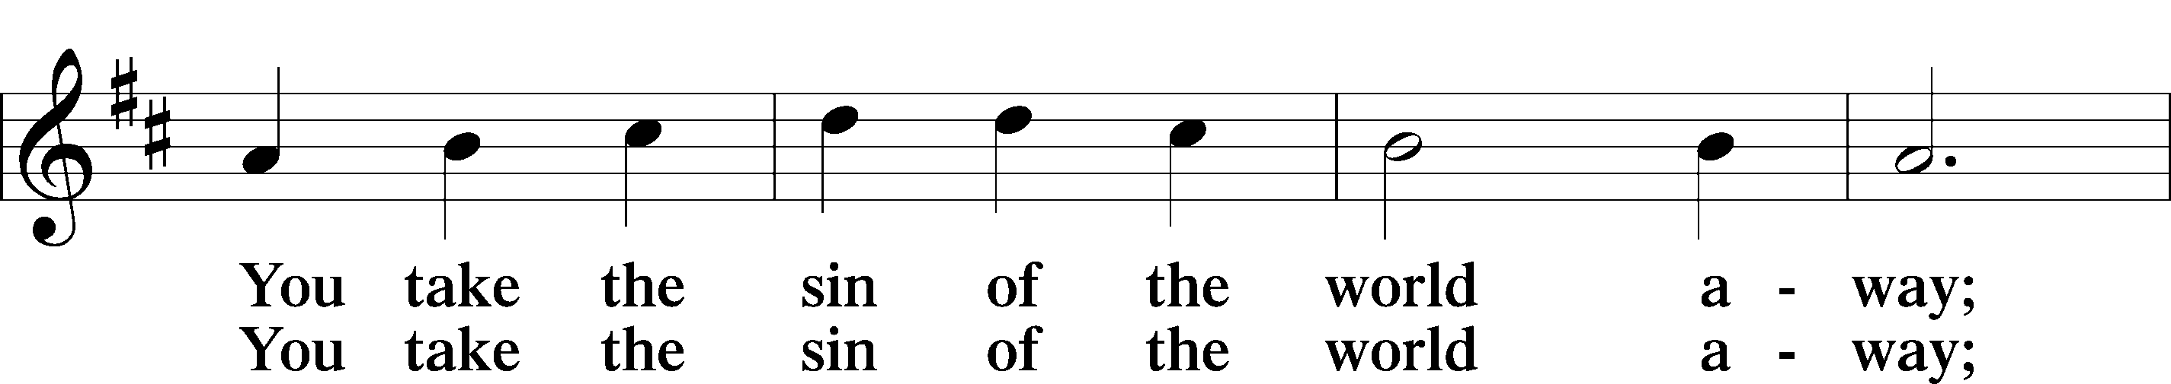
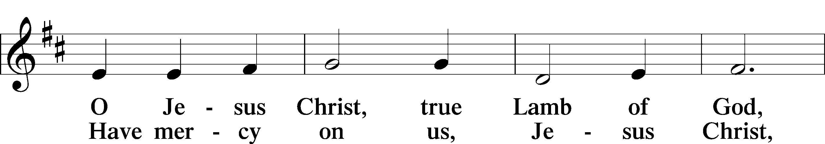
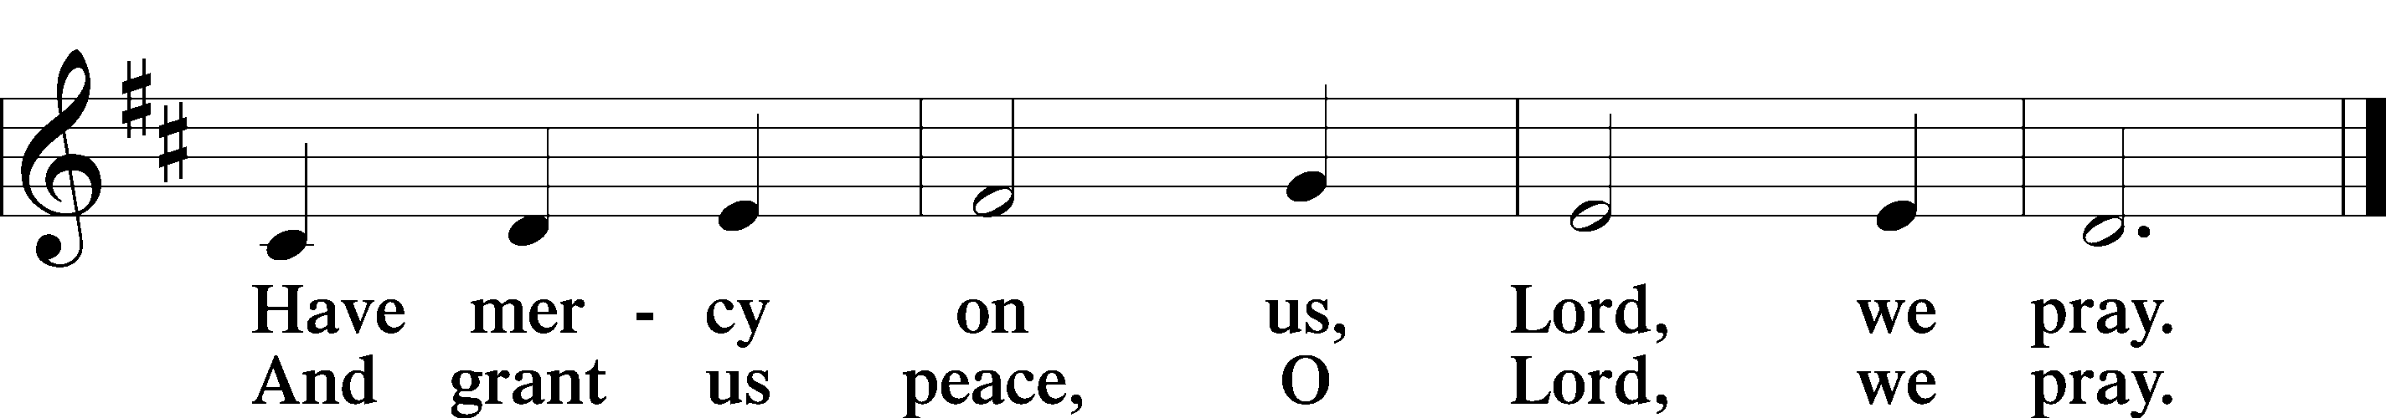

Sit

Distribution

628 Your Table I Approach
498 Come, Holy Ghost, Creator Blest

Stand
Nunc Dimittis
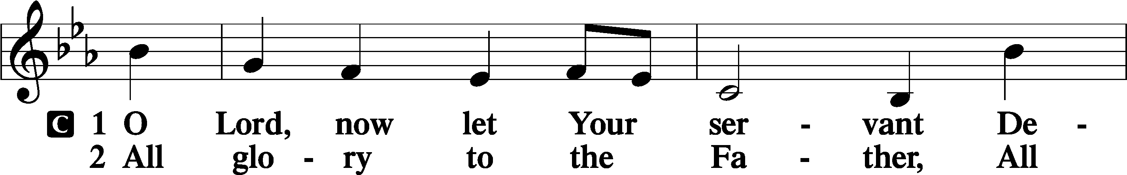
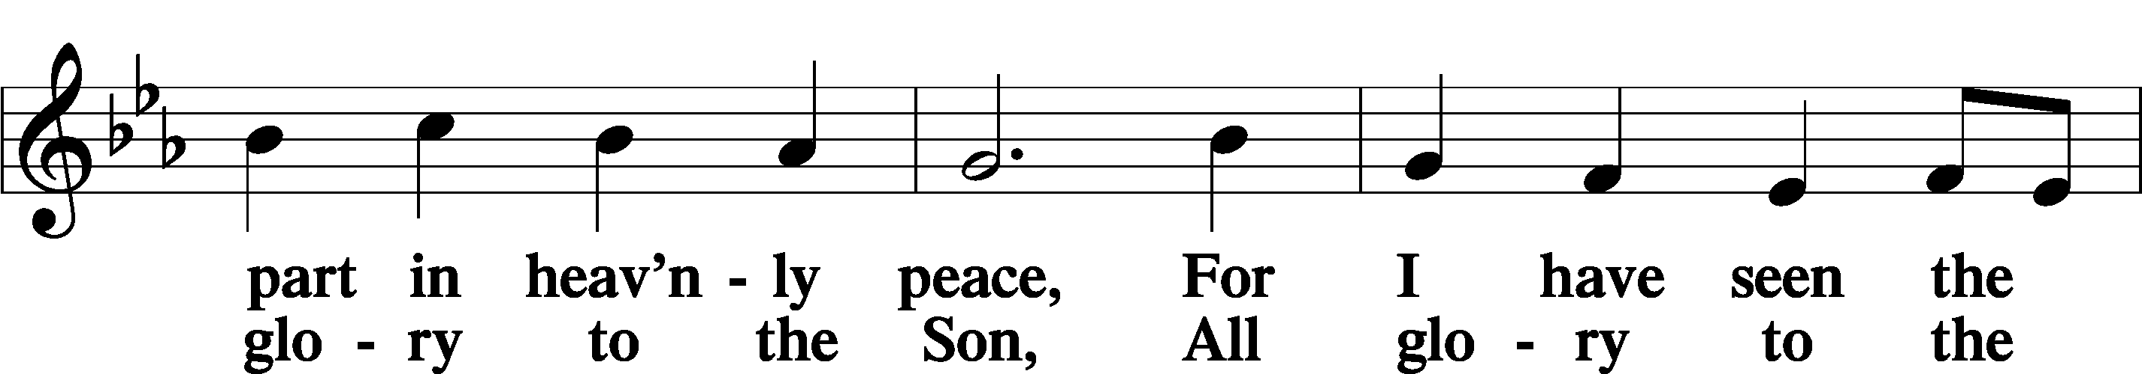
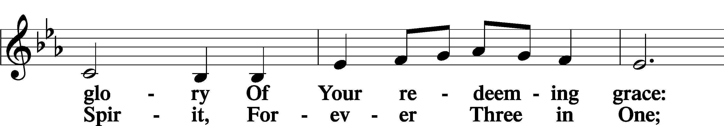
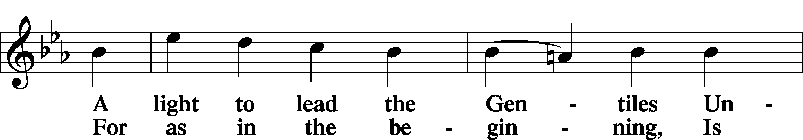
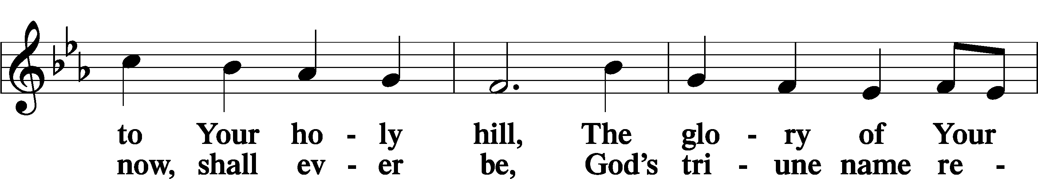
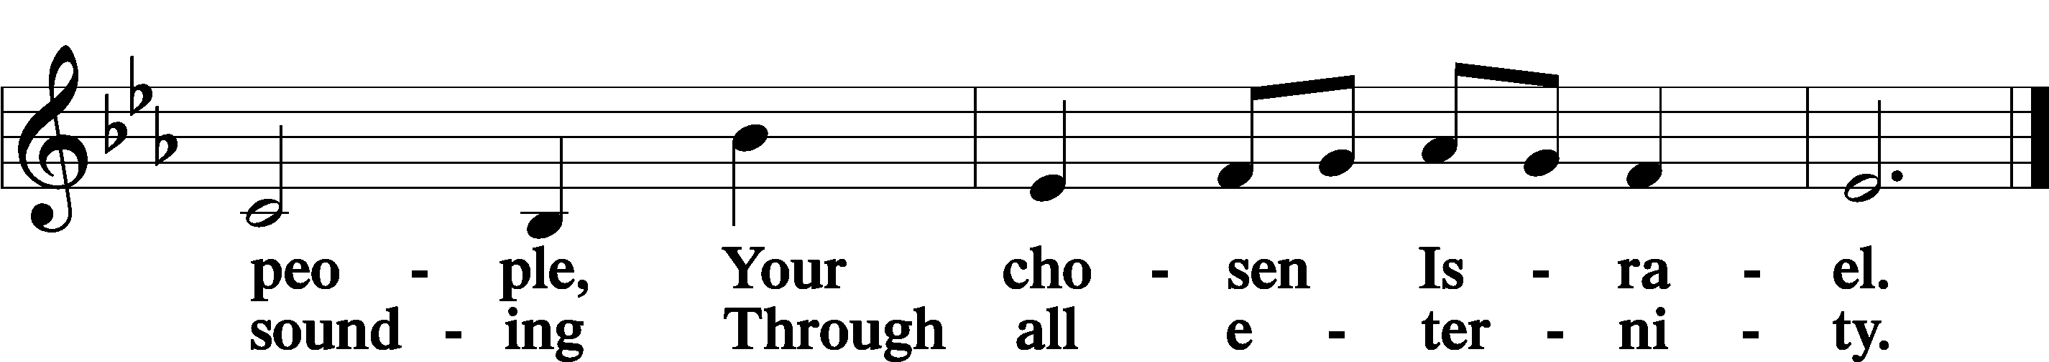

Post-Communion Collect
A Let us pray. We give thanks to You, almighty God, that You have refreshed us through this salutary gift, and we implore You that of Your mercy You would strengthen us through the same in faith toward You and in fervent love toward one another; through Jesus Christ, Your Son, our Lord, who lives and reigns with You and the Holy Spirit, one God, now and forever.
C Amen.
Benedicamus
A Let us bless the Lord.
C Thanks be to God.

Benediction
P The Lord bless you and keep you.
The Lord make His face shine on you and be gracious to you.
The Lord look upon you with favor and T give you peace.

C Amen.

497 Come, Holy Ghost, God and Lord

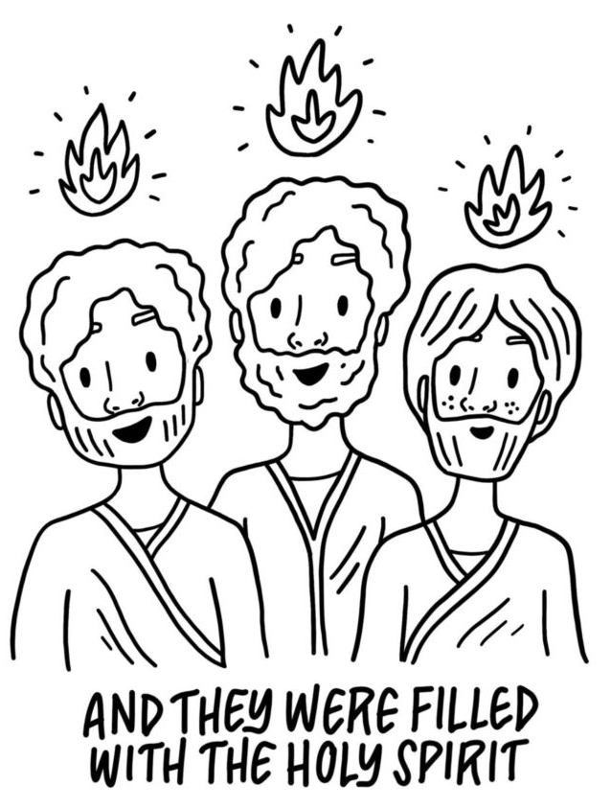
For the Kids

