2nd Sunday after Epiphany
January 18th, 2026

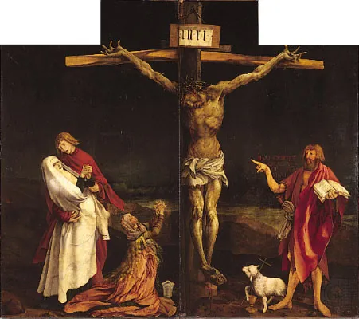

Messiah Lutheran Church
Sartell, MN
www.messiahsartell.com
320-252-5883
Prayer Before Entering
Please take this time to focus on our purpose in gathering and join in prayer before our service begins. Blessed Lord, You have caused all Holy Scriptures to be written for our learning. Grant that we may so hear them, read, mark, learn, and inwardly digest them that, by patience and comfort of Your holy Word, we may embrace and ever hold fast the blessed hope of everlasting life; through Jesus Christ, our Lord.

As We Gather
When Jesus asked His two potential disciples what they were seeking, it was a most important question. People look for power and importance for themselves, relief from certain circumstances, and a host of other agenda items. But our Lord came with one overarching goal: He was needed as light for this dark world (as Isaiah wrote) and the only one who could take away the sin of the world (as John the Baptist announced). After seeking Christ’s help in our sinful condition, we hear that other great question, “Who do you say that I am?”—and when each of us answers it, then, as Paul told the Church in Corinth, we have all the spiritual gifts we need to ask the people around us, “What are you seeking?”

550 Lamb of God

Stand

The sign of the cross may be made by all in remembrance of their Baptism.

P In the name of the Father and of the T Son and of the Holy Spirit.
C Amen.

P Our help is in the name of the Lord,
C who made heaven and earth.

P If You, O Lord, kept a record of sins, O Lord, who could stand?
C But with You there is forgiveness; therefore You are feared.

P Since we are gathered to hear God’s Word, call upon Him in prayer and praise, and receive the body and blood of our Lord Jesus Christ in the fellowship of this altar, let us first consider our unworthiness and confess before God and one another that we have sinned in thought, word, and deed, and that we cannot free ourselves from our sinful condition. Together as His people let us take refuge in the infinite mercy of God, our heavenly Father, seeking His grace for the sake of Christ, and saying:
C God, be merciful to me, a sinner.

Silence for reflection on God’s Word and for self-examination.

C Almighty God, have mercy upon us, forgive us our sins, and lead us to everlasting life. Amen.

P Almighty God in His mercy has given His Son to die for you and for His sake forgives you all your sins. As a called and ordained servant of Christ, and by His authority, I therefore forgive you all your sins in the name of the Father and of the T Son and of the Holy Spirit.

C Amen.

Introit Psalm 19:1–4a, b; antiphon: v. 14
P Let the words of my mouth and the meditation of my heart be
acceptable in your sight,
O Lord, my rock and my redeemer.
C The heavens declare the glory of God,
and the sky above proclaims his handiwork.
P Day to day pours out speech,
and night to night reveals knowledge.
C There is no speech, nor are there words,
whose voice is not heard.
P Their measuring line goes out through all the earth, and their words to
the end of the world.
In them he has set a tent for the sun.
All: Glory be to the Father and to the Son
and to the Holy Spirit;
as it was in the beginning,
is now, and will be forever. Amen.
P Let the words of my mouth and the meditation of my heart be
acceptable in your sight,
O Lord, my rock and my redeemer.
Kyrie
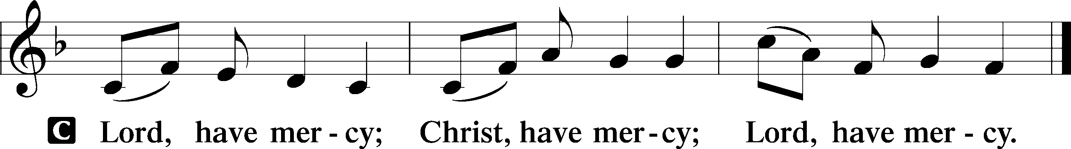

Gloria in Excelsis
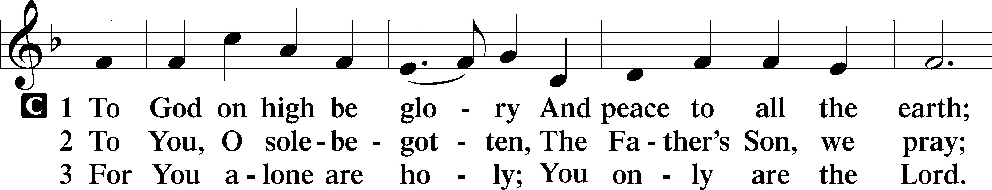
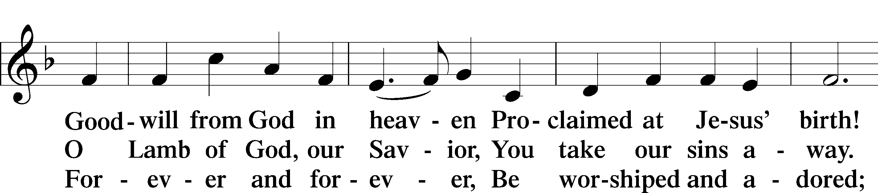
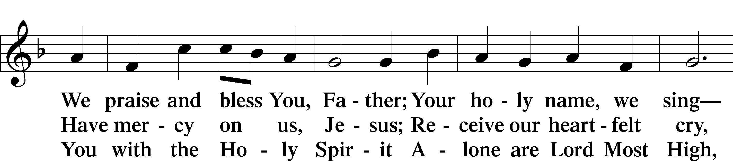
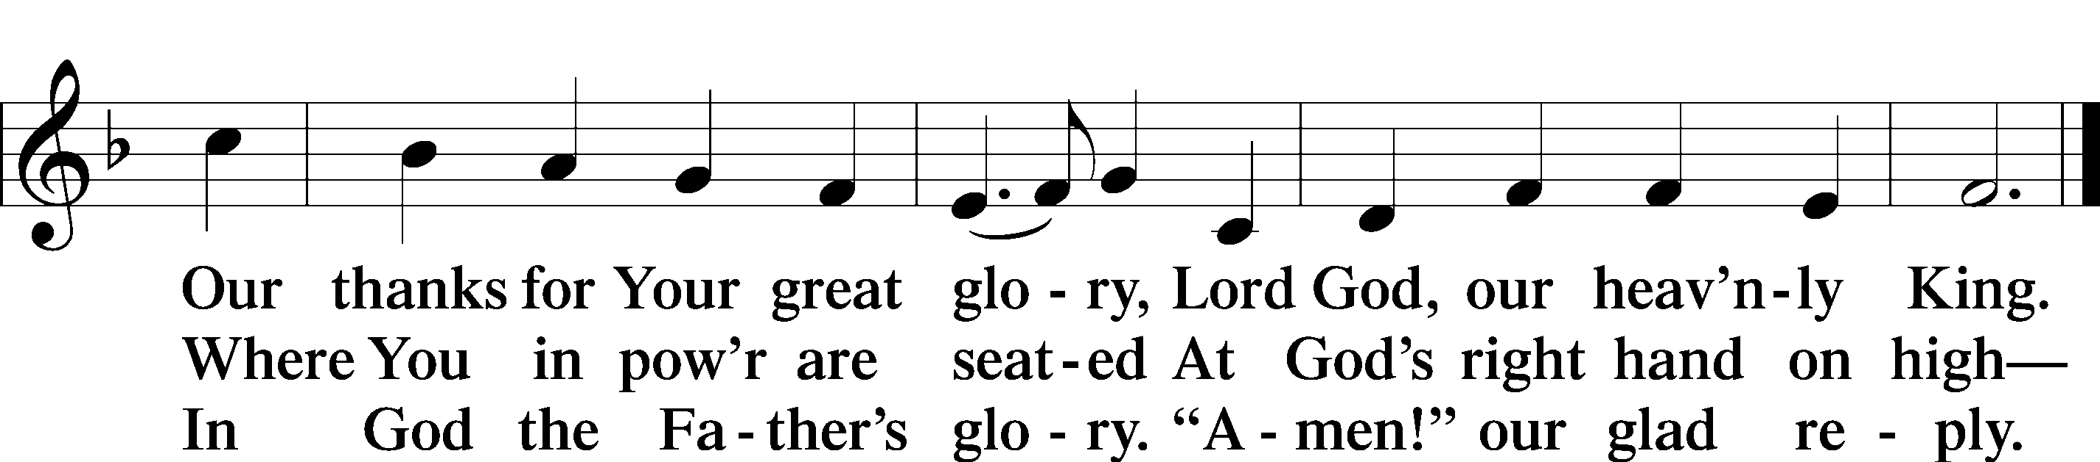

Salutation and Collect of the Day
P The Lord be with you.
C And also with you.

P Let us pray.
Almighty and everlasting God, who governs all things in heaven and on earth, mercifully hear the prayers of Your people and grant us Your peace through all our days; through Jesus Christ, Your Son, our Lord, who lives and reigns with You and the Holy Spirit, one God, now and forever.

C Amen.

Sit

Old Testament Reading Isaiah 49:1–7
1Listen to me, O coastlands, and give attention, you peoples from afar.
The Lord called me from the womb, from the body of my mother he named my name. 2He made my mouth like a sharp sword; in the shadow of his hand he hid me; he made me a polished arrow; in his quiver he hid me away. 3And he said to me, “You are my servant, Israel, in whom I will be glorified.” 4But I said, “I have labored in vain; I have spent my strength for nothing and vanity; yet surely my right is with the Lord, and my recompense with my God.” 5And now the Lord says, he who formed me from the womb to be his servant, to bring Jacob back to him; and that Israel might be gathered to him—for I am honored in the eyes of the Lord, and my God has become my strength—6he says: “It is too light a thing that you should be my servant to raise up the tribes of Jacob and to bring back the preserved of Israel; I will make you as a light for the nations, that my salvation may reach to the end of the earth.” Thus says the Lord, he Redeemer of Israel and his Holy One, to one deeply despised, abhorred by the nation, the servant of rulers: “Kings shall see and arise; princes, and they shall prostrate themselves; because of the Lord, who is faithful, the Holy One of Israel, who has chosen you.”

A This is the Word of the Lord.
C Thanks be to God.

Epistle 1 Corinthians 1:1–9
1Paul, called by the will of God to be an apostle of Christ Jesus, and our brother Sosthenes,
2To the church of God that is in Corinth, to those sanctified in Christ Jesus, called to be saints together with all those who in every place call upon the name of our Lord Jesus Christ, both their Lord and ours:
3Grace to you and peace from God our Father and the Lord Jesus Christ.
4I give thanks to my God always for you because of the grace of God that was given you in Christ Jesus, 5that in every way you were enriched in him in all speech and all knowledge—6even as the testimony about Christ was confirmed among you—7so that you are not lacking in any spiritual gift, as you wait for the revealing of our Lord Jesus Christ, 8who will sustain you to the end, guiltless in the day of our Lord Jesus Christ. 9God is faithful, by whom you were called into the fellowship of his Son, Jesus Christ our Lord.

A This is the Word of the Lord.
C Thanks be to God.

Stand

Alleluia and Verse
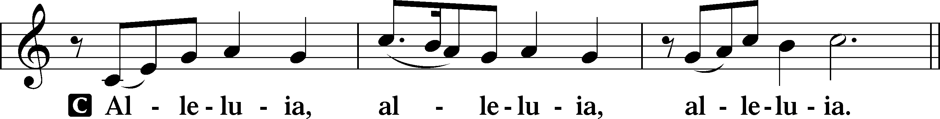
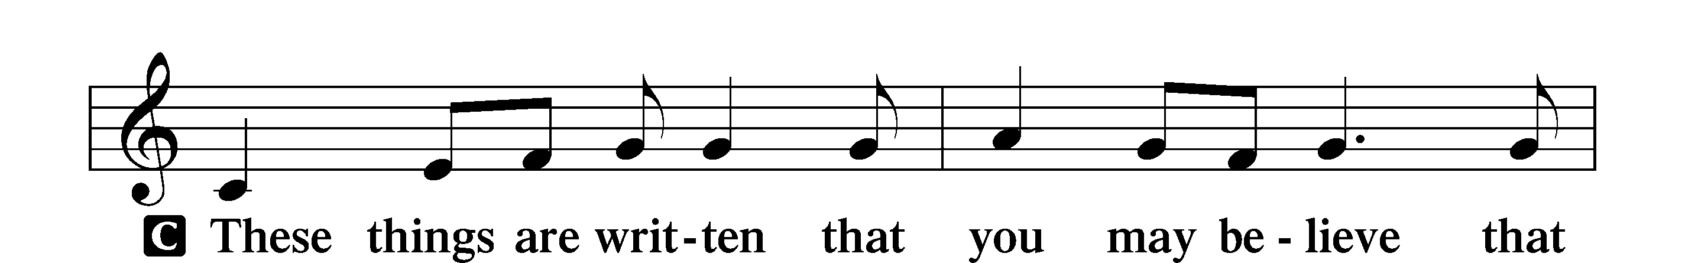
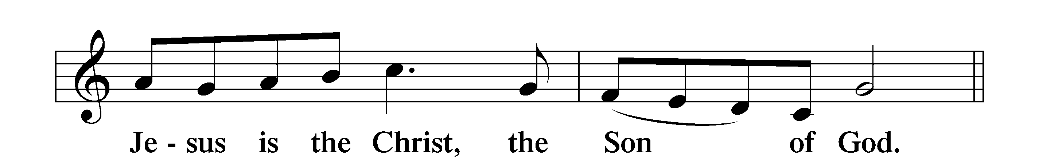
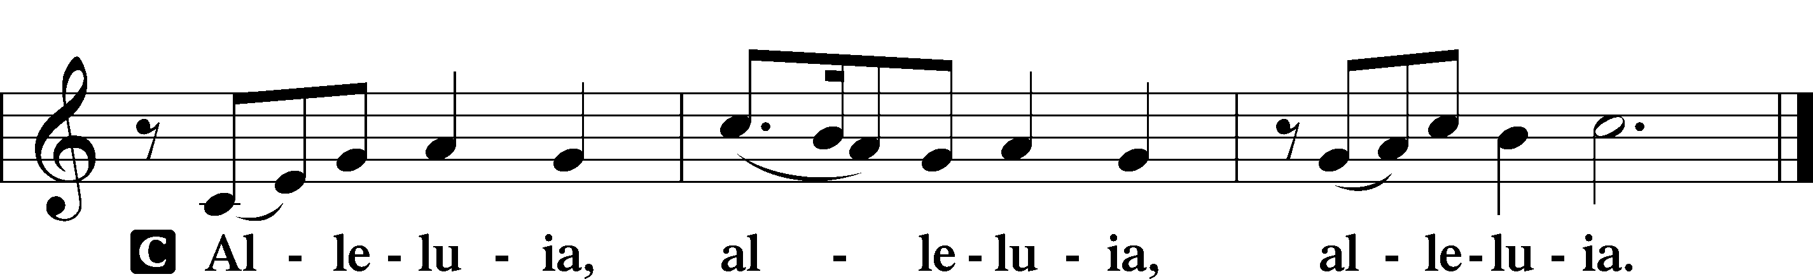

Holy Gospel John 1:29–42a
P The Holy Gospel according to St. John, the first chapter.
C Glory to You, O Lord.

29The next day [John] saw Jesus coming toward him, and said, “Behold, the Lamb of God, who takes away the sin of the world! 30This is he of whom I said, ‘After me comes a man who ranks before me, because he was before me.’ 31I myself did not know him, but for this purpose I came baptizing with water, that he might be revealed to Israel.” 32And John bore witness: “I saw the Spirit descend from heaven like a dove, and it remained on him. 33I myself did not know him, but he who sent me to baptize with water said to me, ‘He on whom you see the Spirit descend and remain, this is he who baptizes with the Holy Spirit.’ 34And I have seen and have borne witness that this is the Son of God.”
35The next day again John was standing with two of his disciples, 36and he looked at Jesus as he walked by and said, “Behold, the Lamb of God!” 37The two disciples heard him say this, and they followed Jesus. 38Jesus turned and saw them following and said to them, “What are you seeking?” And they said to him, “Rabbi” (which means Teacher), “where are you staying?” 39He said to them, “Come and you will see.” So they came and saw where he was staying, and they stayed with him that day, for it was about the tenth hour. 40One of the two who heard John speak and followed Jesus was Andrew, Simon Peter’s brother. 41He first found his own brother Simon and said to him, “We have found the Messiah” (which means Christ). 42He brought him to Jesus.

P This is the Gospel of the Lord.
C Praise to You, O Christ.

Apostles’ Creed
C I believe in God, the Father Almighty,
maker of heaven and earth.
And in Jesus Christ, His only Son, our Lord,
who was conceived by the Holy Spirit,
born of the virgin Mary,
suffered under Pontius Pilate,
was crucified, died and was buried.
He descended into hell.
The third day He rose again from the dead.
He ascended into heaven
and sits at the right hand of God the Father Almighty.
From thence He will come to judge the living and the dead.

I believe in the Holy Spirit,
the holy Christian Church,
the communion of saints,
the forgiveness of sins,
the resurrection of the body,
and the life T everlasting. Amen.

Sit

606 I Lay My Sins on Jesus

Sermon

Offering. We generously give our offerings to the LORD out of thanksgiving for His generosity of forgiveness, life, and salvation in Christ (2 Corinthians 9:8). We believe that our offerings are not only to support the proclamation of the Gospel here and around the world, but also to help us all grow in faith and trust in Him (2 Corinthians 9:7). We have placed an offering plate in the narthex so you are able to freely give back to Him as you are able. To Him be all the glory!

Stand

Prayer of the Church

Lord’s Prayer

Benedicamus
A Let us bless the Lord.
C Thanks be to God.

Benediction
P The Lord bless you and keep you.
The Lord make His face shine on you and be gracious to you.
The Lord look upon you with favor and T give you peace.

C Amen.

547 The Lamb

Announcements

Annual congregational meeting will be after worship next Sunday, Jan. 25.

In honor of Life Sunday there is a red rose to bring attention to God’s gift of life at all stages.

