5th Sunday After the Epiphany
February 8th, 2026



Messiah Lutheran Church
Sartell, MN
www.messiahsartell.com
320-252-5883
Prayer Before Entering
Please take this time to focus on our purpose in gathering and join in prayer before our service begins. Blessed Lord, You have caused all Holy Scriptures to be written for our learning. Grant that we may so hear them, read, mark, learn, and inwardly digest them that, by patience and comfort of Your holy Word, we may embrace and ever hold fast the blessed hope of everlasting life; through Jesus Christ, our Lord.

As We Gather
We consider today Jesus’ words “You are the light of the world.” Jesus tells His followers that their light should not be hidden, but rather it should help others to see. As we go about our daily lives, by God’s grace we walk in the light of Jesus. Warmed by His light, we share that light He has given us with others in how we act, in what we say, and especially in spreading the good news about Jesus’ forgiveness.

579 The Law of God Is Good and Wise

Stand

The sign of the cross may be made by all in remembrance of their Baptism.

P In the name of the Father and of the T Son and of the Holy Spirit.
C Amen.

P Our help is in the name of the Lord,
C who made heaven and earth.

P If You, O Lord, kept a record of sins, O Lord, who could stand?
C But with You there is forgiveness; therefore You are feared.

P Since we are gathered to hear God’s Word, call upon Him in prayer and praise, and receive the body and blood of our Lord Jesus Christ in the fellowship of this altar, let us first consider our unworthiness and confess before God and one another that we have sinned in thought, word, and deed, and that we cannot free ourselves from our sinful condition. Together as His people let us take refuge in the infinite mercy of God, our heavenly Father, seeking His grace for the sake of Christ, and saying:
C God, be merciful to me, a sinner.
Silence for reflection on God’s Word and for self-examination.

C Almighty God, have mercy upon us, forgive us our sins, and lead us to everlasting life. Amen.

P Almighty God in His mercy has given His Son to die for you and for His sake forgives you all your sins. As a called and ordained servant of Christ, and by His authority, I therefore forgive you all your sins in the name of the Father and of the T Son and of the Holy Spirit.

C Amen.

Introit Psalm 119:9–16; antiphon: v. 12
P Blessèd are you, O Lord;
teach me your statutes!
C How can a young man keep his way pure?
By guarding it according to your word.
P With my whole heart I seek you;
let me not wander from your commandments!
C I have stored up your word in my heart,
that I might not sin against you.
P Blessèd are you, O Lord;
teach me your statutes!
C With my lips I declare
all the just decrees of your mouth.
P In the way of your testimonies I delight
as much as in all riches.
C I will meditate on your precepts
and fix my eyes on your ways.
P I will delight in your statutes;
I will not forget your word.
All: Glory be to the Father and to the Son
and to the Holy Spirit;
as it was in the beginning,
is now, and will be forever. Amen.
P Blessèd are you, O Lord;
teach me your statutes!

Kyrie
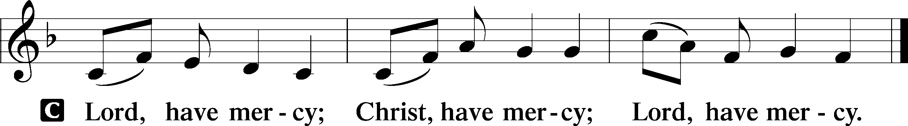

Gloria in Excelsis
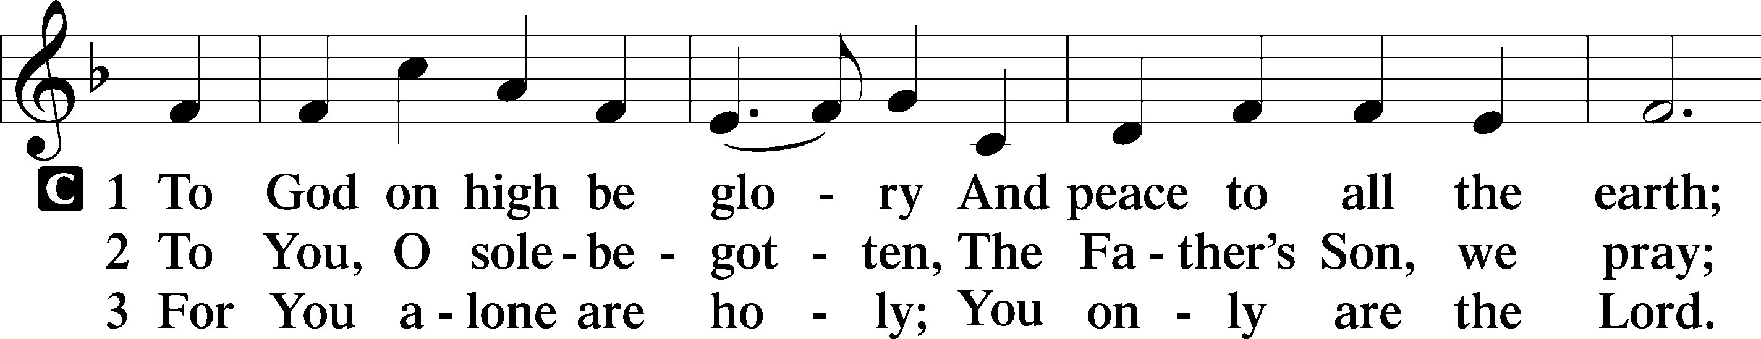
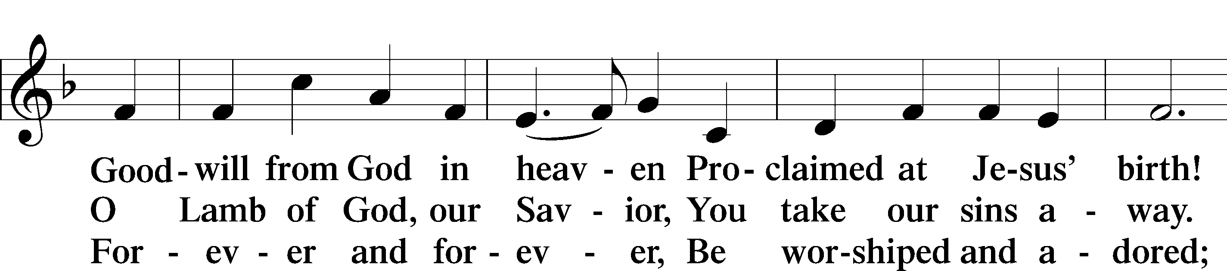
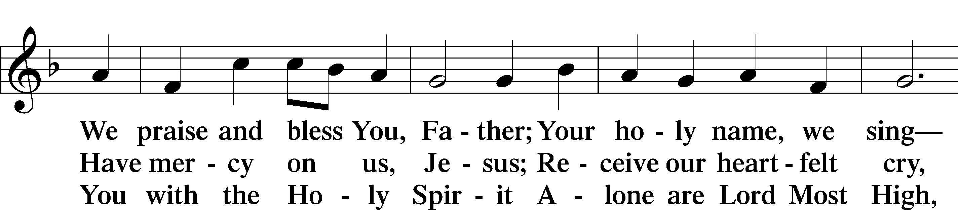
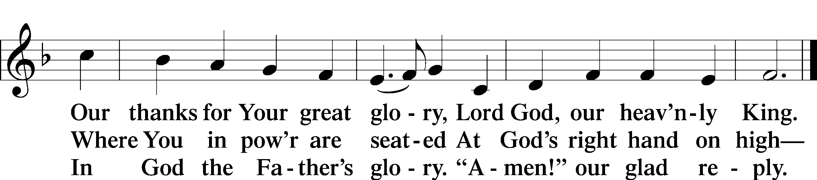

Salutation and Collect of the Day
P The Lord be with you.
C And also with you.

P Let us pray.O Lord, keep Your family the Church continually in the true faith that, relying on the hope of Your heavenly grace, we may ever be defended by Your mighty power; through Jesus Christ, Your Son, our Lord, who lives and reigns with You and the Holy Spirit, one God, now and forever.
C Amen.

Sit

Old Testament Reading Isaiah 58:3–9a
3“‘Why have we fasted, and you see it not? Why have we humbled ourselves, and you take no knowledge of it?’ Behold, in the day of your fast you seek your own pleasure, and oppress all your workers. 4Behold, you fast only to quarrel and to fightand to hit with a wicked fist. Fasting like yours this day will not make your voice to be heard on high. 5Is such the fast that I choose, a day for a person to humble himself? Is it to bow down his head like a reed, and to spread sackcloth and ashes under him? Will you call this a fast, and a day acceptable to the Lord? 6“Is not this the fast that I choose: to loose the bonds of wickedness, to undo the straps of the yoke, to let the oppressed go free, and to break every yoke? 7Is it not to share your bread with the hungry and bring the homeless poor into your house; when you see the naked, to cover him, and not to hide yourself from your own flesh? 8Then shall your light break forth like the dawn, and your healing shall spring up speedily; your righteousness shall go before you; the glory of the Lord shall be your rear guard. 9Then you shall call, and the Lord will answer; you shall cry, and he will say, ‘Here I am.’”

A This is the Word of the Lord.
C Thanks be to God.

Epistle 1 Corinthians 2:1–16
1And I, when I came to you, brothers, did not come proclaiming to you the testimony of God with lofty speech or wisdom. 2For I decided to know nothing among you except Jesus Christ and him crucified. 3And I was with you in weakness and in fear and much trembling, 4and my speech and my message were not in plausible words of wisdom, but in demonstration of the Spirit and of power, 5that your faith might not rest in the wisdom of men but in the power of God.
6Yet among the mature we do impart wisdom, although it is not a wisdom of this age or of the rulers of this age, who are doomed to pass away. 7But we impart a secret and hidden wisdom of God, which God decreed before the ages for our glory. 8None of the rulers of this age understood this, for if they had, they would not have crucified the Lord of glory. 9But, as it is written, “What no eye has seen, nor ear heard, nor the heart of man imagined, what God has prepared for those who love him”— 10these things God has revealed to us through the Spirit. For the Spirit searches everything, even the depths of God. 11For who knows a person’s thoughts except the spirit of that person, which is in him? So also no one comprehends the thoughts of God except the Spirit of God. 12Now we have received not the spirit of the world, but the Spirit who is from God, that we might understand the things freely given us by God. 13And we impart this in words not taught by human wisdom but taught by the Spirit, interpreting spiritual truths to those who are spiritual.
14The natural person does not accept the things of the Spirit of God, for they are folly to him, and he is not able to understand them because they are spiritually discerned. 15The spiritual person judges all things, but is himself to be judged by no one. 16“For who has understood the mind of the Lord so as to instruct him?” But we have the mind of Christ.

A This is the Word of the Lord.
C Thanks be to God.

Stand

Alleluia and Verse
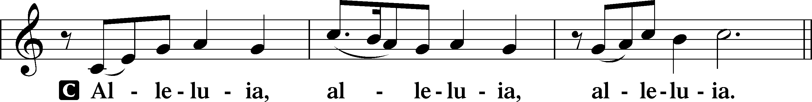
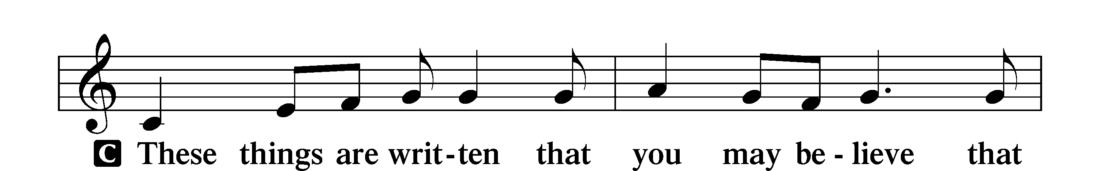
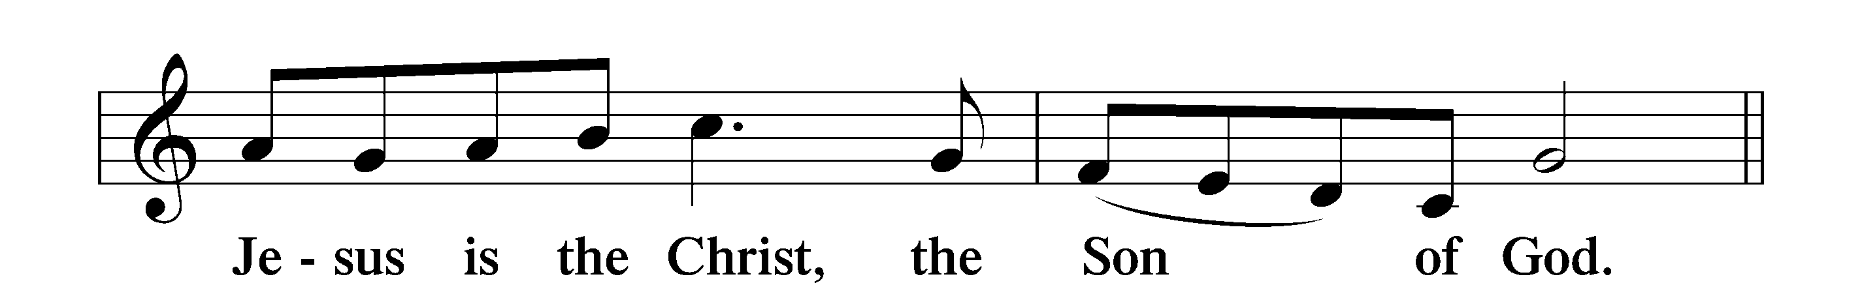
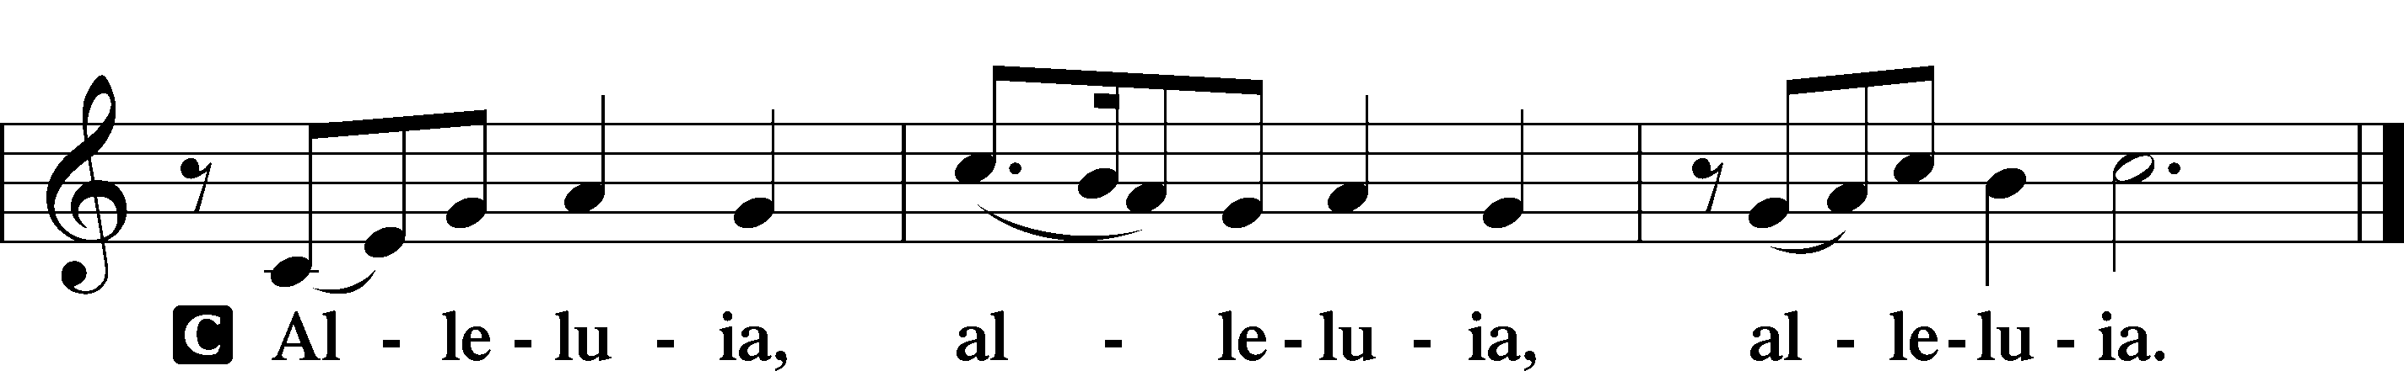

Holy Gospel Matthew 5:13–20
P The Holy Gospel according to St. Matthew, the fifth chapter.
C Glory to You, O Lord.
13[Jesus said:] “You are the salt of the earth, but if salt has lost its taste, how shall its saltiness be restored? It is no longer good for anything except to be thrown out and trampled under people’s feet.
14“You are the light of the world. A city set on a hill cannot be hidden. 15Nor do people light a lamp and put it under a basket, but on a stand, and it gives light to all in the house. 16In the same way, let your light shine before others, so that they may see your good works and give glory to your Father who is in heaven.
17“Do not think that I have come to abolish the Law or the Prophets; I have not come to abolish them but to fulfill them. 18For truly, I say to you, until heaven and earth pass away, not an iota, not a dot, will pass from the Law until all is accomplished. 19Therefore whoever relaxes one of the least of these commandments and teaches others to do the same will be called least in the kingdom of heaven, but whoever does them and teaches them will be called great in the kingdom of heaven. 20For I tell you, unless your righteousness exceeds that of the scribes and Pharisees, you will never enter the kingdom of heaven.”

P This is the Gospel of the Lord.
C Praise to You, O Christ.

Nicene Creed
C I believe in one God,
the Father Almighty,
maker of heaven and earth
and of all things visible and invisible.
And in one Lord Jesus Christ,
the only-begotten Son of God,
begotten of His Father before all worlds,
God of God, Light of Light,
very God of very God,
begotten, not made,
being of one substance with the Father,
by whom all things were made;
who for us men and for our salvation came down from heaven
and was incarnate by the Holy Spirit of the virgin Mary
and was made man;
and was crucified also for us under Pontius Pilate.
He suffered and was buried.
And the third day He rose again according to the Scriptures
and ascended into heaven
and sits at the right hand of the Father.
And He will come again with glory to judge both the living and the dead,
whose kingdom will have no end.

And I believe in the Holy Spirit,
the Lord and giver of life,
who proceeds from the Father and the Son,
who with the Father and the Son together is worshiped and glorified,
who spoke by the prophets.
And I believe in one holy Christian and apostolic Church,
I acknowledge one Baptism for the remission of sins,
and I look for the resurrection of the dead
and the life T of the world to come.

Amen.

Sit

580 The Gospel Shows the Father’s Grace

Sermon

Offering. We generously give our offerings to the LORD out of thanksgiving for His generosity of forgiveness, life, and salvation in Christ (2 Corinthians 9:8). We believe that our offerings are not only to support the proclamation of the Gospel here and around the world, but also to help us all grow in faith and trust in Him (2 Corinthians 9:7). We have placed an offering plate in the narthex so you are able to freely give back to Him as you are able. To Him be all the glory!

Stand

Prayer of the Church

Holy Communion is celebrated in the belief and glad confidence that our Lord gives us not only bread and wine, but the body and blood of Christ from the cross, for us Christian to eat and drink for the forgiveness of sins (Matthew 26:28). Because we are called to examine ourselves before receiving the Lord’s Supper (I Corinthians 11:28-29), we encourage you to consider the questions on pages 329-330 in the hymnal. We also believe that when we commune, we are confessing our unity with the community we join (I Corinthians 10:17). If you desire to commune with us for the first time or have questions, our pastor is happy to speak with you.
Preface
P The Lord be with you.
C And also with you.

P Lift up your hearts.
C We lift them to the Lord.

P Let us give thanks to the Lord our God.
C It is right to give Him thanks and praise.

P It is truly good, right, and salutary that we should at all times and in all places give thanks to You, O Lord, holy Father, almighty and everlasting God, for the countless blessings You so freely bestow on us and all creation. Above all, we give thanks for Your boundless love shown to us when You sent Your only-begotten Son, Jesus Christ, into our flesh and laid on Him our sin, giving Him into death that we might not die eternally. Because He is now risen from the dead and lives and reigns to all eternity, all who believe in Him will overcome sin and death and will rise again to new life. Therefore with angels and archangels and with all the company of heaven we laud and magnify Your glorious name, evermore praising You and saying:

Sanctus
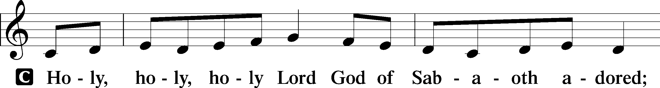
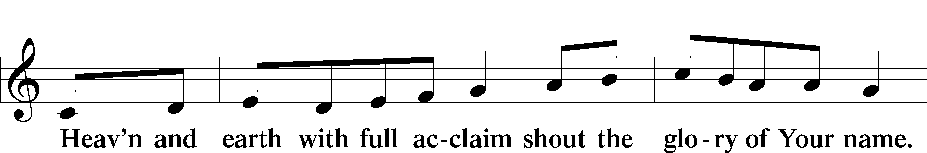
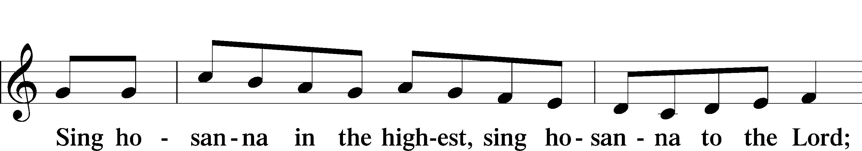
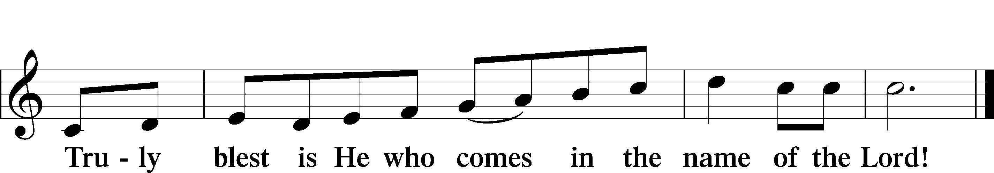
Prayer of Thanksgiving
P Blessed are You, O Lord our God, king of all creation, for You have had mercy on us and given Your only-begotten Son that whoever believes in Him should not perish but have eternal life.

As the glory of Your presence once filled Your ancient temple, so in the incarnation of Your Son, Jesus Christ, You manifested the fullness of Your glory in human flesh.

We give You thanks that in His most Holy Supper You reveal Your glory to us. Grant us faithfully to eat His body and drink His blood so that we may one day behold Your glory face to face.

Hear us as we pray in His name and as He has taught us:

Lord’s Prayer

The Words of Our Lord

Pax Domini
P The peace of the Lord be with you always.
C Amen.

Agnus Dei
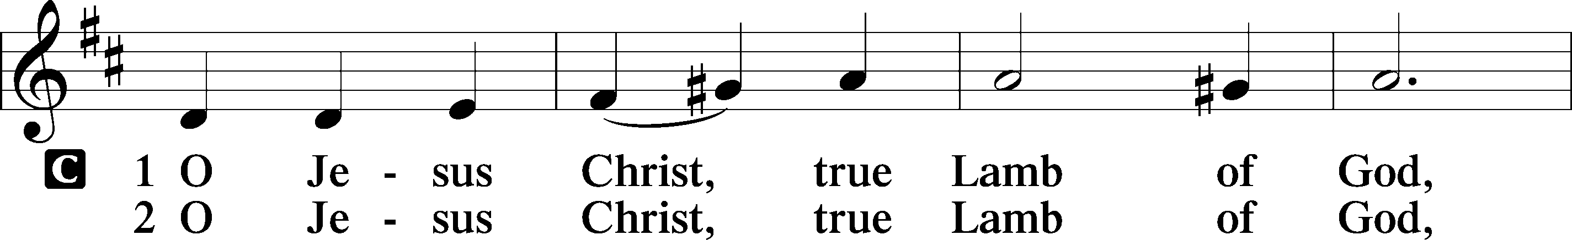
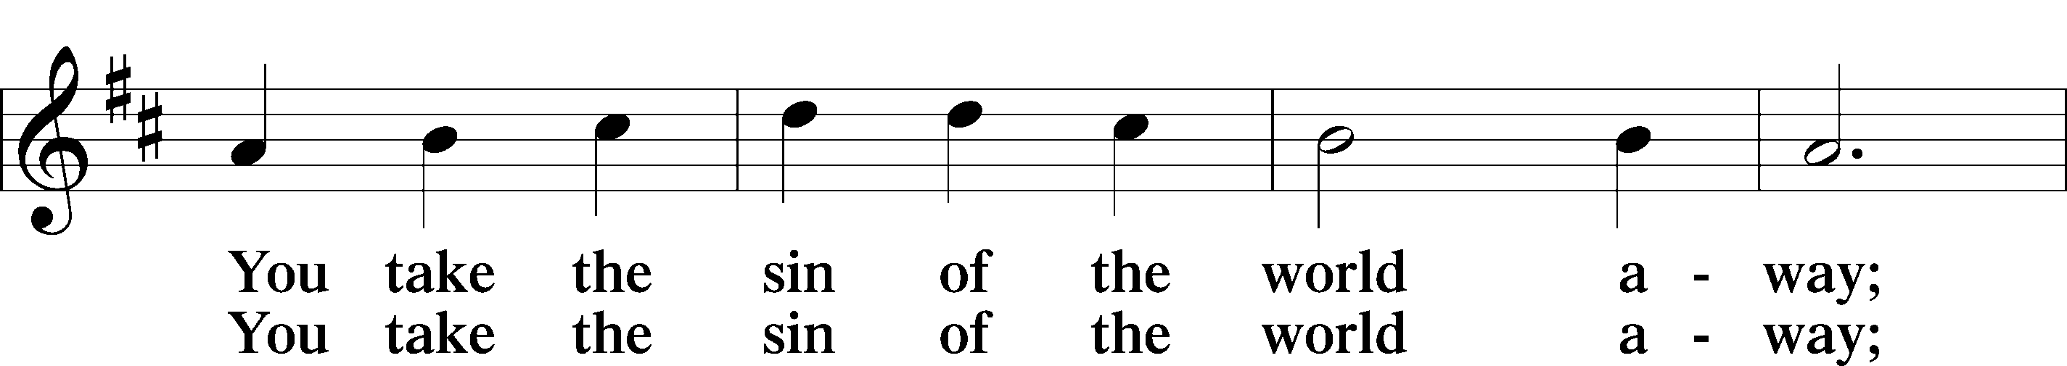
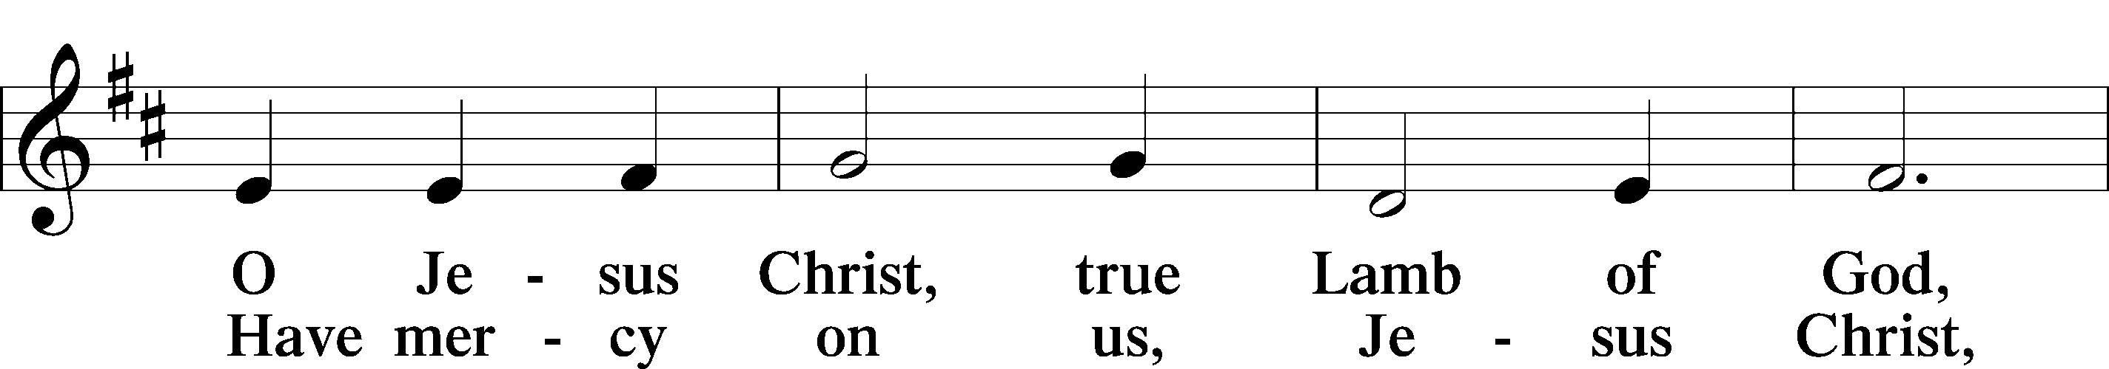
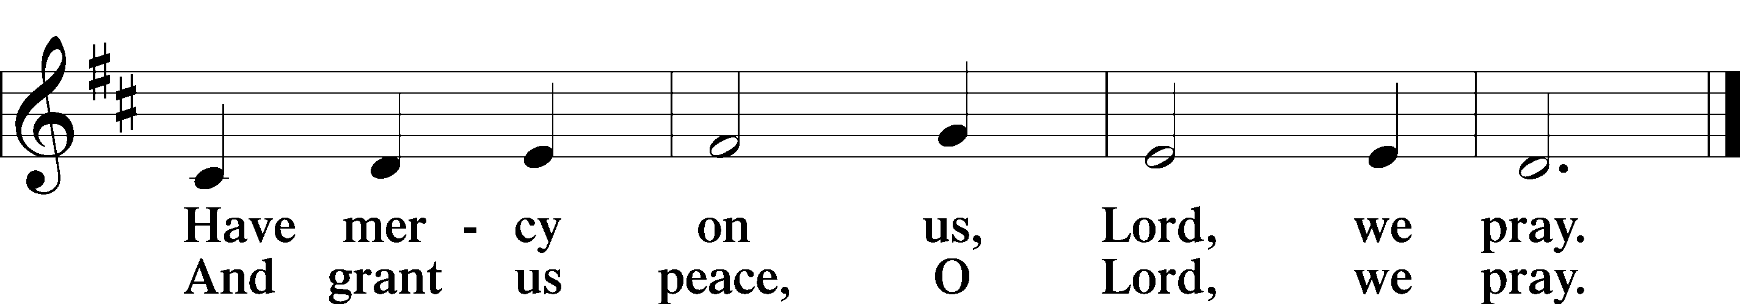

Sit
Distribution

629 What Is This Bread

628 Your Table I Approach

Stand

Nunc Dimittis
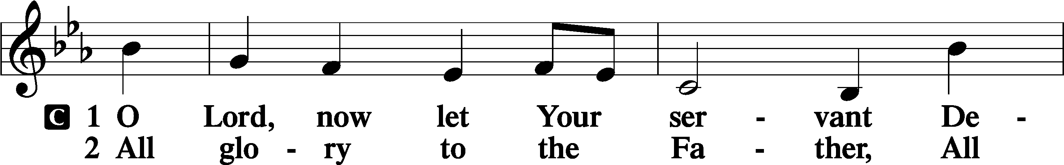
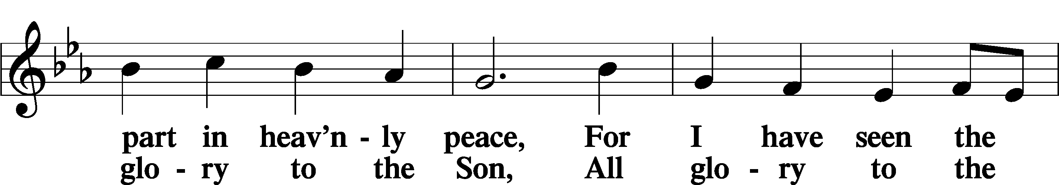
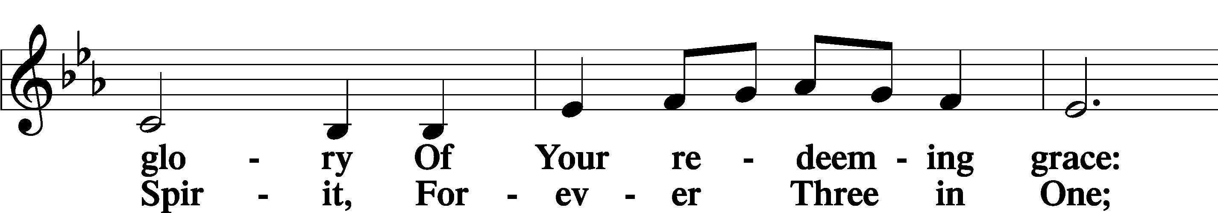
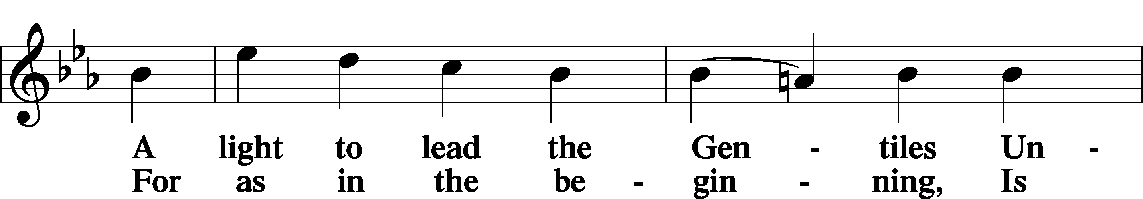
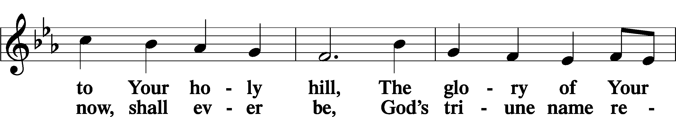
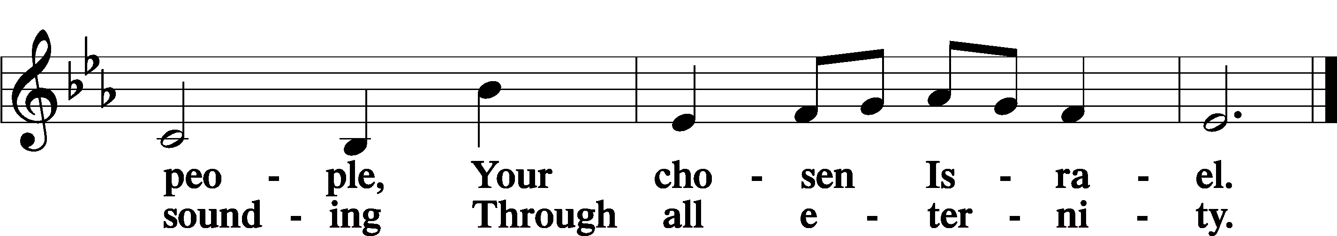

Post-Communion Collect
A Let us pray. We give thanks to You, almighty God, that You have refreshed us through this salutary gift, and we implore You that of Your mercy You would strengthen us through the same in faith toward You and in fervent love toward one another; through Jesus Christ, Your Son, our Lord, who lives and reigns with You and the Holy Spirit, one God, now and forever.
C Amen.

Benedicamus
A Let us bless the Lord.
C Thanks be to God.

Benediction
P The Lord bless you and keep you.
The Lord make His face shine on you and be gracious to you.
The Lord look upon you with favor and T give you peace.

C Amen.

854 Forth in Thy Name, O Lord, I Go

Announcements

Join us today for Scout Sunday at Messiah! The Scouts would like to serve our congregation treats/refreshments after worship today. Scouts from a variety of their dens aged kindergarten through 5th grade along with their leaders will be here to serve. There will be information about their program and some of the fun things they do! Join us!

Midweek Lenten Worship Services: 6 p.m.
Wednesdays: February 18 (Ash Wednesday) & 25, March 4, 11, 18 and 25

Lenten Suppers will be at 4:45 p.m. every Wednesday during Lent.
A sign-up sheet to volunteer is posted in the narthex.

