All Saints’ Day
November 1st, 2026

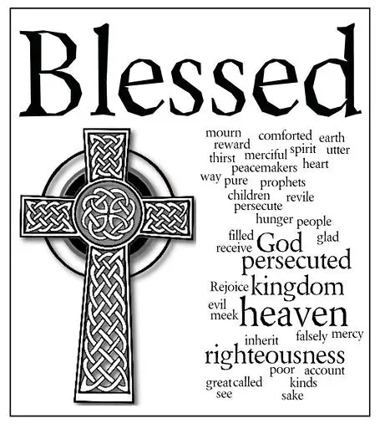

Messiah Lutheran Church
Sartell, MN
www.messiahsartell.com
320-252-5883
Prayer Before Entering
Please take this time to focus on our purpose in gathering and join in prayer before our service begins. Blessed Lord, You have caused all Holy Scriptures to be written for our learning. Grant that we may so hear them, read, mark, learn, and inwardly digest them that, by patience and comfort of Your holy Word, we may embrace and ever hold fast the blessed hope of everlasting life; through Jesus Christ, our Lord.

As We Gather
Today we lift our eyes from the present and focus them on the promises of God that will be fulfilled in the future. What a blessed day it will be when we will gather with all of Jesus’ holy ones around His throne in heaven! But today is also a blessed day. In Matthew 5, Jesus speaks blessings over a crowd gathered on a mountainside. Place yourself in that crowd today. Hear Jesus bless you also! Listen as He speaks of mercy, purity, and peace. And know this: Jesus does not simply speak of these blessings; He freely gives them to you! How blessed you are—today, tomorrow, and forever!

677 For All the Saints sts. 1–4

Stand

The sign of the cross may be made by all in remembrance of their Baptism.

P In the name of the Father and of the T Son and of the Holy Spirit.
C Amen.

P Our help is in the name of the Lord,
C who made heaven and earth.

P If You, O Lord, kept a record of sins, O Lord, who could stand?
C But with You there is forgiveness; therefore You are feared.

P Since we are gathered to hear God’s Word, call upon Him in prayer and praise, let us first consider our unworthiness and confess before God and one another that we have sinned in thought, word, and deed, and that we cannot free ourselves from our sinful condition. Together as His people let us take refuge in the infinite mercy of God, our heavenly Father, seeking His grace for the sake of Christ, and saying:
C God, be merciful to me, a sinner.

Silence for reflection on God’s Word and for self-examination.

C Almighty God, have mercy upon us, forgive us our sins, and lead us to everlasting life. Amen.

P Almighty God in His mercy has given His Son to die for you and for His sake forgives you all your sins. As a called and ordained servant of Christ, and by His authority, I therefore forgive you all your sins in the name of the Father and of the T Son and of the Holy Spirit.

C Amen.

Introit Psalm 31:1, 3, 5; antiphon: Revelation 7:14b
P These are the ones coming out of the great tribulation.
C They have washed their robes and made them white in the blood
of the Lamb.
P In you, O Lord, do I take refuge; let me never be put to shame;
in your righteousness deliver me.
C For you are my rock and my fortress;
and for your name’s sake you lead me and guide me.
P Into your hand I commit my spirit;
you have redeemed me, O Lord, faithful God.
All: Glory be to the Father and to the Son
and to the Holy Spirit;
as it was in the beginning,
is now, and will be forever. Amen.
P These are the ones coming out of the great tribulation.
C They have washed their robes and made them white in the blood of
the Lamb.

Kyrie
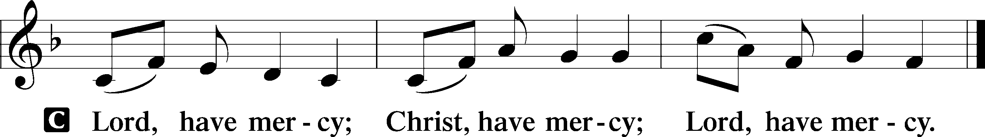
Gloria in Excelsis
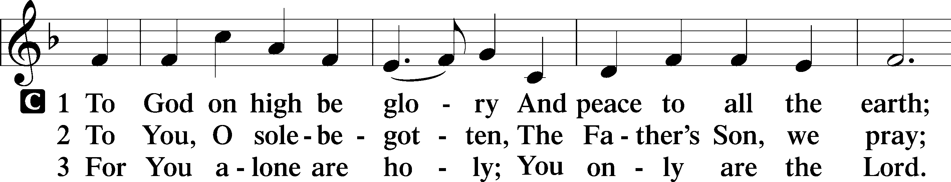
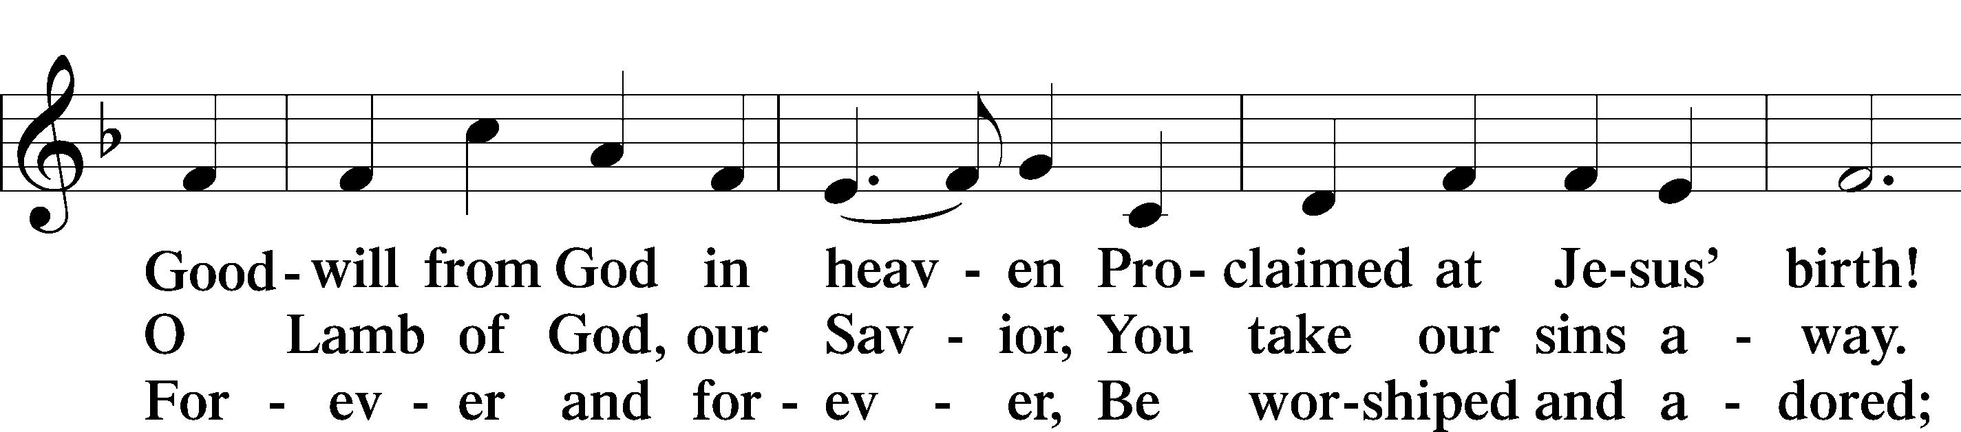
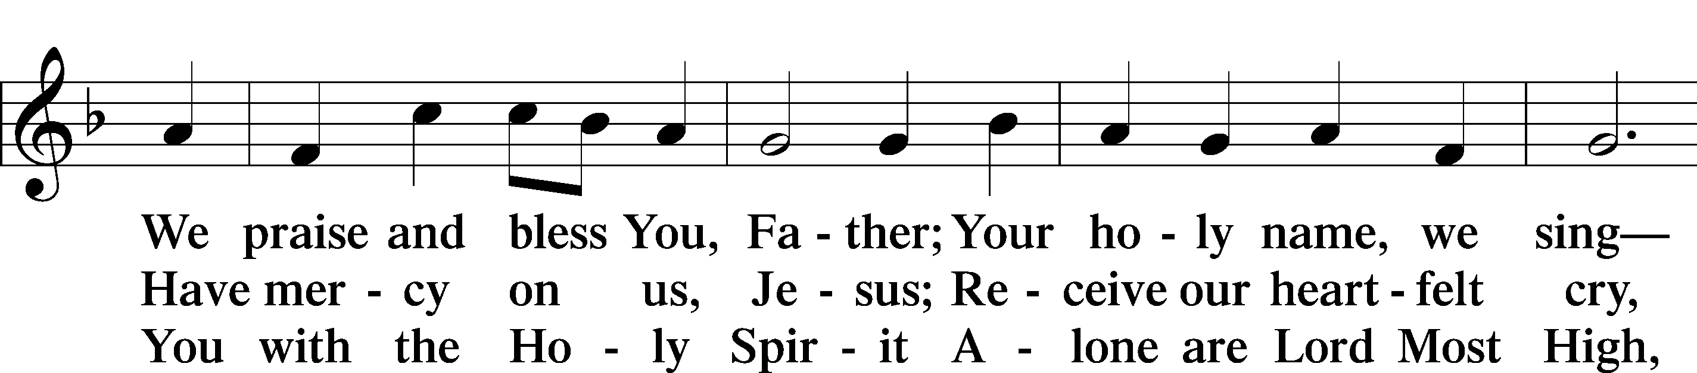
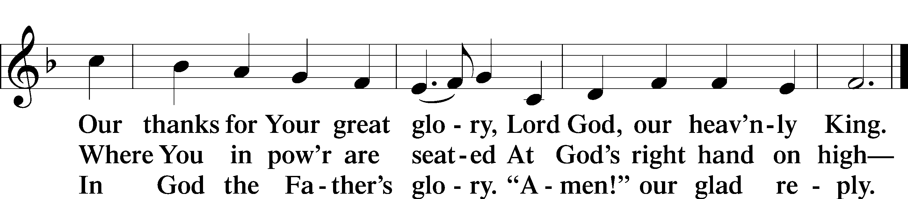

Salutation and Collect of the Day
P The Lord be with you.
C And also with you.

P Let us pray.
Almighty and everlasting God, You knit together Your faithful people of all times and places into one holy communion, the mystical body of Your Son, Jesus Christ. Grant us so to follow Your blessed saints in all virtuous and godly living that, together with them, we may come to the unspeakable joys You have prepared for those who love You; through Jesus Christ, our Lord, who lives and reigns with You and the Holy Spirit, one God, now and forever.

C Amen.

Sit
First Reading Revelation 7:2–17
2Then I saw another angel ascending from the rising of the sun, with the seal of the living God, and he called with a loud voice to the four angels who had been given power to harm earth and sea, 3saying, “Do not harm the earth or the sea or the trees, until we have sealed the servants of our God on their foreheads.” 4And I heard the number of the sealed, 144,000, sealed from every tribe of the sons of Israel:
512,000 from the tribe of Judah were sealed,
12,000 from the tribe of Reuben,
12,000 from the tribe of Gad,
612,000 from the tribe of Asher,
12,000 from the tribe of Naphtali,
12,000 from the tribe of Manasseh,
712,000 from the tribe of Simeon,
12,000 from the tribe of Levi,
12,000 from the tribe of Issachar,
812,000 from the tribe of Zebulun,
12,000 from the tribe of Joseph,
12,000 from the tribe of Benjamin were sealed.
9After this I looked, and behold, a great multitude that no one could number, from every nation, from all tribes and peoples and languages, standing before the throne and before the Lamb, clothed in white robes, with palm branches in their hands, 10and crying out with a loud voice, “Salvation belongs to our God who sits on the throne, and to the Lamb!” 11And all the angels were standing around the throne and around the elders and the four living creatures, and they fell on their faces before the throne and worshiped God, 12saying, “Amen! Blessing and glory and wisdom and thanksgiving and honor and power and might be to our God forever and ever! Amen.”
13Then one of the elders addressed me, saying, “Who are these, clothed in white robes, and from where have they come?” 14I said to him, “Sir, you know.” And he said to me, “These are the ones coming out of the great tribulation. They have washed their robes and made them white in the blood of the Lamb.
15“Therefore they are before the throne of God,
and serve him day and night in his temple;
and he who sits on the throne will shelter them with his presence.
16They shall hunger no more, neither thirst anymore;
the sun shall not strike them,
nor any scorching heat.
17For the Lamb in the midst of the throne will be their shepherd,
and he will guide them to springs of living water,
and God will wipe away every tear from their eyes.”

A This is the Word of the Lord.
C Thanks be to God.

Epistle 1 John 3:1–3
1See what kind of love the Father has given to us, that we should be called children of God; and so we are. The reason why the world does not know us is that it did not know him. 2Beloved, we are God’s children now, and what we will be has not yet appeared; but we know that when he appears we shall be like him, because we shall see him as he is. 3And everyone who thus hopes in him purifies himself as he is pure.

A This is the Word of the Lord.
C Thanks be to God.

Stand

Alleluia and Verse
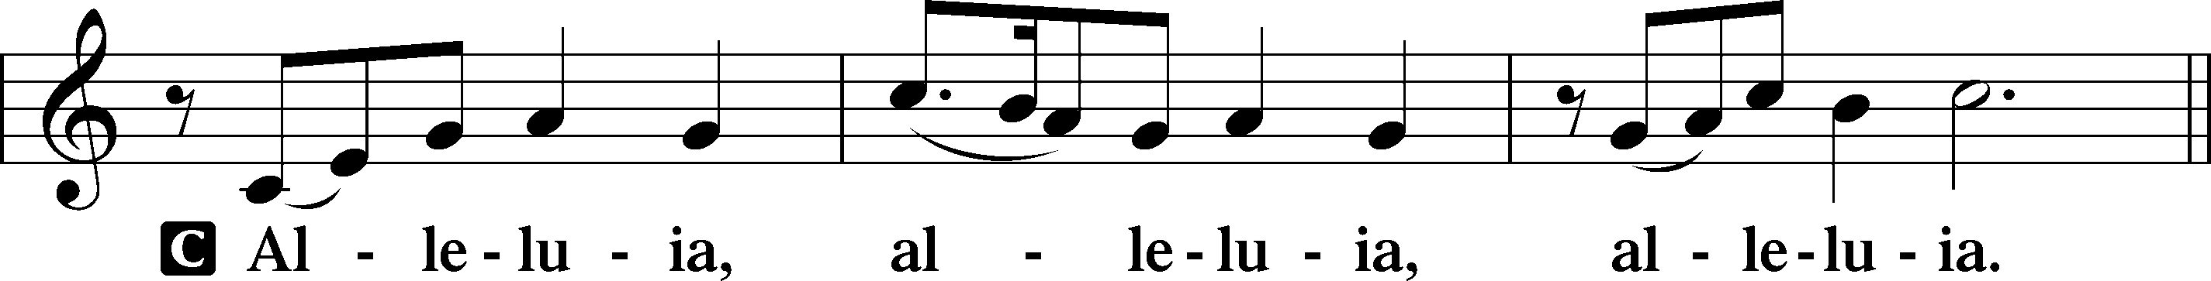
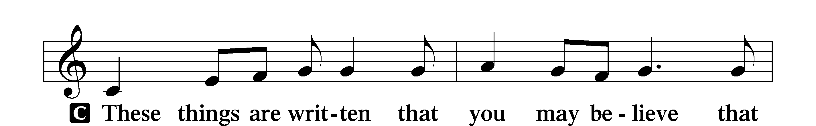
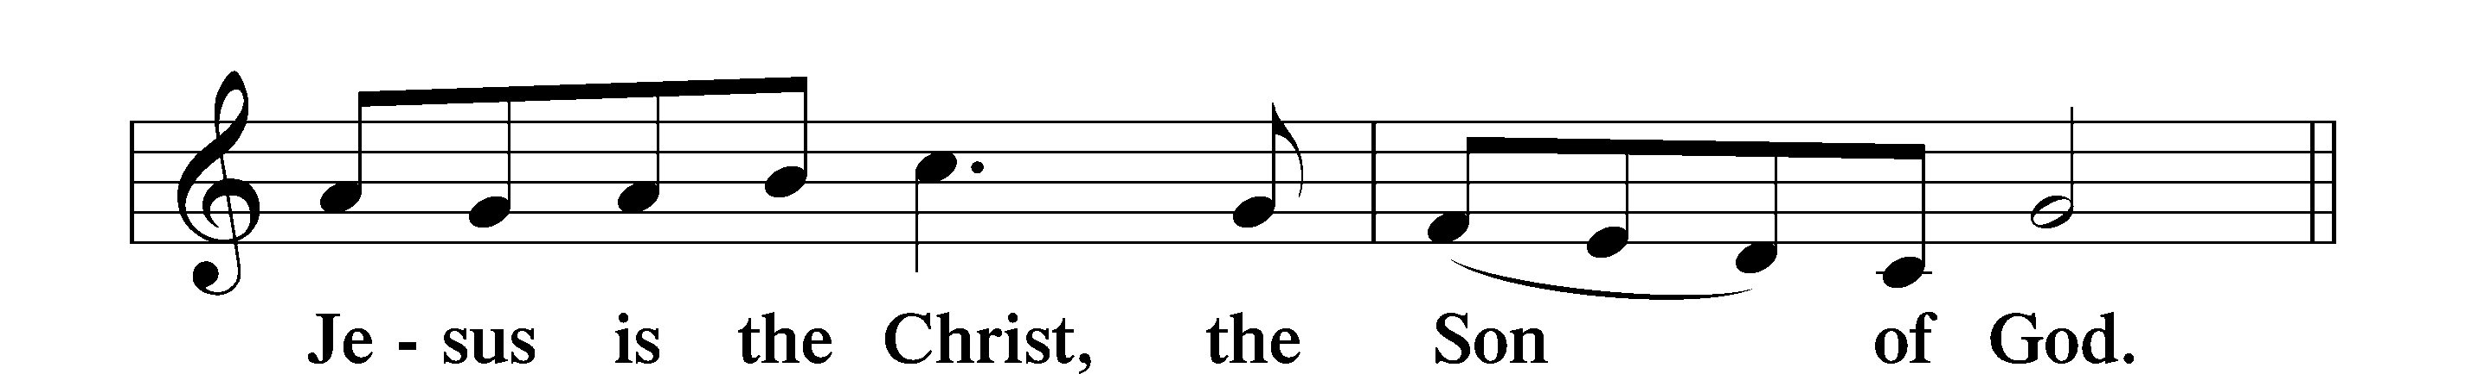
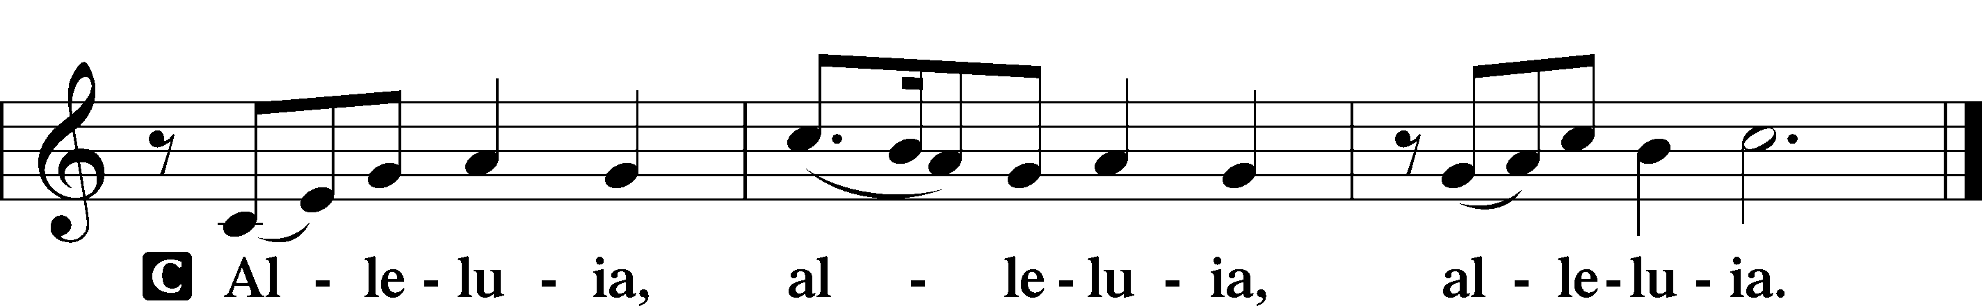
Holy Gospel Matthew 5:1–12
P The Holy Gospel according to St. Matthew, the fifth chapter.
C Glory to You, O Lord.

1Seeing the crowds, [Jesus] went up on the mountain, and when he sat down, his disciples came to him.
2And he opened his mouth and taught them, saying:
3“Blessed are the poor in spirit, for theirs is the kingdom of heaven.
4“Blessed are those who mourn, for they shall be comforted.
5“Blessed are the meek, for they shall inherit the earth.
6“Blessed are those who hunger and thirst for righteousness, for they shall be satisfied.
7“Blessed are the merciful, for they shall receive mercy.
8“Blessed are the pure in heart, for they shall see God.
9“Blessed are the peacemakers, for they shall be called sons of God.
10“Blessed are those who are persecuted for righteousness’ sake, for theirs is the kingdom of heaven.
11“Blessed are you when others revile you and persecute you and utter all kinds of evil against you falsely on my account. 12Rejoice and be glad, for your reward is great in heaven, for so they persecuted the prophets who were before you.”

P This is the Gospel of the Lord.
C Praise to You, O Christ.

Apostles’ Creed
C I believe in God, the Father Almighty,
maker of heaven and earth.
And in Jesus Christ, His only Son, our Lord,
who was conceived by the Holy Spirit,
born of the virgin Mary,
suffered under Pontius Pilate,
was crucified, died and was buried.
He descended into hell.
The third day He rose again from the dead.
He ascended into heaven
and sits at the right hand of God the Father Almighty.
From thence He will come to judge the living and the dead.

I believe in the Holy Spirit,
the holy Christian Church,
the communion of saints,
the forgiveness of sins,
the resurrection of the body,
and the life T everlasting. Amen.

Sit

677 For All the Saints sts. 5–8

Sermon

Offering. We generously give our offerings to the LORD out of thanksgiving for His generosity of forgiveness, life, and salvation in Christ (2 Corinthians 9:8). We believe that our offerings are not only to support the proclamation of the Gospel here and around the world, but also to help us all grow in faith and trust in Him (2 Corinthians 9:7). We have placed an offering plate in the narthex so you are able to freely give back to Him as you are able. To Him be all the glory!

Stand

Prayer of the Church

Lord’s Prayer

Benedicamus
A Let us bless the Lord.
C Thanks be to God.

Benediction
P The Lord bless you and keep you.
The Lord make His face shine on you and be gracious to you.
The Lord look upon you with favor and T give you peace.
C Amen.

671 Sing with All the Saints in Glory

