17th Sunday After Pentecost
September 20th, 2026

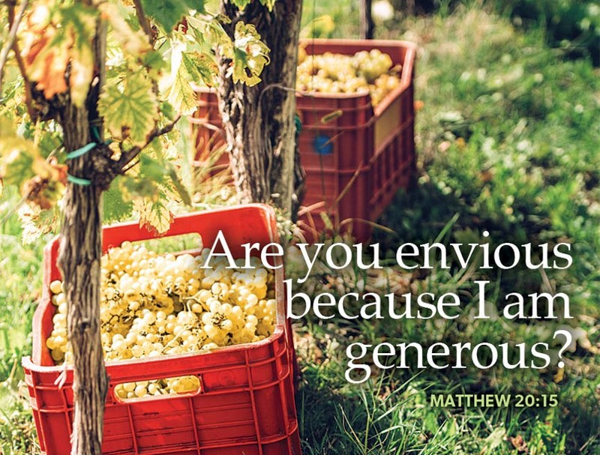

Messiah Lutheran Church
Sartell, MN
www.messiahsartell.com
320-252-5883
Prayer Before Entering
Please take this time to focus on our purpose in gathering and join in prayer before our service begins. Blessed Lord, You have caused all Holy Scriptures to be written for our learning. Grant that we may so hear them, read, mark, learn, and inwardly digest them that, by patience and comfort of Your holy Word, we may embrace and ever hold fast the blessed hope of everlasting life; through Jesus Christ, our Lord.

As We Gather
On the surface, the parable of the laborers in the vineyard seems wrong. Shouldn’t the worker receive the wages he or she deserves for his or her time and labor? It offends our sense of fair play that one who worked less should receive the same as one who worked more. If you only focus on the perspective of the laborer, that might seem true, but if you focus on the generosity of the vineyard owner, you get a very different perspective. God’s mercy is not the reward for our labor but a pure gift of grace given to those who deserve none of His kindness. When you begin to look at this parable from that perspective, God’s abundant generosity becomes clear. The Lord does what none of us would do—forgives all our sins, no matter how great, and bestows upon us the mercy and salvation we did nothing to earn and could never deserve. How can anyone begrudge Him such generosity?

688 “Come, Follow Me,” the Savior Spake

Stand

The sign of the cross may be made by all in remembrance of their Baptism.

P In the name of the Father and of the T Son and of the Holy Spirit.
C Amen.

P Our help is in the name of the Lord,
C who made heaven and earth.

P If You, O Lord, kept a record of sins, O Lord, who could stand?
C But with You there is forgiveness; therefore You are feared.

P Since we are gathered to hear God’s Word, call upon Him in prayer and praise, let us first consider our unworthiness and confess before God and one another that we have sinned in thought, word, and deed, and that we cannot free ourselves from our sinful condition. Together as His people let us take refuge in the infinite mercy of God, our heavenly Father, seeking His grace for the sake of Christ, and saying:
C God, be merciful to me, a sinner.

Silence for reflection on God’s Word and for self-examination.

C Almighty God, have mercy upon us, forgive us our sins, and lead us to everlasting life. Amen.

P Almighty God in His mercy has given His Son to die for you and for His sake forgives you all your sins. As a called and ordained servant of Christ, and by His authority, I therefore forgive you all your sins in the name of the Father and of the T Son and of the Holy Spirit.

C Amen.

Introit Psalm 116:12–13, 15–16; antiphon: v. 17
P I will offer to you the sacrifice of thanksgiving
and call on the name of the Lord.
C What shall I render to the Lord
for all his benefits to me?
P I will lift up the cup of salvation
and call on the name of the Lord.
C Precious in the sight of the Lord
is the death of his saints.
P O Lord, I am your servant;
I am your servant, the son of your maidservant. You have loosed my
bonds.
All: Glory be to the Father and to the Son
and to the Holy Spirit;
as it was in the beginning,
is now, and will be forever. Amen.
P I will offer to you the sacrifice of thanksgiving
and call on the name of the Lord.
Kyrie
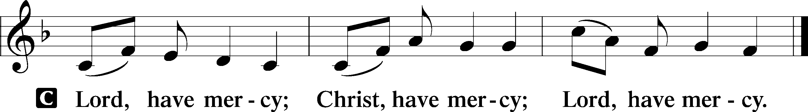

Gloria in Excelsis
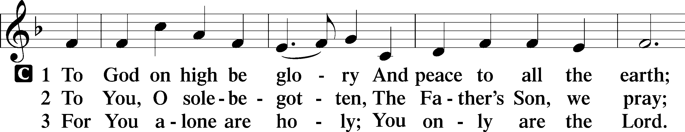
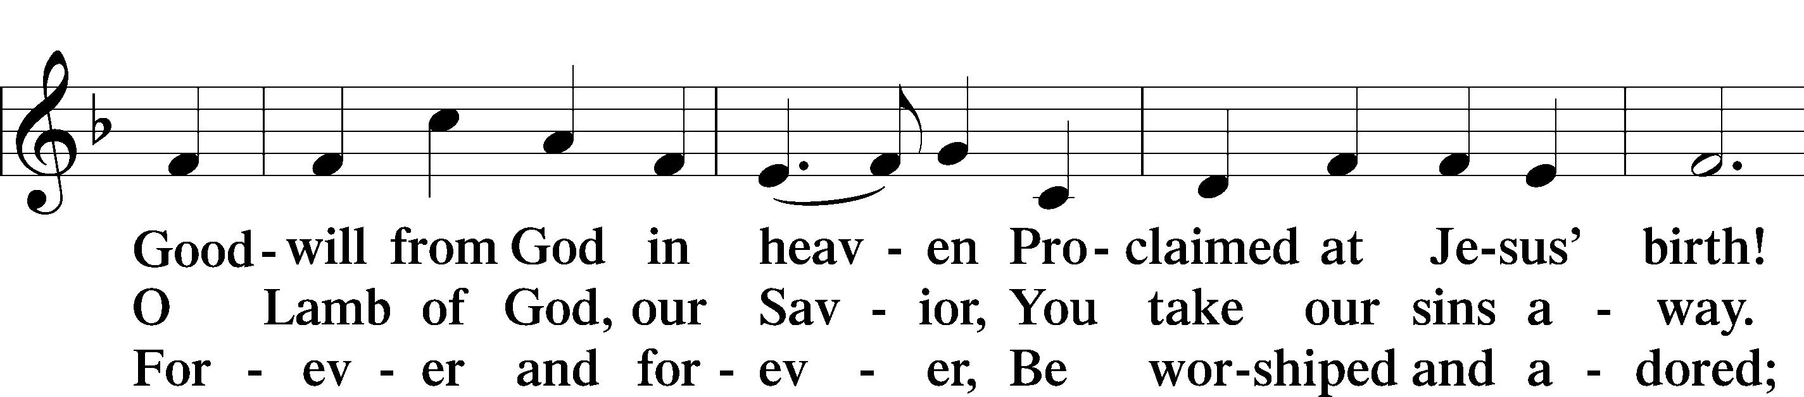
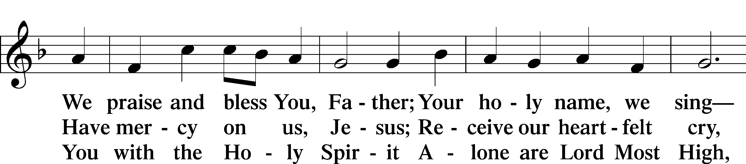
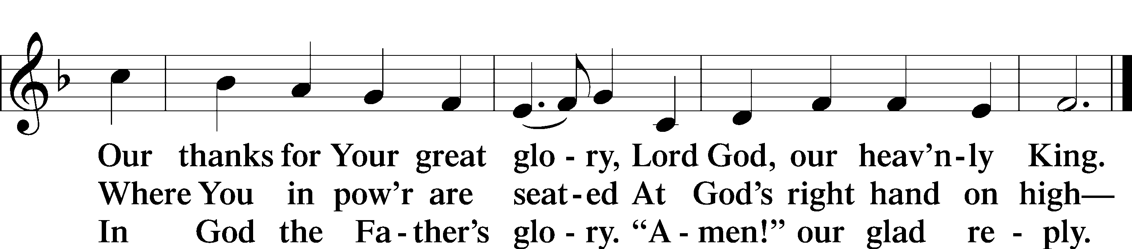

Salutation and Collect of the Day
P The Lord be with you.
C And also with you.

P Let us pray.
Lord God, heavenly Father, since we cannot stand before You relying on anything we have done, help us trust in Your abiding grace and live according to Your Word; through Jesus Christ, Your Son, our Lord, who lives and reigns with You and the Holy Spirit, one God, now and forever.
C Amen.

Sit

Old Testament Reading Isaiah 55:6–9
6“Seek the Lord while he may be found;
call upon him while he is near;
7let the wicked forsake his way,
and the unrighteous man his thoughts;
let him return to the Lord, that he may have compassion on him,
and to our God, for he will abundantly pardon.
8For my thoughts are not your thoughts,
neither are your ways my ways, declares the Lord.
9For as the heavens are higher than the earth,
so are my ways higher than your ways
and my thoughts than your thoughts.”

A This is the Word of the Lord.
C Thanks be to God.

Epistle Philippians 1:12–14, 19–30
12I want you to know, brothers, that what has happened to me has really served to advance the gospel, 13so that it has become known throughout the whole imperial guard and to all the rest that my imprisonment is for Christ. 14And most of the brothers, having become confident in the Lord by my imprisonment, are much more bold to speak the word without fear. . . .
19for I know that through your prayers and the help of the Spirit of Jesus Christ this will turn out for my deliverance, 20as it is my eager expectation and hope that I will not be at all ashamed, but that with full courage now as always Christ will be honored in my body, whether by life or by death. 21For to me to live is Christ, and to die is gain. 22If I am to live in the flesh, that means fruitful labor for me. Yet which I shall choose I cannot tell. 23I am hard pressed between the two. My desire is to depart and be with Christ, for that is far better. 24But to remain in the flesh is more necessary on your account. 25Convinced of this, I know that I will remain and continue with you all, for your progress and joy in the faith, 26so that in me you may have ample cause to glory in Christ Jesus, because of my coming to you again.
27Only let your manner of life be worthy of the gospel of Christ, so that whether I come and see you or am absent, I may hear of you that you are standing firm in one spirit, with one mind striving side by side for the faith of the gospel, 28and not frightened in anything by your opponents. This is a clear sign to them of their destruction, but of your salvation, and that from God. 29For it has been granted to you that for the sake of Christ you should not only believe in him but also suffer for his sake, 30engaged in the same conflict that you saw I had and now hear that I still have.

A This is the Word of the Lord.
C Thanks be to God.

Stand

Alleluia and Verse
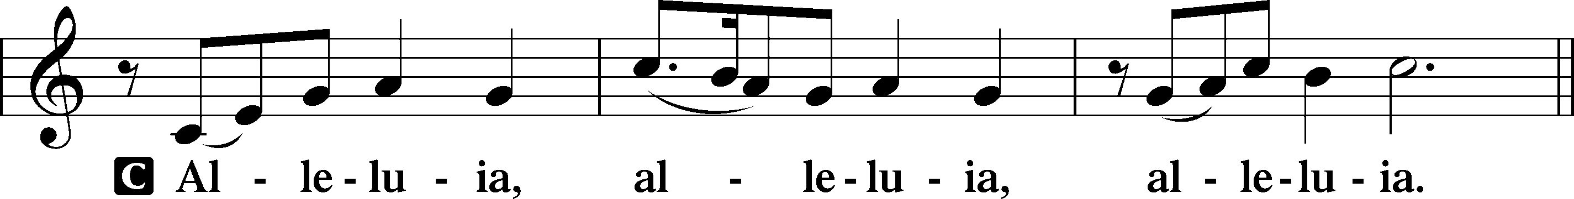
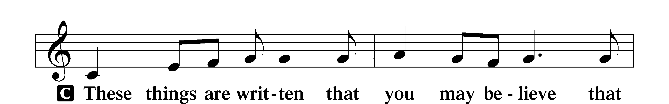
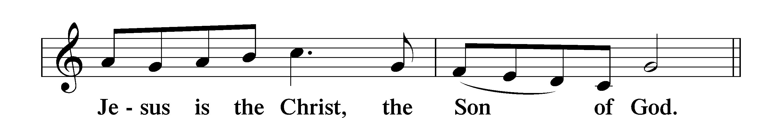
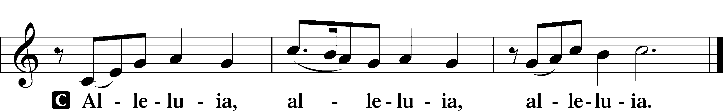

Holy Gospel Matthew 20:1–16
P The Holy Gospel according to St. Matthew, the twentieth chapter.
C Glory to You, O Lord.

1[Jesus said:] “The kingdom of heaven is like a master of a house who went out early in the morning to hire laborers for his vineyard. 2After agreeing with the laborers for a denarius a day, he sent them into his vineyard. 3And going out about the third hour he saw others standing idle in the marketplace, 4and to them he said, ‘You go into the vineyard too, and whatever is right I will give you.’ 5So they went. Going out again about the sixth hour and the ninth hour, he did the same. 6And about the eleventh hour he went out and found others standing. And he said to them, ‘Why do you stand here idle all day?’ 7They said to him, ‘Because no one has hired us.’ He said to them, ‘You go into the vineyard too.’ 8And when evening came, the owner of the vineyard said to his foreman, ‘Call the laborers and pay them their wages, beginning with the last, up to the first.’ 9And when those hired about the eleventh hour came, each of them received a denarius. 10Now when those hired first came, they thought they would receive more, but each of them also received a denarius. 11And on receiving it they grumbled at the master of the house, 12saying, ‘These last worked only one hour, and you have made them equal to us who have borne the burden of the day and the scorching heat.’ 13But he replied to one of them, ‘Friend, I am doing you no wrong. Did you not agree with me for a denarius? 14Take what belongs to you and go. I choose to give to this last worker as I give to you. 15Am I not allowed to do what I choose with what belongs to me? Or do you begrudge my generosity?’ 16So the last will be first, and the first last.”

P This is the Gospel of the Lord.
C Praise to You, O Christ.

Apostles’ Creed
C I believe in God, the Father Almighty,
maker of heaven and earth.
And in Jesus Christ, His only Son, our Lord,
who was conceived by the Holy Spirit,
born of the virgin Mary,
suffered under Pontius Pilate,
was crucified, died and was buried.
He descended into hell.
The third day He rose again from the dead.
He ascended into heaven
and sits at the right hand of God the Father Almighty.
From thence He will come to judge the living and the dead.
I believe in the Holy Spirit,
the holy Christian Church,
the communion of saints,
the forgiveness of sins,
the resurrection of the body,
and the life T everlasting. Amen.
Sit

827 Hark, the Voice of Jesus Calling

Sermon

Offering. We generously give our offerings to the LORD out of thanksgiving for His generosity of forgiveness, life, and salvation in Christ (2 Corinthians 9:8). We believe that our offerings are not only to support the proclamation of the Gospel here and around the world, but also to help us all grow in faith and trust in Him (2 Corinthians 9:7). We have placed an offering plate in the narthex so you are able to freely give back to Him as you are able. To Him be all the glory!

Stand

Prayer of the Church

Lord’s Prayer

Benedicamus
A Let us bless the Lord.
C Thanks be to God.

Benediction
P The Lord bless you and keep you.
The Lord make His face shine on you and be gracious to you.
The Lord look upon you with favor and T give you peace.
C Amen.

924 Lord, Dismiss Us with Your Blessing

Announcement

Calling all noodle helpers! We’ll be mixing, rolling, cutting, and hanging noodles on Mondays, Sept. 28, and Oct. 12 at 12:30 p.m. Whether you’re a noodle pro,
a first-timer, or just coming for coffee and fellowship, we’d love to have you.
All helping hands are welcome as we prepare for the
Sartell Area Churches’ Craft and Bake Sale on Oct. 31.

