First Sunday in Lent
February 22nd, 2026

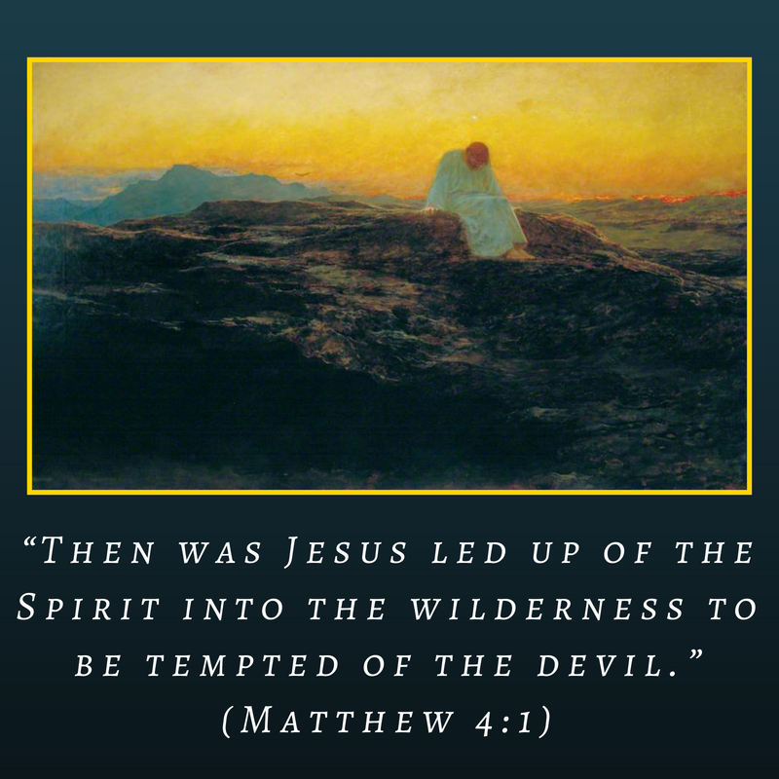

“Then Jesus was led up by the Spirit into the wilderness to be tempted by the devil.”

~ Matthew 4:1

Messiah Lutheran Church
Sartell, MN
www.messiahsartell.com
320-252-5883
Prayer Before Entering
Please take this time to focus on our purpose in gathering and join in prayer before our service begins. Blessed Lord, You have caused all Holy Scriptures to be written for our learning. Grant that we may so hear them, read, mark, learn, and inwardly digest them that, by patience and comfort of Your holy Word, we may embrace and ever hold fast the blessed hope of everlasting life; through Jesus Christ, our Lord.

As We Gather
The First Sunday in Lent begins with the temptation of Jesus. Alone in the wilderness, Jesus faces the temptations of the devil, who tries to use God’s own Word to entrap Jesus. The collect reminds us that we are also walking through the wilderness of this world, taunted and tempted by the devil, who still uses God’s Word to entrap us. Jesus does not simply show us how to resist but reveals that our strength lies in the same Word of God. In Christ, we stand strong against the wiles of the devil and, when and if we fall, we find refuge in Christ to be forgiven and restored.

418 O Lord, throughout These Forty Days

Stand

The sign of the cross may be made by all in remembrance of their Baptism.

P In the name of the Father and of the T Son and of the Holy Spirit.
C Amen.

P Our help is in the name of the Lord,
C who made heaven and earth.

P If You, O Lord, kept a record of sins, O Lord, who could stand?
C But with You there is forgiveness; therefore You are feared.

P Since we are gathered to hear God’s Word, call upon Him in prayer and praise, and receive the body and blood of our Lord Jesus Christ in the fellowship of this altar, let us first consider our unworthiness and confess before God and one another that we have sinned in thought, word, and deed, and that we cannot free ourselves from our sinful condition. Together as His people let us take refuge in the infinite mercy of God, our heavenly Father, seeking His grace for the sake of Christ, and saying:
C God, be merciful to me, a sinner.

Silence for reflection on God’s Word and for self-examination.

C Almighty God, have mercy upon us, forgive us our sins, and lead us to everlasting life. Amen.

P Almighty God in His mercy has given His Son to die for you and for His sake forgives you all your sins. As a called and ordained servant of Christ, and by His authority, I therefore forgive you all your sins in the name of the Father and of the T Son and of the Holy Spirit.

C Amen.

Introit Psalm 91:9–13; antiphon: vv. 15–16
P When he calls to me, I will answer him; I will be with him in trouble;
I will rescue him and honor him.
C With long life I will satisfy him
and show him my salvation.
P Because you have made the Lord your dwelling place—
the Most High, who is my refuge—
C no evil shall be allowed to befall you,
no plague come near your tent.
P For he will command his angels concerning you
to guard you in all your ways.
C On their hands they will bear you up,
lest you strike your foot against a stone.
P You will tread on the lion and the adder;
the young lion and the serpent you will trample underfoot.
All: Glory be to the Father and to the Son
and to the Holy Spirit;
as it was in the beginning,
is now, and will be forever. Amen.
P When he calls to me, I will answer him; I will be with him in trouble;
I will rescue him and honor him.
With long life I will satisfy him
and show him my salvation.

Kyrie
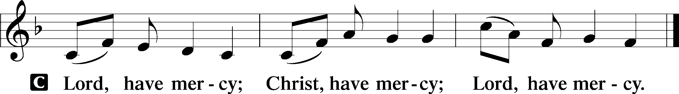

Salutation and Collect of the Day
P The Lord be with you.
C And also with you.

P Let us pray.
O Lord God, You led Your ancient people through the wilderness and brought them to the promised land. Guide the people of Your Church that following our Savior we may walk through the wilderness of this world toward the glory of the world to come; through Jesus Christ, Your Son, our Lord, who lives and reigns with You and the Holy Spirit, one God, now and forever.

C Amen.

Sit

Old Testament Reading Genesis 3:1–21
1Now the serpent was more crafty than any other beast of the field that the Lord God had made.
He said to the woman, “Did God actually say, ‘You shall not eat of any tree in the garden’?” 2And the woman said to the serpent, “We may eat of the fruit of the trees in the garden, 3but God said, ‘You shall not eat of the fruit of the tree that is in the midst of the garden, neither shall you touch it, lest you die.’” 4But the serpent said to the woman, “You will not surely die. 5For God knows that when you eat of it your eyes will be opened, and you will be like God, knowing good and evil.” 6So when the woman saw that the tree was good for food, and that it was a delight to the eyes, and that the tree was to be desired to make one wise, she took of its fruit and ate, and she also gave some to her husband who was with her, and he ate. 7Then the eyes of both were opened, and they knew that they were naked. And they sewed fig leaves together and made themselves loincloths.
8And they heard the sound of the Lord God walking in the garden in the cool of the day, and the man and his wife hid themselves from the presence of the Lord God among the trees of the garden. 9But the Lord God called to the man and said to him, “Where are you?” 10And he said, “I heard the sound of you in the garden, and I was afraid, because I was naked, and I hid myself.” 11He said, “Who told you that you were naked? Have you eaten of the tree of which I commanded you not to eat?” 12The man said, “The woman whom you gave to be with me, she gave me fruit of the tree, and I ate.” 13Then the Lord God said to the woman, “What is this that you have done?” The woman said, “The serpent deceived me, and I ate.”
14The Lord God said to the serpent, “Because you have done this, cursed are you above all livestock and above all beasts of the field;
on your belly you shall go, and dust you shall eat all the days of your life.
15I will put enmity between you and the woman, and between your offspring and her offspring; he shall bruise your head, and you shall bruise his heel.” 16To the woman he said, “I will surely multiply your pain in childbearing; in pain you shall bring forth children. Your desire shall be for your husband, and he shall rule over you.” 17And to Adam he said, “Because you have listened to the voice of your wife and have eaten of the tree of which I commanded you, ‘You shall not eat of it,’ cursed is the ground because of you; in pain you shall eat of it all the days of your life; 18thorns and thistles it shall bring forth for you; and you shall eat the plants of the field. 19By the sweat of your face you shall eat bread, till you return to the ground, for out of it you were taken; for you are dust, and to dust you shall return.”
20The man called his wife’s name Eve, because she was the mother of all living. 21And the Lord God made for Adam and for his wife garments of skins and clothed them.

A This is the Word of the Lord.
C Thanks be to God.

Epistle Romans 5:12–19
12Therefore, just as sin came into the world through one man, and death through sin, and so death spread to all men because all sinned— 13for sin indeed was in the world before the law was given, but sin is not counted where there is no law. 14Yet death reigned from Adam to Moses, even over those whose sinning was not like the transgression of Adam, who was a type of the one who was to come.
15But the free gift is not like the trespass. For if many died through one man’s trespass, much more have the grace of God and the free gift by the grace of that one man Jesus Christ abounded for many. 16And the free gift is not like the result of that one man’s sin. For the judgment following one trespass brought condemnation, but the free gift following many trespasses brought justification. 17If, because of one man’s trespass, death reigned through that one man, much more will those who receive the abundance of grace and the free gift of righteousness reign in life through the one man Jesus Christ.
18Therefore, as one trespass led to condemnation for all men, so one act of righteousness leads to justification and life for all men. 19For as by the one man’s disobedience the many were made sinners, so by the one man’s obedience the many will be made righteous.

A This is the Word of the Lord.
C Thanks be to God.

Stand

Holy Gospel Matthew 4:1–11
P The Holy Gospel according to St. Matthew, the fourth chapter.
C Glory to You, O Lord.

1Then Jesus was led up by the Spirit into the wilderness to be tempted by the devil. 2And after fasting forty days and forty nights, he was hungry. 3And the tempter came and said to him, “If you are the Son of God, command these stones to become loaves of bread.”
4But he answered, “It is written, “‘Man shall not live by bread alone, but by every word that comes from the mouth of God.’” 5Then the devil took him to the holy city and set him on the pinnacle of the temple 6and said to him, “If you are the Son of God, throw yourself down, for it is written, “‘He will command his angels concerning you,’ and “‘On their hands they will bear you up, lest you strike your foot against a stone.’”
7Jesus said to him, “Again it is written, ‘You shall not put the Lord your God to the test.’” 8Again, the devil took him to a very high mountain and showed him all the kingdoms of the world and their glory. 9And he said to him, “All these I will give you, if you will fall down and worship me.” 10Then Jesus said to him, “Be gone, Satan! For it is written, “‘You shall worship the Lord your God and him only shall you serve.’”
11Then the devil left him, and behold, angels came and were ministering to him.
P This is the Gospel of the Lord.
C Praise to You, O Christ.

Nicene Creed
C I believe in one God,
the Father Almighty,
maker of heaven and earth
and of all things visible and invisible.
And in one Lord Jesus Christ,
the only-begotten Son of God,
begotten of His Father before all worlds,
God of God, Light of Light,
very God of very God,
begotten, not made,
being of one substance with the Father,
by whom all things were made;
who for us men and for our salvation came down from heaven
and was incarnate by the Holy Spirit of the virgin Mary
and was made man;
and was crucified also for us under Pontius Pilate.
He suffered and was buried.
And the third day He rose again according to the Scriptures
and ascended into heaven
and sits at the right hand of the Father.
And He will come again with glory to judge both the living and the dead,
whose kingdom will have no end.

And I believe in the Holy Spirit,
the Lord and giver of life,
who proceeds from the Father and the Son,
who with the Father and the Son together is worshiped and glorified,
who spoke by the prophets.
And I believe in one holy Christian and apostolic Church,
I acknowledge one Baptism for the remission of sins,
and I look for the resurrection of the dead
and the life T of the world to come.

Amen.

Sit
562 All Mankind Fell in Adam’s Fall

Sermon

Offering. We generously give our offerings to the LORD out of thanksgiving for His generosity of forgiveness, life, and salvation in Christ (2 Corinthians 9:8). We believe that our offerings are not only to support the proclamation of the Gospel here and around the world, but also to help us all grow in faith and trust in Him (2 Corinthians 9:7). We have placed an offering plate in the narthex so you are able to freely give back to Him as you are able. To Him be all the glory!

Stand

Prayer of the Church

Holy Communion is celebrated in the belief and glad confidence that our Lord gives us not only bread and wine, but the body and blood of Christ from the cross, for us Christian to eat and drink for the forgiveness of sins (Matthew 26:28). Because we are called to examine ourselves before receiving the Lord’s Supper (I Corinthians 11:28-29), we encourage you to consider the questions on pages 329-330 in the hymnal. We also believe that when we commune, we are confessing our unity with the community we join (I Corinthians 10:17). If you desire to commune with us for the first time or have questions, our pastor is happy to speak with you.

Preface
P The Lord be with you.
C And also with you.

P Lift up your hearts.
C We lift them to the Lord.

P Let us give thanks to the Lord our God.
C It is right to give Him thanks and praise.

P It is truly good, right, and salutary that we should at all times and in all places give thanks to You, O Lord, holy Father, almighty and everlasting God, for the countless blessings You so freely bestow on us and all creation. Above all, we give thanks for Your boundless love shown to us when You sent Your only-begotten Son, Jesus Christ, into our flesh and laid on Him our sin, giving Him into death that we might not die eternally. Because He is now risen from the dead and lives and reigns to all eternity, all who believe in Him will overcome sin and death and will rise again to new life. Therefore with angels and archangels and with all the company of heaven we laud and magnify Your glorious name, evermore praising You and saying:

Sanctus
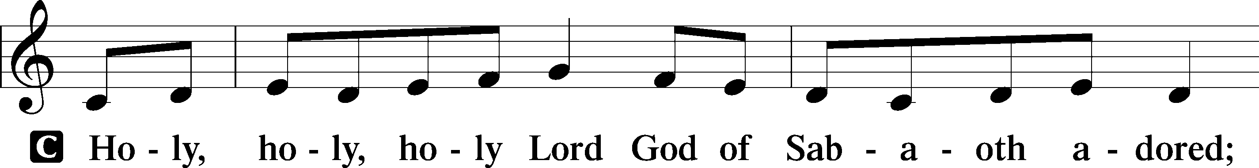
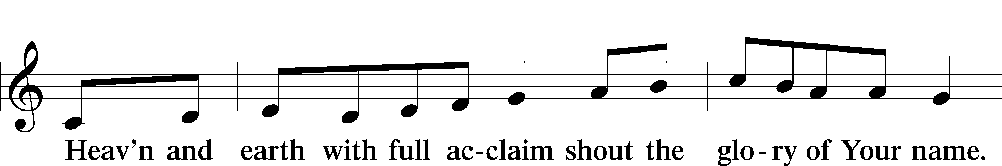
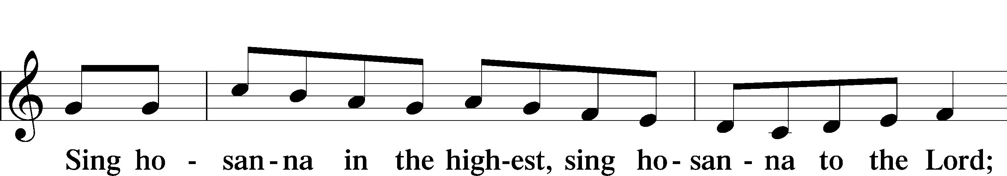
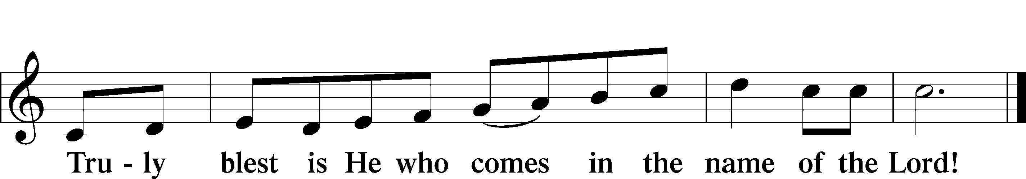

Prayer of Thanksgiving
P Blessed are You, O Lord our God, king of all creation, for You have had mercy on us and given Your only-begotten Son that whoever believes in Him should not perish but have eternal life.

At Your command, Abraham prepared to offer his son Isaac as a sacrifice on the mountain; yet, in mercy You provided a ram as a substitute. We give You thanks that on Calvary You spared not Your only Son but sent Him to offer His life as a ransom for many.

As we eat and drink His body and blood, grant us, like Abraham our father, to trust in Your promise now fulfilled in Christ, the Lamb of God, who takes away the sin of the world.

Hear us as we pray in His name and as He has taught us:

Lord’s Prayer

The Words of Our Lord

Pax Domini
P The peace of the Lord be with you always.
C Amen.

Agnus Dei
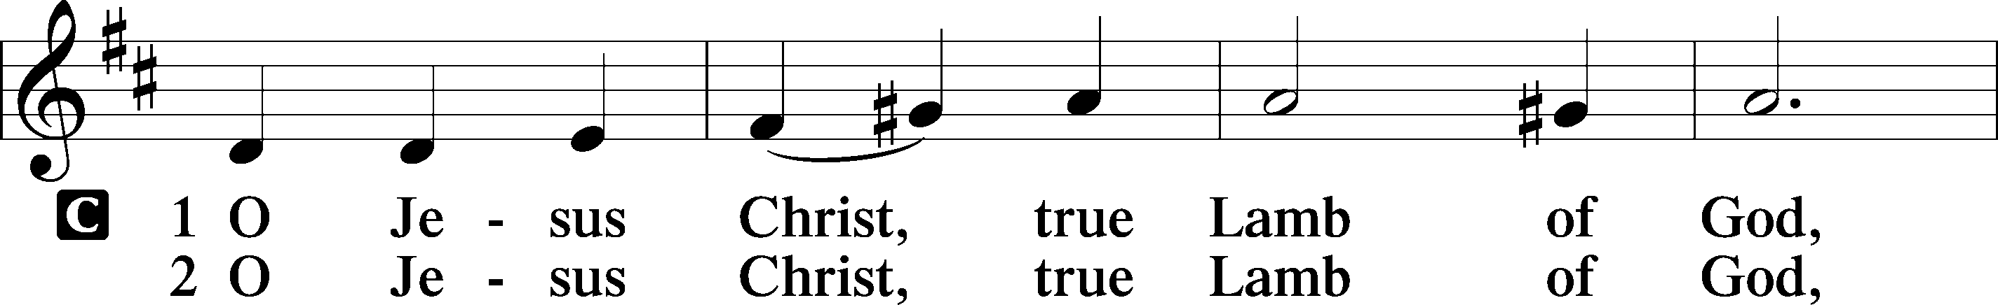
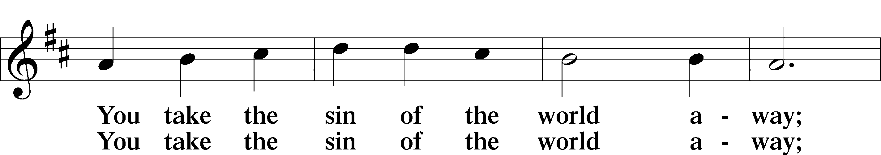
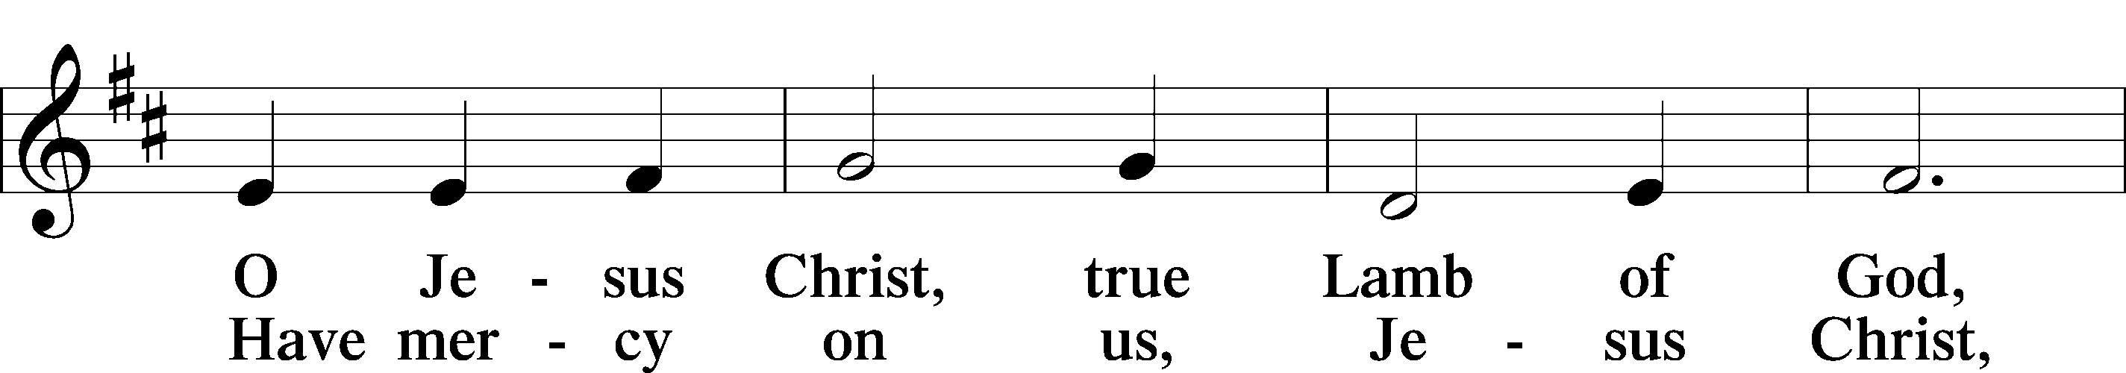
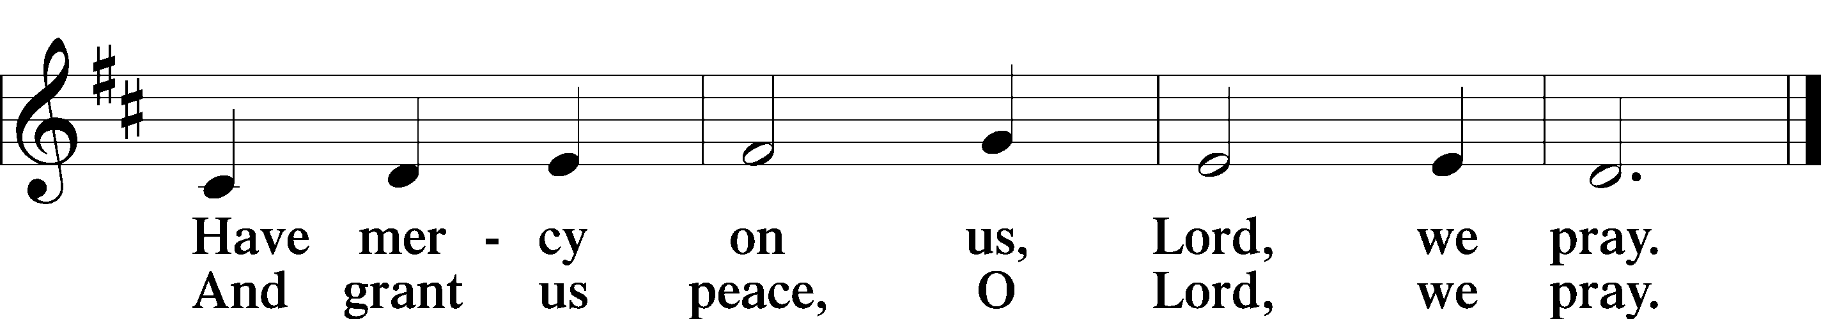

Sit

Distribution

634 The Death of Jesus Christ, Our Lord

637 Draw Near and Take the Body of the Lord

Stand

Nunc Dimittis
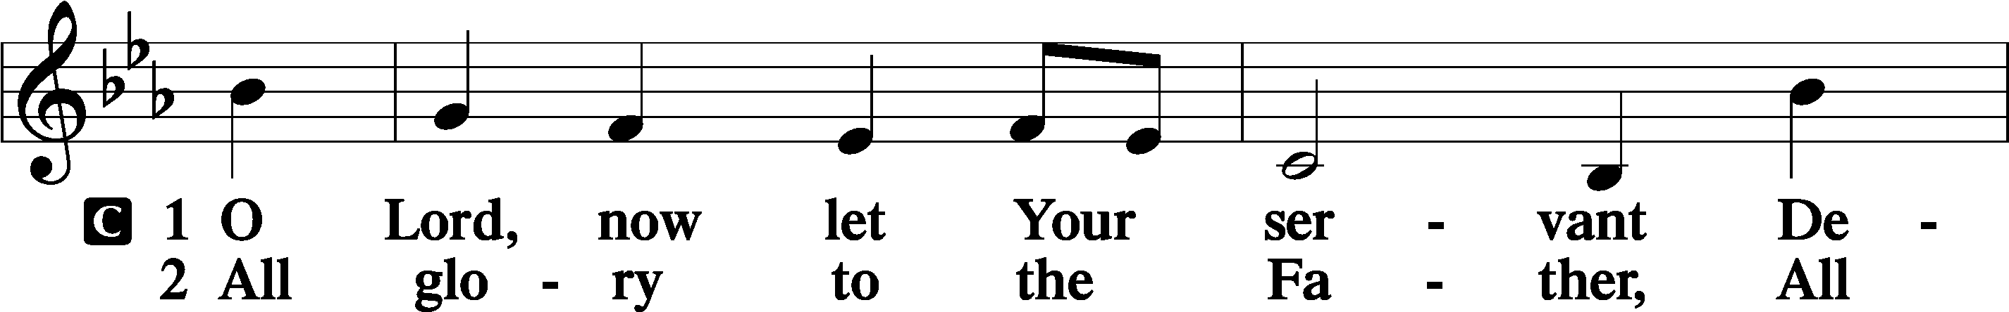
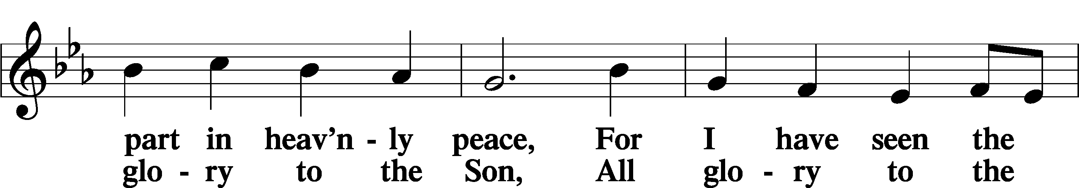
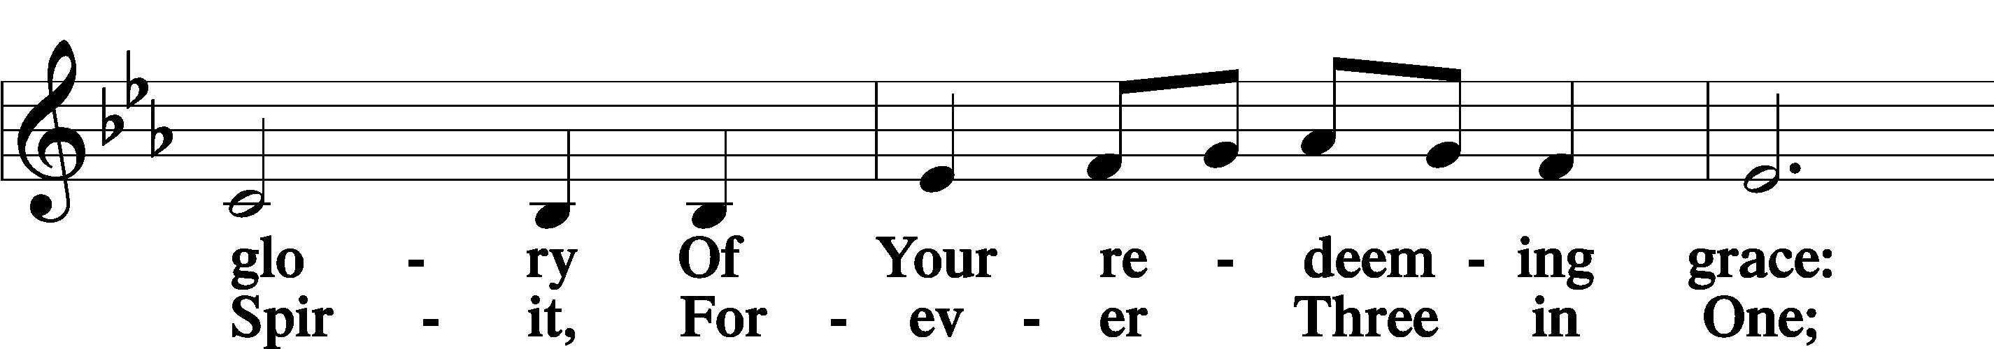
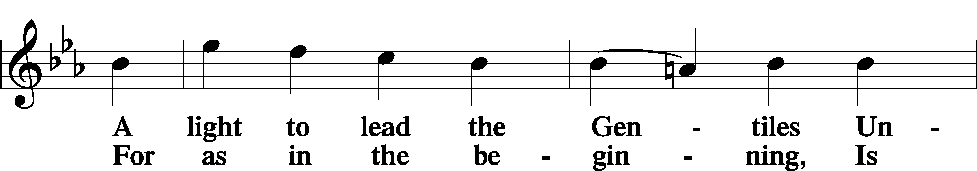
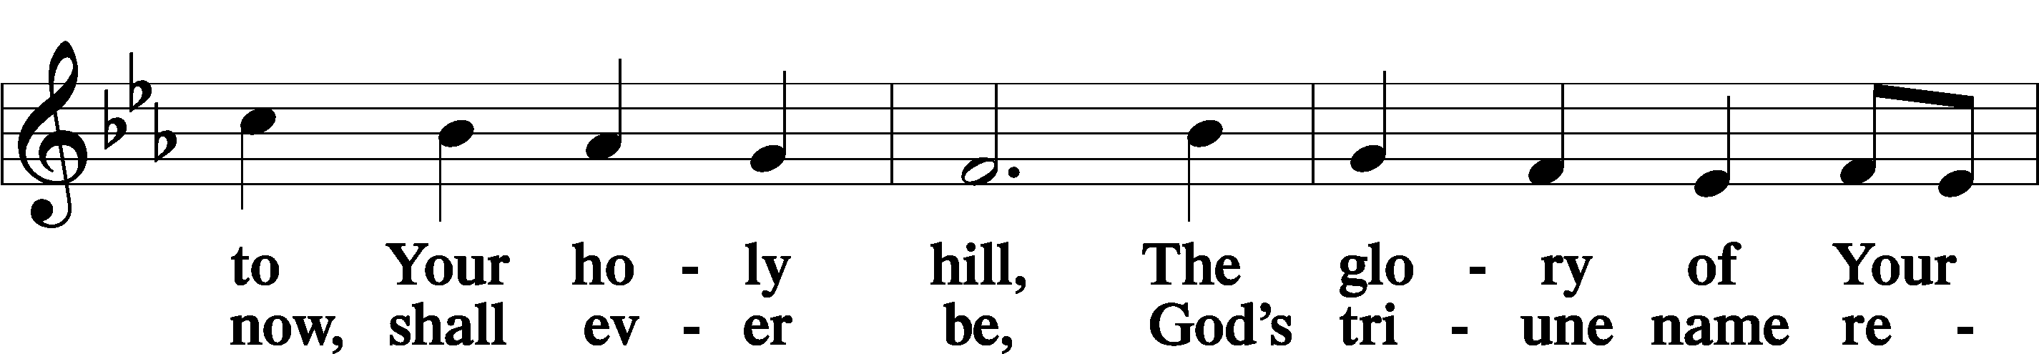
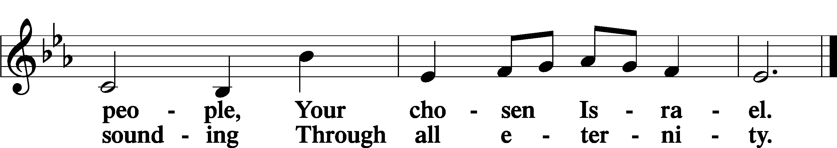

Post-Communion Collect
A Let us pray. We give thanks to You, almighty God, that You have refreshed us through this salutary gift, and we implore You that of Your mercy You would strengthen us through the same in faith toward You and in fervent love toward one another; through Jesus Christ, Your Son, our Lord, who lives and reigns with You and the Holy Spirit, one God, now and forever.
C Amen.

Benedicamus
A Let us bless the Lord.
C Thanks be to God.

Benediction
P The Lord bless you and keep you.
The Lord make His face shine on you and be gracious to you.
The Lord look upon you with favor and T give you peace.

C Amen.

655 Lord, Keep Us Steadfast in Your Word

Announcements

Midweek Lenten Worship Services: 6 p.m.
Wednesdays: February 25, March 4, 11, 18 and 25

Lenten Suppers will be at 4:45 p.m. every Wednesday during Lent.
A sign-up sheet to volunteer is posted in the narthex.

