11th Sunday after Pentecost
August 24th, 2025



Messiah Lutheran Church
Sartell, MN
www.messiahsartell.com
320-252-5883

Prayer Before Entering
Please take this time to focus on our purpose in gathering and join in prayer before our service begins. Blessed Lord, You have caused all Holy Scriptures to be written for our learning. Grant that we may so hear them, read, mark, learn, and inwardly digest them that, by patience and comfort of Your holy Word, we may embrace and ever hold fast the blessed hope of everlasting life; through Jesus Christ, our Lord.

As We Gather
How often don’t we find ourselves exactly where the disciples were: Will those who are saved be few? After all, the Church seems increasingly isolated, the culture increasingly secular, and the barriers to mission increasingly greater. Jesus insists that no one whom the Father has appointed will be lost. That is our comfort. Not all who claim to belong to the Lord are His. That is the reality. The last will be first and many will come from east, west, north, and south to recline at the Lord’s Table in the Kingdom. That is our faith. Numbers are God’s to count. Trust in His Word is our foundation, and telling the good news of Christ is our calling.

915 Today Your Mercy Calls Us

Stand

The sign of the cross may be made by all in remembrance of their Baptism.

P In the name of the Father and of the T Son and of the Holy Spirit.
C Amen.

P Our help is in the name of the Lord,
C who made heaven and earth.

P If You, O Lord, kept a record of sins, O Lord, who could stand?
C But with You there is forgiveness; therefore You are feared.

P Since we are gathered to hear God’s Word, call upon Him in prayer and praise, and receive the body and blood of our Lord Jesus Christ in the fellowship of this altar, let us first consider our unworthiness and confess before God and one another that we have sinned in thought, word, and deed, and that we cannot free ourselves from our sinful condition. Together as His people let us take refuge in the infinite mercy of God, our heavenly Father, seeking His grace for the sake of Christ, and saying:
C God, be merciful to me, a sinner.

Silence for reflection on God’s Word and for self-examination.

C Almighty God, have mercy upon us, forgive us our sins, and lead us to everlasting life. Amen.

P Almighty God in His mercy has given His Son to die for you and for His sake forgives you all your sins. As a called and ordained servant of Christ, and by His authority, I therefore forgive you all your sins in the name of the Father and of the T Son and of the Holy Spirit.

C Amen.

Introit Psalm 117; antiphon: Psalm 96:6a; 115:18
P Splendor and majesty are before him;
we will bless the Lord from this time forth and forevermore. Praise
the Lord!
C Praise the Lord, all nations!
Extol him, all peoples!
P For great is his steadfast love toward us,
and the faithfulness of the Lord endures forever. Praise the Lord!
All: Glory be to the Father and to the Son
and to the Holy Spirit;
as it was in the beginning,
is now, and will be forever. Amen.
P Splendor and majesty are before him;
we will bless the Lord from this time forth and forevermore. Praise
the Lord!

Kyrie
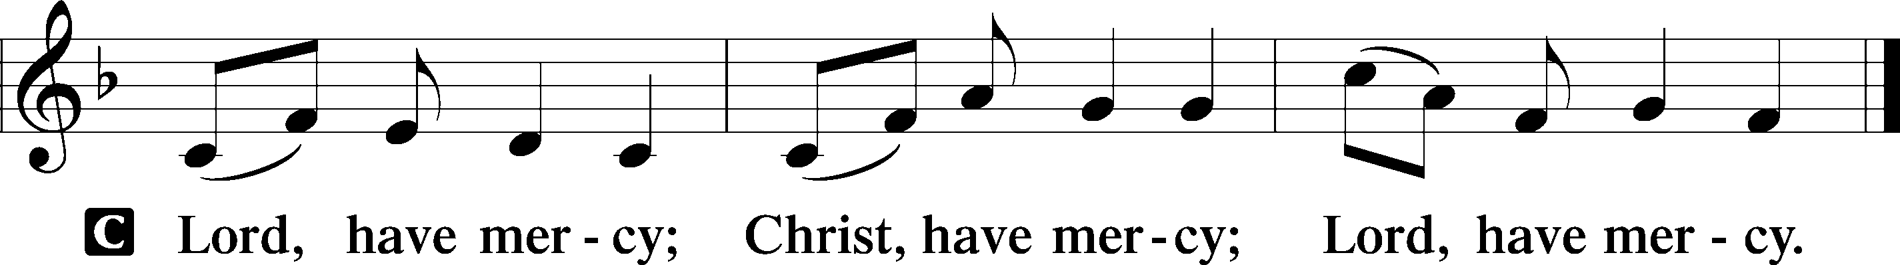

Gloria in Excelsis
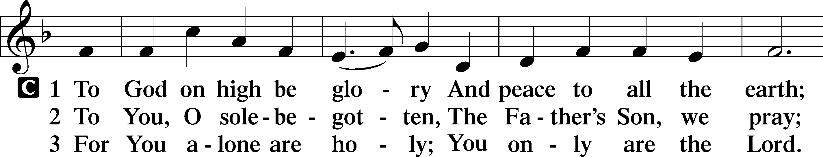
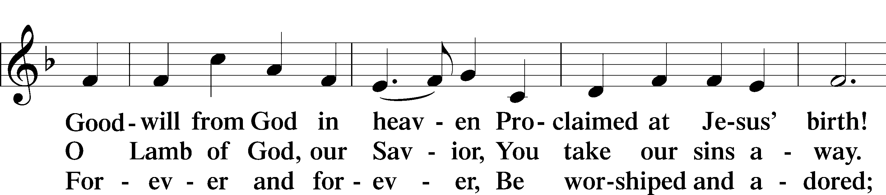
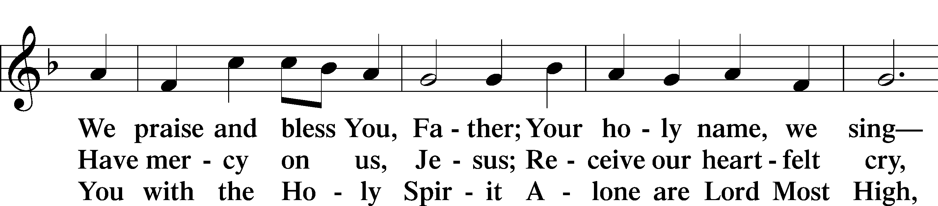
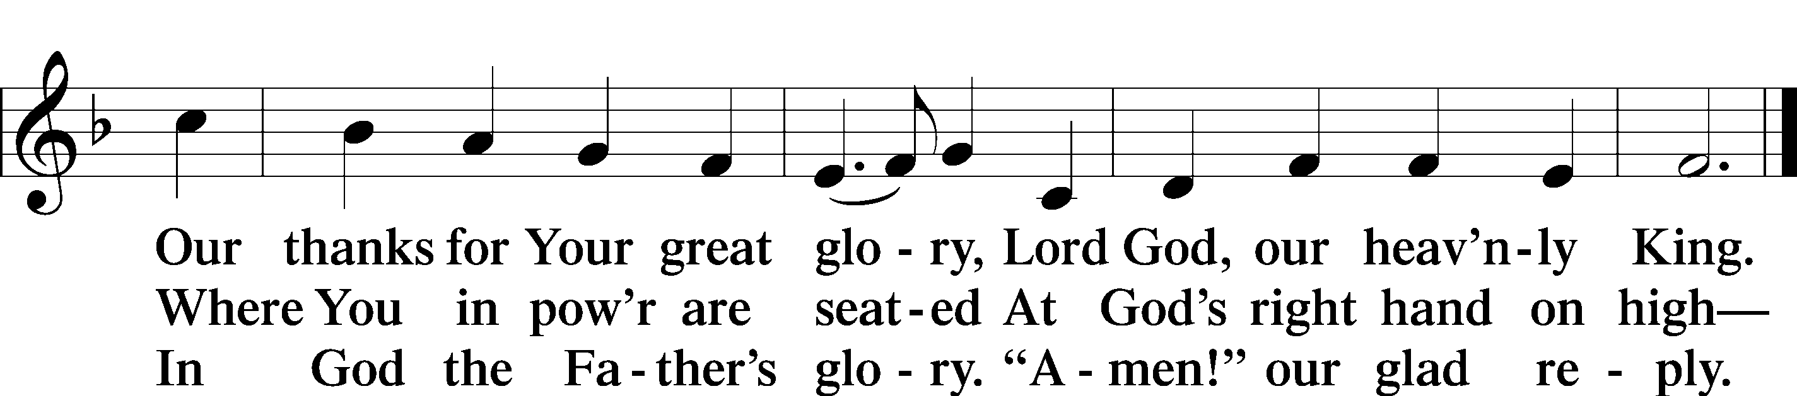

Salutation and Collect of the Day
P The Lord be with you.
C And also with you.

P Let us pray.
O Lord, You have called us to enter Your kingdom through the narrow door. Guide us by Your Word and Spirit, and lead us now and always into the feast of Your Son, Jesus Christ, who lives and reigns with You and the Holy Spirit, one God, now and forever.

C Amen.

Sit
Old Testament Reading Isaiah 66:18–23
18“For I know their works and their thoughts, and the time is coming to gather all nations and tongues. And they shall come and shall see my glory, 19and I will set a sign among them. And from them I will send survivors to the nations, to Tarshish, Pul, and Lud, who draw the bow, to Tubal and Javan, to the coastlands afar off, that have not heard my fame or seen my glory. And they shall declare my glory among the nations. 20And they shall bring all your brothers from all the nations as an offering to the Lord, on horses and in chariots and in litters and on mules and on dromedaries, to my holy mountain Jerusalem, says the Lord, just as the Israelites bring their grain offering in a clean vessel to the house of the Lord. 21And some of them also I will take for priests and for Levites, says the Lord.22“For as the new heavens and the new earth that I make shall remain before me, says the Lord, so shall your offspring and your name remain. 23From new moon to new moon, and from Sabbath to Sabbath,
all flesh shall come to worship before me, declares the Lord.”

A This is the Word of the Lord.
C Thanks be to God.

Epistle Hebrews 12:4–24
4In your struggle against sin you have not yet resisted to the point of shedding your blood. 5And have you forgotten the exhortation that addresses you as sons? “My son, do not regard lightly the discipline of the Lord, nor be weary when reproved by him. 6For the Lord disciplines the one he loves, and chastises every son whom he receives.”
7It is for discipline that you have to endure. God is treating you as sons. For what son is there whom his father does not discipline? 8If you are left without discipline, in which all have participated, then you are illegitimate children and not sons. 9Besides this, we have had earthly fathers who disciplined us and we respected them. Shall we not much more be subject to the Father of spirits and live? 10For they disciplined us for a short time as it seemed best to them, but he disciplines us for our good, that we may share his holiness. 11For the moment all discipline seems painful rather than pleasant, but later it yields the peaceful fruit of righteousness to those who have been trained by it.
12Therefore lift your drooping hands and strengthen your weak knees, 13and make straight paths for your feet, so that what is lame may not be put out of joint but rather be healed. 14Strive for peace with everyone, and for the holiness without which no one will see the Lord. 15See to it that no one fails to obtain the grace of God; that no “root of bitterness” springs up and causes trouble, and by it many become defiled; 16that no one is sexually immoral or unholy like Esau, who sold his birthright for a single meal. 17For you know that afterward, when he desired to inherit the blessing, he was rejected, for he found no chance to repent, though he sought it with tears.
18For you have not come to what may be touched, a blazing fire and darkness and gloom and a tempest 19and the sound of a trumpet and a voice whose words made the hearers beg that no further messages be spoken to them. 20For they could not endure the order that was given, “If even a beast touches the mountain, it shall be stoned.” 21Indeed, so terrifying was the sight that Moses said, “I tremble with fear.” 22But you have come to Mount Zion and to the city of the living God, the heavenly Jerusalem, and to innumerable angels in festal gathering, 23and to the assembly of the firstborn who are enrolled in heaven, and to God, the judge of all, and to the spirits of the righteous made perfect, 24and to Jesus, the mediator of a new covenant, and to the sprinkled blood that speaks a better word than the blood of Abel.

A This is the Word of the Lord.
C Thanks be to God.

Stand

Alleluia and Verse
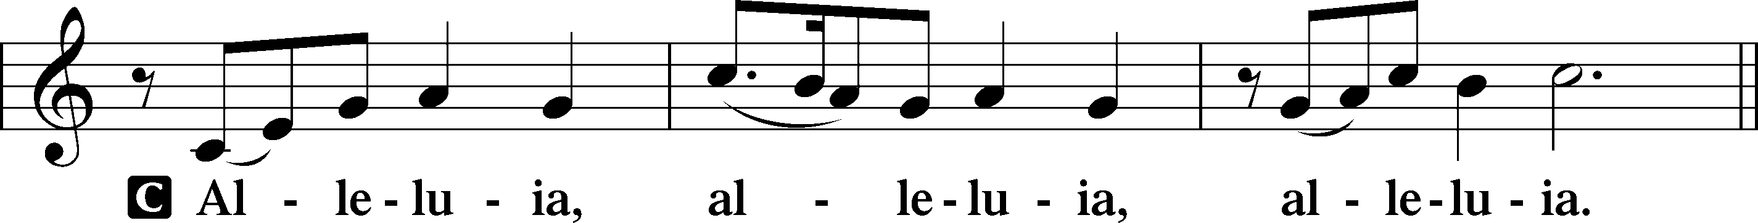
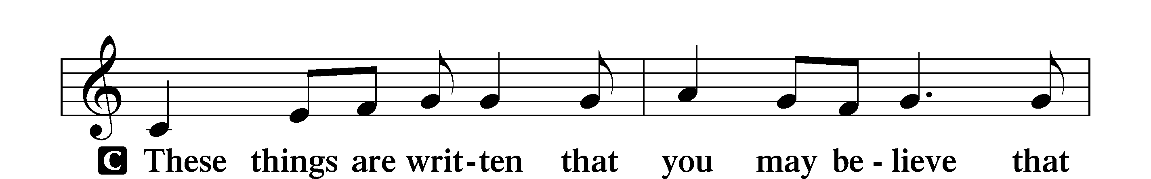
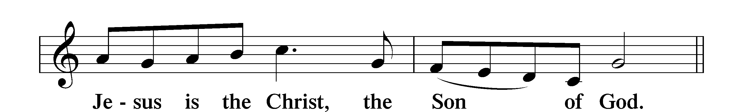
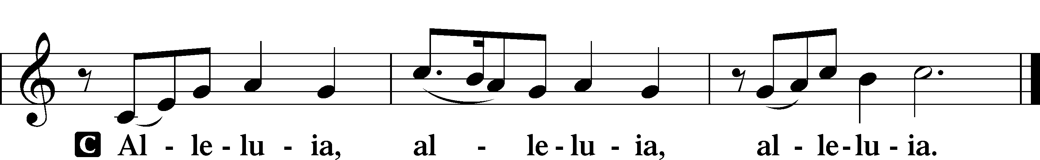

Holy Gospel Luke 13:22–30
P The Holy Gospel according to St. Luke, the thirteenth chapter.
C Glory to You, O Lord.

22[Jesus] went on his way through towns and villages, teaching and journeying toward Jerusalem. 23And someone said to him, “Lord, will those who are saved be few?” And he said to them, 24“Strive to enter through the narrow door. For many, I tell you, will seek to enter and will not be able. 25When once the master of the house has risen and shut the door, and you begin to stand outside and to knock at the door, saying, ‘Lord, open to us,’ then he will answer you, ‘I do not know where you come from.’ 26Then you will begin to say, ‘We ate and drank in your presence, and you taught in our streets.’ 27But he will say, ‘I tell you, I do not know where you come from. Depart from me, all you workers of evil!’ 28In that place there will be weeping and gnashing of teeth, when you see Abraham and Isaac and Jacob and all the prophets in the kingdom of God but you yourselves cast out. 29And people will come from east and west, and from north and south, and recline at table in the kingdom of God. 30And behold, some are last who will be first, and some are first who will be last.”

P This is the Gospel of the Lord.
C Praise to You, O Christ.

Nicene Creed
C I believe in one God,
the Father Almighty,
maker of heaven and earth
and of all things visible and invisible.
And in one Lord Jesus Christ,
the only-begotten Son of God,
begotten of His Father before all worlds,
God of God, Light of Light,
very God of very God,
begotten, not made,
being of one substance with the Father,
by whom all things were made;

who for us men and for our salvation came down from heaven
and was incarnate by the Holy Spirit of the virgin Mary
and was made man;
and was crucified also for us under Pontius Pilate.
He suffered and was buried.

And the third day He rose again according to the Scriptures
and ascended into heaven
and sits at the right hand of the Father.
And He will come again with glory to judge both the living and the dead,
whose kingdom will have no end.

And I believe in the Holy Spirit,
the Lord and giver of life,
who proceeds from the Father and the Son,
who with the Father and the Son together is worshiped and glorified,
who spoke by the prophets.
And I believe in one holy Christian and apostolic Church,
I acknowledge one Baptism for the remission of sins,
and I look for the resurrection of the dead
and the life T of the world to come.

Amen.

Sit

526 You Are the Way; through You Alone

Sermon

Offering. We generously give our offerings to the LORD out of thanksgiving for His generosity of forgiveness, life, and salvation in Christ (2 Corinthians 9:8). We believe that our offerings are not only to support the proclamation of the Gospel here and around the world, but also to help us all grow in faith and trust in Him (2 Corinthians 9:7). We have placed an offering plate in the narthex so you are able to freely give back to Him as you are able. To Him be all the glory!

Stand

Prayer of the Church

Holy Communion is celebrated in the belief and glad confidence that our Lord gives us not only bread and wine, but the body and blood of Christ from the cross, for us Christian to eat and drink for the forgiveness of sins (Matthew 26:28). Because we are called to examine ourselves before receiving the Lord’s Supper (I Corinthians 11:28-29), we encourage you to consider the questions on pages 329-330 in the hymnal. We also believe that when we commune, we are confessing our unity with the community we join (I Corinthians 10:17). If you desire to commune with us for the first time or have questions, our pastor is happy to speak with you.

Preface
P The Lord be with you.
C And also with you.

P Lift up your hearts.
C We lift them to the Lord.

P Let us give thanks to the Lord our God.
C It is right to give Him thanks and praise.

P It is truly good, right, and salutary that we should at all times and in all places give thanks to You, O Lord, holy Father, almighty and everlasting God, for the countless blessings You so freely bestow on us and all creation. Above all, we give thanks for Your boundless love shown to us when You sent Your only-begotten Son, Jesus Christ, into our flesh and laid on Him our sin, giving Him into death that we might not die eternally. Because He is now risen from the dead and lives and reigns to all eternity, all who believe in Him will overcome sin and death and will rise again to new life. Therefore with angels and archangels and with all the company of heaven we laud and magnify Your glorious name, evermore praising You and saying:

Sanctus
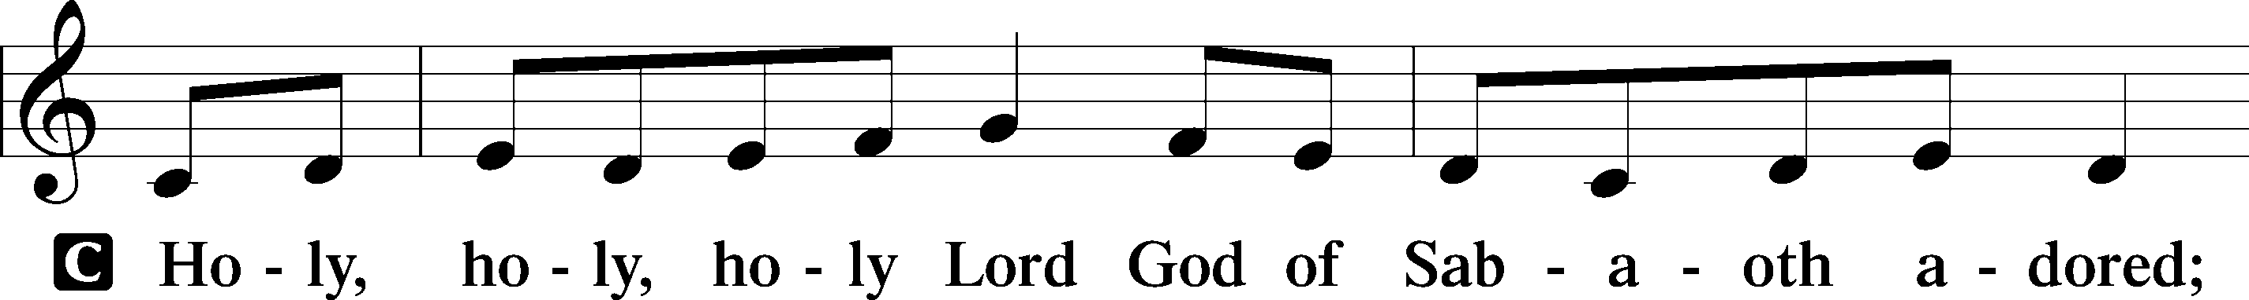
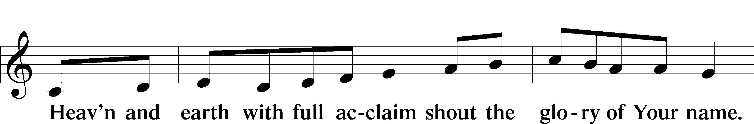
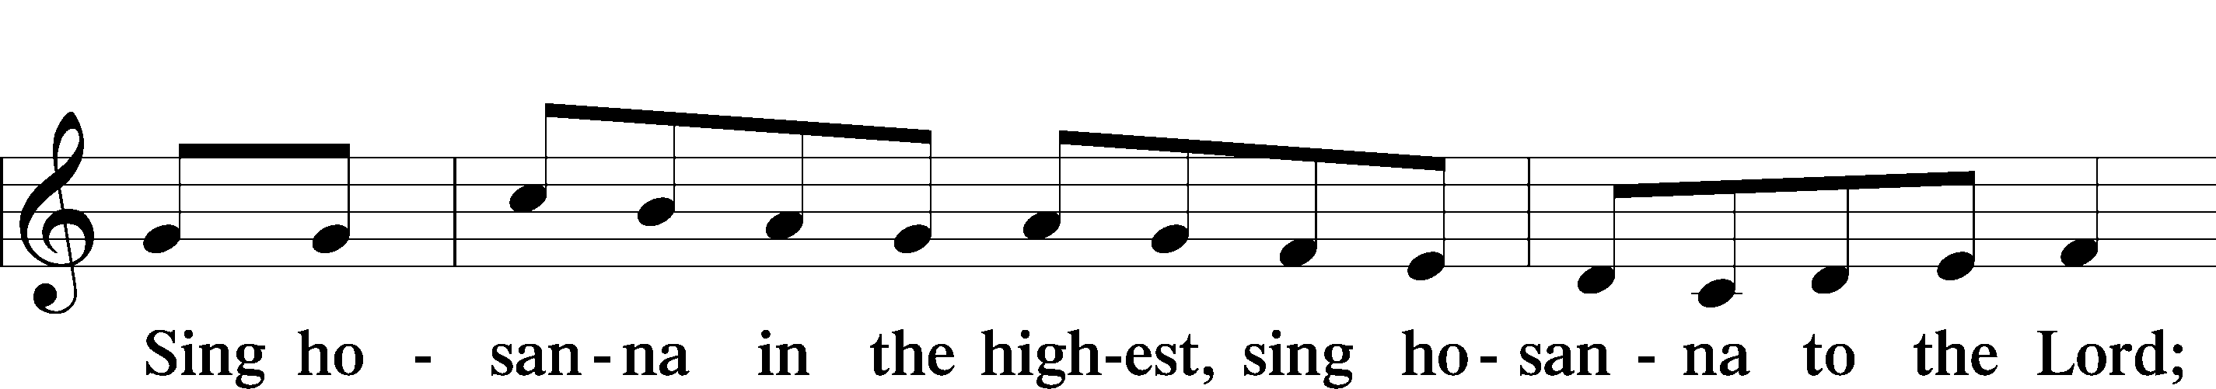
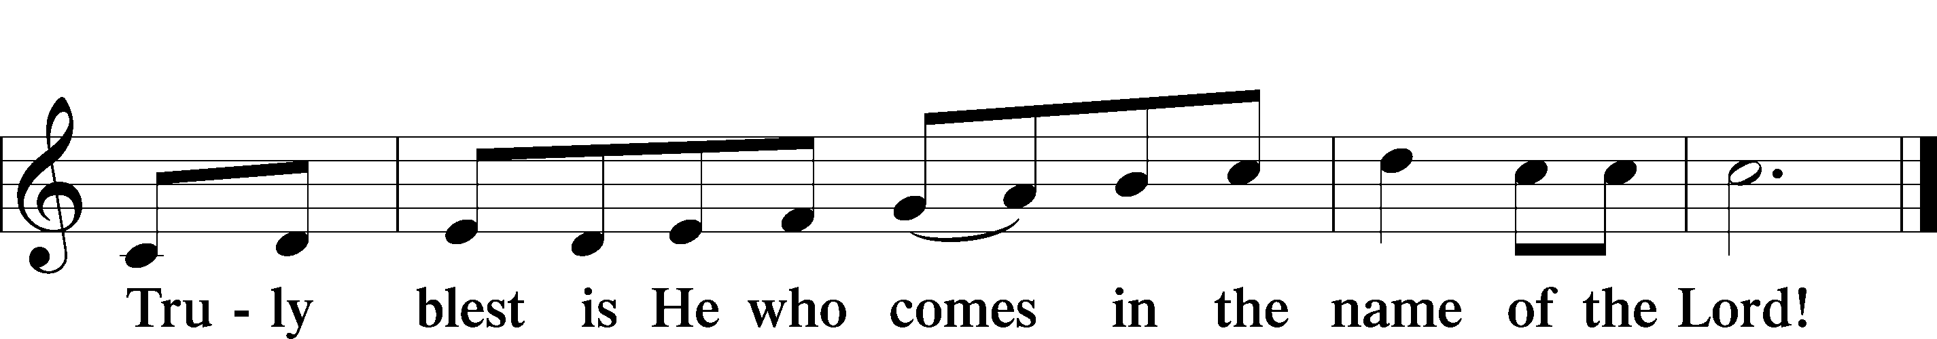
Prayer of Thanksgiving
P Blessed are You, O Lord our God, king of all creation, for You have had mercy on us and given Your only-begotten Son that whoever believes in Him should not perish but have eternal life.

In Your righteous judgment You condemned the sin of Adam and Eve, who ate the forbidden fruit, and You justly barred them and all their children from the tree of life. Yet, in Your great mercy, You promised salvation by a second Adam, Your Son, Jesus Christ, our Lord, and made His cross a life-giving tree for all who trust in Him.

We give You thanks for the redemption You have prepared for us through Jesus Christ. Grant us Your Holy Spirit that we may faithfully eat and drink of the fruits of His cross and receive the blessings of forgiveness, life, and salvation that come to us in His body and blood.

Hear us as we pray in His name and as He has taught us:

Lord’s Prayer

The Words of Our Lord

Pax Domini
P The peace of the Lord be with you always.
C Amen.

Agnus Dei
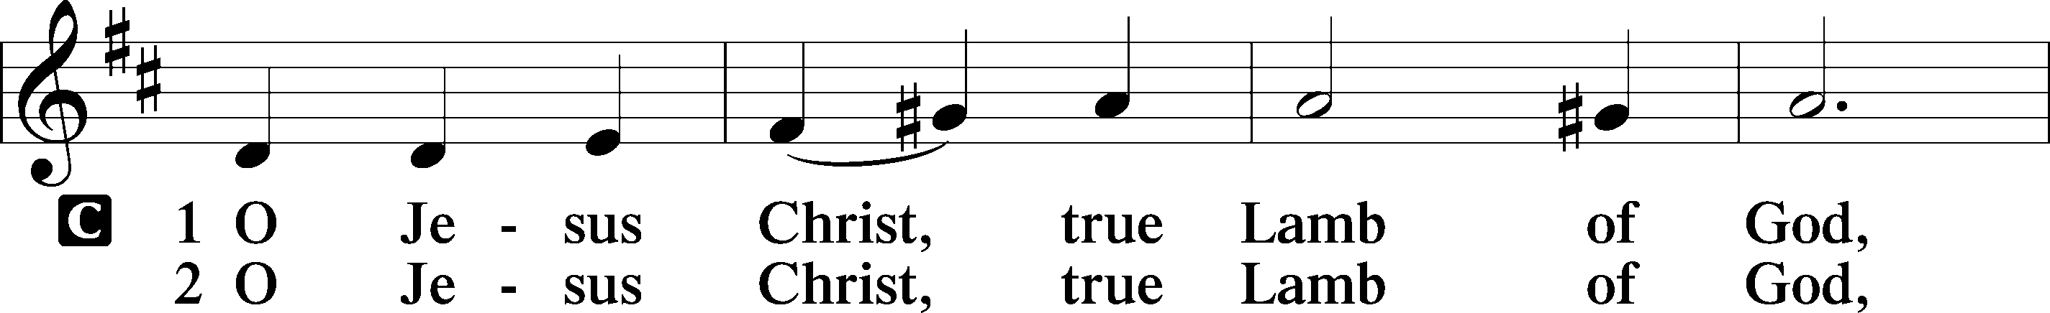
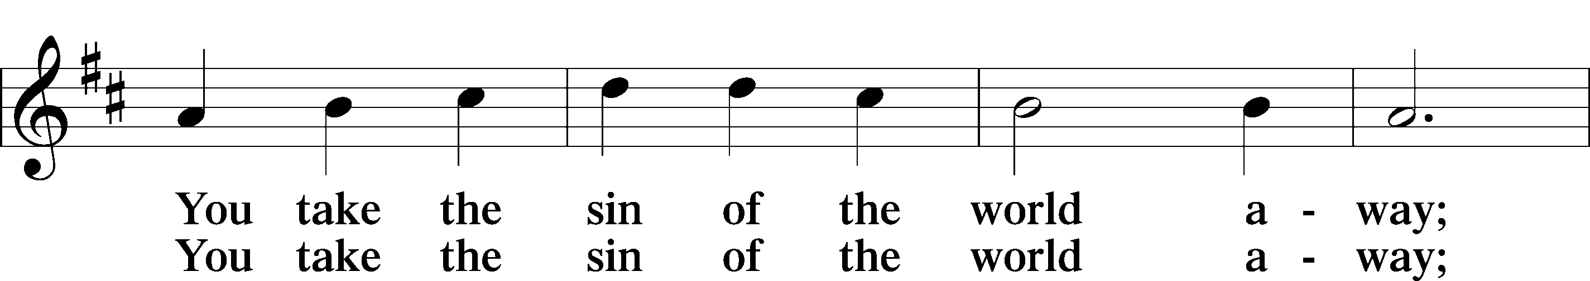
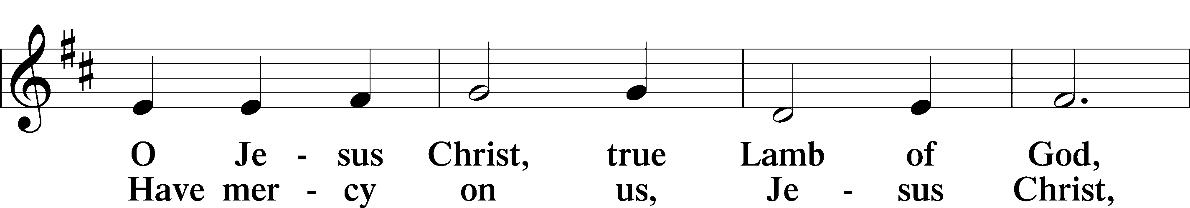
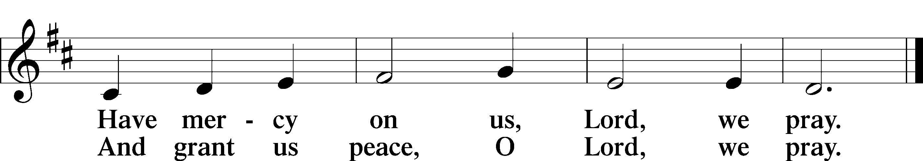
Sit

Distribution

620 Jesus Comes Today with Healing

637 Draw Near and Take the Body of the Lord

Stand

Nunc Dimittis
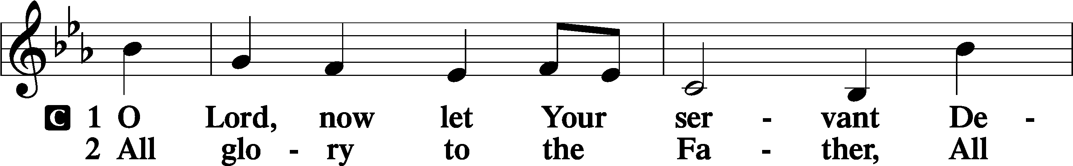
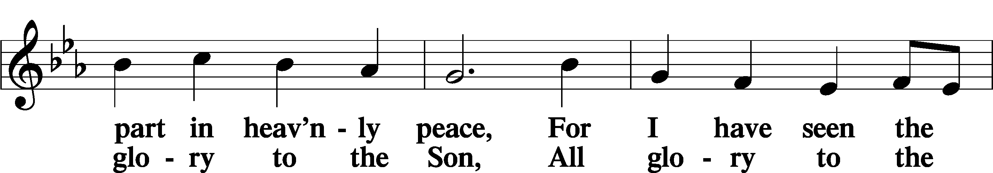
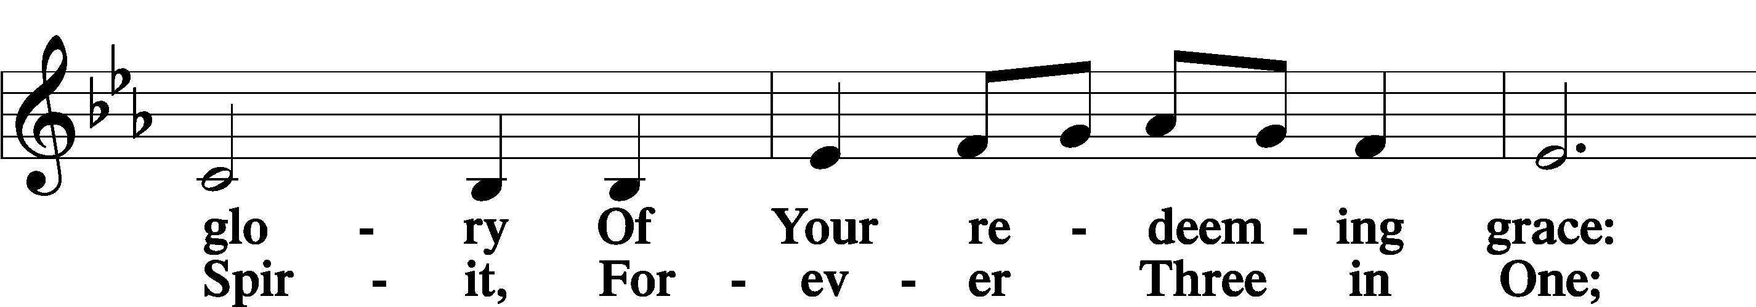
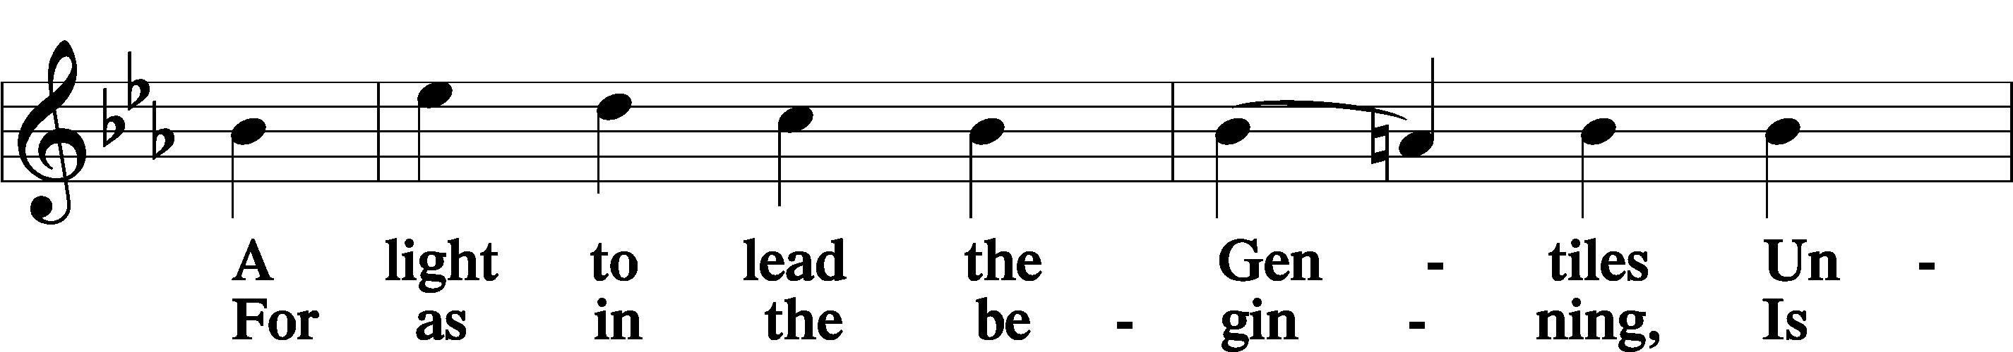
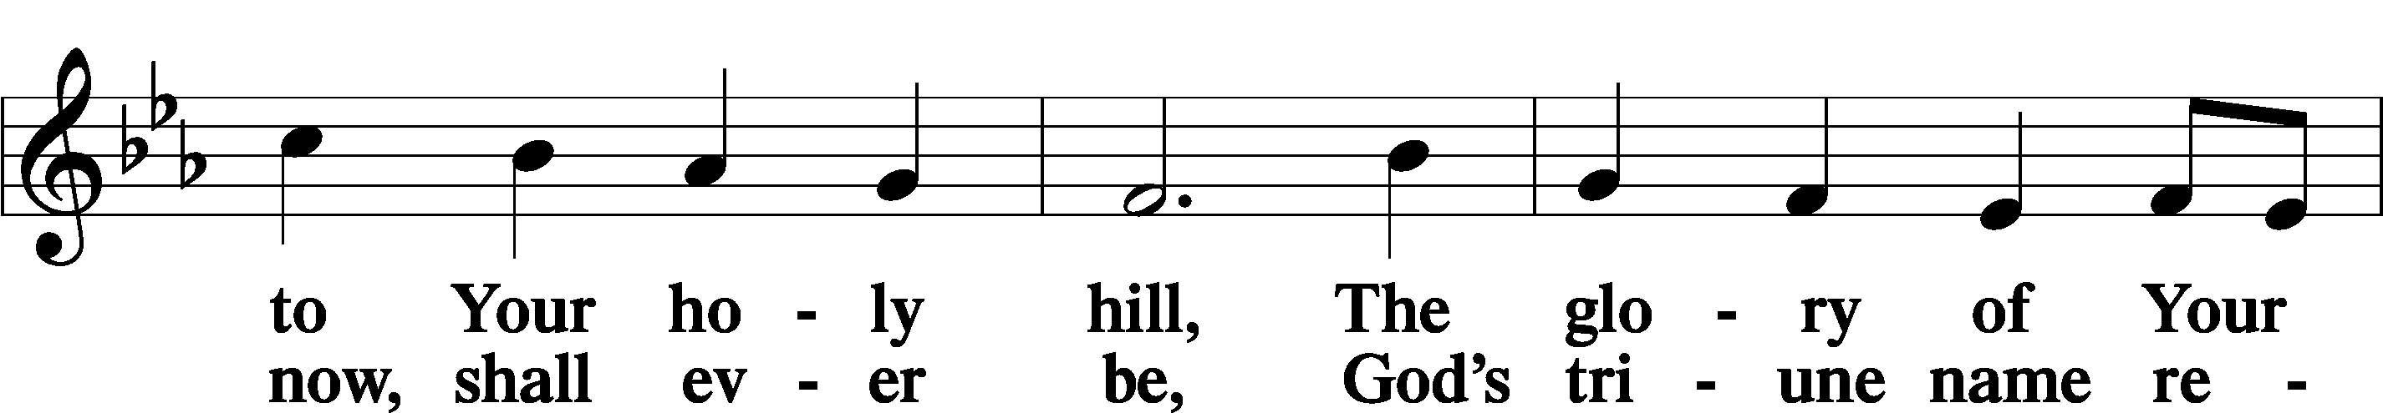
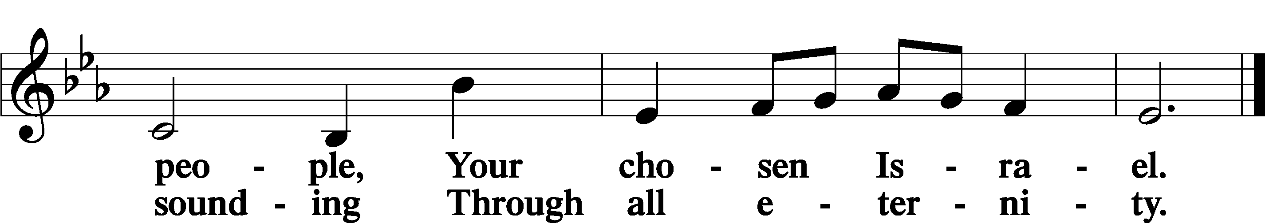

Post-Communion Collect
A Let us pray. We give thanks to You, almighty God, that You have refreshed us through this salutary gift, and we implore You that of Your mercy You would strengthen us through the same in faith toward You and in fervent love toward one another; through Jesus Christ, Your Son, our Lord, who lives and reigns with You and the Holy Spirit, one God, now and forever.
C Amen.

Benedicamus
A Let us bless the Lord.
C Thanks be to God.

Benediction
P The Lord bless you and keep you.
The Lord make His face shine on you and be gracious to you.
The Lord look upon you with favor and T give you peace.

C Amen.

922 Go, My Children, with My Blessing sts. 1–4

Announcement

September 7th is our Fall Fellowship Meal after Bible Study, we will be grilling burgers and hotdogs, we ask that you bring salads, sides, and deserts to share as we celebrate life in Christ together.

