First Sunday in Advent
November 30th, 2025

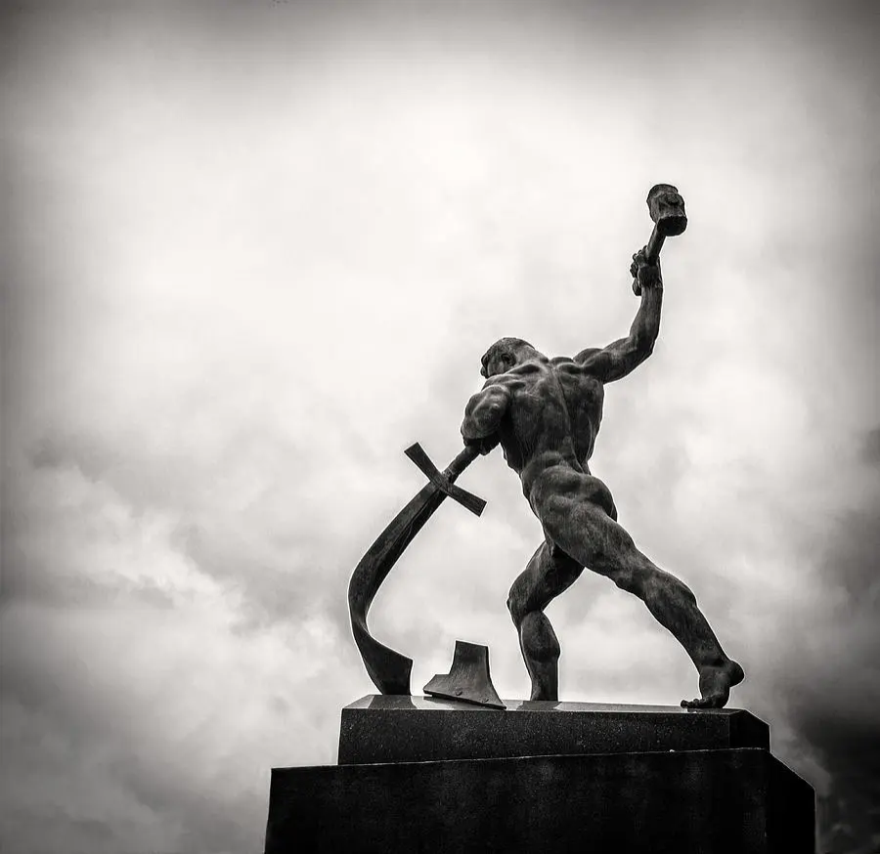
They shall beat their swords into plowshares, and their spears into pruning hooks; nation shall not lift up sword against nation, neither shall they learn war anymore.
-Isaiah 5:4b

Messiah Lutheran Church
Sartell, MN
www.messiahsartell.com
320-252-5883

Prayer Before Entering
Please take this time to focus on our purpose in gathering and join in prayer before our service begins. Blessed Lord, You have caused all Holy Scriptures to be written for our learning. Grant that we may so hear them, read, mark, learn, and inwardly digest them that, by patience and comfort of Your holy Word, we may embrace and ever hold fast the blessed hope of everlasting life; through Jesus Christ, our Lord.

As We Gather
“Look out!” is about all we can yell as something unexpected is about to happen. The person we are warning has to be awake in order to respond. That’s why Jesus tells His disciples, including us, to be awake and watchful for His return. He is our Lord and Master—our King! Advent is a gracious time of preparation for Jesus’ coming, once in history, to us in Word and Sacrament today, and at the end of time. When our Lord returns, it will be to usher in the kingdom of God, which Isaiah says will be so peaceful they will “beat their swords into plowshares.” Before that day, preparing means leading loving lives, Paul tells us, for “salvation is nearer to us now than when we first believed.” Look out! The King comes!

593 See This Wonder in the Making

Celebration of Holy Baptism
Stand

The sign of the cross may be made by all in remembrance of their Baptism.

P In the name of the Father and of the T Son and of the Holy Spirit.
C Amen.

Dear friends, Christ our Lord says in the last chapter of Matthew, “All authority in heaven and on earth has been given to Me. Therefore, go and make disciples of all nations, baptizing them in the name of the Father and of the Son and of the Holy Spirit.” In the last chapter of Mark our Lord promises, “Whoever believes and is baptized will be saved.” And the apostle Peter has written, “Baptism now saves you.”

The Word of God also teaches that we are all, just like Mara Anne, conceived and born sinful and are under the power of the devil until Christ claims us as His own. We would be lost forever unless delivered from sin, death, and everlasting condemnation. But the Father of all mercy and grace has sent His Son Jesus Christ, who atoned for the sin of the whole world, that whoever believes in Him should not perish but have eternal life.

The Signing
(The pastor makes the sign of the holy cross upon the forehead and heart of the child while saying)
Mara Anne, receive the sign of the holy cross both upon your forehead and upon your heart to mark you as one redeemed by Christ the crucified.

To the Congregation
All of us gathered here as family members share responsibility for the spiritual well-being of this child of God, since we represent for her the Body of Christ in this place. I therefore ask all of you, family members in Christ: Do you promise to prayerfully remember Mara Anne and encourage her in the faith and participation in His church throughout the entirety of her life? We will with the help of God.

Renunciation and Confession of Faith
Let us all together confess the Christian faith into which we are baptized and give witness of the faith she will now enter.

Therefore, I ask you, do you renounce the devil and all his works and all his ways? I do renounce them!

Let us confess together the faith of the whole Christian church.
C I believe in God, the Father Almighty,
maker of heaven and earth.
And in Jesus Christ, His only Son, our Lord,
who was conceived by the Holy Spirit,
born of the virgin Mary,
suffered under Pontius Pilate,
was crucified, died and was buried.
He descended into hell.
The third day He rose again from the dead.
He ascended into heaven
and sits at the right hand of God the Father Almighty.
From thence He will come to judge the living and the dead.
I believe in the Holy Spirit,
the holy Christian Church,
the communion of saints,
the forgiveness of sins,
the resurrection of the body,
and the life T everlasting. Amen.

Sit

The Baptism
Mara Anne, I baptize you in the name of the Father and of the Son (+) and of the Holy Spirit. Amen.

The Blessing
Almighty God, the Father of our Lord Jesus Christ, who has given you the new birth of water and the Spirit and has forgiven all your sin, strengthen you with His grace to life everlasting. Peace be with you. Amen.

The Presentation of White Garment
Receive this white garment to show that you have been clothed with the robe of Christ’s righteousness that covers all your sin. So shall you stand without fear before the judgment seat of Christ to receive the inheritance prepared for you from the foundation of the world.

Presentation of the Candle
Receive this burning light to show that you have received Christ who is the Light of the world. Live always in the light of Christ, and be ever watchful for His coming, that you may meet Him with joy and enter with Him into the marriage feast of the Lamb in His kingdom, which shall have no end.

Presentation to the Congregation
Through Baptism, God has added Mara Anne to His own people, to declare the wonderful deeds of our Savior, who has called us out of darkness into His marvelous light.

Mara, we welcome you into the Lord’s family. We receive you as a fellow member of the body of Christ, a child of the same heavenly Father, to work with us in His kingdom. Amen.

Prayer

The sign of the cross may be made by all in remembrance of their Baptism.

P In the name of the Father and of the T Son and of the Holy Spirit.
C Amen.

P Our help is in the name of the Lord,
C who made heaven and earth.

P If You, O Lord, kept a record of sins, O Lord, who could stand?
C But with You there is forgiveness; therefore You are feared.
P Since we are gathered to hear God’s Word, call upon Him in prayer and praise, and receive the body and blood of our Lord Jesus Christ in the fellowship of this altar, let us first consider our unworthiness and confess before God and one another that we have sinned in thought, word, and deed, and that we cannot free ourselves from our sinful condition. Together as His people let us take refuge in the infinite mercy of God, our heavenly Father, seeking His grace for the sake of Christ, and saying:
C God, be merciful to me, a sinner.

Silence for reflection on God’s Word and for self-examination.

C Almighty God, have mercy upon us, forgive us our sins, and lead us to everlasting life. Amen.
P Almighty God in His mercy has given His Son to die for you and for His sake forgives you all your sins. As a called and ordained servant of Christ, and by His authority, I therefore forgive you all your sins in the name of the Father and of the T Son and of the Holy Spirit.
C Amen.

Introit Psalm 118:25–28; antiphon: Zechariah 9:9b, alt.
P Behold, your king is coming to you;
righteous and having salvation.
C Save us, we pray, O Lord!
O Lord, we pray, give us success!
P Blessèd is he who comes in the name of the Lord!
We bless you from the house of the Lord.
C The Lord is God, and he has made his light to shine upon us.
Bind the festal sacrifice with cords, up to the horns of the altar!
P You are my God, and I will give thanks to you;
you are my God; I will extol you.
All: Glory be to the Father and to the Son
and to the Holy Spirit;
as it was in the beginning,
is now, and will be forever. Amen.
P Behold, your king is coming to you;
righteous and having salvation.

Kyrie
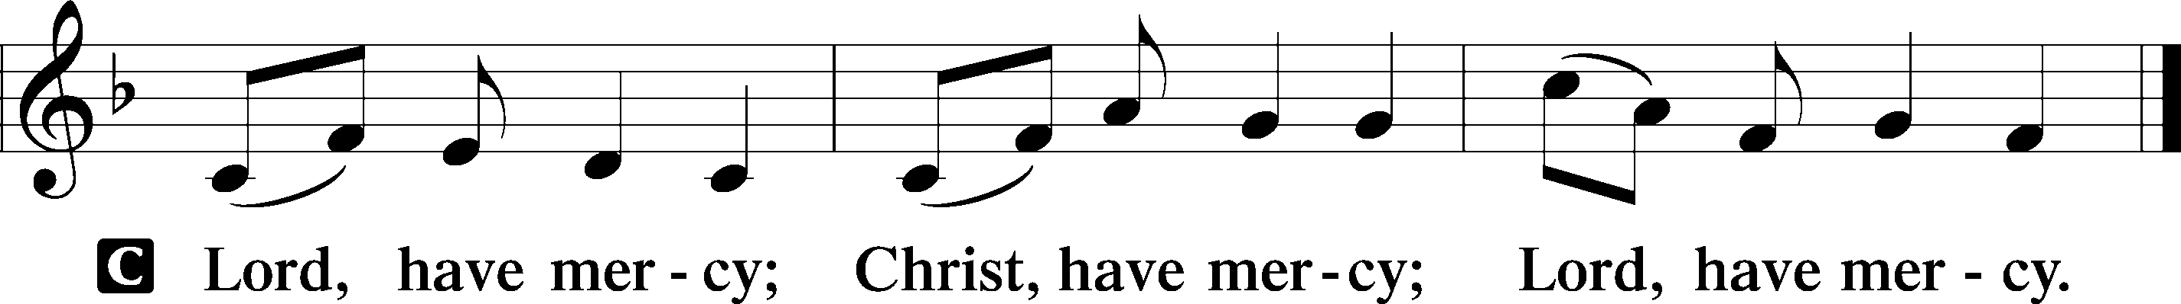
Salutation and Collect of the Day
P The Lord be with you.
C And also with you.

P Let us pray.
Stir up Your power, O Lord, and come, that by Your protection we may be rescued from the threatening perils of our sins and saved by Your mighty deliverance; for You live and reign with the Father and the Holy Spirit, one God, now and forever.

C Amen.

Sit

Old Testament Reading Isaiah 2:1–5
1The word that Isaiah the son of Amoz saw concerning Judah and Jerusalem. 2It shall come to pass in the latter days that the mountain of the house of the Lord shall be established as the highest of the mountains, and shall be lifted up above the hills; and all the nations shall flow to it, 3and many peoples shall come, and say: “Come, let us go up to the mountain of the Lord, to the house of the God of Jacob, that he may teach us his ways and that we may walk in his paths.” For out of Zion shall go the law, and the word of the Lord from Jerusalem. 4He shall judge between the nations, and shall decide disputes for many peoples;
and they shall beat their swords into plowshares, and their spears into pruning hooks; nation shall not lift up sword against nation, neither shall they learn war anymore. 5O house of Jacob, come, let us walk in the light of the Lord.

A This is the Word of the Lord.
C Thanks be to God.

Epistle Romans 13:8–14
8Owe no one anything, except to love each other, for the one who loves another has fulfilled the law. 9The commandments, “You shall not commit adultery, You shall not murder, You shall not steal, You shall not covet,” and any other commandment, are summed up in this word: “You shall love your neighbor as yourself.” 10Love does no wrong to a neighbor; therefore love is the fulfilling of the law.
11Besides this you know the time, that the hour has come for you to wake from sleep. For salvation is nearer to us now than when we first believed. 12The night is far gone; the day is at hand. So then let us cast off the works of darkness and put on the armor of light. 13Let us walk properly as in the daytime, not in orgies and drunkenness, not in sexual immorality and sensuality, not in quarreling and jealousy. 14But put on the Lord Jesus Christ, and make no provision for the flesh, to gratify its desires.

A This is the Word of the Lord.
C Thanks be to God.

Stand

Alleluia and Verse
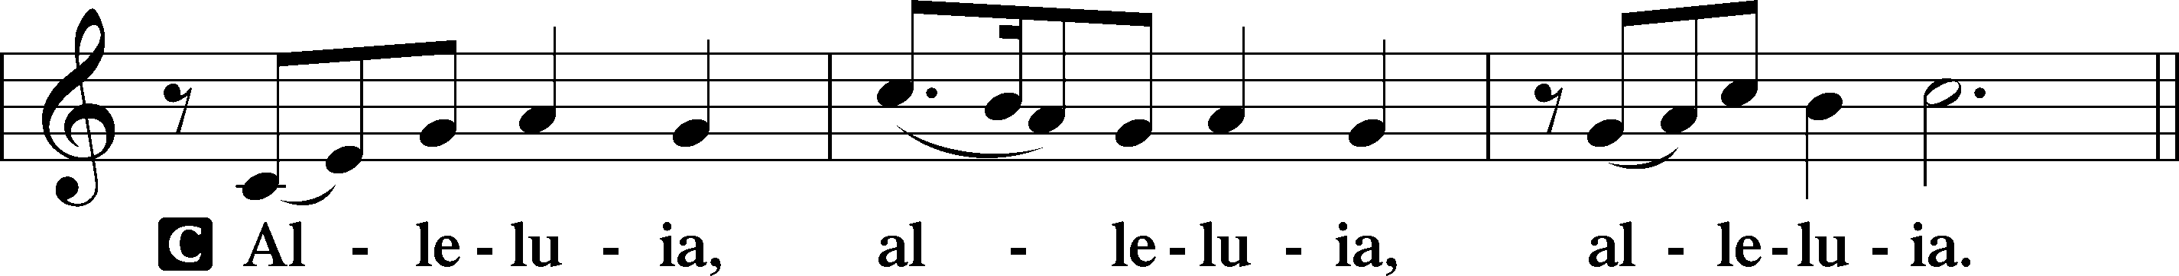
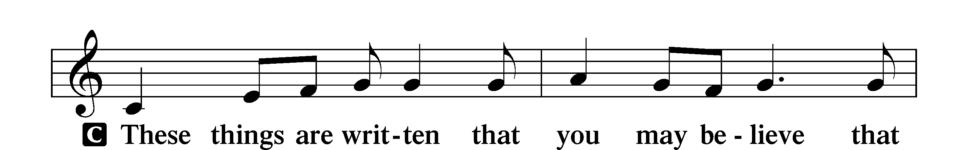
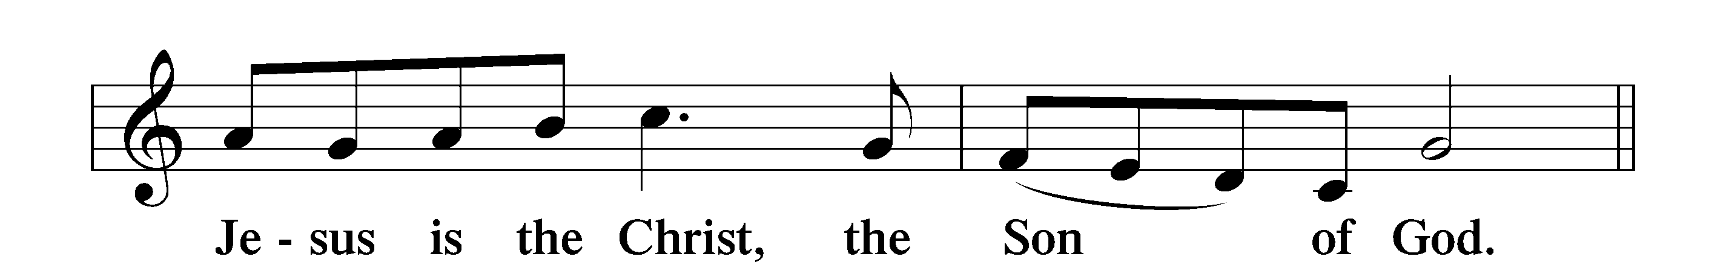
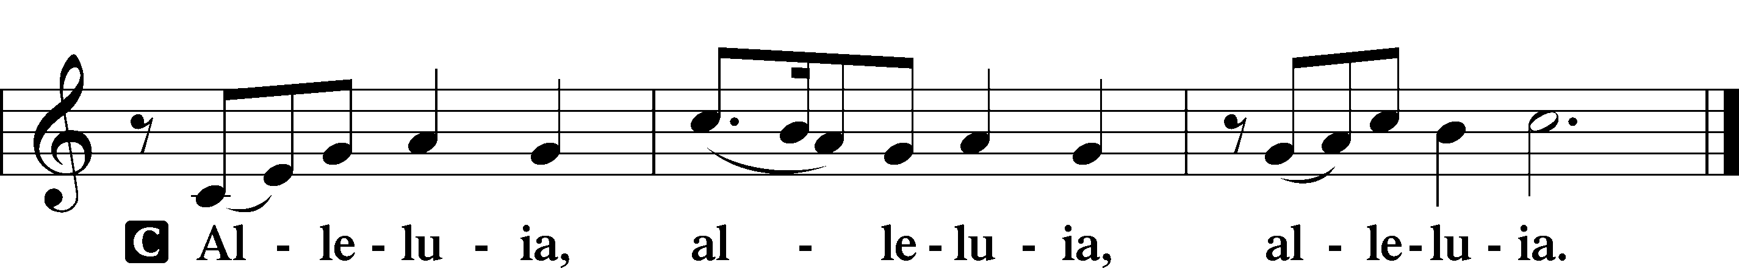

Holy Gospel Matthew 24:36–44
P The Holy Gospel according to St. Matthew, the twenty-fourth chapter.
C Glory to You, O Lord.

36[Jesus said:] “But concerning that day and hour no one knows, not even the angels of heaven, nor the Son, but the Father only. 37As were the days of Noah, so will be the coming of the Son of Man. 38For as in those days before the flood they were eating and drinking, marrying and giving in marriage, until the day when Noah entered the ark, 39and they were unaware until the flood came and swept them all away, so will be the coming of the Son of Man. 40Then two men will be in the field; one will be taken and one left. 41Two women will be grinding at the mill; one will be taken and one left. 42Therefore, stay awake, for you do not know on what day your Lord is coming. 43But know this, that if the master of the house had known in what part of the night the thief was coming, he would have stayed awake and would not have let his house be broken into. 44Therefore you also must be ready, for the Son of Man is coming at an hour you do not expect.
P This is the Gospel of the Lord.
C Praise to You, O Christ.

Sit

343 Prepare the Royal Highway

Sermon

Offering. We generously give our offerings to the LORD out of thanksgiving for His generosity of forgiveness, life, and salvation in Christ (2 Corinthians 9:8). We believe that our offerings are not only to support the proclamation of the Gospel here and around the world, but also to help us all grow in faith and trust in Him (2 Corinthians 9:7). We have placed an offering plate in the narthex so you are able to freely give back to Him as you are able. To Him be all the glory!

Stand

Prayer of the Church

Holy Communion is celebrated in the belief and glad confidence that our Lord gives us not only bread and wine, but the body and blood of Christ from the cross, for us Christian to eat and drink for the forgiveness of sins (Matthew 26:28). Because we are called to examine ourselves before receiving the Lord’s Supper (I Corinthians 11:28-29), we encourage you to consider the questions on pages 329-330 in the hymnal. We also believe that when we commune, we are confessing our unity with the community we join (I Corinthians 10:17). If you desire to commune with us for the first time or have questions, our pastor is happy to speak with you.

Preface
P The Lord be with you.
C And also with you.

P Lift up your hearts.
C We lift them to the Lord.

P Let us give thanks to the Lord our God.
C It is right to give Him thanks and praise.

P It is truly good, right, and salutary that we should at all times and in all places give thanks to You, O Lord, holy Father, almighty and everlasting God, for the countless blessings You so freely bestow on us and all creation. Above all, we give thanks for Your boundless love shown to us when You sent Your only-begotten Son, Jesus Christ, into our flesh and laid on Him our sin, giving Him into death that we might not die eternally. Because He is now risen from the dead and lives and reigns to all eternity, all who believe in Him will overcome sin and death and will rise again to new life. Therefore with angels and archangels and with all the company of heaven we laud and magnify Your glorious name, evermore praising You and saying:

Sanctus
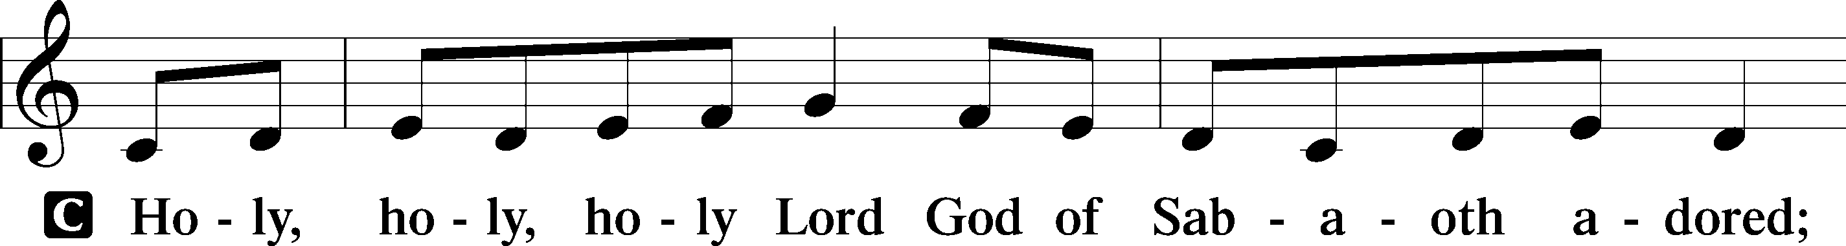
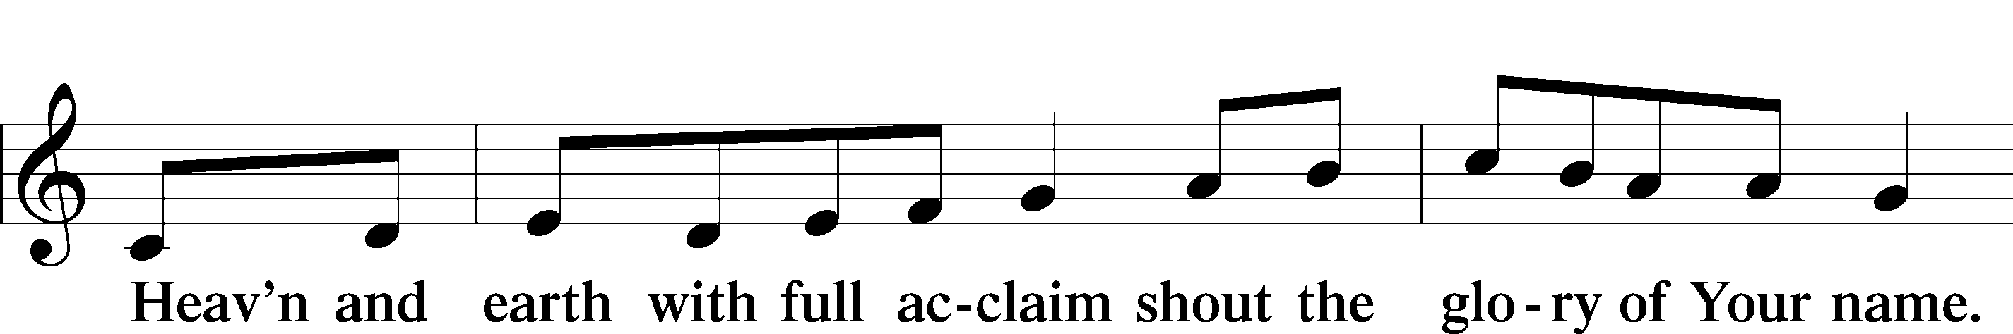
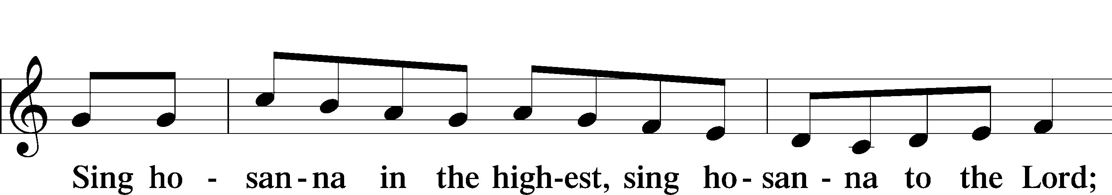
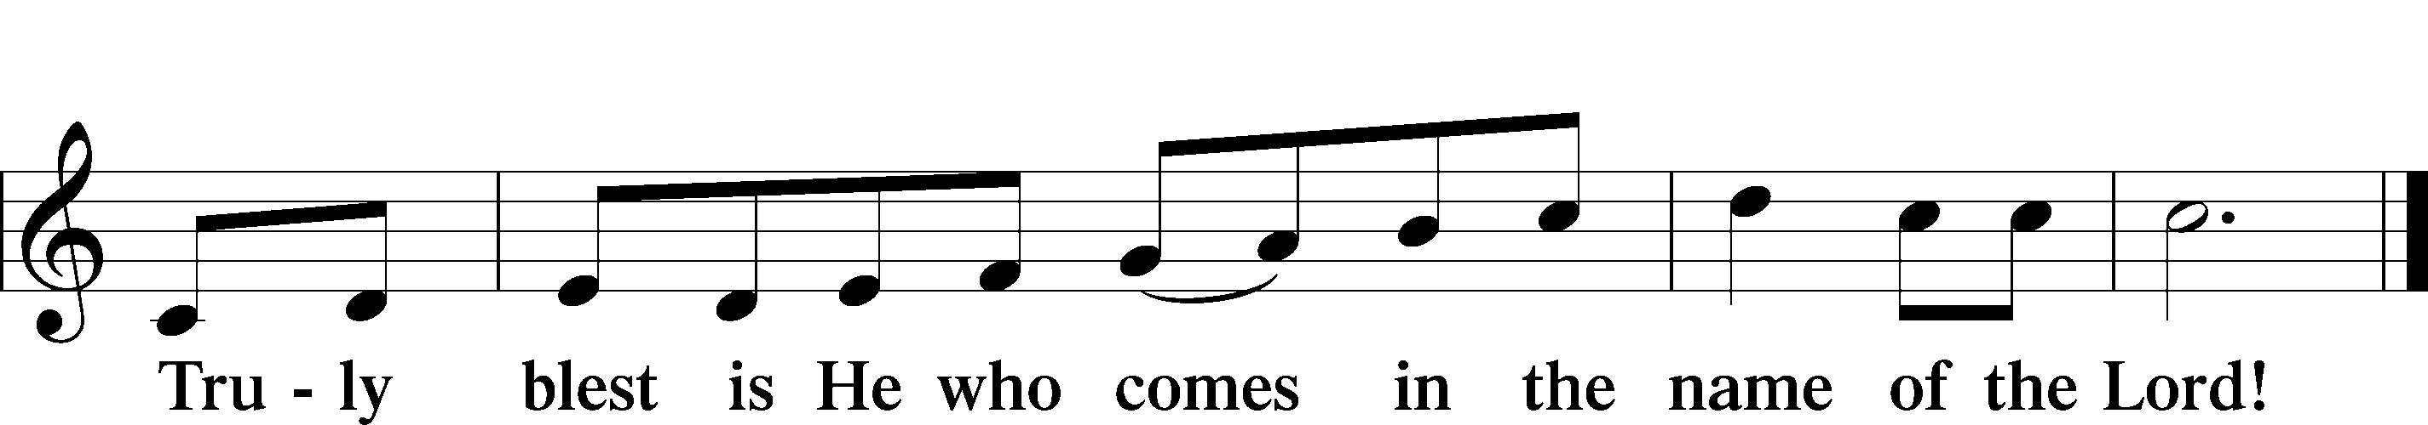

Prayer of Thanksgiving
P Blessed are You, O Lord our God, king of all creation, for You have had mercy on us and given Your only-begotten Son that whoever believes in Him should not perish but have eternal life.

In Your boundless mercy You sent Your servant, John the Baptist, to proclaim that in Christ the kingdom of heaven draws near.

With thankful hearts we pray, “Come, Lord Jesus,” confident that in His body and blood, given us to eat and drink, we receive the forgiveness of sins and so proclaim His death until He comes again in glory.

Hear us as we pray in His name and as He has taught us:

Lord’s Prayer

The Words of Our Lord

Pax Domini
P The peace of the Lord be with you always.
C Amen.

Agnus Dei
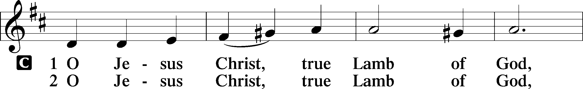
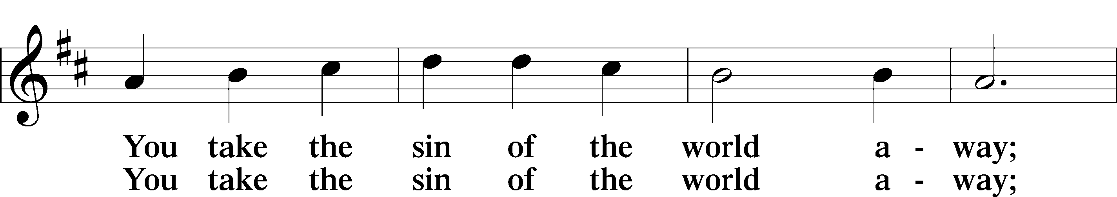
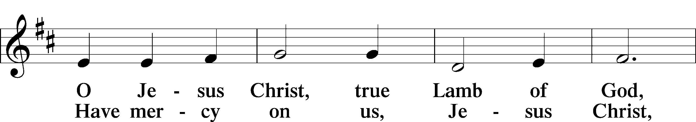
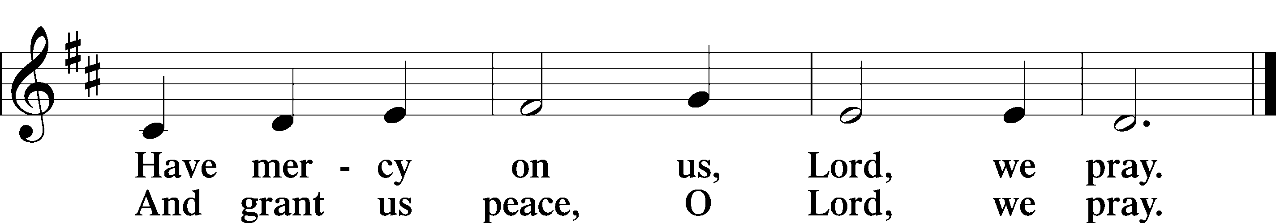

Sit

Distribution

Choir: Neath Vine and Fig Tree

617 O Lord, We Praise Thee

Stand

Nunc Dimittis
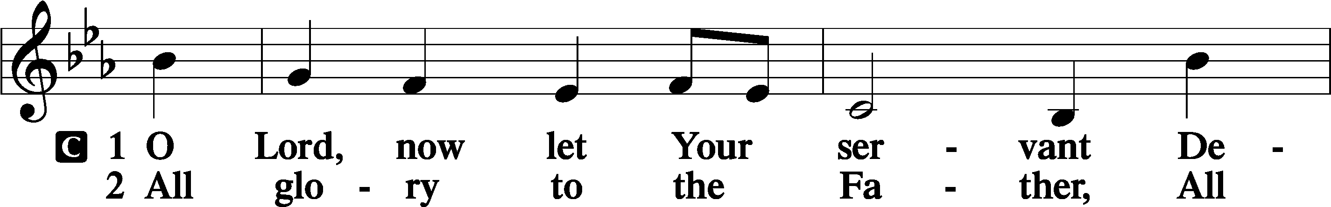
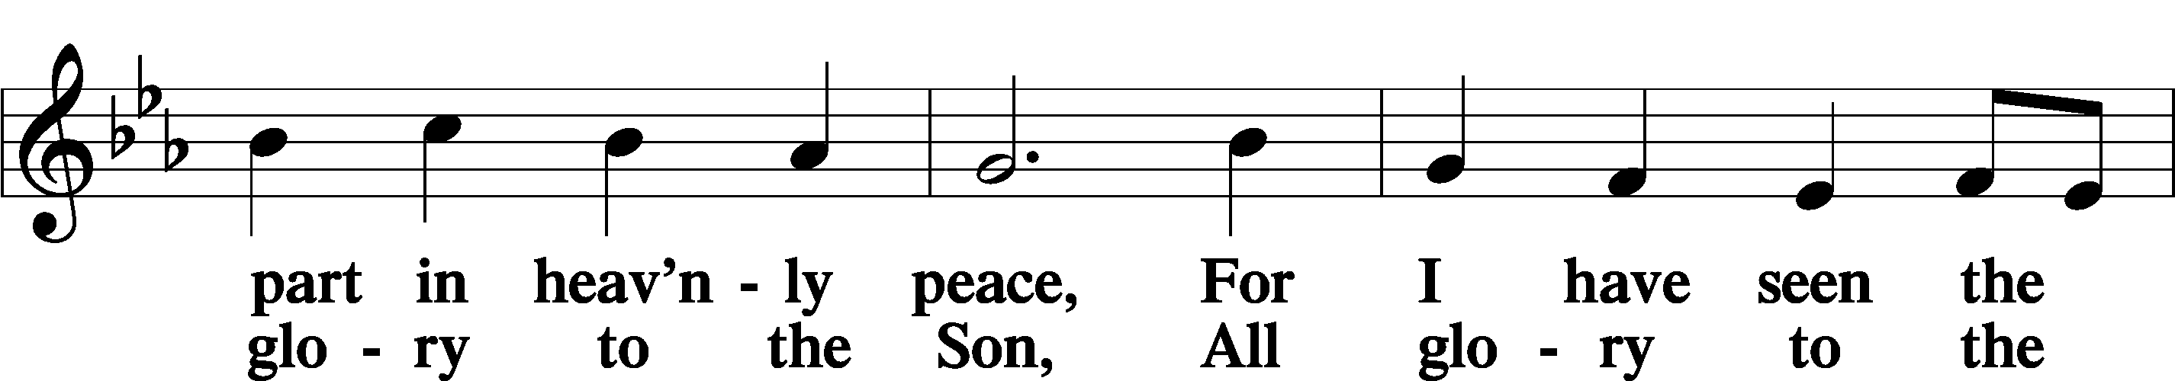
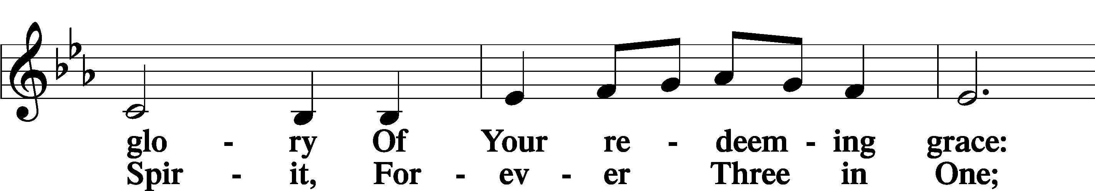
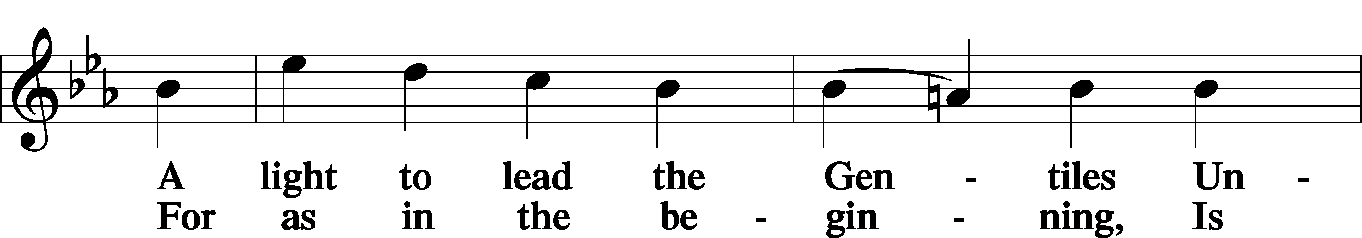
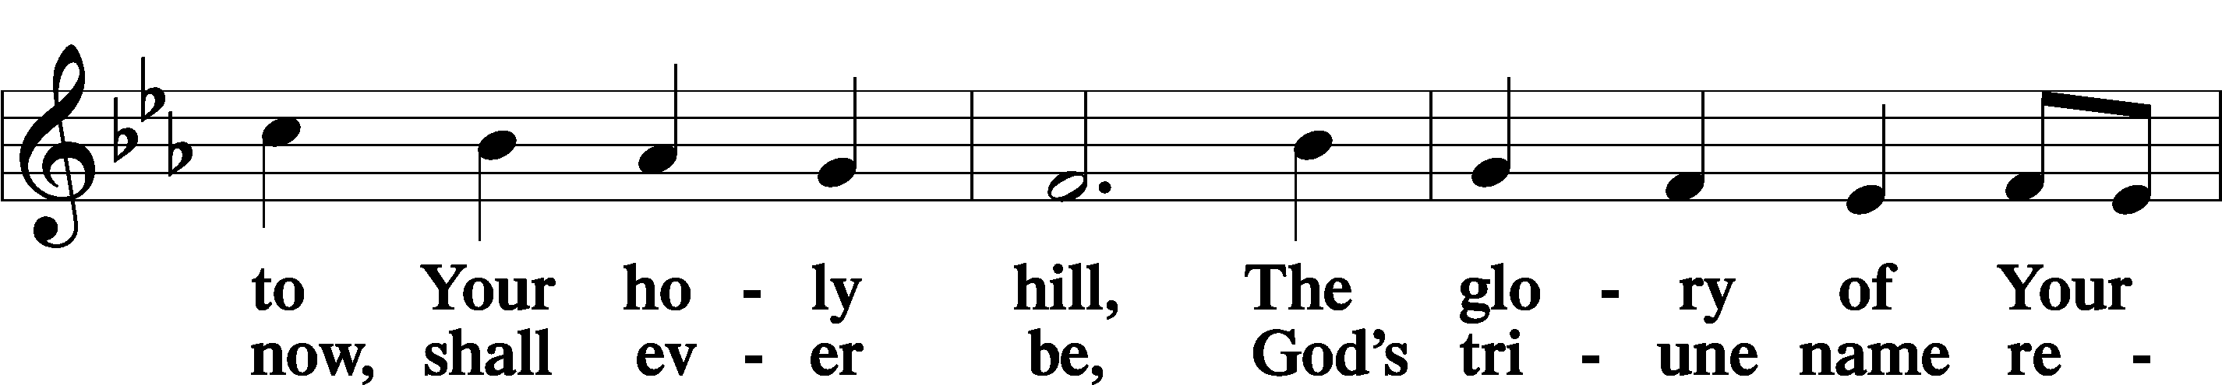
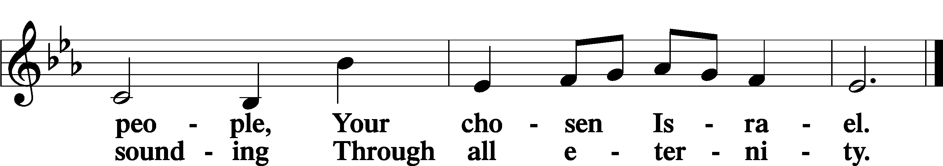

Post-Communion Collect
A Let us pray. We give thanks to You, almighty God, that You have refreshed us through this salutary gift, and we implore You that of Your mercy You would strengthen us through the same in faith toward You and in fervent love toward one another; through Jesus Christ, Your Son, our Lord, who lives and reigns with You and the Holy Spirit, one God, now and forever.
C Amen.

Benedicamus
A Let us bless the Lord.
C Thanks be to God.

Benediction
P The Lord bless you and keep you.
The Lord make His face shine on you and be gracious to you.
The Lord look upon you with favor and T give you peace.

C Amen.

353 Jesus Came, the Heavens Adoring

Announcements:

Street Assessments: The exact amount of the assessment is $38,382.96.
To date, we have raised $36,985.61. Only $1,397.35 to go! Thanks be to God!
Any additional funds that come in over the amount needed will be applied
towards the principal owed on the mortgage.

Mid-week Advent Services will be Wednesdays, Dec. 3, 10 & 17
Advent Supper: 4:45 p.m.
Worship Time: 6 p.m.
There is a sign-up in the narthex to serve and provide food for the suppers.
Dec. 3 will be covered by the Garman family.
Free-will offering. Funds raised will go to our Families in Need.

