Second Sunday of Easter
April 12th, 2026

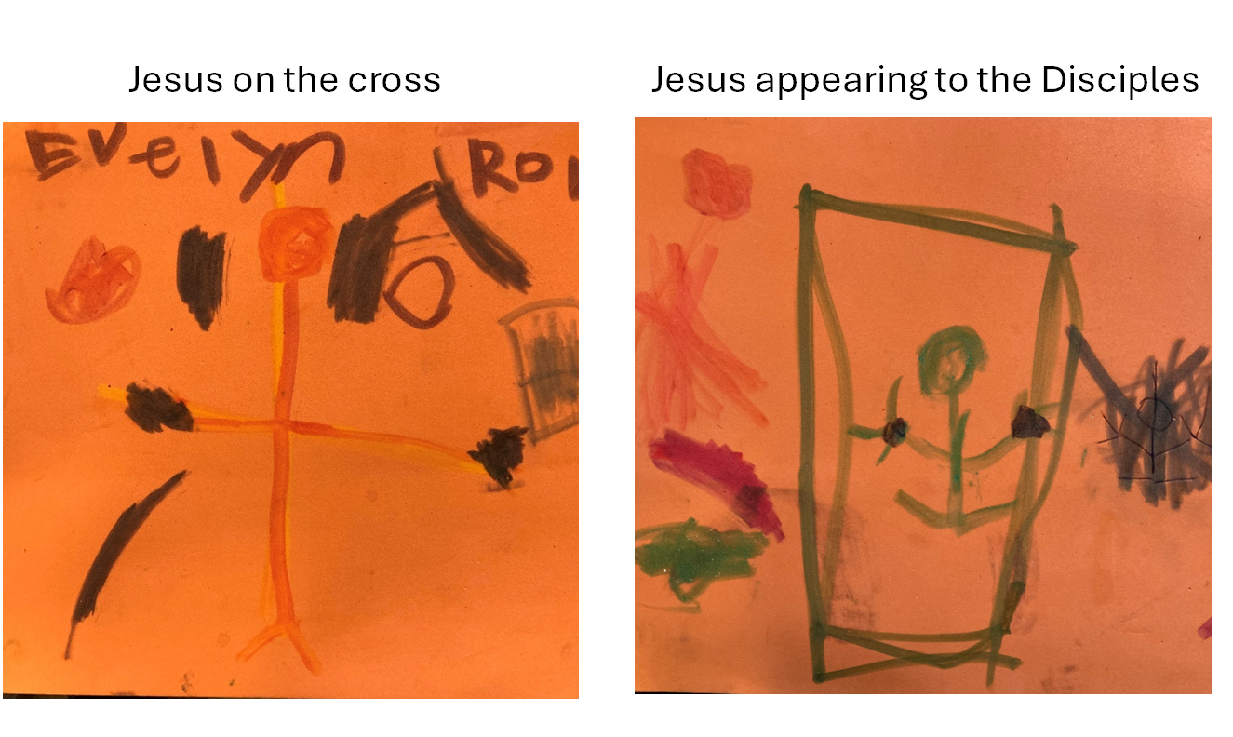

Messiah Lutheran Church
Sartell, MN
www.messiahsartell.com
320-252-5883
Prayer Before Entering
Please take this time to focus on our purpose in gathering and join in prayer before our service begins. Blessed Lord, You have caused all Holy Scriptures to be written for our learning. Grant that we may so hear them, read, mark, learn, and inwardly digest them that, by patience and comfort of Your holy Word, we may embrace and ever hold fast the blessed hope of everlasting life; through Jesus Christ, our Lord.

As We Gather
Sometimes the simplest of words carry the greatest of importance. As Jesus speaks with the doubting disciple Thomas gathered in a special room with the disciples a few days after the resurrection, He says simply, “See.” But that is all He needs to say. It confirms the powerful truth that He is indeed arisen from the dead. Today we are faithful people gathered in a different room—but also with those who are disciples of the Lord. And He has promised to be with us and among us in the upper room. As we worship, we will see signs of His abiding presence.

472 These Things Did Thomas Count as Real

Stand

The sign of the cross may be made by all in remembrance of their Baptism.

P In the name of the Father and of the T Son and of the Holy Spirit.
C Amen.

P Our help is in the name of the Lord,
C who made heaven and earth.

P If You, O Lord, kept a record of sins, O Lord, who could stand?
C But with You there is forgiveness; therefore You are feared.

P Since we are gathered to hear God’s Word, call upon Him in prayer and praise, and receive the body and blood of our Lord Jesus Christ in the fellowship of this altar, let us first consider our unworthiness and confess before God and one another that we have sinned in thought, word, and deed, and that we cannot free ourselves from our sinful condition. Together as His people let us take refuge in the infinite mercy of God, our heavenly Father, seeking His grace for the sake of Christ, and saying:
C God, be merciful to me, a sinner.
Silence for reflection on God’s Word and for self-examination.

C Almighty God, have mercy upon us, forgive us our sins, and lead us to everlasting life. Amen.

P Almighty God in His mercy has given His Son to die for you and for His sake forgives you all your sins. As a called and ordained servant of Christ, and by His authority, I therefore forgive you all your sins in the name of the Father and of the T Son and of the Holy Spirit.

C Amen.

Introit Psalm 105:1–5, 8; antiphon: 1 Peter 2:2–3
P Like newborn infants, long for the pure spiritual milk, that by it you
may grow up to salvation—
if indeed you have tasted that the Lord is good.
C Oh give thanks to the Lord; call upon his name;
make known his deeds among the peoples!
P Sing to him, sing praises to him;
tell of all his wondrous works!
C Glory in his holy name;
let the hearts of those who seek the Lord rejoice!
P Seek the Lord and his strength;
seek his presence continually!
C Remember the wondrous works that he has done,
his miracles, and the judgments he uttered.
P He remembers his covenant forever,
the word that he commanded, for a thousand generations.
All: Glory be to the Father and to the Son
and to the Holy Spirit;
as it was in the beginning,
is now, and will be forever. Amen.
P Like newborn infants, long for the pure spiritual milk, that by it you
may grow up to salvation—
if indeed you have tasted that the Lord is good.
Kyrie
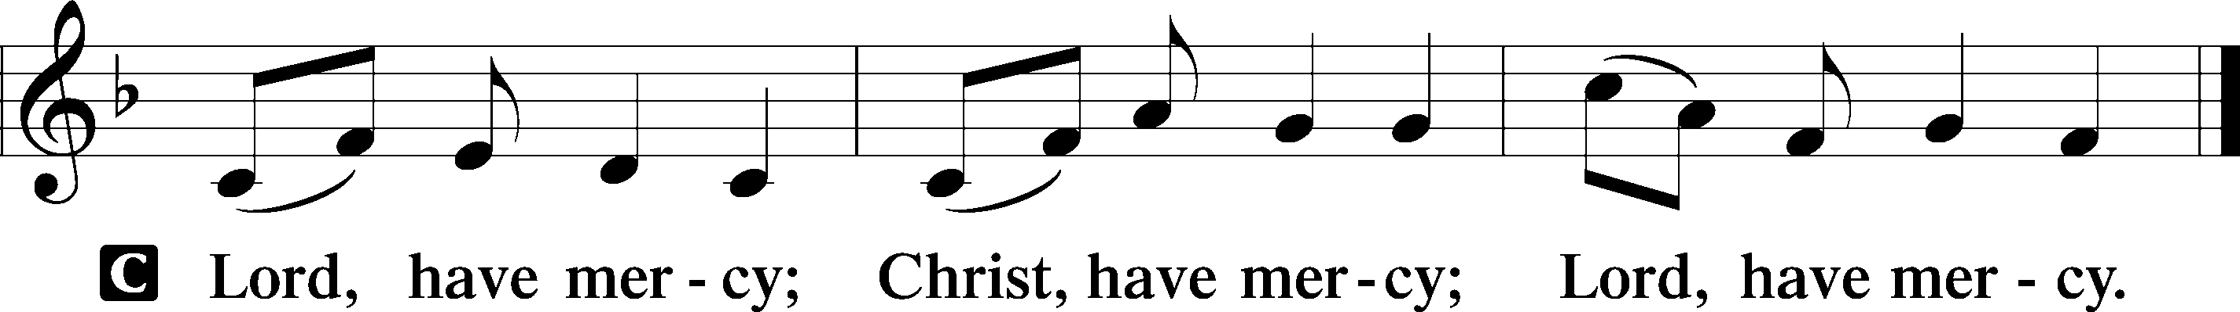

Gloria in Excelsis
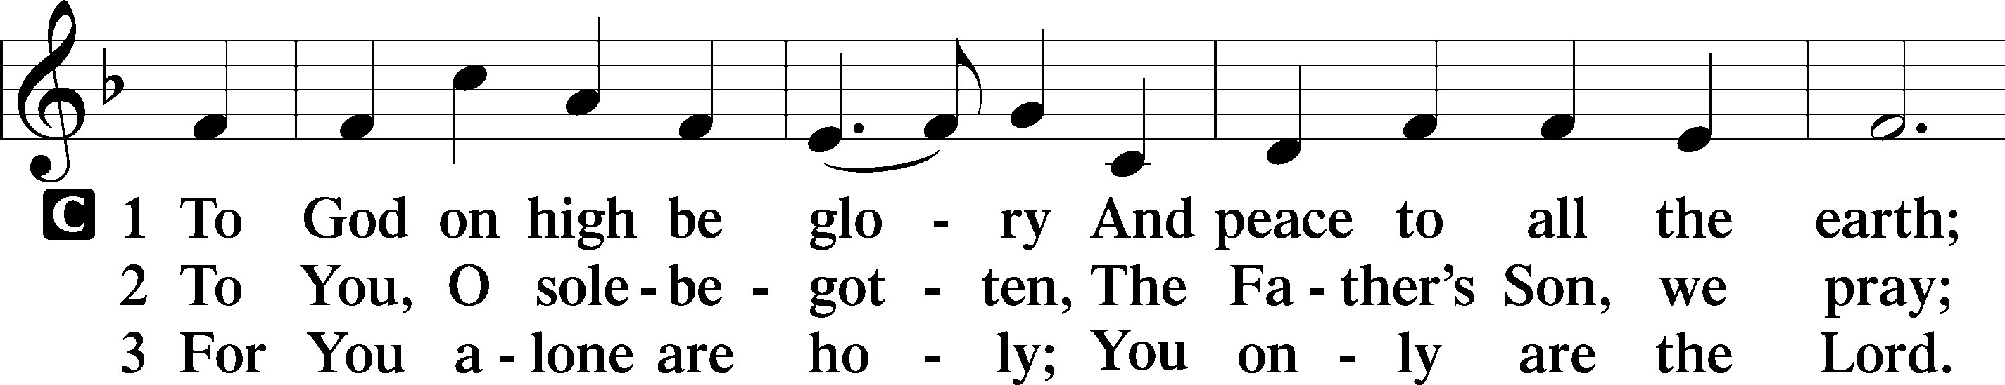
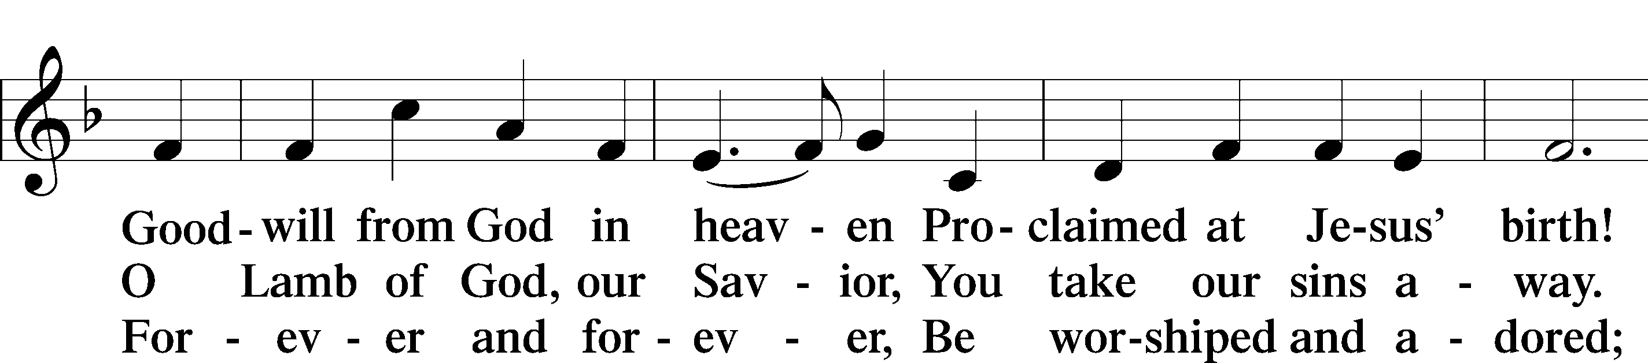
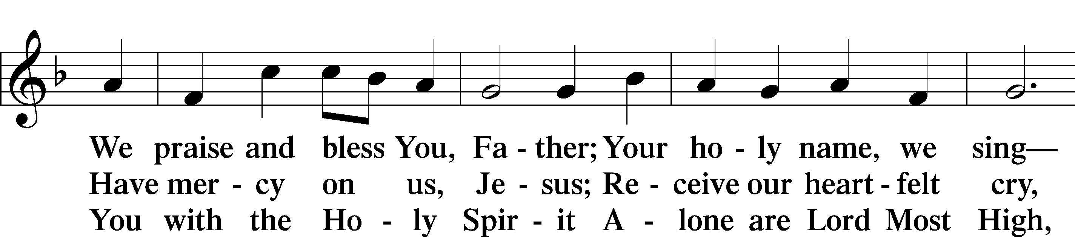
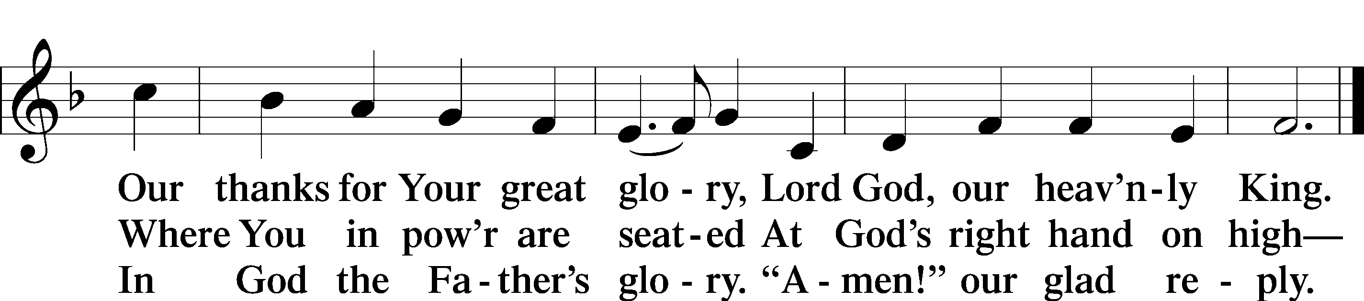

Salutation and Collect of the Day
P The Lord be with you.
C And also with you.

P Let us pray.
Almighty God, grant that we who have celebrated the Lord’s resurrection may by Your grace confess in our life and conversation that Jesus is Lord and God; through the same Jesus Christ, Your Son, who lives and reigns with You and the Holy Spirit, one God, now and forever.
C Amen.

Sit

First Reading Acts 5:29–42
29But Peter and the apostles answered, “We must obey God rather than men. 30The God of our fathers raised Jesus, whom you killed by hanging him on a tree. 31God exalted him at his right hand as Leader and Savior, to give repentance to Israel and forgiveness of sins. 32And we are witnesses to these things, and so is the Holy Spirit, whom God has given to those who obey him.”
33When they heard this, they were enraged and wanted to kill them. 34But a Pharisee in the council named Gamaliel, a teacher of the law held in honor by all the people, stood up and gave orders to put the men outside for a little while. 35And he said to them, “Men of Israel, take care what you are about to do with these men. 36For before these days Theudas rose up, claiming to be somebody, and a number of men, about four hundred, joined him. He was killed, and all who followed him were dispersed and came to nothing. 37After him Judas the Galilean rose up in the days of the census and drew away some of the people after him. He too perished, and all who followed him were scattered. 38So in the present case I tell you, keep away from these men and let them alone, for if this plan or this undertaking is of man, it will fail; 39but if it is of God, you will not be able to overthrow them. You might even be found opposing God!” So they took his advice, 40and when they had called in the apostles, they beat them and charged them not to speak in the name of Jesus, and let them go. 41Then they left the presence of the council, rejoicing that they were counted worthy to suffer dishonor for the name. 42And every day, in the temple and from house to house, they did not cease teaching and preaching Jesus as the Christ.

A This is the Word of the Lord.
C Thanks be to God.

Epistle 1 Peter 1:3–9
3Blessed be the God and Father of our Lord Jesus Christ! According to his great mercy, he has caused us to be born again to a living hope through the resurrection of Jesus Christ from the dead, 4to an inheritance that is imperishable, undefiled, and unfading, kept in heaven for you, 5who by God’s power are being guarded through faith for a salvation ready to be revealed in the last time. 6In this you rejoice, though now for a little while, if necessary, you have been grieved by various trials, 7so that the tested genuineness of your faith—more precious than gold that perishes though it is tested by fire—may be found to result in praise and glory and honor at the revelation of Jesus Christ. 8Though you have not seen him, you love him. Though you do not now see him, you believe in him and rejoice with joy that is inexpressible and filled with glory, 9obtaining the outcome of your faith, the salvation of your souls.

A This is the Word of the Lord.
C Thanks be to God.

Stand

Alleluia and Verse
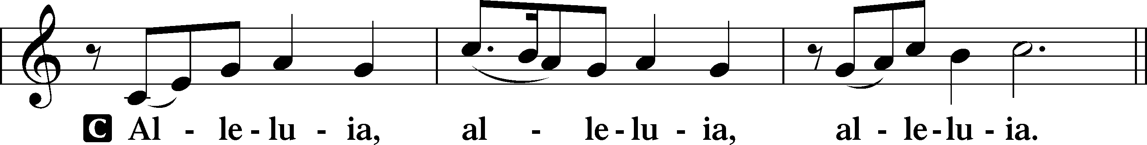
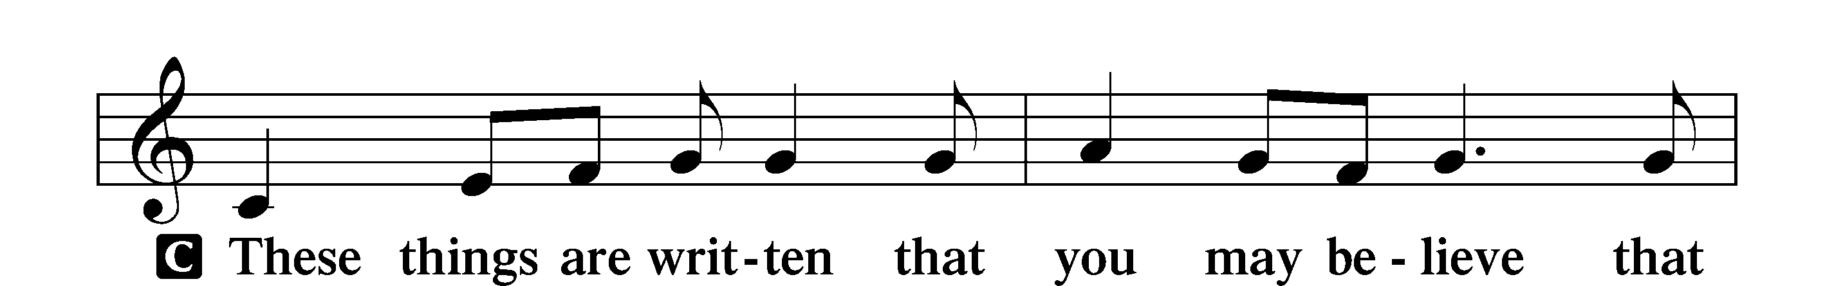
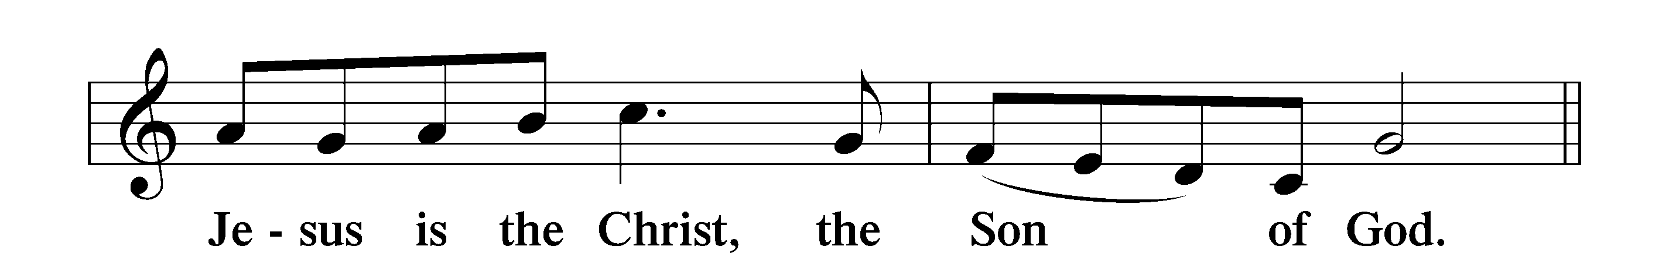
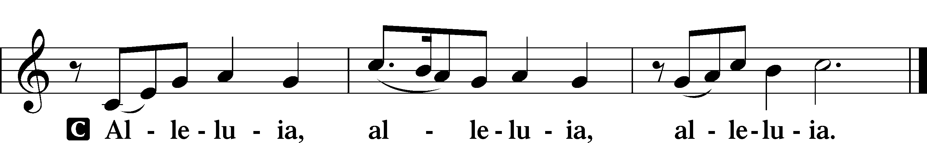

Holy Gospel John 20:19–31
P The Holy Gospel according to St. John, the twentieth chapter.
C Glory to You, O Lord.

19On the evening of that day, the first day of the week, the doors being locked where the disciples were for fear of the Jews, Jesus came and stood among them and said to them, “Peace be with you.” 20When he had said this, he showed them his hands and his side. Then the disciples were glad when they saw the Lord. 21Jesus said to them again, “Peace be with you. As the Father has sent me, even so I am sending you.” 22And when he had said this, he breathed on them and said to them, “Receive the Holy Spirit. 23If you forgive the sins of anyone, they are forgiven; if you withhold forgiveness from anyone, it is withheld.”
24Now Thomas, one of the Twelve, called the Twin, was not with them when Jesus came. 25So the other disciples told him, “We have seen the Lord.” But he said to them, “Unless I see in his hands the mark of the nails, and place my finger into the mark of the nails, and place my hand into his side, I will never believe.”
26Eight days later, his disciples were inside again, and Thomas was with them. Although the doors were locked, Jesus came and stood among them and said, “Peace be with you.” 27Then he said to Thomas, “Put your finger here, and see my hands; and put out your hand, and place it in my side. Do not disbelieve, but believe.” 28Thomas answered him, “My Lord and my God!” 29Jesus said to him, “Have you believed because you have seen me? Blessed are those who have not seen and yet have believed.”
30Now Jesus did many other signs in the presence of the disciples, which are not written in this book; 31but these are written so that you may believe that Jesus is the Christ, the Son of God, and that by believing you may have life in his name.

P This is the Gospel of the Lord.
C Praise to You, O Christ.

Nicene Creed
C I believe in one God,
the Father Almighty,
maker of heaven and earth
and of all things visible and invisible.
And in one Lord Jesus Christ,
the only-begotten Son of God,
begotten of His Father before all worlds,
God of God, Light of Light,
very God of very God,
begotten, not made,
being of one substance with the Father,
by whom all things were made;
who for us men and for our salvation came down from heaven
and was incarnate by the Holy Spirit of the virgin Mary
and was made man;
and was crucified also for us under Pontius Pilate.
He suffered and was buried.
And the third day He rose again according to the Scriptures
and ascended into heaven
and sits at the right hand of the Father.
And He will come again with glory to judge both the living and the dead,
whose kingdom will have no end.

And I believe in the Holy Spirit,
the Lord and giver of life,
who proceeds from the Father and the Son,
who with the Father and the Son together is worshiped and glorified,
who spoke by the prophets.
And I believe in one holy Christian and apostolic Church,
I acknowledge one Baptism for the remission of sins,
and I look for the resurrection of the dead
and the life T of the world to come.

Amen.

Sit

Choir: Walk by Faith Not by Sight

Sermon

Offering. We generously give our offerings to the LORD out of thanksgiving for His generosity of forgiveness, life, and salvation in Christ (2 Corinthians 9:8). We believe that our offerings are not only to support the proclamation of the Gospel here and around the world, but also to help us all grow in faith and trust in Him (2 Corinthians 9:7). We have placed an offering plate in the narthex so you are able to freely give back to Him as you are able. To Him be all the glory!

Stand

Prayer of the Church

Holy Communion is celebrated in the belief and glad confidence that our Lord gives us not only bread and wine, but the body and blood of Christ from the cross, for us Christian to eat and drink for the forgiveness of sins (Matthew 26:28). Because we are called to examine ourselves before receiving the Lord’s Supper (I Corinthians 11:28-29), we encourage you to consider the questions on pages 329-330 in the hymnal. We also believe that when we commune, we are confessing our unity with the community we join (I Corinthians 10:17). If you desire to commune with us for the first time or have questions, our pastor is happy to speak with you.

Preface
P The Lord be with you.
C And also with you.
P Lift up your hearts.
C We lift them to the Lord.

P Let us give thanks to the Lord our God.
C It is right to give Him thanks and praise.

P It is truly good, right, and salutary that we should at all times and in all places give thanks to You, O Lord, holy Father, almighty and everlasting God, for the countless blessings You so freely bestow on us and all creation. Above all, we give thanks for Your boundless love shown to us when You sent Your only-begotten Son, Jesus Christ, into our flesh and laid on Him our sin, giving Him into death that we might not die eternally. Because He is now risen from the dead and lives and reigns to all eternity, all who believe in Him will overcome sin and death and will rise again to new life. Therefore with angels and archangels and with all the company of heaven we laud and magnify Your glorious name, evermore praising You and saying:

Sanctus
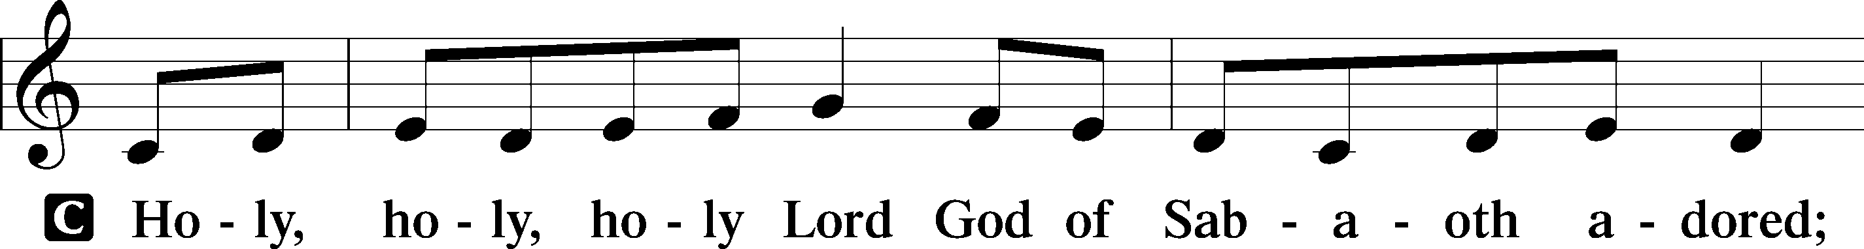
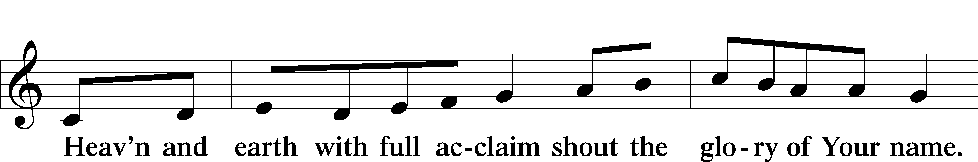
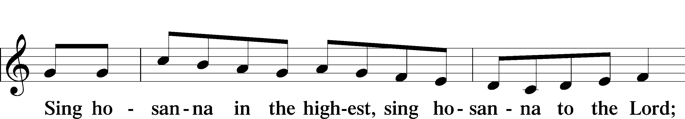
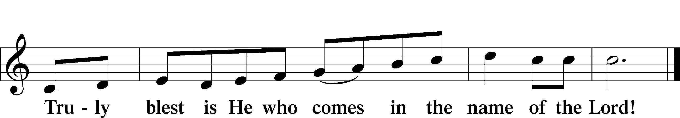
Prayer of Thanksgiving
P Blessed are You, O Lord our God, king of all creation, for You have had mercy on us and given Your only-begotten Son that whoever believes in Him should not perish but have eternal life.

For Christ, our Passover Lamb, has been sacrificed. By His death, He has redeemed us from bondage to sin and death, and by His resurrection, He has delivered us into new life in Him.

Grant us to keep the Feast in sincerity and truth, faithfully eating His body given into death and drinking His life’s blood poured out for our salvation until we pass through death to the promised land of life eternal.

Hear us as we pray in His name and as He has taught us:

Lord’s Prayer

The Words of Our Lord

Pax Domini
P The peace of the Lord be with you always.
C Amen.

Agnus Dei
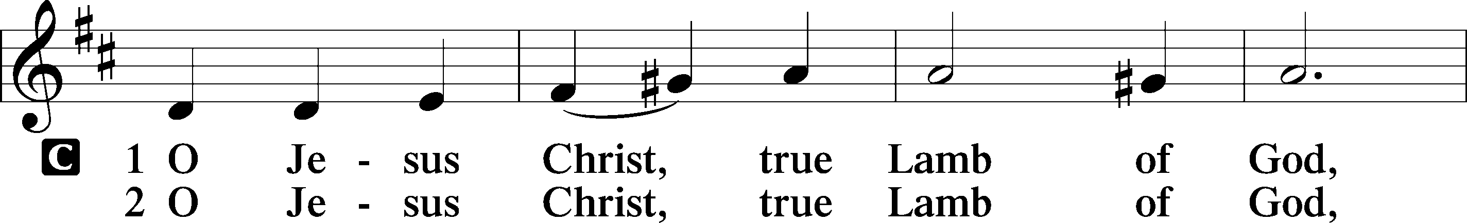
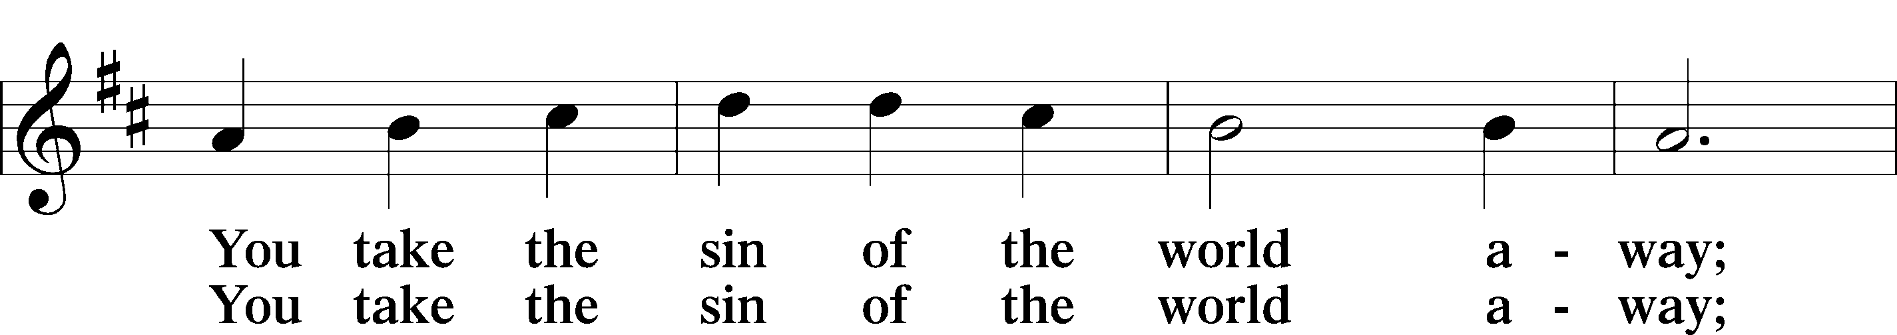
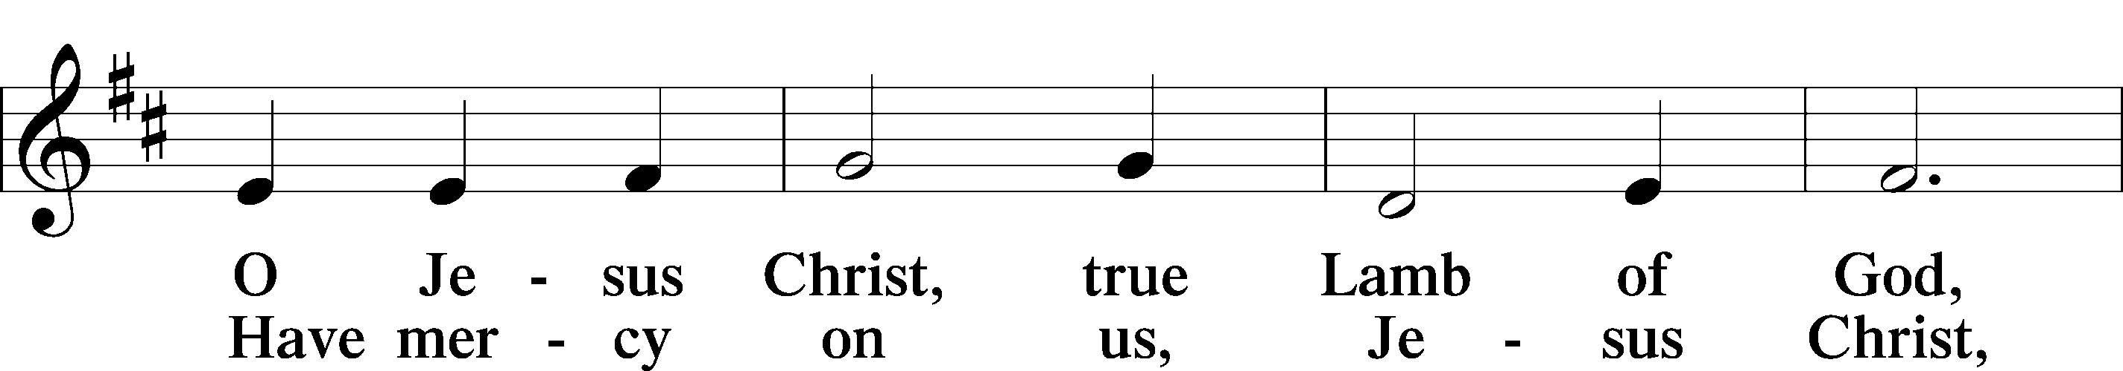
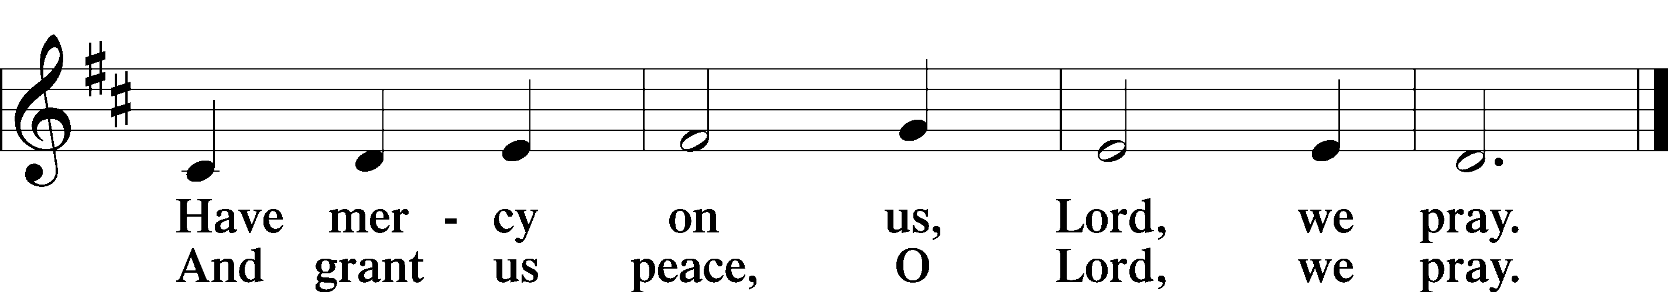

Sit

Distribution

470 O Sons and Daughters of the King

625 Lord Jesus Christ, Life-Giving Bread

Stand

Nunc Dimittis
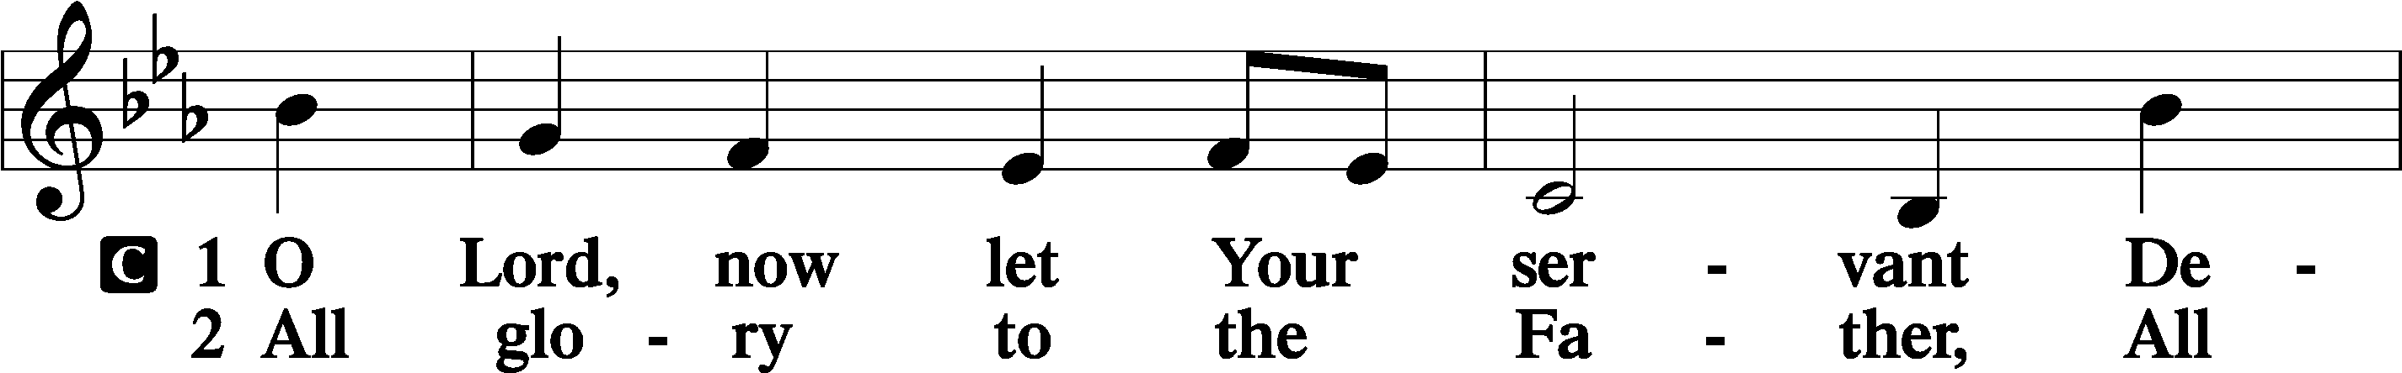
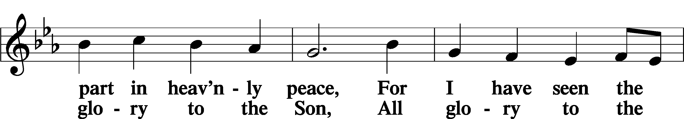
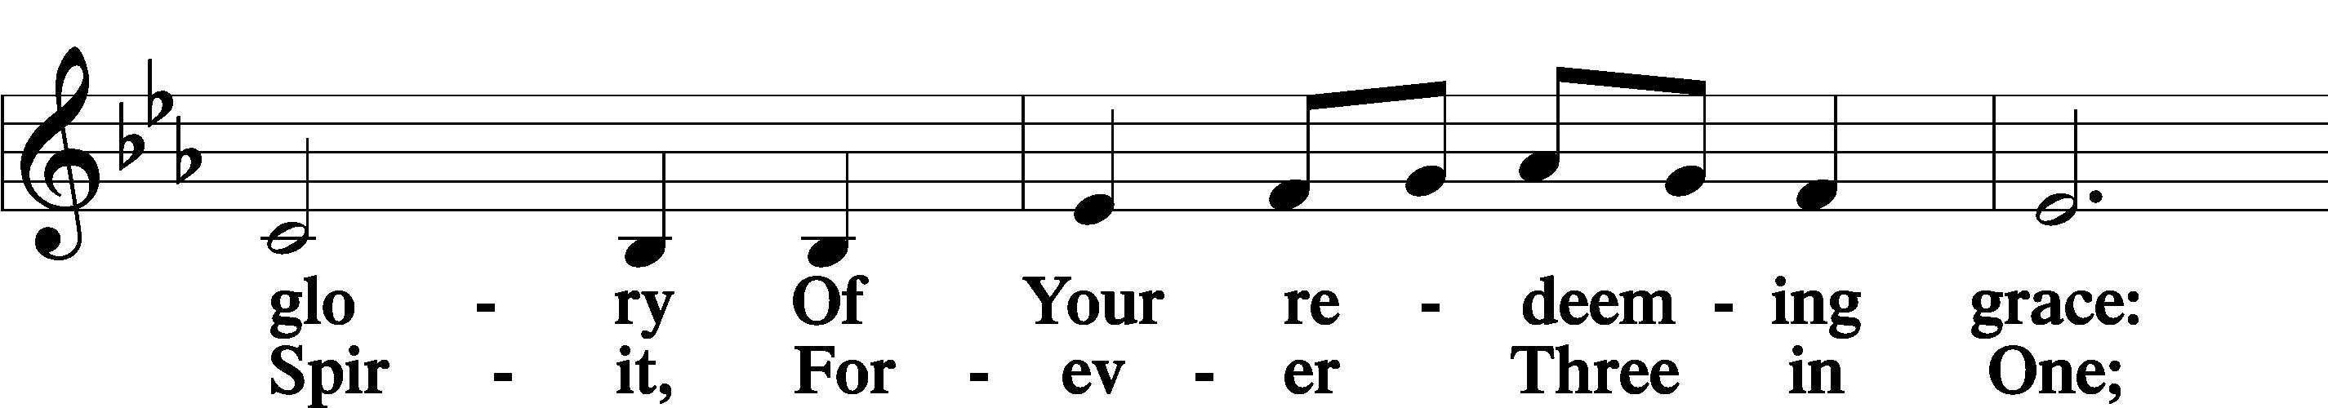
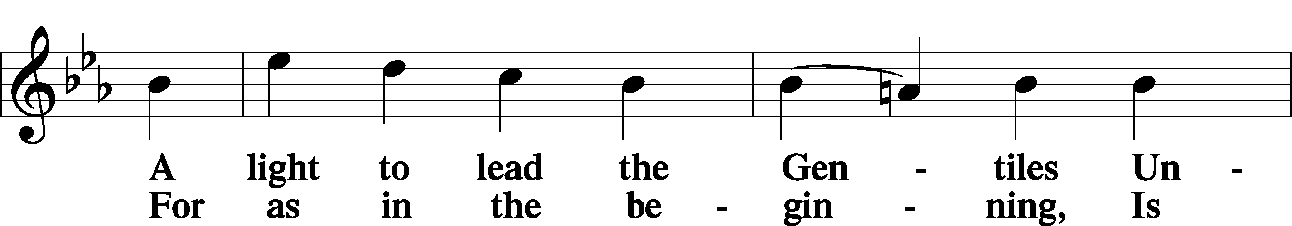
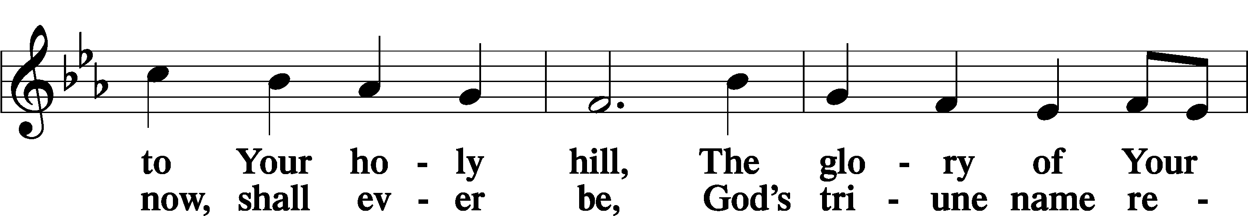
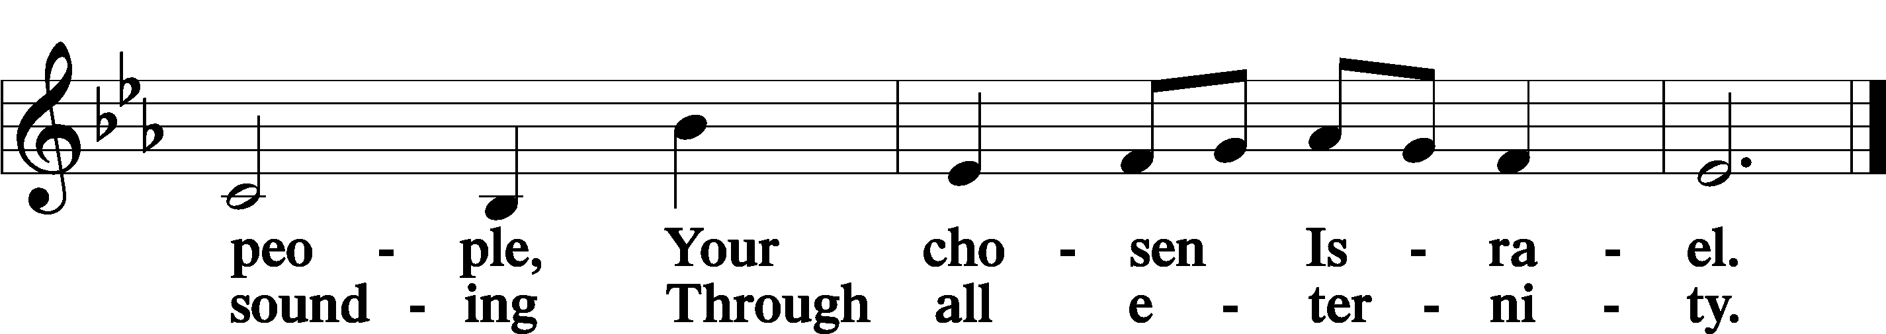

Post-Communion Collect
A Let us pray. We give thanks to You, almighty God, that You have refreshed us through this salutary gift, and we implore You that of Your mercy You would strengthen us through the same in faith toward You and in fervent love toward one another; through Jesus Christ, Your Son, our Lord, who lives and reigns with You and the Holy Spirit, one God, now and forever.
C Amen.

Benedicamus
A Let us bless the Lord.
C Thanks be to God.

Benediction
P The Lord bless you and keep you.
The Lord make His face shine on you and be gracious to you.
The Lord look upon you with favor and T give you peace.

C Amen.

920 Forth in the Peace of Christ We Go

