19th Sunday After Pentecost
October 4th, 2026

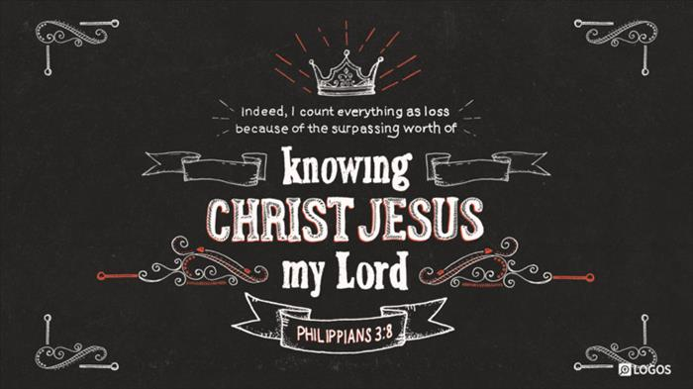

Messiah Lutheran Church
Sartell, MN
www.messiahsartell.com
320-252-5883
Prayer Before Entering
Please take this time to focus on our purpose in gathering and join in prayer before our service begins. Blessed Lord, You have caused all Holy Scriptures to be written for our learning. Grant that we may so hear them, read, mark, learn, and inwardly digest them that, by patience and comfort of Your holy Word, we may embrace and ever hold fast the blessed hope of everlasting life; through Jesus Christ, our Lord.

As We Gather
We all have a past. From the people whose names are known to all to the anonymous known only to God, we all come with history that has marked us for sin and death. The gift of God is that He forgives that sinful past, removes all condemnation, and bestows a future upon us. Nowhere is this more obvious than in the story of Paul. The Lord forgave his past, restored him beyond every expectation, and gave him a future serving as an apostle in life with the prize of eternal life in death. No matter who we are, we have the same promise. God forgives all our sin, restores us to be His own and live under Him in His kingdom, and bears in us the fruit of the Kingdom now and the prize of everlasting life in His own time. All of this we know now by faith, trusting in the righteousness that God has given to us in Christ and not in ourselves.

753 All for Christ I Have Forsaken

Stand

The sign of the cross may be made by all in remembrance of their Baptism.

P In the name of the Father and of the T Son and of the Holy Spirit.
C Amen.

P Our help is in the name of the Lord,
C who made heaven and earth.

P If You, O Lord, kept a record of sins, O Lord, who could stand?
C But with You there is forgiveness; therefore You are feared.

P Since we are gathered to hear God’s Word, call upon Him in prayer and praise, let us first consider our unworthiness and confess before God and one another that we have sinned in thought, word, and deed, and that we cannot free ourselves from our sinful condition. Together as His people let us take refuge in the infinite mercy of God, our heavenly Father, seeking His grace for the sake of Christ, and saying:
C God, be merciful to me, a sinner.

Silence for reflection on God’s Word and for self-examination.

C Almighty God, have mercy upon us, forgive us our sins, and lead us to everlasting life. Amen.

P Almighty God in His mercy has given His Son to die for you and for His sake forgives you all your sins. As a called and ordained servant of Christ, and by His authority, I therefore forgive you all your sins in the name of the Father and of the T Son and of the Holy Spirit.

C Amen.

Introit Psalm 118:22–24; antiphon: v. 1
P Oh give thanks to the Lord, for he is good;
for his steadfast love endures forever!
C The stone that the builders rejected
has become the cornerstone.
P This is the Lord’s doing;
it is marvelous in our eyes.
C This is the day that the Lord has made;
let us rejoice and be glad in it.
All: Glory be to the Father and to the Son
and to the Holy Spirit;
as it was in the beginning,
is now, and will be forever. Amen.
P Oh give thanks to the Lord, for he is good;
for his steadfast love endures forever!

Kyrie
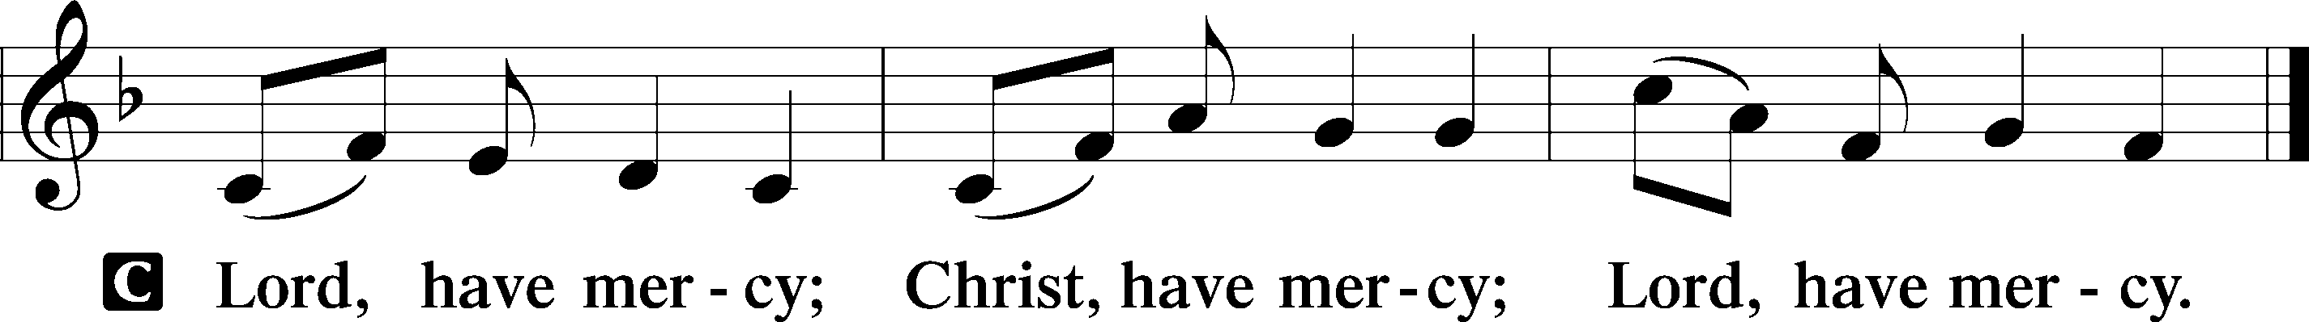

Gloria in Excelsis
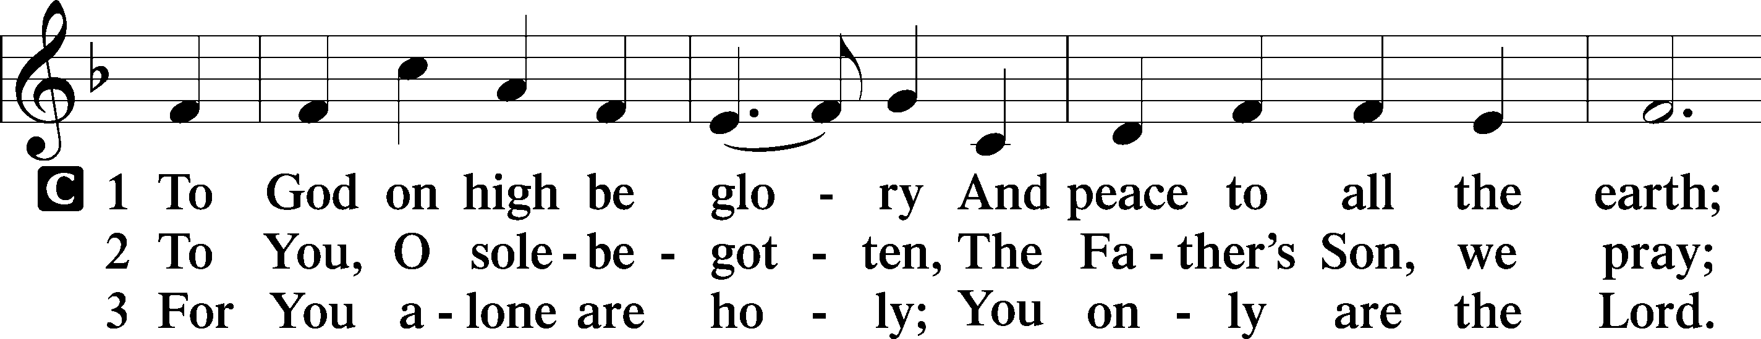
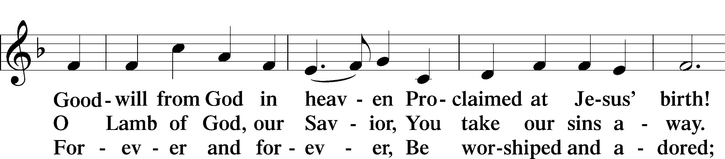
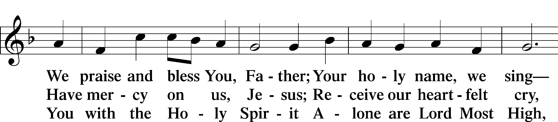
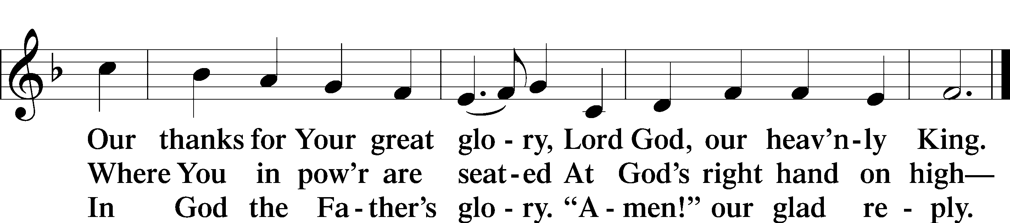

Salutation and Collect of the Day
P The Lord be with you.
C And also with you.

P Let us pray.
Gracious God, You gave Your Son into the hands of sinful men who killed Him. Forgive us when we reject Your unfailing love, and grant us the fullness of Your salvation; through Jesus Christ, Your Son, our Lord, who lives and reigns with You and the Holy Spirit, one God, now and forever.

C Amen.

Sit
Old Testament Reading Isaiah 5:1–7
1Let me sing for my beloved
my love song concerning his vineyard:
My beloved had a vineyard
on a very fertile hill.
2He dug it and cleared it of stones,
and planted it with choice vines;
he built a watchtower in the midst of it,
and hewed out a wine vat in it;
and he looked for it to yield grapes,
but it yielded wild grapes.
3And now, O inhabitants of Jerusalem
and men of Judah,
judge between me and my vineyard.
4What more was there to do for my vineyard,
that I have not done in it?
When I looked for it to yield grapes,
why did it yield wild grapes?
5And now I will tell you
what I will do to my vineyard.
I will remove its hedge,
and it shall be devoured;
I will break down its wall,
and it shall be trampled down.
6I will make it a waste;
it shall not be pruned or hoed,
and briers and thorns shall grow up;
I will also command the clouds
that they rain no rain upon it.
7For the vineyard of the Lord of hosts
is the house of Israel,
and the men of Judah
are his pleasant planting;
and he looked for justice,
but behold, bloodshed;
for righteousness,
but behold, an outcry!

A This is the Word of the Lord.
C Thanks be to God.
Epistle Philippians 3:4b–14
If anyone else thinks he has reason for confidence in the flesh, I have more: 5circumcised on the eighth day, of the people of Israel, of the tribe of Benjamin, a Hebrew of Hebrews; as to the law, a Pharisee; 6as to zeal, a persecutor of the church; as to righteousness, under the law blameless. 7But whatever gain I had, I counted as loss for the sake of Christ. 8Indeed, I count everything as loss because of the surpassing worth of knowing Christ Jesus my Lord. For his sake I have suffered the loss of all things and count them as rubbish, in order that I may gain Christ 9and be found in him, not having a righteousness of my own that comes from the law, but that which comes through faith in Christ, the righteousness from God that depends on faith— 10that I may know him and the power of his resurrection, and may share his sufferings, becoming like him in his death, 11that by any means possible I may attain the resurrection from the dead.
12Not that I have already obtained this or am already perfect, but I press on to make it my own, because Christ Jesus has made me his own. 13Brothers, I do not consider that I have made it my own. But one thing I do: forgetting what lies behind and straining forward to what lies ahead, 14I press on toward the goal for the prize of the upward call of God in Christ Jesus.

A This is the Word of the Lord.
C Thanks be to God.

Stand

Alleluia and Verse
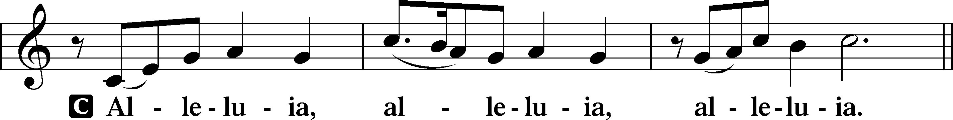
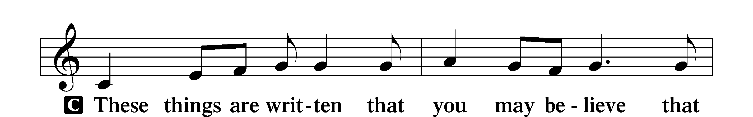
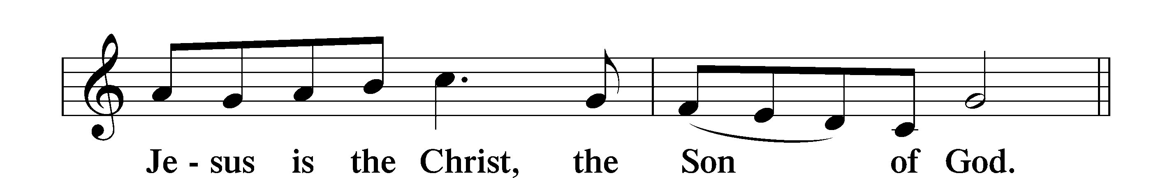
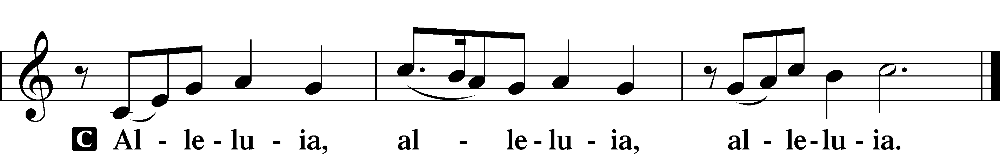
Holy Gospel Matthew 21:33–46
P The Holy Gospel according to St. Matthew, the twenty-first chapter.
C Glory to You, O Lord.

33[Jesus said:] “Hear another parable. There was a master of a house who planted a vineyard and put a fence around it and dug a winepress in it and built a tower and leased it to tenants, and went into another country. 34When the season for fruit drew near, he sent his servants to the tenants to get his fruit. 35And the tenants took his servants and beat one, killed another, and stoned another. 36Again he sent other servants, more than the first. And they did the same to them. 37Finally he sent his son to them, saying, ‘They will respect my son.’ 38But when the tenants saw the son, they said to themselves, ‘This is the heir. Come, let us kill him and have his inheritance.’ 39And they took him and threw him out of the vineyard and killed him. 40When therefore the owner of the vineyard comes, what will he do to those tenants?” 41They said to him, “He will put those wretches to a miserable death and let out the vineyard to other tenants who will give him the fruits in their seasons.”
42Jesus said to them, “Have you never read in the Scriptures: “‘The stone that the builders rejected has become the cornerstone; this was the Lord’s doing, and it is marvelous in our eyes’? 43Therefore I tell you, the kingdom of God will be taken away from you and given to a people producing its fruits. 44And the one who falls on this stone will be broken to pieces; and when it falls on anyone, it will crush him.” 45When the chief priests and the Pharisees heard his parables, they perceived that he was speaking about them. 46And although they were seeking to arrest him, they feared the crowds, because they held him to be a prophet.

P This is the Gospel of the Lord.
C Praise to You, O Christ.

Apostles’ Creed
C I believe in God, the Father Almighty,
maker of heaven and earth.
And in Jesus Christ, His only Son, our Lord,
who was conceived by the Holy Spirit,
born of the virgin Mary,
suffered under Pontius Pilate,
was crucified, died and was buried.
He descended into hell.
The third day He rose again from the dead.
He ascended into heaven
and sits at the right hand of God the Father Almighty.
From thence He will come to judge the living and the dead.
I believe in the Holy Spirit,
the holy Christian Church,
the communion of saints,
the forgiveness of sins,
the resurrection of the body,
and the life T everlasting. Amen.

Sit

566 By Grace I’m Saved

Sermon

Offering. We generously give our offerings to the LORD out of thanksgiving for His generosity of forgiveness, life, and salvation in Christ (2 Corinthians 9:8). We believe that our offerings are not only to support the proclamation of the Gospel here and around the world, but also to help us all grow in faith and trust in Him (2 Corinthians 9:7). We have placed an offering plate in the narthex so you are able to freely give back to Him as you are able. To Him be all the glory!

Stand

Prayer of the Church

Lord’s Prayer

Benedicamus
A Let us bless the Lord.
C Thanks be to God.

Benediction
P The Lord bless you and keep you.
The Lord make His face shine on you and be gracious to you.
The Lord look upon you with favor and T give you peace.
C Amen.

611 Chief of Sinners Though I Be

Announcements

Calling all noodle helpers! We’ll be mixing, rolling, cutting, and
hanging noodles on Monday, Oct. 12 at 12:30 p.m. Join us!

New Choir Starting Time: Wednesdays at 5:30 p.m.!

