The Transfiguration of Our Lord
February 15th, 2026

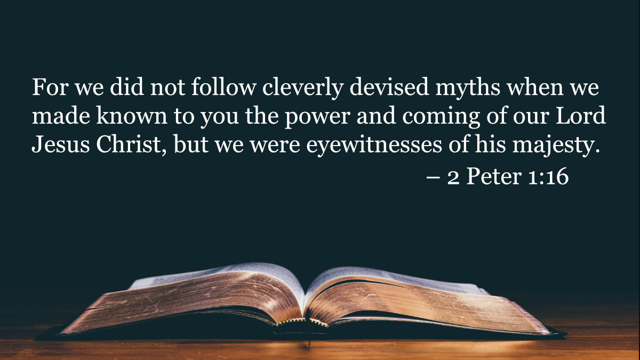

Messiah Lutheran Church
Sartell, MN
www.messiahsartell.com
320-252-5883
Prayer Before Entering
Please take this time to focus on our purpose in gathering and join in prayer before our service begins. Blessed Lord, You have caused all Holy Scriptures to be written for our learning. Grant that we may so hear them, read, mark, learn, and inwardly digest them that, by patience and comfort of Your holy Word, we may embrace and ever hold fast the blessed hope of everlasting life; through Jesus Christ, our Lord.

As We Gather
There is nothing quite like being an eyewitness, giving a special perspective to share on the event. Peter writes about being on the Mount of Transfiguration as he, James, and John were privileged to have a special vision of the Lord Jesus Christ. He states: “We were eyewitnesses of His majesty. For when He received honor and glory from God the Father, and the voice was borne to Him by the Majestic Glory, ‘This is My beloved Son, with whom I am well pleased,’ we ourselves heard this very voice borne from heaven, for we were with Him on the holy mountain” (2 Peter 1:16b–18). Today, through the words of Scripture, we, too, become eyewitnesses and are given a glimpse of glory in the vision of our transfigured Lord!

414 ’Tis Good, Lord, to Be Here

Stand

The sign of the cross may be made by all in remembrance of their Baptism.

P In the name of the Father and of the T Son and of the Holy Spirit.
C Amen.

P Our help is in the name of the Lord,
C who made heaven and earth.

P If You, O Lord, kept a record of sins, O Lord, who could stand?
C But with You there is forgiveness; therefore You are feared.

P Since we are gathered to hear God’s Word, call upon Him in prayer and praise, let us first consider our unworthiness and confess before God and one another that we have sinned in thought, word, and deed, and that we cannot free ourselves from our sinful condition. Together as His people let us take refuge in the infinite mercy of God, our heavenly Father, seeking His grace for the sake of Christ, and saying:
C God, be merciful to me, a sinner.

Silence for reflection on God’s Word and for self-examination.

C Almighty God, have mercy upon us, forgive us our sins, and lead us to everlasting life. Amen.

P Almighty God in His mercy has given His Son to die for you and for His sake forgives you all your sins. As a called and ordained servant of Christ, and by His authority, I therefore forgive you all your sins in the name of the Father and of the T Son and of the Holy Spirit.

C Amen.

Introit Psalm 99:1–5; antiphon: v. 9
P Exalt the Lord our God, and worship at his holy mountain;
for the Lord our God is holy!
C The Lord reigns; let the peoples tremble!
He sits enthroned upon the cherubim; let the earth quake!
P The Lord is great in Zion;
he is exalted over all the peoples.
C Let them praise your great and awesome name!
Holy is he!
P The King in his might loves justice.
You have established equity; you have executed justice and
righteousness in Jacob.
C Exalt the Lord our God; worship at his footstool!
Holy is he!
All: Glory be to the Father and to the Son
and to the Holy Spirit;
as it was in the beginning,
is now, and will be forever. Amen.
P Exalt the Lord our God, and worship at his holy mountain;
or the Lord our God is holy!

Kyrie
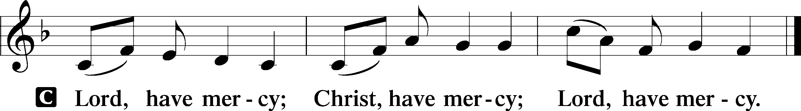
Gloria in Excelsis
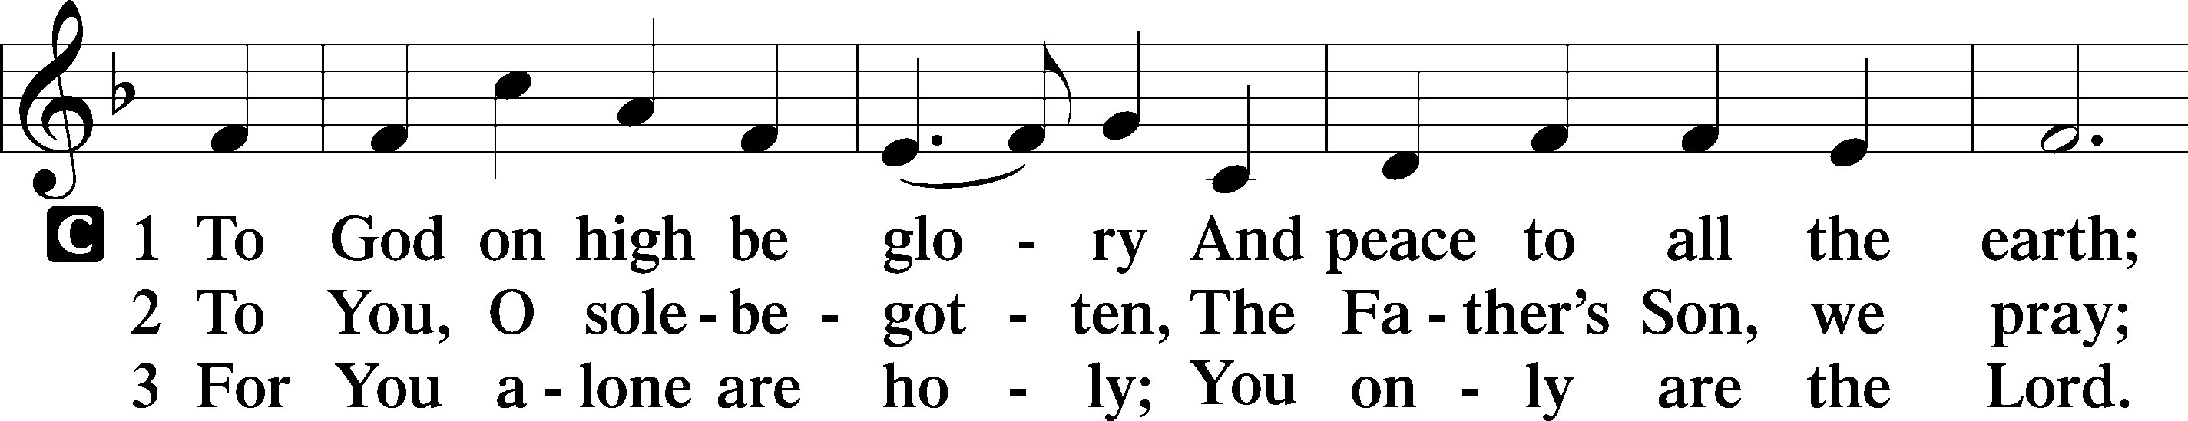
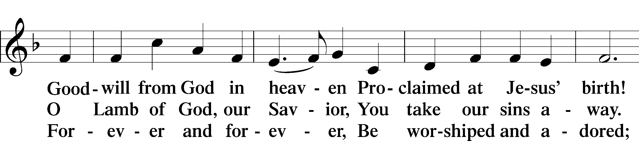
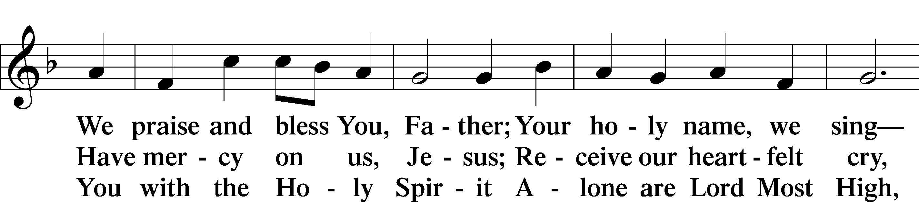
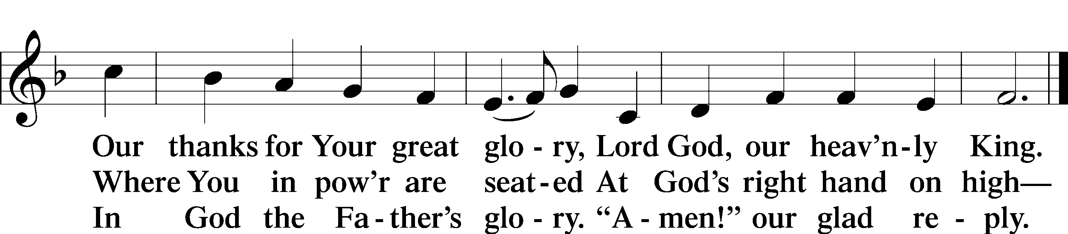

Salutation and Collect of the Day
P The Lord be with you.
C And also with you.

P Let us pray.
O God, in the glorious transfiguration of Your beloved Son You confirmed the mysteries of the faith by the testimony of Moses and Elijah. In the voice that came from the bright cloud You wonderfully foreshowed our adoption by grace. Mercifully make us co-heirs with the King in His glory and bring us to the fullness of our inheritance in heaven; through the same Jesus Christ, our Lord, who lives and reigns with You and the Holy Spirit, one God, now and forever.

C Amen.

Sit
Old Testament Reading Exodus 24:8–18
8And Moses took the blood and threw it on the people and said, “Behold the blood of the covenant that the Lord has made with you in accordance with all these words.”
9Then Moses and Aaron, Nadab, and Abihu, and seventy of the elders of Israel went up, 10and they saw the God of Israel. There was under his feet as it were a pavement of sapphire stone, like the very heaven for clearness. 11And he did not lay his hand on the chief men of the people of Israel; they beheld God, and ate and drank.
12The Lord said to Moses, “Come up to me on the mountain and wait there, that I may give you the tablets of stone, with the law and the commandment, which I have written for their instruction.” 13So Moses rose with his assistant Joshua, and Moses went up into the mountain of God. 14And he said to the elders, “Wait here for us until we return to you. And behold, Aaron and Hur are with you. Whoever has a dispute, let him go to them.”
15Then Moses went up on the mountain, and the cloud covered the mountain. 16The glory of the Lord dwelt on Mount Sinai, and the cloud covered it six days. And on the seventh day he called to Moses out of the midst of the cloud. 17Now the appearance of the glory of the Lord was like a devouring fire on the top of the mountain in the sight of the people of Israel. 18Moses entered the cloud and went up on the mountain. And Moses was on the mountain forty days and forty nights.

A This is the Word of the Lord.
C Thanks be to God.

Epistle 2 Peter 1:16–21
16For we did not follow cleverly devised myths when we made known to you the power and coming of our Lord Jesus Christ, but we were eyewitnesses of his majesty. 17For when he received honor and glory from God the Father, and the voice was borne to him by the Majestic Glory, “This is my beloved Son, with whom I am well pleased,” 18we ourselves heard this very voice borne from heaven, for we were with him on the holy mountain. 19And we have something more sure, the prophetic word, to which you will do well to pay attention as to a lamp shining in a dark place, until the day dawns and the morning star rises in your hearts, 20knowing this first of all, that no prophecy of Scripture comes from someone’s own interpretation. 21For no prophecy was ever produced by the will of man, but men spoke from God as they were carried along by the Holy Spirit.
A This is the Word of the Lord.
C Thanks be to God.

Stand

Alleluia and Verse
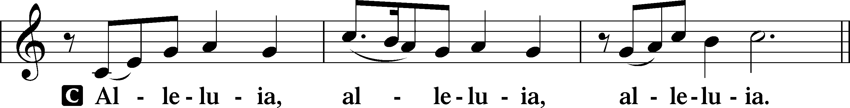
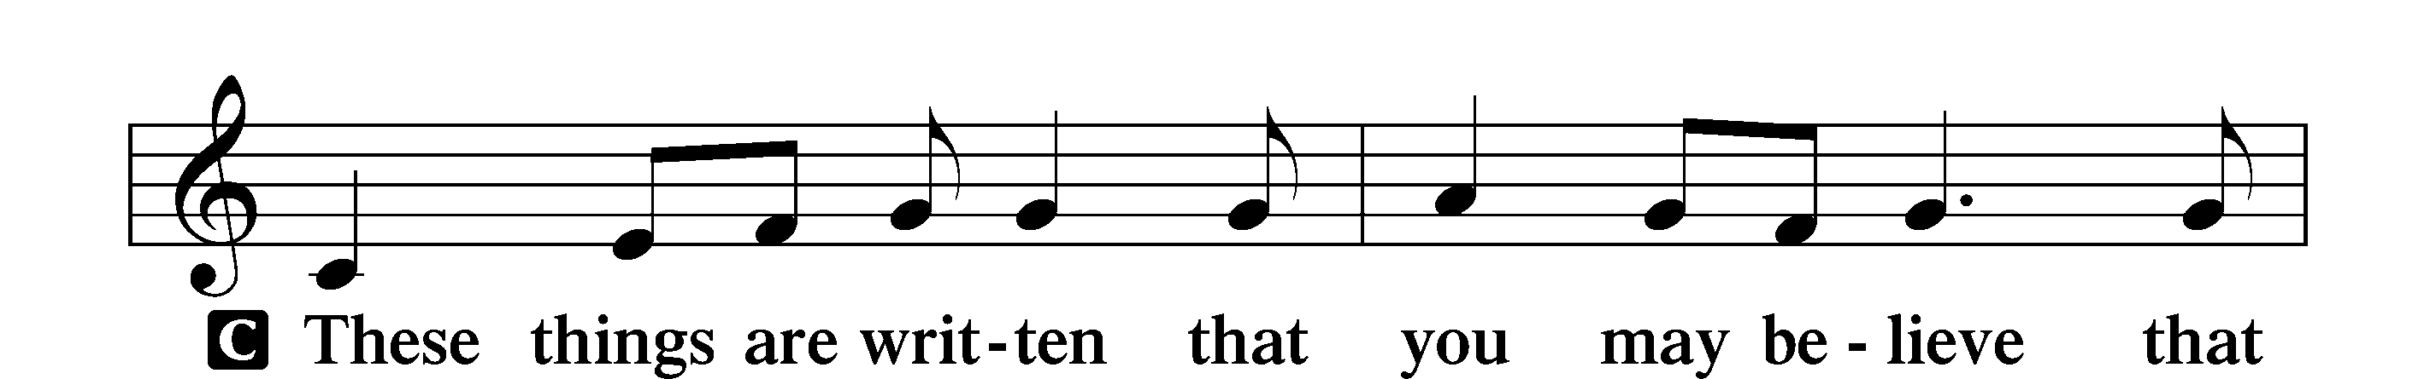
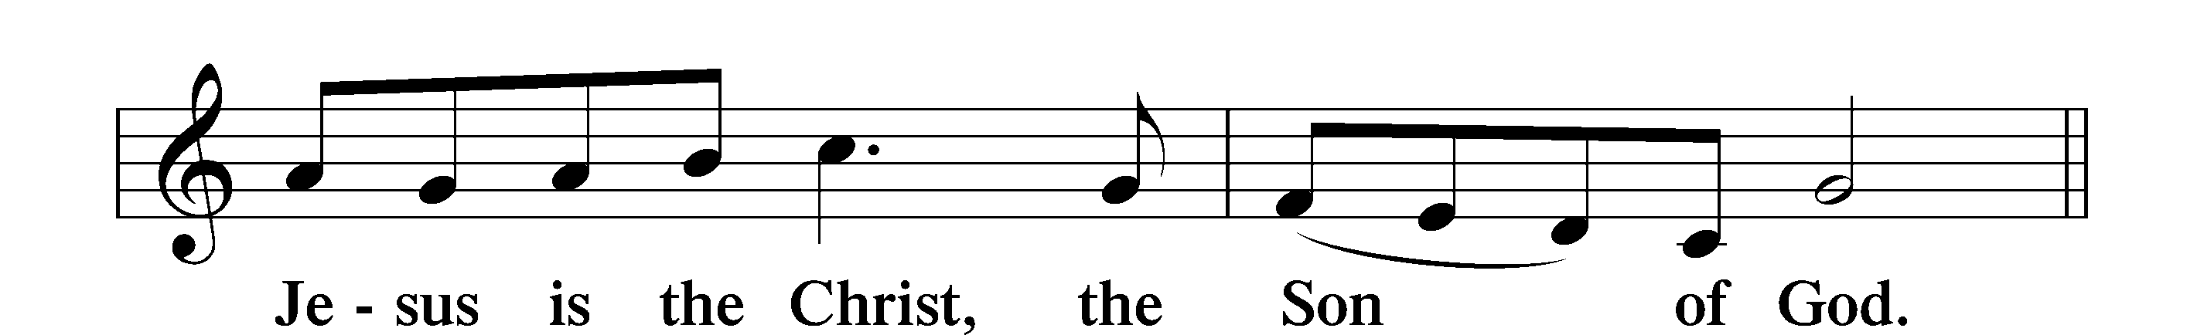
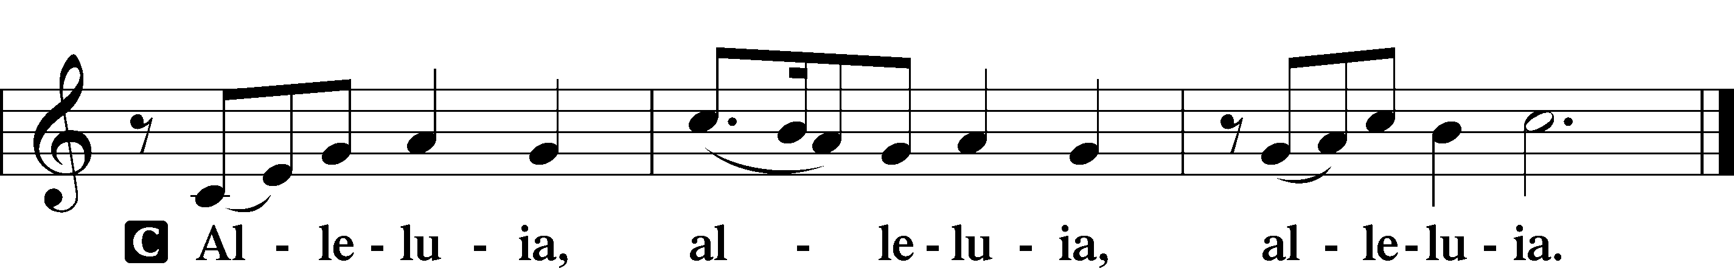

Holy Gospel Matthew 17:1–9
P The Holy Gospel according to St. Matthew, the seventeenth chapter.
C Glory to You, O Lord.

1After six days Jesus took with him Peter and James, and John his brother, and led them up a high mountain by themselves. 2And he was transfigured before them, and his face shone like the sun, and his clothes became white as light. 3And behold, there appeared to them Moses and Elijah, talking with him. 4And Peter said to Jesus, “Lord, it is good that we are here. If you wish, I will make three tents here, one for you and one for Moses and one for Elijah.” 5He was still speaking when, behold, a bright cloud overshadowed them, and a voice from the cloud said, “This is my beloved Son, with whom I am well pleased; listen to him.” 6When the disciples heard this, they fell on their faces and were terrified. 7But Jesus came and touched them, saying, “Rise, and have no fear.” 8And when they lifted up their eyes, they saw no one but Jesus only.
9And as they were coming down the mountain, Jesus commanded them, “Tell no one the vision, until the Son of Man is raised from the dead.”

P This is the Gospel of the Lord.
C Praise to You, O Christ.

Apostles’ Creed
C I believe in God, the Father Almighty,
maker of heaven and earth.
And in Jesus Christ, His only Son, our Lord,
who was conceived by the Holy Spirit,
born of the virgin Mary,
suffered under Pontius Pilate,
was crucified, died and was buried.
He descended into hell.
The third day He rose again from the dead.
He ascended into heaven
and sits at the right hand of God the Father Almighty.
From thence He will come to judge the living and the dead.

I believe in the Holy Spirit,
the holy Christian Church,
the communion of saints,
the forgiveness of sins,
the resurrection of the body,
and the life T everlasting. Amen.

Sit

413 O Wondrous Type! O Vision Fair

Sermon

Offering. We generously give our offerings to the LORD out of thanksgiving for His generosity of forgiveness, life, and salvation in Christ (2 Corinthians 9:8). We believe that our offerings are not only to support the proclamation of the Gospel here and around the world, but also to help us all grow in faith and trust in Him (2 Corinthians 9:7). We have placed an offering plate in the narthex so you are able to freely give back to Him as you are able. To Him be all the glory!

Stand

Prayer of the Church
Lord’s Prayer

Benedicamus
A Let us bless the Lord.
C Thanks be to God.

Benediction
P The Lord bless you and keep you.
The Lord make His face shine on you and be gracious to you.
The Lord look upon you with favor and T give you peace.

C Amen.

416 Swiftly Pass the Clouds of Glory

Midweek Lenten Worship Services: 6 p.m.
Ash Wednesday, February 18
February 25 and March 4, 11, 18 and 25

Lenten Suppers will be at 4:45 p.m. every Wednesday during Lent.
A sign-up sheet to volunteer is posted in the back of the Narthex.

