Reformation Day (Observed)
October 25th, 2026

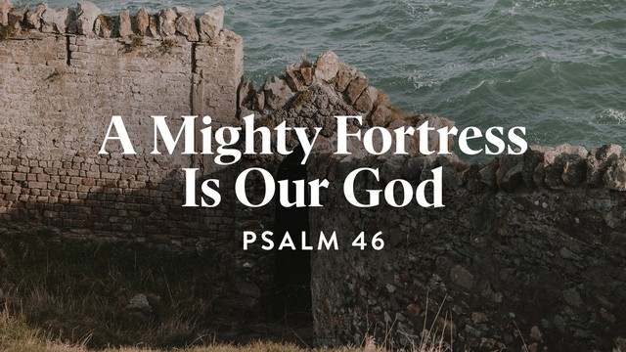

Messiah Lutheran Church
Sartell, MN
www.messiahsartell.com
320-252-5883
Prayer Before Entering
Please take this time to focus on our purpose in gathering and join in prayer before our service begins. Blessed Lord, You have caused all Holy Scriptures to be written for our learning. Grant that we may so hear them, read, mark, learn, and inwardly digest them that, by patience and comfort of Your holy Word, we may embrace and ever hold fast the blessed hope of everlasting life; through Jesus Christ, our Lord.

As We Gather
Martin Luther’s great hymn “A Mighty Fortress Is Our God” is based on Psalm 46. When the psalm was first written, it gave courage to God’s Old Testament people. Centuries later, when Luther wrote the hymn, the world was filled with plagues and death, and the devil was recognized as active in the lives of everyday people. Further, neither the Roman Catholic Church nor the government accepted the teachings of the reformers. Now, in our day, we face cyber warfare, pandemics, terrorists, political polarization, and ecclesiastical division. Because of our Baptism into the death and resurrection of Christ, we need not fear. Our gracious God is a very present help in this time of trouble. He is our refuge against the powers of the created world around us and the forces of evil from every source. From His throne flow streams of mercy to give us confident joy. We know that in the end “the kingdom ours remaineth.”

904 Blessed Jesus, at Your Word

Stand

The sign of the cross may be made by all in remembrance of their Baptism.

P In the name of the Father and of the T Son and of the Holy Spirit.
C Amen.

P Our help is in the name of the Lord,
C who made heaven and earth.

P If You, O Lord, kept a record of sins, O Lord, who could stand?
C But with You there is forgiveness; therefore You are feared.

P Since we are gathered to hear God’s Word, call upon Him in prayer and praise, and receive the body and blood of our Lord Jesus Christ in the fellowship of this altar, let us first consider our unworthiness and confess before God and one another that we have sinned in thought, word, and deed, and that we cannot free ourselves from our sinful condition. Together as His people let us take refuge in the infinite mercy of God, our heavenly Father, seeking His grace for the sake of Christ, and saying:
C God, be merciful to me, a sinner.

Silence for reflection on God’s Word and for self-examination.

C Almighty God, have mercy upon us, forgive us our sins, and lead us to everlasting life. Amen.

P Almighty God in His mercy has given His Son to die for you and for His sake forgives you all your sins. As a called and ordained servant of Christ, and by His authority, I therefore forgive you all your sins in the name of the Father and of the T Son and of the Holy Spirit.

C Amen.

Stand

Introit Psalm 34:1–2, 11, 22; antiphon: Psalm 119:46
P I will speak of your testimonies before kings, [O Lord,]
and shall not be put to shame.
C I will bless the Lord at all times;
his praise shall continually be in my mouth.
P My soul makes its boast in the Lord;
let the humble hear and be glad.
C Come, O children, listen to me;
I will teach you the fear of the Lord.
P The Lord redeems the life of his servants;
none of those who take refuge in him will be condemned.
All: Glory be to the Father and to the Son
and to the Holy Spirit;
as it was in the beginning,
is now, and will be forever. Amen.
P I will speak of your testimonies before kings, [O Lord,]
and shall not be put to shame.

Kyrie
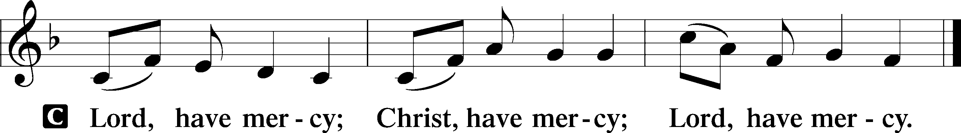
Gloria in Excelsis
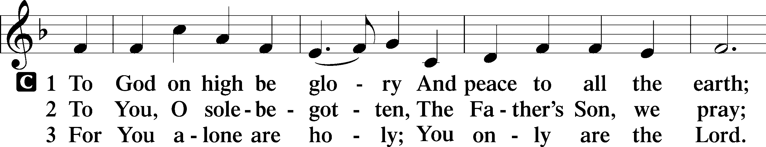
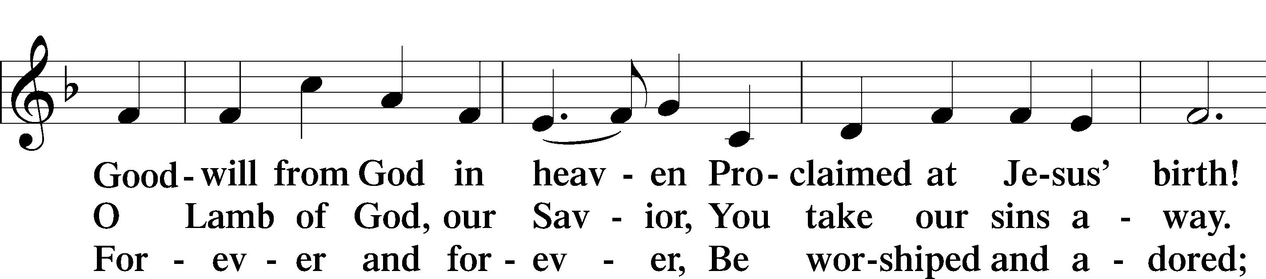
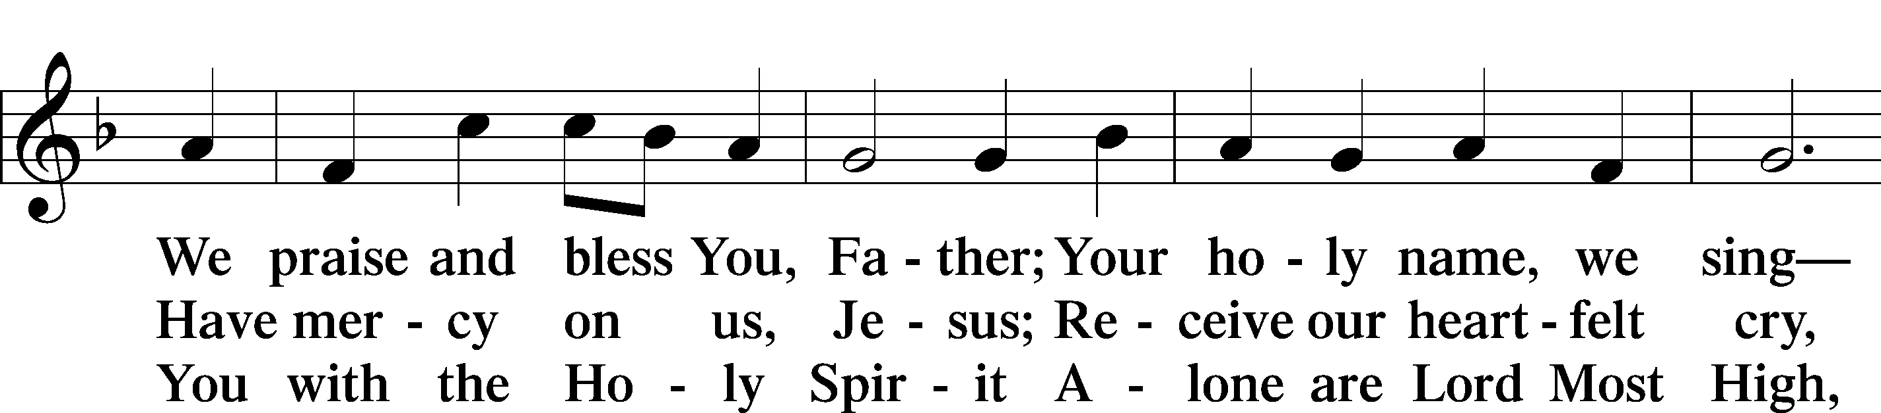
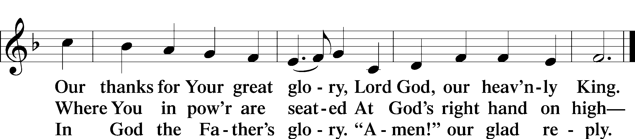

Salutation and Collect of the Day
P The Lord be with you.
C And also with you.

P Let us pray.
Almighty and gracious Lord, pour out Your Holy Spirit on Your faithful people. Keep us steadfast in Your grace and truth, protect and deliver us in times of temptation, defend us against all enemies, and grant to Your Church Your saving peace; through Jesus Christ, Your Son, our Lord, who lives and reigns with You and the Holy Spirit, one God, now and forever.

C Amen.

Sit
First Reading Revelation 14:6–7
6Then I saw another angel flying directly overhead, with an eternal gospel to proclaim to those who dwell on earth, to every nation and tribe and language and people. 7And he said with a loud voice, “Fear God and give him glory, because the hour of his judgment has come, and worship him who made heaven and earth, the sea and the springs of water.”

A This is the Word of the Lord.
C Thanks be to God.

Choir Sings: Soul’s Celebration

Psalm Psalm 46
1God is our refuge and strength,
a very present help in trouble.
2Therefore we will not fear though the earth gives way,
though the mountains be moved into the heart of the sea,
3though its waters roar and foam,
though the mountains tremble at its swelling.
4There is a river whose streams make glad the city of God,
the holy habitation of the Most High.
5God is in the midst of her; she shall not be moved;
God will help her when morning dawns.
6The nations rage, the kingdoms totter;
he utters his voice, the earth melts.
7The Lord of hosts is with us;
the God of Jacob is our fortress.
8Come, behold the works of the Lord,
how he has brought desolations on the earth.
9He makes wars cease to the end of the earth;
he breaks the bow and shatters the spear;
he burns the chariots with fire.
10“Be still, and know that I am God.
I will be exalted among the nations,
I will be exalted in the earth!”
11The Lord of hosts is with us;
the God of Jacob is our fortress.
Epistle Romans 3:19–28
19Now we know that whatever the law says it speaks to those who are under the law, so that every mouth may be stopped, and the whole world may be held accountable to God. 20For by works of the law no human being will be justified in his sight, since through the law comes knowledge of sin.
21But now the righteousness of God has been manifested apart from the law, although the Law and the Prophets bear witness to it— 22the righteousness of God through faith in Jesus Christ for all who believe. For there is no distinction: 23for all have sinned and fall short of the glory of God, 24and are justified by his grace as a gift, through the redemption that is in Christ Jesus, 25whom God put forward as a propitiation by his blood, to be received by faith. This was to show God’s righteousness, because in his divine forbearance he had passed over former sins. 26It was to show his righteousness at the present time, so that he might be just and the justifier of the one who has faith in Jesus.
27Then what becomes of our boasting? It is excluded. By what kind of law? By a law of works? No, but by the law of faith. 28For we hold that one is justified by faith apart from works of the law.

A This is the Word of the Lord.
C Thanks be to God.

Stand

Alleluia and Verse
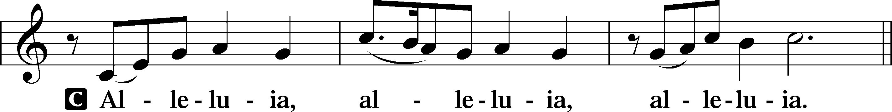
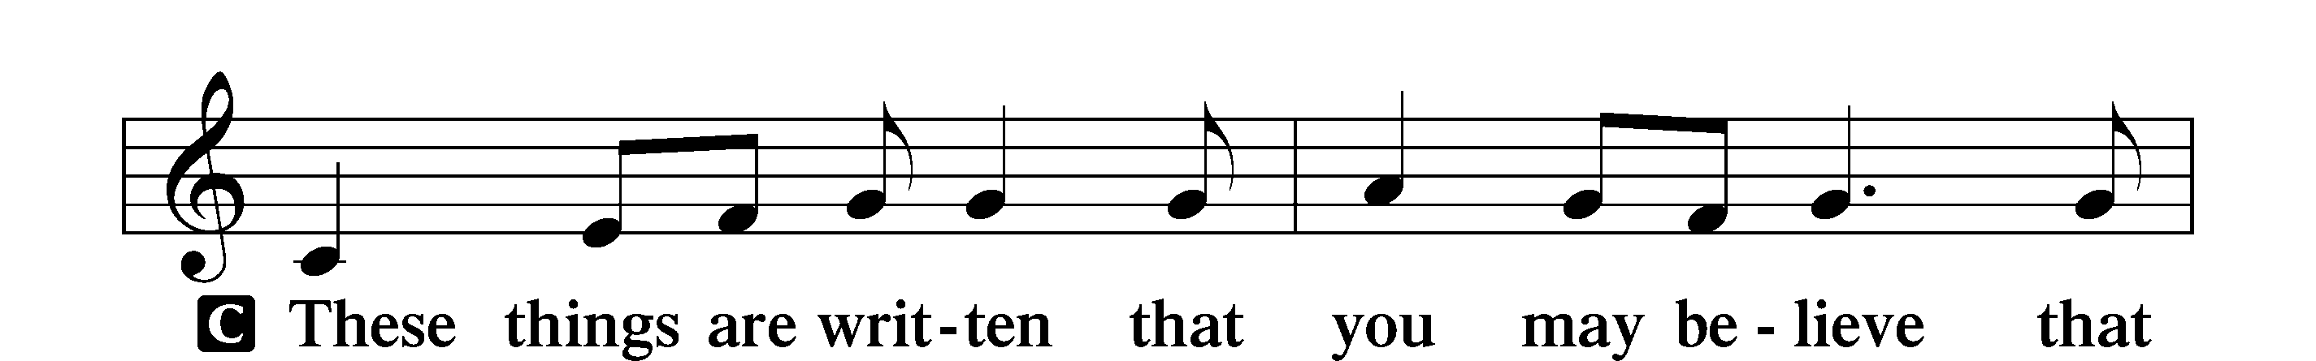
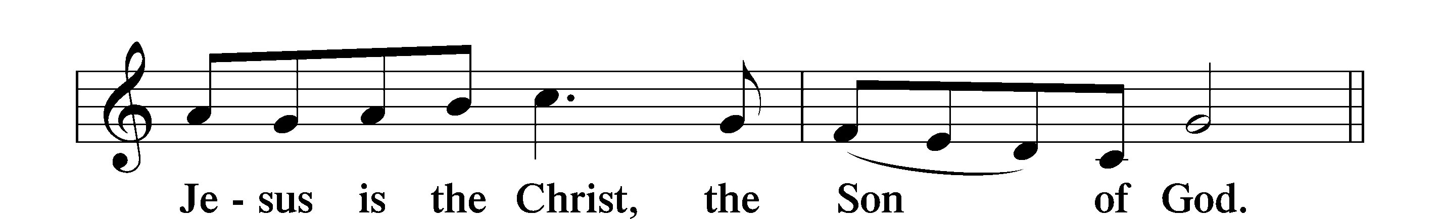
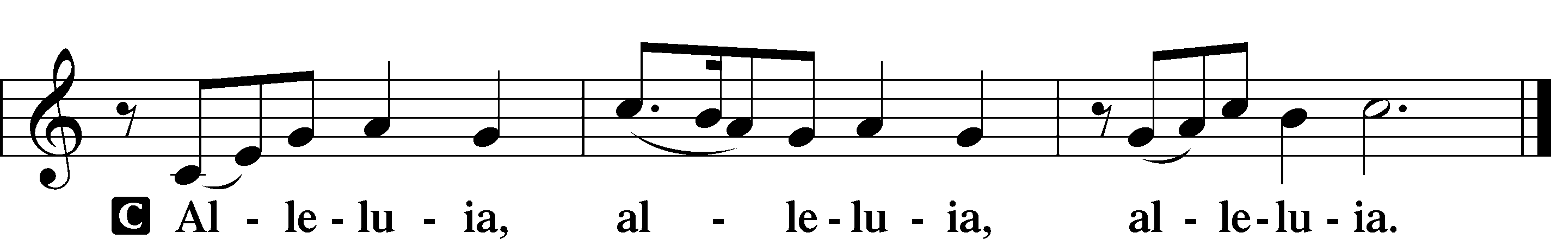
Holy Gospel John 8:31–36
P The Holy Gospel according to St. John, the eighth chapter.
C Glory to You, O Lord.

31So Jesus said to the Jews who had believed in him, “If you abide in my word, you are truly my disciples, 32and you will know the truth, and the truth will set you free.” 33They answered him, “We are offspring of Abraham and have never been enslaved to anyone. How is it that you say, ‘You will become free’?”
34Jesus answered them, “Truly, truly, I say to you, everyone who commits sin is a slave to sin. 35The slave does not remain in the house forever; the son remains forever. 36So if the Son sets you free, you will be free indeed.”

P This is the Gospel of the Lord.
C Praise to You, O Christ.

Nicene Creed
C I believe in one God,
the Father Almighty,
maker of heaven and earth
and of all things visible and invisible.
And in one Lord Jesus Christ,
the only-begotten Son of God,
begotten of His Father before all worlds,
God of God, Light of Light,
very God of very God,
begotten, not made,
being of one substance with the Father,
by whom all things were made;
who for us men and for our salvation came down from heaven
and was incarnate by the Holy Spirit of the virgin Mary
and was made man;
and was crucified also for us under Pontius Pilate.
He suffered and was buried.
And the third day He rose again according to the Scriptures
and ascended into heaven
and sits at the right hand of the Father.
And He will come again with glory to judge both the living and the dead,
whose kingdom will have no end.

And I believe in the Holy Spirit,
the Lord and giver of life,
who proceeds from the Father and the Son,
who with the Father and the Son together is worshiped and glorified,
who spoke by the prophets.
And I believe in one holy Christian and apostolic Church,
I acknowledge one Baptism for the remission of sins,
and I look for the resurrection of the dead
and the life T of the world to come.
Amen.

Sit

656 A Mighty Fortress Is Our God

Sermon

Offering. We generously give our offerings to the LORD out of thanksgiving for His generosity of forgiveness, life, and salvation in Christ (2 Corinthians 9:8). We believe that our offerings are not only to support the proclamation of the Gospel here and around the world, but also to help us all grow in faith and trust in Him (2 Corinthians 9:7). We have placed an offering plate in the narthex so you are able to freely give back to Him as you are able. To Him be all the glory!

Stand

Prayer of the Church

Holy Communion is celebrated in the belief and glad confidence that our Lord gives us not only bread and wine, but the body and blood of Christ from the cross, for us Christian to eat and drink for the forgiveness of sins (Matthew 26:28). Because we are called to examine ourselves before receiving the Lord’s Supper (I Corinthians 11:28-29), we encourage you to consider the questions on pages 329-330 in the hymnal. We also believe that when we commune, we are confessing our unity with the community we join (I Corinthians 10:17). If you desire to commune with us for the first time or have questions, our pastor is happy to speak with you.

Preface
P The Lord be with you.
C And also with you.

P Lift up your hearts.
C We lift them to the Lord.

P Let us give thanks to the Lord our God.
C It is right to give Him thanks and praise.

P It is truly good, right, and salutary that we should at all times and in all places give thanks to You, O Lord, holy Father, almighty and everlasting God, for the countless blessings You so freely bestow on us and all creation. Above all, we give thanks for Your boundless love shown to us when You sent Your only-begotten Son, Jesus Christ, into our flesh and laid on Him our sin, giving Him into death that we might not die eternally. Because He is now risen from the dead and lives and reigns to all eternity, all who believe in Him will overcome sin and death and will rise again to new life. Therefore with angels and archangels and with all the company of heaven we laud and magnify Your glorious name, evermore praising You and saying:

Sanctus
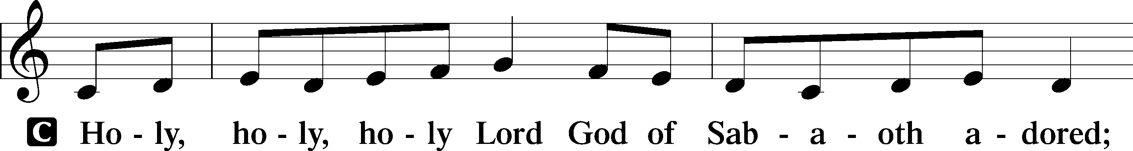
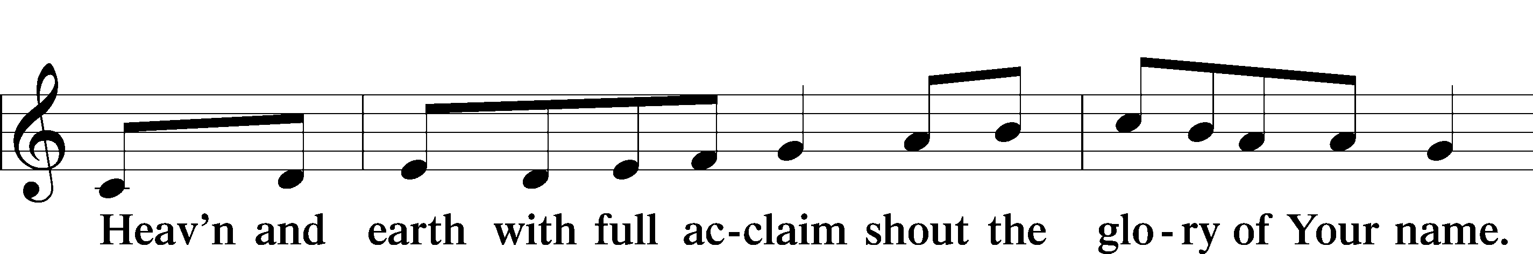
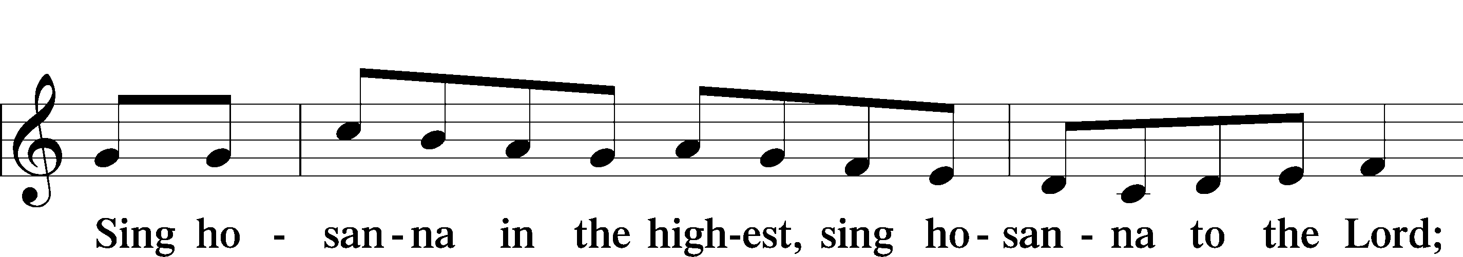
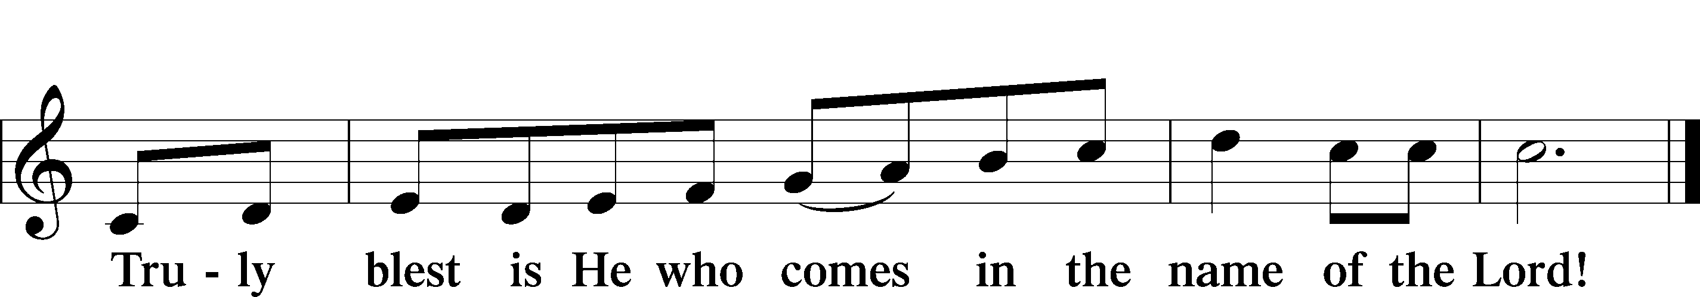

Prayer of Thanksgiving
P Blessed are You, O Lord our God, king of all creation, for You have had mercy on us and given Your only-begotten Son that whoever believes in Him should not perish but have eternal life.

In Your righteous judgment You condemned the sin of Adam and Eve, who ate the forbidden fruit, and You justly barred them and all their children from the tree of life. Yet, in Your great mercy, You promised salvation by a second Adam, Your Son, Jesus Christ, our Lord, and made His cross a life-giving tree for all who trust in Him.

We give You thanks for the redemption You have prepared for us through Jesus Christ. Grant us Your Holy Spirit that we may faithfully eat and drink of the fruits of His cross and receive the blessings of forgiveness, life, and salvation that come to us in His body and blood.

Hear us as we pray in His name and as He has taught us:

Lord’s Prayer

The Words of Our Lord

Pax Domini
P The peace of the Lord be with you always.
C Amen.

Agnus Dei
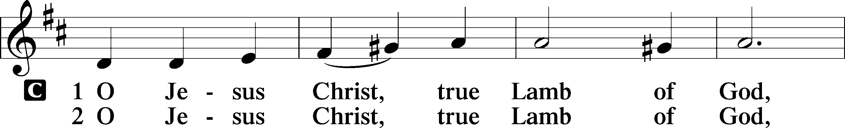
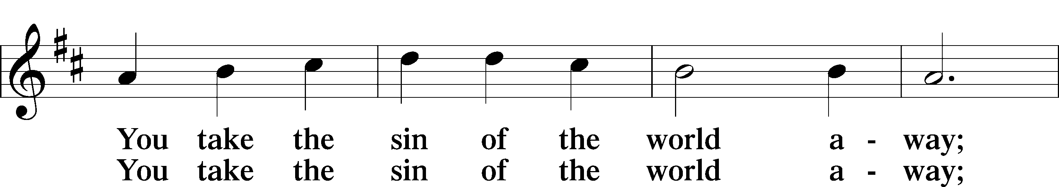
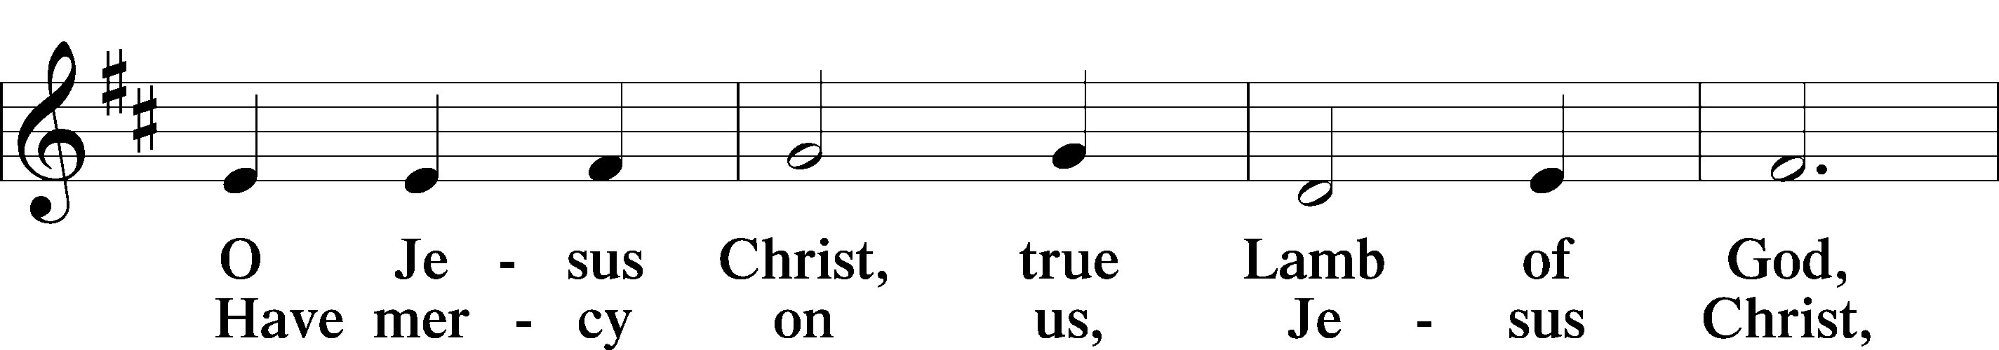
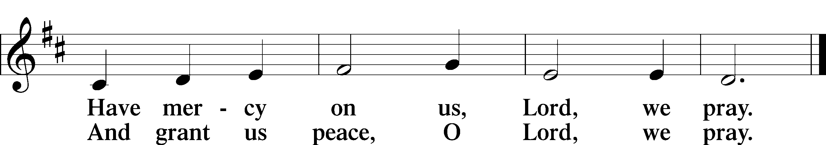
Sit

Distribution

633 At the Lamb’s High Feast We Sing

637 Draw Near and Take the Body of the Lord

Stand

Nunc Dimittis
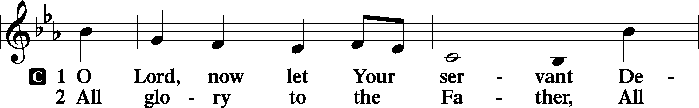
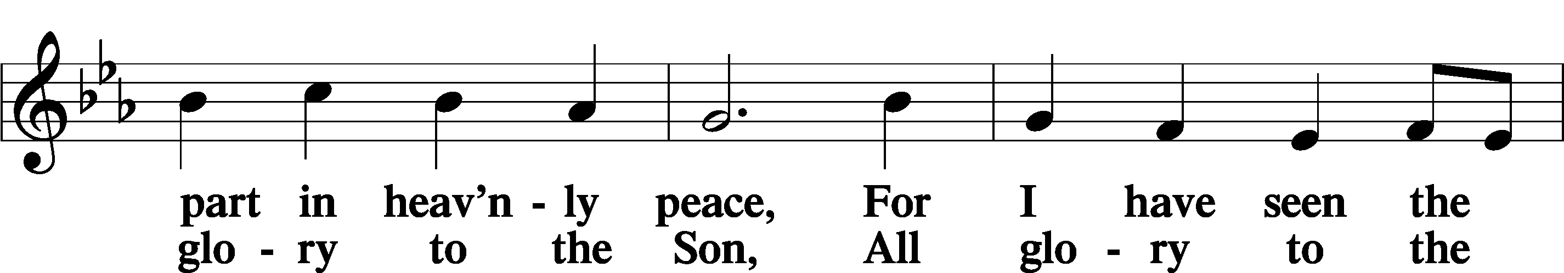
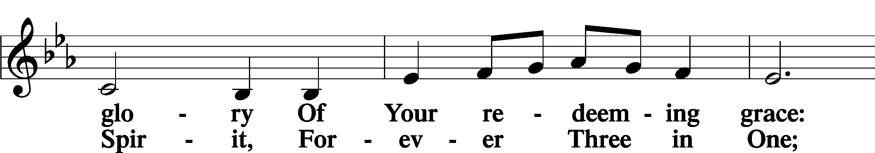
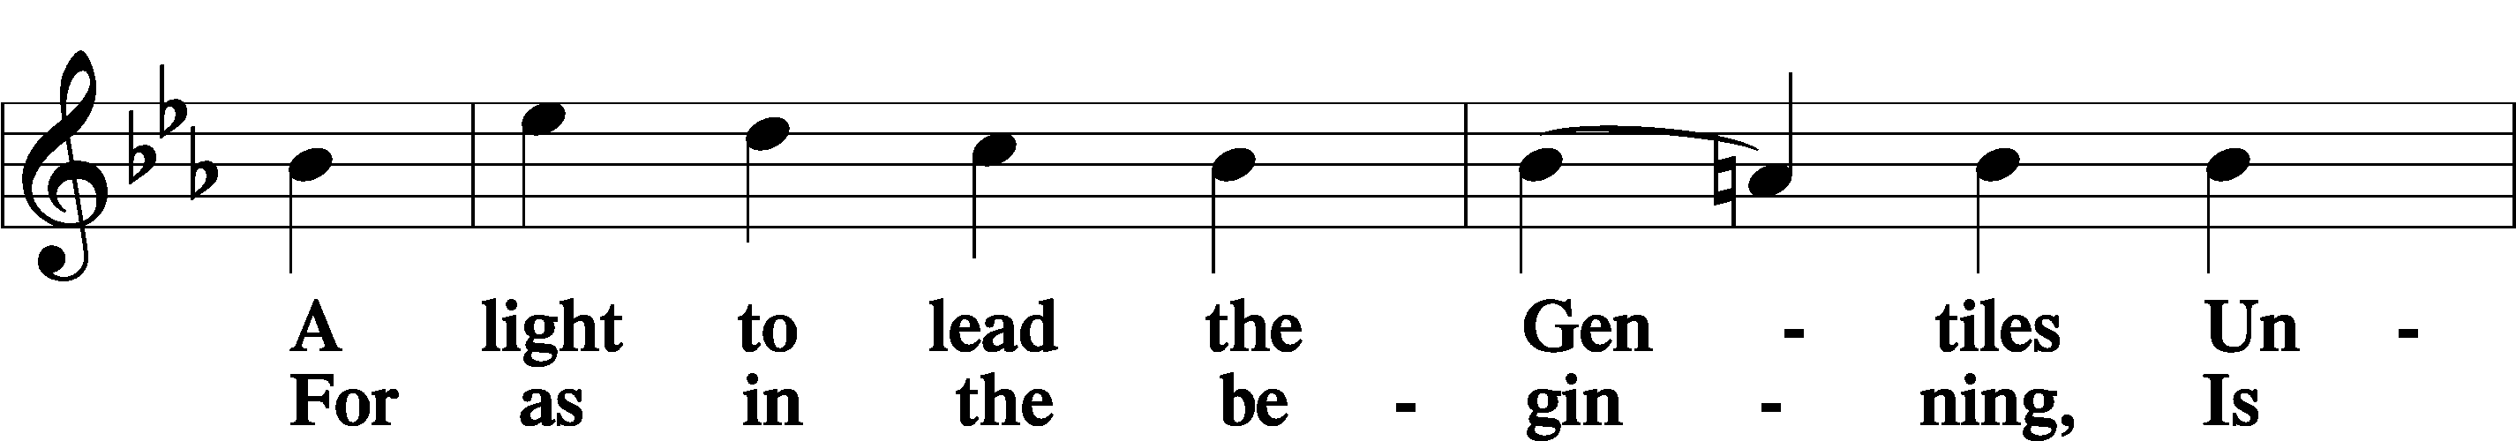
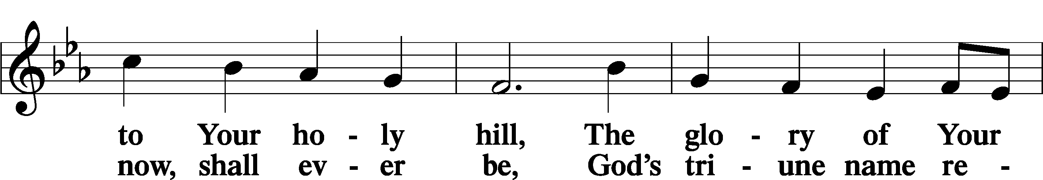
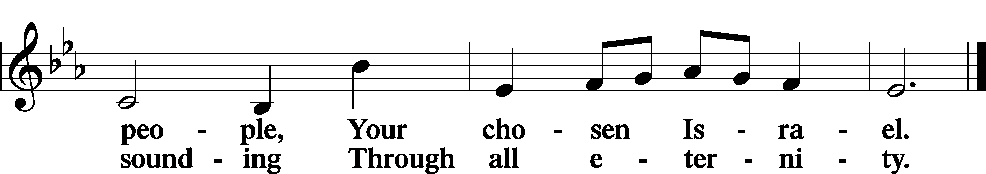

Post-Communion Collect
A Let us pray. We give thanks to You, almighty God, that You have refreshed us through this salutary gift, and we implore You that of Your mercy You would strengthen us through the same in faith toward You and in fervent love toward one another; through Jesus Christ, Your Son, our Lord, who lives and reigns with You and the Holy Spirit, one God, now and forever.
C Amen.

Benedicamus
A Let us bless the Lord.
C Thanks be to God.

Benediction
P The Lord bless you and keep you.
The Lord make His face shine on you and be gracious to you.
The Lord look upon you with favor and T give you peace.
C Amen.

655 Lord, Keep Us Steadfast in Your Word

Announcement:

Please join us this evening for Movie Night at Messiah! We will be showing the
movie “Luther” at 4:00 p.m. The powerful story about faith, courage and the
reformation. Bring your favorite snacks and beverages.



