The Baptism of Our Lord
January 11th, 2026

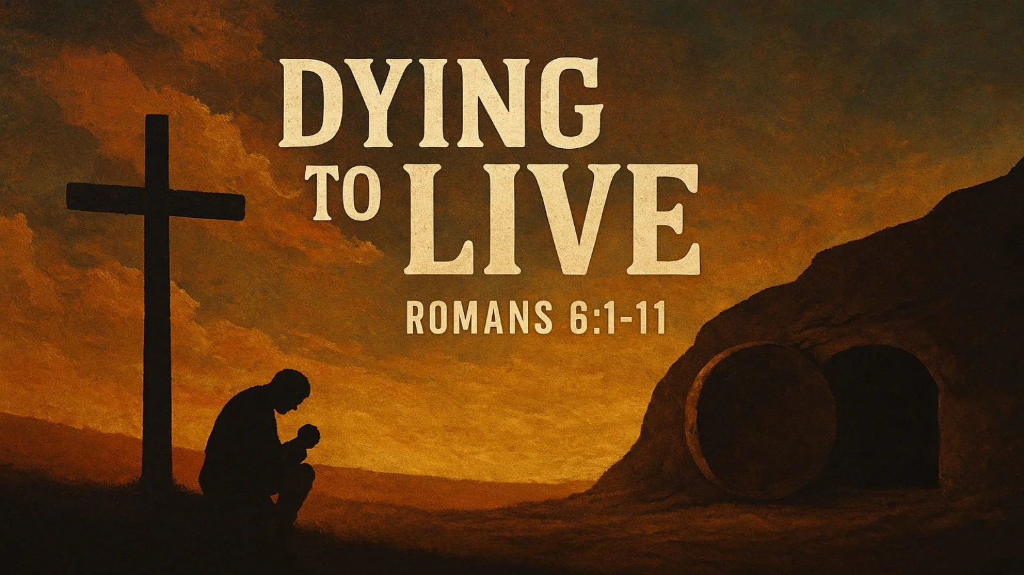

Messiah Lutheran Church
Sartell, MN
www.messiahsartell.com
320-252-5883
Prayer Before Entering
Please take this time to focus on our purpose in gathering and join in prayer before our service begins. Blessed Lord, You have caused all Holy Scriptures to be written for our learning. Grant that we may so hear them, read, mark, learn, and inwardly digest them that, by patience and comfort of Your holy Word, we may embrace and ever hold fast the blessed hope of everlasting life; through Jesus Christ, our Lord.

As We Gather
The First Sunday after the Epiphany takes us in mind and heart to the Jordan River, where Jesus is baptized. This day, observed each year in the Church, is a reminder of the importance of Baptism in the life of every Christian, for it is in dying with Christ through Baptism that we are born anew to eternal life. Although we may have not been baptized in the river Jordan, we share with our Lord the experience of being baptized. Through Baptism, we are connected to Christ and given a whole new way of living for time and for eternity. “But I am baptized!” Martin Luther would exclaim when life situations seemed overwhelming. Knowing that we live daily in baptismal grace makes the difference in our lives as well.

405 To Jordan’s River Came Our Lord

Stand

The sign of the cross may be made by all in remembrance of their Baptism.

P In the name of the Father and of the T Son and of the Holy Spirit.
C Amen.

P Our help is in the name of the Lord,
C who made heaven and earth.

P If You, O Lord, kept a record of sins, O Lord, who could stand?
C But with You there is forgiveness; therefore You are feared.

P Since we are gathered to hear God’s Word, call upon Him in prayer and praise, and receive the body and blood of our Lord Jesus Christ in the fellowship of this altar, let us first consider our unworthiness and confess before God and one another that we have sinned in thought, word, and deed, and that we cannot free ourselves from our sinful condition. Together as His people let us take refuge in the infinite mercy of God, our heavenly Father, seeking His grace for the sake of Christ, and saying:
C God, be merciful to me, a sinner.

Silence for reflection on God’s Word and for self-examination.

C Almighty God, have mercy upon us, forgive us our sins, and lead us to everlasting life. Amen.

P Almighty God in His mercy has given His Son to die for you and for His sake forgives you all your sins. As a called and ordained servant of Christ, and by His authority, I therefore forgive you all your sins in the name of the Father and of the T Son and of the Holy Spirit.

C Amen.

Introit Psalm 2:7–11, 12c; antiphon: Isaiah 42:1a
P Behold my servant, whom I uphold,
my chosen, in whom my soul delights.
C I will tell of the decree:
The Lord said to me, “You are my Son; today I have begotten you.
P Ask of me, and I will make the nations your heritage,
and the ends of the earth your possession.
C You shall break them with a rod of iron
and dash them in pieces like a potter’s vessel.”
P Now therefore, O kings, be wise;
be warned, O rulers of the earth.
C Serve the Lord with fear,
and rejoice with trembling,
P for his wrath is quickly kindled.
Blessèd are all who take refuge in him.
All: Glory be to the Father and to the Son
and to the Holy Spirit;
as it was in the beginning,
is now, and will be forever. Amen.
P Behold my servant, whom I uphold,
my chosen, in whom my soul delights.

Kyrie
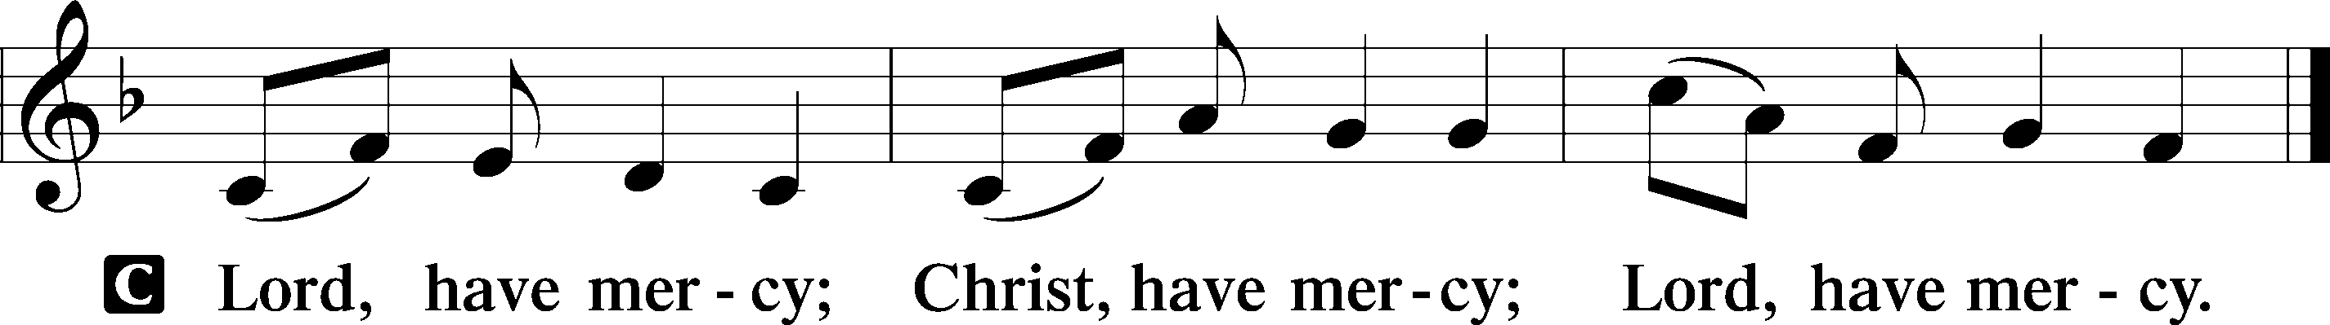

Gloria in Excelsis
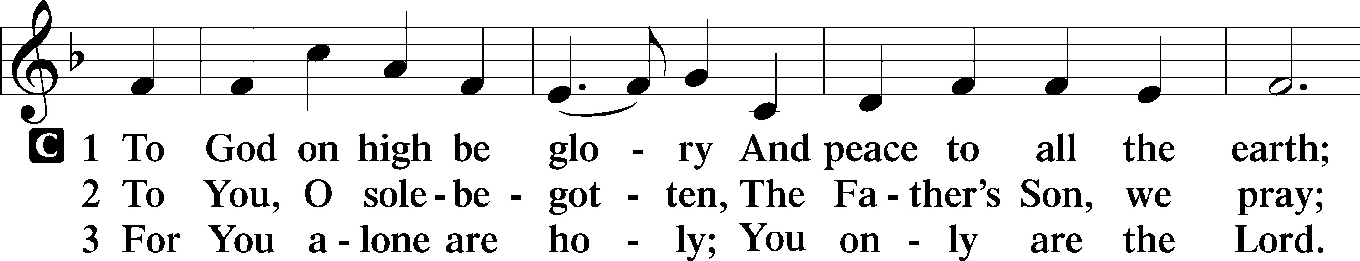
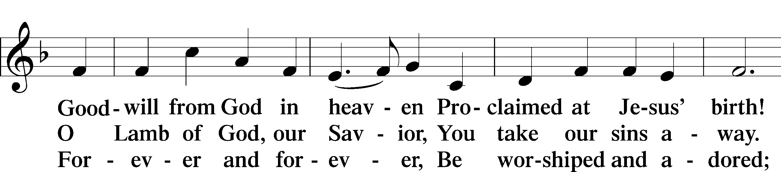
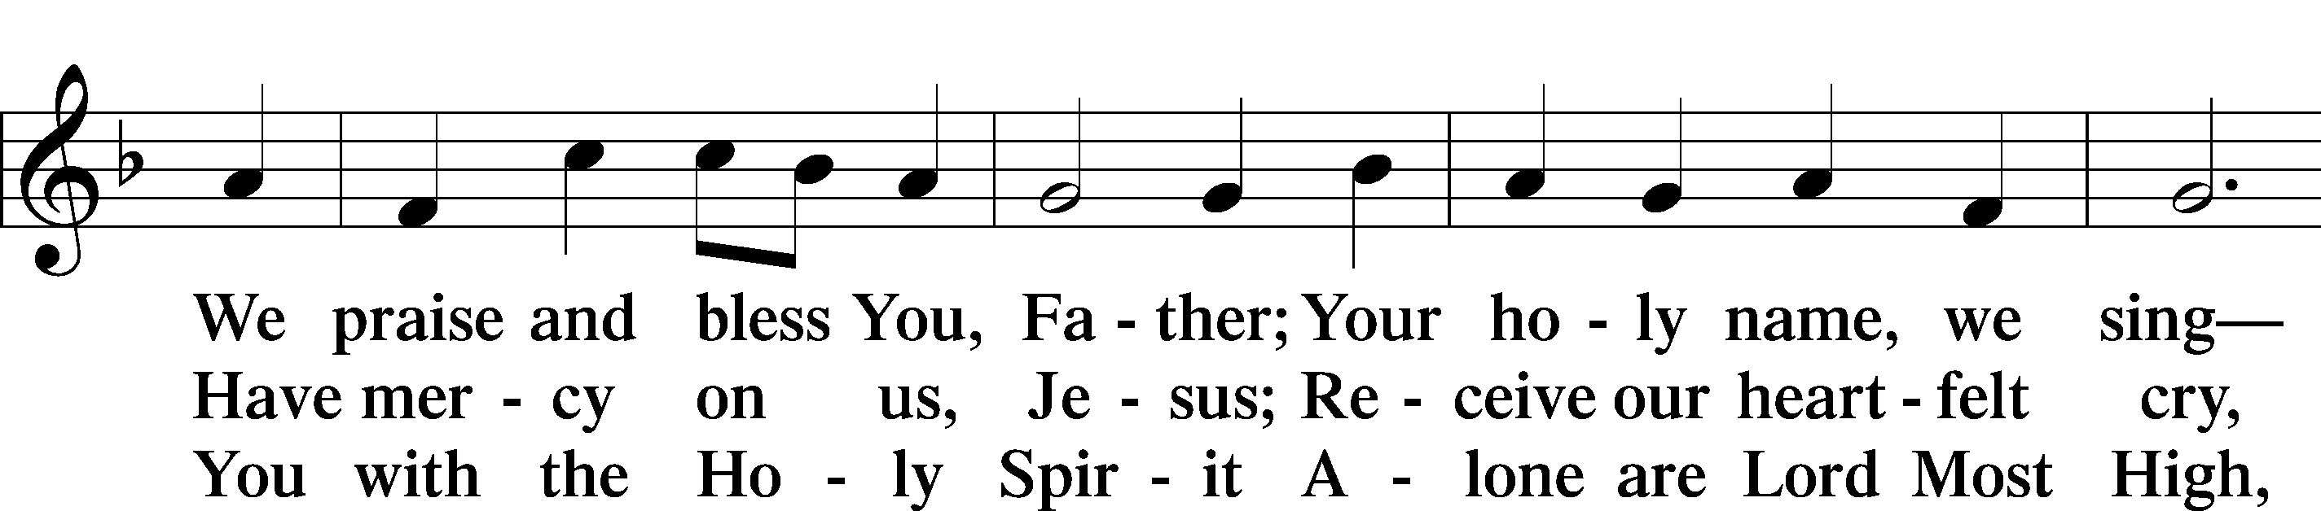
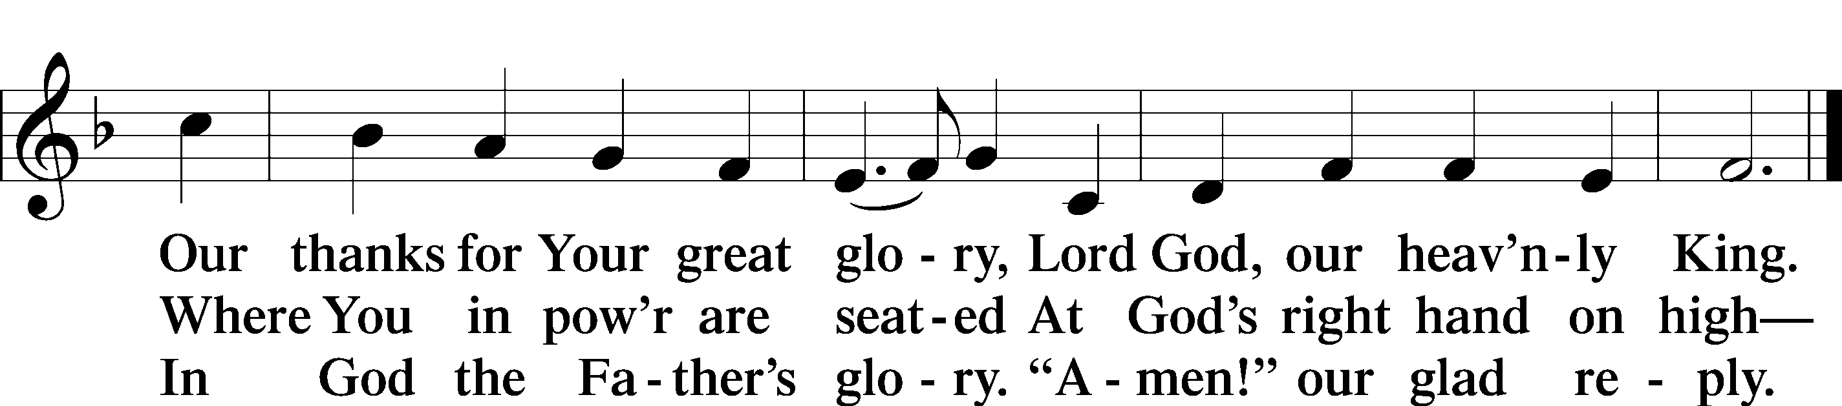

Salutation and Collect of the Day
P The Lord be with you.
C And also with you.

P Let us pray.
Father in heaven, at the Baptism of Jesus in the Jordan River You proclaimed Him Your beloved Son and anointed Him with the Holy Spirit. Make all who are baptized in His name faithful in their calling as Your children and inheritors with Him of everlasting life; through the same Jesus Christ, our Lord, who lives and reigns with You and the Holy Spirit, one God, now and forever.

C Amen.

Sit

Old Testament Reading Isaiah 42:1–9
1Behold my servant, whom I uphold, my chosen, in whom my soul delights; I have put my Spirit upon him; he will bring forth justice to the nations. 2He will not cry aloud or lift up his voice, or make it heard in the street; 3a bruised reed he will not break, and a faintly burning wick he will not quench; he will faithfully bring forth justice. 4He will not grow faint or be discouraged till he has established justice in the earth; and the coastlands wait for his law. 5Thus says God, the Lord, who created the heavens and stretched them out, who spread out the earth and what comes from it, who gives breath to the people on it and spirit to those who walk in it: 6“I am the Lord; I have called you in righteousness; I will take you by the hand and keep you; I will give you as a covenant for the people, a light for the nations, 7to open the eyes that are blind, to bring out the prisoners from the dungeon, from the prison those who sit in darkness. 8I am the Lord; that is my name; my glory I give to no other, nor my praise to carved idols. 9Behold, the former things have come to pass, and new things I now declare; before they spring forth I tell you of them.”

A This is the Word of the Lord.
C Thanks be to God.

Epistle Romans 6:1–11
1What shall we say then? Are we to continue in sin that grace may abound? 2By no means! How can we who died to sin still live in it? 3Do you not know that all of us who have been baptized into Christ Jesus were baptized into his death? 4We were buried therefore with him by baptism into death, in order that, just as Christ was raised from the dead by the glory of the Father, we too might walk in newness of life.
5For if we have been united with him in a death like his, we shall certainly be united with him in a resurrection like his. 6We know that our old self was crucified with him in order that the body of sin might be brought to nothing, so that we would no longer be enslaved to sin. 7For one who has died has been set free from sin. 8Now if we have died with Christ, we believe that we will also live with him. 9We know that Christ being raised from the dead will never die again; death no longer has dominion over him. 10For the death he died he died to sin, once for all, but the life he lives he lives to God. 11So you also must consider yourselves dead to sin and alive to God in Christ Jesus.

A This is the Word of the Lord.
C Thanks be to God.

Stand

Alleluia and Verse
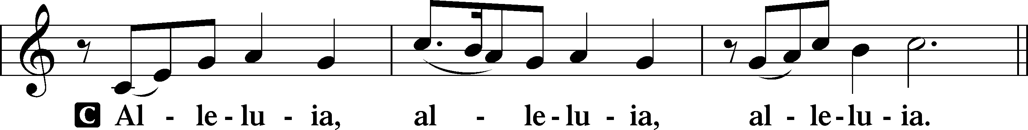
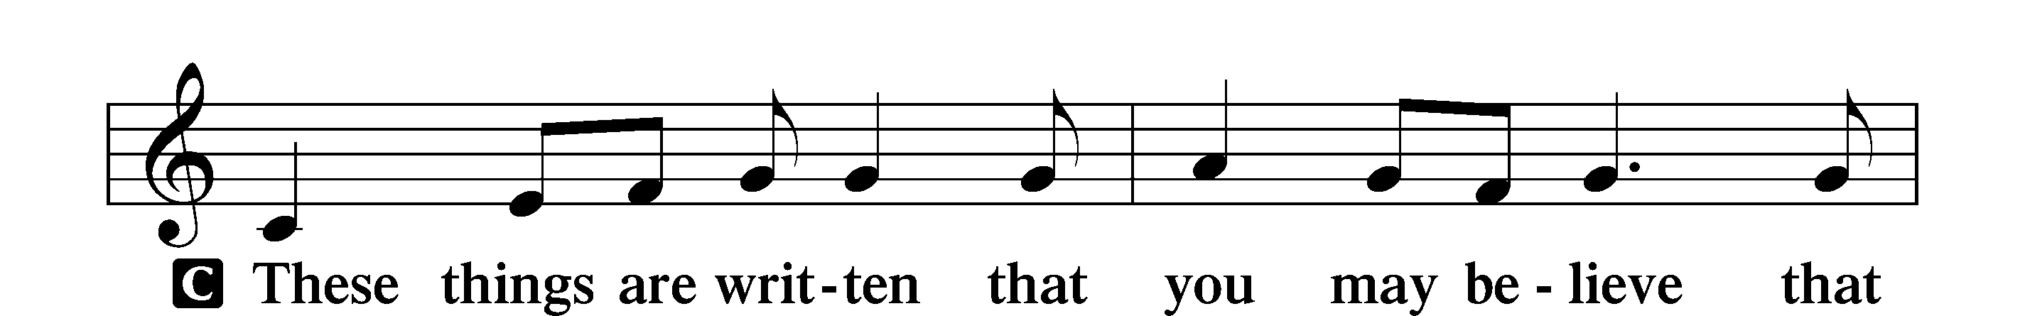
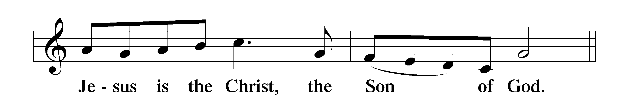
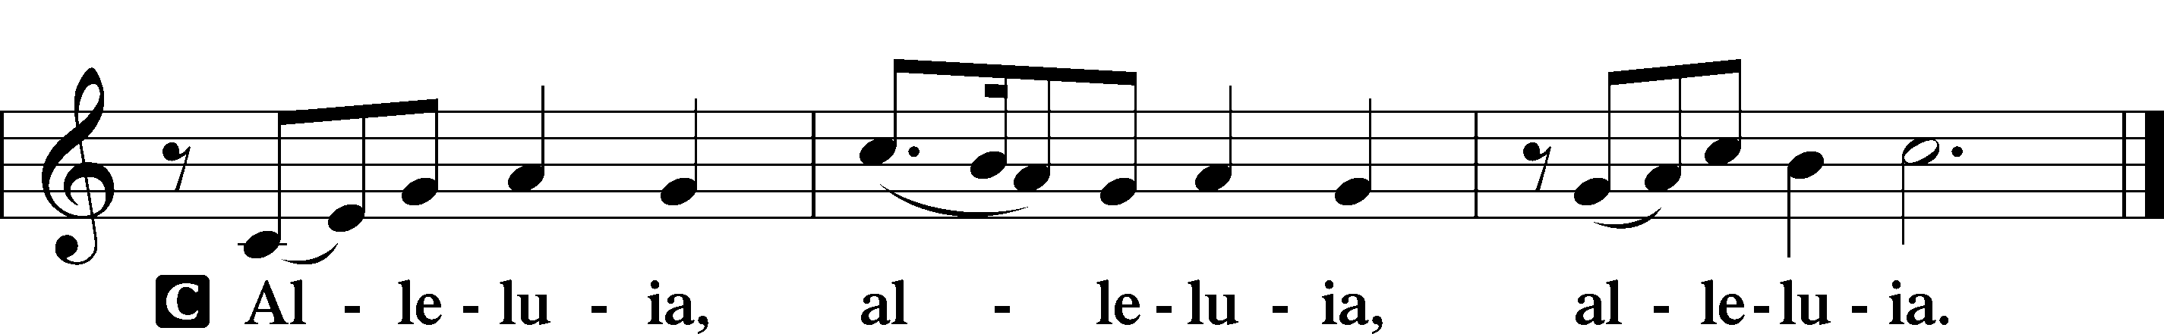

Holy Gospel Matthew 3:13–17
P The Holy Gospel according to St. Matthew, the third chapter.
C Glory to You, O Lord.

13Then Jesus came from Galilee to the Jordan to John, to be baptized by him. 14John would have prevented him, saying, “I need to be baptized by you, and do you come to me?” 15But Jesus answered him, “Let it be so now, for thus it is fitting for us to fulfill all righteousness.” Then he consented. 16And when Jesus was baptized, immediately he went up from the water, and behold, the heavens were opened to him, and he saw the Spirit of God descending like a dove and coming to rest on him; 17and behold, a voice from heaven said, “This is my beloved Son, with whom I am well pleased.”

P This is the Gospel of the Lord.
C Praise to You, O Christ.

Nicene Creed
C I believe in one God,
the Father Almighty,
maker of heaven and earth
and of all things visible and invisible.
And in one Lord Jesus Christ,
the only-begotten Son of God,
begotten of His Father before all worlds,
God of God, Light of Light,
very God of very God,
begotten, not made,
being of one substance with the Father,
by whom all things were made;
who for us men and for our salvation came down from heaven
and was incarnate by the Holy Spirit of the virgin Mary
and was made man;
and was crucified also for us under Pontius Pilate.
He suffered and was buried.
And the third day He rose again according to the Scriptures
and ascended into heaven
and sits at the right hand of the Father.
And He will come again with glory to judge both the living and the dead,
whose kingdom will have no end.

And I believe in the Holy Spirit,
the Lord and giver of life,
who proceeds from the Father and the Son,
who with the Father and the Son together is worshiped and glorified,
who spoke by the prophets.

And I believe in one holy Christian and apostolic Church,
I acknowledge one Baptism for the remission of sins,
and I look for the resurrection of the dead
and the life T of the world to come.

Amen.

Sit

404 Jesus, Once with Sinners Numbered

Sermon

Offering. We generously give our offerings to the LORD out of thanksgiving for His generosity of forgiveness, life, and salvation in Christ (2 Corinthians 9:8). We believe that our offerings are not only to support the proclamation of the Gospel here and around the world, but also to help us all grow in faith and trust in Him (2 Corinthians 9:7). We have placed an offering plate in the narthex so you are able to freely give back to Him as you are able. To Him be all the glory!

Stand

Prayer of the Church

Holy Communion is celebrated in the belief and glad confidence that our Lord gives us not only bread and wine, but the body and blood of Christ from the cross, for us Christian to eat and drink for the forgiveness of sins (Matthew 26:28). Because we are called to examine ourselves before receiving the Lord’s Supper (I Corinthians 11:28-29), we encourage you to consider the questions on pages 329-330 in the hymnal. We also believe that when we commune, we are confessing our unity with the community we join (I Corinthians 10:17). If you desire to commune with us for the first time or have questions, our pastor is happy to speak with you.

Preface
P The Lord be with you.
C And also with you.

P Lift up your hearts.
C We lift them to the Lord.

P Let us give thanks to the Lord our God.
C It is right to give Him thanks and praise.

P It is truly good, right, and salutary that we should at all times and in all places give thanks to You, O Lord, holy Father, almighty and everlasting God, for the countless blessings You so freely bestow on us and all creation. Above all, we give thanks for Your boundless love shown to us when You sent Your only-begotten Son, Jesus Christ, into our flesh and laid on Him our sin, giving Him into death that we might not die eternally. Because He is now risen from the dead and lives and reigns to all eternity, all who believe in Him will overcome sin and death and will rise again to new life. Therefore with angels and archangels and with all the company of heaven we laud and magnify Your glorious name, evermore praising You and saying:

Sanctus
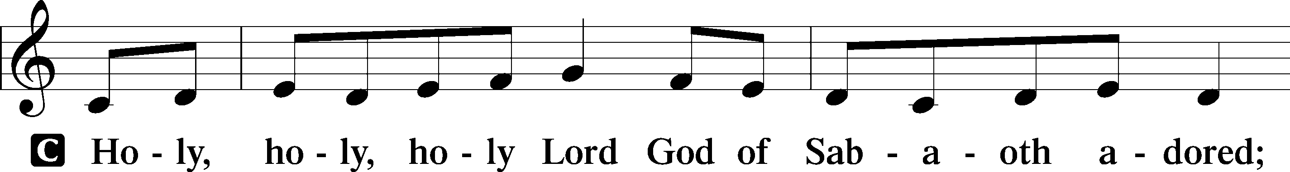
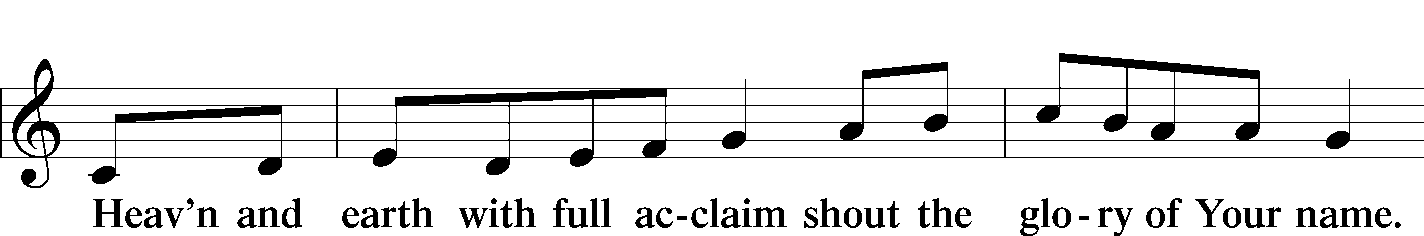
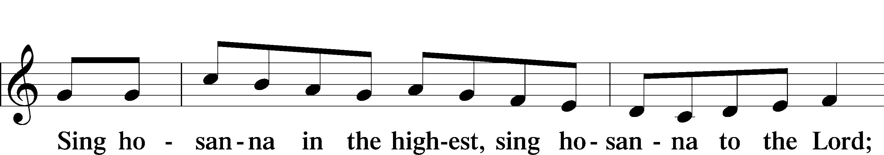
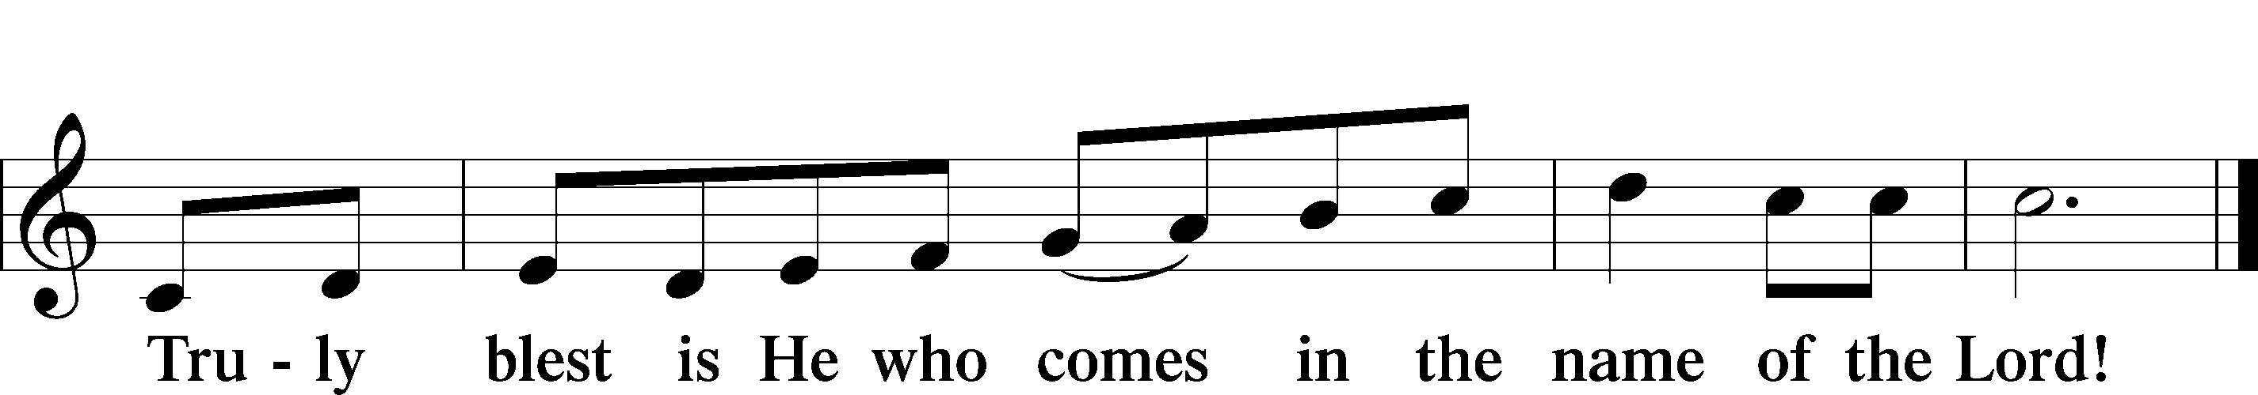

Prayer of Thanksgiving
P Blessed are You, O Lord our God, king of all creation, for You have had mercy on us and given Your only-begotten Son that whoever believes in Him should not perish but have eternal life.

As the glory of Your presence once filled Your ancient temple, so in the incarnation of Your Son, Jesus Christ, You manifested the fullness of Your glory in human flesh.
We give You thanks that in His most Holy Supper You reveal Your glory to us. Grant us faithfully to eat His body and drink His blood so that we may one day behold Your glory face to face.

Hear us as we pray in His name and as He has taught us:

Lord’s Prayer

The Words of Our Lord

Pax Domini
P The peace of the Lord be with you always.
C Amen.

Agnus Dei
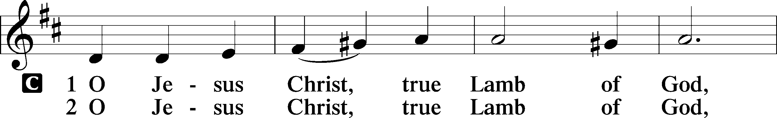
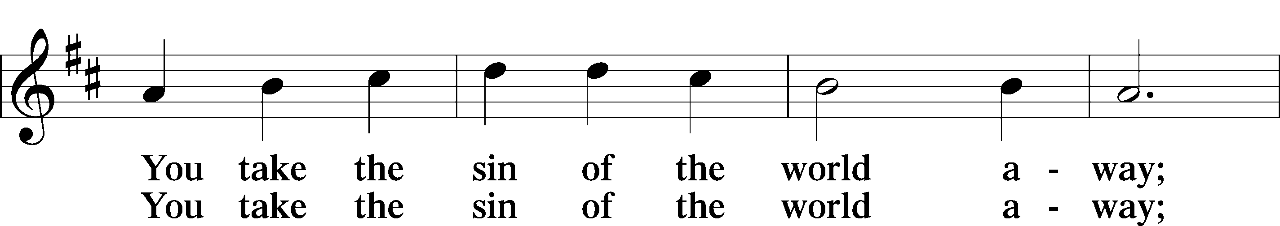
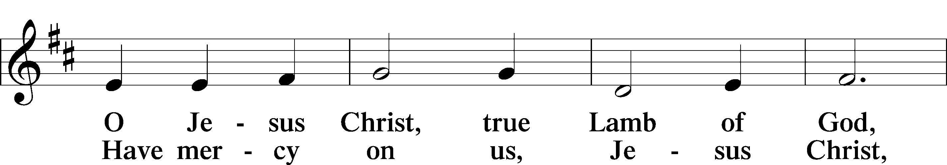
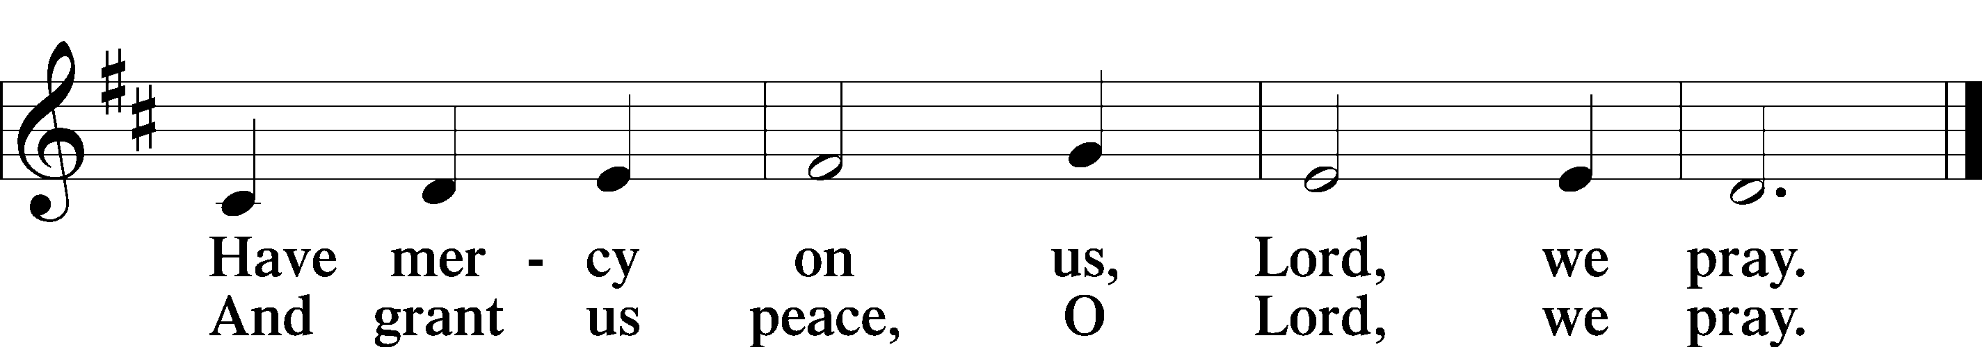

Sit

Distribution

602 The Gifts Christ Freely Gives

637 Draw Near and Take the Body of the Lord

Stand
Nunc Dimittis
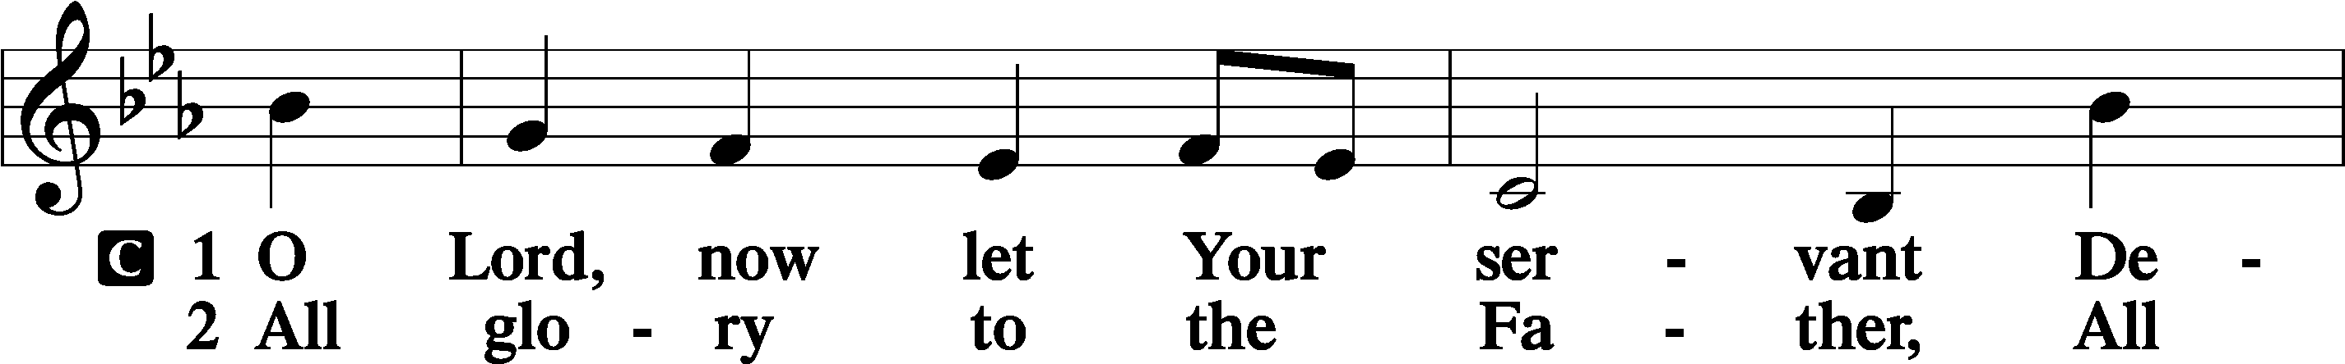
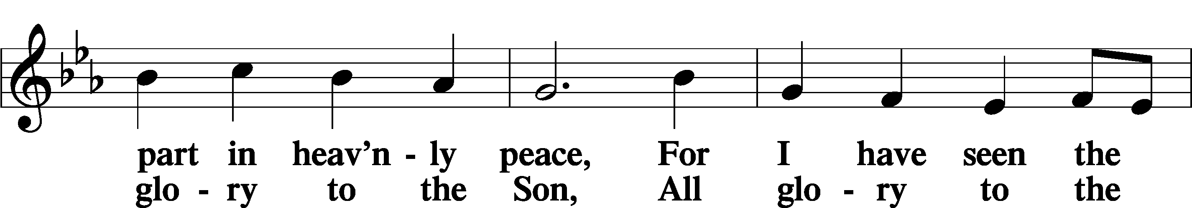
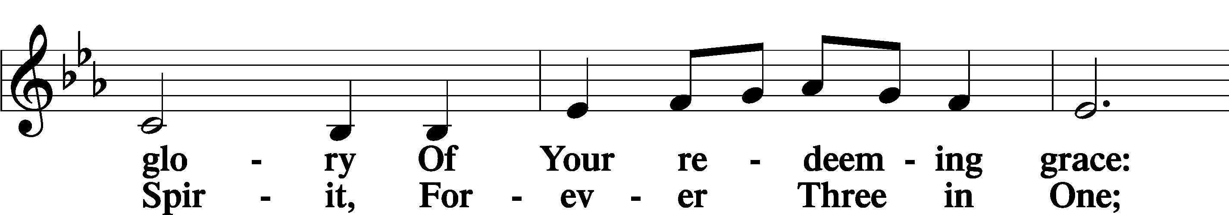
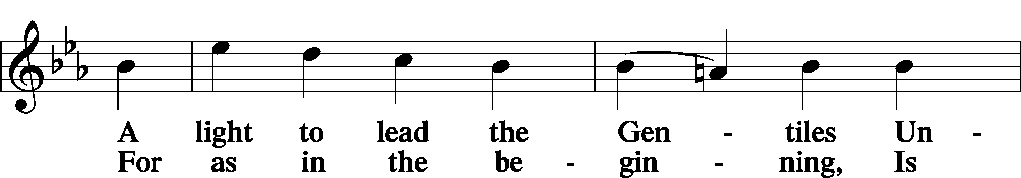
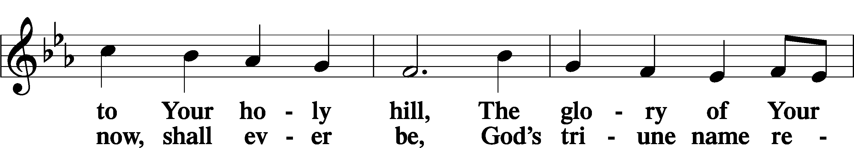
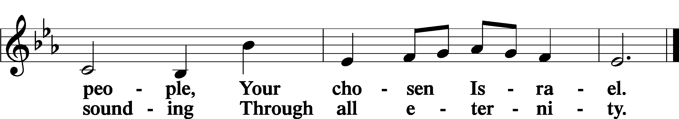

Post-Communion Collect
A Let us pray. We give thanks to You, almighty God, that You have refreshed us through this salutary gift, and we implore You that of Your mercy You would strengthen us through the same in faith toward You and in fervent love toward one another; through Jesus Christ, Your Son, our Lord, who lives and reigns with You and the Holy Spirit, one God, now and forever.
C Amen.

Benedicamus
A Let us bless the Lord.
C Thanks be to God.

Benediction
P The Lord bless you and keep you.
The Lord make His face shine on you and be gracious to you.
The Lord look upon you with favor and T give you peace.

C Amen.

594 God’s Own Child, I Gladly Say It

For the Kids

