11th Sunday After Pentecost
August 9th, 2026

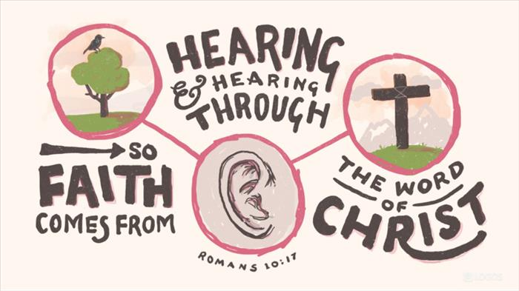

Messiah Lutheran Church
Sartell, MN
www.messiahsartell.com
320-252-5883
Prayer Before Entering
Please take this time to focus on our purpose in gathering and join in prayer before our service begins. Blessed Lord, You have caused all Holy Scriptures to be written for our learning. Grant that we may so hear them, read, mark, learn, and inwardly digest them that, by patience and comfort of Your holy Word, we may embrace and ever hold fast the blessed hope of everlasting life; through Jesus Christ, our Lord.

As We Gather
Faith comes from hearing, and hearing through the Word of Christ. In Romans 10, St. Paul teaches that righteousness does not come through our own efforts or by lowering God’s Law to something we can accomplish. The Law cannot save sinners; only Christ can. Therefore, the Church must never exchange the clear proclamation of Jesus Christ crucified and risen for moral advice, social messages, or the idea that our actions alone can preach the Gospel. God gives faith through His spoken Word—the good news that Christ has fulfilled the Law, died for all sinners, and risen again for our salvation. As we hear this Gospel again and again, the Holy Spirit creates and strengthens faith in our hearts and opens our mouths to confess Jesus as Lord.

578 Thy Strong Word

Stand

The sign of the cross may be made by all in remembrance of their Baptism.

P In the name of the Father and of the T Son and of the Holy Spirit.
C Amen.

P Our help is in the name of the Lord,
C who made heaven and earth.

P If You, O Lord, kept a record of sins, O Lord, who could stand?
C But with You there is forgiveness; therefore You are feared.

P Since we are gathered to hear God’s Word, call upon Him in prayer and praise, and receive the body and blood of our Lord Jesus Christ in the fellowship of this altar, let us first consider our unworthiness and confess before God and one another that we have sinned in thought, word, and deed, and that we cannot free ourselves from our sinful condition. Together as His people let us take refuge in the infinite mercy of God, our heavenly Father, seeking His grace for the sake of Christ, and saying:
C God, be merciful to me, a sinner.
Silence for reflection on God’s Word and for self-examination.

C Almighty God, have mercy upon us, forgive us our sins, and lead us to everlasting life. Amen.

P Almighty God in His mercy has given His Son to die for you and for His sake forgives you all your sins. As a called and ordained servant of Christ, and by His authority, I therefore forgive you all your sins in the name of the Father and of the T Son and of the Holy Spirit.

C Amen.

Introit Psalm 34:4–8; antiphon: v. 1
P I will bless the Lord at all times;
his praise shall continually be in my mouth.
C I sought the Lord, and he answered me
and delivered me from all my fears.
P Those who look to him are radiant,
and their faces shall never be ashamed.
C This poor man cried, and the Lord heard him
and saved him out of all his troubles.
P The angel of the Lord encamps around those who fear him,
and delivers them.
C Oh, taste and see that the Lord is good!
Blessèd is the man who takes refuge in him!
All: Glory be to the Father and to the Son
and to the Holy Spirit;
as it was in the beginning,
is now, and will be forever. Amen.
P I will bless the Lord at all times;
his praise shall continually be in my mouth.

Kyrie
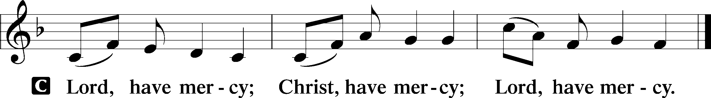

Gloria in Excelsis
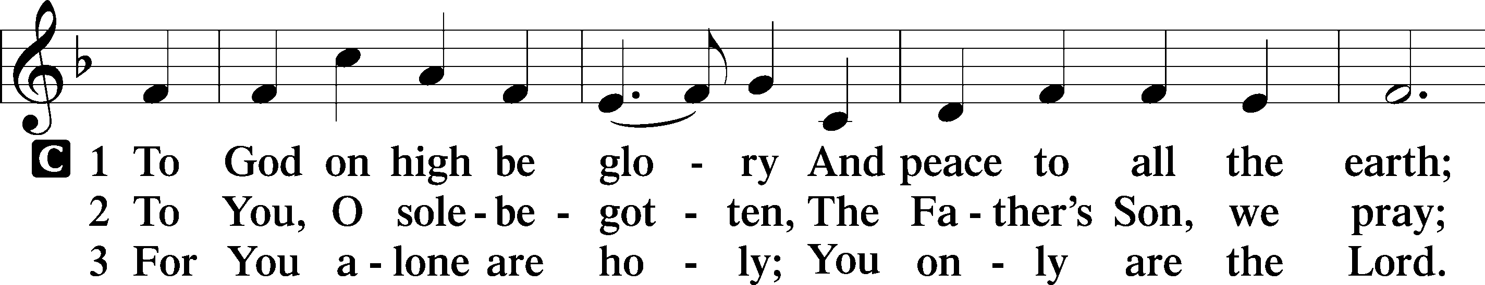
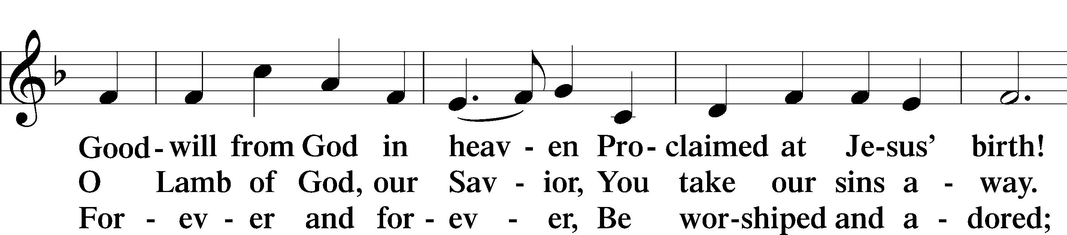
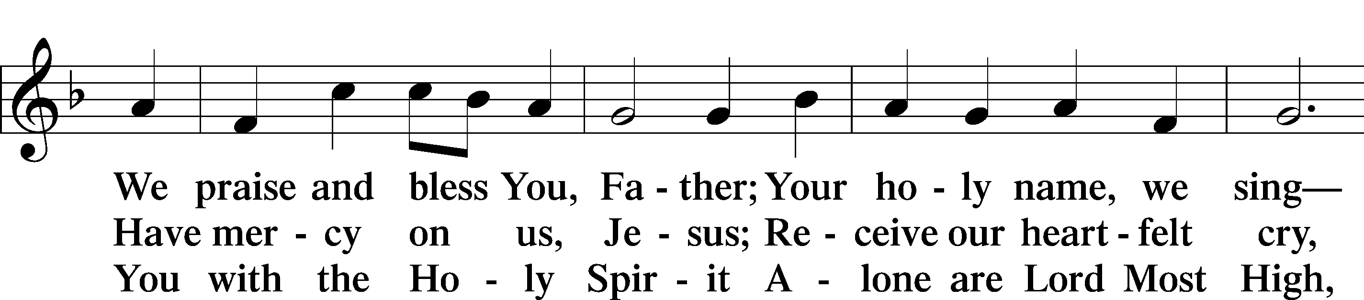
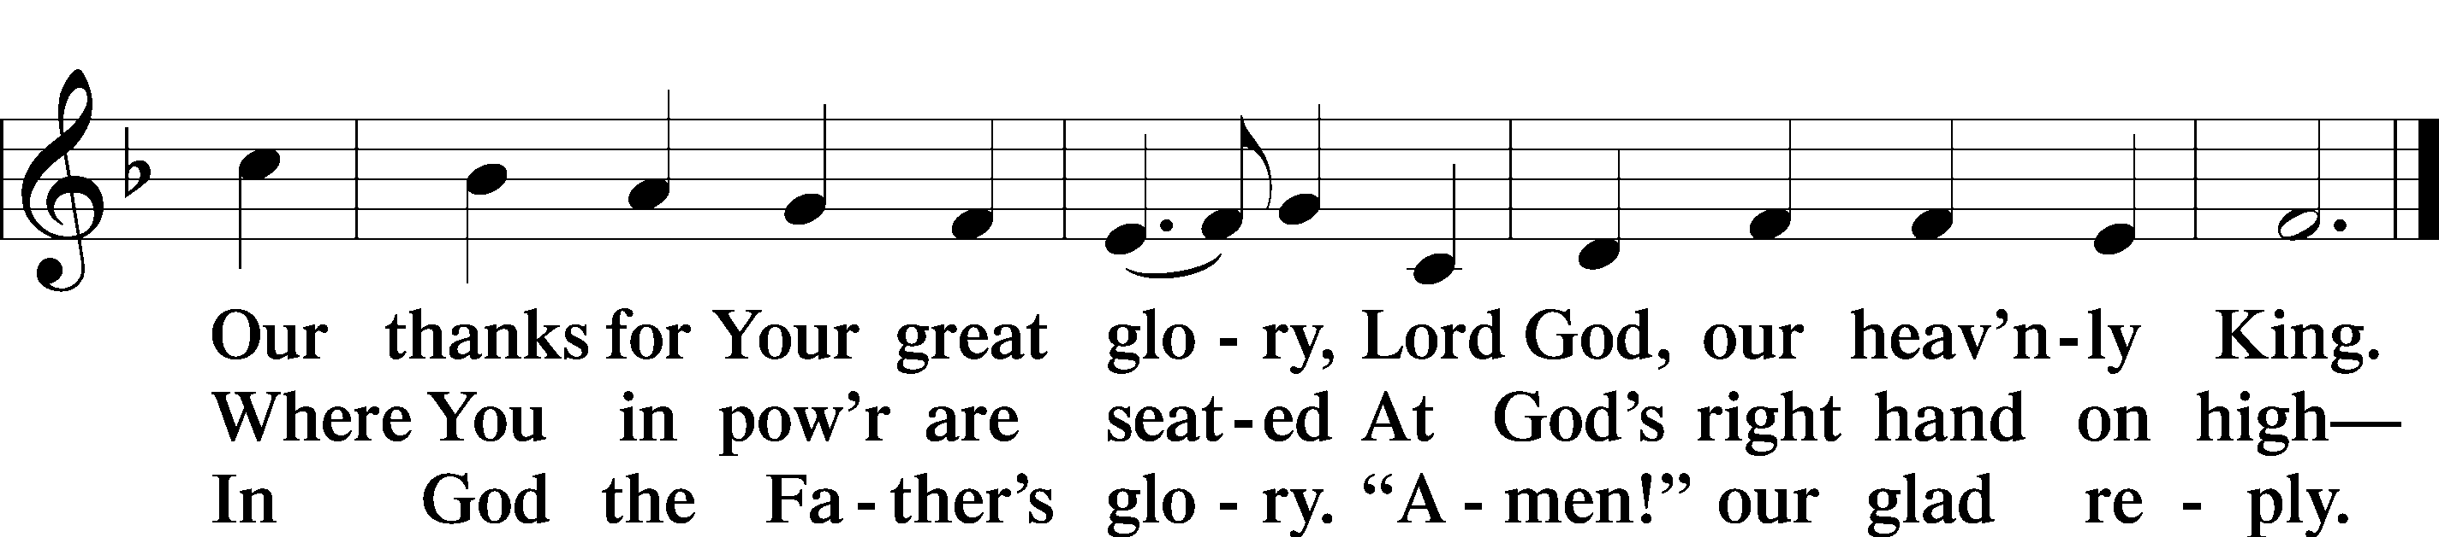

Salutation and Collect of the Day
P The Lord be with you.
C And also with you.

P Let us pray.
Almighty and most merciful God, preserve us from all harm and danger that we, being ready in both body and soul, may cheerfully accomplish what You want done; through Jesus Christ, Your Son, our Lord, who lives and reigns with You and the Holy Spirit, one God, now and forever.

C Amen.

Sit
Old Testament Reading Job 38:4–18
4[The Lord said to Job:] “Where were you when I laid the foundation of the earth? Tell me, if you have understanding. 5Who determined its measurements—surely you know! Or who stretched the line upon it?
6On what were its bases sunk, or who laid its cornerstone, 7when the morning stars sang together and all the sons of God shouted for joy?
8“Or who shut in the sea with doors when it burst out from the womb,
9when I made clouds its garment and thick darkness its swaddling band, 10and prescribed limits for it and set bars and doors, 11and said, ‘Thus far shall you come, and no farther, and here shall your proud waves be stayed’? 12“Have you commanded the morning since your days began, and caused the dawn to know its place, 13that it might take hold of the skirts of the earth, and the wicked be shaken out of it? 14It is changed like clay under the seal, and its features stand out like a garment. 15From the wicked their light is withheld, and their uplifted arm is broken. 16“Have you entered into the springs of the sea, or walked in the recesses of the deep? 17Have the gates of death been revealed to you, or have you seen the gates of deep darkness? 18Have you comprehended the expanse of the earth? Declare, if you know all this.”

A This is the Word of the Lord.
C Thanks be to God.

Epistle Romans 10:5–17
5Moses writes about the righteousness that is based on the law, that the person who does the commandments shall live by them. 6But the righteousness based on faith says, “Do not say in your heart, ‘Who will ascend into heaven?’” (that is, to bring Christ down) 7or “‘Who will descend into the abyss?’” (that is, to bring Christ up from the dead). 8But what does it say? “The word is near you, in your mouth and in your heart” (that is, the word of faith that we proclaim); 9because, if you confess with your mouth that Jesus is Lord and believe in your heart that God raised him from the dead, you will be saved. 10For with the heart one believes and is justified, and with the mouth one confesses and is saved. 11For the Scripture says, “Everyone who believes in him will not be put to shame.” 12For there is no distinction between Jew and Greek; the same Lord is Lord of all, bestowing his riches on all who call on him. 13For “everyone who calls on the name of the Lord will be saved.”
14But how are they to call on him in whom they have not believed? And how are they to believe in him of whom they have never heard? And how are they to hear without someone preaching? 15And how are they to preach unless they are sent? As it is written, “How beautiful are the feet of those who preach the good news!” 16But they have not all obeyed the gospel. For Isaiah says, “Lord, who has believed what he has heard from us?” 17So faith comes from hearing, and hearing through the word of Christ.

A This is the Word of the Lord.
C Thanks be to God.

Stand

Alleluia and Verse
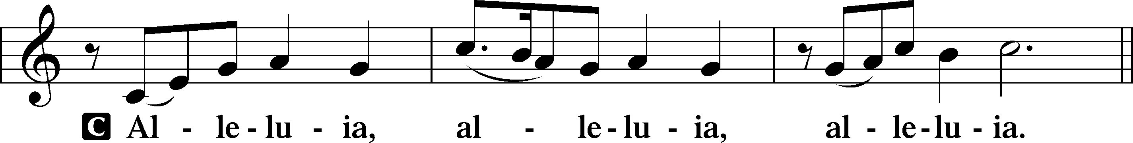
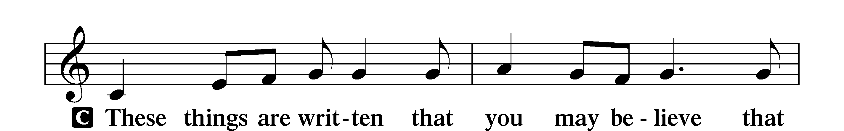
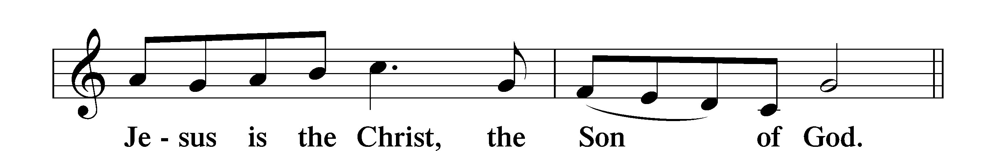
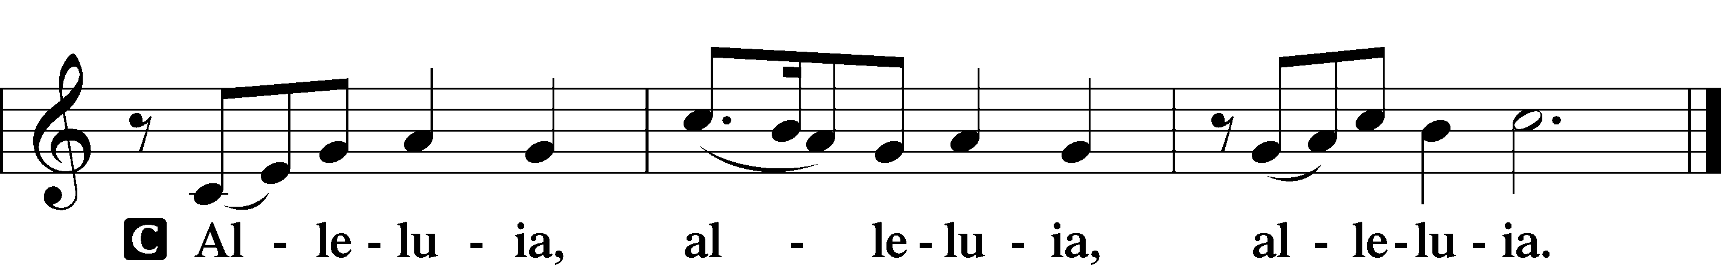

Holy Gospel Matthew 14:22–33
P The Holy Gospel according to St. Matthew, the fourteenth chapter.
C Glory to You, O Lord.

22Immediately [Jesus] made the disciples get into the boat and go before him to the other side, while he dismissed the crowds. 23And after he had dismissed the crowds, he went up on the mountain by himself to pray. When evening came, he was there alone, 24but the boat by this time was a long way from the land, beaten by the waves, for the wind was against them. 25And in the fourth watch of the night he came to them, walking on the sea. 26But when the disciples saw him walking on the sea, they were terrified, and said, “It is a ghost!” and they cried out in fear. 27But immediately Jesus spoke to them, saying, “Take heart; it is I. Do not be afraid.”
28And Peter answered him, “Lord, if it is you, command me to come to you on the water.” 29He said, “Come.” So Peter got out of the boat and walked on the water and came to Jesus. 30But when he saw the wind, he was afraid, and beginning to sink he cried out, “Lord, save me.” 31Jesus immediately reached out his hand and took hold of him, saying to him, “O you of little faith, why did you doubt?” 32And when they got into the boat, the wind ceased. 33And those in the boat worshiped him, saying, “Truly you are the Son of God.”

P This is the Gospel of the Lord.
C Praise to You, O Christ.

Nicene Creed
C I believe in one God,
the Father Almighty,
maker of heaven and earth
and of all things visible and invisible.
And in one Lord Jesus Christ,
the only-begotten Son of God,
begotten of His Father before all worlds,
God of God, Light of Light,
very God of very God,
begotten, not made,
being of one substance with the Father,
by whom all things were made;
who for us men and for our salvation came down from heaven
and was incarnate by the Holy Spirit of the virgin Mary
and was made man;
and was crucified also for us under Pontius Pilate.
He suffered and was buried.
And the third day He rose again according to the Scriptures
and ascended into heaven
and sits at the right hand of the Father.
And He will come again with glory to judge both the living and the dead,
whose kingdom will have no end.

And I believe in the Holy Spirit,
the Lord and giver of life,
who proceeds from the Father and the Son,
who with the Father and the Son together is worshiped and glorified,
who spoke by the prophets.
And I believe in one holy Christian and apostolic Church,
I acknowledge one Baptism for the remission of sins,
and I look for the resurrection of the dead
and the life T of the world to come.
Amen.
Sit

831 “How Shall They Hear,” Who Have Not Heard

Sermon

Offering. We generously give our offerings to the LORD out of thanksgiving for His generosity of forgiveness, life, and salvation in Christ (2 Corinthians 9:8). We believe that our offerings are not only to support the proclamation of the Gospel here and around the world, but also to help us all grow in faith and trust in Him (2 Corinthians 9:7). We have placed an offering plate in the narthex so you are able to freely give back to Him as you are able. To Him be all the glory!
Stand

Prayer of the Church

Holy Communion is celebrated in the belief and glad confidence that our Lord gives us not only bread and wine, but the body and blood of Christ from the cross, for us Christian to eat and drink for the forgiveness of sins (Matthew 26:28). Because we are called to examine ourselves before receiving the Lord’s Supper (I Corinthians 11:28-29), we encourage you to consider the questions on pages 329-330 in the hymnal. We also believe that when we commune, we are confessing our unity with the community we join (I Corinthians 10:17). If you desire to commune with us for the first time or have questions, our pastor is happy to speak with you.

Preface
P The Lord be with you.
C And also with you.

P Lift up your hearts.
C We lift them to the Lord.

P Let us give thanks to the Lord our God.
C It is right to give Him thanks and praise.

P It is truly good, right, and salutary that we should at all times and in all places give thanks to You, O Lord, holy Father, almighty and everlasting God, for the countless blessings You so freely bestow on us and all creation. Above all, we give thanks for Your boundless love shown to us when You sent Your only-begotten Son, Jesus Christ, into our flesh and laid on Him our sin, giving Him into death that we might not die eternally. Because He is now risen from the dead and lives and reigns to all eternity, all who believe in Him will overcome sin and death and will rise again to new life. Therefore with angels and archangels and with all the company of heaven we laud and magnify Your glorious name, evermore praising You and saying:

Sanctus
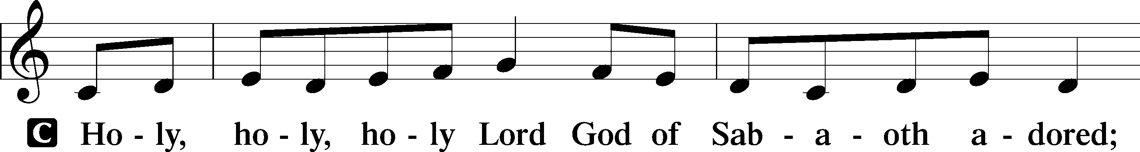
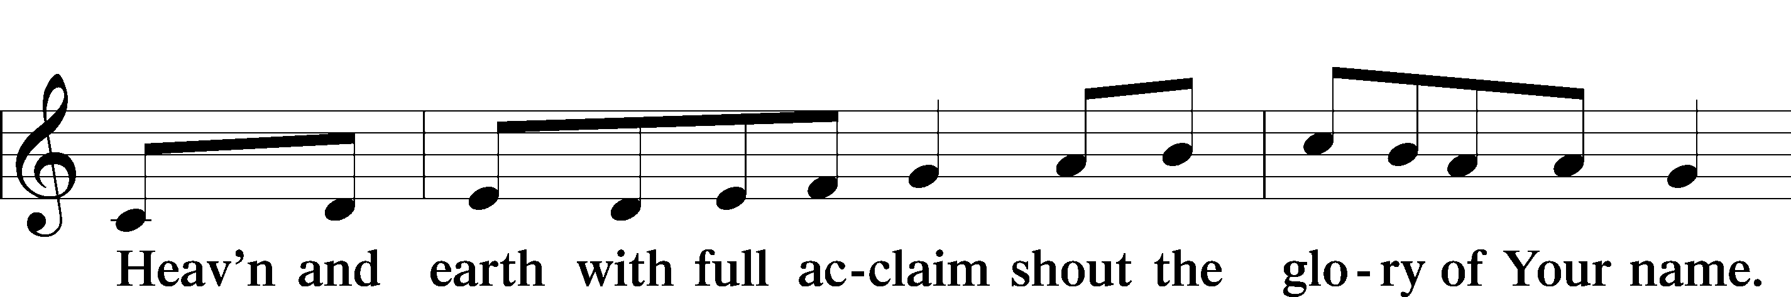
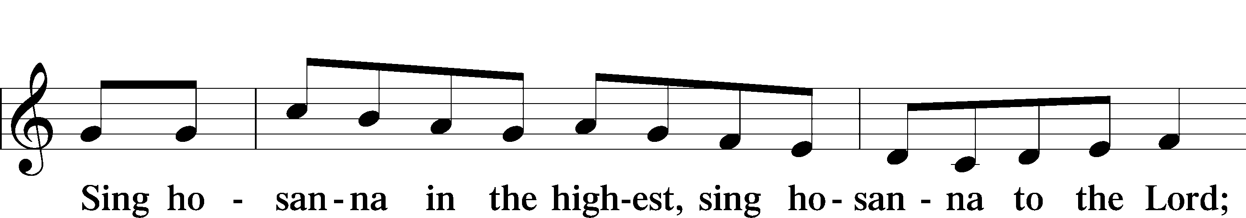
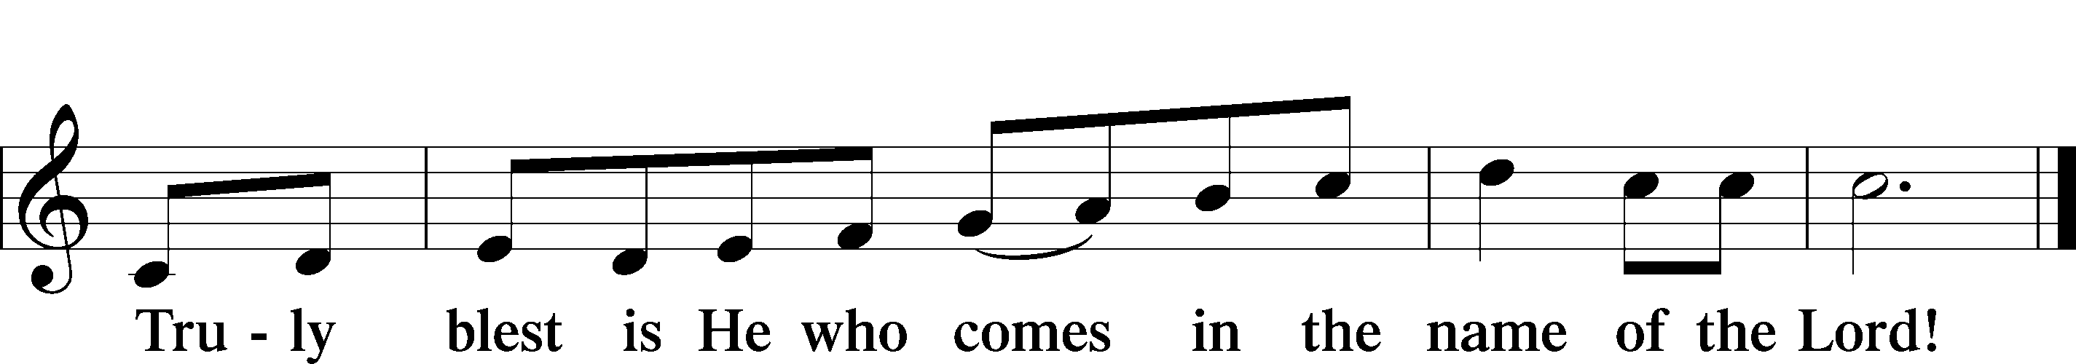

Prayer of Thanksgiving
P Blessed are You, O Lord our God, king of all creation, for You have had mercy on us and given Your only-begotten Son that whoever believes in Him should not perish but have eternal life.

In Your righteous judgment You condemned the sin of Adam and Eve, who ate the forbidden fruit, and You justly barred them and all their children from the tree of life. Yet, in Your great mercy, You promised salvation by a second Adam, Your Son, Jesus Christ, our Lord, and made His cross a life-giving tree for all who trust in Him.
We give You thanks for the redemption You have prepared for us through Jesus Christ. Grant us Your Holy Spirit that we may faithfully eat and drink of the fruits of His cross and receive the blessings of forgiveness, life, and salvation that come to us in His body and blood.

Hear us as we pray in His name and as He has taught us:

Lord’s Prayer

The Words of Our Lord

Pax Domini
P The peace of the Lord be with you always.
C Amen.

Agnus Dei
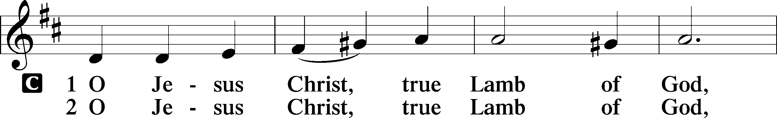
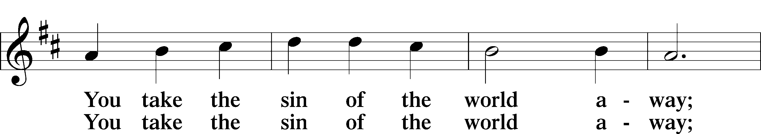
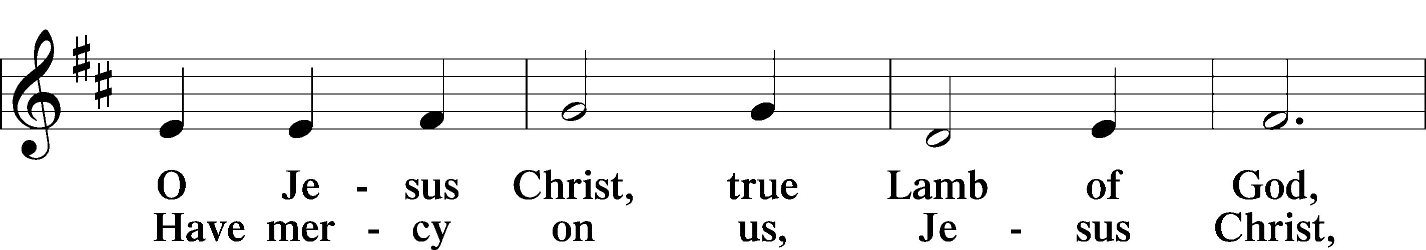
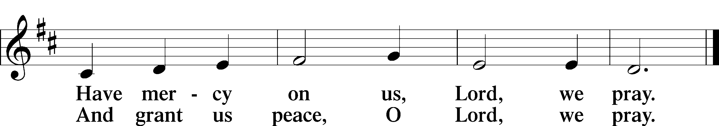

Sit

Distribution
622 Lord Jesus Christ, You Have Prepared
629 What Is This Bread

Stand
Nunc Dimittis
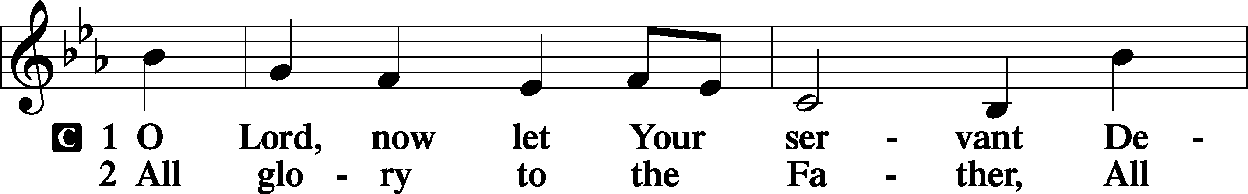
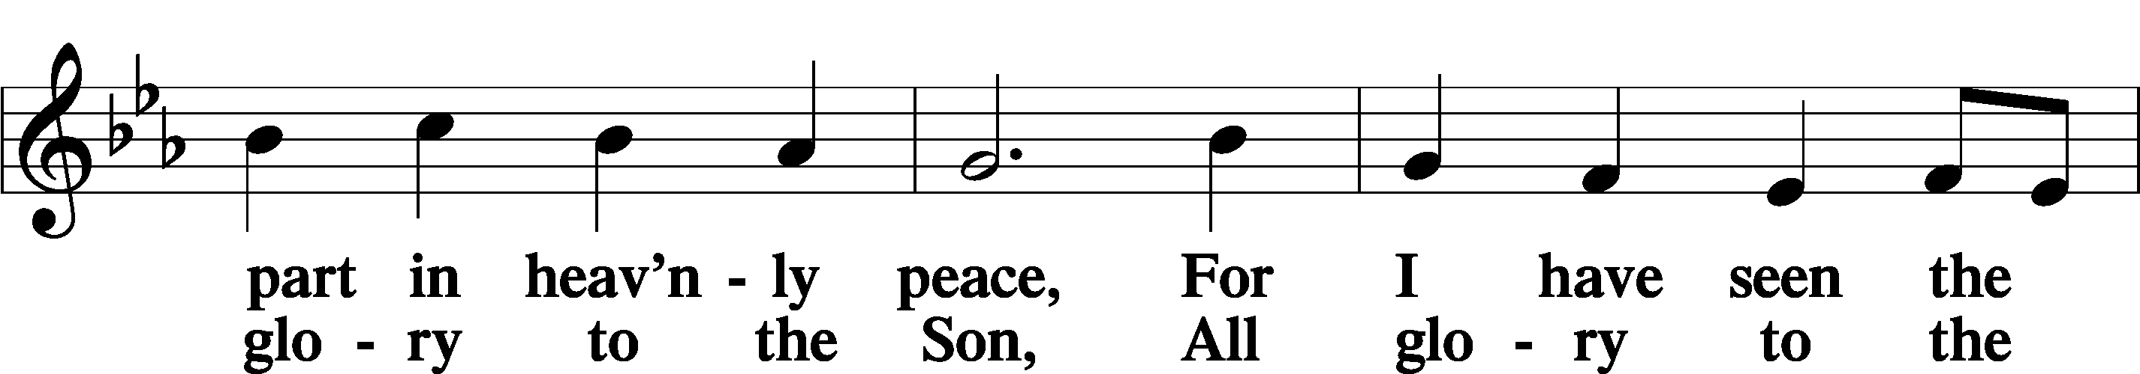
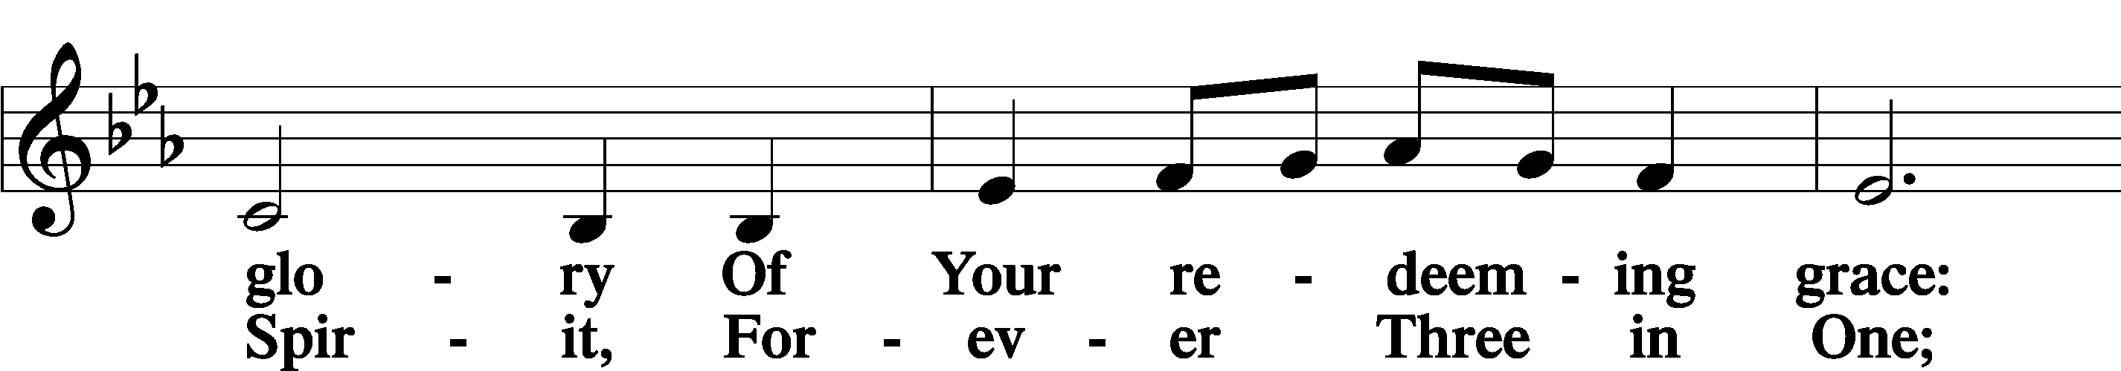
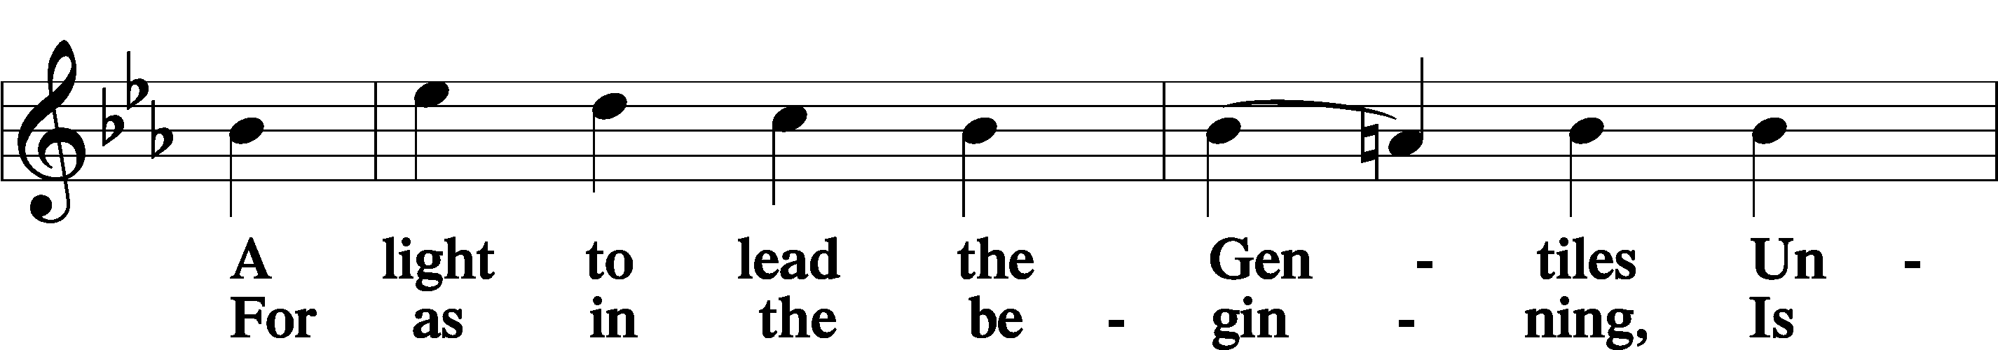
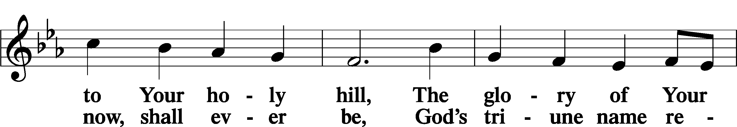
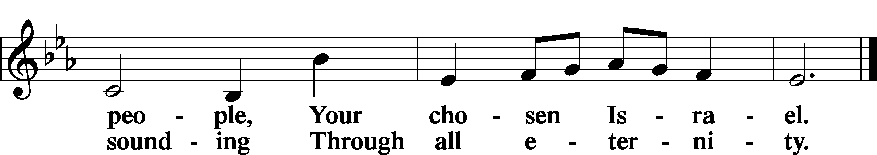

Post-Communion Collect
A Let us pray. We give thanks to You, almighty God, that You have refreshed us through this salutary gift, and we implore You that of Your mercy You would strengthen us through the same in faith toward You and in fervent love toward one another; through Jesus Christ, Your Son, our Lord, who lives and reigns with You and the Holy Spirit, one God, now and forever.
C Amen.

Benedicamus
A Let us bless the Lord.
C Thanks be to God.

Benediction
P The Lord bless you and keep you.
The Lord make His face shine on you and be gracious to you.
The Lord look upon you with favor and T give you peace.

C Amen.

588 Jesus Loves Me sts. 1, ref, 2

Announcement

Thanks be to God! We have received enough funds to cover
the costs of the parking lot lights and seal coating.
Thank you for your generosity!

