Third Sunday in Lent
March 8th, 2026

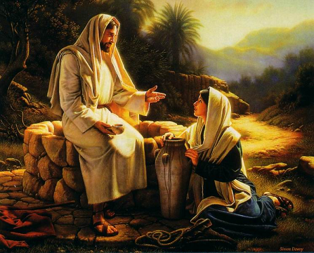

Messiah Lutheran Church
Sartell, MN
www.messiahsartell.com
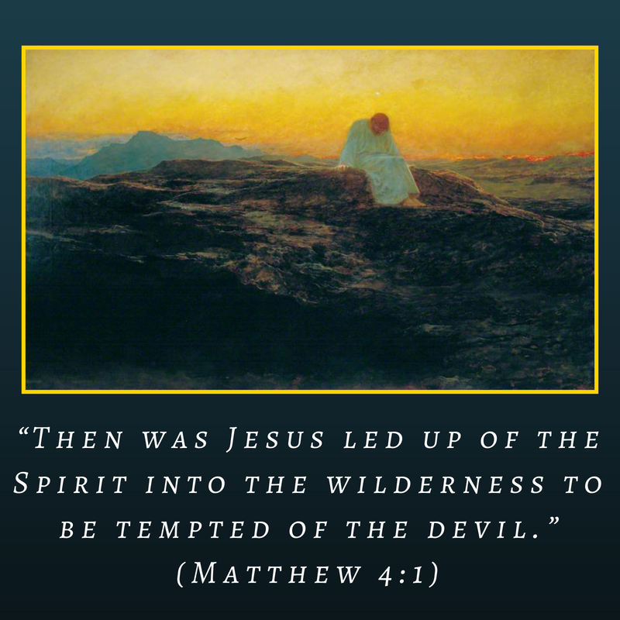
320-252-5883
Prayer Before Entering
Please take this time to focus on our purpose in gathering and join in prayer before our service begins. Blessed Lord, You have caused all Holy Scriptures to be written for our learning. Grant that we may so hear them, read, mark, learn, and inwardly digest them that, by patience and comfort of Your holy Word, we may embrace and ever hold fast the blessed hope of everlasting life; through Jesus Christ, our Lord.

As We Gather
God’s mercy and grace are revealed to those who deserve anything but. The Israelites who wandered the wilderness complained of no water. They didn’t deserve anything because of their sinfulness, yet God responds in mercy and grace, providing water from a rock. A marginalized Samaritan woman didn’t receive compassion from her community and didn’t deserve it from our Savior Jesus Christ, yet she was given and shown mercy and grace and came to believe He is the Savior of the world. We, too, have gone astray and deserve much less than mercy and grace from God Himself. Yet, while we were still sinners, Christ died for us.

699 I Heard the Voice of Jesus Say

Stand

The sign of the cross may be made by all in remembrance of their Baptism.

P In the name of the Father and of the T Son and of the Holy Spirit.
C Amen.

P Our help is in the name of the Lord,
C who made heaven and earth.

P If You, O Lord, kept a record of sins, O Lord, who could stand?
C But with You there is forgiveness; therefore You are feared.

P Since we are gathered to hear God’s Word, call upon Him in prayer and praise, and receive the body and blood of our Lord Jesus Christ in the fellowship of this altar, let us first consider our unworthiness and confess before God and one another that we have sinned in thought, word, and deed, and that we cannot free ourselves from our sinful condition. Together as His people let us take refuge in the infinite mercy of God, our heavenly Father, seeking His grace for the sake of Christ, and saying:
C God, be merciful to me, a sinner.

Silence for reflection on God’s Word and for self-examination.

C Almighty God, have mercy upon us, forgive us our sins, and lead us to everlasting life. Amen.

P Almighty God in His mercy has given His Son to die for you and for His sake forgives you all your sins. As a called and ordained servant of Christ, and by His authority, I therefore forgive you all your sins in the name of the Father and of the T Son and of the Holy Spirit.

C Amen.

Introit Psalm 84:1–4; antiphon: v. 5
P Blessèd are those whose strength is in you,
in whose heart are the highways to Zion.
C How lovely is your dwelling place,
O Lord of hosts!
P My soul longs, yes, faints for the courts of the Lord;
my heart and flesh sing for joy to the living God.
C Even the sparrow finds a home, and the swallow a nest for herself,
where she may lay her young,
at your altars, O Lord of hosts, my King and my God.
P Blessèd are those who dwell in your house,
ever singing your praise!
All: Glory be to the Father and to the Son
and to the Holy Spirit;
as it was in the beginning,
is now, and will be forever. Amen.
P Blessèd are those whose strength is in you,
in whose heart are the highways to Zion.

Kyrie
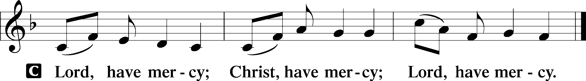
Salutation and Collect of the Day
P The Lord be with you.
C And also with you.

P Let us pray.
O God, You see that of ourselves we have no strength. By Your mighty power defend us from all adversities that may happen to the body and from all evil thoughts that may assault and hurt the soul; through Jesus Christ, Your Son, our Lord, who lives and reigns with You and the Holy Spirit, one God, now and forever.

C Amen.

Sit

Old Testament Reading Exodus 17:1–7
1All the congregation of the people of Israel moved on from the wilderness of Sin by stages, according to the commandment of the Lord, and camped at Rephidim, but there was no water for the people to drink. 2Therefore the people quarreled with Moses and said, “Give us water to drink.” And Moses said to them, “Why do you quarrel with me? Why do you test the Lord?” 3But the people thirsted there for water, and the people grumbled against Moses and said, “Why did you bring us up out of Egypt, to kill us and our children and our livestock with thirst?” 4So Moses cried to the Lord, “What shall I do with this people? They are almost ready to stone me.” 5And the Lord said to Moses, “Pass on before the people, taking with you some of the elders of Israel, and take in your hand the staff with which you struck the Nile, and go. 6Behold, I will stand before you there on the rock at Horeb, and you shall strike the rock, and water shall come out of it, and the people will drink.” And Moses did so, in the sight of the elders of Israel. 7And he called the name of the place Massah and Meribah, because of the quarreling of the people of Israel, and because they tested the Lord by saying, “Is the Lord among us or not?”

A This is the Word of the Lord.
C Thanks be to God.

Epistle Romans 5:1–8
1Therefore, since we have been justified by faith, we have peace with God through our Lord Jesus Christ. 2Through him we have also obtained access by faith into this grace in which we stand, and we rejoice in hope of the glory of God. 3More than that, we rejoice in our sufferings, knowing that suffering produces endurance, 4and endurance produces character, and character produces hope, 5and hope does not put us to shame, because God’s love has been poured into our hearts through the Holy Spirit who has been given to us.
6For while we were still weak, at the right time Christ died for the ungodly. 7For one will scarcely die for a righteous person—though perhaps for a good person one would dare even to die— 8but God shows his love for us in that while we were still sinners, Christ died for us.

A This is the Word of the Lord.
C Thanks be to God.

Stand

Holy Gospel John 4:5–26
P The Holy Gospel according to St. John, the fourth chapter.
C Glory to You, O Lord.

5[Jesus] came to a town of Samaria called Sychar, near the field that Jacob had given to his son Joseph. 6Jacob’s well was there; so Jesus, wearied as he was from his journey, was sitting beside the well. It was about the sixth hour.
7There came a woman of Samaria to draw water. Jesus said to her, “Give me a drink.” 8(For his disciples had gone away into the city to buy food.) 9The Samaritan woman said to him, “How is it that you, a Jew, ask for a drink from me, a woman of Samaria?” (For Jews have no dealings with Samaritans.) 10Jesus answered her, “If you knew the gift of God, and who it is that is saying to you, ‘Give me a drink,’ you would have asked him, and he would have given you living water.” 11The woman said to him, “Sir, you have nothing to draw water with, and the well is deep. Where do you get that living water? 12Are you greater than our father Jacob? He gave us the well and drank from it himself, as did his sons and his livestock.” 13Jesus said to her, “Everyone who drinks of this water will be thirsty again, 14but whoever drinks of the water that I will give him will never be thirsty forever. The water that I will give him will become in him a spring of water welling up to eternal life.” 15The woman said to him, “Sir, give me this water, so that I will not be thirsty or have to come here to draw water.”
16Jesus said to her, “Go, call your husband, and come here.” 17The woman answered him, “I have no husband.” Jesus said to her, “You are right in saying, ‘I have no husband’; 18for you have had five husbands, and the one you now have is not your husband. What you have said is true.” 19The woman said to him, “Sir, I perceive that you are a prophet. 20Our fathers worshiped on this mountain, but you say that in Jerusalem is the place where people ought to worship.” 21Jesus said to her, “Woman, believe me, the hour is coming when neither on this mountain nor in Jerusalem will you worship the Father. 22You worship what you do not know; we worship what we know, for salvation is from the Jews. 23But the hour is coming, and is now here, when the true worshipers will worship the Father in spirit and truth, for the Father is seeking such people to worship him. 24God is spirit, and those who worship him must worship in spirit and truth.” 25The woman said to him, “I know that Messiah is coming (he who is called Christ). When he comes, he will tell us all things.” 26Jesus said to her, “I who speak to you am he.”

P This is the Gospel of the Lord.
C Praise to You, O Christ.

Nicene Creed
C I believe in one God,
the Father Almighty,
maker of heaven and earth
and of all things visible and invisible.
And in one Lord Jesus Christ,
the only-begotten Son of God,
begotten of His Father before all worlds,
God of God, Light of Light,
very God of very God,
begotten, not made,
being of one substance with the Father,
by whom all things were made;
who for us men and for our salvation came down from heaven
and was incarnate by the Holy Spirit of the virgin Mary
and was made man;
and was crucified also for us under Pontius Pilate.
He suffered and was buried.
And the third day He rose again according to the Scriptures
and ascended into heaven
and sits at the right hand of the Father.
And He will come again with glory to judge both the living and the dead,
whose kingdom will have no end.

And I believe in the Holy Spirit,
the Lord and giver of life,
who proceeds from the Father and the Son,
who with the Father and the Son together is worshiped and glorified,
who spoke by the prophets.
And I believe in one holy Christian and apostolic Church,
I acknowledge one Baptism for the remission of sins,
and I look for the resurrection of the dead
and the life T of the world to come.

Amen.

Sit

855 For All the Faithful Women sts. 1, 10, 3

Sermon

Offering. We generously give our offerings to the LORD out of thanksgiving for His generosity of forgiveness, life, and salvation in Christ (2 Corinthians 9:8). We believe that our offerings are not only to support the proclamation of the Gospel here and around the world, but also to help us all grow in faith and trust in Him (2 Corinthians 9:7). We have placed an offering plate in the narthex so you are able to freely give back to Him as you are able. To Him be all the glory!

Stand

Prayer of the Church

Holy Communion is celebrated in the belief and glad confidence that our Lord gives us not only bread and wine, but the body and blood of Christ from the cross, for us Christian to eat and drink for the forgiveness of sins (Matthew 26:28). Because we are called to examine ourselves before receiving the Lord’s Supper (I Corinthians 11:28-29), we encourage you to consider the questions on pages 329-330 in the hymnal. We also believe that when we commune, we are confessing our unity with the community we join (I Corinthians 10:17). If you desire to commune with us for the first time or have questions, our pastor is happy to speak with you.

Preface
P The Lord be with you.
C And also with you.

P Lift up your hearts.
C We lift them to the Lord.

P Let us give thanks to the Lord our God.
C It is right to give Him thanks and praise.

P It is truly good, right, and salutary that we should at all times and in all places give thanks to You, O Lord, holy Father, almighty and everlasting God, for the countless blessings You so freely bestow on us and all creation. Above all, we give thanks for Your boundless love shown to us when You sent Your only-begotten Son, Jesus Christ, into our flesh and laid on Him our sin, giving Him into death that we might not die eternally. Because He is now risen from the dead and lives and reigns to all eternity, all who believe in Him will overcome sin and death and will rise again to new life. Therefore with angels and archangels and with all the company of heaven we laud and magnify Your glorious name, evermore praising You and saying:

Sanctus
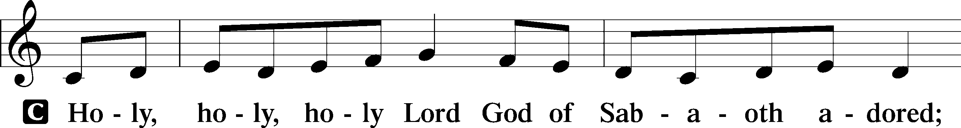
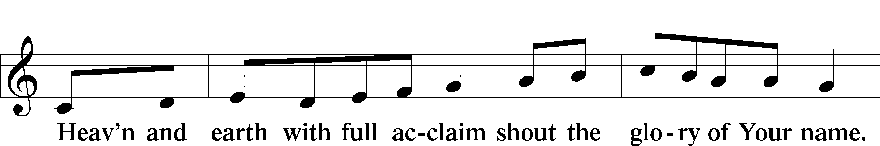
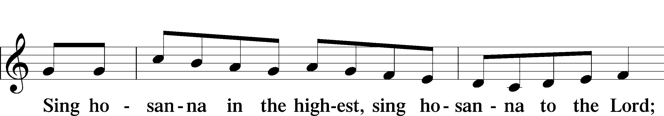
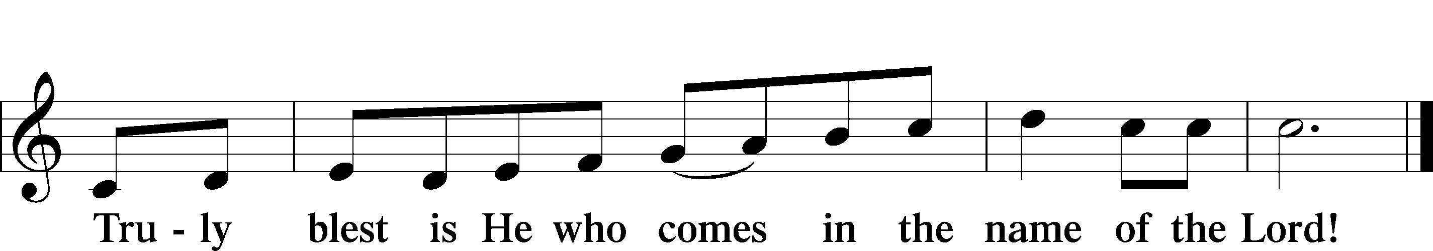

Prayer of Thanksgiving
P Blessed are You, O Lord our God, king of all creation, for You have had mercy on us and given Your only-begotten Son that whoever believes in Him should not perish but have eternal life.

At Your command, Abraham prepared to offer his son Isaac as a sacrifice on the mountain; yet, in mercy You provided a ram as a substitute. We give You thanks that on Calvary You spared not Your only Son but sent Him to offer His life as a ransom for many.

As we eat and drink His body and blood, grant us, like Abraham our father, to trust in Your promise now fulfilled in Christ, the Lamb of God, who takes away the sin of the world.

Hear us as we pray in His name and as He has taught us:

Lord’s Prayer

The Words of Our Lord

Pax Domini
P The peace of the Lord be with you always.
C Amen.

Agnus Dei
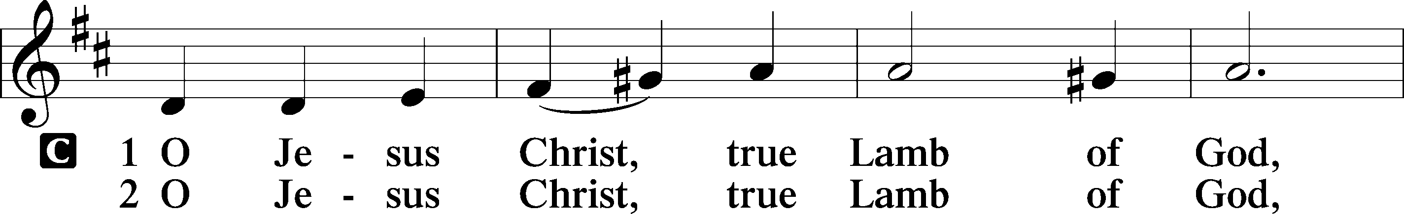
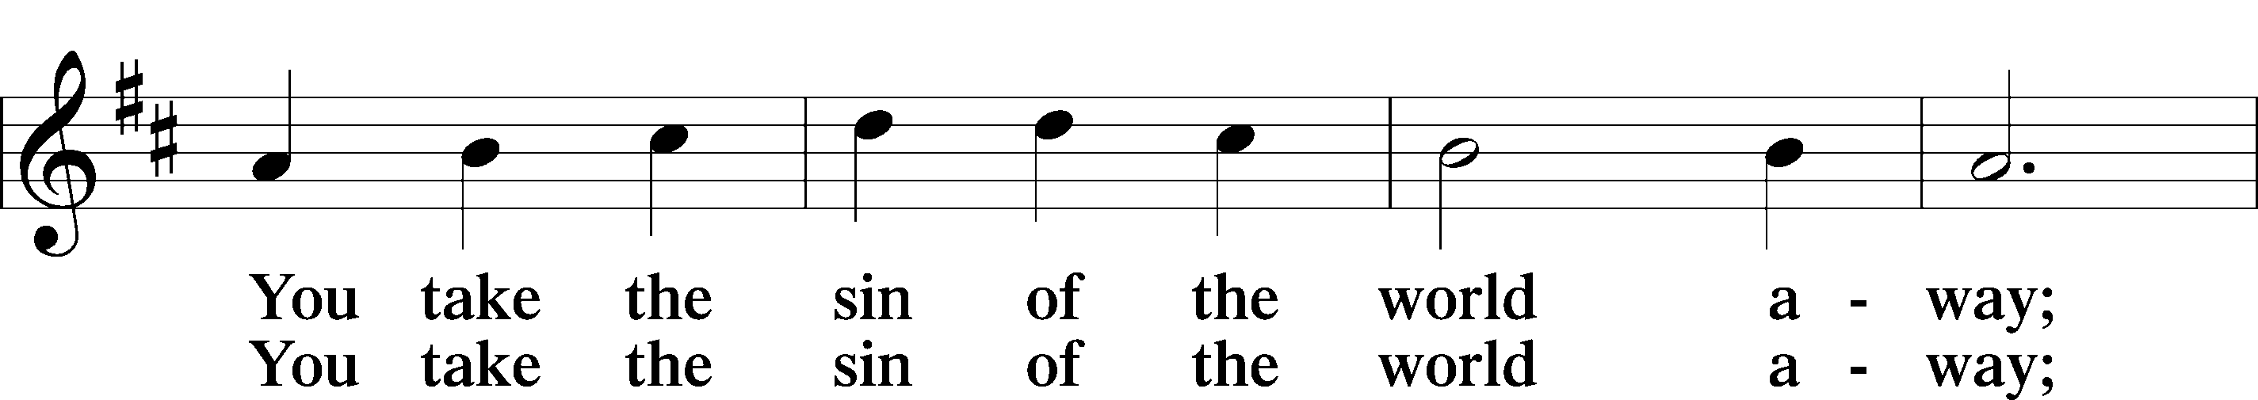
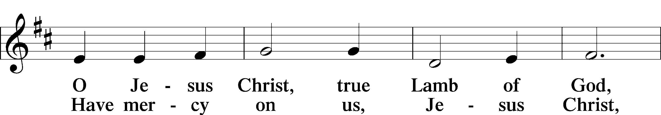
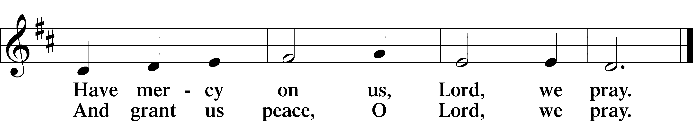

Sit

Distribution

637 Draw Near and Take the Body of the Lord

634 The Death of Jesus Christ, Our Lord

Stand

Nunc Dimittis
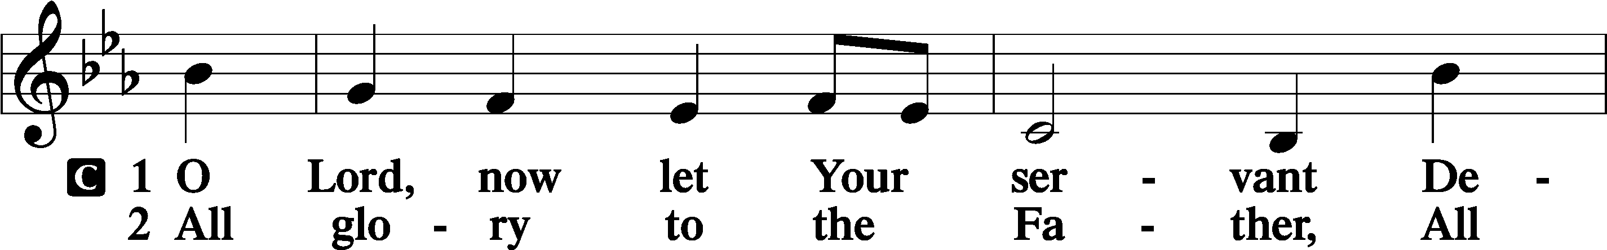
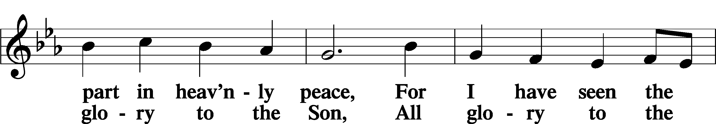
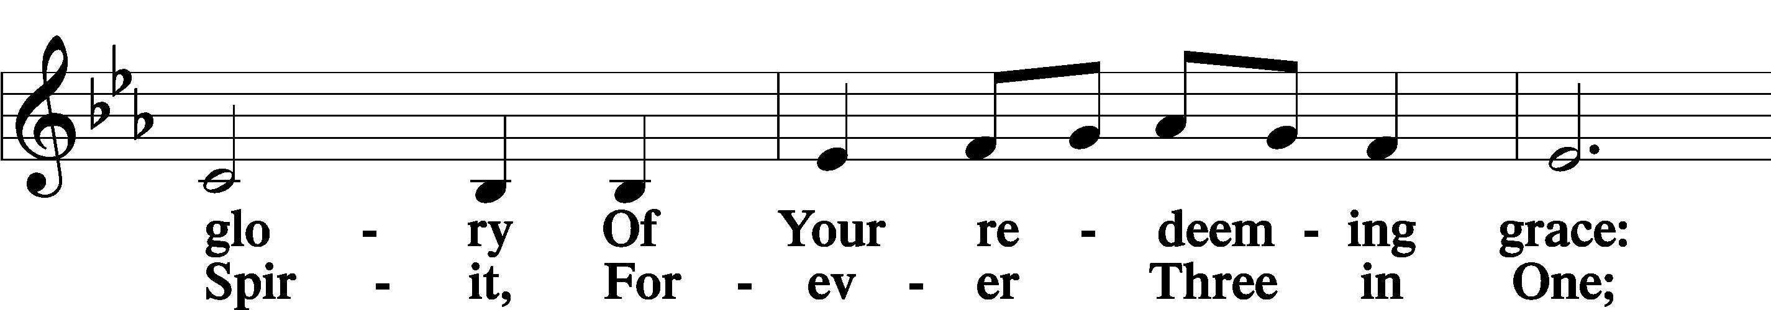
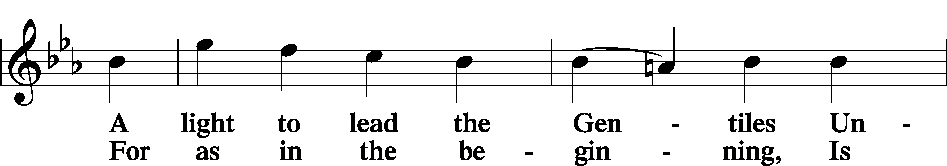
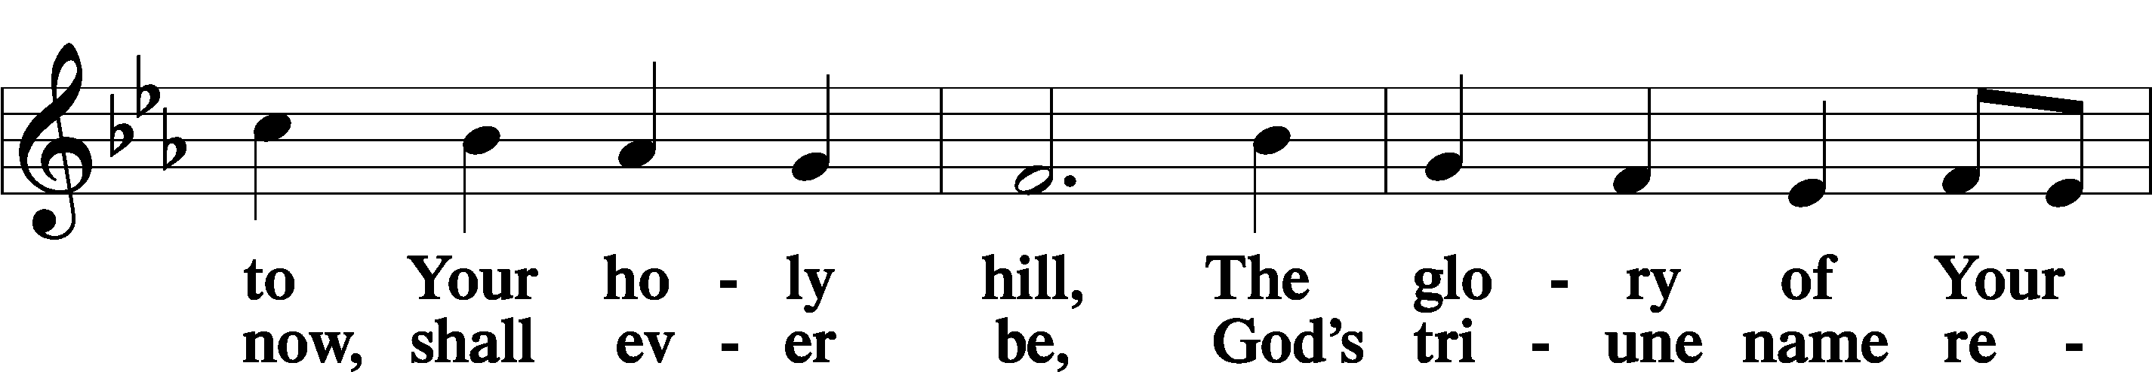
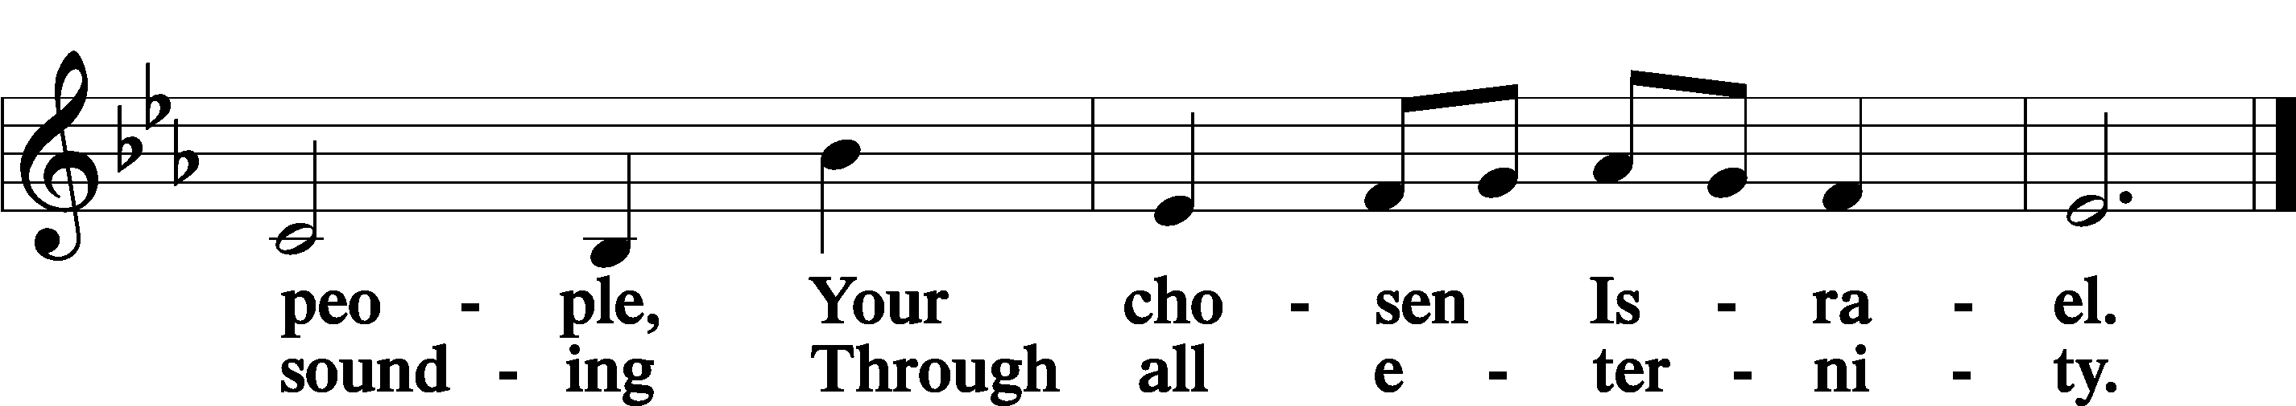

Post-Communion Collect
A Let us pray. We give thanks to You, almighty God, that You have refreshed us through this salutary gift, and we implore You that of Your mercy You would strengthen us through the same in faith toward You and in fervent love toward one another; through Jesus Christ, Your Son, our Lord, who lives and reigns with You and the Holy Spirit, one God, now and forever.
C Amen.

Benedicamus
A Let us bless the Lord.
C Thanks be to God.

Benediction
P The Lord bless you and keep you.
The Lord make His face shine on you and be gracious to you.
The Lord look upon you with favor and T give you peace.

C Amen.

423 Jesus, Refuge of the Weary

Announcements

Midweek Lenten Worship Services: 6 p.m.
Wednesdays: March 11, 18 and 25
Maundy Thursday: April 2nd
Good Friday: April 3rd

Lenten Suppers will be at 4:45 p.m. every Wednesday during Lent.

For the Kids

