18th Sunday after Pentecost
October 12th, 2025

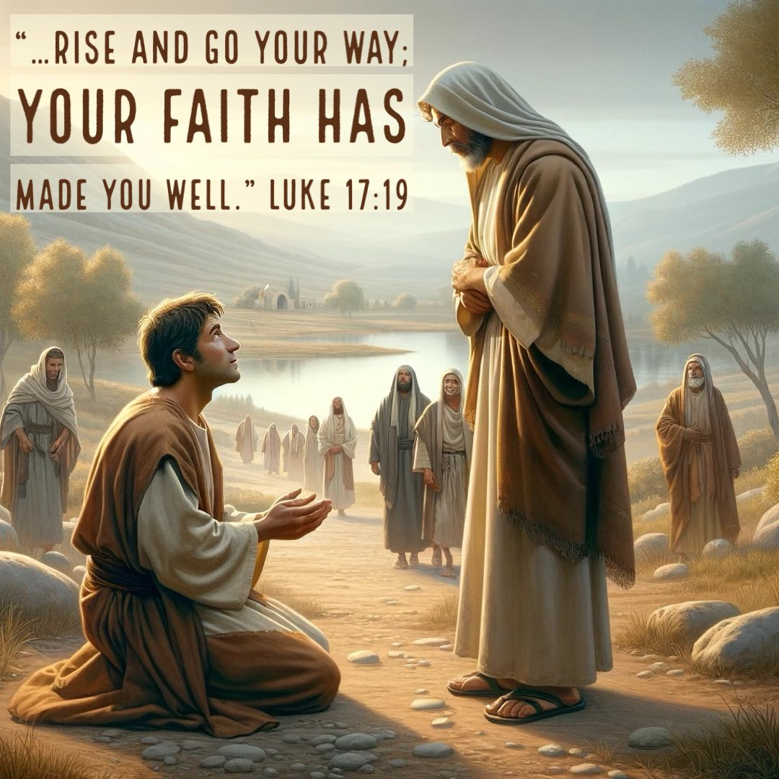

Messiah Lutheran Church
Sartell, MN
www.messiahsartell.com
320-252-5883
Prayer Before Entering
Please take this time to focus on our purpose in gathering and join in prayer before our service begins. Blessed Lord, You have caused all Holy Scriptures to be written for our learning. Grant that we may so hear them, read, mark, learn, and inwardly digest them that, by patience and comfort of Your holy Word, we may embrace and ever hold fast the blessed hope of everlasting life; through Jesus Christ, our Lord.

As We Gather
We have heard the Gospel account of the ten lepers so often we know it by heart. But we may still struggle to see clearly God’s mercy in our hour of need, the full expression of His healing grace even to everlasting life, and how to respond with gratitude and thanksgiving. Christians, the Lord knows our need, and He will not abandon us in our hour of need. For us the goal remains to keep our eyes focused upon Jesus and to trust that His grace is sufficient for all our need. We pray the Lord to give us a grateful heart to rejoice in His gracious favor and not to forget all His benefits.

542 When I Behold Jesus Christ

Stand

The sign of the cross may be made by all in remembrance of their Baptism.

P In the name of the Father and of the T Son and of the Holy Spirit.
C Amen.

P Our help is in the name of the Lord,
C who made heaven and earth.

P If You, O Lord, kept a record of sins, O Lord, who could stand?
C But with You there is forgiveness; therefore You are feared.

P Since we are gathered to hear God’s Word, call upon Him in prayer and praise, and receive the body and blood of our Lord Jesus Christ in the fellowship of this altar, let us first consider our unworthiness and confess before God and one another that we have sinned in thought, word, and deed, and that we cannot free ourselves from our sinful condition. Together as His people let us take refuge in the infinite mercy of God, our heavenly Father, seeking His grace for the sake of Christ, and saying:
C God, be merciful to me, a sinner.

Silence for reflection on God’s Word and for self-examination.

C Almighty God, have mercy upon us, forgive us our sins, and lead us to everlasting life. Amen.

P Almighty God in His mercy has given His Son to die for you and for His sake forgives you all your sins. As a called and ordained servant of Christ, and by His authority, I therefore forgive you all your sins in the name of the Father and of the T Son and of the Holy Spirit.

C Amen.

Introit Psalm 34:2–4, 17; antiphon: Psalm 48:1a
P Great is the Lord and greatly to be praised
in the city of our God!
C My soul makes its boast in the Lord;
let the humble hear and be glad.
P Oh, magnify the Lord with me,
and let us exalt his name together!
C I sought the Lord, and he answered me
and delivered me from all my fears.
P When the righteous cry for help, the Lord hears
and delivers them out of all their troubles.
All: Glory be to the Father and to the Son
and to the Holy Spirit;
as it was in the beginning,
is now, and will be forever. Amen.
P Great is the Lord and greatly to be praised
in the city of our God!

Kyrie
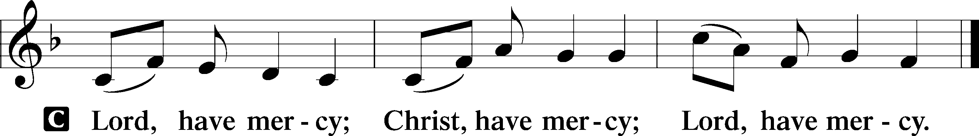

Gloria in Excelsis
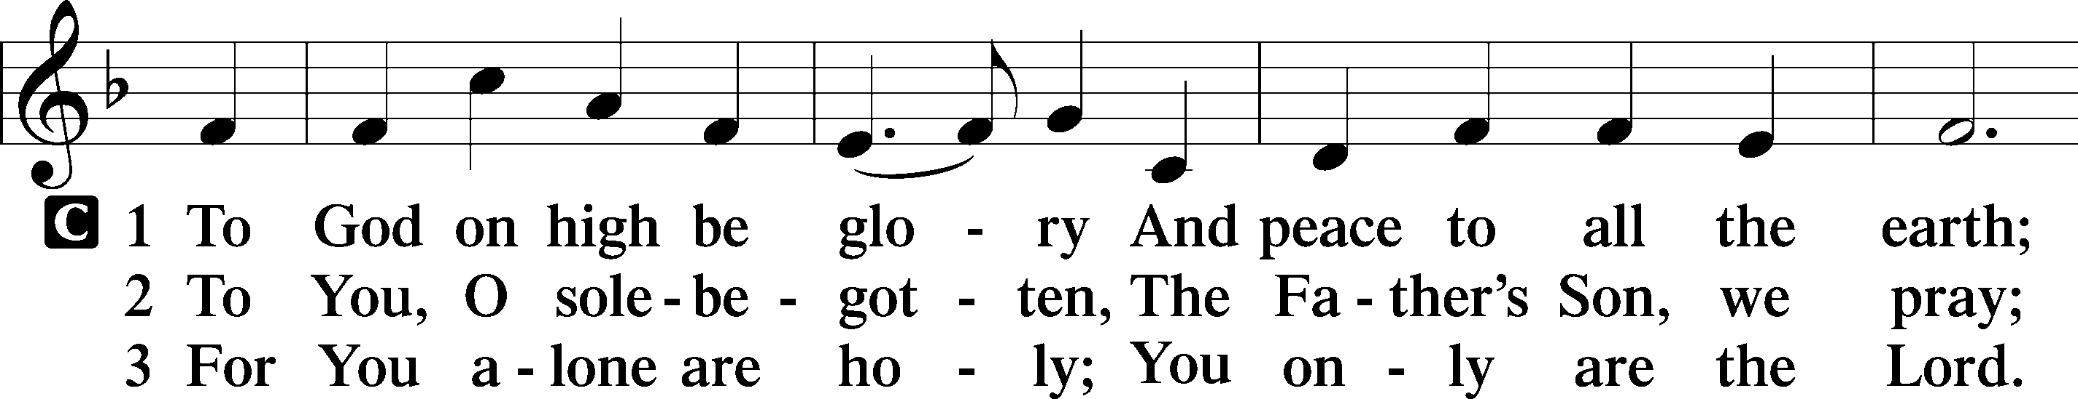
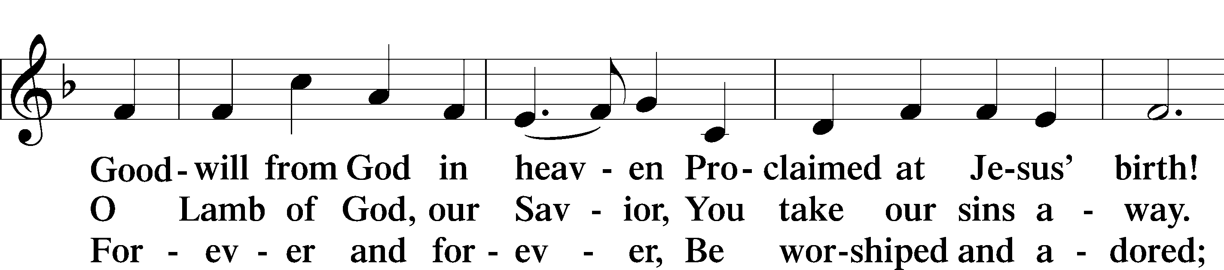
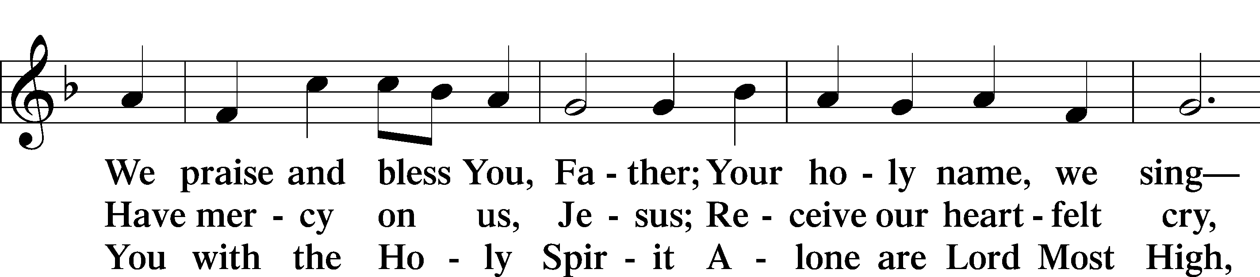
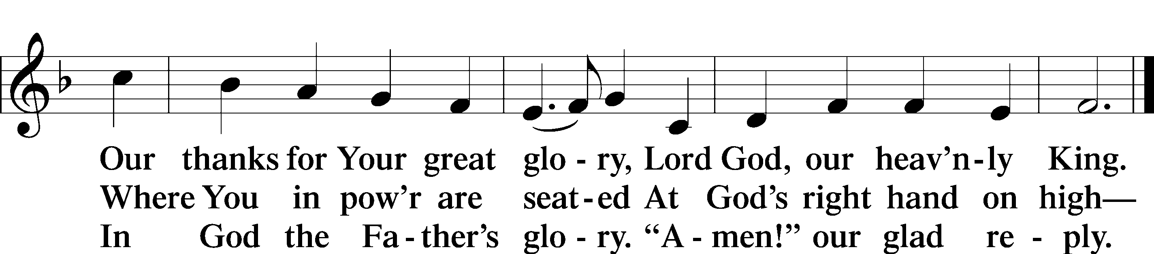

Salutation and Collect of the Day
P The Lord be with you.
C And also with you.

P Let us pray.
Almighty God, You show mercy to Your people in all their troubles. Grant us always to recognize Your goodness, give thanks for Your compassion, and praise Your holy name; through Jesus Christ, Your Son, our Lord, who lives and reigns with You and the Holy Spirit, one God, now and forever.

C Amen.

Sit
Old Testament Reading Ruth 1:1–19a
1In the days when the judges ruled there was a famine in the land, and a man of Bethlehem in Judah went to sojourn in the country of Moab, he and his wife and his two sons. 2The name of the man was Elimelech and the name of his wife Naomi, and the names of his two sons were Mahlon and Chilion. They were Ephrathites from Bethlehem in Judah. They went into the country of Moab and remained there. 3But Elimelech, the husband of Naomi, died, and she was left with her two sons. 4These took Moabite wives; the name of the one was Orpah and the name of the other Ruth. They lived there about ten years, 5and both Mahlon and Chilion died, so that the woman was left without her two sons and her husband.
6Then she arose with her daughters-in-law to return from the country of Moab, for she had heard in the fields of Moab that the Lord had visited his people and given them food. 7So she set out from the place where she was with her two daughters-in-law, and they went on the way to return to the land of Judah. 8But Naomi said to her two daughters-in-law, “Go, return each of you to her mother’s house. May the Lord deal kindly with you, as you have dealt with the dead and with me. 9The Lord grant that you may find rest, each of you in the house of her husband!” Then she kissed them, and they lifted up their voices and wept. 10And they said to her, “No, we will return with you to your people.” 11But Naomi said, “Turn back, my daughters; why will you go with me? Have I yet sons in my womb that they may become your husbands? 12Turn back, my daughters; go your way, for I am too old to have a husband. If I should say I have hope, even if I should have a husband this night and should bear sons, 13would you therefore wait till they were grown? Would you therefore refrain from marrying? No, my daughters, for it is exceedingly bitter to me for your sake that the hand of the Lord has gone out against me.” 14Then they lifted up their voices and wept again. And Orpah kissed her mother-in-law, but Ruth clung to her.
15And she said, “See, your sister-in-law has gone back to her people and to her gods; return after your sister-in-law.” 16But Ruth said, “Do not urge me to leave you or to return from following you. For where you go I will go, and where you lodge I will lodge. Your people shall be my people, and your God my God. 17Where you die I will die, and there will I be buried. May the Lord do so to me and more also if anything but death parts me from you.” 18And when Naomi saw that she was determined to go with her, she said no more.19So the two of them went on until they came to Bethlehem.

A This is the Word of the Lord.
C Thanks be to God.
Epistle 2 Timothy 2:1–13
1You then, my child, be strengthened by the grace that is in Christ Jesus, 2and what you have heard from me in the presence of many witnesses entrust to faithful men who will be able to teach others also. 3Share in suffering as a good soldier of Christ Jesus. 4No soldier gets entangled in civilian pursuits, since his aim is to please the one who enlisted him. 5An athlete is not crowned unless he competes according to the rules. 6It is the hard-working farmer who ought to have the first share of the crops. 7Think over what I say, for the Lord will give you understanding in everything. 8Remember Jesus Christ, risen from the dead, the offspring of David, as preached in my gospel, 9for which I am suffering, bound with chains as a criminal. But the word of God is not bound! 10Therefore I endure everything for the sake of the elect, that they also may obtain the salvation that is in Christ Jesus with eternal glory. 11The saying is trustworthy, for: If we have died with him, we will also live with him; 12if we endure, we will also reign with him; if we deny him, he also will deny us; 13if we are faithless, he remains faithful— for he cannot deny himself.

A This is the Word of the Lord.
C Thanks be to God.

Stand

Alleluia and Verse
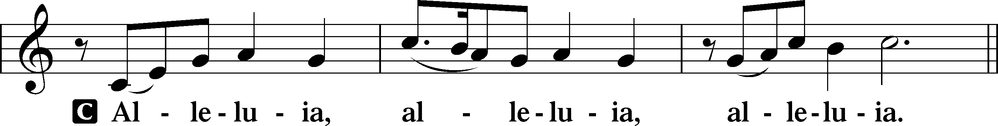
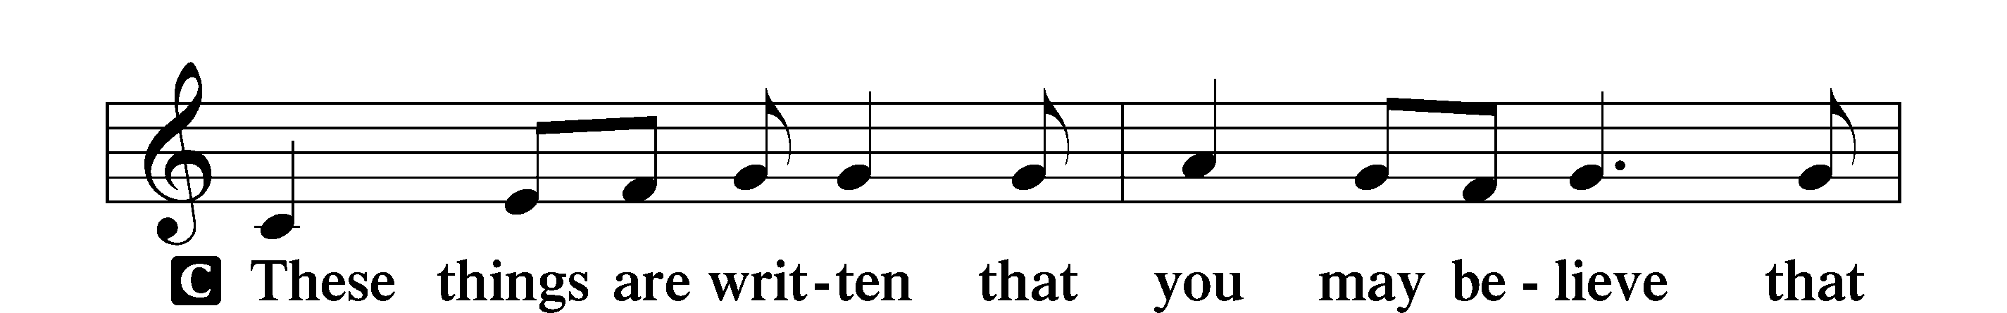
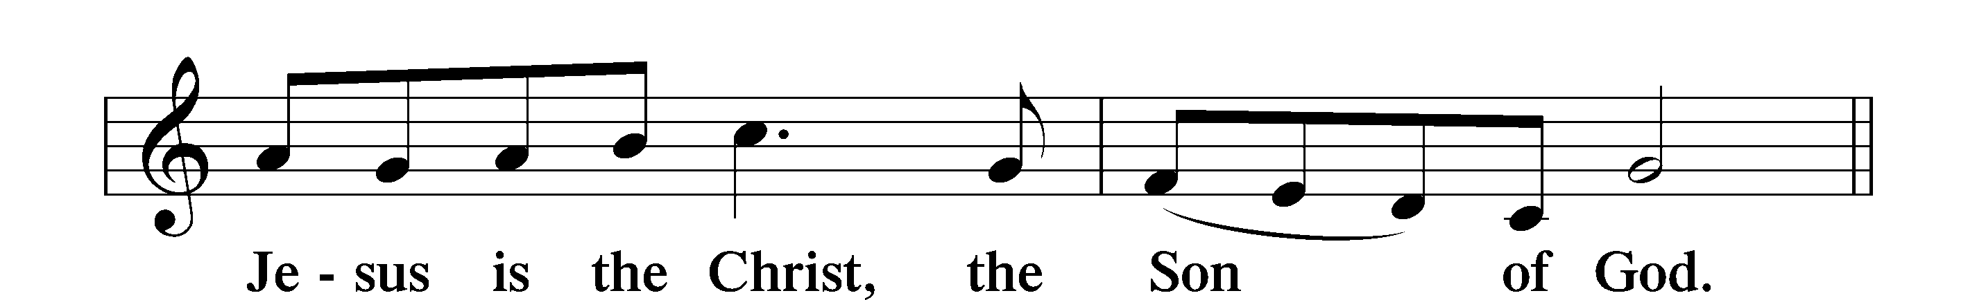
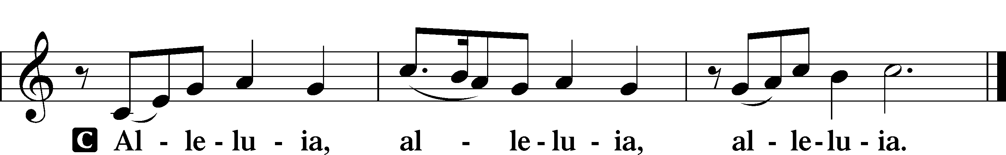

Holy Gospel Luke 17:11–19
P The Holy Gospel according to St. Luke, the seventeenth chapter.
C Glory to You, O Lord.

11On the way to Jerusalem [Jesus] was passing along between Samaria and Galilee. 12And as he entered a village, he was met by ten lepers, who stood at a distance 13and lifted up their voices, saying, “Jesus, Master, have mercy on us.” 14When he saw them he said to them, “Go and show yourselves to the priests.” And as they went they were cleansed. 15Then one of them, when he saw that he was healed, turned back, praising God with a loud voice; 16and he fell on his face at Jesus’ feet, giving him thanks. Now he was a Samaritan. 17Then Jesus answered, “Were not ten cleansed? Where are the nine? 18Was no one found to return and give praise to God except this foreigner?” 19And he said to him, “Rise and go your way; your faith has made you well.”

P This is the Gospel of the Lord.
C Praise to You, O Christ.

Nicene Creed
C I believe in one God,
the Father Almighty,
maker of heaven and earth
and of all things visible and invisible.
And in one Lord Jesus Christ,
the only-begotten Son of God,
begotten of His Father before all worlds,
God of God, Light of Light,
very God of very God,
begotten, not made,
being of one substance with the Father,
by whom all things were made;

who for us men and for our salvation came down from heaven
and was incarnate by the Holy Spirit of the virgin Mary
and was made man;
and was crucified also for us under Pontius Pilate.
He suffered and was buried.

And the third day He rose again according to the Scriptures
and ascended into heaven
and sits at the right hand of the Father.
And He will come again with glory to judge both the living and the dead,
whose kingdom will have no end.

And I believe in the Holy Spirit,
the Lord and giver of life,
who proceeds from the Father and the Son,
who with the Father and the Son together is worshiped and glorified,
who spoke by the prophets.
And I believe in one holy Christian and apostolic Church,
I acknowledge one Baptism for the remission of sins,
and I look for the resurrection of the dead
and the life T of the world to come.

Amen.

Sit

435 Come to Calvary’s Holy Mountain

Sermon

Offering. We generously give our offerings to the LORD out of thanksgiving for His generosity of forgiveness, life, and salvation in Christ (2 Corinthians 9:8). We believe that our offerings are not only to support the proclamation of the Gospel here and around the world, but also to help us all grow in faith and trust in Him (2 Corinthians 9:7). We have placed an offering plate in the narthex so you are able to freely give back to Him as you are able. To Him be all the glory!

Stand

Prayer of the Church

Holy Communion is celebrated in the belief and glad confidence that our Lord gives us not only bread and wine, but the body and blood of Christ from the cross, for us Christian to eat and drink for the forgiveness of sins (Matthew 26:28). Because we are called to examine ourselves before receiving the Lord’s Supper (I Corinthians 11:28-29), we encourage you to consider the questions on pages 329-330 in the hymnal. We also believe that when we commune, we are confessing our unity with the community we join (I Corinthians 10:17). If you desire to commune with us for the first time or have questions, our pastor is happy to speak with you.

Preface
P The Lord be with you.
C And also with you.

P Lift up your hearts.
C We lift them to the Lord.

P Let us give thanks to the Lord our God.
C It is right to give Him thanks and praise.

P It is truly good, right, and salutary that we should at all times and in all places give thanks to You, O Lord, holy Father, almighty and everlasting God, for the countless blessings You so freely bestow on us and all creation. Above all, we give thanks for Your boundless love shown to us when You sent Your only-begotten Son, Jesus Christ, into our flesh and laid on Him our sin, giving Him into death that we might not die eternally. Because He is now risen from the dead and lives and reigns to all eternity, all who believe in Him will overcome sin and death and will rise again to new life. Therefore with angels and archangels and with all the company of heaven we laud and magnify Your glorious name, evermore praising You and saying:

Sanctus
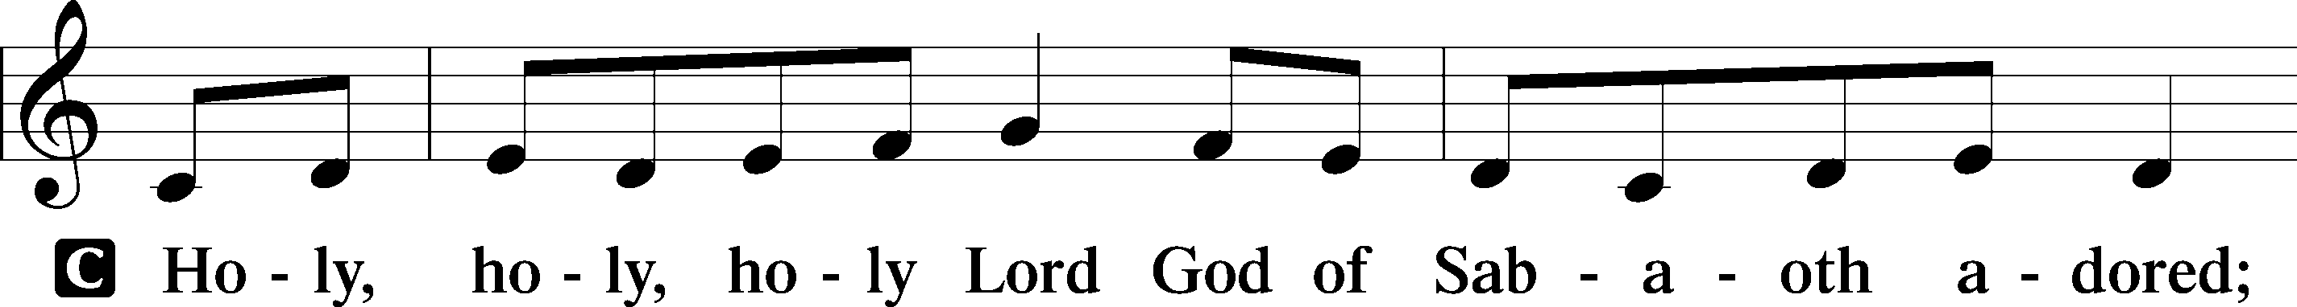
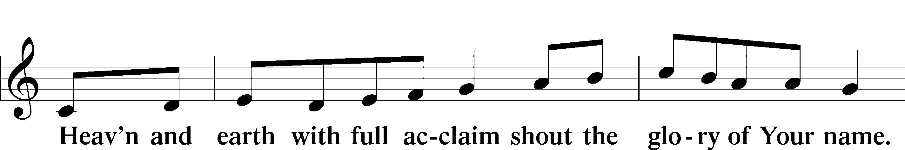
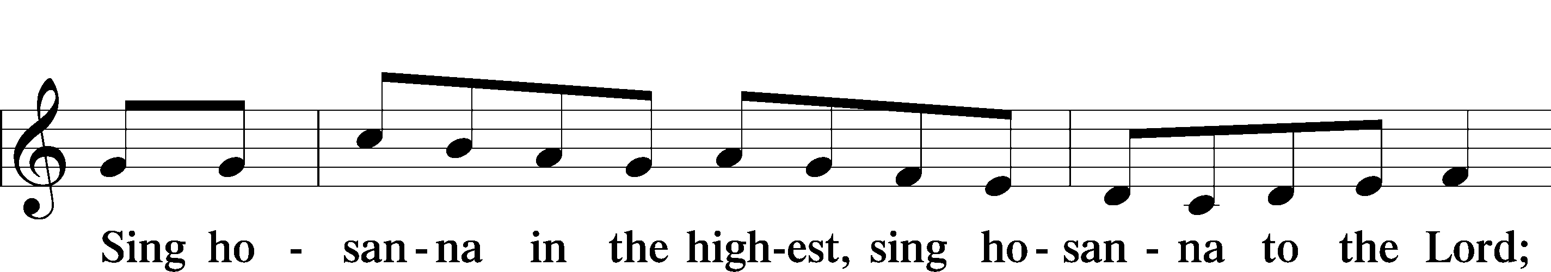
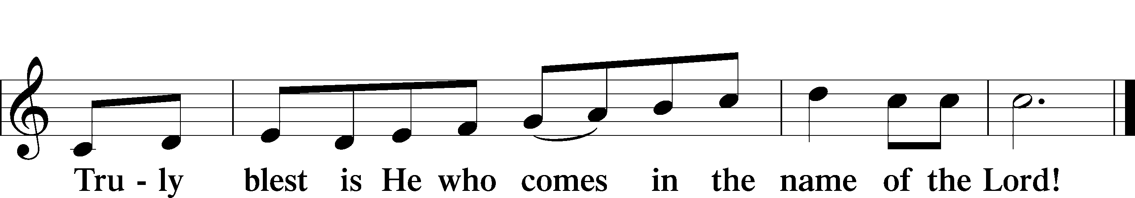

Prayer of Thanksgiving
P Blessed are You, O Lord our God, king of all creation, for You have had mercy on us and given Your only-begotten Son that whoever believes in Him should not perish but have eternal life.
In Your righteous judgment You condemned the sin of Adam and Eve, who ate the forbidden fruit, and You justly barred them and all their children from the tree of life. Yet, in Your great mercy, You promised salvation by a second Adam, Your Son, Jesus Christ, our Lord, and made His cross a life-giving tree for all who trust in Him.

We give You thanks for the redemption You have prepared for us through Jesus Christ. Grant us Your Holy Spirit that we may faithfully eat and drink of the fruits of His cross and receive the blessings of forgiveness, life, and salvation that come to us in His body and blood.

Hear us as we pray in His name and as He has taught us:

Lord’s Prayer

The Words of Our Lord

Pax Domini
P The peace of the Lord be with you always.
C Amen.

Agnus Dei
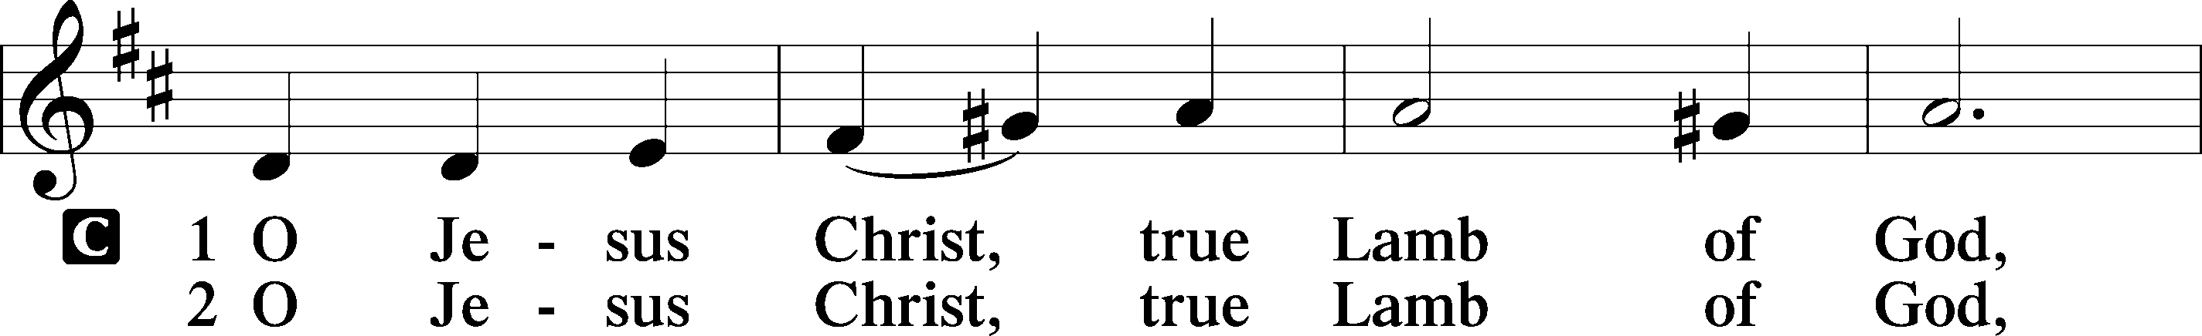
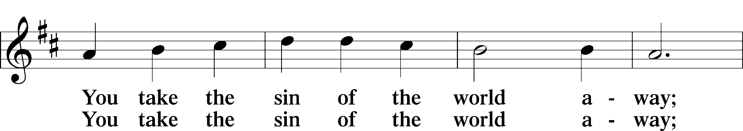
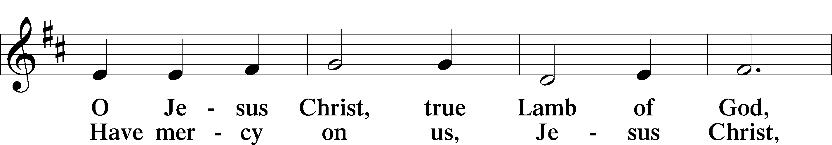
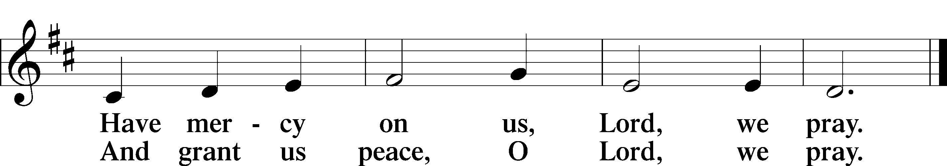

Sit

Distribution

622 Lord Jesus Christ, You Have Prepared

625 Lord Jesus Christ, Life-Giving Bread

Stand

Nunc Dimittis
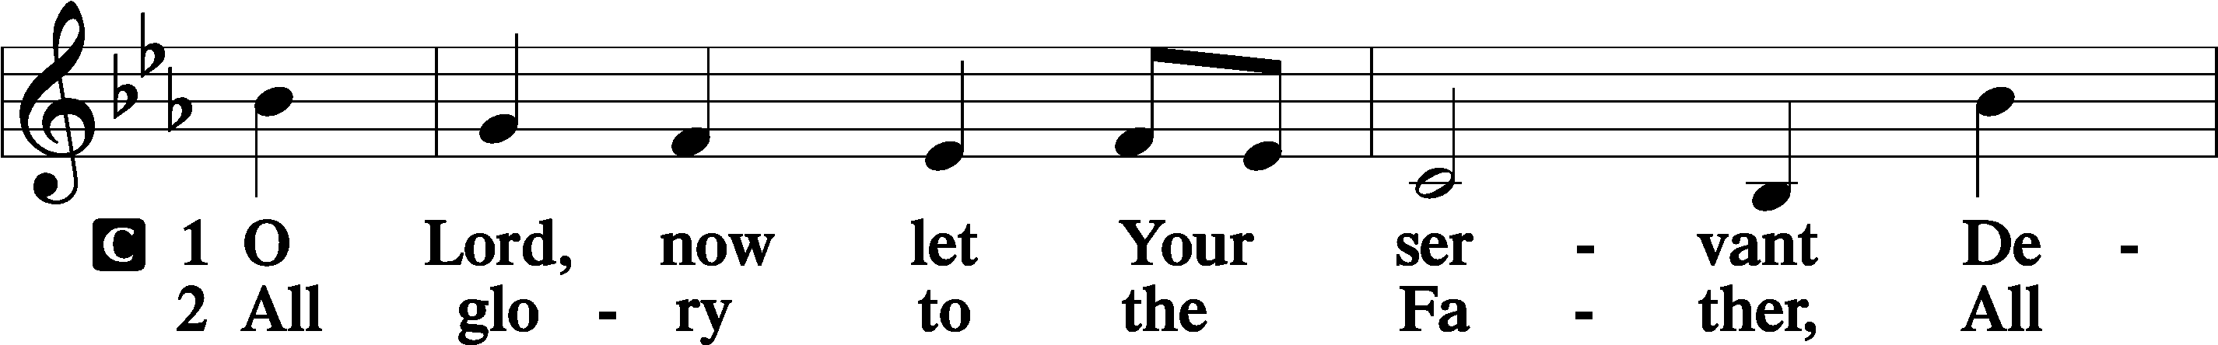
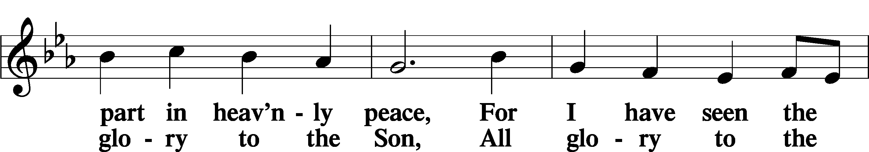
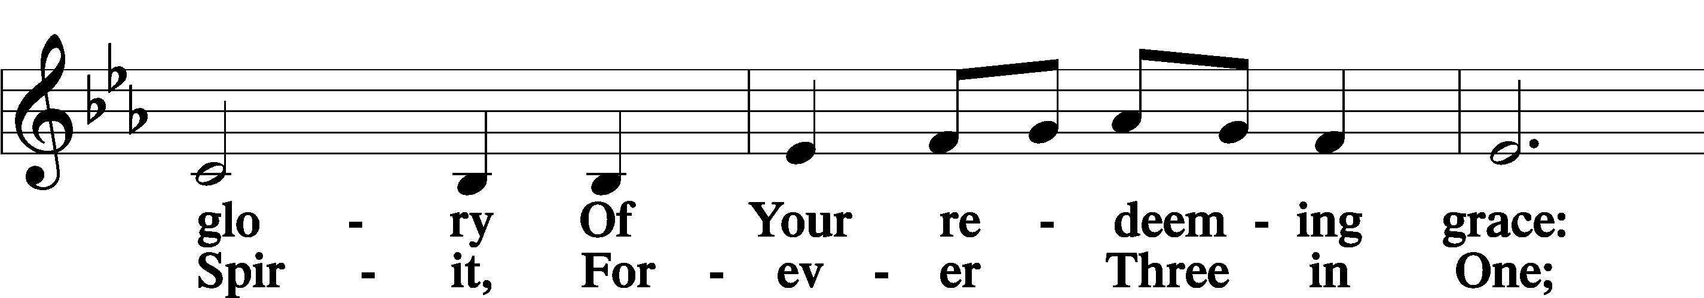
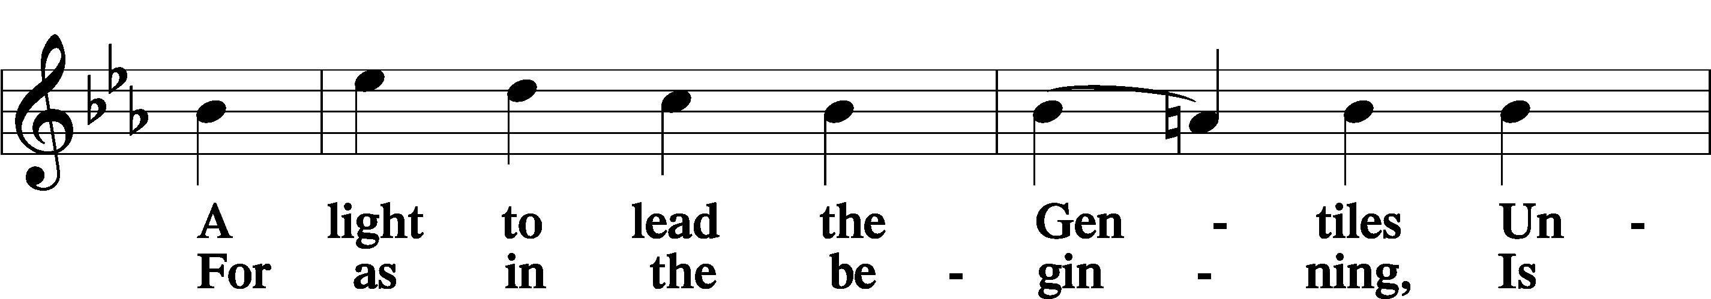
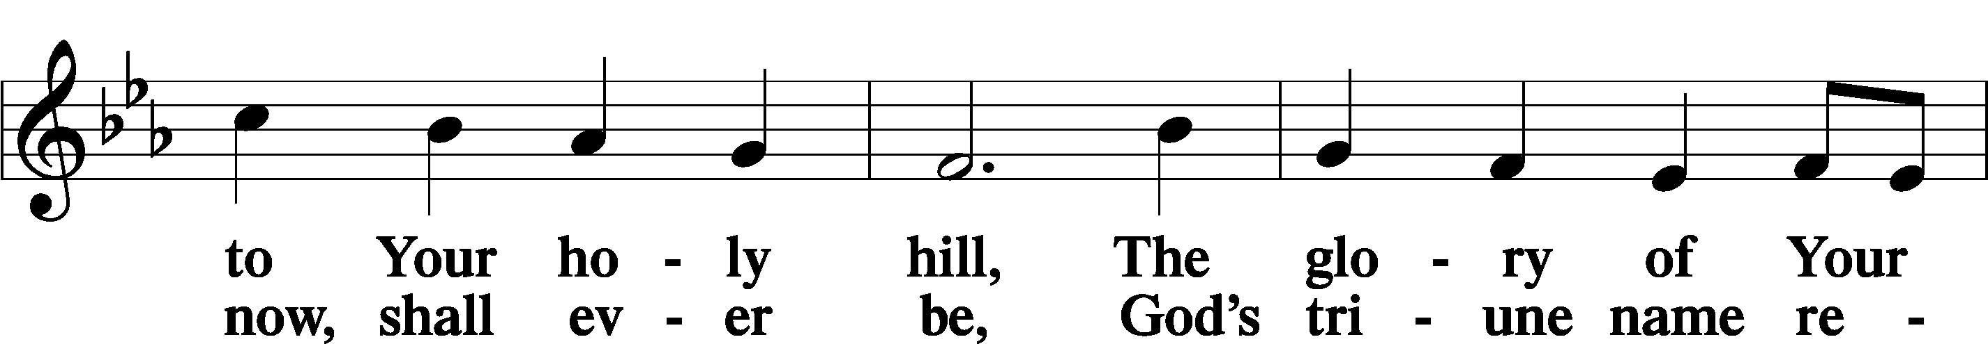
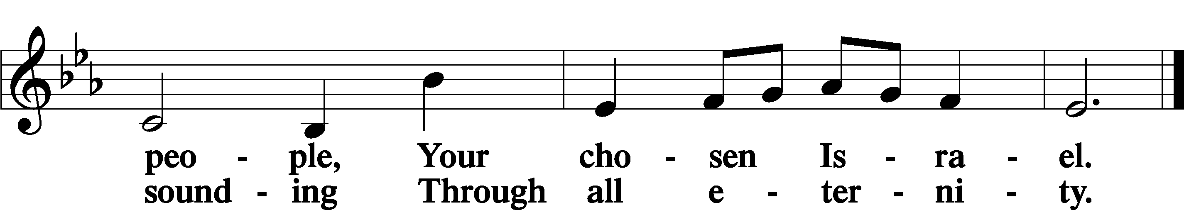

Post-Communion Collect
A Let us pray. We give thanks to You, almighty God, that You have refreshed us through this salutary gift, and we implore You that of Your mercy You would strengthen us through the same in faith toward You and in fervent love toward one another; through Jesus Christ, Your Son, our Lord, who lives and reigns with You and the Holy Spirit, one God, now and forever.
C Amen.

Benedicamus
A Let us bless the Lord.
C Thanks be to God.

Benediction
P The Lord bless you and keep you.
The Lord make His face shine on you and be gracious to you.
The Lord look upon you with favor and T give you peace.

C Amen.

895 Now Thank We All Our God

