Fourth Sunday of Easter
April 26th, 2026

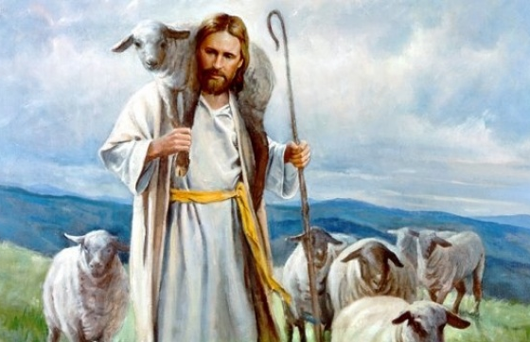

Messiah Lutheran Church
Sartell, MN
www.messiahsartell.com
320-252-5883
Prayer Before Entering
Please take this time to focus on our purpose in gathering and join in prayer before our service begins. Blessed Lord, You have caused all Holy Scriptures to be written for our learning. Grant that we may so hear them, read, mark, learn, and inwardly digest them that, by patience and comfort of Your holy Word, we may embrace and ever hold fast the blessed hope of everlasting life; through Jesus Christ, our Lord.

As We Gather
Even as we celebrate Jesus as our Good Shepherd, we also acknowledge that His shepherding love and care continues through the undershepherds whom He sends to protect, preserve, and provide for His sheep. The pastors do not replace Jesus, our Good Shepherd, but are the means by which our Lord continues His work among us through His Word and Sacraments. His Word and promise continue and He is among us just as He has said, still leading us to the still quiet waters, the rich green pastures, and the safe refuge so familiar to us in the words of Psalm 23.

709 The King of Love My Shepherd Is

Stand

The sign of the cross may be made by all in remembrance of their Baptism.

P In the name of the Father and of the T Son and of the Holy Spirit.
C Amen.

P Our help is in the name of the Lord,
C who made heaven and earth.

P If You, O Lord, kept a record of sins, O Lord, who could stand?
C But with You there is forgiveness; therefore You are feared.

P Since we are gathered to hear God’s Word, call upon Him in prayer and praise, and receive the body and blood of our Lord Jesus Christ in the fellowship of this altar, let us first consider our unworthiness and confess before God and one another that we have sinned in thought, word, and deed, and that we cannot free ourselves from our sinful condition. Together as His people let us take refuge in the infinite mercy of God, our heavenly Father, seeking His grace for the sake of Christ, and saying:
C God, be merciful to me, a sinner.
Silence for reflection on God’s Word and for self-examination.

C Almighty God, have mercy upon us, forgive us our sins, and lead us to everlasting life. Amen.

P Almighty God in His mercy has given His Son to die for you and for His sake forgives you all your sins. As a called and ordained servant of Christ, and by His authority, I therefore forgive you all your sins in the name of the Father and of the T Son and of the Holy Spirit.

C Amen.

Introit Psalm 95:1–3, 6–7a; antiphon: John 10:14, 15b
P I am the good shepherd.
I know my own and my own know me, and I lay down my life for the
sheep.
C Oh come, let us sing to the Lord;
let us make a joyful noise to the rock of our salvation!
P Let us come into his presence with thanksgiving;
let us make a joyful noise to him with songs of praise!
C For the Lord is a great God,
and a great King above all gods.
P Oh come, let us worship and bow down;
let us kneel before the Lord, our Maker!
C For he is our God,
and we are the people of his pasture, and the sheep of his hand.
All: Glory be to the Father and to the Son
and to the Holy Spirit;
as it was in the beginning,
is now, and will be forever. Amen.
P I am the good shepherd.
I know my own and my own know me, and I lay down my life for the
sheep.

Kyrie
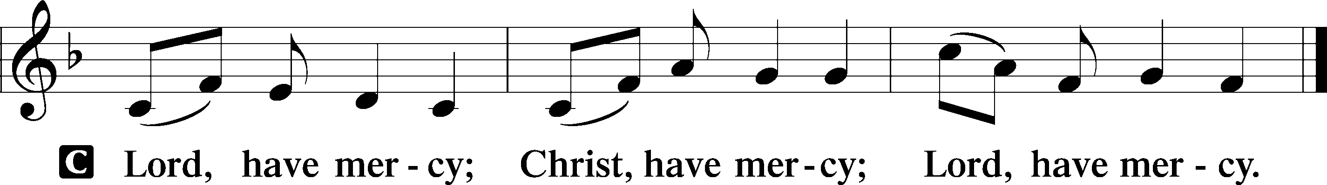

Gloria in Excelsis
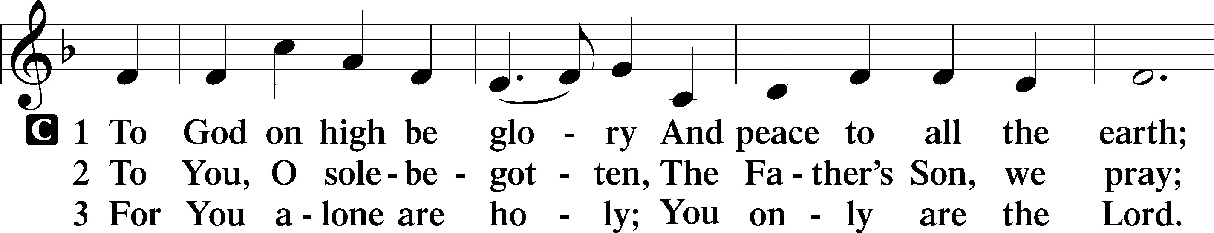
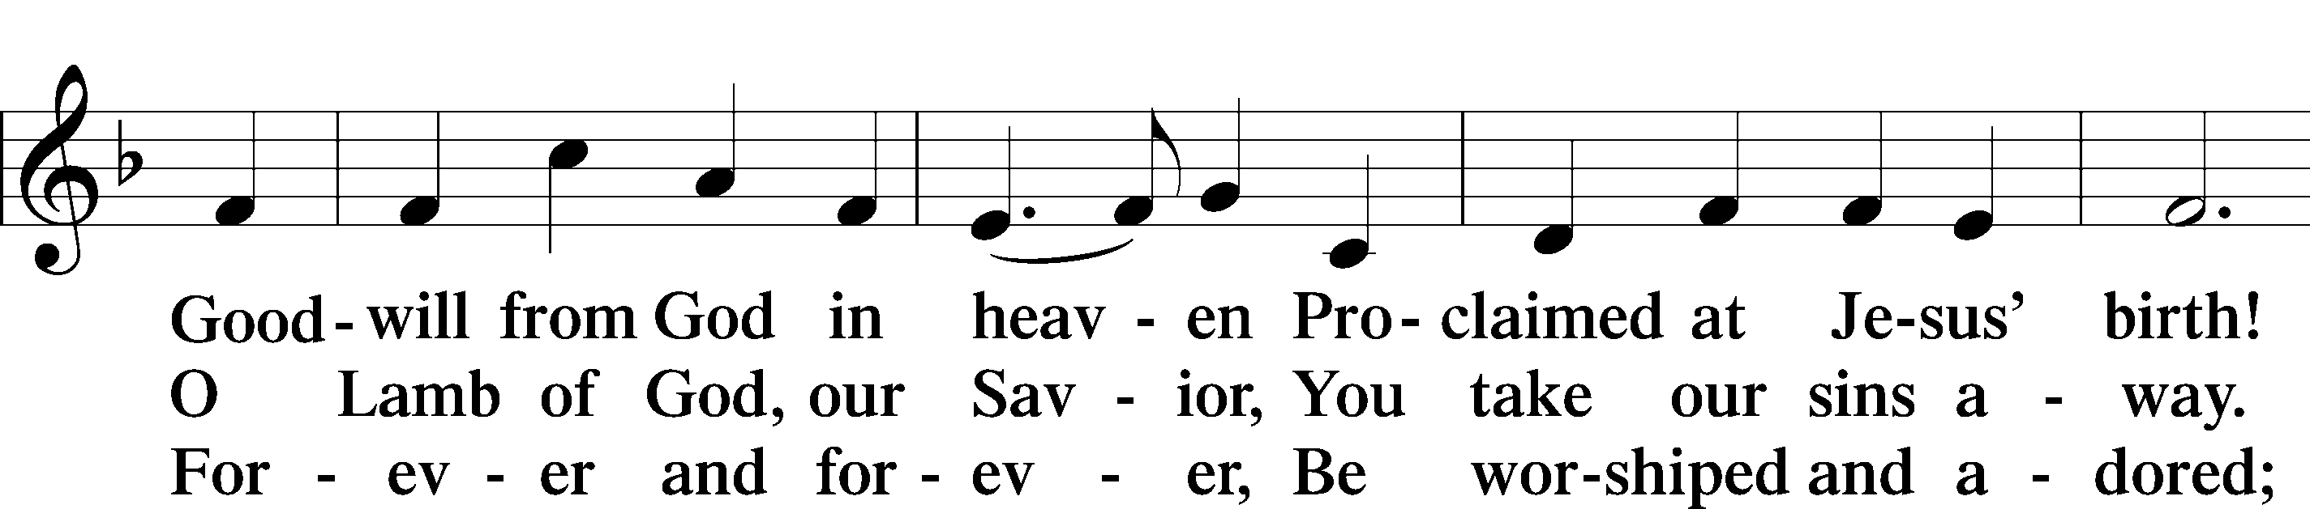
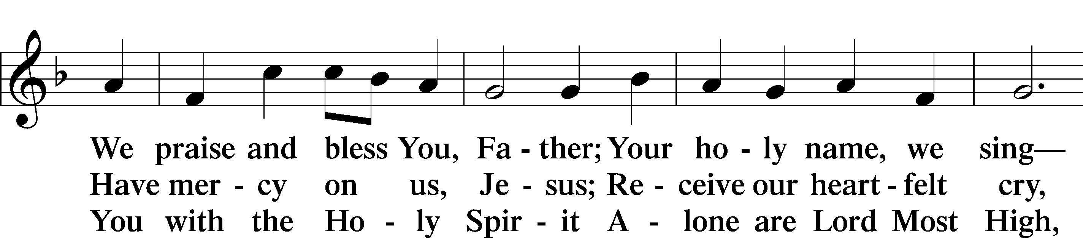
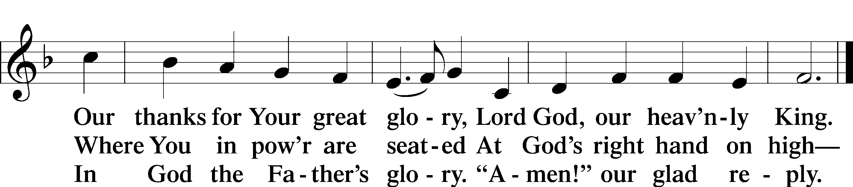

Salutation and Collect of the Day
P The Lord be with you.
C And also with you.

P Let us pray.
Almighty God, merciful Father, since You have wakened from death the Shepherd of Your sheep, grant us Your Holy Spirit that when we hear the voice of our Shepherd we may know Him who calls us each by name and follow where He leads; through the same Jesus Christ, Your Son, our Lord, who lives and reigns with You and the Holy Spirit, one God, now and forever.

C Amen.

Sit
First Reading Acts 2:42–47
42They devoted themselves to the apostles’ teaching and fellowship, to the breaking of bread and the prayers. 43And awe came upon every soul, and many wonders and signs were being done through the apostles. 44And all who believed were together and had all things in common. 45And they were selling their possessions and belongings and distributing the proceeds to all, as any had need. 46And day by day, attending the temple together and breaking bread in their homes, they received their food with glad and generous hearts, 47praising God and having favor with all the people. And the Lord added to their number day by day those who were being saved.

A This is the Word of the Lord.
C Thanks be to God.

Psalm Psalm 23; antiphon: v. 1
1The Lord is my shepherd;
I shall not want.
2He makes me lie down in green pastures.
He leads me beside still waters.
3He restores my soul.
He leads me in paths of righteousness for his name’s sake.
4Even though I walk through the valley of the shadow of death,
I will fear no evil, for you are with me;
your rod and your staff, they comfort me.
5You prepare a table before me
in the presence of my enemies;
you anoint my head with oil;
my cup overflows.
6Surely goodness and mercy shall follow me
all the days of my life,
and I shall dwell in the house of the Lord forever.

Epistle 1 Peter 2:19–25
19This is a gracious thing, when, mindful of God, one endures sorrows while suffering unjustly. 20For what credit is it if, when you sin and are beaten for it, you endure? But if when you do good and suffer for it you endure, this is a gracious thing in the sight of God. 21For to this you have been called, because Christ also suffered for you, leaving you an example, so that you might follow in his steps. 22He committed no sin, neither was deceit found in his mouth. 23When he was reviled, he did not revile in return; when he suffered, he did not threaten, but continued entrusting himself to him who judges justly. 24He himself bore our sins in his body on the tree, that we might die to sin and live to righteousness. By his wounds you have been healed. 25For you were straying like sheep, but have now returned to the Shepherd and Overseer of your souls.

A This is the Word of the Lord.
C Thanks be to God.

Stand

Alleluia and Verse
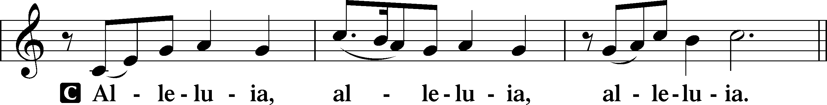
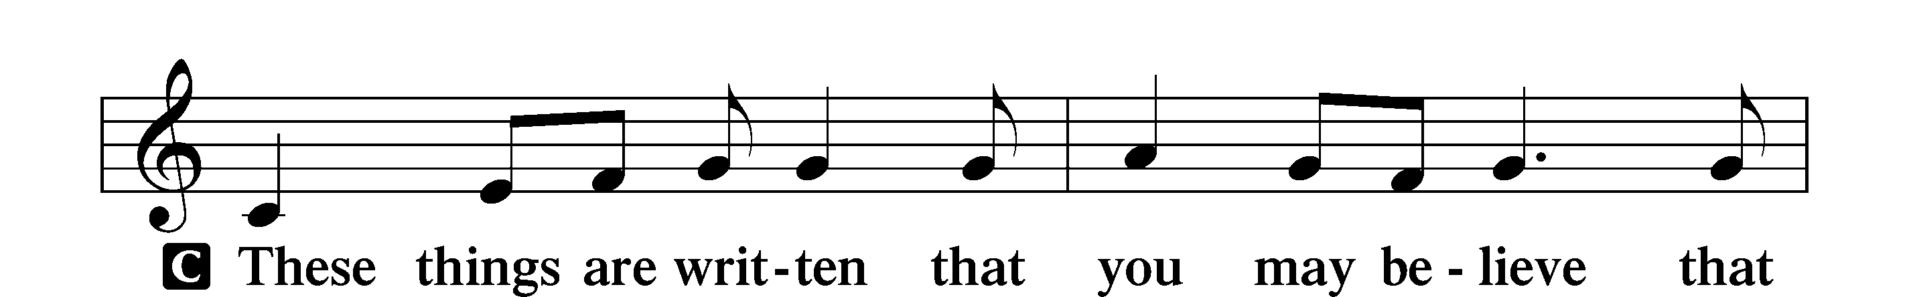
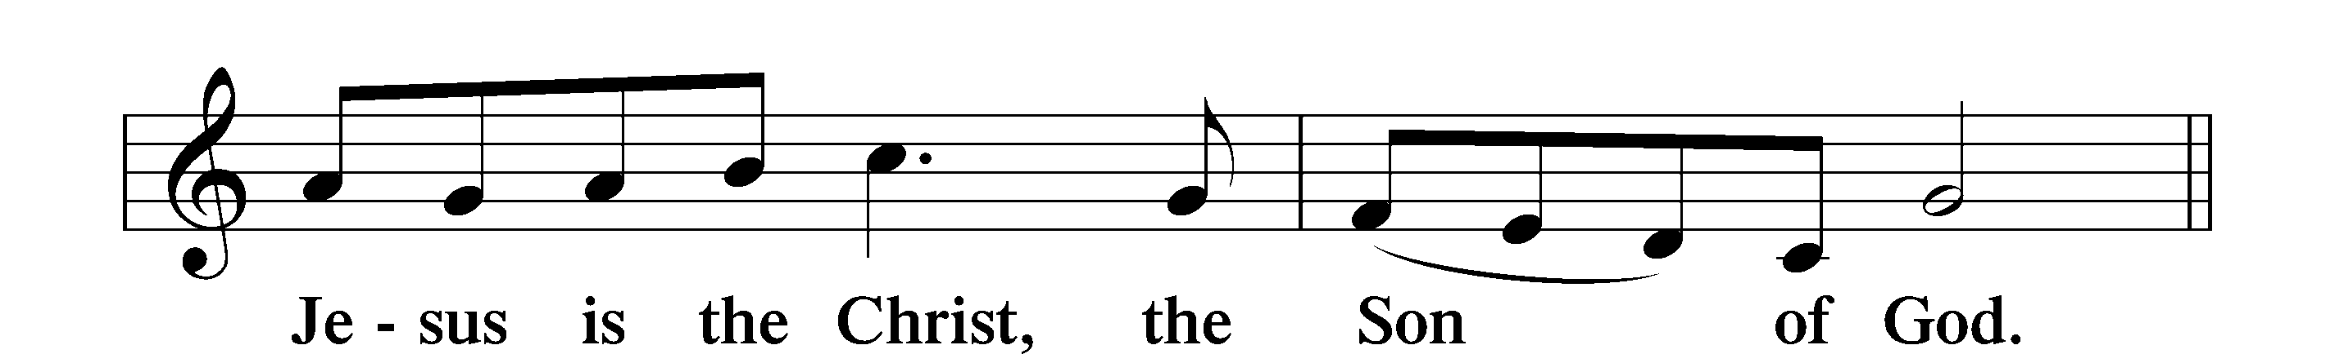
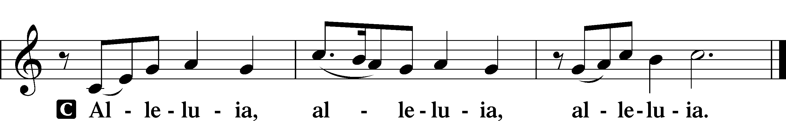

Holy Gospel John 10:1–10
P The Holy Gospel according to St. John, the tenth chapter.
C Glory to You, O Lord.

1[Jesus said:] “Truly, truly, I say to you, he who does not enter the sheepfold by the door but climbs in by another way, that man is a thief and a robber. 2But he who enters by the door is the shepherd of the sheep. 3To him the gatekeeper opens. The sheep hear his voice, and he calls his own sheep by name and leads them out. 4When he has brought out all his own, he goes before them, and the sheep follow him, for they know his voice. 5A stranger they will not follow, but they will flee from him, for they do not know the voice of strangers.” 6This figure of speech Jesus used with them, but they did not understand what he was saying to them.
7So Jesus again said to them, “Truly, truly, I say to you, I am the door of the sheep. 8All who came before me are thieves and robbers, but the sheep did not listen to them. 9I am the door. If anyone enters by me, he will be saved and will go in and out and find pasture. 10The thief comes only to steal and kill and destroy. I came that they may have life and have it abundantly.”

P This is the Gospel of the Lord.
C Praise to You, O Christ.

Nicene Creed
C I believe in one God,
the Father Almighty,
maker of heaven and earth
and of all things visible and invisible.
And in one Lord Jesus Christ,
the only-begotten Son of God,
begotten of His Father before all worlds,
God of God, Light of Light,
very God of very God,
begotten, not made,
being of one substance with the Father,
by whom all things were made;
who for us men and for our salvation came down from heaven
and was incarnate by the Holy Spirit of the virgin Mary
and was made man;
and was crucified also for us under Pontius Pilate.
He suffered and was buried.
And the third day He rose again according to the Scriptures
and ascended into heaven
and sits at the right hand of the Father.
And He will come again with glory to judge both the living and the dead,
whose kingdom will have no end.

And I believe in the Holy Spirit,
the Lord and giver of life,
who proceeds from the Father and the Son,
who with the Father and the Son together is worshiped and glorified,
who spoke by the prophets.
And I believe in one holy Christian and apostolic Church,
I acknowledge one Baptism for the remission of sins,
and I look for the resurrection of the dead
and the life T of the world to come.

Amen.

Sit

710 The Lord’s My Shepherd, I’ll Not Want

Sermon

Offering. We generously give our offerings to the LORD out of thanksgiving for His generosity of forgiveness, life, and salvation in Christ (2 Corinthians 9:8). We believe that our offerings are not only to support the proclamation of the Gospel here and around the world, but also to help us all grow in faith and trust in Him (2 Corinthians 9:7). We have placed an offering plate in the narthex so you are able to freely give back to Him as you are able. To Him be all the glory!

Stand

Prayer of the Church

Holy Communion is celebrated in the belief and glad confidence that our Lord gives us not only bread and wine, but the body and blood of Christ from the cross, for us Christian to eat and drink for the forgiveness of sins (Matthew 26:28). Because we are called to examine ourselves before receiving the Lord’s Supper (I Corinthians 11:28-29), we encourage you to consider the questions on pages 329-330 in the hymnal. We also believe that when we commune, we are confessing our unity with the community we join (I Corinthians 10:17). If you desire to commune with us for the first time or have questions, our pastor is happy to speak with you.

Preface
P The Lord be with you.
C And also with you.
P Lift up your hearts.
C We lift them to the Lord.

P Let us give thanks to the Lord our God.
C It is right to give Him thanks and praise.

P It is truly good, right, and salutary that we should at all times and in all places give thanks to You, O Lord, holy Father, almighty and everlasting God, for the countless blessings You so freely bestow on us and all creation. Above all, we give thanks for Your boundless love shown to us when You sent Your only-begotten Son, Jesus Christ, into our flesh and laid on Him our sin, giving Him into death that we might not die eternally. Because He is now risen from the dead and lives and reigns to all eternity, all who believe in Him will overcome sin and death and will rise again to new life. Therefore with angels and archangels and with all the company of heaven we laud and magnify Your glorious name, evermore praising You and saying:

Sanctus
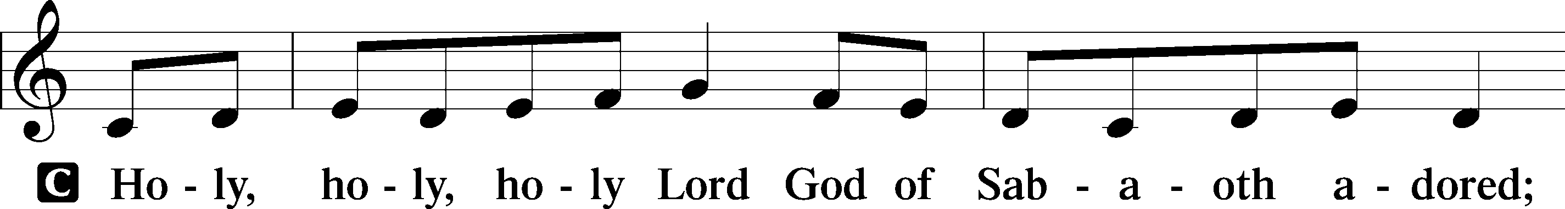
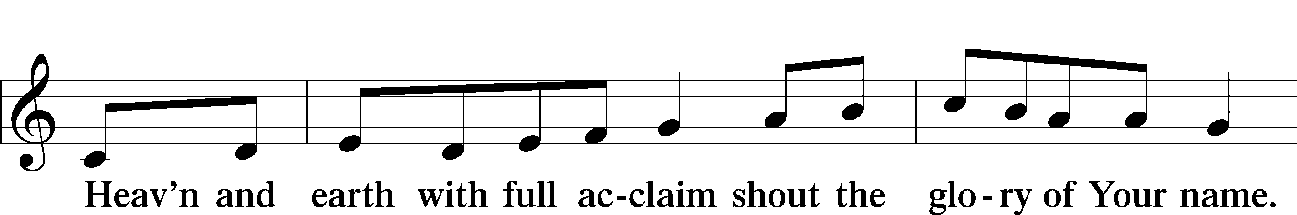
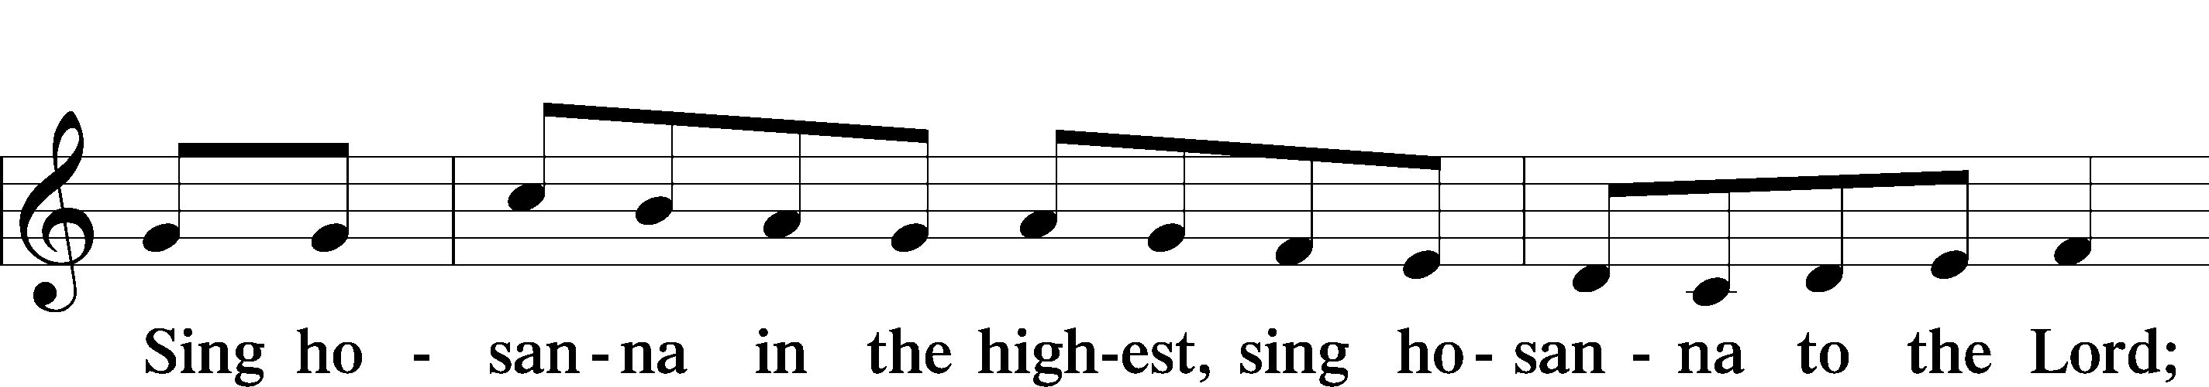
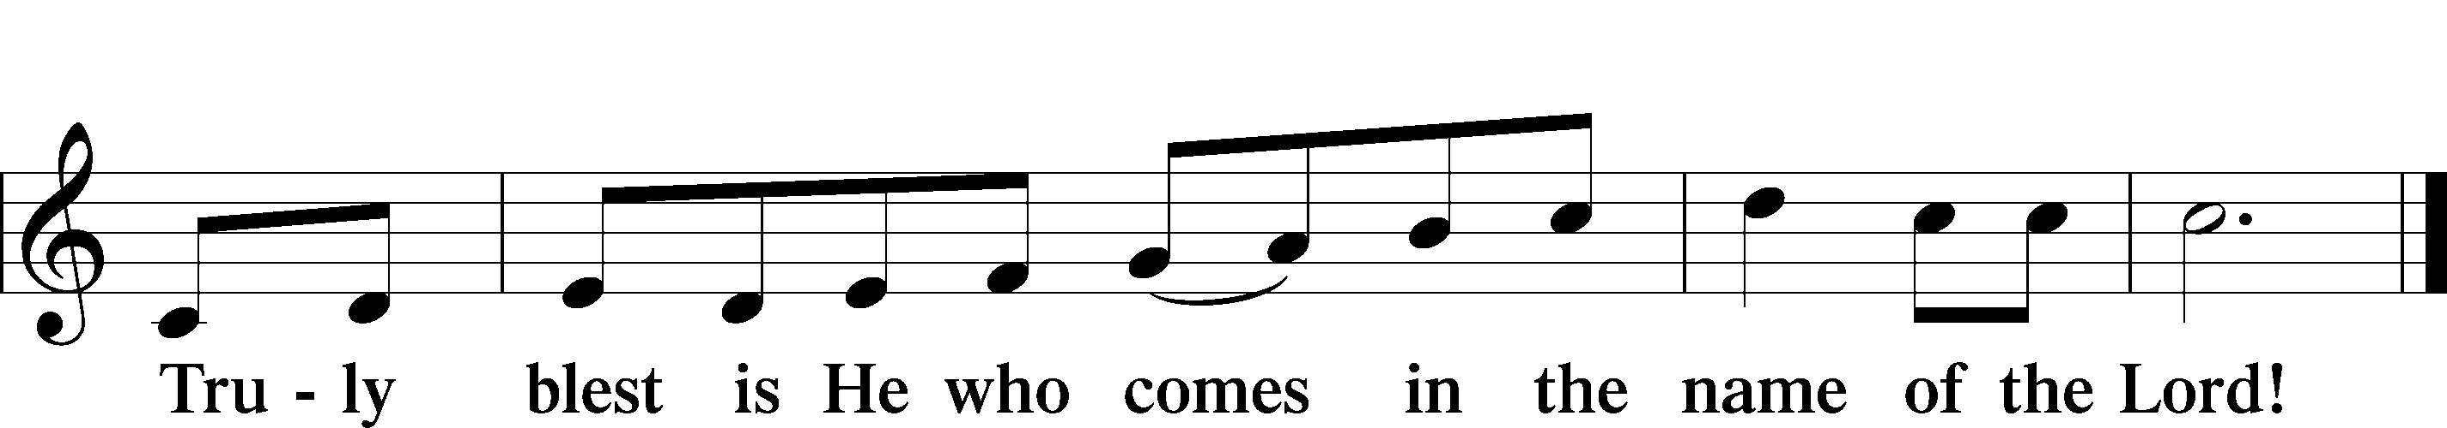

Prayer of Thanksgiving
P Blessed are You, O Lord our God, king of all creation, for You have had mercy on us and given Your only-begotten Son that whoever believes in Him should not perish but have eternal life.

For Christ, our Passover Lamb, has been sacrificed. By His death, He has redeemed us from bondage to sin and death, and by His resurrection, He has delivered us into new life in Him.

Grant us to keep the Feast in sincerity and truth, faithfully eating His body given into death and drinking His life’s blood poured out for our salvation until we pass through death to the promised land of life eternal.

Hear us as we pray in His name and as He has taught us:

Lord’s Prayer

The Words of Our Lord

Pax Domini
P The peace of the Lord be with you always.
C Amen.

Agnus Dei
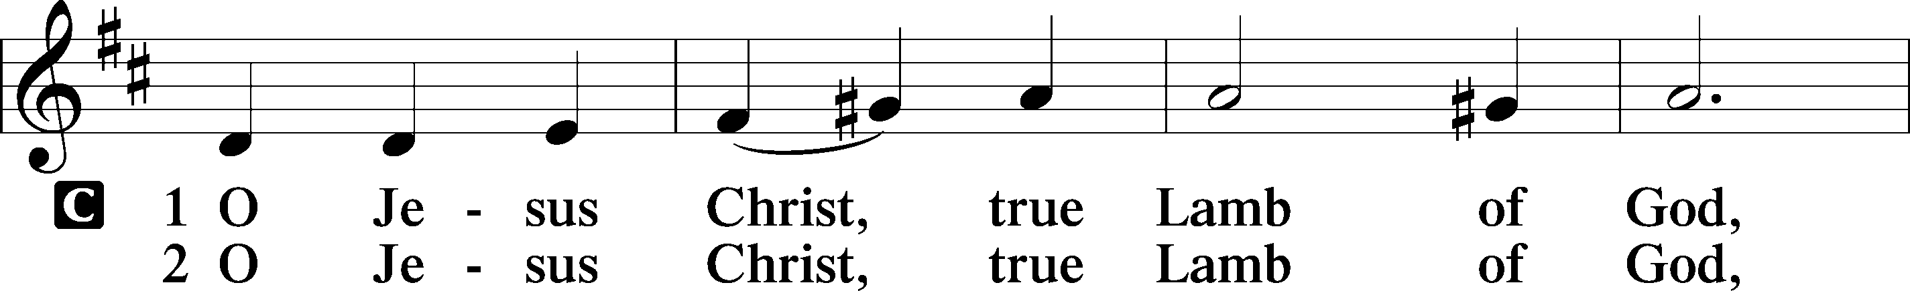
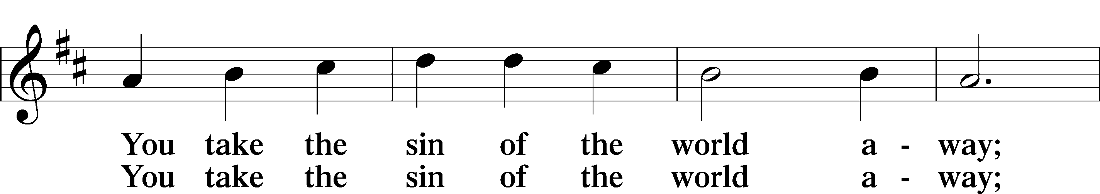
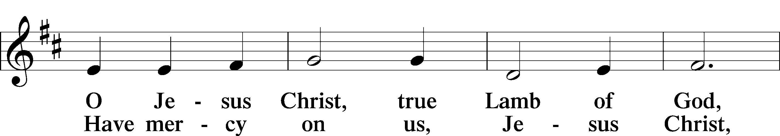
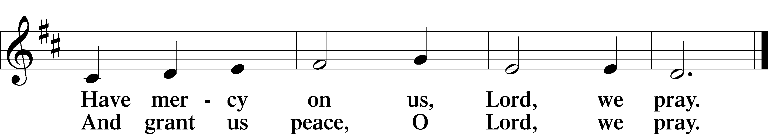

Sit

Distribution

620 Jesus Comes Today with Healing

641 You Satisfy the Hungry Heart

Stand

Nunc Dimittis
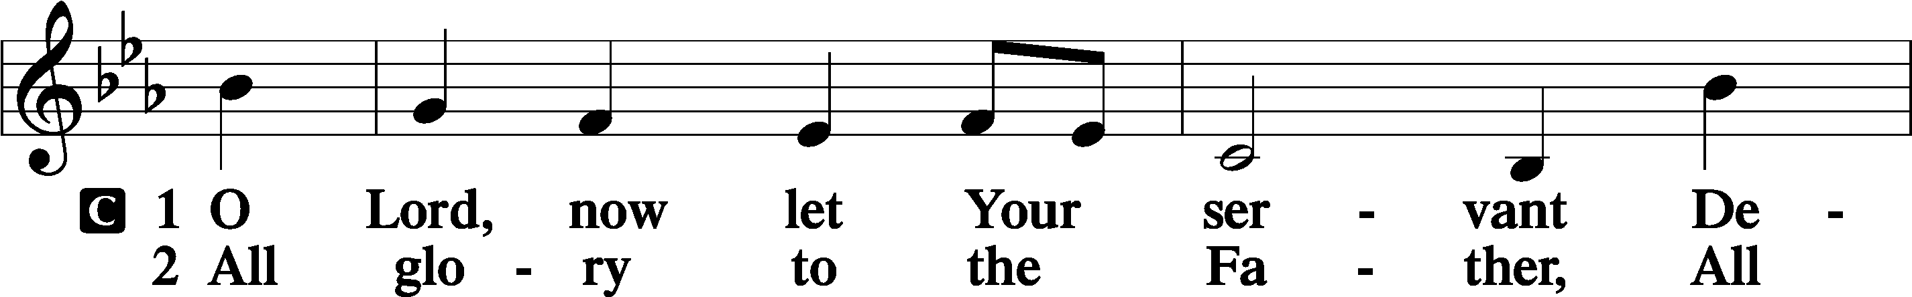
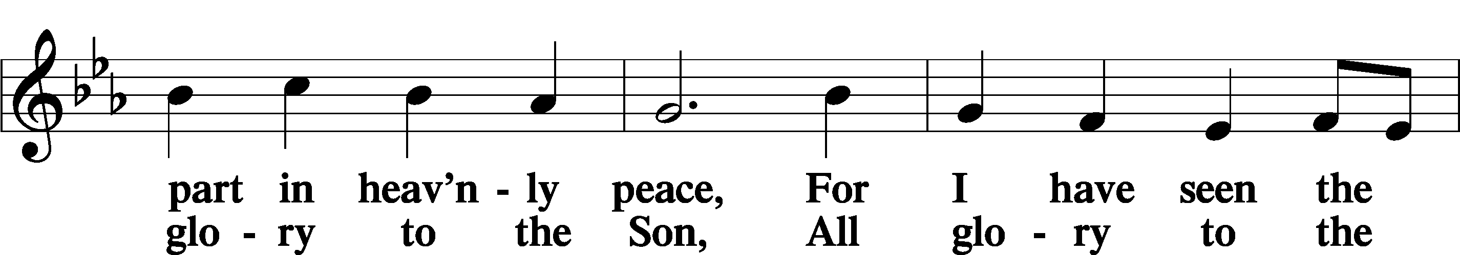
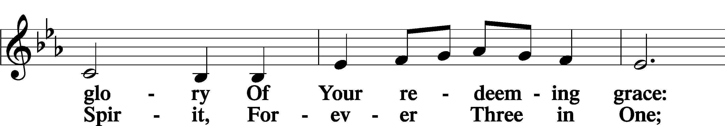
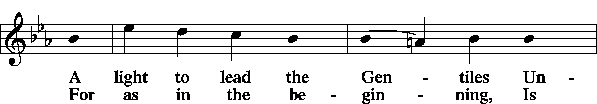
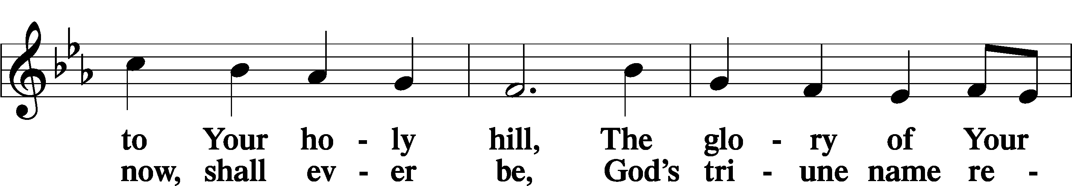
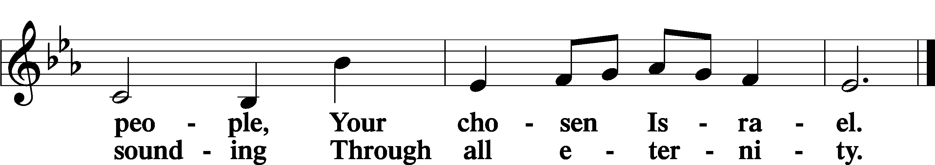

Post-Communion Collect
A Let us pray. We give thanks to You, almighty God, that You have refreshed us through this salutary gift, and we implore You that of Your mercy You would strengthen us through the same in faith toward You and in fervent love toward one another; through Jesus Christ, Your Son, our Lord, who lives and reigns with You and the Holy Spirit, one God, now and forever.
C Amen.

Benedicamus
A Let us bless the Lord.
C Thanks be to God.

Benediction
P The Lord bless you and keep you.
The Lord make His face shine on you and be gracious to you.
The Lord look upon you with favor and T give you peace.

C Amen.

711 Savior, like a Shepherd Lead Us

Announcements

Thank you to everyone who came out to help with the Spring Clean-up!

Calling all men! We want to start a men’s ministry group here at Messiah, I am currently trying to figure out scheduling. If you are interested, please share what days’ work with best for you, especially those still working full-time. Also share your ideas for topics or interests for study/discussion. You can call, text, email, or even send me a letter via snail mail your ideas but I want to hear from you.

