18th Sunday After Pentecost
September 27th, 2026

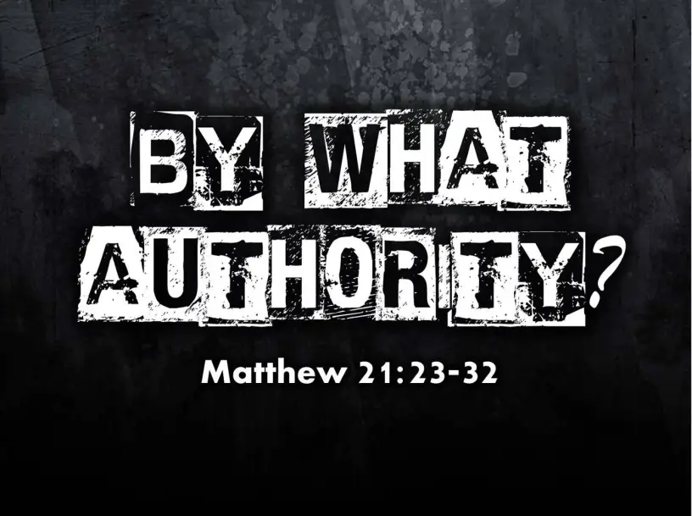

Messiah Lutheran Church
Sartell, MN
www.messiahsartell.com
320-252-5883
Prayer Before Entering
Please take this time to focus on our purpose in gathering and join in prayer before our service begins. Blessed Lord, You have caused all Holy Scriptures to be written for our learning. Grant that we may so hear them, read, mark, learn, and inwardly digest them that, by patience and comfort of Your holy Word, we may embrace and ever hold fast the blessed hope of everlasting life; through Jesus Christ, our Lord.

As We Gather
As we gather in God’s presence, we remember that Jesus speaks with the authority of God—an authority that not only exposes our sin but also calls us to repentance, forgives us, and gives us life. Like the son who first resisted his father but later went into the vineyard, we often fall short, yet the Holy Spirit turns our hearts back to the Lord. Through Christ’s obedient death and victorious resurrection, our sins are forgiven and we are invited to trust His Word, receive His grace, and joyfully serve in His kingdom.

570 Just as I Am, without One Plea

Stand

The sign of the cross may be made by all in remembrance of their Baptism.

P In the name of the Father and of the T Son and of the Holy Spirit.
C Amen.

P Our help is in the name of the Lord,
C who made heaven and earth.

P If You, O Lord, kept a record of sins, O Lord, who could stand?
C But with You there is forgiveness; therefore You are feared.

P Since we are gathered to hear God’s Word, call upon Him in prayer and praise, let us first consider our unworthiness and confess before God and one another that we have sinned in thought, word, and deed, and that we cannot free ourselves from our sinful condition. Together as His people let us take refuge in the infinite mercy of God, our heavenly Father, seeking His grace for the sake of Christ, and saying:
C God, be merciful to me, a sinner.
Silence for reflection on God’s Word and for self-examination.

C Almighty God, have mercy upon us, forgive us our sins, and lead us to everlasting life. Amen.

P Almighty God in His mercy has given His Son to die for you and for His sake forgives you all your sins. As a called and ordained servant of Christ, and by His authority, I therefore forgive you all your sins in the name of the Father and of the T Son and of the Holy Spirit.

C Amen.

Introit Psalm 147:1–5; antiphon: v. 6
P The Lord lifts up the humble;
he casts the wicked to the ground.
C Praise the Lord! For it is good to sing praises to our God;
for it is pleasant, and a song of praise is fitting.
P The Lord builds up Jerusalem;
he gathers the outcasts of Israel.
C He heals the brokenhearted
and binds up their wounds.
P He determines the number of the stars;
he gives to all of them their names.
C Great is our Lord, and abundant in power;
his understanding is beyond measure.
All: Glory be to the Father and to the Son
and to the Holy Spirit;
as it was in the beginning,
is now, and will be forever. Amen.
P The Lord lifts up the humble;
he casts the wicked to the ground.

Kyrie
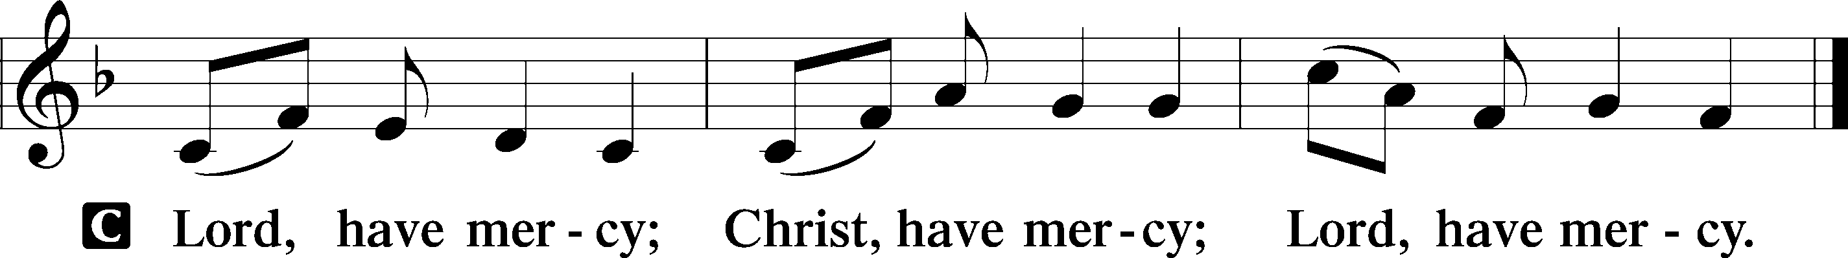

Gloria in Excelsis
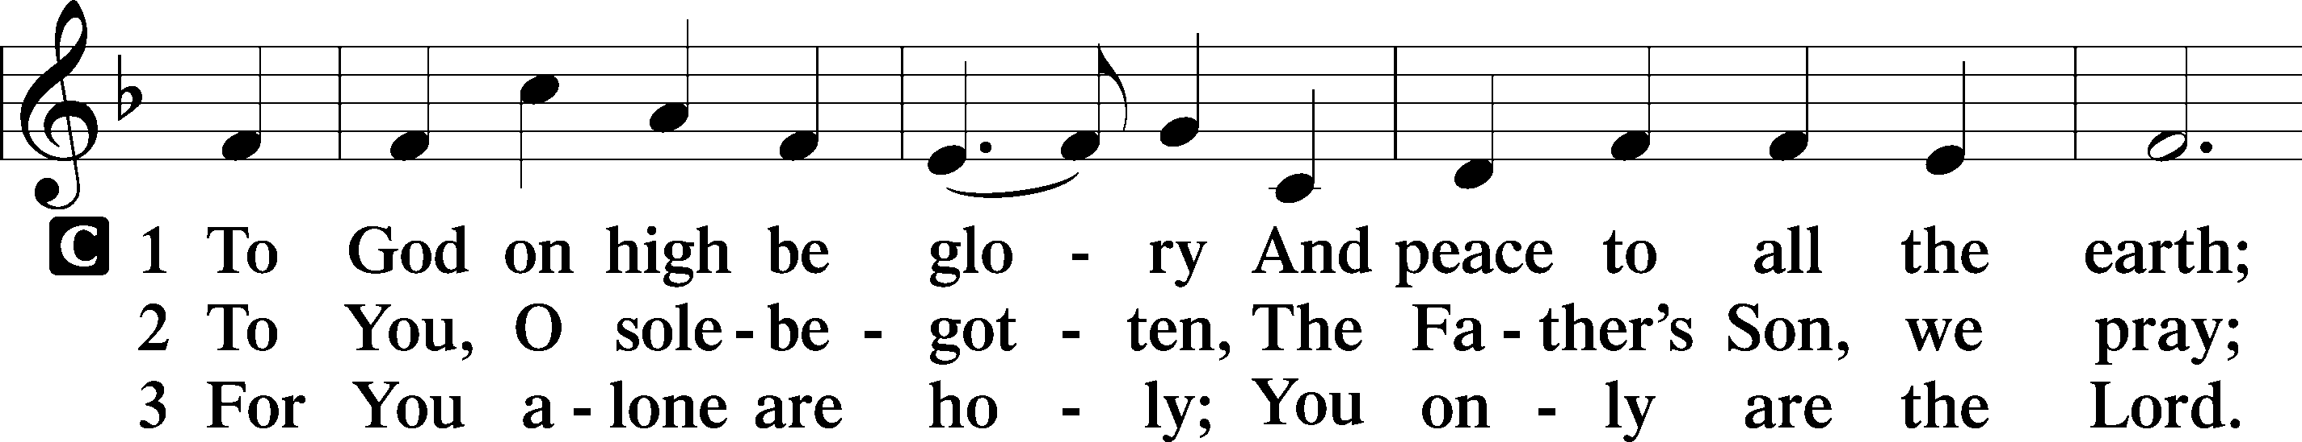
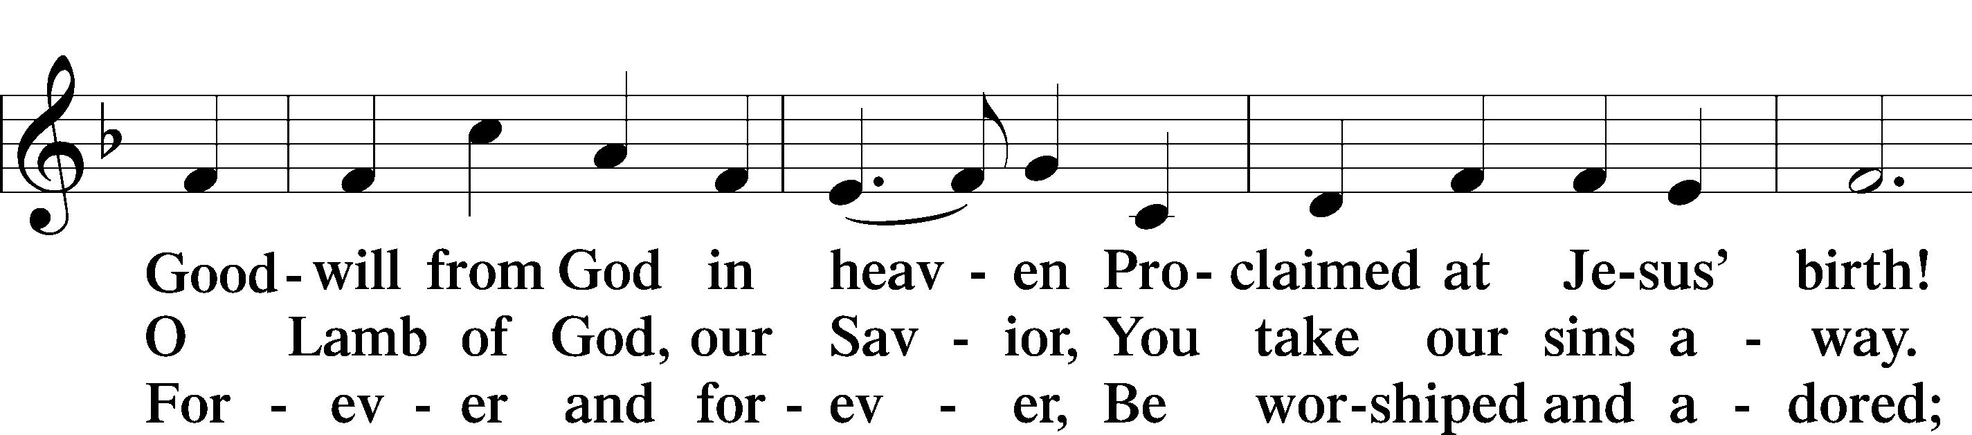
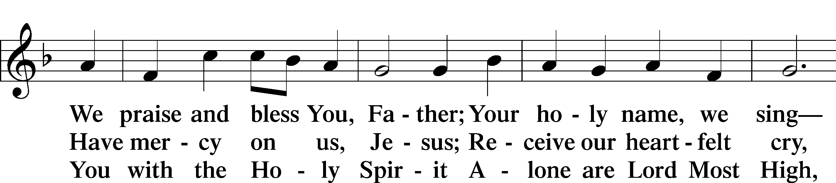
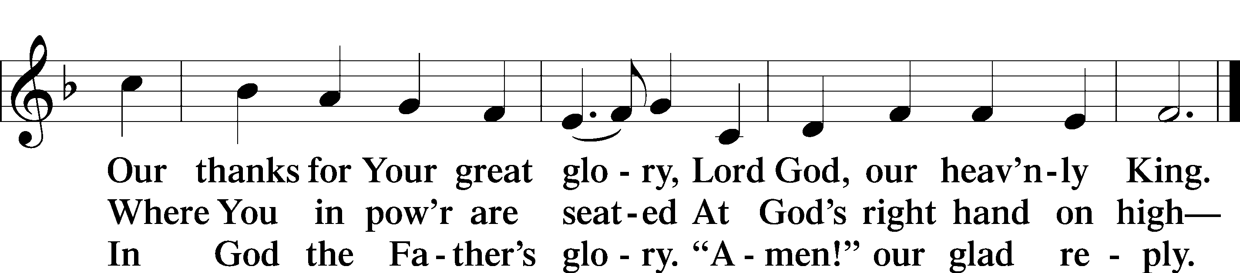

Salutation and Collect of the Day
P The Lord be with you.
C And also with you.

P Let us pray.
Almighty God, You exalted Your Son to the place of all honor and authority. Enlighten our minds by Your Holy Spirit that, confessing Jesus as Lord, we may be led into all truth; through the same Jesus Christ, our Lord, who lives and reigns with You and the Holy Spirit, one God, now and forever.

C Amen.

Sit
Old Testament Reading Ezekiel 18:1–4, 25–32
1The word of the Lord came to me: 2“What do you mean by repeating this proverb concerning the land of Israel, ‘The fathers have eaten sour grapes, and the children’s teeth are set on edge’? 3As I live, declares the Lord God, this proverb shall no more be used by you in Israel. 4Behold, all souls are mine; the soul of the father as well as the soul of the son is mine: the soul who sins shall die. . . .
25“Yet you say, ‘The way of the Lord is not just.’ Hear now, O house of Israel: Is my way not just? Is it not your ways that are not just? 26When a righteous person turns away from his righteousness and does injustice, he shall die for it; for the injustice that he has done he shall die. 27Again, when a wicked person turns away from the wickedness he has committed and does what is just and right, he shall save his life. 28Because he considered and turned away from all the transgressions that he had committed, he shall surely live; he shall not die. 29Yet the house of Israel says, ‘The way of the Lord is not just.’ O house of Israel, are my ways not just? Is it not your ways that are not just?
30“Therefore I will judge you, O house of Israel, every one according to his ways, declares the Lord God. Repent and turn from all your transgressions, lest iniquity be your ruin. 31Cast away from you all the transgressions that you have committed, and make yourselves a new heart and a new spirit! Why will you die, O house of Israel? 32For I have no pleasure in the death of anyone, declares the Lord God; so turn, and live.”

A This is the Word of the Lord.
C Thanks be to God.

Epistle Philippians 2:1–4, 14–18
1If there is any encouragement in Christ, any comfort from love, any participation in the Spirit, any affection and sympathy, 2complete my joy by being of the same mind, having the same love, being in full accord and of one mind. 3Do nothing from rivalry or conceit, but in humility count others more significant than yourselves. 4Let each of you look not only to his own interests, but also to the interests of others. . . .
14Do all things without grumbling or questioning, 15that you may be blameless and innocent, children of God without blemish in the midst of a crooked and twisted generation, among whom you shine as lights in the world, 16holding fast to the word of life, so that in the day of Christ I may be proud that I did not run in vain or labor in vain. 17Even if I am to be poured out as a drink offering upon the sacrificial offering of your faith, I am glad and rejoice with you all. 18Likewise you also should be glad and rejoice with me.

A This is the Word of the Lord.
C Thanks be to God.

Stand

Alleluia and Verse
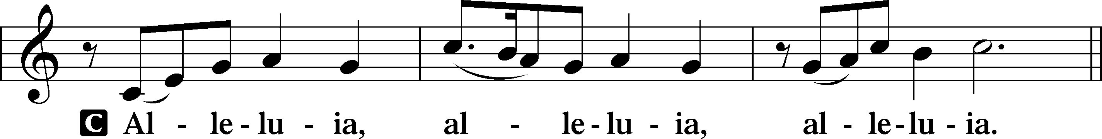
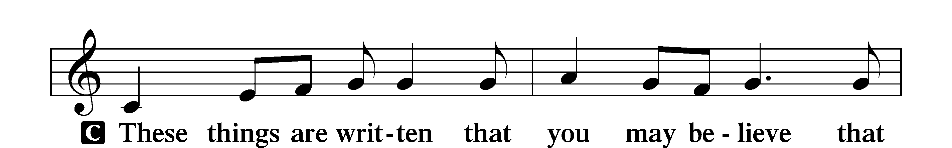
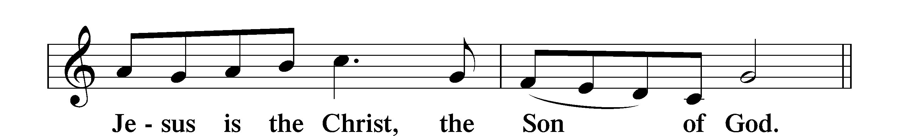
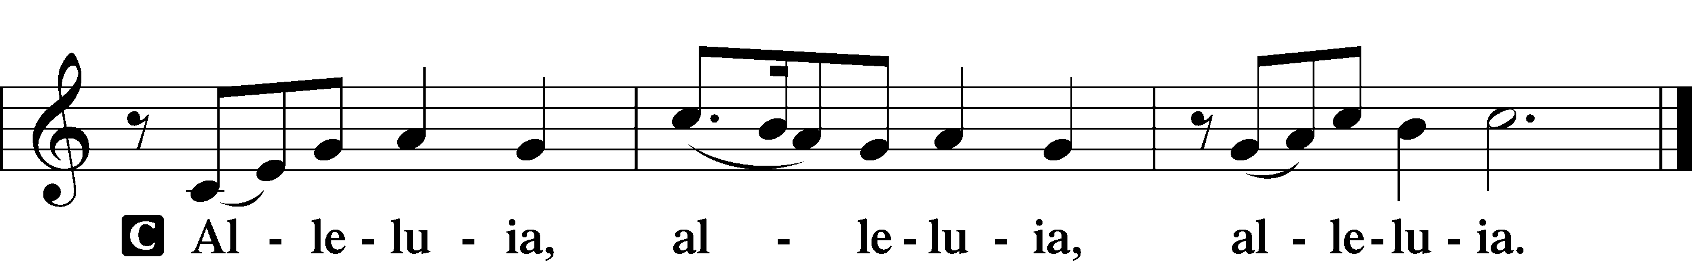

Holy Gospel Matthew 21:23–27
P The Holy Gospel according to St. Matthew, the twenty-first chapter.
C Glory to You, O Lord.

23When [Jesus] entered the temple, the chief priests and the elders of the people came up to him as he was teaching, and said, “By what authority are you doing these things, and who gave you this authority?” 24Jesus answered them, “I also will ask you one question, and if you tell me the answer, then I also will tell you by what authority I do these things. 25The baptism of John, from where did it come? From heaven or from man?” And they discussed it among themselves, saying, “If we say, ‘From heaven,’ he will say to us, ‘Why then did you not believe him?’ 26But if we say, ‘From man,’ we are afraid of the crowd, for they all hold that John was a prophet.” 27So they answered Jesus, “We do not know.” And he said to them, “Neither will I tell you by what authority I do these things.”

P This is the Gospel of the Lord.
C Praise to You, O Christ.

Nicene Creed
C I believe in one God,
the Father Almighty,
maker of heaven and earth
and of all things visible and invisible.
And in one Lord Jesus Christ,
the only-begotten Son of God,
begotten of His Father before all worlds,
God of God, Light of Light,
very God of very God,
begotten, not made,
being of one substance with the Father,
by whom all things were made;
who for us men and for our salvation came down from heaven
and was incarnate by the Holy Spirit of the virgin Mary
and was made man;
and was crucified also for us under Pontius Pilate.
He suffered and was buried.
And the third day He rose again according to the Scriptures
and ascended into heaven
and sits at the right hand of the Father.
And He will come again with glory to judge both the living and the dead,
whose kingdom will have no end.

And I believe in the Holy Spirit,
the Lord and giver of life,
who proceeds from the Father and the Son,
who with the Father and the Son together is worshiped and glorified,
who spoke by the prophets.
And I believe in one holy Christian and apostolic Church,
I acknowledge one Baptism for the remission of sins,
and I look for the resurrection of the dead
and the life T of the world to come.
Amen.

Sit
655 Lord, Keep Us Steadfast in Your Word

Sermon

Offering. We generously give our offerings to the LORD out of thanksgiving for His generosity of forgiveness, life, and salvation in Christ (2 Corinthians 9:8). We believe that our offerings are not only to support the proclamation of the Gospel here and around the world, but also to help us all grow in faith and trust in Him (2 Corinthians 9:7). We have placed an offering plate in the narthex so you are able to freely give back to Him as you are able. To Him be all the glory!

Rite of Confirmation LSB 272-274

Stand

Prayer of the Church

Holy Communion is celebrated in the belief and glad confidence that our Lord gives us not only bread and wine, but the body and blood of Christ from the cross, for us Christian to eat and drink for the forgiveness of sins (Matthew 26:28). Because we are called to examine ourselves before receiving the Lord’s Supper (I Corinthians 11:28-29), we encourage you to consider the questions on pages 329-330 in the hymnal. We also believe that when we commune, we are confessing our unity with the community we join (I Corinthians 10:17). If you desire to commune with us for the first time or have questions, our pastor is happy to speak with you.

Preface
P The Lord be with you.
C And also with you.

P Lift up your hearts.
C We lift them to the Lord.

P Let us give thanks to the Lord our God.
C It is right to give Him thanks and praise.

P It is truly good, right, and salutary that we should at all times and in all places give thanks to You, O Lord, holy Father, almighty and everlasting God, for the countless blessings You so freely bestow on us and all creation. Above all, we give thanks for Your boundless love shown to us when You sent Your only-begotten Son, Jesus Christ, into our flesh and laid on Him our sin, giving Him into death that we might not die eternally. Because He is now risen from the dead and lives and reigns to all eternity, all who believe in Him will overcome sin and death and will rise again to new life. Therefore with angels and archangels and with all the company of heaven we laud and magnify Your glorious name, evermore praising You and saying:

Sanctus
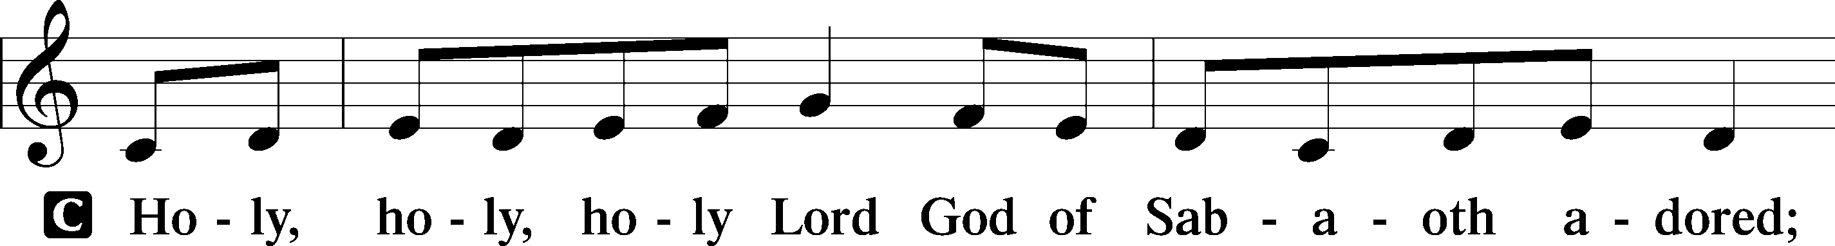
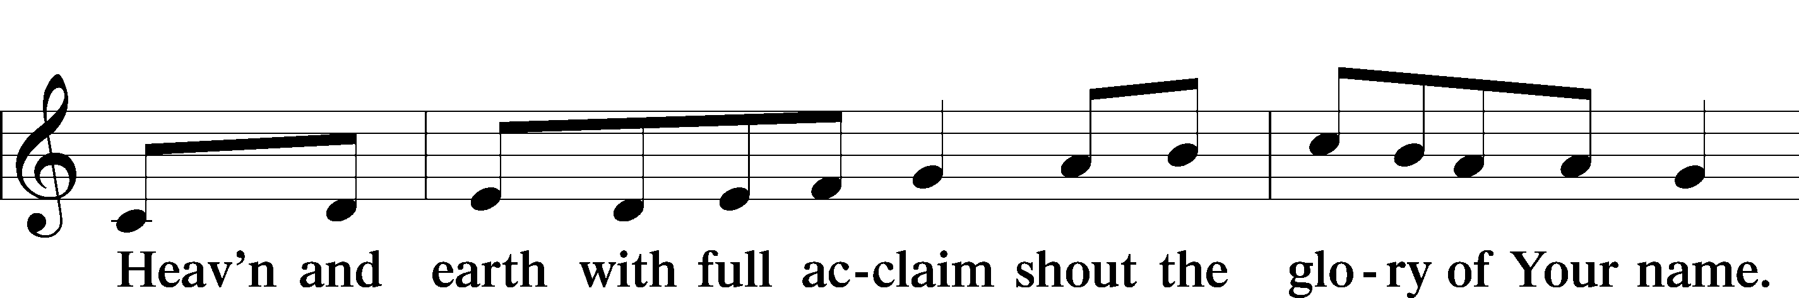
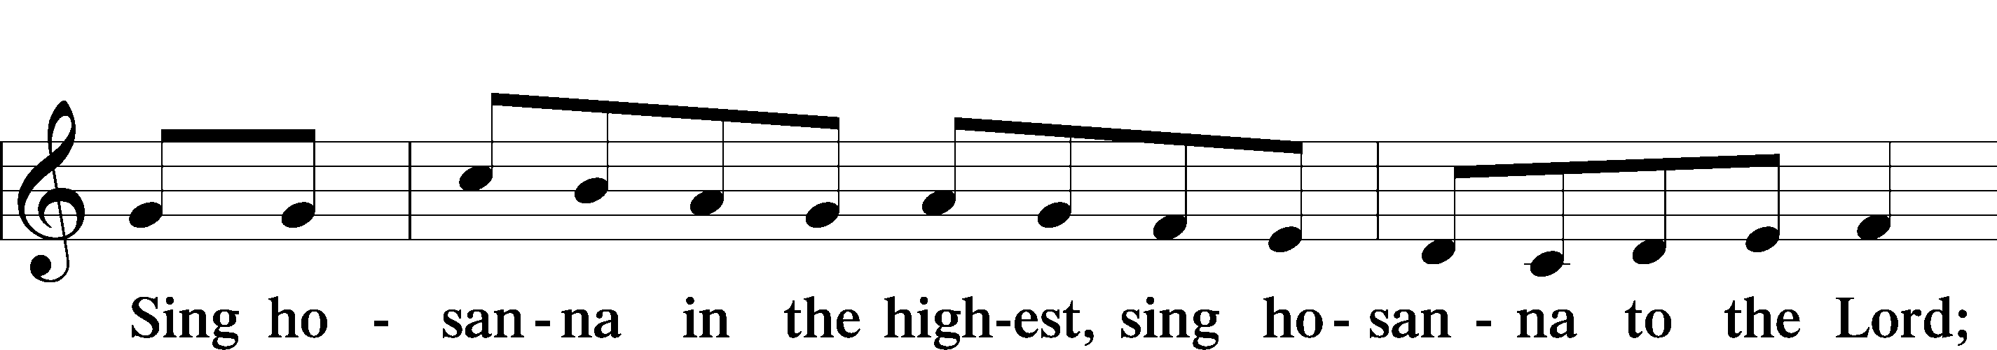
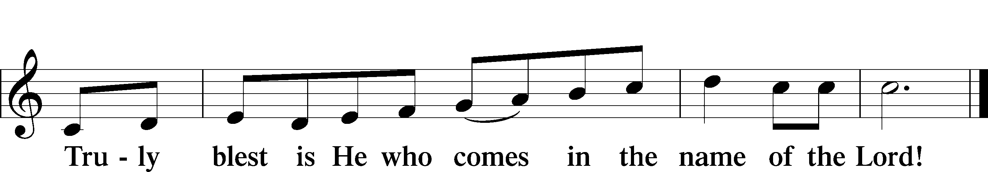

Prayer of Thanksgiving
P Blessed are You, O Lord our God, king of all creation, for You have had mercy on us and given Your only-begotten Son that whoever believes in Him should not perish but have eternal life.

In Your righteous judgment You condemned the sin of Adam and Eve, who ate the forbidden fruit, and You justly barred them and all their children from the tree of life. Yet, in Your great mercy, You promised salvation by a second Adam, Your Son, Jesus Christ, our Lord, and made His cross a life-giving tree for all who trust in Him.

We give You thanks for the redemption You have prepared for us through Jesus Christ. Grant us Your Holy Spirit that we may faithfully eat and drink of the fruits of His cross and receive the blessings of forgiveness, life, and salvation that come to us in His body and blood.

Hear us as we pray in His name and as He has taught us:
Lord’s Prayer

The Words of Our Lord

Pax Domini
P The peace of the Lord be with you always.
C Amen.

Agnus Dei
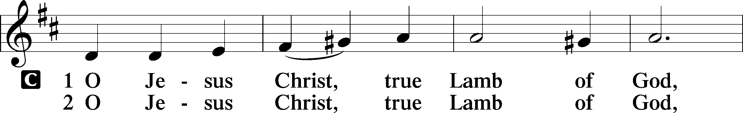
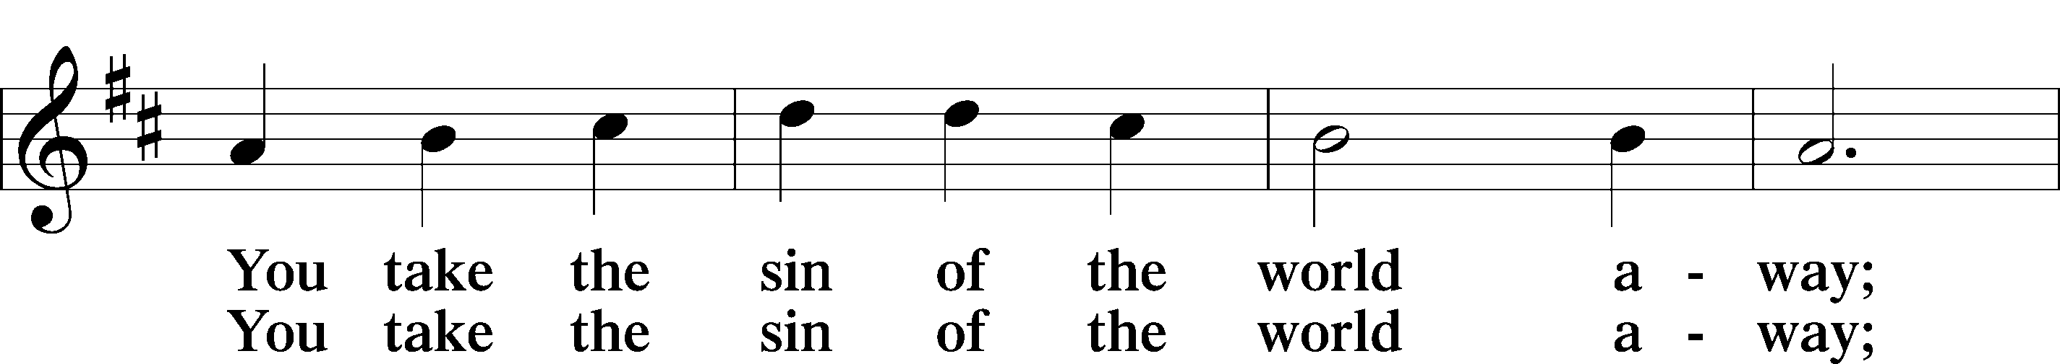
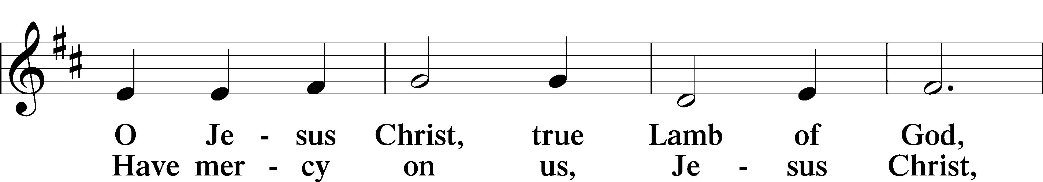
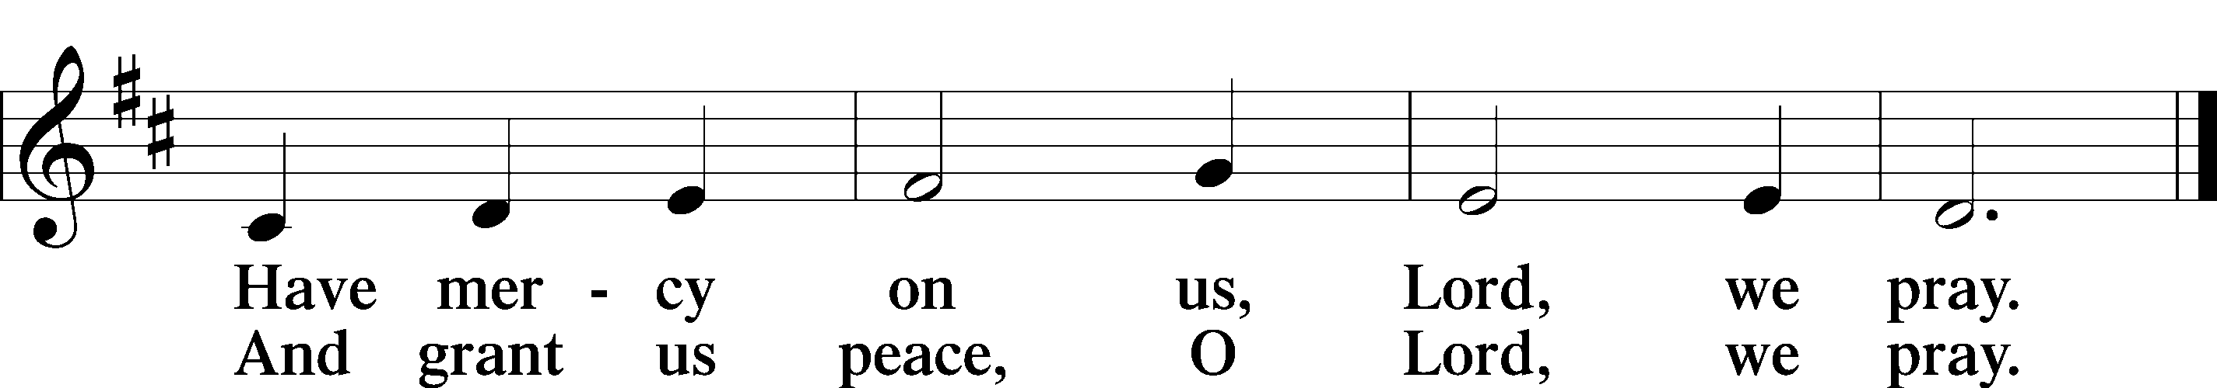

Sit

Distribution

621 Let All Mortal Flesh Keep Silence

622 Lord Jesus Christ, You Have Prepared

Stand

Nunc Dimittis
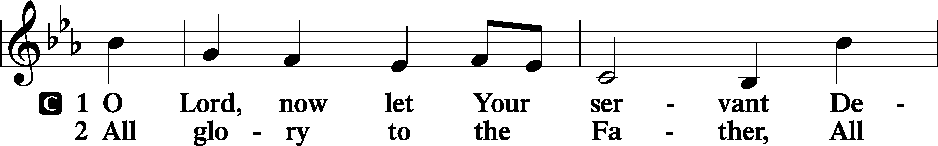
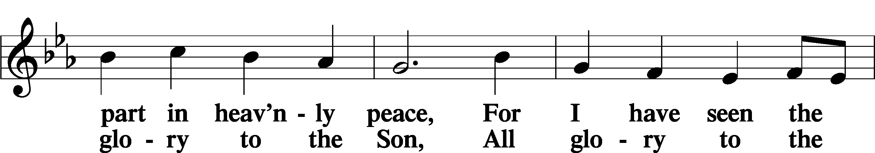
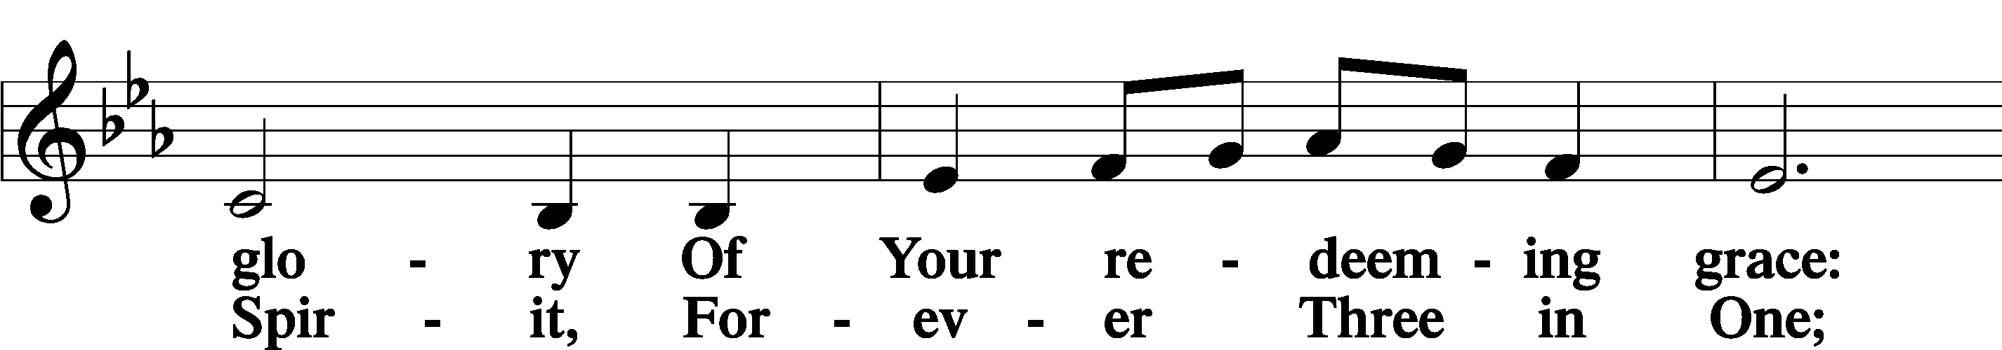
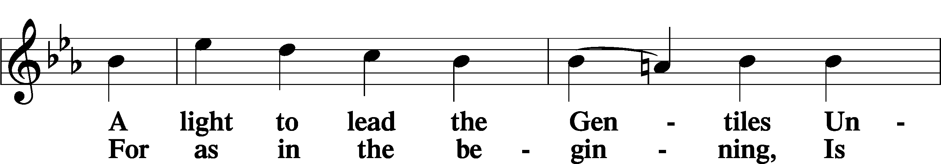
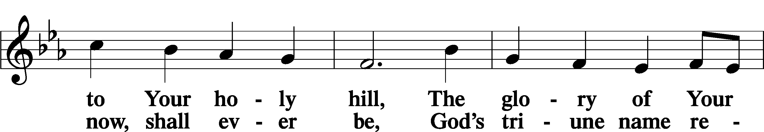
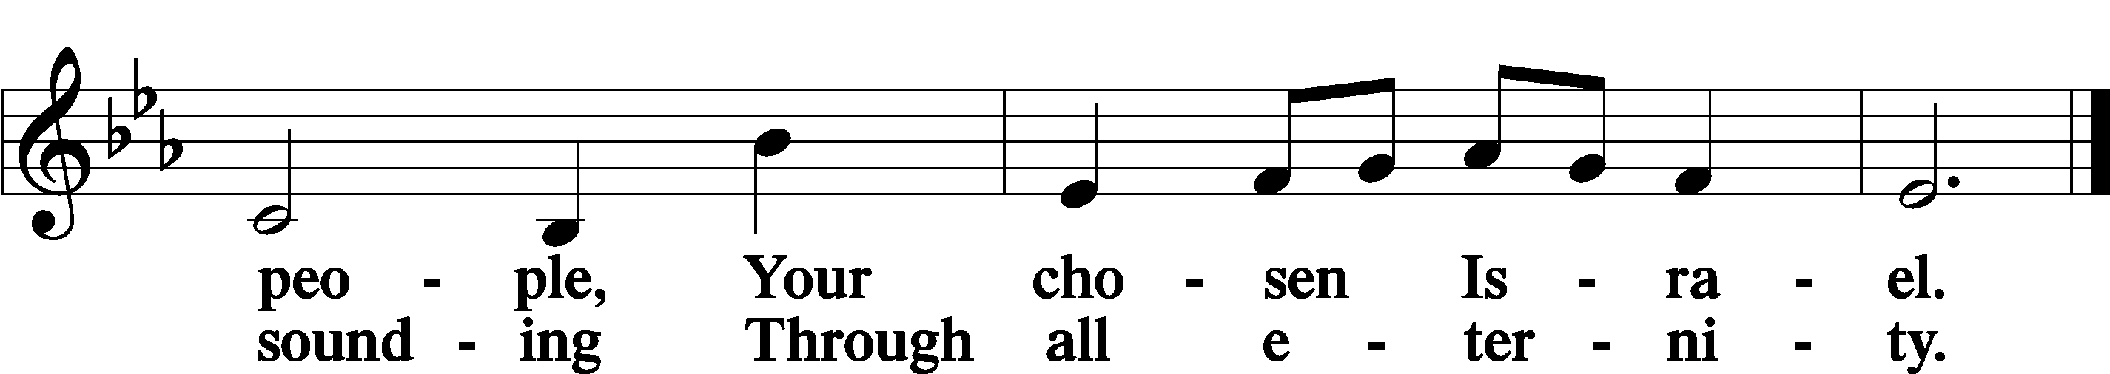

Post-Communion Collect
A Let us pray. We give thanks to You, almighty God, that You have refreshed us through this salutary gift, and we implore You that of Your mercy You would strengthen us through the same in faith toward You and in fervent love toward one another; through Jesus Christ, Your Son, our Lord, who lives and reigns with You and the Holy Spirit, one God, now and forever.
C Amen.

Benedicamus
A Let us bless the Lord.
C Thanks be to God.

Benediction
P The Lord bless you and keep you.
The Lord make His face shine on you and be gracious to you.
The Lord look upon you with favor and T give you peace.

C Amen.

857 Lord, Help Us Walk Your Servant Way

Announcement

Please join us for cake and fellowship after today’s service to celebrate
the confirmation of the Held family and Gordy Koring’s 90th birthday!

