The Holy Trinity
May 31st, 2026

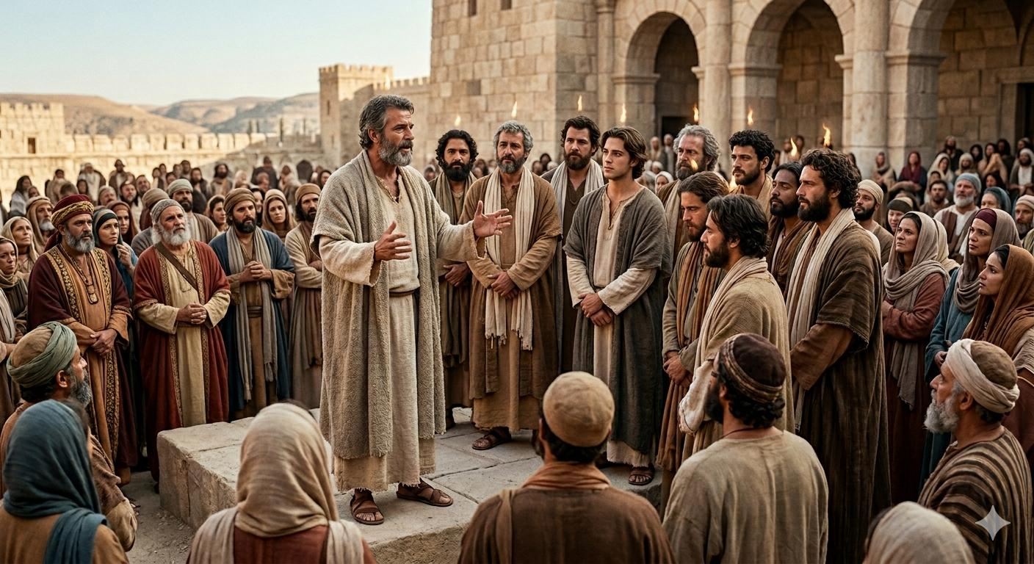

Messiah Lutheran Church
Sartell, MN
www.messiahsartell.com
320-252-5883
Prayer Before Entering
Please take this time to focus on our purpose in gathering and join in prayer before our service begins. Blessed Lord, You have caused all Holy Scriptures to be written for our learning. Grant that we may so hear them, read, mark, learn, and inwardly digest them that, by patience and comfort of Your holy Word, we may embrace and ever hold fast the blessed hope of everlasting life; through Jesus Christ, our Lord.

As We Gather
Holy Trinity, a time we commemorate and celebrate, is different than any other recognized time in the Church Year. Unlike Christmas, Easter, or last week’s Pentecost, where we rejoice in and reflect upon an action of God for our salvation, Holy Trinity is a time to rejoice in and reflect upon a doctrine. We gather around our shared confession of God as we know Him to be in the Trinity: Father, Son, and Holy Spirit. Even in the mystery of things we cannot fully understand or comprehend by our own reason, we trust God’s revelation through His Word made known to us of who He is and what He has done, that apart from Him there is no other.

Athanasian Creed
P Whoever desires to be saved must, above all, hold the catholic faith.
C Whoever does not keep it whole and undefiled will without doubt perish eternally.

P And the catholic faith is this,
C that we worship one God in Trinity and Trinity in Unity, neither confusing the persons nor dividing the substance.

P For the Father is one person, the Son is another, and the Holy Spirit is another.
C But the Godhead of the Father and of the Son and of the Holy Spirit is one: the glory equal, the majesty coeternal.

P Such as the Father is, such is the Son, and such is the Holy Spirit:
C the Father uncreated, the Son uncreated, the Holy Spirit uncreated;

P the Father infinite, the Son infinite, the Holy Spirit infinite;
C the Father eternal, the Son eternal, the Holy Spirit eternal.
P And yet there are not three Eternals, but one Eternal,
C just as there are not three Uncreated or three Infinites, but one Uncreated and one Infinite.

P In the same way, the Father is almighty, the Son almighty, the Holy Spirit almighty;
C and yet there are not three Almighties, but one Almighty.

P So the Father is God, the Son is God, the Holy Spirit is God;
C and yet there are not three Gods, but one God.

P So the Father is Lord, the Son is Lord, the Holy Spirit is Lord;
C and yet there are not three Lords, but one Lord.

506 Glory Be to God the Father

Stand

The sign of the cross may be made by all in remembrance of their Baptism.

P In the name of the Father and of the T Son and of the Holy Spirit.
C Amen.

P Our help is in the name of the Lord,
C who made heaven and earth.

P If You, O Lord, kept a record of sins, O Lord, who could stand?
C But with You there is forgiveness; therefore You are feared.

P Since we are gathered to hear God’s Word, call upon Him in prayer and praise, let us first consider our unworthiness and confess before God and one another that we have sinned in thought, word, and deed, and that we cannot free ourselves from our sinful condition. Together as His people let us take refuge in the infinite mercy of God, our heavenly Father, seeking His grace for the sake of Christ, and saying:
C God, be merciful to me, a sinner.

Silence for reflection on God’s Word and for self-examination.
C Almighty God, have mercy upon us, forgive us our sins, and lead us to everlasting life. Amen.

P Almighty God in His mercy has given His Son to die for you and for His sake forgives you all your sins. As a called and ordained servant of Christ, and by His authority, I therefore forgive you all your sins in the name of the Father and of the T Son and of the Holy Spirit.

C Amen.

Introit Psalm 16:8–11; antiphon: Liturgical Text
P Blessèd be the Holy Trinity and the undivided Unity.
Let us give glory to him because he has shown his mercy to us.
C I have set the Lord always before me;
because he is at my right hand, I shall not be shaken.
P Therefore my heart is glad, and my whole being rejoices;
my flesh also dwells secure.
C For you will not abandon my soul to Sheol,
or let your holy one see corruption.
P You make known to me the path of life;
in your presence there is fullness of joy; at your right hand are
pleasures forevermore.
All: Glory be to the Father and to the Son
and to the Holy Spirit;
as it was in the beginning,
is now, and will be forever. Amen.
P Blessèd be the Holy Trinity and the undivided Unity.
Let us give glory to him because he has shown his mercy to us.

Kyrie
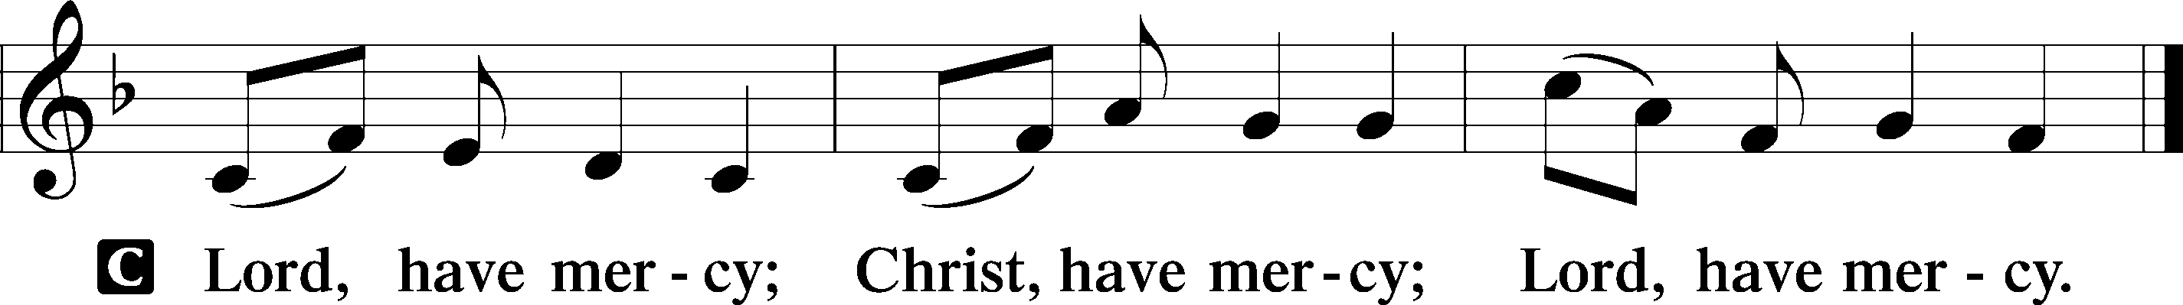

Gloria in Excelsis
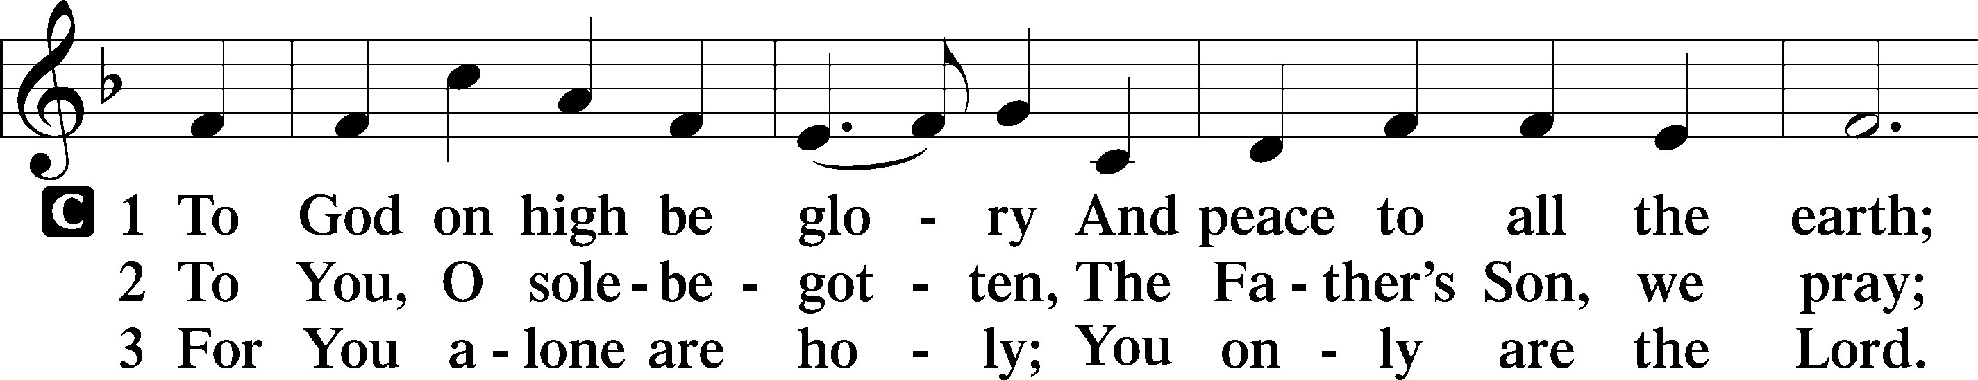
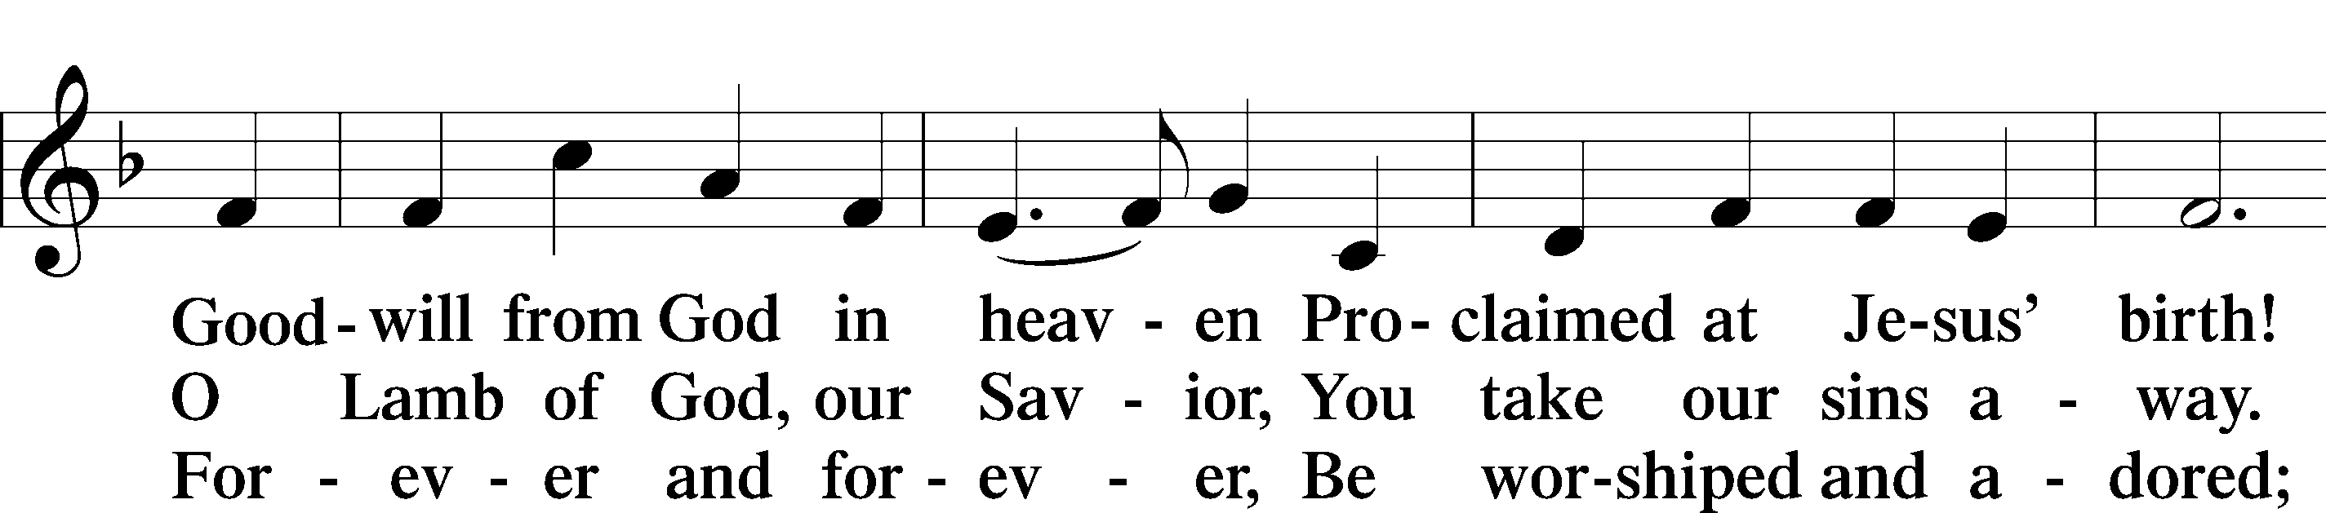
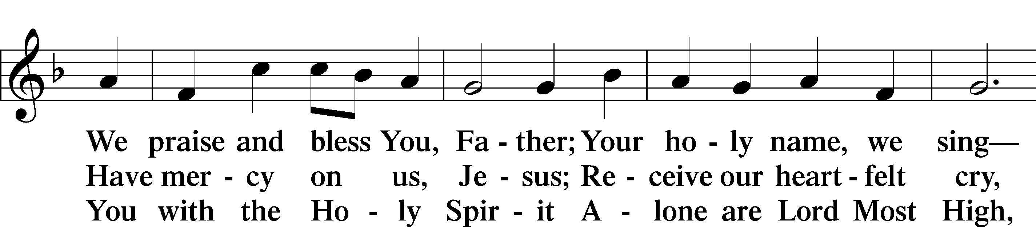
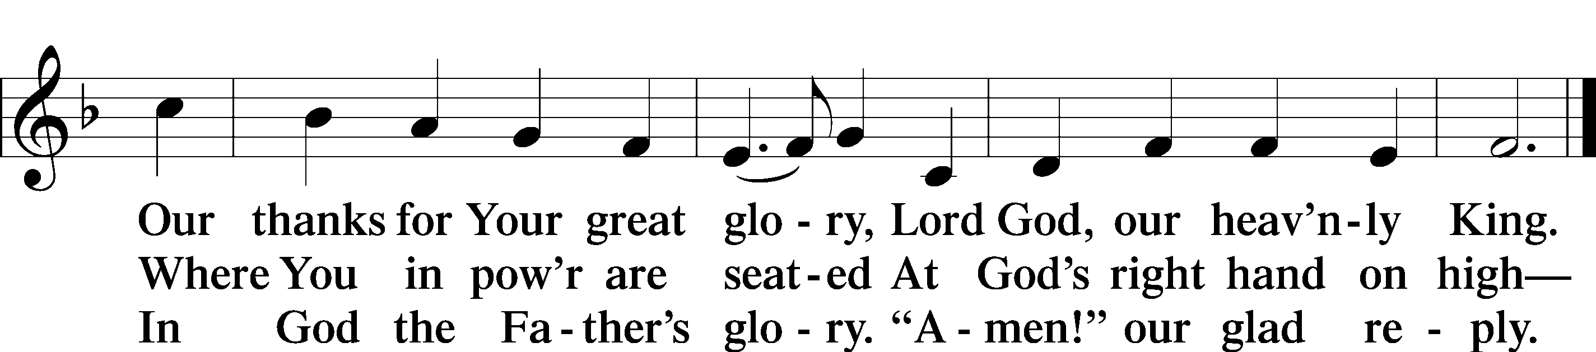

Salutation and Collect of the Day
P The Lord be with you.
C And also with you.

P Let us pray.
Almighty and everlasting God, You have given us grace to acknowledge the glory of the eternal Trinity by the confession of a true faith and to worship the Unity in the power of the Divine Majesty. Keep us steadfast in this faith and defend us from all adversities; for You, O Father, Son, and Holy Spirit, live and reign, one God, now and forever.

C Amen.

Sit
Athanasian Creed
P Just as we are compelled by the Christian truth to acknowledge each distinct person as God and Lord, so also are we prohibited by the catholic religion to say that there are three Gods or Lords.
C The Father is not made nor created nor begotten by anyone.

P The Son is neither made nor created, but begotten of the Father alone.
C The Holy Spirit is of the Father and of the Son, neither made nor created nor begotten, but proceeding.

P Thus, there is one Father, not three Fathers; one Son, not three Sons; one Holy Spirit, not three Holy Spirits.
C And in this Trinity none is before or after another; none is greater or less than another;

P but the whole three persons are coeternal with each other and coequal, so that in all things, as has been stated above, the Trinity in Unity and Unity in Trinity is to be worshiped.
C Therefore, whoever desires to be saved must think thus about the Trinity.

Old Testament Reading Genesis 1:1—2:4a
1In the beginning, God created the heavens and the earth. 2The earth was without form and void, and darkness was over the face of the deep. And the Spirit of God was hovering over the face of the waters.
3And God said, “Let there be light,” and there was light. 4And God saw that the light was good. And God separated the light from the darkness. 5God called the light Day, and the darkness he called Night. And there was evening and there was morning, the first day.
6And God said, “Let there be an expanse in the midst of the waters, and let it separate the waters from the waters.” 7And God made the expanse and separated the waters that were under the expanse from the waters that were above the expanse. And it was so. 8And God called the expanse Heaven. And there was evening and there was morning, the second day.
9And God said, “Let the waters under the heavens be gathered together into one place, and let the dry land appear.” And it was so. 10God called the dry land Earth, and the waters that were gathered together he called Seas. And God saw that it was good.
11And God said, “Let the earth sprout vegetation, plants yielding seed, and fruit trees bearing fruit in which is their seed, each according to its kind, on the earth.” And it was so. 12The earth brought forth vegetation, plants yielding seed according to their own kinds, and trees bearing fruit in which is their seed, each according to its kind. And God saw that it was good. 13And there was evening and there was morning, the third day.
14And God said, “Let there be lights in the expanse of the heavens to separate the day from the night. And let them be for signs and for seasons, and for days and years, 15and let them be lights in the expanse of the heavens to give light upon the earth.” And it was so. 16And God made the two great lights—the greater light to rule the day and the lesser light to rule the night—and the stars. 17And God set them in the expanse of the heavens to give light on the earth, 18to rule over the day and over the night, and to separate the light from the darkness. And God saw that it was good. 19And there was evening and there was morning, the fourth day.
20And God said, “Let the waters swarm with swarms of living creatures, and let birds fly above the earth across the expanse of the heavens.” 21So God created the great sea creatures and every living creature that moves, with which the waters swarm, according to their kinds, and every winged bird according to its kind. And God saw that it was good. 22And God blessed them, saying, “Be fruitful and multiply and fill the waters in the seas, and let birds multiply on the earth.” 23And there was evening and there was morning, the fifth day.
24And God said, “Let the earth bring forth living creatures according to their kinds—livestock and creeping things and beasts of the earth according to their kinds.” And it was so. 25And God made the beasts of the earth according to their kinds and the livestock according to their kinds, and everything that creeps on the ground according to its kind. And God saw that it was good.
26Then God said, “Let us make man in our image, after our likeness. And let them have dominion over the fish of the sea and over the birds of the heavens and over the livestock and over all the earth and over every creeping thing that creeps on the earth.” 27So God created man in his own image, in the image of God he created him; male and female he created them.
28And God blessed them. And God said to them, “Be fruitful and multiply and fill the earth and subdue it and have dominion over the fish of the sea and over the birds of the heavens and over every living thing that moves on the earth.” 29And God said, “Behold, I have given you every plant yielding seed that is on the face of all the earth, and every tree with seed in its fruit. You shall have them for food. 30And to every beast of the earth and to every bird of the heavens and to everything that creeps on the earth, everything that has the breath of life, I have given every green plant for food.” And it was so. 31And God saw everything that he had made, and behold, it was very good. And there was evening and there was morning, the sixth day.
1Thus the heavens and the earth were finished, and all the host of them. 2And on the seventh day God finished his work that he had done, and he rested on the seventh day from all his work that he had done. 3So God blessed the seventh day and made it holy, because on it God rested from all his work that he had done in creation. 4These are the generations
of the heavens and the earth when they were created.

A This is the Word of the Lord.
C Thanks be to God.

Second Reading Acts 2:14a, 22–36
14Peter, standing with the eleven, lifted up his voice and addressed them, . . .
22“Men of Israel, hear these words: Jesus of Nazareth, a man attested to you by God with mighty works and wonders and signs that God did through him in your midst, as you yourselves know— 23this Jesus, delivered up according to the definite plan and foreknowledge of God, you crucified and killed by the hands of lawless men. 24God raised him up, loosing the pangs of death, because it was not possible for him to be held by it. 25For David says concerning him,
“‘I saw the Lord always before me,
for he is at my right hand that I may not be shaken;
26therefore my heart was glad, and my tongue rejoiced;
my flesh also will dwell in hope.
27For you will not abandon my soul to Hades,
or let your Holy One see corruption.
28You have made known to me the paths of life;
you will make me full of gladness with your presence.’
29“Brothers, I may say to you with confidence about the patriarch David that he both died and was buried, and his tomb is with us to this day. 30Being therefore a prophet, and knowing that God had sworn with an oath to him that he would set one of his descendants on his throne, 31he foresaw and spoke about the resurrection of the Christ, that he was not abandoned to Hades, nor did his flesh see corruption. 32This Jesus God raised up, and of that we all are witnesses. 33Being therefore exalted at the right hand of God, and having received from the Father the promise of the Holy Spirit, he has poured out this that you yourselves are seeing and hearing. 34For David did not ascend into the heavens, but he himself says, “‘The Lord said to my Lord, Sit at my right hand, 35until I make your enemies your footstool.’ 36Let all the house of Israel therefore know for certain that God has made him both Lord and Christ, this Jesus whom you crucified.”

A This is the Word of the Lord.
C Thanks be to God.

Stand

Alleluia and Verse
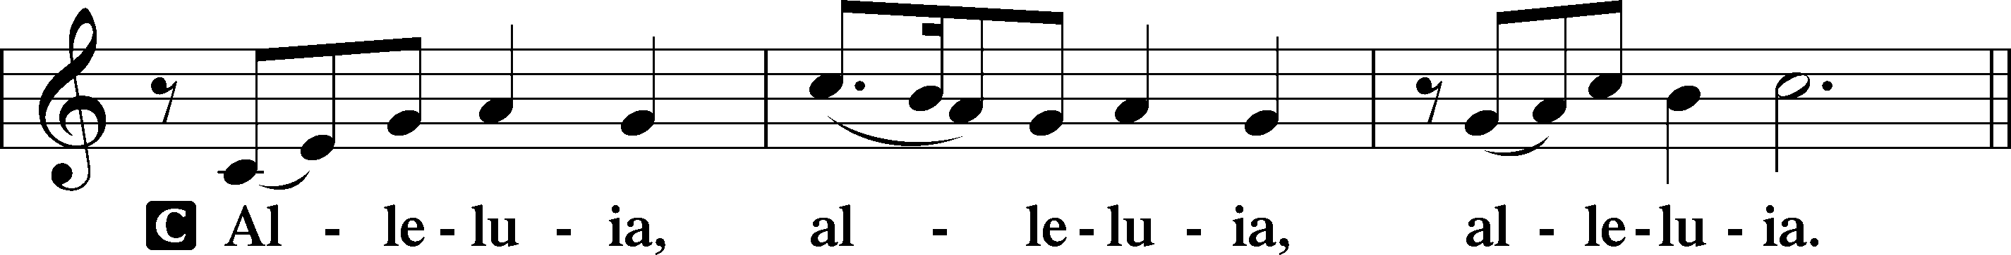
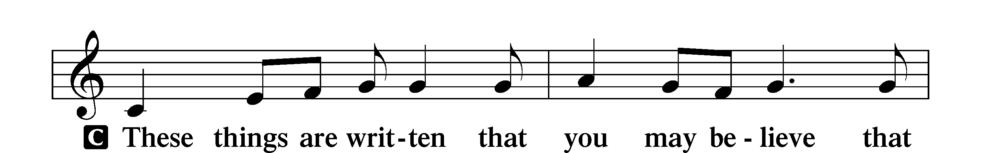
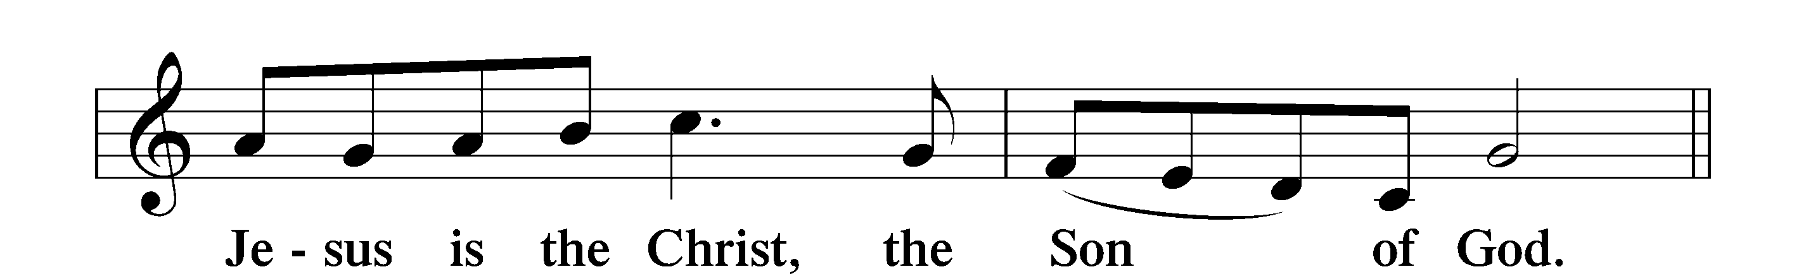
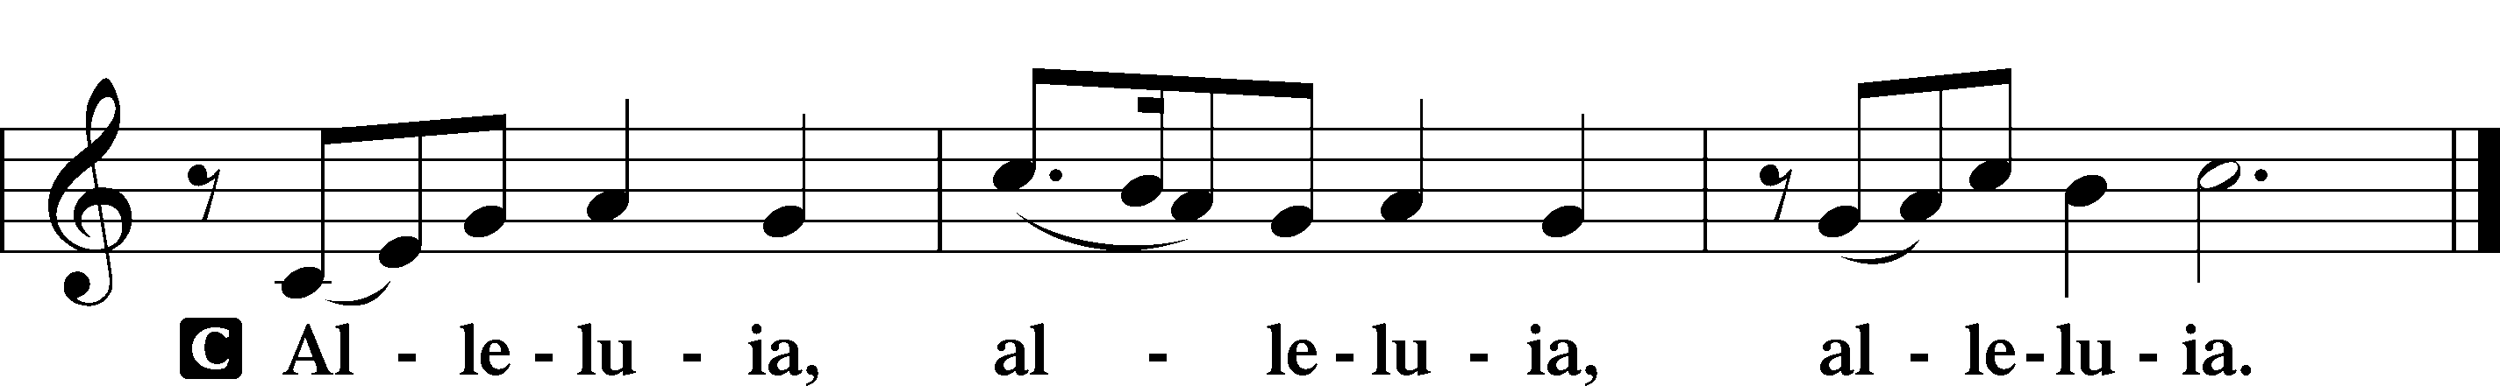

Holy Gospel Matthew 28:16–20
P The Holy Gospel according to St. Matthew, the twenty-eighth chapter.
C Glory to You, O Lord.

16Now the eleven disciples went to Galilee, to the mountain to which Jesus had directed them. 17And when they saw him they worshiped him, but some doubted. 18And Jesus came and said to them, “All authority in heaven and on earth has been given to me. 19Go therefore and make disciples of all nations, baptizing them in the name of the Father and of the Son and of the Holy Spirit, 20teaching them to observe all that I have commanded you. And behold, I am with you always, to the end of the age.”

P This is the Gospel of the Lord.
C Praise to You, O Christ.

Athanasian Creed
P But it is also necessary for everlasting salvation that one faithfully believe the incarnation of our Lord Jesus Christ.
C Therefore, it is the right faith that we believe and confess that our Lord Jesus Christ, the Son of God, is at the same time both God and man.

P He is God, begotten from the substance of the Father before all ages; and He is man, born from the substance of His mother in this age:
C perfect God and perfect man, composed of a rational soul and human flesh;

P equal to the Father with respect to His divinity, less than the Father with respect to His humanity.
C Although He is God and man, He is not two, but one Christ:

P one, however, not by the conversion of the divinity into flesh, but by the assumption of the humanity into God;
C one altogether, not by confusion of substance, but by unity of person.

P For as the rational soul and flesh is one man, so God and man is one Christ,
C who suffered for our salvation, descended into hell, rose again the third day from the dead,

P ascended into heaven, and is seated at the right hand of the Father, God Almighty, from whence He will come to judge the living and the dead.
C At His coming all people will rise again with their bodies and give an account concerning their own deeds.

P And those who have done good will enter into eternal life, and those who have done evil into eternal fire.
C This is the catholic faith; whoever does not believe it faithfully and firmly cannot be saved.

Sit

507 Holy, Holy, Holy sts. 1–4

Sermon

Offering. We generously give our offerings to the LORD out of thanksgiving for His generosity of forgiveness, life, and salvation in Christ (2 Corinthians 9:8). We believe that our offerings are not only to support the proclamation of the Gospel here and around the world, but also to help us all grow in faith and trust in Him (2 Corinthians 9:7). We have placed an offering plate in the narthex so you are able to freely give back to Him as you are able. To Him be all the glory!

Stand

Prayer of the Church

Lord’s Prayer

Benedicamus
A Let us bless the Lord.
C Thanks be to God.

Benediction
P The Lord bless you and keep you.
The Lord make His face shine on you and be gracious to you.
The Lord look upon you with favor and T give you peace.
C Amen.

953 We All Believe in One True God

Announcement

There will be a brief congregational meeting about parking lot seal coating
on Sunday, June 7 after Worship.

