24th Sunday After Pentecost
November 8th, 2026

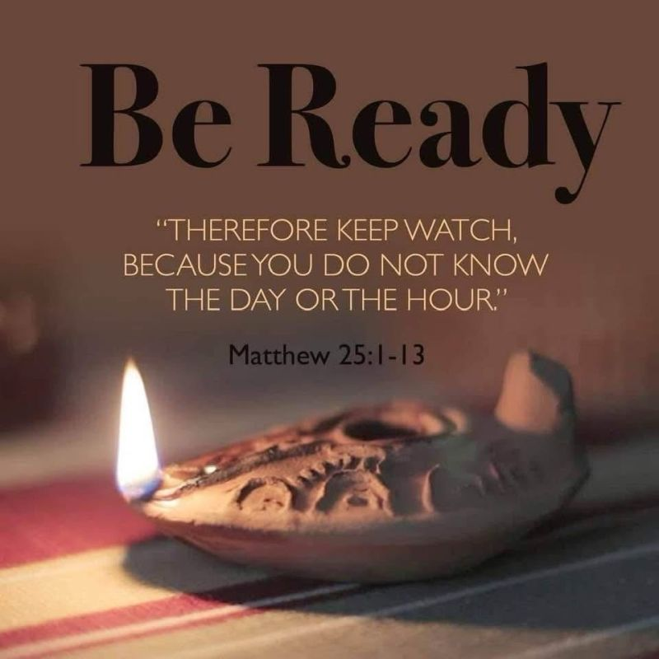

Messiah Lutheran Church
Sartell, MN
www.messiahsartell.com
320-252-5883
Prayer Before Entering
Please take this time to focus on our purpose in gathering and join in prayer before our service begins. Blessed Lord, You have caused all Holy Scriptures to be written for our learning. Grant that we may so hear them, read, mark, learn, and inwardly digest them that, by patience and comfort of Your holy Word, we may embrace and ever hold fast the blessed hope of everlasting life; through Jesus Christ, our Lord.

As We Gather
The Lord is grieved by the empty worship of His people. Their songs and their offerings mean nothing when their hearts are far from Him, and He will not accept them any longer (Amos 5:21–23). And the day of the Lord will actually catch them off guard and unprepared. Jesus offers the same warning in the parable of the ten virgins, calling His disciples to watch for a bridegroom who will come at an unknown day and hour (Matthew 25:13). Jesus’ warning calls us to attention as we reflect on our own position of waiting for His return. His warning is followed by Paul’s further description of what our waiting looks like. Since we believe that Jesus died and rose again, our waiting is also filled with hope (1 Thessalonians 4:13–14).

514 The Bridegroom Soon Will Call Us

Stand

The sign of the cross may be made by all in remembrance of their Baptism.

P In the name of the Father and of the T Son and of the Holy Spirit.
C Amen.

P Our help is in the name of the Lord,
C who made heaven and earth.

P If You, O Lord, kept a record of sins, O Lord, who could stand?
C But with You there is forgiveness; therefore You are feared.

P Since we are gathered to hear God’s Word, call upon Him in prayer and praise, and receive the body and blood of our Lord Jesus Christ in the fellowship of this altar, let us first consider our unworthiness and confess before God and one another that we have sinned in thought, word, and deed, and that we cannot free ourselves from our sinful condition. Together as His people let us take refuge in the infinite mercy of God, our heavenly Father, seeking His grace for the sake of Christ, and saying:
C God, be merciful to me, a sinner.

Silence for reflection on God’s Word and for self-examination.

C Almighty God, have mercy upon us, forgive us our sins, and lead us to everlasting life. Amen.

P Almighty God in His mercy has given His Son to die for you and for His sake forgives you all your sins. As a called and ordained servant of Christ, and by His authority, I therefore forgive you all your sins in the name of the Father and of the T Son and of the Holy Spirit.

C Amen.

Stand

Introit Psalm 84:1, 9–12; antiphon: v. 3
P Even the sparrow finds a home, and the swallow a nest for herself,
where she may lay her young,
at your altars, O Lord of hosts, my King and my God.
C How lovely is your dwelling place,
O Lord of hosts!
P Behold our shield, O God;
look on the face of your anointed!
C For a day in your courts is better than a thousand elsewhere.
I would rather be a doorkeeper in the house of my God than dwell
in the tents of wickedness.
P For the Lord God is a sun and shield; the Lord bestows favor and
honor.
No good thing does he withhold from those who walk uprightly.
C O Lord of hosts,
blessèd is the one who trusts in you!
All: Glory be to the Father and to the Son
and to the Holy Spirit;
as it was in the beginning,
is now, and will be forever. Amen.
P Even the sparrow finds a home, and the swallow a nest for herself,
where she may lay her young,
at your altars, O Lord of hosts, my King and my God.

Kyrie
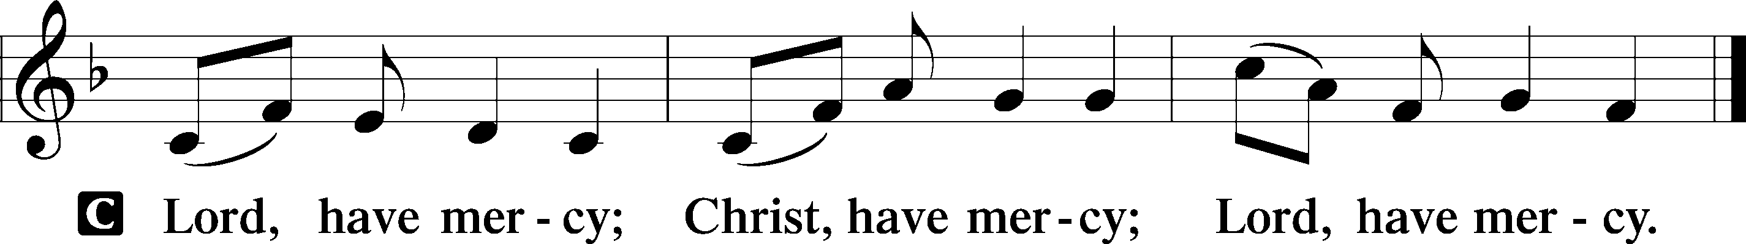

Gloria in Excelsis
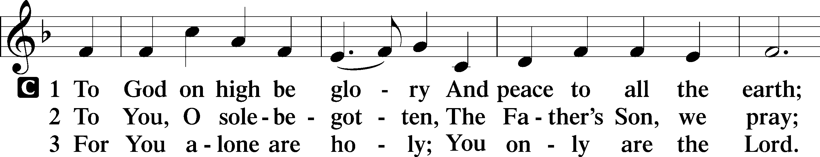
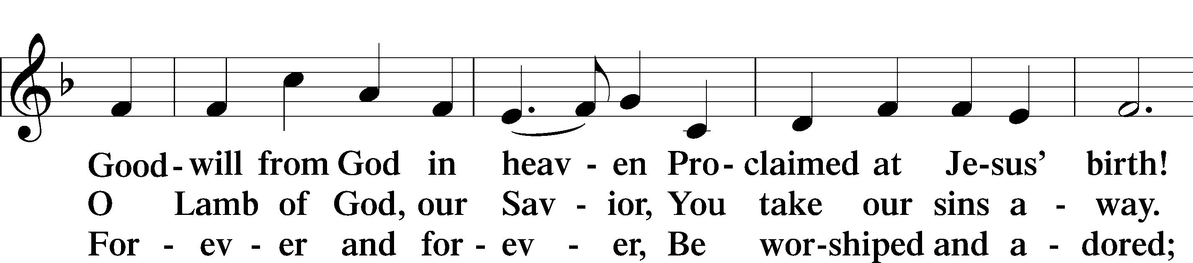
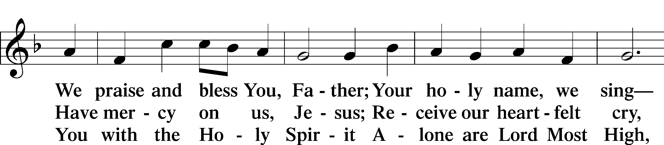
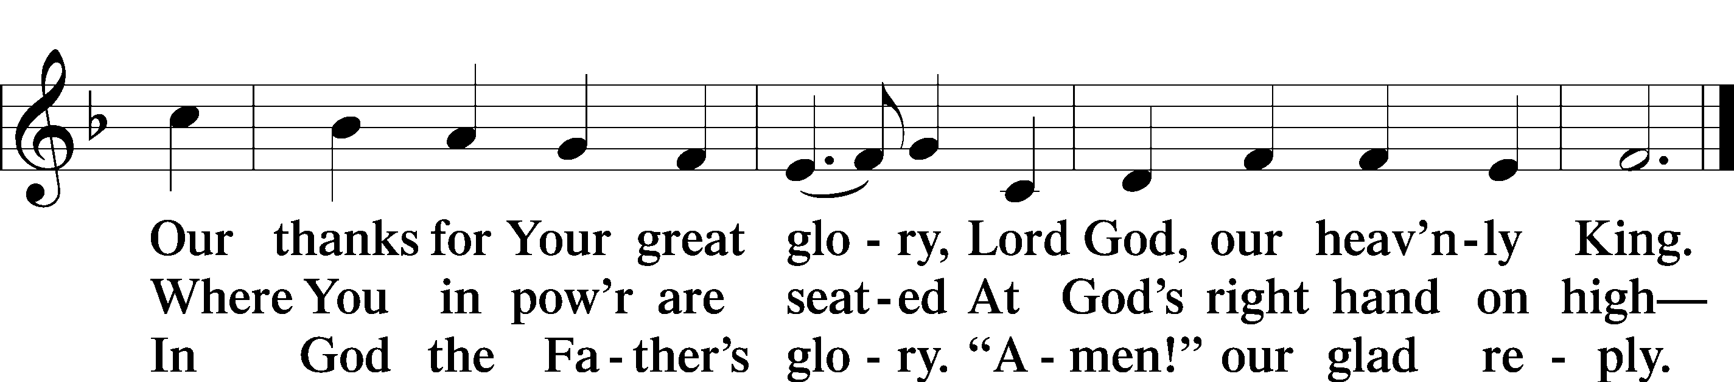

Salutation and Collect of the Day
P The Lord be with you.
C And also with you.

P Let us pray.
Lord God, heavenly Father, send forth Your Son to lead home His bride, the Church, that with all the company of the redeemed we may finally enter into His eternal wedding feast; through the same Jesus Christ, our Lord, who lives and reigns with You and the Holy Spirit, one God, now and forever.

C Amen.

Sit

Old Testament Reading Amos 5:18–24
18Woe to you who desire the day of the Lord! Why would you have the day of the Lord? It is darkness, and not light, 19as if a man fled from a lion, and a bear met him, or went into the house and leaned his hand against the wall, and a serpent bit him. 20Is not the day of the Lord darkness, and not light, and gloom with no brightness in it? 21“I hate, I despise your feasts, and I take no delight in your solemn assemblies. 22Even though you offer me your burnt offerings and grain offerings, I will not accept them; and the peace offerings of your fattened animals, I will not look upon them. 23Take away from me the noise of your songs; to the melody of your harps I will not listen. 24But let justice roll down like waters, and righteousness like an ever-flowing stream.”

A This is the Word of the Lord.
C Thanks be to God.

Epistle 1 Thessalonians 4:13–18
13But we do not want you to be uninformed, brothers, about those who are asleep, that you may not grieve as others do who have no hope. 14For since we believe that Jesus died and rose again, even so, through Jesus, God will bring with him those who have fallen asleep. 15For this we declare to you by a word from the Lord, that we who are alive, who are left until the coming of the Lord, will not precede those who have fallen asleep. 16For the Lord himself will descend from heaven with a cry of command, with the voice of an archangel, and with the sound of the trumpet of God. And the dead in Christ will rise first. 17Then we who are alive, who are left, will be caught up together with them in the clouds to meet the Lord in the air, and so we will always be with the Lord. 18Therefore encourage one another with these words.
A This is the Word of the Lord.
C Thanks be to God.

Stand

Alleluia and Verse
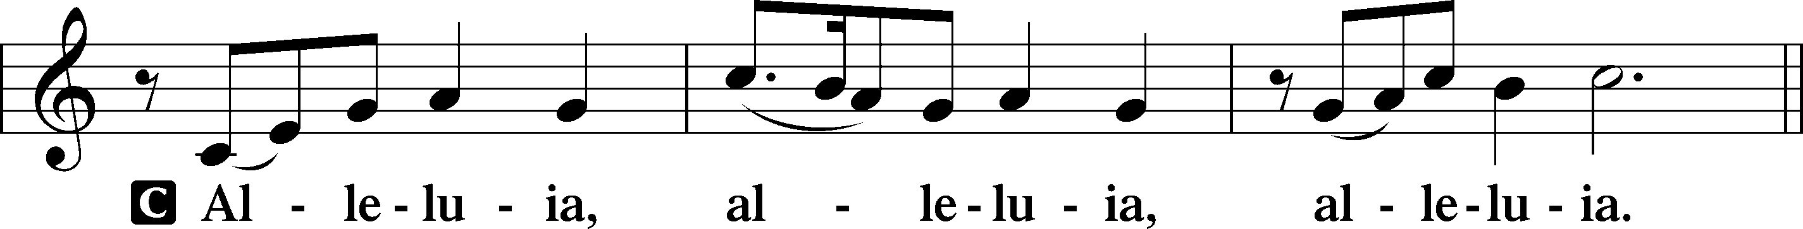
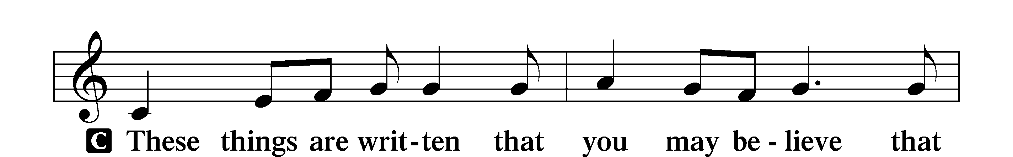
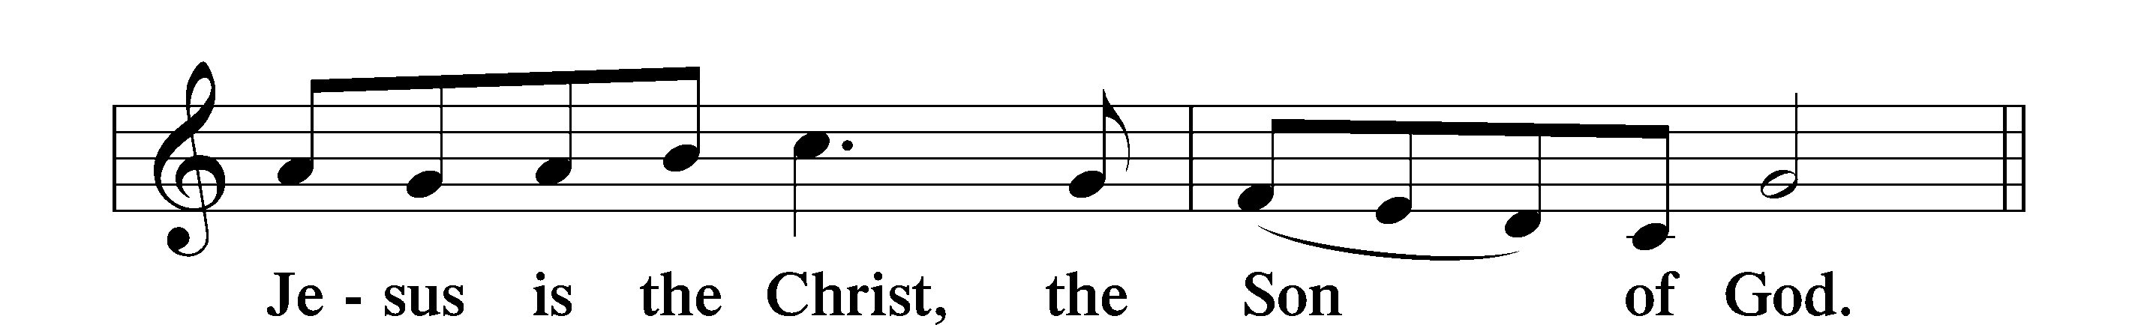
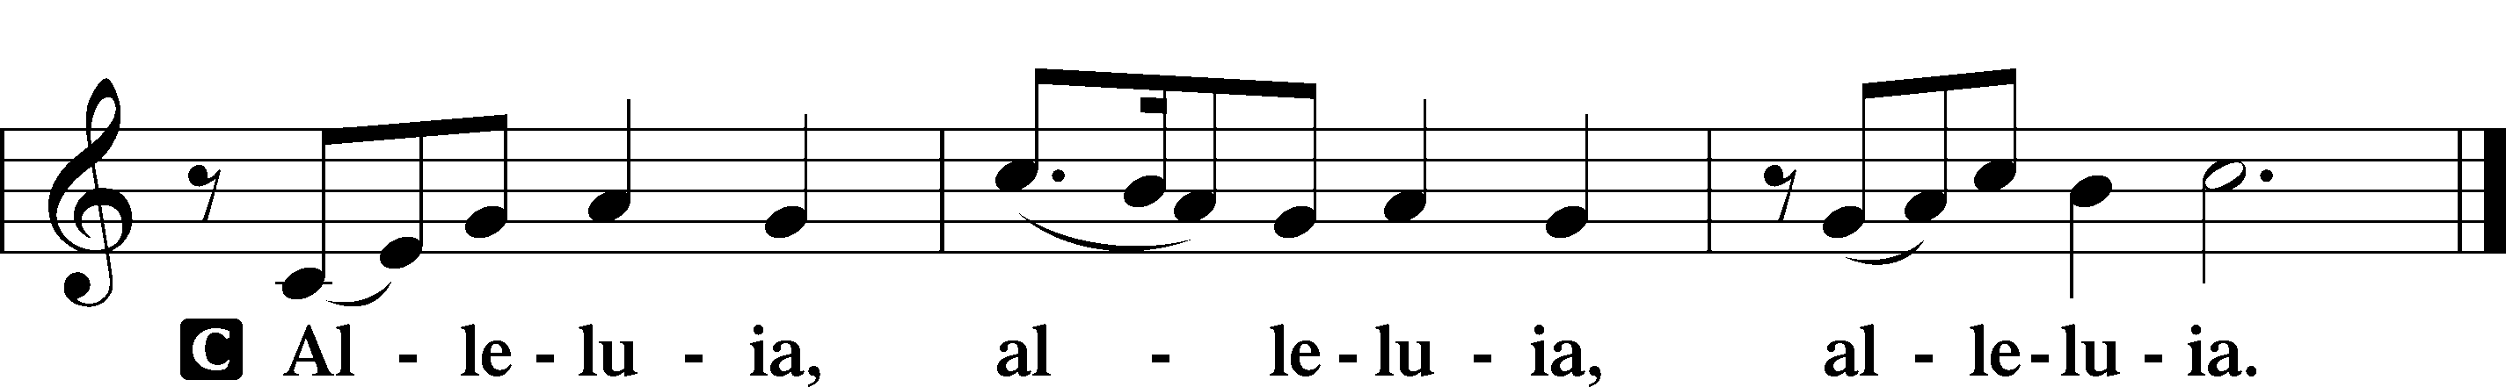

Holy Gospel Matthew 25:1–13
P The Holy Gospel according to St. Matthew, the twenty-fifth chapter.
C Glory to You, O Lord.
1[Jesus said:] “The kingdom of heaven will be like ten virgins who took their lamps and went to meet the bridegroom. 2Five of them were foolish, and five were wise. 3For when the foolish took their lamps, they took no oil with them, 4but the wise took flasks of oil with their lamps. 5As the bridegroom was delayed, they all became drowsy and slept. 6But at midnight there was a cry, ‘Here is the bridegroom! Come out to meet him.’ 7Then all those virgins rose and trimmed their lamps. 8And the foolish said to the wise, ‘Give us some of your oil, for our lamps are going out.’ 9But the wise answered, saying, ‘Since there will not be enough for us and for you, go rather to the dealers and buy for yourselves.’ 10And while they were going to buy, the bridegroom came, and those who were ready went in with him to the marriage feast, and the door was shut. 11Afterward the other virgins came also, saying, ‘Lord, lord, open to us.’ 12But he answered, ‘Truly, I say to you, I do not know you.’ 13Watch therefore, for you know neither the day nor the hour.”

P This is the Gospel of the Lord.
C Praise to You, O Christ.

Sit

516 Wake, Awake, for Night Is Flying

Sermon

Offering. We generously give our offerings to the LORD out of thanksgiving for His generosity of forgiveness, life, and salvation in Christ (2 Corinthians 9:8). We believe that our offerings are not only to support the proclamation of the Gospel here and around the world, but also to help us all grow in faith and trust in Him (2 Corinthians 9:7). We have placed an offering plate in the narthex so you are able to freely give back to Him as you are able. To Him be all the glory!

Stand

Prayer of the Church

Holy Communion is celebrated in the belief and glad confidence that our Lord gives us not only bread and wine, but the body and blood of Christ from the cross, for us Christian to eat and drink for the forgiveness of sins (Matthew 26:28). Because we are called to examine ourselves before receiving the Lord’s Supper (I Corinthians 11:28-29), we encourage you to consider the questions on pages 329-330 in the hymnal. We also believe that when we commune, we are confessing our unity with the community we join (I Corinthians 10:17). If you desire to commune with us for the first time or have questions, our pastor is happy to speak with you.

Preface
P The Lord be with you.
C And also with you.

P Lift up your hearts.
C We lift them to the Lord.

P Let us give thanks to the Lord our God.
C It is right to give Him thanks and praise.
P It is truly good, right, and salutary that we should at all times and in all places give thanks to You, O Lord, holy Father, almighty and everlasting God, for the countless blessings You so freely bestow on us and all creation. Above all, we give thanks for Your boundless love shown to us when You sent Your only-begotten Son, Jesus Christ, into our flesh and laid on Him our sin, giving Him into death that we might not die eternally. Because He is now risen from the dead and lives and reigns to all eternity, all who believe in Him will overcome sin and death and will rise again to new life. Therefore with angels and archangels and with all the company of heaven we laud and magnify Your glorious name, evermore praising You and saying:

Sanctus
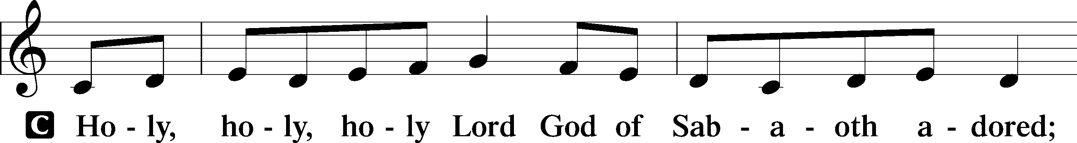
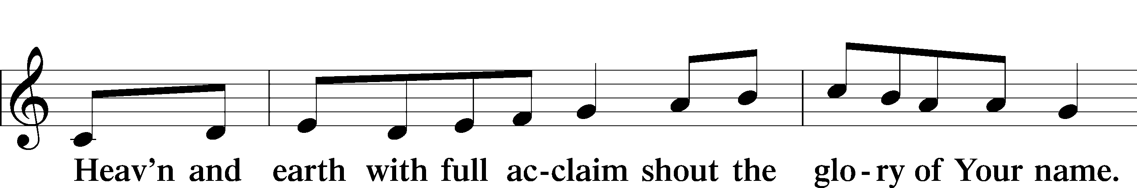
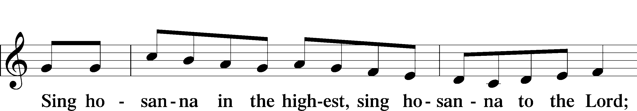
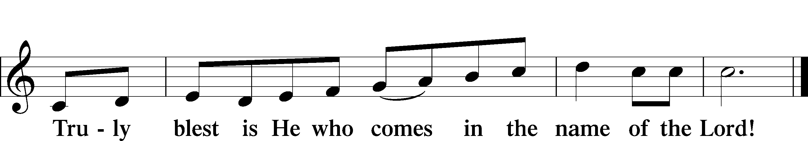

Prayer of Thanksgiving
P Blessed are You, O Lord our God, king of all creation, for You have had mercy on us and given Your only-begotten Son that whoever believes in Him should not perish but have eternal life.

In Your righteous judgment You condemned the sin of Adam and Eve, who ate the forbidden fruit, and You justly barred them and all their children from the tree of life. Yet, in Your great mercy, You promised salvation by a second Adam, Your Son, Jesus Christ, our Lord, and made His cross a life-giving tree for all who trust in Him.

We give You thanks for the redemption You have prepared for us through Jesus Christ. Grant us Your Holy Spirit that we may faithfully eat and drink of the fruits of His cross and receive the blessings of forgiveness, life, and salvation that come to us in His body and blood.

Hear us as we pray in His name and as He has taught us:

Lord’s Prayer

The Words of Our Lord

Pax Domini
P The peace of the Lord be with you always.
C Amen.

Agnus Dei
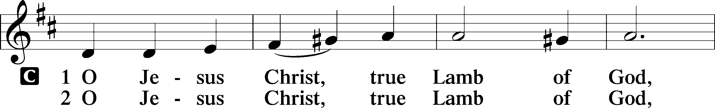
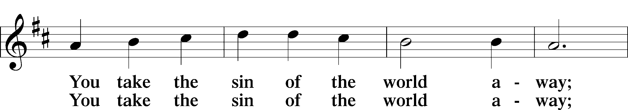
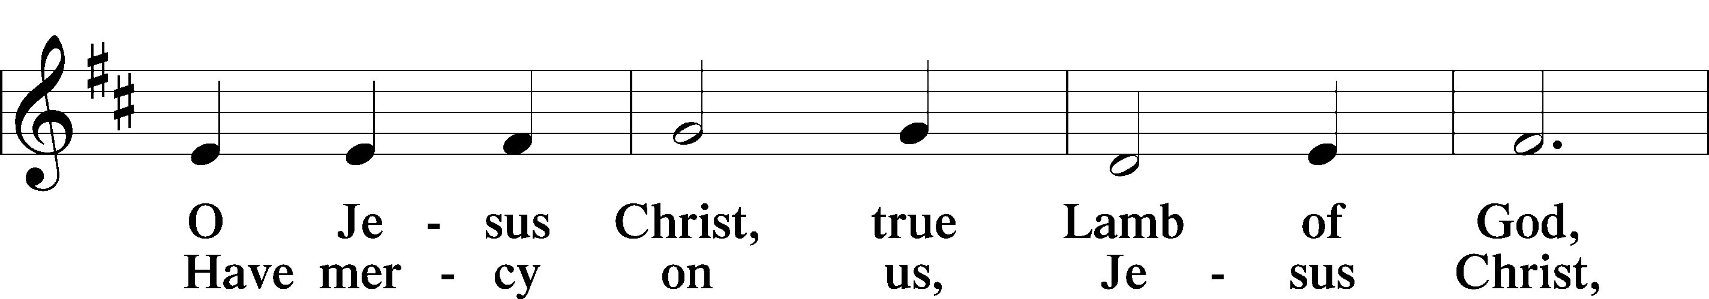
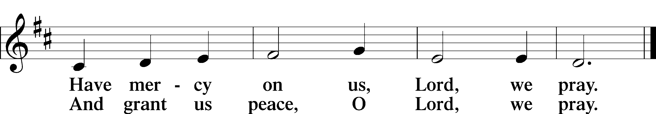

Sit

Distribution

622 Lord Jesus Christ, You Have Prepared

617 O Lord, We Praise Thee

Stand

Nunc Dimittis
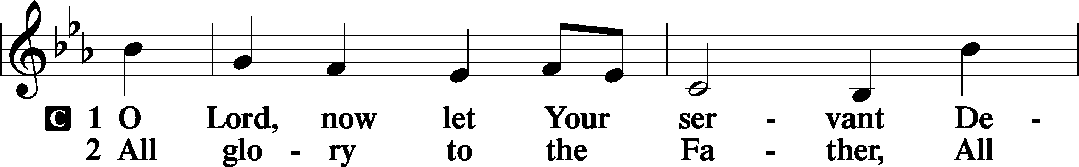
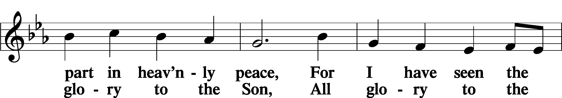
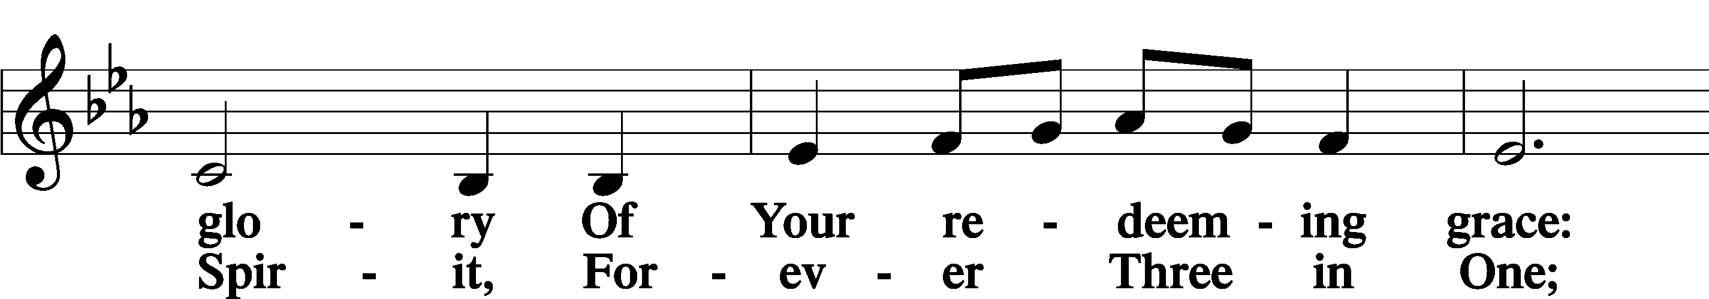
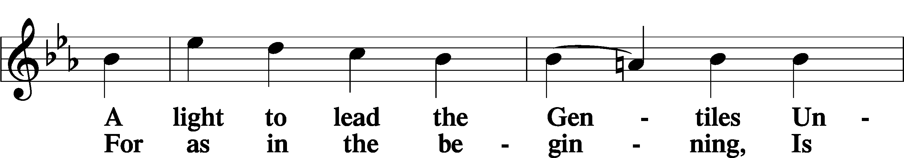
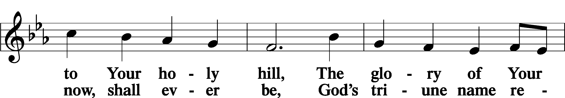
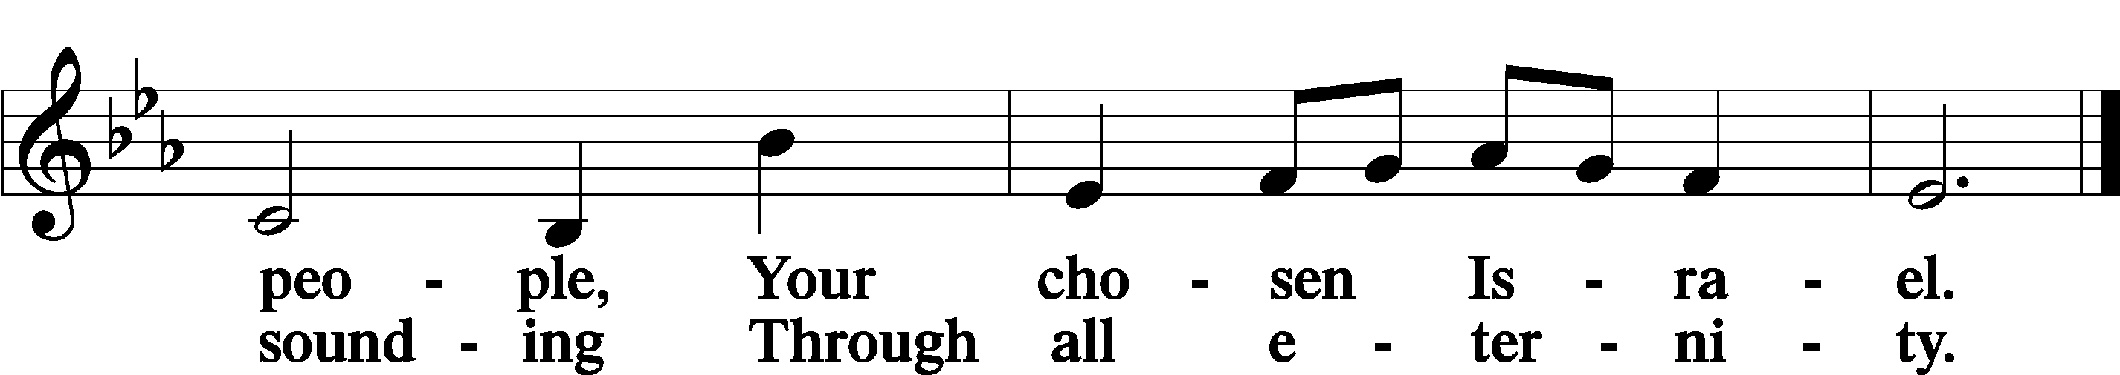

Post-Communion Collect
A Let us pray. We give thanks to You, almighty God, that You have refreshed us through this salutary gift, and we implore You that of Your mercy You would strengthen us through the same in faith toward You and in fervent love toward one another; through Jesus Christ, Your Son, our Lord, who lives and reigns with You and the Holy Spirit, one God, now and forever.
C Amen.

Benedicamus
A Let us bless the Lord.
C Thanks be to God.

Benediction
P The Lord bless you and keep you.
The Lord make His face shine on you and be gracious to you.
The Lord look upon you with favor and T give you peace.

C Amen.

515 Rejoice, Rejoice, Believers

For the Kids

