Fifth Sunday in Lent
March 22nd, 2026

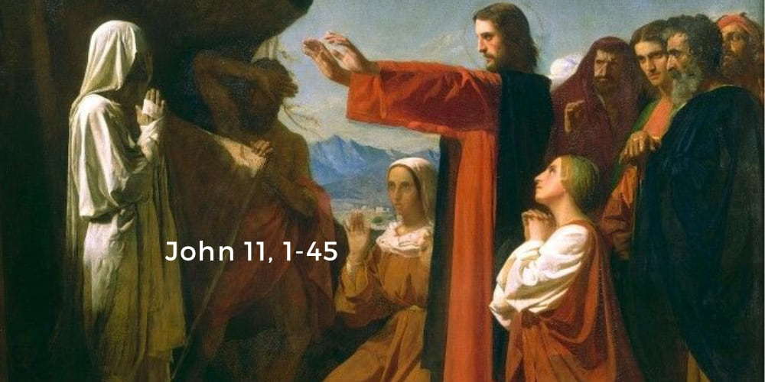

Messiah Lutheran Church
Sartell, MN
www.messiahsartell.com
320-252-5883
Prayer Before Entering
Please take this time to focus on our purpose in gathering and join in prayer before our service begins. Blessed Lord, You have caused all Holy Scriptures to be written for our learning. Grant that we may so hear them, read, mark, learn, and inwardly digest them that, by patience and comfort of Your holy Word, we may embrace and ever hold fast the blessed hope of everlasting life; through Jesus Christ, our Lord.

As We Gather
While Lent focuses on Christ’s suffering and upcoming death, these Readings turn to the resurrection and life. Ezekiel takes us to the valley of the dry bones, and we hear the promise “you shall know that I am the Lord, when I open your graves, and raise you from your graves” (Ezekiel 37:13). Romans 8 finishes with the promise “He who raised Christ Jesus from the dead will also give life to your mortal bodies through His Spirit who dwells in you” (v. 11). John 11 tells of Lazarus coming out of the tomb after four days, but the climax comes earlier when Jesus declares He is the resurrection and life. Every Sunday, including those in Lent, is a celebration of Christ’s resurrection.

592 Dearest Jesus, We Are Here

Celebration of Holy Baptism
Stand

The sign of the cross may be made by all in remembrance of their Baptism.

P In the name of the Father and of the T Son and of the Holy Spirit.
C Amen.

Dear friends, Christ our Lord says in the last chapter of Matthew, “All authority in heaven and on earth has been given to Me. Therefore, go and make disciples of all nations, baptizing them in the name of the Father and of the Son and of the Holy Spirit.” In the last chapter of Mark our Lord promises, “Whoever believes and is baptized will be saved.” And the apostle Peter has written, “Baptism now saves you.”

The Word of God also teaches that we are all, just like Hudson Shae, conceived and born sinful and are under the power of the devil until Christ claims us as His own. We would be lost forever unless delivered from sin, death, and everlasting condemnation. But the Father of all mercy and grace has sent His Son Jesus Christ, who atoned for the sin of the whole world, that whoever believes in Him should not perish but have eternal life.

The Signing
(The pastor makes the sign of the holy cross upon the forehead and heart of the child while saying)
Hudson Shae, receive the sign of the holy cross both upon your forehead and upon your heart to mark you as one redeemed by Christ the crucified.

To the Congregation
All of us gathered here as family members share responsibility for the spiritual well-being of this child of God, since we represent for him the Body of Christ in this place. I therefore ask all of you, family members in Christ: Do you promise to prayerfully remember Hudson Shae and encourage him in the faith and participation in His church throughout the entirety of his life? We will with the help of God.

Renunciation and Confession of Faith
Let us all together confess the Christian faith into which we are baptized and give witness of the faith he will now enter.

Therefore, I ask you, do you renounce the devil and all his works and all his ways? I do renounce them!

Let us confess together the faith of the whole Christian church.
C I believe in God, the Father Almighty,
maker of heaven and earth.
And in Jesus Christ, His only Son, our Lord,
who was conceived by the Holy Spirit,
born of the virgin Mary,
suffered under Pontius Pilate,
was crucified, died and was buried.
He descended into hell.
The third day He rose again from the dead.
He ascended into heaven
and sits at the right hand of God the Father Almighty.
From thence He will come to judge the living and the dead.
I believe in the Holy Spirit,
the holy Christian Church,
the communion of saints,
the forgiveness of sins,
the resurrection of the body,
and the life T everlasting. Amen.

Sit

The Baptism
Hudson Shae, I baptize you in the name of the Father and of the Son (+) and of the Holy Spirit. Amen.

The Blessing
Almighty God, the Father of our Lord Jesus Christ, who has given you the new birth of water and the Spirit and has forgiven all your sin, strengthen you with His grace to life everlasting. Peace be with you. Amen.

The Presentation of White Garment
Receive this white garment to show that you have been clothed with the robe of Christ’s righteousness that covers all your sin. So shall you stand without fear before the judgment seat of Christ to receive the inheritance prepared for you from the foundation of the world.

Presentation of the Candle
Receive this burning light to show that you have received Christ who is the Light of the world. Live always in the light of Christ, and be ever watchful for His coming, that you may meet Him with joy and enter with Him into the marriage feast of the Lamb in His kingdom, which shall have no end.

Presentation to the Congregation
Through Baptism, God has added Hudson Shae to His own people, to declare the wonderful deeds of our Savior, who has called us out of darkness into His marvelous light.

Hudson, we welcome you into the Lord’s family. We receive you as a fellow member of the body of Christ, a child of the same heavenly Father, to work with us in His kingdom. Amen.

Prayer

Stand

The sign of the cross may be made by all in remembrance of their Baptism.

P In the name of the Father and of the T Son and of the Holy Spirit.
C Amen.

P Our help is in the name of the Lord,
C who made heaven and earth.

P If You, O Lord, kept a record of sins, O Lord, who could stand?
C But with You there is forgiveness; therefore You are feared.
P Since we are gathered to hear God’s Word, call upon Him in prayer and praise, and receive the body and blood of our Lord Jesus Christ in the fellowship of this altar, let us first consider our unworthiness and confess before God and one another that we have sinned in thought, word, and deed, and that we cannot free ourselves from our sinful condition. Together as His people let us take refuge in the infinite mercy of God, our heavenly Father, seeking His grace for the sake of Christ, and saying:
C God, be merciful to me, a sinner.

Silence for reflection on God’s Word and for self-examination.

C Almighty God, have mercy upon us, forgive us our sins, and lead us to everlasting life. Amen.

P Almighty God in His mercy has given His Son to die for you and for His sake forgives you all your sins. As a called and ordained servant of Christ, and by His authority, I therefore forgive you all your sins in the name of the Father and of the T Son and of the Holy Spirit.

C Amen.

Introit Psalm 116:1–4, 8; antiphon: v. 15
P Precious in the sight of the Lord
is the death of his saints.
C I love the Lord, because he has heard
my voice and my pleas for mercy.
P Because he inclined his ear to me,
therefore I will call on him as long as I live.
C The snares of death encompassed me; the pangs of Sheol laid hold on me;
I suffered distress and anguish.
P Then I called on the name of the Lord:
“O Lord, I pray, deliver my soul!”
C For you have delivered my soul from death,
my eyes from tears, my feet from stumbling.
All: Glory be to the Father and to the Son
and to the Holy Spirit;
as it was in the beginning,
is now, and will be forever. Amen.
P Precious in the sight of the Lord
is the death of his saints.

Kyrie
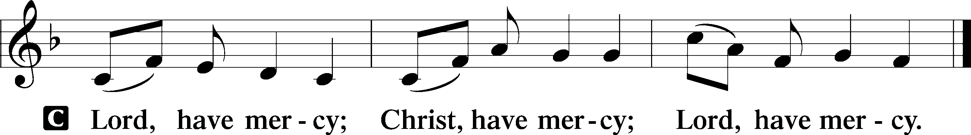

Salutation and Collect of the Day
P The Lord be with you.
C And also with you.

P Let us pray.
Almighty God, by Your great goodness mercifully look upon Your people that we may be governed and preserved evermore in body and soul; through Jesus Christ, Your Son, our Lord, who lives and reigns with You and the Holy Spirit, one God, now and forever.

C Amen.

Sit

Old Testament Reading Ezekiel 37:1–14
1The hand of the Lord was upon me, and he brought me out in the Spirit of the Lord and set me down in the middle of the valley; it was full of bones. 2And he led me around among them, and behold, there were very many on the surface of the valley, and behold, they were very dry. 3And he said to me, “Son of man, can these bones live?” And I answered, “O Lord God, you know.” 4Then he said to me, “Prophesy over these bones, and say to them, O dry bones, hear the word of the Lord. 5Thus says the Lord God to these bones: Behold, I will cause breath to enter you, and you shall live. 6And I will lay sinews upon you, and will cause flesh to come upon you, and cover you with skin, and put breath in you, and you shall live, and you shall know that I am the Lord.” 7So I prophesied as I was commanded. And as I prophesied, there was a sound, and behold, a rattling, and the bones came together, bone to its bone. 8And I looked, and behold, there were sinews on them, and flesh had come upon them, and skin had covered them. But there was no breath in them. 9Then he said to me, “Prophesy to the breath; prophesy, son of man, and say to the breath, Thus says the Lord God: Come from the four winds, O breath, and breathe on these slain, that they may live.” 10So I prophesied as he commanded me, and the breath came into them, and they lived and stood on their feet, an exceedingly great army. 11Then he said to me, “Son of man, these bones are the whole house of Israel. Behold, they say, ‘Our bones are dried up, and our hope is lost; we are clean cut off.’ 12Therefore prophesy, and say to them, Thus says the Lord God: Behold, I will open your graves and raise you from your graves, O my people. And I will bring you into the land of Israel. 13And you shall know that I am the Lord, when I open your graves, and raise you from your graves, O my people. 14And I will put my Spirit within you, and you shall live, and I will place you in your own land. Then you shall know that I am the Lord; I have spoken, and I will do it, declares the Lord.”

A This is the Word of the Lord.
C Thanks be to God.

Epistle Romans 8:1–11
1There is therefore now no condemnation for those who are in Christ Jesus. 2For the law of the Spirit of life has set you free in Christ Jesus from the law of sin and death. 3For God has done what the law, weakened by the flesh, could not do. By sending his own Son in the likeness of sinful flesh and for sin, he condemned sin in the flesh, 4in order that the righteous requirement of the law might be fulfilled in us, who walk not according to the flesh but according to the Spirit. 5For those who live according to the flesh set their minds on the things of the flesh, but those who live according to the Spirit set their minds on the things of the Spirit. 6To set the mind on the flesh is death, but to set the mind on the Spirit is life and peace. 7For the mind that is set on the flesh is hostile to God, for it does not submit to God’s law; indeed, it cannot. 8Those who are in the flesh cannot please God. 9You, however, are not in the flesh but in the Spirit, if in fact the Spirit of God dwells in you. Anyone who does not have the Spirit of Christ does not belong to him. 10But if Christ is in you, although the body is dead because of sin, the Spirit is life because of righteousness. 11If the Spirit of him who raised Jesus from the dead dwells in you, he who raised Christ Jesus from the dead will also give life to your mortal bodies through his Spirit who dwells in you.

A This is the Word of the Lord.
C Thanks be to God.

Stand

Holy Gospel John 11:1–45
P The Holy Gospel according to St. John, the eleventh chapter.
C Glory to You, O Lord.

1Now a certain man was ill, Lazarus of Bethany, the village of Mary and her sister Martha. 2It was Mary who anointed the Lord with ointment and wiped his feet with her hair, whose brother Lazarus was ill. 3So the sisters sent to him, saying, “Lord, he whom you love is ill.” 4But when Jesus heard it he said, “This illness does not lead to death. It is for the glory of God, so that the Son of God may be glorified through it.”
5Now Jesus loved Martha and her sister and Lazarus. 6So, when he heard that Lazarus was ill, he stayed two days longer in the place where he was. 7Then after this he said to the disciples, “Let us go to Judea again.” 8The disciples said to him, “Rabbi, the Jews were just now seeking to stone you, and are you going there again?” 9Jesus answered, “Are there not twelve hours in the day? If anyone walks in the day, he does not stumble, because he sees the light of this world. 10But if anyone walks in the night, he stumbles, because the light is not in him.” 11After saying these things, he said to them, “Our friend Lazarus has fallen asleep, but I go to awaken him.” 12The disciples said to him, “Lord, if he has fallen asleep, he will recover.” 13Now Jesus had spoken of his death, but they thought that he meant taking rest in sleep. 14Then Jesus told them plainly, “Lazarus has died, 15and for your sake I am glad that I was not there, so that you may believe. But let us go to him.” 16So Thomas, called the Twin, said to his fellow disciples, “Let us also go, that we may die with him.”
17Now when Jesus came, he found that Lazarus had already been in the tomb four days. 18Bethany was near Jerusalem, about two miles off, 19and many of the Jews had come to Martha and Mary to console them concerning their brother. 20So when Martha heard that Jesus was coming, she went and met him, but Mary remained seated in the house. 21Martha said to Jesus, “Lord, if you had been here, my brother would not have died. 22But even now I know that whatever you ask from God, God will give you.” 23Jesus said to her, “Your brother will rise again.” 24Martha said to him, “I know that he will rise again in the resurrection on the last day.” 25Jesus said to her, “I am the resurrection and the life. Whoever believes in me, though he die, yet shall he live, 26and everyone who lives and believes in me shall never die. Do you believe this?” 27She said to him, “Yes, Lord; I believe that you are the Christ, the Son of God, who is coming into the world.”
28When she had said this, she went and called her sister Mary, saying in private, “The Teacher is here and is calling for you.” 29And when she heard it, she rose quickly and went to him. 30Now Jesus had not yet come into the village, but was still in the place where Martha had met him. 31When the Jews who were with her in the house, consoling her, saw Mary rise quickly and go out, they followed her, supposing that she was going to the tomb to weep there. 32Now when Mary came to where Jesus was and saw him, she fell at his feet, saying to him, “Lord, if you had been here, my brother would not have died.” 33When Jesus saw her weeping, and the Jews who had come with her also weeping, he was deeply moved in his spirit and greatly troubled. 34And he said, “Where have you laid him?” They said to him, “Lord, come and see.” 35Jesus wept. 36So the Jews said, “See how he loved him!” 37But some of them said, “Could not he who opened the eyes of the blind man also have kept this man from dying?”
38Then Jesus, deeply moved again, came to the tomb. It was a cave, and a stone lay against it. 39Jesus said, “Take away the stone.” Martha, the sister of the dead man, said to him, “Lord, by this time there will be an odor, for he has been dead four days.” 40Jesus said to her, “Did I not tell you that if you believed you would see the glory of God?” 41So they took away the stone. And Jesus lifted up his eyes and said, “Father, I thank you that you have heard me. 42I knew that you always hear me, but I said this on account of the people standing around, that they may believe that you sent me.” 43When he had said these things, he cried out with a loud voice, “Lazarus, come out.” 44The man who had died came out, his hands and feet bound with linen strips, and his face wrapped with a cloth. Jesus said to them, “Unbind him, and let him go.”
45Many of the Jews therefore, who had come with Mary and had seen what he did, believed in him.

P This is the Gospel of the Lord.
C Praise to You, O Christ.

Sit

430 My Song Is Love Unknown sts. 1–4

Sermon

Offering. We generously give our offerings to the LORD out of thanksgiving for His generosity of forgiveness, life, and salvation in Christ (2 Corinthians 9:8). We believe that our offerings are not only to support the proclamation of the Gospel here and around the world, but also to help us all grow in faith and trust in Him (2 Corinthians 9:7). We have placed an offering plate in the narthex so you are able to freely give back to Him as you are able. To Him be all the glory!

Stand

Prayer of the Church

Holy Communion is celebrated in the belief and glad confidence that our Lord gives us not only bread and wine, but the body and blood of Christ from the cross, for us Christian to eat and drink for the forgiveness of sins (Matthew 26:28). Because we are called to examine ourselves before receiving the Lord’s Supper (I Corinthians 11:28-29), we encourage you to consider the questions on pages 329-330 in the hymnal. We also believe that when we commune, we are confessing our unity with the community we join (I Corinthians 10:17). If you desire to commune with us for the first time or have questions, our pastor is happy to speak with you.

Preface
P The Lord be with you.
C And also with you.

P Lift up your hearts.
C We lift them to the Lord.

P Let us give thanks to the Lord our God.
C It is right to give Him thanks and praise.

P It is truly good, right, and salutary that we should at all times and in all places give thanks to You, O Lord, holy Father, almighty and everlasting God, for the countless blessings You so freely bestow on us and all creation. Above all, we give thanks for Your boundless love shown to us when You sent Your only-begotten Son, Jesus Christ, into our flesh and laid on Him our sin, giving Him into death that we might not die eternally. Because He is now risen from the dead and lives and reigns to all eternity, all who believe in Him will overcome sin and death and will rise again to new life. Therefore with angels and archangels and with all the company of heaven we laud and magnify Your glorious name, evermore praising You and saying:

Sanctus
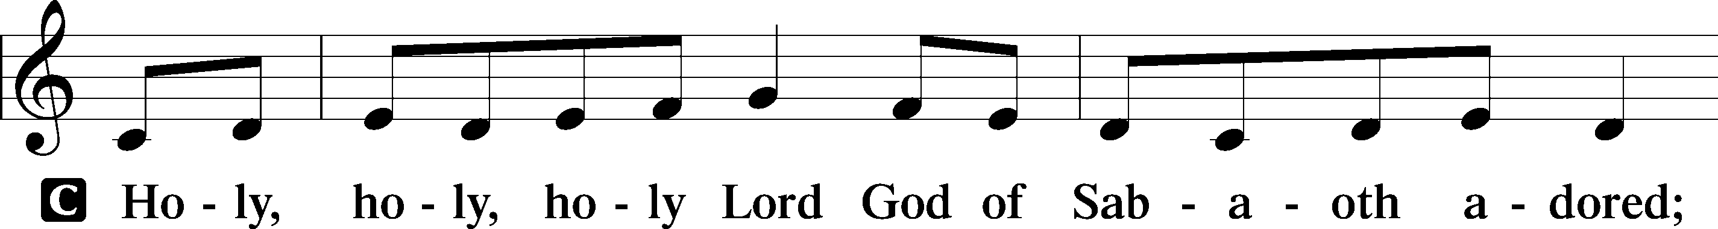
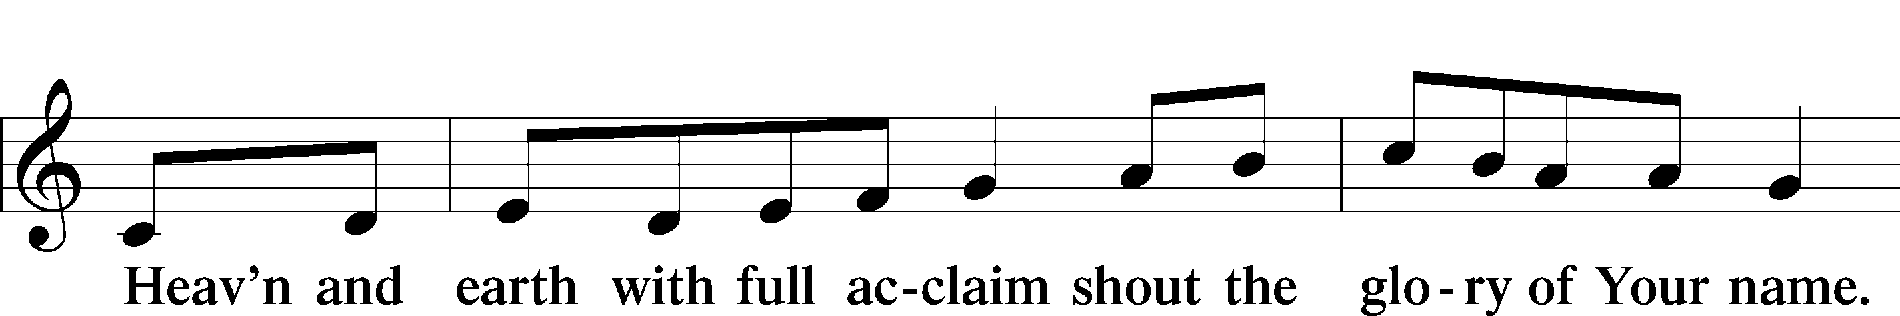
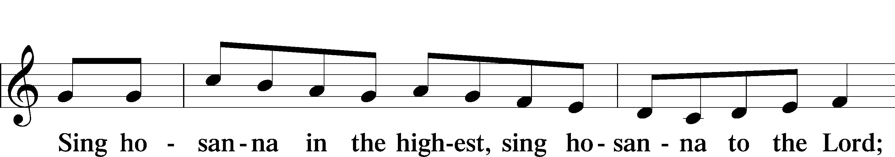
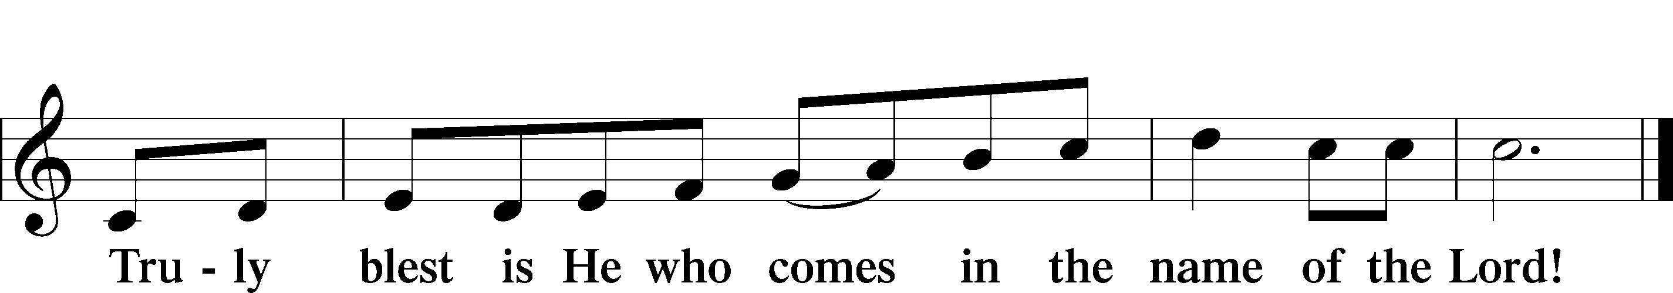

Prayer of Thanksgiving
P Blessed are You, O Lord our God, king of all creation, for You have had mercy on us and given Your only-begotten Son that whoever believes in Him should not perish but have eternal life.

At Your command, Abraham prepared to offer his son Isaac as a sacrifice on the mountain; yet, in mercy You provided a ram as a substitute. We give You thanks that on Calvary You spared not Your only Son but sent Him to offer His life as a ransom for many.

As we eat and drink His body and blood, grant us, like Abraham our father, to trust in Your promise now fulfilled in Christ, the Lamb of God, who takes away the sin of the world.

Hear us as we pray in His name and as He has taught us:

Lord’s Prayer

The Words of Our Lord

Pax Domini
P The peace of the Lord be with you always.
C Amen.

Agnus Dei
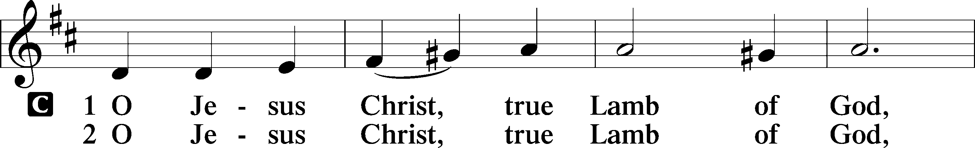
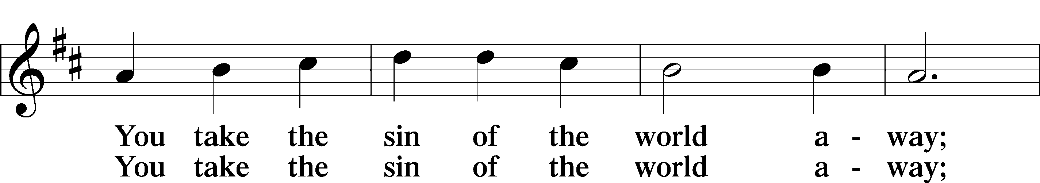
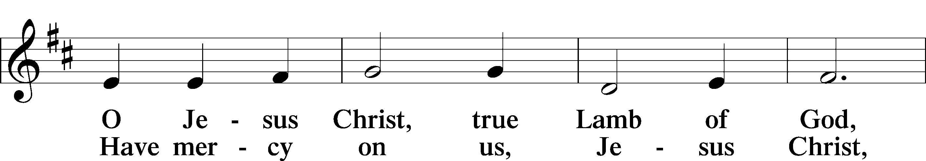
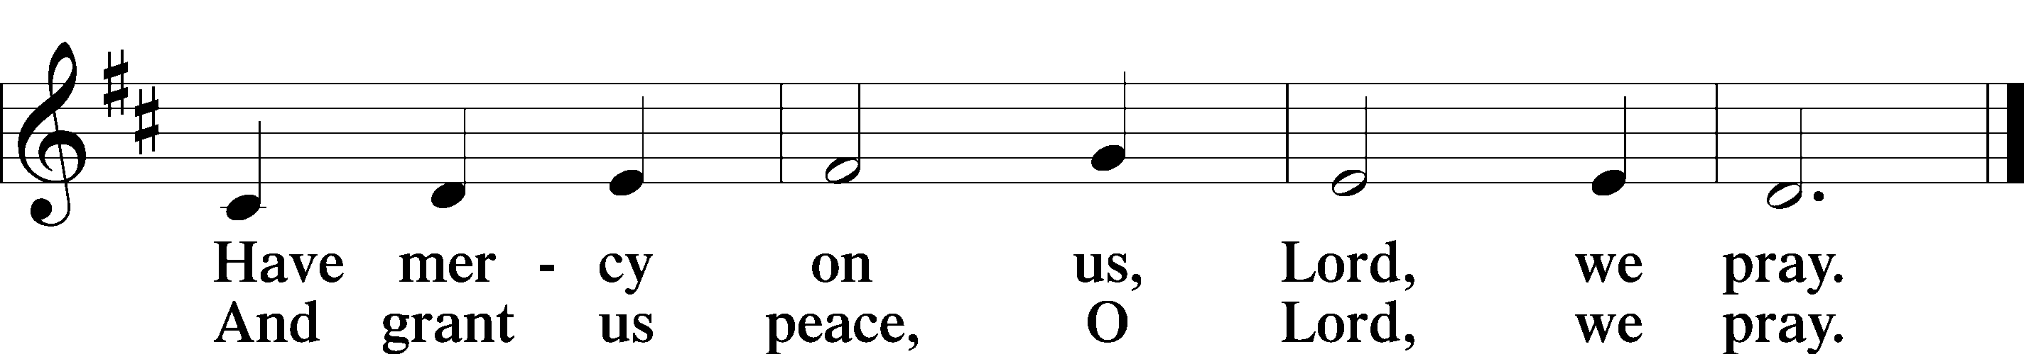

Sit

Distribution

420 Christ, the Life of All the Living

625 Lord Jesus Christ, Life-Giving Bread

Stand

Nunc Dimittis
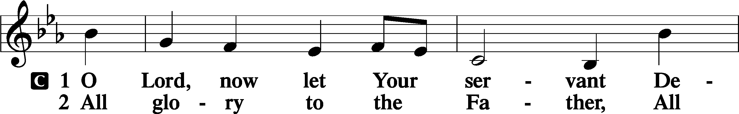
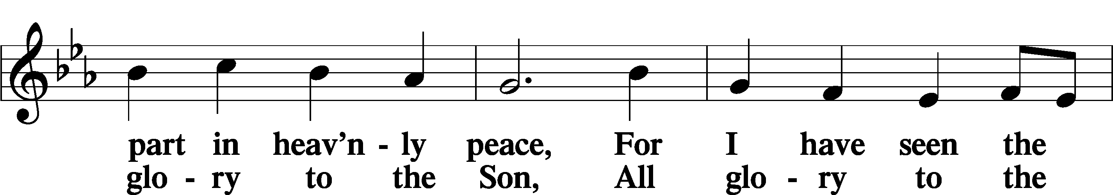
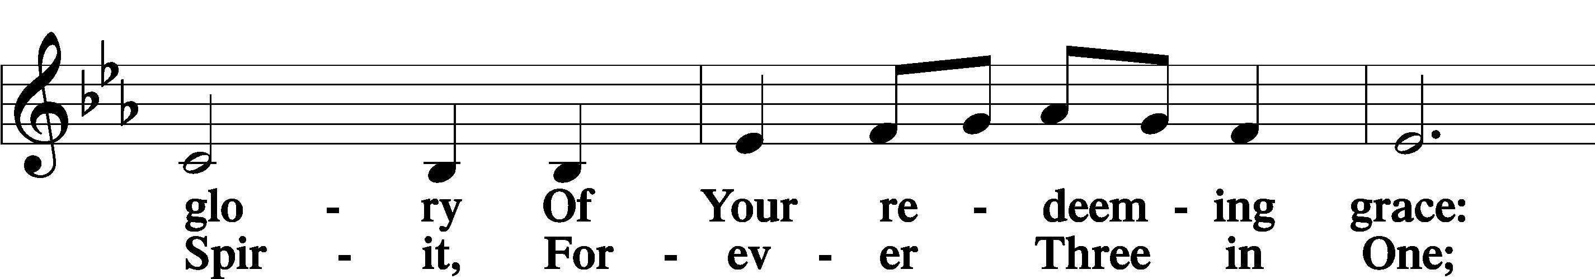
(continued on next page)
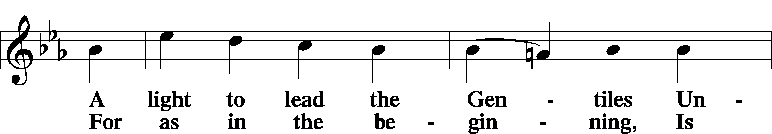
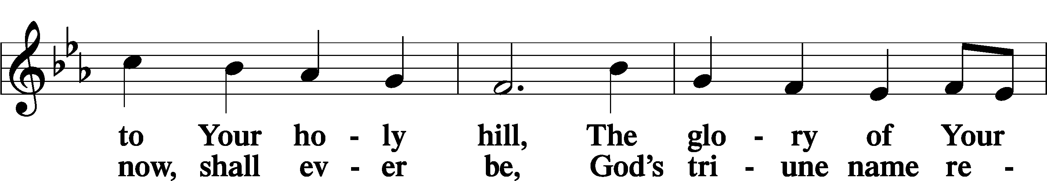
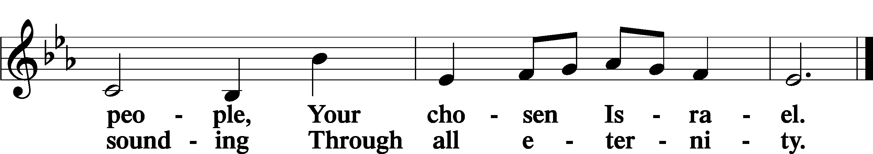

Post-Communion Collect
A Let us pray. We give thanks to You, almighty God, that You have refreshed us through this salutary gift, and we implore You that of Your mercy You would strengthen us through the same in faith toward You and in fervent love toward one another; through Jesus Christ, Your Son, our Lord, who lives and reigns with You and the Holy Spirit, one God, now and forever.
C Amen.

Benedicamus
A Let us bless the Lord.
C Thanks be to God.

Benediction
P The Lord bless you and keep you.
The Lord make His face shine on you and be gracious to you.
The Lord look upon you with favor and T give you peace.

C Amen.

752 Be Still, My Soul

Announcements

Midweek Lenten Worship Services: 6 p.m.
Wednesday, March 25 • Maundy Thursday, April 2nd • Good Friday, April 3rd

Lenten Suppers will be at 4:45 p.m. every Wednesday during Lent.
Free-will offering goes to Families in Need.

Easter Flower orders due today! Signup is in the Narthex.

