Fifth Sunday of Easter
May 3rd, 2026

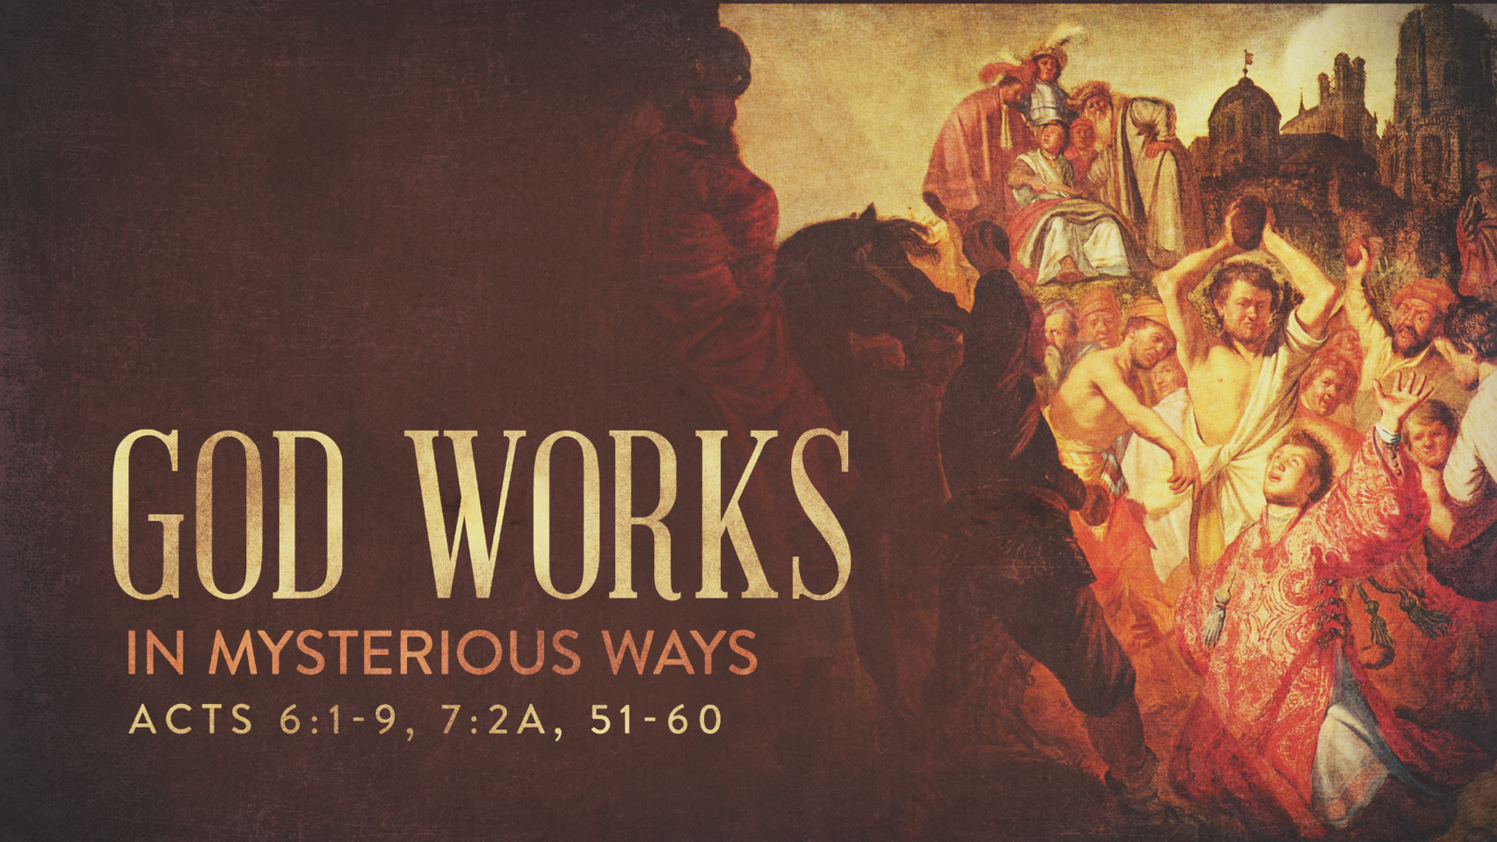

Messiah Lutheran Church
Sartell, MN
www.messiahsartell.com
320-252-5883
Prayer Before Entering
Please take this time to focus on our purpose in gathering and join in prayer before our service begins. Blessed Lord, You have caused all Holy Scriptures to be written for our learning. Grant that we may so hear them, read, mark, learn, and inwardly digest them that, by patience and comfort of Your holy Word, we may embrace and ever hold fast the blessed hope of everlasting life; through Jesus Christ, our Lord.

As We Gather
Today we focus on the story of Stephen, a faithful follower of Jesus who trusted God even when his faith was challenged. His story reminds us that living as Christians isn’t always easy, but we are never alone. God gives His people strength, forgiveness, and hope, and Jesus stands with us in every struggle. As we worship today, we are invited to look again to Christ, who supports His church and calls us to trust Him with courage and confidence.

828 We Are Called to Stand Together

Stand

The sign of the cross may be made by all in remembrance of their Baptism.

P In the name of the Father and of the T Son and of the Holy Spirit.
C Amen.

P Our help is in the name of the Lord,
C who made heaven and earth.

P If You, O Lord, kept a record of sins, O Lord, who could stand?
C But with You there is forgiveness; therefore You are feared.

P Since we are gathered to hear God’s Word, call upon Him in prayer and praise, let us first consider our unworthiness and confess before God and one another that we have sinned in thought, word, and deed, and that we cannot free ourselves from our sinful condition. Together as His people let us take refuge in the infinite mercy of God, our heavenly Father, seeking His grace for the sake of Christ, and saying:
C God, be merciful to me, a sinner.

Silence for reflection on God’s Word and for self-examination.
C Almighty God, have mercy upon us, forgive us our sins, and lead us to everlasting life. Amen.

P Almighty God in His mercy has given His Son to die for you and for His sake forgives you all your sins. As a called and ordained servant of Christ, and by His authority, I therefore forgive you all your sins in the name of the Father and of the T Son and of the Holy Spirit.

C Amen.

Introit Psalm 30:1–5; antiphon: Psalm 149:1
P Praise the Lord! Sing to the Lord a new song,
his praise in the assembly of the godly!
C I will extol you, O Lord, for you have drawn me up
and have not let my foes rejoice over me.
P O Lord my God, I cried to you for help,
and you have healed me.
C O Lord, you have brought up my soul from Sheol;
you restored me to life from among those who go down to the pit.
P Sing praises to the Lord, O you his saints,
and give thanks to his holy name.
C For his anger is but for a moment, and his favor is for a lifetime.
Weeping may tarry for the night, but joy comes with the morning.
All: Glory be to the Father and to the Son
and to the Holy Spirit;
as it was in the beginning,
is now, and will be forever. Amen.
P Praise the Lord! Sing to the Lord a new song,
his praise in the assembly of the godly!

Kyrie
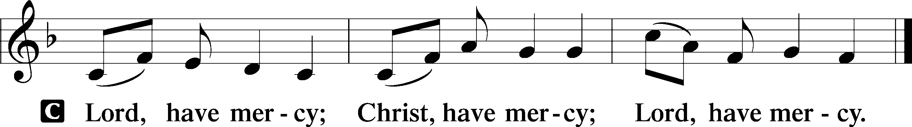

Gloria in Excelsis
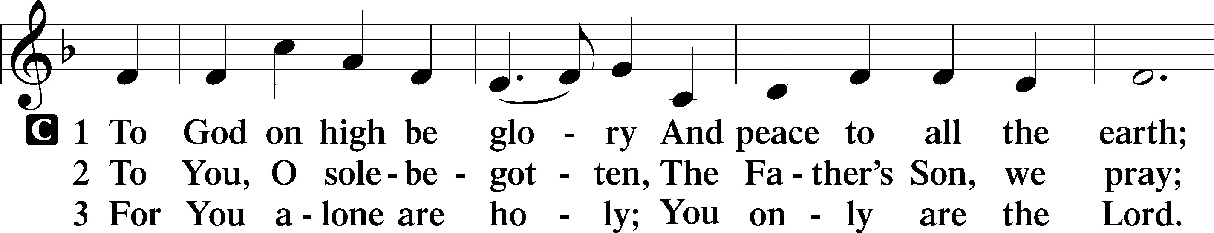
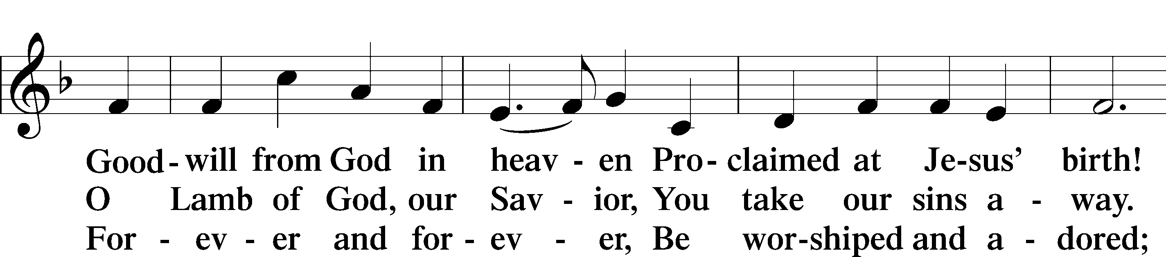
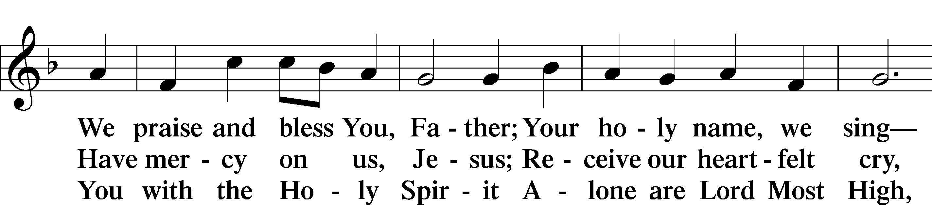
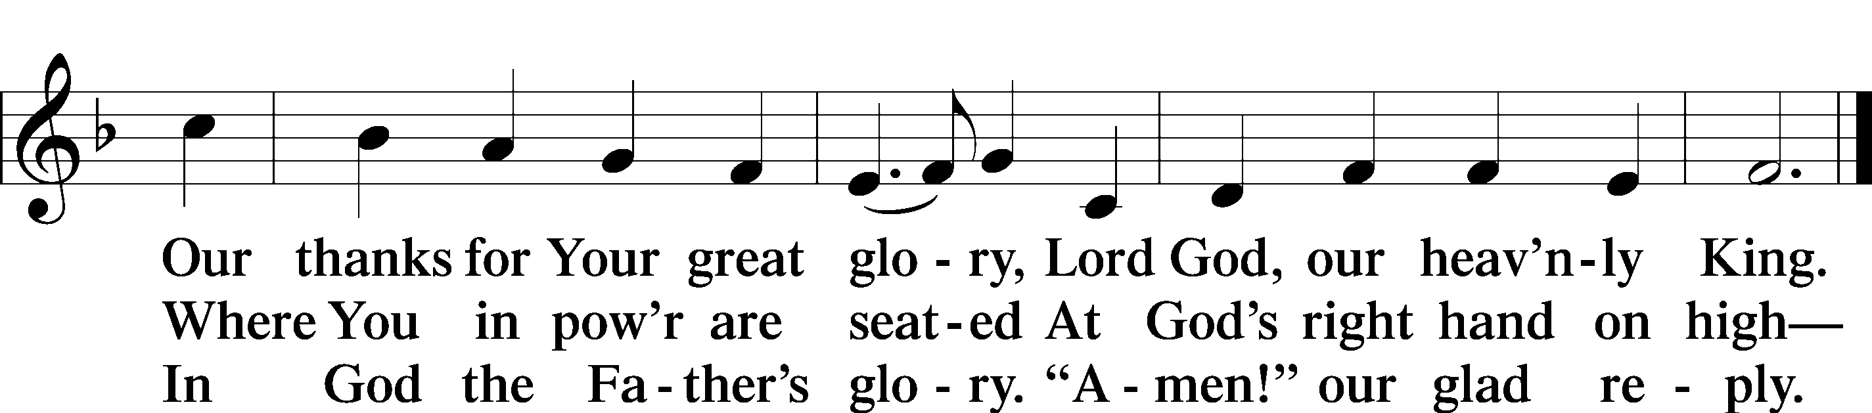

Salutation and Collect of the Day
P The Lord be with you.
C And also with you.

P Let us pray.
O God, You make the minds of Your faithful to be of one will. Grant that we may love what You have commanded and desire what You promise, that among the many changes of this world our hearts may be fixed where true joys are found; through Jesus Christ, Your Son, our Lord, who lives and reigns with You and the Holy Spirit, one God, now and forever.

C Amen.

Sit
First Reading Acts 6:1–9; 7:2a, 51–60
1Now in these days when the disciples were increasing in number, a complaint by the Hellenists arose against the Hebrews because their widows were being neglected in the daily distribution. 2And the twelve summoned the full number of the disciples and said, “It is not right that we should give up preaching the word of God to serve tables. 3Therefore, brothers, pick out from among you seven men of good repute, full of the Spirit and of wisdom, whom we will appoint to this duty. 4But we will devote ourselves to prayer and to the ministry of the word.” 5And what they said pleased the whole gathering, and they chose Stephen, a man full of faith and of the Holy Spirit, and Philip, and Prochorus, and Nicanor, and Timon, and Parmenas, and Nicolaus, a proselyte of Antioch. 6These they set before the apostles, and they prayed and laid their hands on them.
7And the word of God continued to increase, and the number of the disciples multiplied greatly in Jerusalem, and a great many of the priests became obedient to the faith. 8And Stephen, full of grace and power, was doing great wonders and signs among the people. 9Then some of those who belonged to the synagogue of the Freedmen (as it was called), and of the Cyrenians, and of the Alexandrians, and of those from Cilicia and Asia, rose up and disputed with Stephen. . . .
2And Stephen said: “Brothers and fathers, hear me. . . .
51You stiff-necked people, uncircumcised in heart and ears, you always resist the Holy Spirit. As your fathers did, so do you. 52Which of the prophets did not your fathers persecute? And they killed those who announced beforehand the coming of the Righteous One, whom you have now betrayed and murdered, 53you who received the law as delivered by angels and did not keep it.” 54Now when they heard these things they were enraged, and they ground their teeth at him. 55But he, full of the Holy Spirit, gazed into heaven and saw the glory of God, and Jesus standing at the right hand of God. 56And he said, “Behold, I see the heavens opened, and the Son of Man standing at the right hand of God.” 57But they cried out with a loud voice and stopped their ears and rushed together at him. 58Then they cast him out of the city and stoned him. And the witnesses laid down their garments at the feet of a young man named Saul. 59And as they were stoning Stephen, he called out, “Lord Jesus, receive my spirit.” 60And falling to his knees he cried out with a loud voice, “Lord, do not hold this sin against them.” And when he had said this, he fell asleep.

A This is the Word of the Lord.
C Thanks be to God.
Epistle 1 Peter 2:2–10
2Like newborn infants, long for the pure spiritual milk, that by it you may grow up to salvation— 3if indeed you have tasted that the Lord is good. 4As you come to him, a living stone rejected by men but in the sight of God chosen and precious, 5you yourselves like living stones are being built up as a spiritual house, to be a holy priesthood, to offer spiritual sacrifices acceptable to God through Jesus Christ. 6For it stands in Scripture: “Behold, I am laying in Zion a stone, a cornerstone chosen and precious, and whoever believes in him will not be put to shame.” 7So the honor is for you who believe, but for those who do not believe, “The stone that the builders rejected has become the cornerstone,” 8and “A stone of stumbling, and a rock of offense.” They stumble because they disobey the word, as they were destined to do.
9But you are a chosen race, a royal priesthood, a holy nation, a people for his own possession, that you may proclaim the excellencies of him who called you out of darkness into his marvelous light. 10Once you were not a people, but now you are God’s people; once you had not received mercy, but now you have received mercy.

A This is the Word of the Lord.
C Thanks be to God.

Stand

Alleluia and Verse
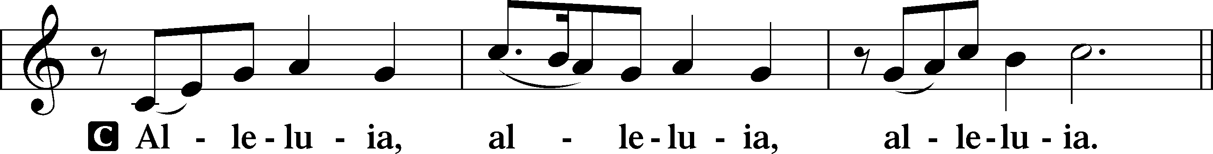
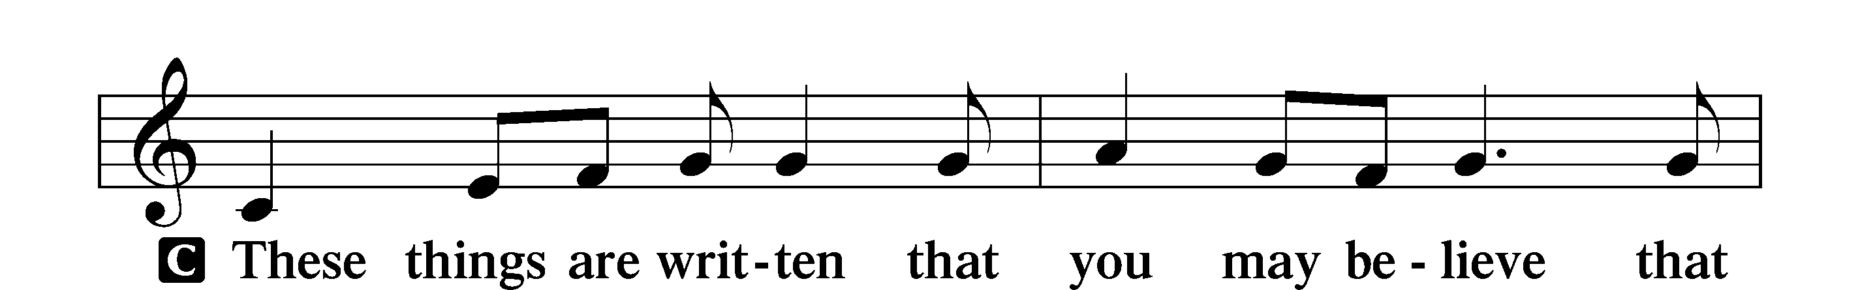
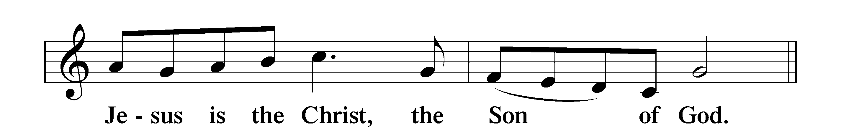
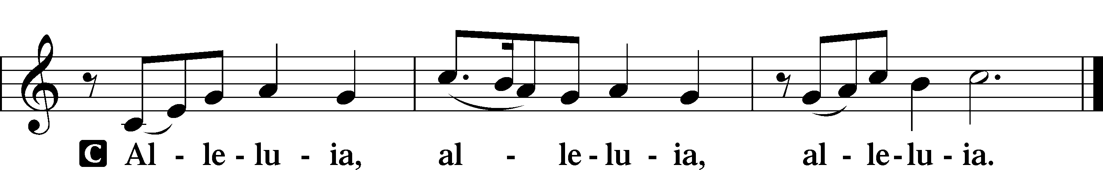
Holy Gospel John 14:1–14
P The Holy Gospel according to St. John, the fourteenth chapter.
C Glory to You, O Lord.

1[Jesus said:] “Let not your hearts be troubled. Believe in God; believe also in me. 2In my Father’s house are many rooms. If it were not so, would I have told you that I go to prepare a place for you? 3And if I go and prepare a place for you, I will come again and will take you to myself, that where I am you may be also. 4And you know the way to where I am going.” 5Thomas said to him, “Lord, we do not know where you are going. How can we know the way?” 6Jesus said to him, “I am the way, and the truth, and the life. No one comes to the Father except through me. 7If you had known me, you would have known my Father also. From now on you do know him and have seen him.” 8Philip said to him, “Lord, show us the Father, and it is enough for us.” 9Jesus said to him, “Have I been with you so long, and you still do not know me, Philip? Whoever has seen me has seen the Father. How can you say, ‘Show us the Father’? 10Do you not believe that I am in the Father and the Father is in me? The words that I say to you I do not speak on my own authority, but the Father who dwells in me does his works. 11Believe me that I am in the Father and the Father is in me, or else believe on account of the works themselves. 12“Truly, truly, I say to you, whoever believes in me will also do the works that I do; and greater works than these will he do, because I am going to the Father. 13Whatever you ask in my name, this I will do, that the Father may be glorified in the Son. 14If you ask me anything in my name, I will do it.”

P This is the Gospel of the Lord.
C Praise to You, O Christ.

Apostles’ Creed
C I believe in God, the Father Almighty,
maker of heaven and earth.
And in Jesus Christ, His only Son, our Lord,
who was conceived by the Holy Spirit,
born of the virgin Mary,
suffered under Pontius Pilate,
was crucified, died and was buried.
He descended into hell.
The third day He rose again from the dead.
He ascended into heaven
and sits at the right hand of God the Father Almighty.
From thence He will come to judge the living and the dead.
I believe in the Holy Spirit,
the holy Christian Church,
the communion of saints,
the forgiveness of sins,
the resurrection of the body,
and the life T everlasting. Amen.

Sit

645 Built on the Rock

Sermon

Offering. We generously give our offerings to the LORD out of thanksgiving for His generosity of forgiveness, life, and salvation in Christ (2 Corinthians 9:8). We believe that our offerings are not only to support the proclamation of the Gospel here and around the world, but also to help us all grow in faith and trust in Him (2 Corinthians 9:7). We have placed an offering plate in the narthex so you are able to freely give back to Him as you are able. To Him be all the glory!

Stand

Prayer of the Church

Lord’s Prayer

Benedicamus
A Let us bless the Lord.
C Thanks be to God.

Benediction
P The Lord bless you and keep you.
The Lord make His face shine on you and be gracious to you.
The Lord look upon you with favor and T give you peace.
C Amen.

837 Lift High the Cross sts. ref–6

Movie Night showing DAVID! Friday, May 15 at 6 p.m. All are welcome!

Spring Cookout! Sunday, May 17! Free-will offering will go towards replacing parking lot lights. (Est. $400 per light)

