The Ascension of Our Lord
May 17th, 2026

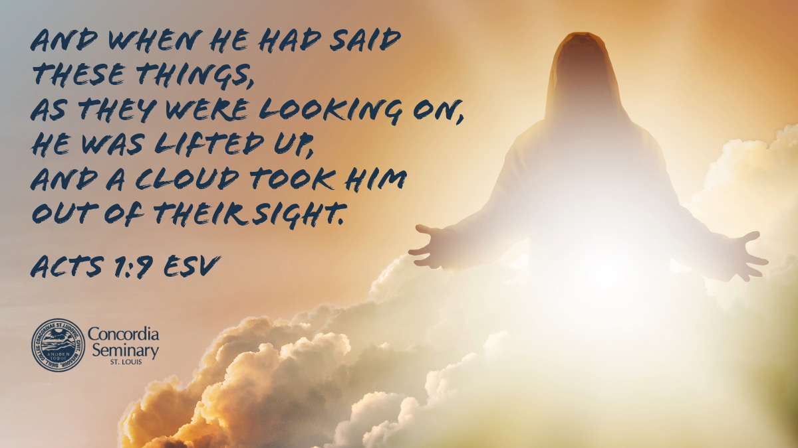

Messiah Lutheran Church
Sartell, MN
www.messiahsartell.com
320-252-5883
Prayer Before Entering
Please take this time to focus on our purpose in gathering and join in prayer before our service begins. Blessed Lord, You have caused all Holy Scriptures to be written for our learning. Grant that we may so hear them, read, mark, learn, and inwardly digest them that, by patience and comfort of Your holy Word, we may embrace and ever hold fast the blessed hope of everlasting life; through Jesus Christ, our Lord.

As We Gather
We gather together this Ascension Day to celebrate Christ the King taking His rightful seat in glory, honor, and authority at God the Father’s right hand. With the ancient worshipers, who clapped their hands and shouted praises to God at the coronation of their king, we rejoice in the victory Jesus earned for us by His death for our sin and His resurrection over death’s grave. Our praises keep rolling from our Easter celebration some forty days ago, all the way to today and even beyond, as we witness that Jesus’ ascension is the capstone of His victory. Scepter in hand and seated upon His throne, Christ reigns over all things in heaven and on earth. We are honored to be in His presence this day and receive from our King the gifts He gracefully bestows.

492 On Christ’s Ascension I Now Build

Stand

The sign of the cross may be made by all in remembrance of their Baptism.

P In the name of the Father and of the T Son and of the Holy Spirit.
C Amen.

P Our help is in the name of the Lord,
C who made heaven and earth.

P If You, O Lord, kept a record of sins, O Lord, who could stand?
C But with You there is forgiveness; therefore You are feared.

P Since we are gathered to hear God’s Word, call upon Him in prayer and praise, let us first consider our unworthiness and confess before God and one another that we have sinned in thought, word, and deed, and that we cannot free ourselves from our sinful condition. Together as His people let us take refuge in the infinite mercy of God, our heavenly Father, seeking His grace for the sake of Christ, and saying:
C God, be merciful to me, a sinner.

Silence for reflection on God’s Word and for self-examination.
C Almighty God, have mercy upon us, forgive us our sins, and lead us to everlasting life. Amen.

P Almighty God in His mercy has given His Son to die for you and for His sake forgives you all your sins. As a called and ordained servant of Christ, and by His authority, I therefore forgive you all your sins in the name of the Father and of the T Son and of the Holy Spirit.

C Amen.

Introit Psalm 110:1, 4–5; antiphon: Psalm 47:5
P God has gone up with a shout,
the Lord with the sound of a trumpet.
C The Lord says to my Lord: “Sit at my right hand,
until I make your enemies your footstool.”
P The Lord has sworn and will not change his mind,
“You are a priest forever after the order of Melchizedek.”
C The Lord is at your right hand;
he will shatter kings on the day of his wrath.
All: Glory be to the Father and to the Son
and to the Holy Spirit;
as it was in the beginning,
is now, and will be forever. Amen.
P God has gone up with a shout,
the Lord with the sound of a trumpet.

Kyrie
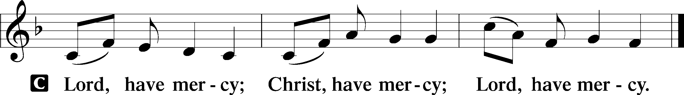

Gloria in Excelsis
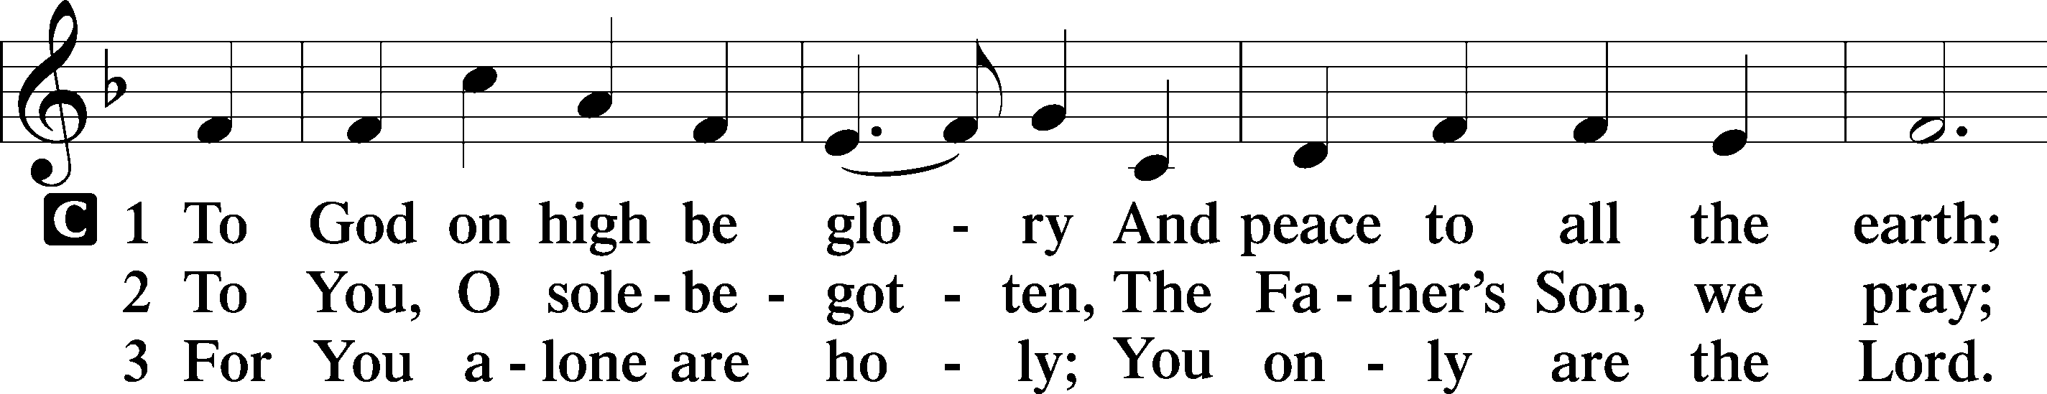
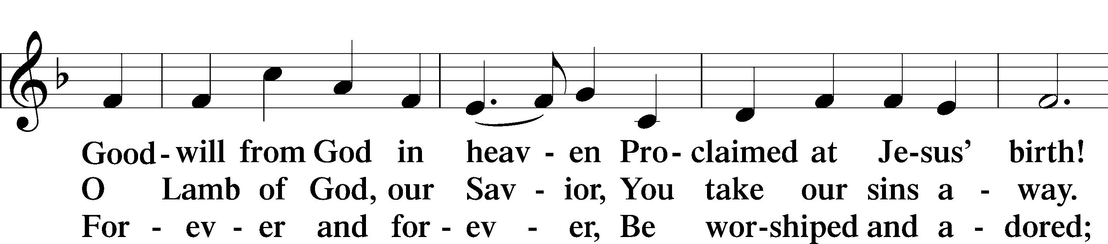
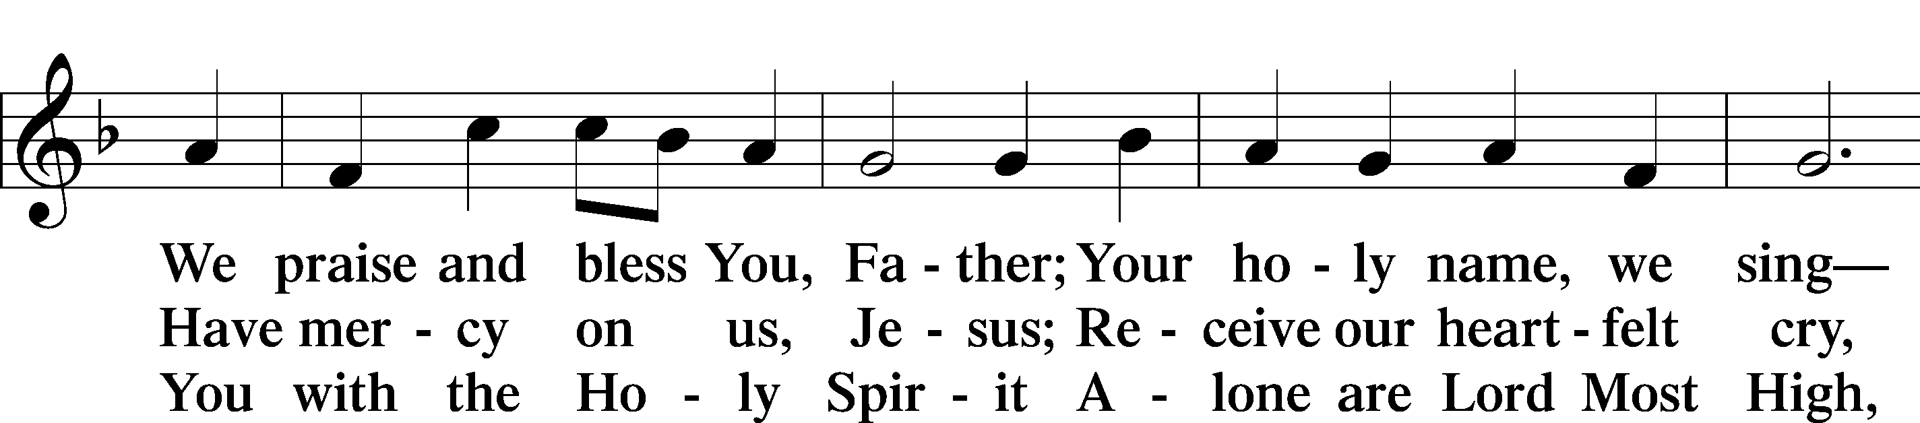
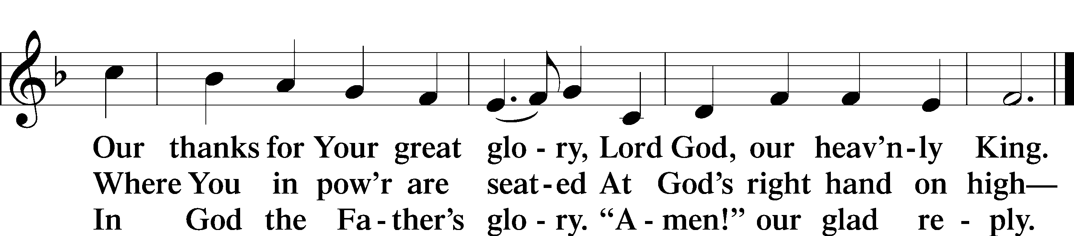

Salutation and Collect of the Day
P The Lord be with you.
C And also with you.

P Let us pray.
Almighty God, as Your only-begotten Son, our Lord Jesus Christ, ascended into the heavens, so may we also ascend in heart and mind and continually dwell there with Him, who lives and reigns with You and the Holy Spirit, one God, now and forever.

C Amen.

Sit
First Reading Acts 1:1–11
1In the first book, O Theophilus, I have dealt with all that Jesus began to do and teach, 2until the day when he was taken up, after he had given commands through the Holy Spirit to the apostles whom he had chosen. 3To them he presented himself alive after his suffering by many proofs, appearing to them during forty days and speaking about the kingdom of God. 4And while staying with them he ordered them not to depart from Jerusalem, but to wait for the promise of the Father, which, he said, “you heard from me; 5for John baptized with water, but you will be baptized with the Holy Spirit not many days from now.”
6So when they had come together, they asked him, “Lord, will you at this time restore the kingdom to Israel?” 7He said to them, “It is not for you to know times or seasons that the Father has fixed by his own authority. 8But you will receive power when the Holy Spirit has come upon you, and you will be my witnesses in Jerusalem and in all Judea and Samaria, and to the end of the earth.” 9And when he had said these things, as they were looking on, he was lifted up, and a cloud took him out of their sight. 10And while they were gazing into heaven as he went, behold, two men stood by them in white robes, 11and said, “Men of Galilee, why do you stand looking into heaven? This Jesus, who was taken up from you into heaven, will come in the same way as you saw him go into heaven.”

A This is the Word of the Lord.
C Thanks be to God.

Epistle Ephesians 1:15–23
15For this reason, because I have heard of your faith in the Lord Jesus and your love toward all the saints, 16I do not cease to give thanks for you, remembering you in my prayers, 17that the God of our Lord Jesus Christ, the Father of glory, may give you a spirit of wisdom and of revelation in the knowledge of him, 18having the eyes of your hearts enlightened, that you may know what is the hope to which he has called you, what are the riches of his glorious inheritance in the saints, 19and what is the immeasurable greatness of his power toward us who believe, according to the working of his great might 20that he worked in Christ when he raised him from the dead and seated him at his right hand in the heavenly places, 21far above all rule and authority and power and dominion, and above every name that is named, not only in this age but also in the one to come. 22And he put all things under his feet and gave him as head over all things to the church, 23which is his body, the fullness of him who fills all in all.

A This is the Word of the Lord.
C Thanks be to God.

Stand

Alleluia and Verse
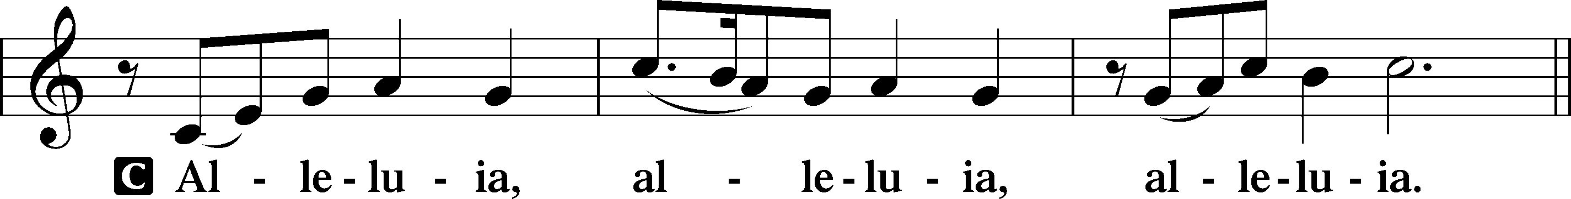
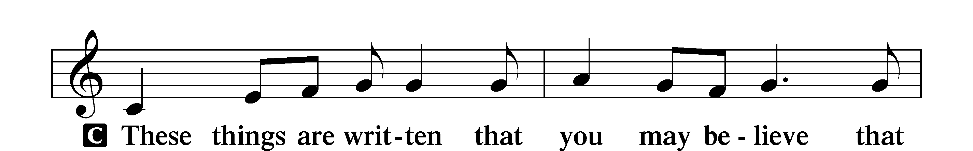
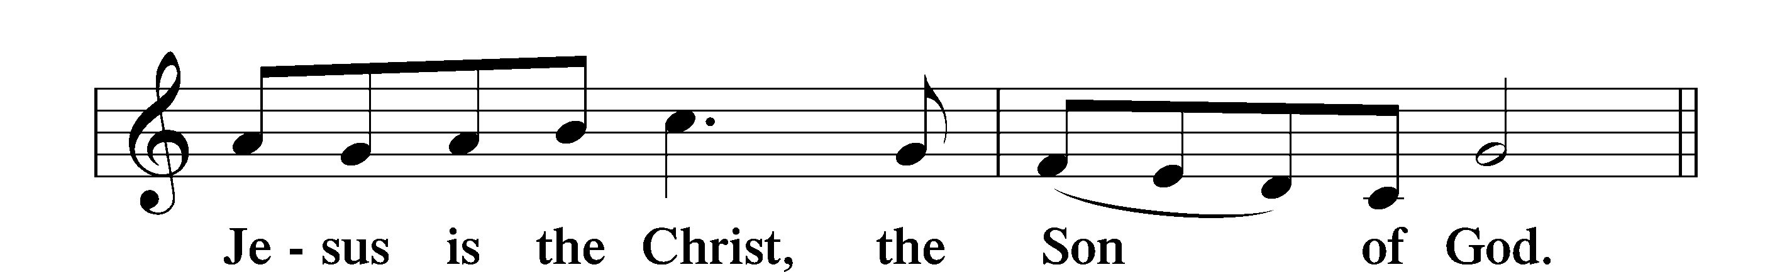
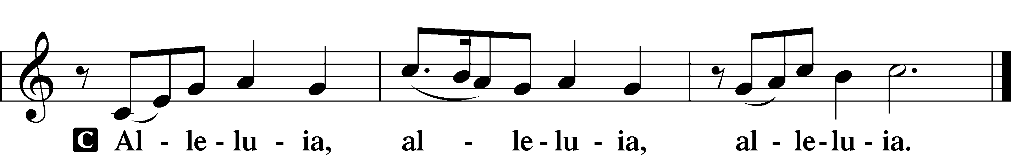

Holy Gospel Luke 24:44–53
P The Holy Gospel according to St. Luke, the twenty-fourth chapter.
C Glory to You, O Lord.

44Then [Jesus] said to them, “These are my words that I spoke to you while I was still with you, that everything written about me in the Law of Moses and the Prophets and the Psalms must be fulfilled.” 45Then he opened their minds to understand the Scriptures, 46and said to them, “Thus it is written, that the Christ should suffer and on the third day rise from the dead, 47and that repentance and forgiveness of sins should be proclaimed in his name to all nations, beginning from Jerusalem. 48You are witnesses of these things. 49And behold, I am sending the promise of my Father upon you. But stay in the city until you are clothed with power from on high.”
50Then he led them out as far as Bethany, and lifting up his hands he blessed them. 51While he blessed them, he parted from them and was carried up into heaven. 52And they worshiped him and returned to Jerusalem with great joy, 53and were continually in the temple blessing God.

P This is the Gospel of the Lord.
C Praise to You, O Christ.

Apostles’ Creed
C I believe in God, the Father Almighty,
maker of heaven and earth.
And in Jesus Christ, His only Son, our Lord,
who was conceived by the Holy Spirit,
born of the virgin Mary,
suffered under Pontius Pilate,
was crucified, died and was buried.
He descended into hell.
The third day He rose again from the dead.
He ascended into heaven
and sits at the right hand of God the Father Almighty.
From thence He will come to judge the living and the dead.
I believe in the Holy Spirit,
the holy Christian Church,
the communion of saints,
the forgiveness of sins,
the resurrection of the body,
and the life T everlasting. Amen.

Sit

494 See, the Lord Ascends in Triumph

Sermon

Offering. We generously give our offerings to the LORD out of thanksgiving for His generosity of forgiveness, life, and salvation in Christ (2 Corinthians 9:8). We believe that our offerings are not only to support the proclamation of the Gospel here and around the world, but also to help us all grow in faith and trust in Him (2 Corinthians 9:7). We have placed an offering plate in the narthex so you are able to freely give back to Him as you are able. To Him be all the glory!

Stand
Prayer of the Church

Lord’s Prayer

Benedicamus
A Let us bless the Lord.
C Thanks be to God.

Benediction
P The Lord bless you and keep you.
The Lord make His face shine on you and be gracious to you.
The Lord look upon you with favor and T give you peace.
C Amen.

477 Alleluia, Alleluia! Hearts to Heaven

Announcement:

Spring Cookout TODAY after Bible Study! Free-will offering will go towards replacing parking lot lights. (Est. $400 per light)

