Seventh Sunday After Pentecost
July 12th, 2026

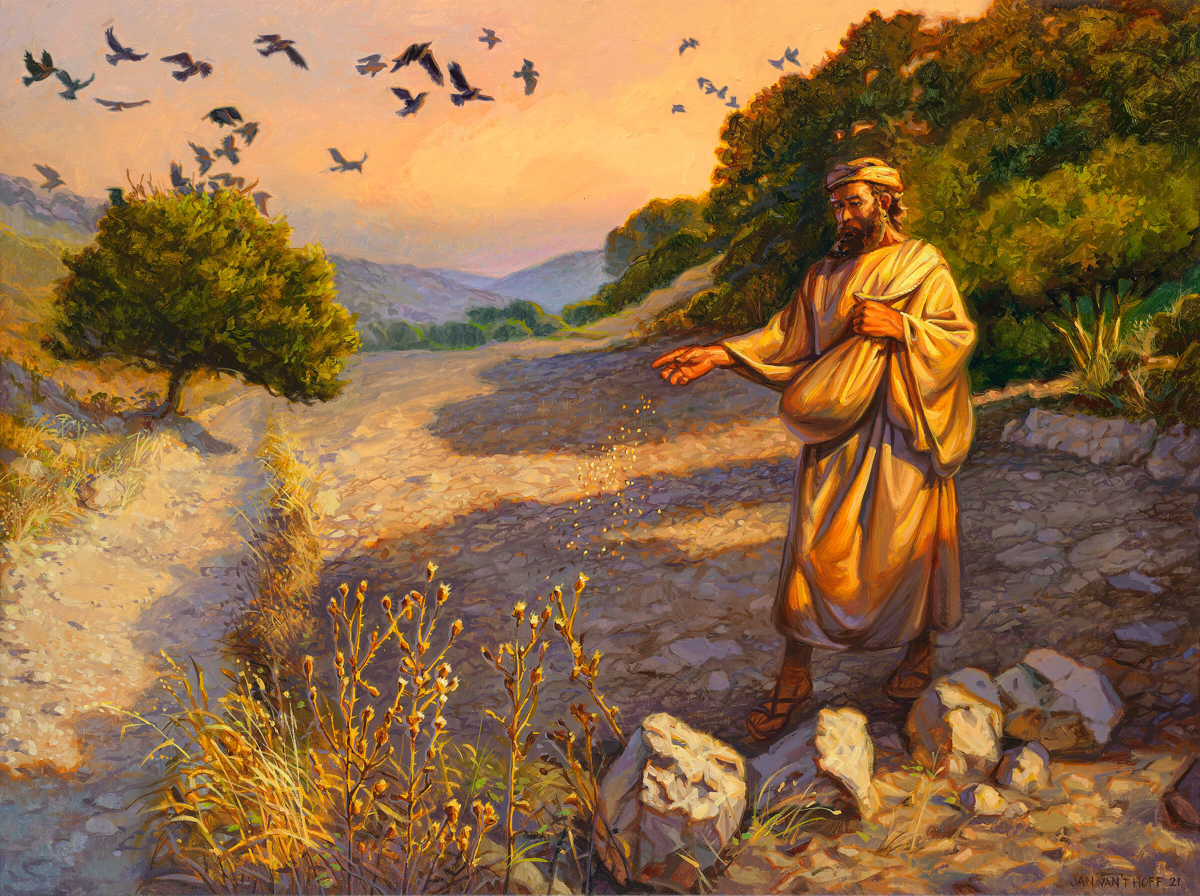

Messiah Lutheran Church
Sartell, MN
www.messiahsartell.com
320-252-5883
Prayer Before Entering
Please take this time to focus on our purpose in gathering and join in prayer before our service begins. Blessed Lord, You have caused all Holy Scriptures to be written for our learning. Grant that we may so hear them, read, mark, learn, and inwardly digest them that, by patience and comfort of Your holy Word, we may embrace and ever hold fast the blessed hope of everlasting life; through Jesus Christ, our Lord.

As We Gather
Today we’ll hear Jesus’ parable of the sower, a simple story about seeds and soil that speaks right into our everyday lives. It reminds us that God keeps planting His Word in us with patience and love, even when our hearts feel hard, distracted, or worn down by life. And the good news is that Jesus doesn’t give up on us. Through His Word, He softens our hearts, grows our faith, gives us peace, and helps that faith bear fruit in our lives.

586 Preach You the Word

Stand

The sign of the cross may be made by all in remembrance of their Baptism.

P In the name of the Father and of the T Son and of the Holy Spirit.
C Amen.

P Our help is in the name of the Lord,
C who made heaven and earth.

P If You, O Lord, kept a record of sins, O Lord, who could stand?
C But with You there is forgiveness; therefore You are feared.

P Since we are gathered to hear God’s Word, call upon Him in prayer and praise, and receive the body and blood of our Lord Jesus Christ in the fellowship of this altar, let us first consider our unworthiness and confess before God and one another that we have sinned in thought, word, and deed, and that we cannot free ourselves from our sinful condition. Together as His people let us take refuge in the infinite mercy of God, our heavenly Father, seeking His grace for the sake of Christ, and saying:
C God, be merciful to me, a sinner.

Silence for reflection on God’s Word and for self-examination.

C Almighty God, have mercy upon us, forgive us our sins, and lead us to everlasting life. Amen.

P Almighty God in His mercy has given His Son to die for you and for His sake forgives you all your sins. As a called and ordained servant of Christ, and by His authority, I therefore forgive you all your sins in the name of the Father and of the T Son and of the Holy Spirit.

C Amen.

Introit Psalm 103:15–19; antiphon: v. 8
P The Lord is merciful and gracious,
slow to anger and abounding in steadfast love.
C As for man, his days are like grass;
he flourishes like a flower of the field;
P for the wind passes over it, and it is gone,
and its place knows it no more.
C But the steadfast love of the Lord is from everlasting to everlasting
on those who fear him,
and his righteousness to children’s children,
P to those who keep his covenant
and remember to do his commandments.
C The Lord has established his throne in the heavens,
and his kingdom rules over all.
All: Glory be to the Father and to the Son
and to the Holy Spirit;
as it was in the beginning,
is now, and will be forever. Amen.
P The Lord is merciful and gracious,
slow to anger and abounding in steadfast love.

Kyrie
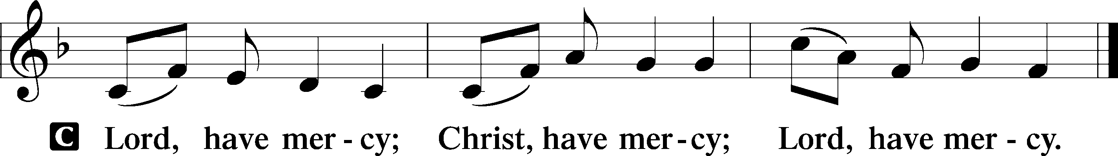

Gloria in Excelsis
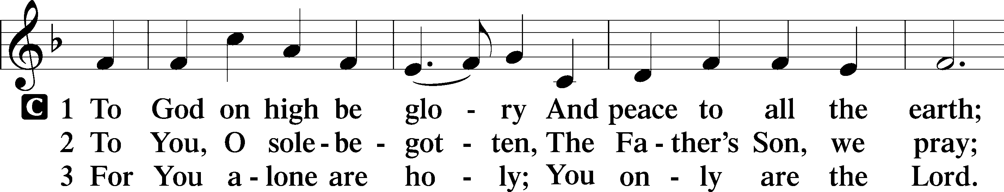
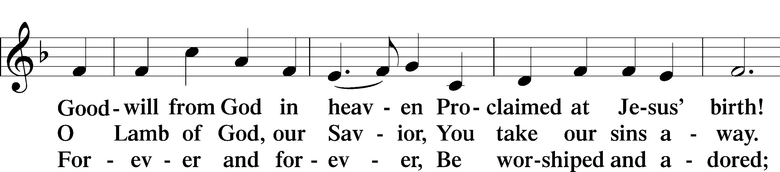
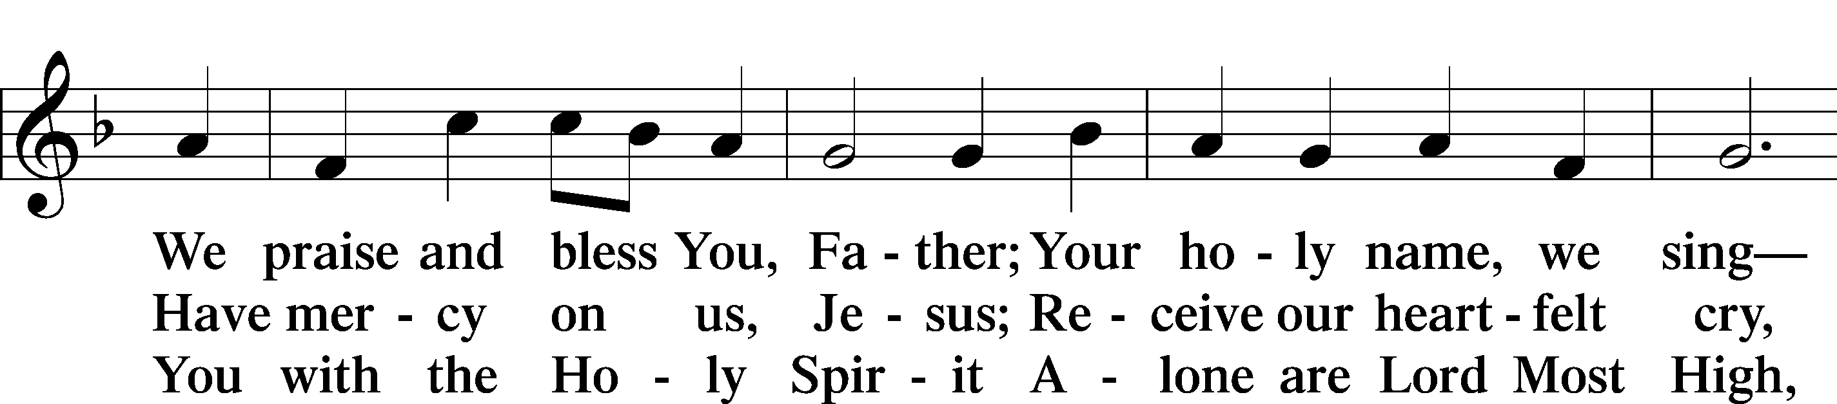
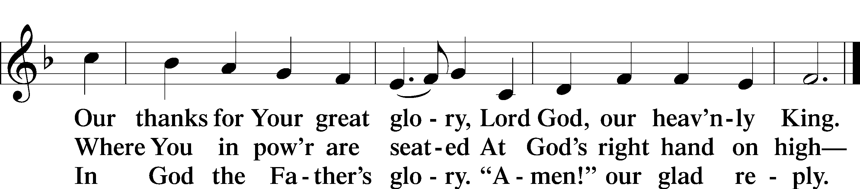

Salutation and Collect of the Day
P The Lord be with you.
C And also with you.

P Let us pray.
Blessed Lord, since You have caused all Holy Scriptures to be written for our learning, grant that we may so hear them, read, mark, learn, and inwardly digest them that we may embrace and ever hold fast the blessed hope of everlasting life; through Jesus Christ, Your Son, our Lord, who lives and reigns with You and the Holy Spirit, one God, now and forever.

C Amen.

Sit
Old Testament Reading Isaiah 55:10–13
10“For as the rain and the snow come down from heaven
and do not return there but water the earth,
making it bring forth and sprout,
giving seed to the sower and bread to the eater,
11so shall my word be that goes out from my mouth;
it shall not return to me empty,
but it shall accomplish that which I purpose,
and shall succeed in the thing for which I sent it.
12“For you shall go out in joy
and be led forth in peace;
the mountains and the hills before you
shall break forth into singing,
and all the trees of the field shall clap their hands.
13Instead of the thorn shall come up the cypress;
instead of the brier shall come up the myrtle;
and it shall make a name for the Lord,
an everlasting sign that shall not be cut off.”

A This is the Word of the Lord.
C Thanks be to God.

Epistle Romans 8:12–17
12So then, brothers, we are debtors, not to the flesh, to live according to the flesh. 13For if you live according to the flesh you will die, but if by the Spirit you put to death the deeds of the body, you will live. 14For all who are led by the Spirit of God are sons of God. 15For you did not receive the spirit of slavery to fall back into fear, but you have received the Spirit of adoption as sons, by whom we cry, “Abba! Father!” 16The Spirit himself bears witness with our spirit that we are children of God, 17and if children, then heirs—heirs of God and fellow heirs with Christ, provided we suffer with him in order that we may also be glorified with him.

A This is the Word of the Lord.
C Thanks be to God.

Stand

Alleluia and Verse
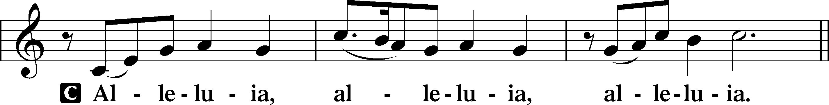
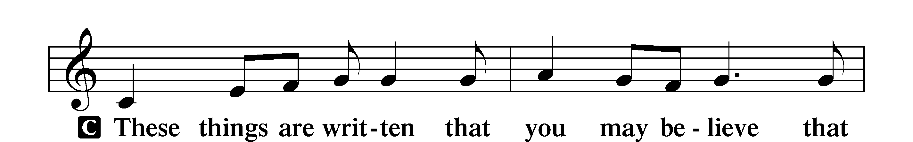
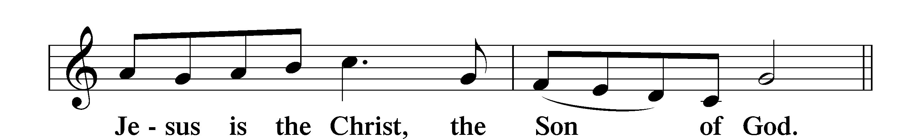
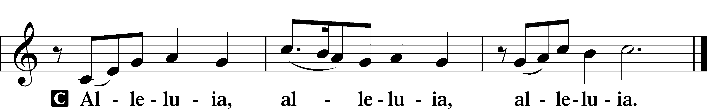

Holy Gospel Matthew 13:1–9, 18–23
P The Holy Gospel according to St. Matthew, the thirteenth chapter.
C Glory to You, O Lord.

1That same day Jesus went out of the house and sat beside the sea. 2And great crowds gathered about him, so that he got into a boat and sat down. And the whole crowd stood on the beach. 3And he told them many things in parables, saying: “A sower went out to sow. 4And as he sowed, some seeds fell along the path, and the birds came and devoured them. 5Other seeds fell on rocky ground, where they did not have much soil, and immediately they sprang up, since they had no depth of soil, 6but when the sun rose they were scorched. And since they had no root, they withered away. 7Other seeds fell among thorns, and the thorns grew up and choked them. 8Other seeds fell on good soil and produced grain, some a hundredfold, some sixty, some thirty. 9He who has ears, let him hear. . . .
18“Hear then the parable of the sower: 19When anyone hears the word of the kingdom and does not understand it, the evil one comes and snatches away what has been sown in his heart. This is what was sown along the path. 20As for what was sown on rocky ground, this is the one who hears the word and immediately receives it with joy, 21yet he has no root in himself, but endures for a while, and when tribulation or persecution arises on account of the word, immediately he falls away. 22As for what was sown among thorns, this is the one who hears the word, but the cares of the world and the deceitfulness of riches choke the word, and it proves unfruitful. 23As for what was sown on good soil, this is the one who hears the word and understands it. He indeed bears fruit and yields, in one case a hundredfold, in another sixty, and in another thirty.”

P This is the Gospel of the Lord.
C Praise to You, O Christ.

Nicene Creed
C I believe in one God,
the Father Almighty,
maker of heaven and earth
and of all things visible and invisible.
And in one Lord Jesus Christ,
the only-begotten Son of God,
begotten of His Father before all worlds,
God of God, Light of Light,
very God of very God,
begotten, not made,
being of one substance with the Father,
by whom all things were made;
who for us men and for our salvation came down from heaven
and was incarnate by the Holy Spirit of the virgin Mary
and was made man;
and was crucified also for us under Pontius Pilate.
He suffered and was buried.
And the third day He rose again according to the Scriptures
and ascended into heaven
and sits at the right hand of the Father.
And He will come again with glory to judge both the living and the dead,
whose kingdom will have no end.
And I believe in the Holy Spirit,
the Lord and giver of life,

who proceeds from the Father and the Son,
who with the Father and the Son together is worshiped and glorified,
who spoke by the prophets.
And I believe in one holy Christian and apostolic Church,
I acknowledge one Baptism for the remission of sins,
and I look for the resurrection of the dead
and the life T of the world to come.

Amen.
Sit

577 Almighty God, Your Word Is Cast

Sermon

Offering. We generously give our offerings to the LORD out of thanksgiving for His generosity of forgiveness, life, and salvation in Christ (2 Corinthians 9:8). We believe that our offerings are not only to support the proclamation of the Gospel here and around the world, but also to help us all grow in faith and trust in Him (2 Corinthians 9:7). We have placed an offering plate in the narthex so you are able to freely give back to Him as you are able. To Him be all the glory!

Stand

Prayer of the Church

Holy Communion is celebrated in the belief and glad confidence that our Lord gives us not only bread and wine, but the body and blood of Christ from the cross, for us Christian to eat and drink for the forgiveness of sins (Matthew 26:28). Because we are called to examine ourselves before receiving the Lord’s Supper (I Corinthians 11:28-29), we encourage you to consider the questions on pages 329-330 in the hymnal. We also believe that when we commune, we are confessing our unity with the community we join (I Corinthians 10:17). If you desire to commune with us for the first time or have questions, our pastor is happy to speak with you.

Preface
P The Lord be with you.
C And also with you.

P Lift up your hearts.
C We lift them to the Lord.

P Let us give thanks to the Lord our God.
C It is right to give Him thanks and praise.

P It is truly good, right, and salutary that we should at all times and in all places give thanks to You, O Lord, holy Father, almighty and everlasting God, for the countless blessings You so freely bestow on us and all creation. Above all, we give thanks for Your boundless love shown to us when You sent Your only-begotten Son, Jesus Christ, into our flesh and laid on Him our sin, giving Him into death that we might not die eternally. Because He is now risen from the dead and lives and reigns to all eternity, all who believe in Him will overcome sin and death and will rise again to new life. Therefore with angels and archangels and with all the company of heaven we laud and magnify Your glorious name, evermore praising You and saying:

Sanctus
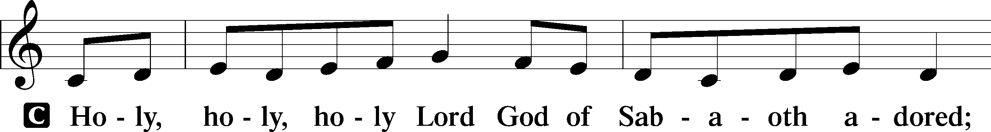
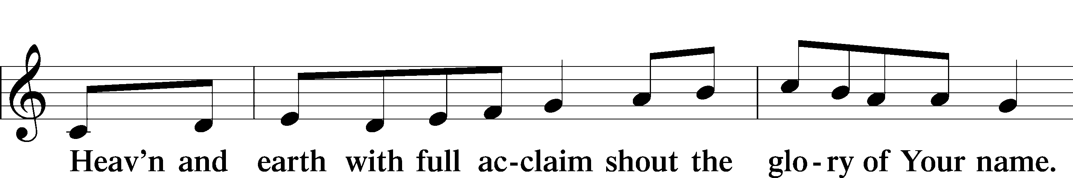
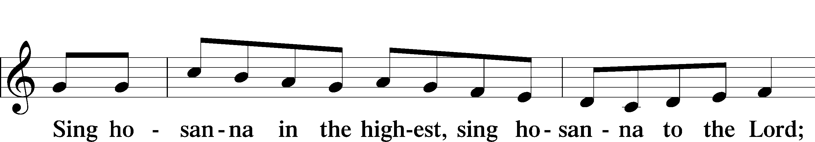
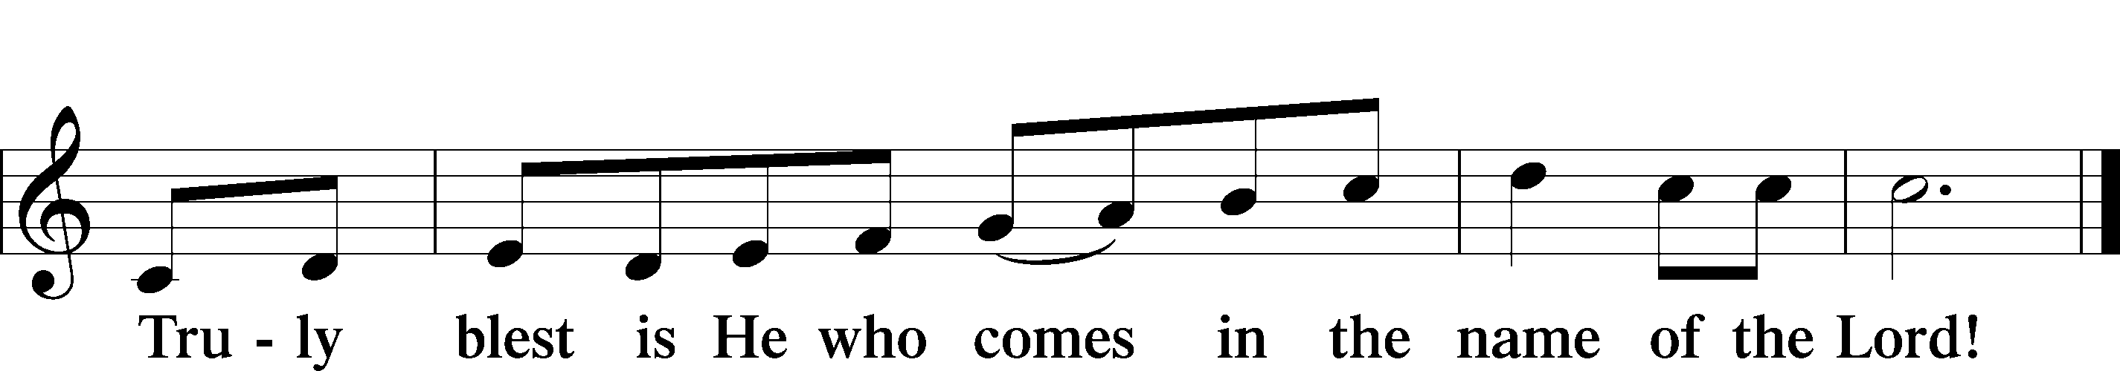

Prayer of Thanksgiving
P Blessed are You, O Lord our God, king of all creation, for You have had mercy on us and given Your only-begotten Son that whoever believes in Him should not perish but have eternal life.

In Your righteous judgment You condemned the sin of Adam and Eve, who ate the forbidden fruit, and You justly barred them and all their children from the tree of life. Yet, in Your great mercy, You promised salvation by a second Adam, Your Son, Jesus Christ, our Lord, and made His cross a life-giving tree for all who trust in Him.
We give You thanks for the redemption You have prepared for us through Jesus Christ. Grant us Your Holy Spirit that we may faithfully eat and drink of the fruits of His cross and receive the blessings of forgiveness, life, and salvation that come to us in His body and blood.

Hear us as we pray in His name and as He has taught us:
Lord’s Prayer

The Words of Our Lord

Pax Domini
P The peace of the Lord be with you always.
C Amen.

Agnus Dei
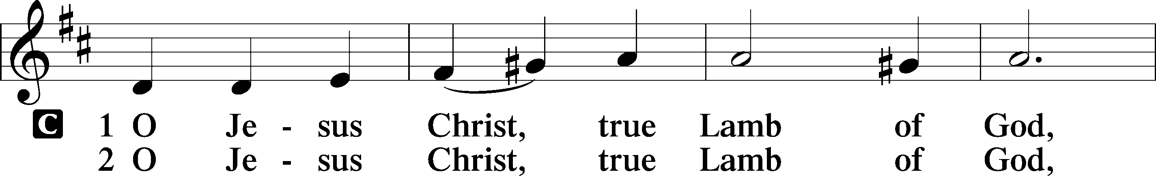
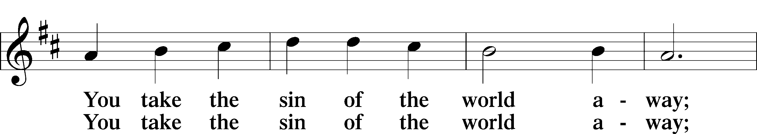
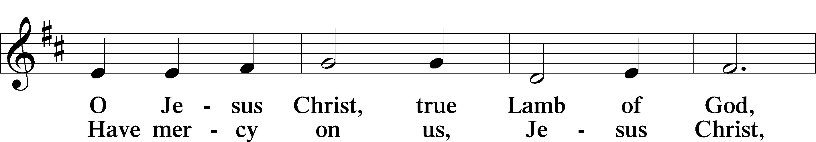
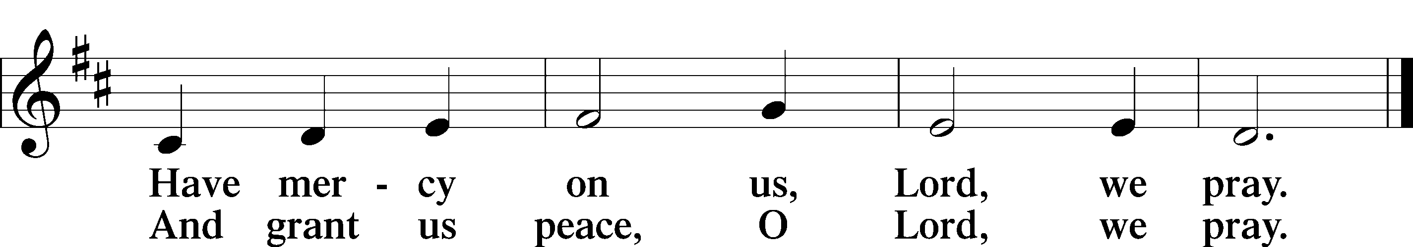

Sit

Distribution

641 You Satisfy the Hungry Heart

628 Your Table I Approach

Stand

Nunc Dimittis
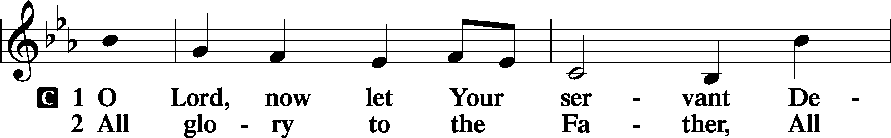
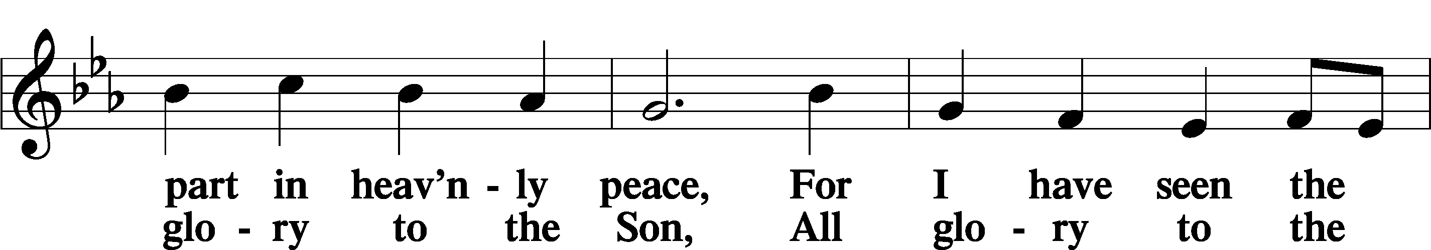
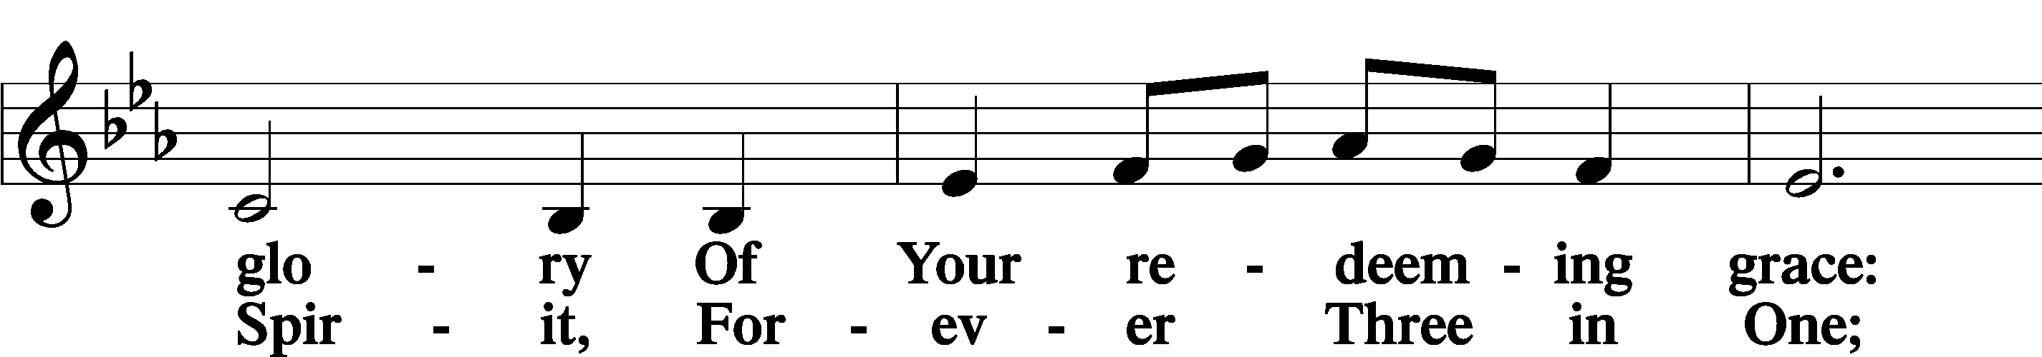
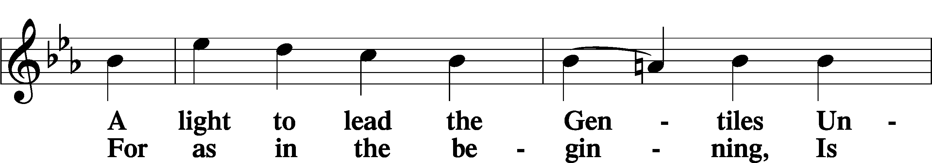
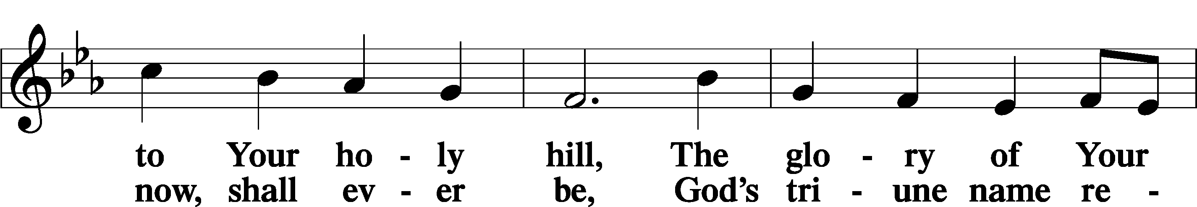
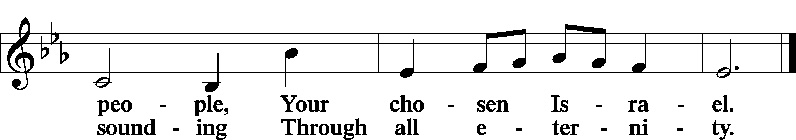

Post-Communion Collect
A Let us pray. We give thanks to You, almighty God, that You have refreshed us through this salutary gift, and we implore You that of Your mercy You would strengthen us through the same in faith toward You and in fervent love toward one another; through Jesus Christ, Your Son, our Lord, who lives and reigns with You and the Holy Spirit, one God, now and forever.
C Amen.

Benedicamus
A Let us bless the Lord.
C Thanks be to God.

Benediction
P The Lord bless you and keep you.
The Lord make His face shine on you and be gracious to you.
The Lord look upon you with favor and T give you peace.

C Amen.

923 Almighty Father, Bless the Word

Announcement

It’s time to update the directory! There should be a form in your church mailbox and there are extra forms on the table in the Narthex. Please fill out and return to me even if you don’t think there have been any changes as I would like to verify everyone’s contact information. Thank you!

~Tara, Secretary

