Palm Sunday
March 29th, 2026

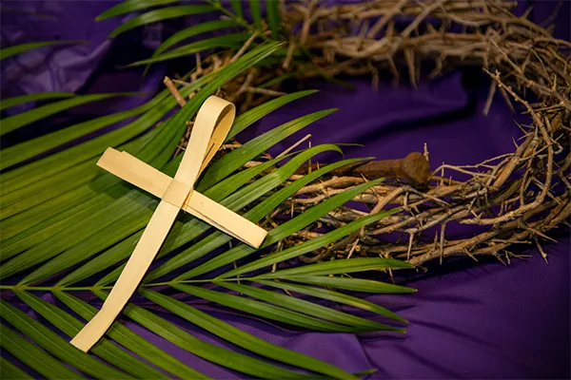

Messiah Lutheran Church
Sartell, MN
www.messiahsartell.com
320-252-5883
Prayer Before Entering
Please take this time to focus on our purpose in gathering and join in prayer before our service begins. Blessed Lord, You have caused all Holy Scriptures to be written for our learning. Grant that we may so hear them, read, mark, learn, and inwardly digest them that, by patience and comfort of Your holy Word, we may embrace and ever hold fast the blessed hope of everlasting life; through Jesus Christ, our Lord.

As We Gather
Palm Sunday begins with unbridled joy as we recall how Jesus entered Jerusalem riding on a donkey, while being acclaimed by the crowds with loud shouts of “Hosanna” and boisterous waving of palm branches. So today we begin with songs of praise and waving of palm branches as we hail Jesus as the One worthy of all glory, laud, and honor. But then the solemnness of Holy Week also begins. Shortly after his triumphant entry our Gospel text shifts our focus to Jesus’ path to the cross. As foretold by prophets long ago, Jesus was stricken and afflicted, beaten and spit upon, crucified, and He died. He did this out of divine love for all of humanity, taking on Himself the sins of all people for our forgiveness. Today’s worship reflects the pattern of our lives. At times we experience unbridled joy and celebration. And then, sometimes in the next moment, we experience heartbreaking suffering. Jesus is there with us—in the joyful celebrations, in the heartbreak and suffering. He alone can transform it all into deeper love for God and neighbor. The hour of Jesus’ death on the cross is the hour of our life and salvation.

Children's Choir: Sing It! Hosanna!

Stand

The sign of the cross may be made by all in remembrance of their Baptism.

P In the name of the Father and of the T Son and of the Holy Spirit.
C Amen.

P Our help is in the name of the Lord,
C who made heaven and earth.

P If You, O Lord, kept a record of sins, O Lord, who could stand?
C But with You there is forgiveness; therefore You are feared.

P Since we are gathered to hear God’s Word, call upon Him in prayer and praise, and receive the body and blood of our Lord Jesus Christ in the fellowship of this altar, let us first consider our unworthiness and confess before God and one another that we have sinned in thought, word, and deed, and that we cannot free ourselves from our sinful condition. Together as His people let us take refuge in the infinite mercy of God, our heavenly Father, seeking His grace for the sake of Christ, and saying:
C God, be merciful to me, a sinner.

Silence for reflection on God’s Word and for self-examination.

C Almighty God, have mercy upon us, forgive us our sins, and lead us to everlasting life. Amen.

P Almighty God in His mercy has given His Son to die for you and for His sake forgives you all your sins. As a called and ordained servant of Christ, and by His authority, I therefore forgive you all your sins in the name of the Father and of the T Son and of the Holy Spirit.

C Amen.

Introit Psalm 24:7–10; antiphon: Psalm 118:26
P Blessèd is he who comes in the name of the Lord!
We bless you from the house of the Lord.
C Lift up your heads, O gates! And be lifted up, O ancient doors,
that the King of glory may come in.
P Who is this King of glory?
The Lord, strong and mighty, the Lord, mighty in battle!
C Lift up your heads, O gates! And lift them up, O ancient doors,
that the King of glory may come in.
P Who is this King of glory?
The Lord of hosts, he is the King of glory!
Blessèd is he who comes in the name of the Lord!
We bless you from the house of the Lord.

Kyrie
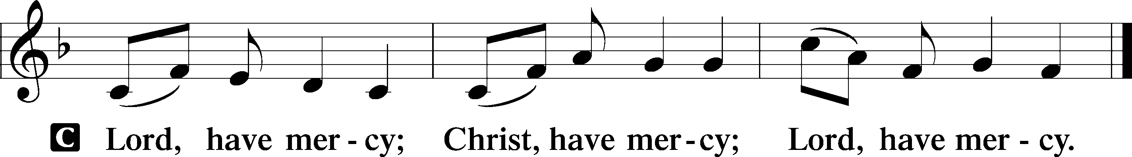
Salutation and Collect of the Day
P The Lord be with you.
C And also with you.

P Let us pray.
Almighty and everlasting God, You sent Your Son, our Savior Jesus Christ, to take upon Himself our flesh and to suffer death upon the cross. Mercifully grant that we may follow the example of His great humility and patience and be made partakers of His resurrection; through the same Jesus Christ, our Lord, who lives and reigns with You and the Holy Spirit, one God, now and forever.

C Amen.

Sit

Old Testament Reading Isaiah 50:4–9a
4The Lord God has given me the tongue of those who are taught,
that I may know how to sustain with a word him who is weary.
Morning by morning he awakens; he awakens my ear to hear as those who are taught. 5The Lord God has opened my ear, and I was not rebellious; I turned not backward. 6I gave my back to those who strike, and my cheeks to those who pull out the beard; I hid not my face from disgrace and spitting. 7But the Lord God helps me; therefore I have not been disgraced; therefore I have set my face like a flint, and I know that I shall not be put to shame. 8He who vindicates me is near. Who will contend with me? Let us stand up together. Who is my adversary? Let him come near to me. 9Behold, the Lord God helps me; who will declare me guilty?

A This is the Word of the Lord.
C Thanks be to God.

Epistle Reading Philippians 2:5–11
A The Epistle is from Philippians, chapter 2.

5Have this mind among yourselves, which is yours in Christ Jesus, 6who, though he was in the form of God, did not count equality with God a thing to be grasped, 7but made himself nothing, taking the form of a servant, being born in the likeness of men. 8And being found in human form, he humbled himself by becoming obedient to the point of death, even death on a cross. 9Therefore God has highly exalted him and bestowed on him the name that is above every name, 10so that at the name of Jesus every knee should bow, in heaven and on earth and under the earth, 11and every tongue confess that Jesus Christ is Lord, to the glory of God the Father.

A This is the Word of the Lord.
C Thanks be to God.

Stand

Gospel John 12:12-43
P The Holy Gospel according to St. John, the twelfth chapter.
C Glory to You, O Lord.

12The next day the large crowd that had come to the feast heard that Jesus was coming to Jerusalem. 13So they took branches of palm trees and went out to meet him, crying out, “Hosanna! Blessed is he who comes in the name of the Lord, even the King of Israel!” 14And Jesus found a young donkey and sat on it, just as it is written,
15“Fear not, daughter of Zion;
behold, your king is coming,
sitting on a donkey’s colt!”
16His disciples did not understand these things at first, but when Jesus was glorified, then they remembered that these things had been written about him and had been done to him. 17The crowd that had been with him when he called Lazarus out of the tomb and raised him from the dead continued to bear witness. 18The reason why the crowd went to meet him was that they heard he had done this sign. 19So the Pharisees said to one another, “You see that you are gaining nothing. Look, the world has gone after him.”
20Now among those who went up to worship at the feast were some Greeks. 21So these came to Philip, who was from Bethsaida in Galilee, and asked him, “Sir, we wish to see Jesus.” 22Philip went and told Andrew; Andrew and Philip went and told Jesus. 23And Jesus answered them, “The hour has come for the Son of Man to be glorified. 24Truly, truly, I say to you, unless a grain of wheat falls into the earth and dies, it remains alone; but if it dies, it bears much fruit. 25Whoever loves his life loses it, and whoever hates his life in this world will keep it for eternal life. 26If anyone serves me, he must follow me; and where I am, there will my servant be also. If anyone serves me, the Father will honor him.
27“Now is my soul troubled. And what shall I say? ‘Father, save me from this hour’? But for this purpose I have come to this hour. 28Father, glorify your name.” Then a voice came from heaven: “I have glorified it, and I will glorify it again.” 29The crowd that stood there and heard it said that it had thundered. Others said, “An angel has spoken to him.” 30Jesus answered, “This voice has come for your sake, not mine. 31Now is the judgment of this world; now will the ruler of this world be cast out. 32And I, when I am lifted up from the earth, will draw all people to myself.” 33He said this to show by what kind of death he was going to die. 34So the crowd answered him, “We have heard from the Law that the Christ remains forever. How can you say that the Son of Man must be lifted up? Who is this Son of Man?” 35So Jesus said to them, “The light is among you for a little while longer. Walk while you have the light, lest darkness overtake you. The one who walks in the darkness does not know where he is going. 36While you have the light, believe in the light, that you may become sons of light.”
When Jesus had said these things, he departed and hid himself from them. 37Though he had done so many signs before them, they still did not believe in him, 38so that the word spoken by the prophet Isaiah might be fulfilled:
“Lord, who has believed what he heard from us,
and to whom has the arm of the Lord been revealed?”
39Therefore they could not believe. For again Isaiah said,
40“He has blinded their eyes
and hardened their heart,
lest they see with their eyes,
and understand with their heart, and turn,
and I would heal them.”
41Isaiah said these things because he saw his glory and spoke of him. 42Nevertheless, many even of the authorities believed in him, but for fear of the Pharisees they did not confess it, so that they would not be put out of the synagogue; 43for they loved the glory that comes from man more than the glory that comes from God.

P This is the Gospel of the Lord.
C Praise to You, O Christ.

Nicene Creed
C I believe in one God,
the Father Almighty,
maker of heaven and earth
and of all things visible and invisible.
And in one Lord Jesus Christ,
the only-begotten Son of God,
begotten of His Father before all worlds,
God of God, Light of Light,
very God of very God,
begotten, not made,
being of one substance with the Father,
by whom all things were made;
who for us men and for our salvation came down from heaven
and was incarnate by the Holy Spirit of the virgin Mary
and was made man;
and was crucified also for us under Pontius Pilate.
He suffered and was buried.
And the third day He rose again according to the Scriptures
and ascended into heaven
and sits at the right hand of the Father.
And He will come again with glory to judge both the living and the dead,
whose kingdom will have no end.

And I believe in the Holy Spirit,
the Lord and giver of life,
who proceeds from the Father and the Son,
who with the Father and the Son together is worshiped and glorified,
who spoke by the prophets.
And I believe in one holy Christian and apostolic Church,
I acknowledge one Baptism for the remission of sins,
and I look for the resurrection of the dead
and the life T of the world to come.

Amen.

Sit
The King of Glory - Choir, the congregation sings the verses below at the end
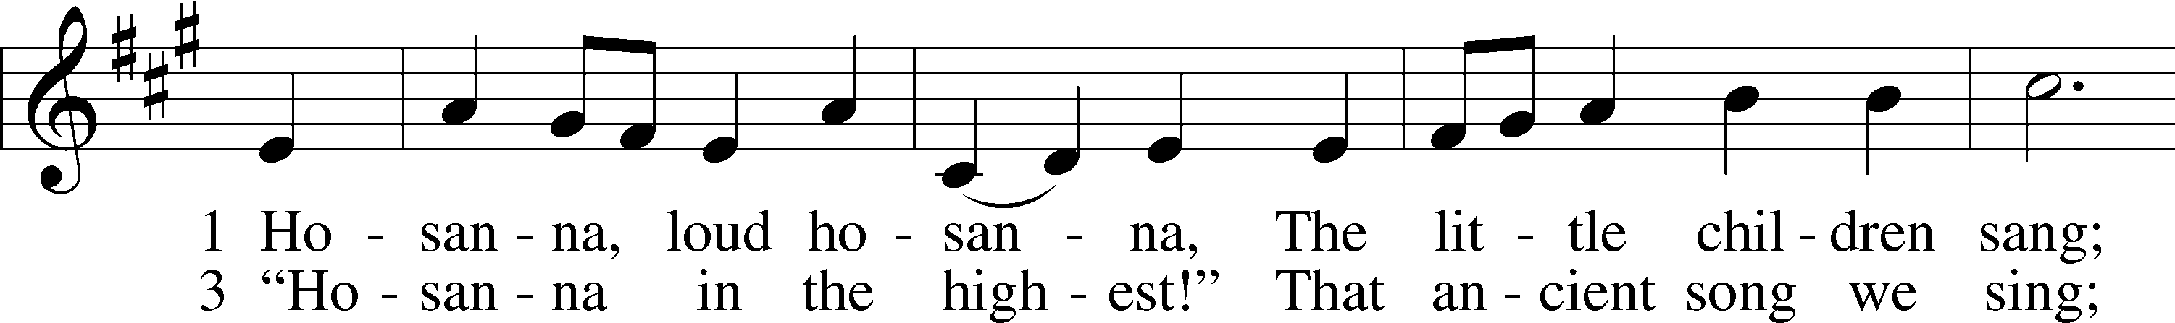
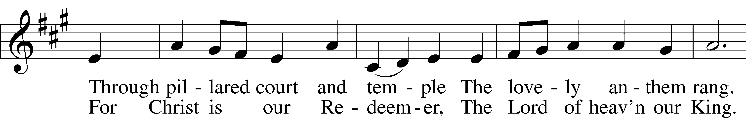
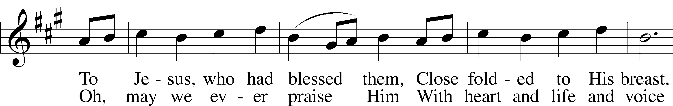
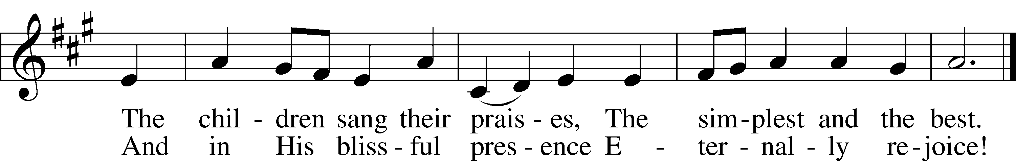

Sermon

Offering. We generously give our offerings to the LORD out of thanksgiving for His generosity of forgiveness, life, and salvation in Christ (2 Corinthians 9:8). We believe that our offerings are not only to support the proclamation of the Gospel here and around the world, but also to help us all grow in faith and trust in Him (2 Corinthians 9:7). We have placed an offering plate in the narthex so you are able to freely give back to Him as you are able. To Him be all the glory!

Stand

Prayer of the Church

Holy Communion is celebrated in the belief and glad confidence that our Lord gives us not only bread and wine, but the body and blood of Christ from the cross, for us Christian to eat and drink for the forgiveness of sins (Matthew 26:28). Because we are called to examine ourselves before receiving the Lord’s Supper (I Corinthians 11:28-29), we encourage you to consider the questions on pages 329-330 in the hymnal. We also believe that when we commune, we are confessing our unity with the community we join (I Corinthians 10:17). If you desire to commune with us for the first time or have questions, our pastor is happy to speak with you.

Preface
P The Lord be with you.
C And also with you.
P Lift up your hearts.
C We lift them to the Lord.

P Let us give thanks to the Lord our God.
C It is right to give Him thanks and praise.

P It is truly good, right, and salutary that we should at all times and in all places give thanks to You, O Lord, holy Father, almighty and everlasting God, for the countless blessings You so freely bestow on us and all creation. Above all, we give thanks for Your boundless love shown to us when You sent Your only-begotten Son, Jesus Christ, into our flesh and laid on Him our sin, giving Him into death that we might not die eternally. Because He is now risen from the dead and lives and reigns to all eternity, all who believe in Him will overcome sin and death and will rise again to new life. Therefore with angels and archangels and with all the company of heaven we laud and magnify Your glorious name, evermore praising You and saying:

Sanctus
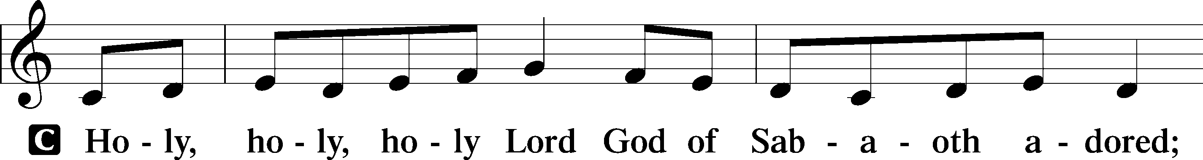
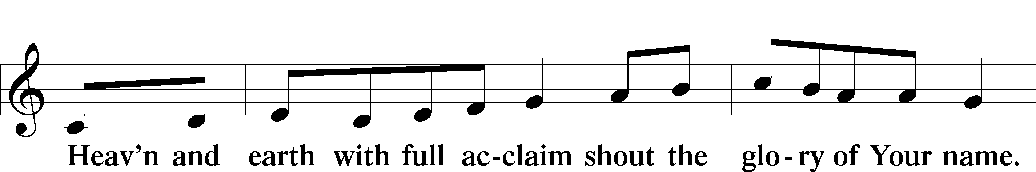
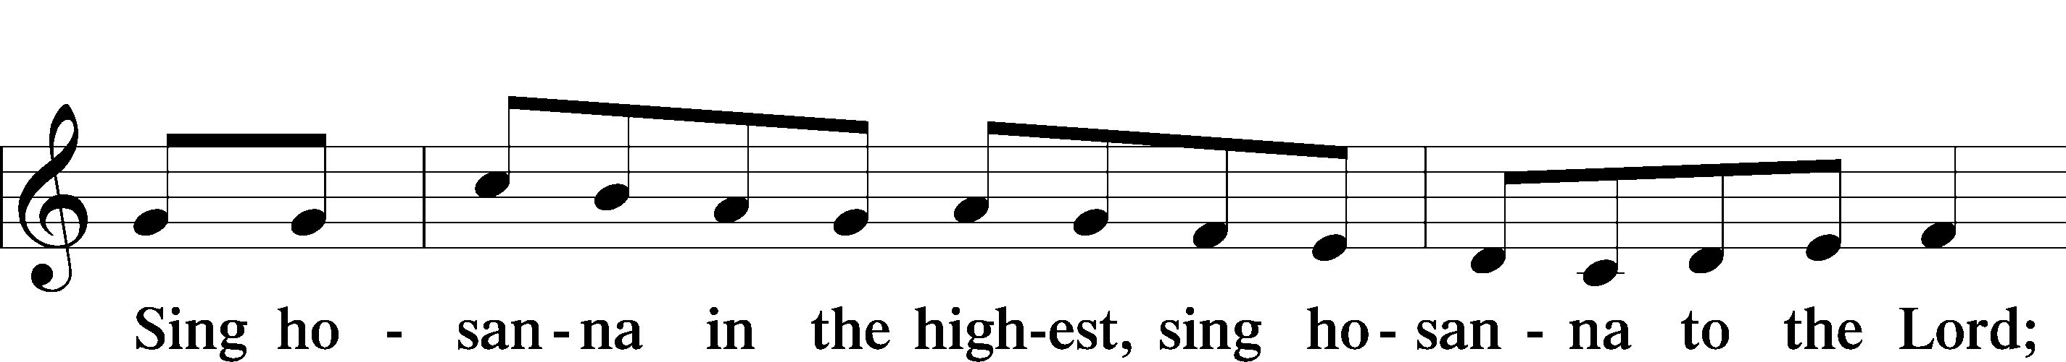
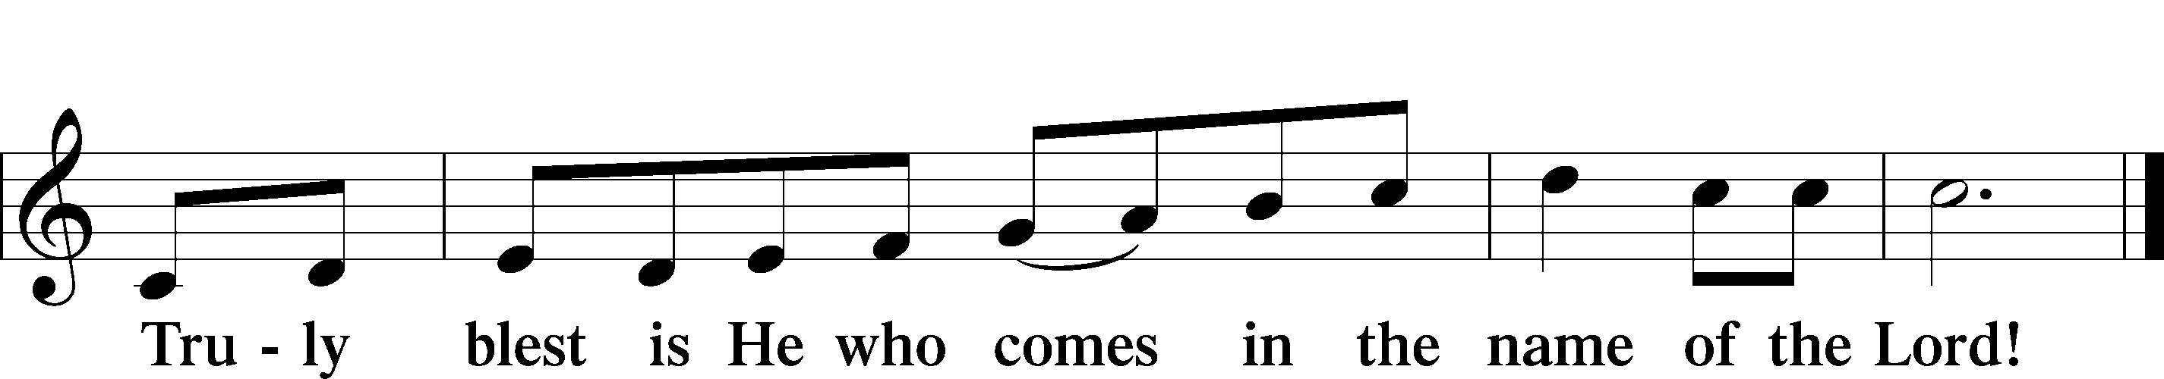
Prayer of Thanksgiving
P Blessed are You, O Lord our God, king of all creation, for You have had mercy on us and given Your only-begotten Son that whoever believes in Him should not perish but have eternal life.

At Your command, Abraham prepared to offer his son Isaac as a sacrifice on the mountain; yet, in mercy You provided a ram as a substitute. We give You thanks that on Calvary You spared not Your only Son but sent Him to offer His life as a ransom for many.

As we eat and drink His body and blood, grant us, like Abraham our father, to trust in Your promise now fulfilled in Christ, the Lamb of God, who takes away the sin of the world.

Hear us as we pray in His name and as He has taught us:

Lord’s Prayer

The Words of Our Lord

Pax Domini
P The peace of the Lord be with you always.
C Amen.

Agnus Dei
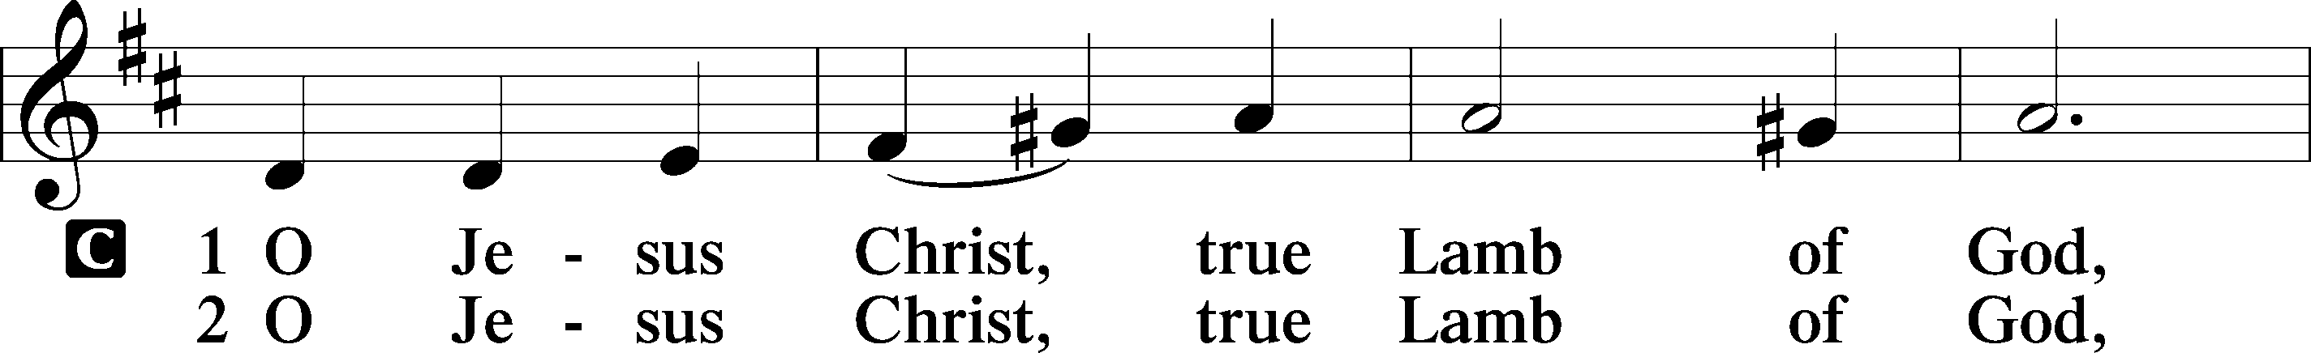
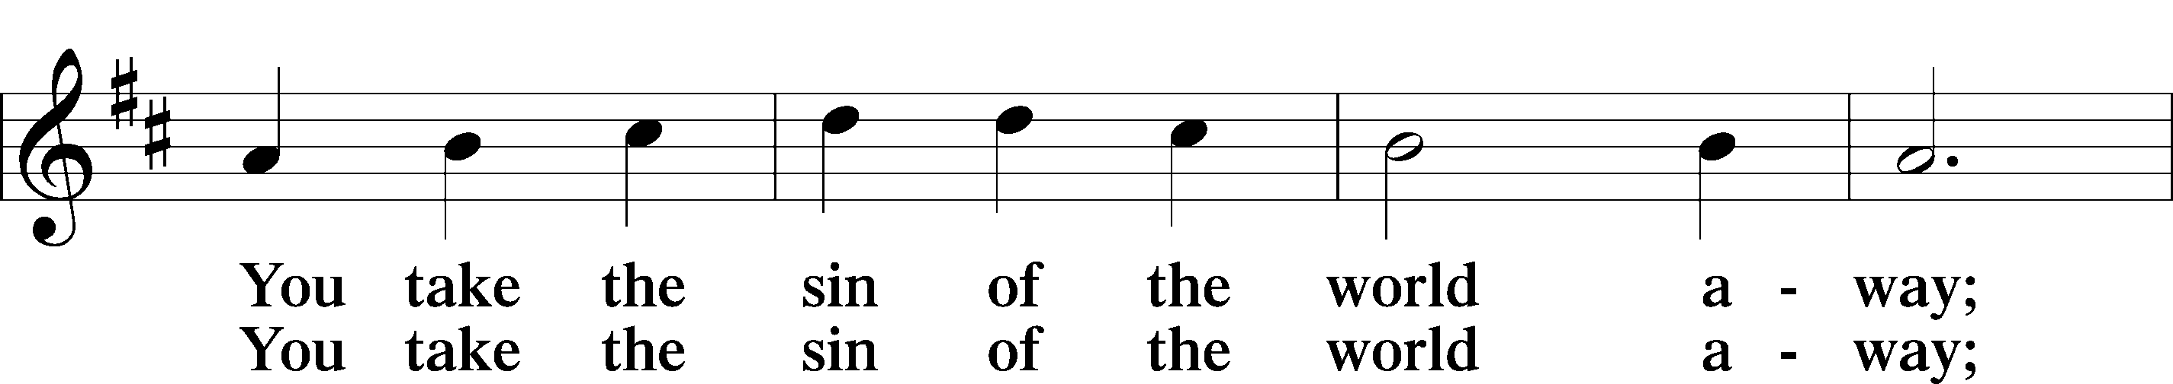
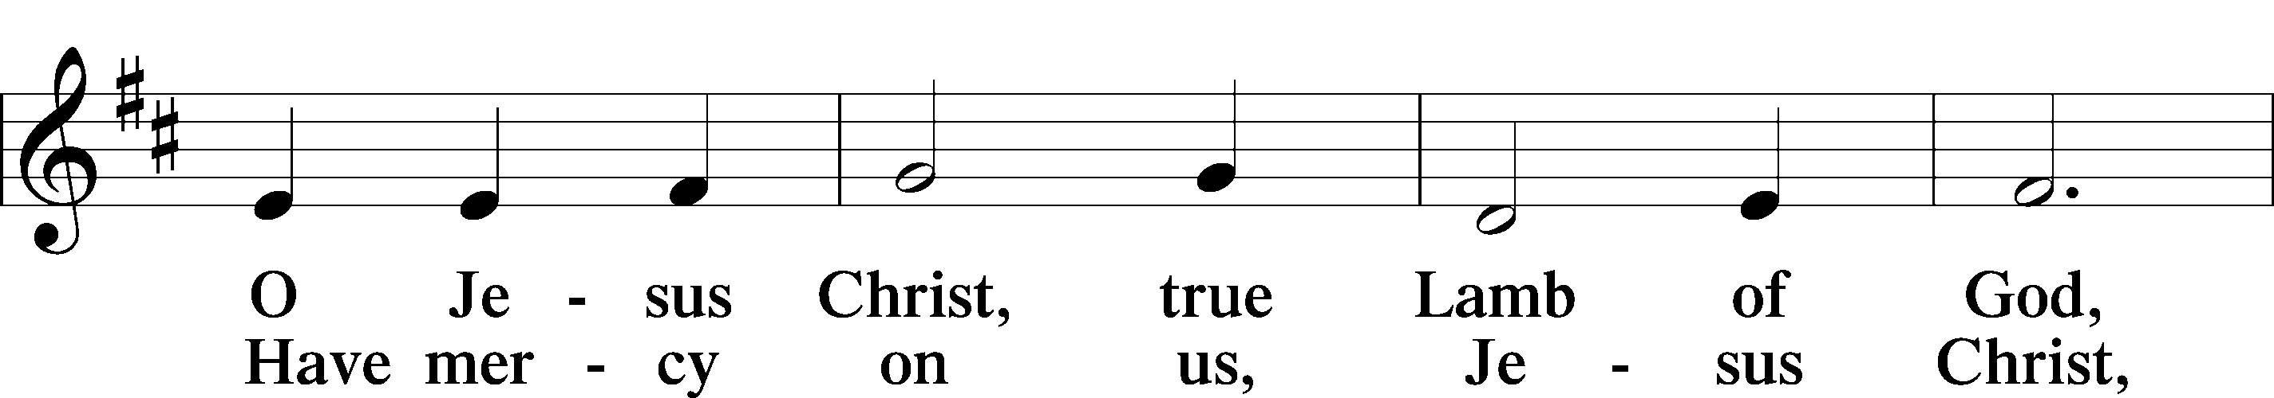
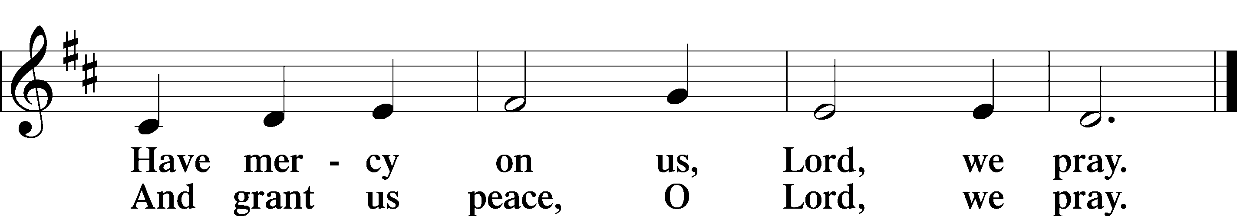

Sit

Distribution

442 All Glory, Laud, and Honor

634 The Death of Jesus Christ, Our Lord

Stand

Nunc Dimittis
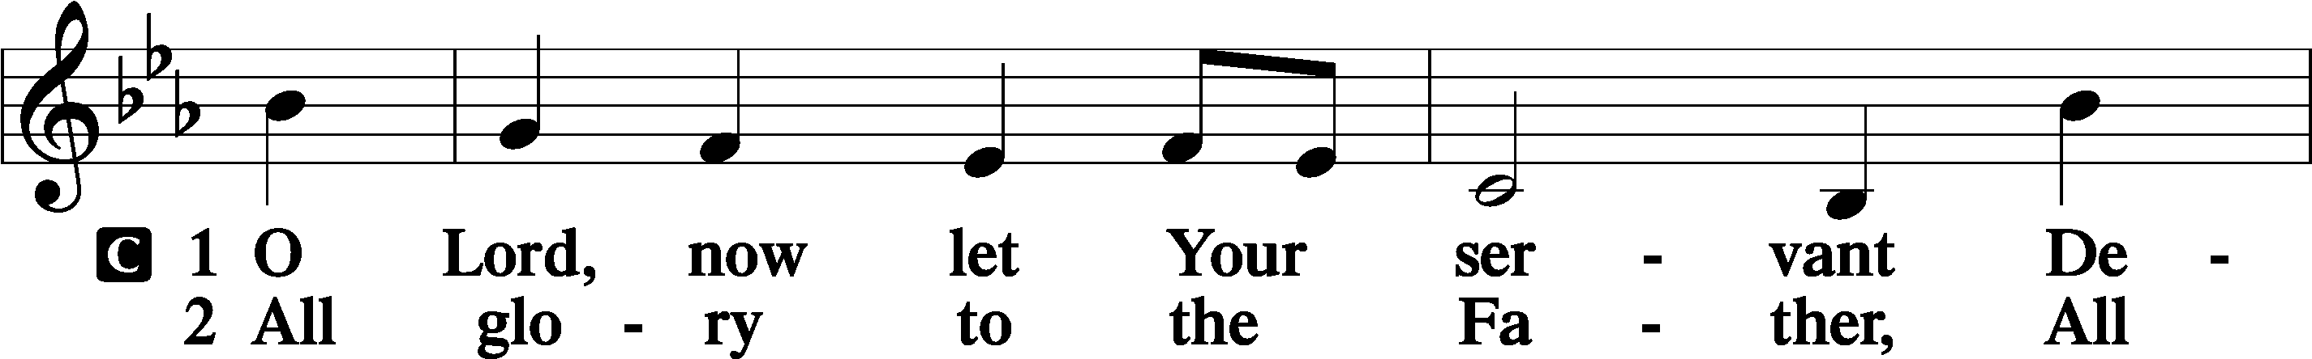
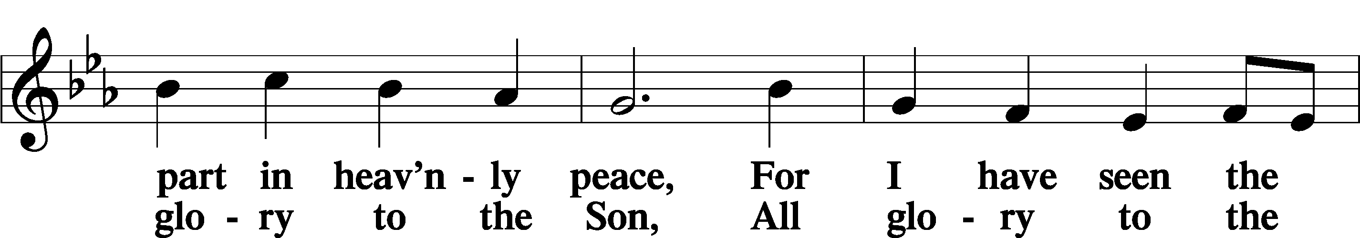
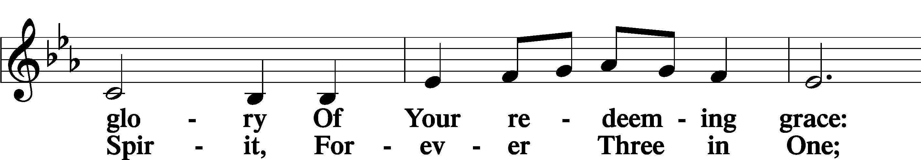
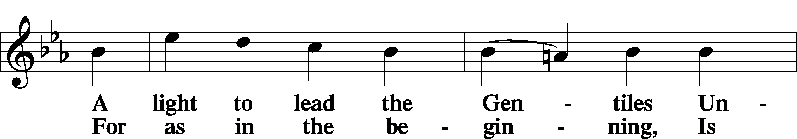
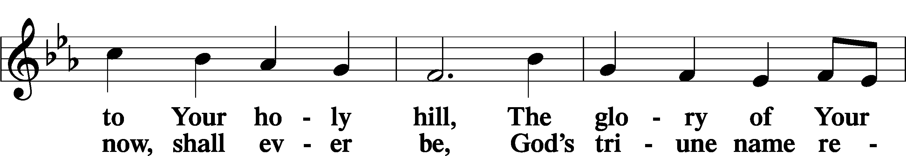
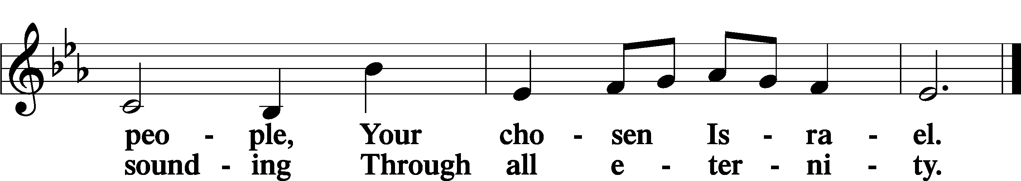

Post-Communion Collect
A Let us pray. We give thanks to You, almighty God, that You have refreshed us through this salutary gift, and we implore You that of Your mercy You would strengthen us through the same in faith toward You and in fervent love toward one another; through Jesus Christ, Your Son, our Lord, who lives and reigns with You and the Holy Spirit, one God, now and forever.
C Amen.

Benedicamus
A Let us bless the Lord.
C Thanks be to God.

Benediction
P The Lord bless you and keep you.
The Lord make His face shine on you and be gracious to you.
The Lord look upon you with favor and T give you peace.

C Amen.

441 Ride On, Ride On in Majesty

Announcements

Midweek Lenten Worship Services: 6 p.m.
Maundy Thursday: April 2nd
Good Friday: April 3rd

Easter Breakfast Sign-up is in the Narthex.
Please sign up to bring food and/or to serve!

