Second Sunday in Lent
March 1st, 2026

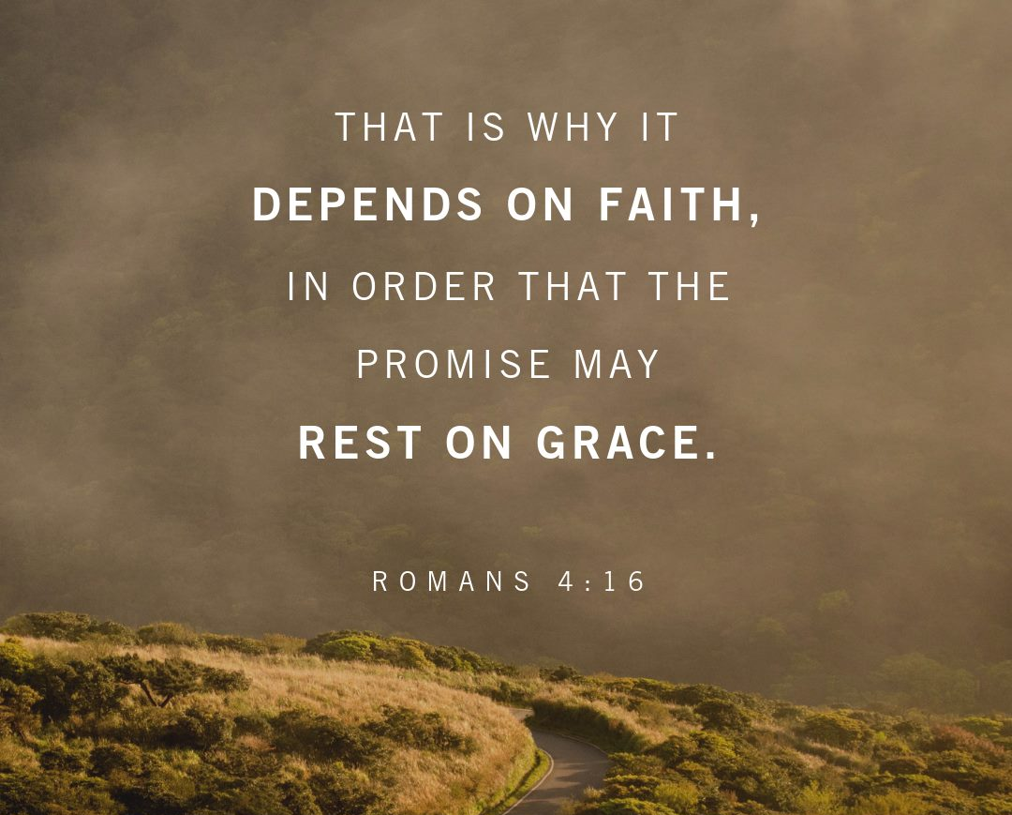

Messiah Lutheran Church
Sartell, MN
www.messiahsartell.com
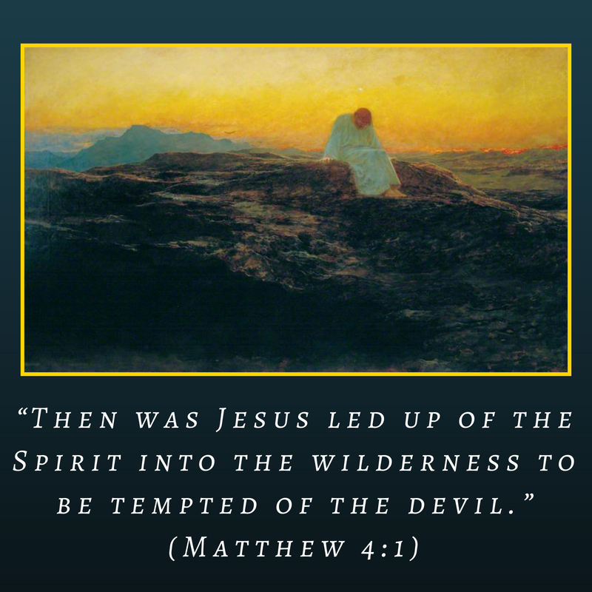
320-252-5883
Prayer Before Entering
Please take this time to focus on our purpose in gathering and join in prayer before our service begins. Blessed Lord, You have caused all Holy Scriptures to be written for our learning. Grant that we may so hear them, read, mark, learn, and inwardly digest them that, by patience and comfort of Your holy Word, we may embrace and ever hold fast the blessed hope of everlasting life; through Jesus Christ, our Lord.

As We Gather
Abraham is a great example of faith. As we often pray for faith and good courage to the Lord who has called us “to ventures of which we cannot see the ending, by paths as yet untrodden, through perils unknown,” Abraham lived with this courage. From Haran to Canaan, Abraham was led by the hand of God toward the unfolding future God had prepared in the incarnation of His only-begotten Son to be our Savior and Redeemer. During Lent we join with Abraham of old and all the saints in trusting the Lord through the unknown tomorrows to the outcome and end we do know in Christ—everlasting life.

570 Just as I Am, without One Plea

Stand

The sign of the cross may be made by all in remembrance of their Baptism.

P In the name of the Father and of the T Son and of the Holy Spirit.
C Amen.

P Our help is in the name of the Lord,
C who made heaven and earth.

P If You, O Lord, kept a record of sins, O Lord, who could stand?
C But with You there is forgiveness; therefore You are feared.

P Since we are gathered to hear God’s Word, call upon Him in prayer and praise, and receive the body and blood of our Lord Jesus Christ in the fellowship of this altar, let us first consider our unworthiness and confess before God and one another that we have sinned in thought, word, and deed, and that we cannot free ourselves from our sinful condition. Together as His people let us take refuge in the infinite mercy of God, our heavenly Father, seeking His grace for the sake of Christ, and saying:
C God, be merciful to me, a sinner.

Silence for reflection on God’s Word and for self-examination.

C Almighty God, have mercy upon us, forgive us our sins, and lead us to everlasting life. Amen.

P Almighty God in His mercy has given His Son to die for you and for His sake forgives you all your sins. As a called and ordained servant of Christ, and by His authority, I therefore forgive you all your sins in the name of the Father and of the T Son and of the Holy Spirit.

C Amen.

Introit Psalm 105:4–7; antiphon: v. 8
P He remembers his covenant forever,
the word that he commanded, for a thousand generations.
C Seek the Lord and his strength;
seek his presence continually!
P Remember the wondrous works that he has done,
his miracles, and the judgments he uttered,
C O offspring of Abraham, his servant,
children of Jacob, his chosen ones!
P He is the Lord our God;
his judgments are in all the earth.
All: Glory be to the Father and to the Son
and to the Holy Spirit;
as it was in the beginning,
is now, and will be forever. Amen.
P He remembers his covenant forever,
the word that he commanded, for a thousand generations.

Kyrie
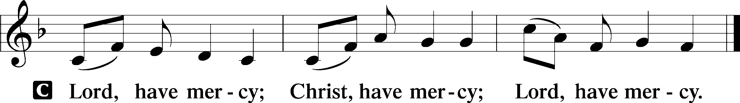
Salutation and Collect of the Day
P The Lord be with you.
C And also with you.

P Let us pray.
O God, You see that of ourselves we have no strength. By Your mighty power defend us from all adversities that may happen to the body and from all evil thoughts that may assault and hurt the soul; through Jesus Christ, Your Son, our Lord, who lives and reigns with You and the Holy Spirit, one God, now and forever.

C Amen.

Sit

Old Testament Reading Genesis 12:1–9
1The Lord said to Abram, “Go from your country and your kindred and your father’s house to the land that I will show you. 2And I will make of you a great nation, and I will bless you and make your name great, so that you will be a blessing. 3I will bless those who bless you, and him who dishonors you I will curse, and in you all the families of the earth shall be blessed.”
4So Abram went, as the Lord had told him, and Lot went with him. Abram was seventy-five years old when he departed from Haran. 5And Abram took Sarai his wife, and Lot his brother’s son, and all their possessions that they had gathered, and the people that they had acquired in Haran, and they set out to go to the land of Canaan. When they came to the land of Canaan, 6Abram passed through the land to the place at Shechem, to the oak of Moreh. At that time the Canaanites were in the land. 7Then the Lord appeared to Abram and said, “To your offspring I will give this land.” So he built there an altar to the Lord, who had appeared to him. 8From there he moved to the hill country on the east of Bethel and pitched his tent, with Bethel on the west and Ai on the east. And there he built an altar to the Lord and called upon the name of the Lord. 9And Abram journeyed on, still going toward the Negeb.

A This is the Word of the Lord.
C Thanks be to God.

Epistle Romans 4:1–8, 13–17
1What then shall we say was gained by Abraham, our forefather according to the flesh? 2For if Abraham was justified by works, he has something to boast about, but not before God. 3For what does the Scripture say? “Abraham believed God, and it was counted to him as righteousness.” 4Now to the one who works, his wages are not counted as a gift but as his due. 5And to the one who does not work but trusts him who justifies the ungodly, his faith is counted as righteousness, 6just as David also speaks of the blessing of the one to whom God counts righteousness apart from works:
7“Blessed are those whose lawless deeds are forgiven,
and whose sins are covered;
8blessed is the man against whom the Lord will not count his sin.” . . .
13For the promise to Abraham and his offspring that he would be heir of the world did not come through the law but through the righteousness of faith. 14For if it is the adherents of the law who are to be the heirs, faith is null and the promise is void. 15For the law brings wrath, but where there is no law there is no transgression.
16That is why it depends on faith, in order that the promise may rest on grace and be guaranteed to all his offspring—not only to the adherent of the law but also to the one who shares the faith of Abraham, who is the father of us all, 17as it is written, “I have made you the father of many nations”—in the presence of the God in whom he believed, who gives life to the dead and calls into existence the things that do not exist.

A This is the Word of the Lord.
C Thanks be to God.

Choir: Psalm 96

Stand

Holy Gospel John 3:1–17
P The Holy Gospel according to St. John, the third chapter.
C Glory to You, O Lord.

1Now there was a man of the Pharisees named Nicodemus, a ruler of the Jews. 2This man came to Jesus by night and said to him, “Rabbi, we know that you are a teacher come from God, for no one can do these signs that you do unless God is with him.” 3Jesus answered him, “Truly, truly, I say to you, unless one is born again he cannot see the kingdom of God.” 4Nicodemus said to him, “How can a man be born when he is old? Can he enter a second time into his mother’s womb and be born?” 5Jesus answered, “Truly, truly, I say to you, unless one is born of water and the Spirit, he cannot enter the kingdom of God. 6That which is born of the flesh is flesh, and that which is born of the Spirit is spirit. 7Do not marvel that I said to you, ‘You must be born again.’ 8The wind blows where it wishes, and you hear its sound, but you do not know where it comes from or where it goes. So it is with everyone who is born of the Spirit.”
9Nicodemus said to him, “How can these things be?” 10Jesus answered him, “Are you the teacher of Israel and yet you do not understand these things? 11Truly, truly, I say to you, we speak of what we know, and bear witness to what we have seen, but you do not receive our testimony. 12If I have told you earthly things and you do not believe, how can you believe if I tell you heavenly things? 13No one has ascended into heaven except he who descended from heaven, the Son of Man. 14And as Moses lifted up the serpent in the wilderness, so must the Son of Man be lifted up, 15that whoever believes in him may have eternal life.
16“For God so loved the world, that he gave his only Son, that whoever believes in him should not perish but have eternal life. 17For God did not send his Son into the world to condemn the world, but in order that the world might be saved through him.”

P This is the Gospel of the Lord.
C Praise to You, O Christ.

Nicene Creed
C I believe in one God,
the Father Almighty,
maker of heaven and earth
and of all things visible and invisible.
And in one Lord Jesus Christ,
the only-begotten Son of God,
begotten of His Father before all worlds,
God of God, Light of Light,
very God of very God,
begotten, not made,
being of one substance with the Father,
by whom all things were made;
who for us men and for our salvation came down from heaven
and was incarnate by the Holy Spirit of the virgin Mary
and was made man;
and was crucified also for us under Pontius Pilate.
He suffered and was buried.
And the third day He rose again according to the Scriptures
and ascended into heaven
and sits at the right hand of the Father.
And He will come again with glory to judge both the living and the dead,
whose kingdom will have no end.

And I believe in the Holy Spirit,
the Lord and giver of life,
who proceeds from the Father and the Son,
who with the Father and the Son together is worshiped and glorified,
who spoke by the prophets.
And I believe in one holy Christian and apostolic Church,
I acknowledge one Baptism for the remission of sins,
and I look for the resurrection of the dead
and the life T of the world to come.

Amen.

Sit

571 God Loved the World So That He Gave

Sermon

Offering. We generously give our offerings to the LORD out of thanksgiving for His generosity of forgiveness, life, and salvation in Christ (2 Corinthians 9:8). We believe that our offerings are not only to support the proclamation of the Gospel here and around the world, but also to help us all grow in faith and trust in Him (2 Corinthians 9:7). We have placed an offering plate in the narthex so you are able to freely give back to Him as you are able. To Him be all the glory!

Stand

Prayer of the Church

Holy Communion is celebrated in the belief and glad confidence that our Lord gives us not only bread and wine, but the body and blood of Christ from the cross, for us Christian to eat and drink for the forgiveness of sins (Matthew 26:28). Because we are called to examine ourselves before receiving the Lord’s Supper (I Corinthians 11:28-29), we encourage you to consider the questions on pages 329-330 in the hymnal. We also believe that when we commune, we are confessing our unity with the community we join (I Corinthians 10:17). If you desire to commune with us for the first time or have questions, our pastor is happy to speak with you.
Preface
P The Lord be with you.
C And also with you.

P Lift up your hearts.
C We lift them to the Lord.

P Let us give thanks to the Lord our God.
C It is right to give Him thanks and praise.

P It is truly good, right, and salutary that we should at all times and in all places give thanks to You, O Lord, holy Father, almighty and everlasting God, for the countless blessings You so freely bestow on us and all creation. Above all, we give thanks for Your boundless love shown to us when You sent Your only-begotten Son, Jesus Christ, into our flesh and laid on Him our sin, giving Him into death that we might not die eternally. Because He is now risen from the dead and lives and reigns to all eternity, all who believe in Him will overcome sin and death and will rise again to new life. Therefore with angels and archangels and with all the company of heaven we laud and magnify Your glorious name, evermore praising You and saying:

Sanctus
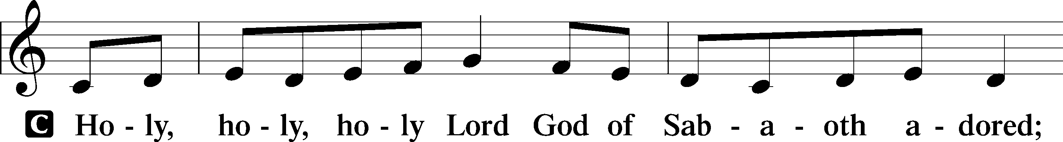
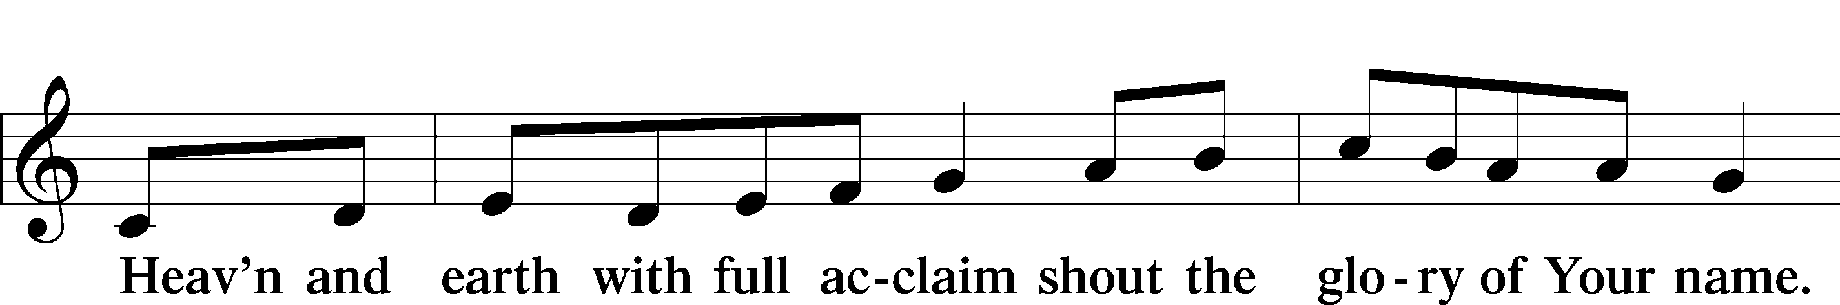
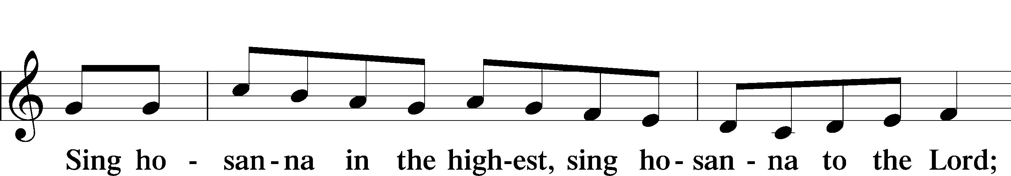
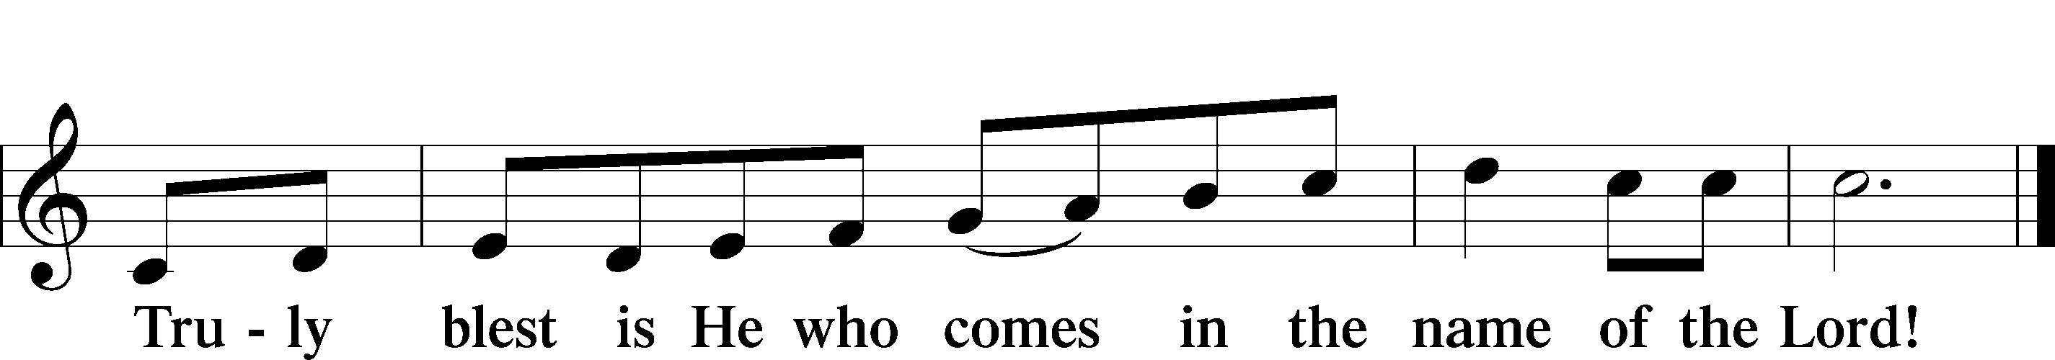
Prayer of Thanksgiving
P Blessed are You, O Lord our God, king of all creation, for You have had mercy on us and given Your only-begotten Son that whoever believes in Him should not perish but have eternal life.

At Your command, Abraham prepared to offer his son Isaac as a sacrifice on the mountain; yet, in mercy You provided a ram as a substitute. We give You thanks that on Calvary You spared not Your only Son but sent Him to offer His life as a ransom for many.

As we eat and drink His body and blood, grant us, like Abraham our father, to trust in Your promise now fulfilled in Christ, the Lamb of God, who takes away the sin of the world.

Hear us as we pray in His name and as He has taught us:

Lord’s Prayer

The Words of Our Lord

Pax Domini
P The peace of the Lord be with you always.
C Amen.

Agnus Dei
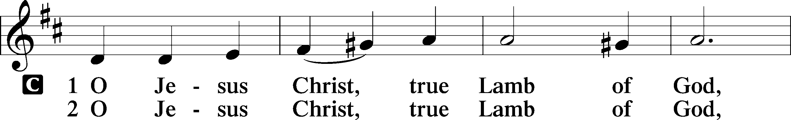
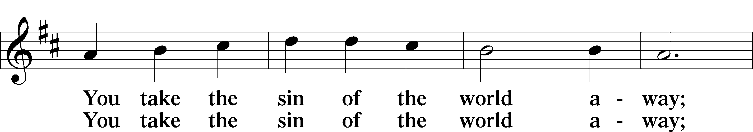
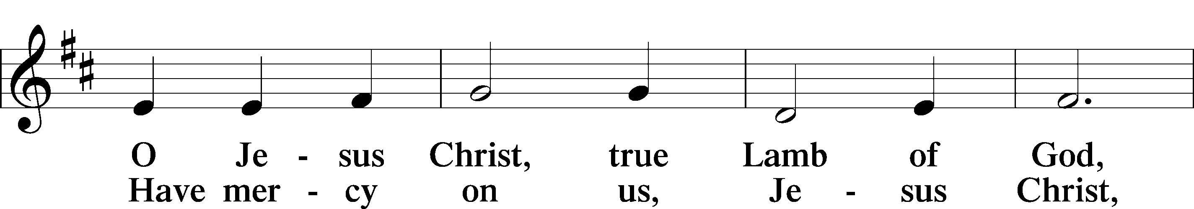
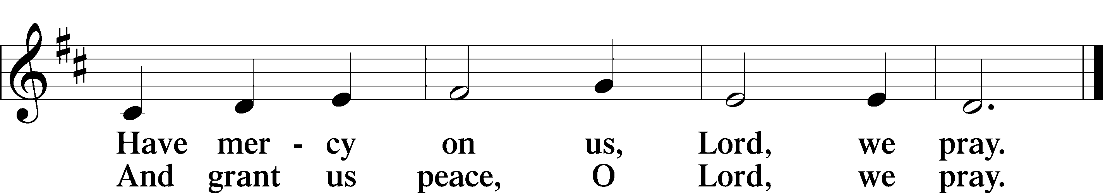

Sit
Distribution

438 A Lamb Goes Uncomplaining Forth

628 Your Table I Approach

Stand

Nunc Dimittis
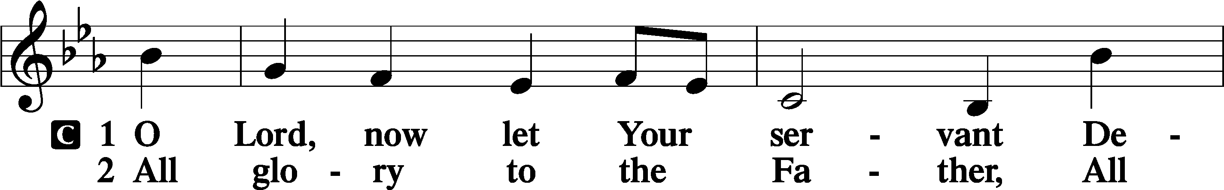
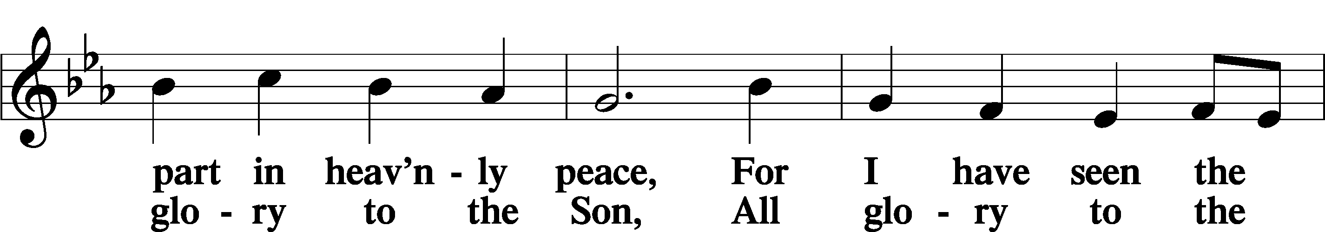
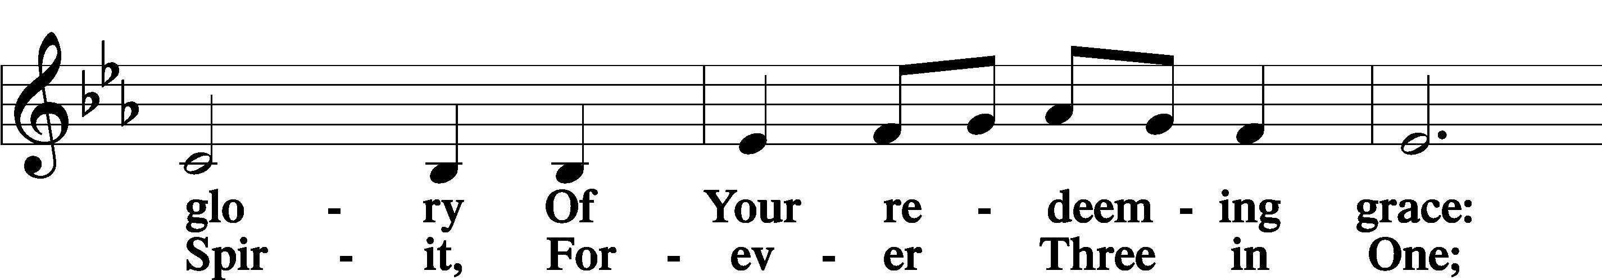
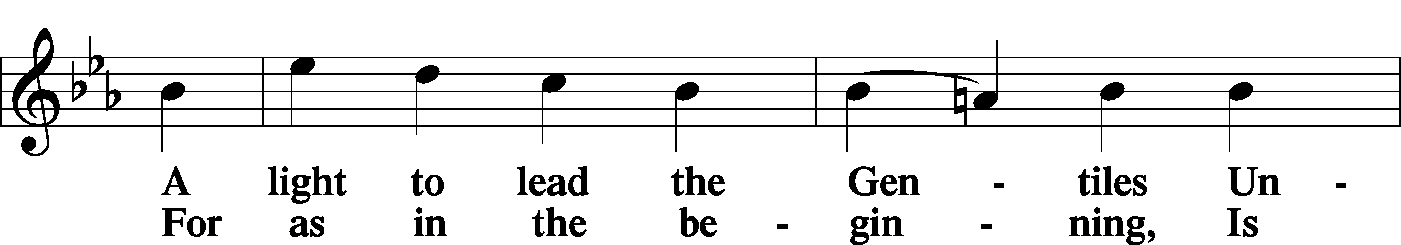
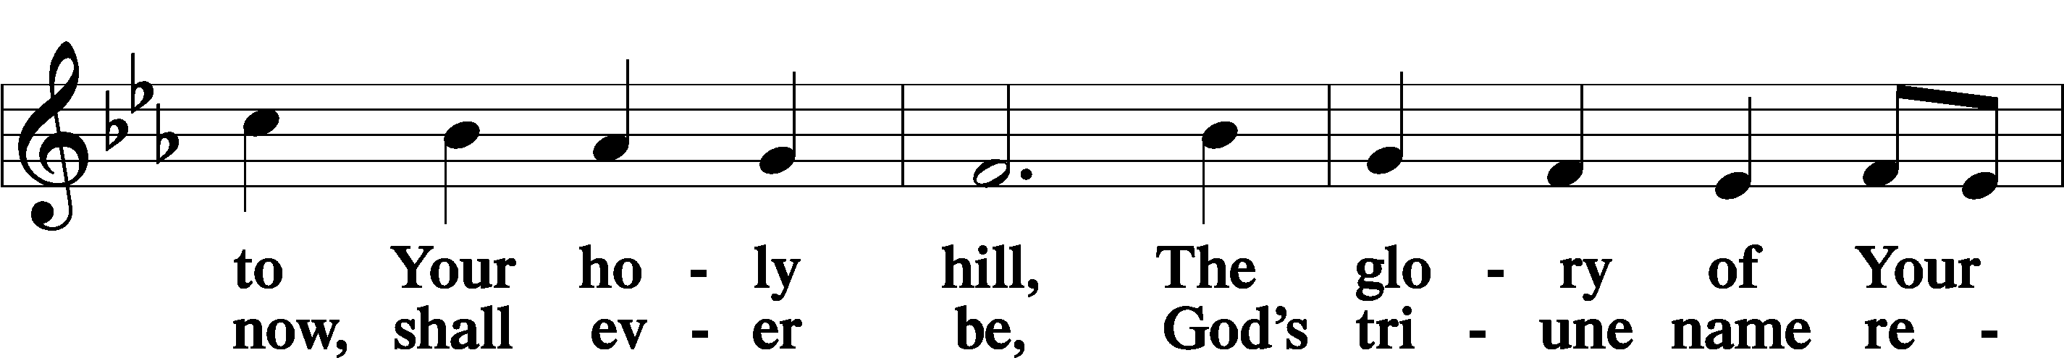
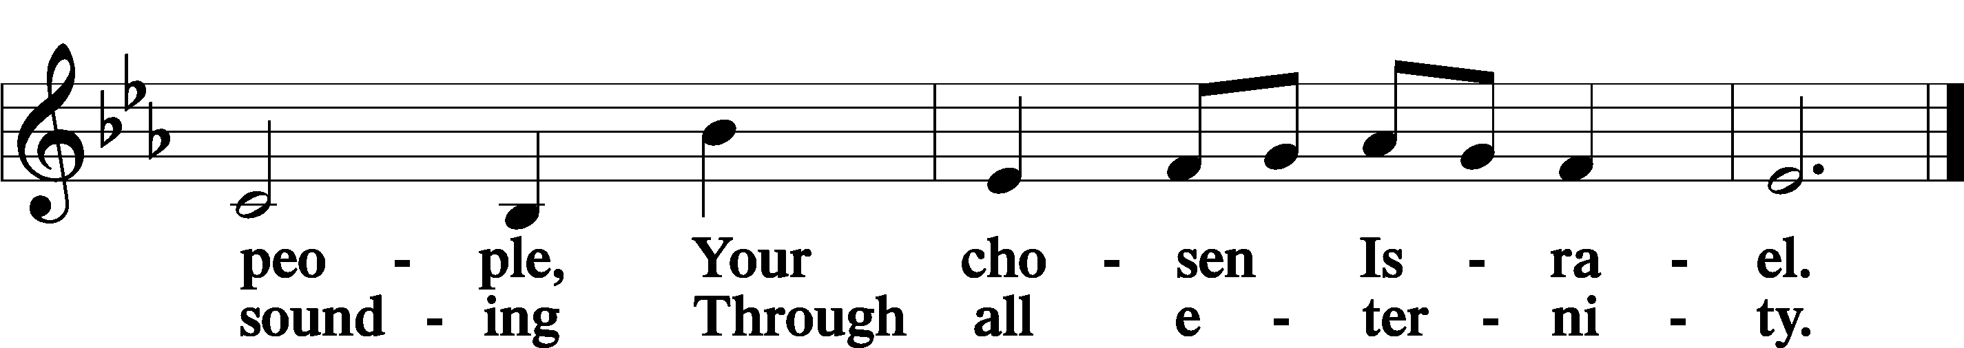

Post-Communion Collect
A Let us pray. We give thanks to You, almighty God, that You have refreshed us through this salutary gift, and we implore You that of Your mercy You would strengthen us through the same in faith toward You and in fervent love toward one another; through Jesus Christ, Your Son, our Lord, who lives and reigns with You and the Holy Spirit, one God, now and forever.
C Amen.

Benedicamus
A Let us bless the Lord.
C Thanks be to God.

Benediction
P The Lord bless you and keep you.
The Lord make His face shine on you and be gracious to you.
The Lord look upon you with favor and T give you peace.

C Amen.

573 Lord, ’Tis Not That I Did Choose Thee

Announcements

Midweek Lenten Worship Services: 6 p.m.
Wednesdays: March 4, 11, 18 and 25
Maundy Thursday: April 2nd
Good Friday: April 3rd

Lenten Suppers will be at 4:45 p.m. every Wednesday during Lent.

