Third Sunday of Easter
April 19th, 2026

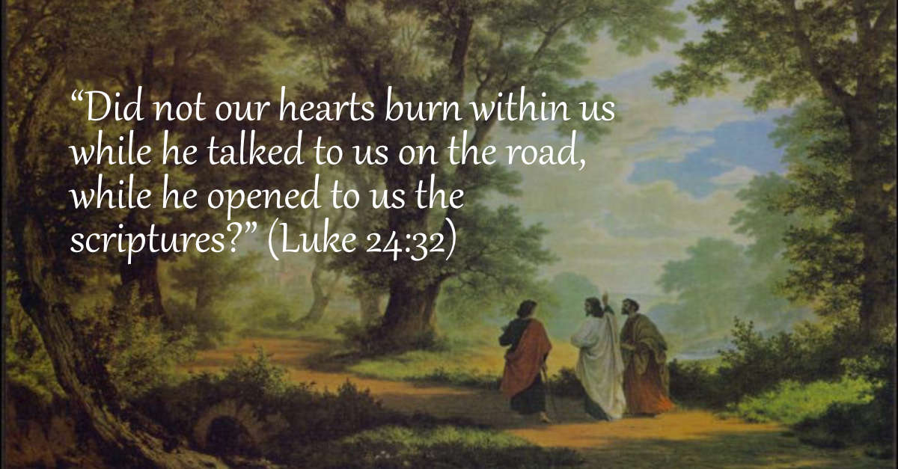

Messiah Lutheran Church
Sartell, MN
www.messiahsartell.com
320-252-5883
Prayer Before Entering
Please take this time to focus on our purpose in gathering and join in prayer before our service begins. Blessed Lord, You have caused all Holy Scriptures to be written for our learning. Grant that we may so hear them, read, mark, learn, and inwardly digest them that, by patience and comfort of Your holy Word, we may embrace and ever hold fast the blessed hope of everlasting life; through Jesus Christ, our Lord.

As We Gather
Today we see Jesus appear to His disciples on the road to Emmaus. They say afterward that their hearts burned within them as Jesus opened up to them the Scriptures. In the Reading from Acts, those gathered on Pentecost are cut to the heart by Peter’s words. And in the Epistle, Peter speaks of purified souls and hearts. It seems our hearts are being greatly affected by Christ. They are cut, burning, and purified by the Word of Christ.

474 Alleluia! Jesus Is Risen

Stand

The sign of the cross may be made by all in remembrance of their Baptism.

P In the name of the Father and of the T Son and of the Holy Spirit.
C Amen.

P Our help is in the name of the Lord,
C who made heaven and earth.

P If You, O Lord, kept a record of sins, O Lord, who could stand?
C But with You there is forgiveness; therefore You are feared.

P Since we are gathered to hear God’s Word, call upon Him in prayer and praise, and receive the body and blood of our Lord Jesus Christ in the fellowship of this altar, let us first consider our unworthiness and confess before God and one another that we have sinned in thought, word, and deed, and that we cannot free ourselves from our sinful condition. Together as His people let us take refuge in the infinite mercy of God, our heavenly Father, seeking His grace for the sake of Christ, and saying:
C God, be merciful to me, a sinner.

Silence for reflection on God’s Word and for self-examination.

C Almighty God, have mercy upon us, forgive us our sins, and lead us to everlasting life. Amen.

P Almighty God in His mercy has given His Son to die for you and for His sake forgives you all your sins. As a called and ordained servant of Christ, and by His authority, I therefore forgive you all your sins in the name of the Father and of the T Son and of the Holy Spirit.

C Amen.

Introit Psalm 133; antiphon: v. 1
P Behold, how good and pleasant it is
when brothers dwell in unity!
C It is like the precious oil on the head, running down on the beard,
on the beard of Aaron,
running down on the collar of his robes!
P It is like the dew of Hermon, which falls on the mountains of Zion!
For there the Lord has commanded the blessing, life forevermore.
All: Glory be to the Father and to the Son
and to the Holy Spirit;
as it was in the beginning,
is now, and will be forever. Amen.
P Behold, how good and pleasant it is
when brothers dwell in unity!

Kyrie
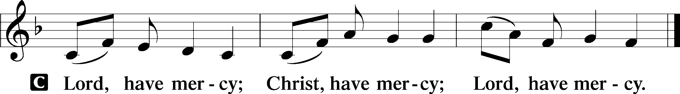

Gloria in Excelsis
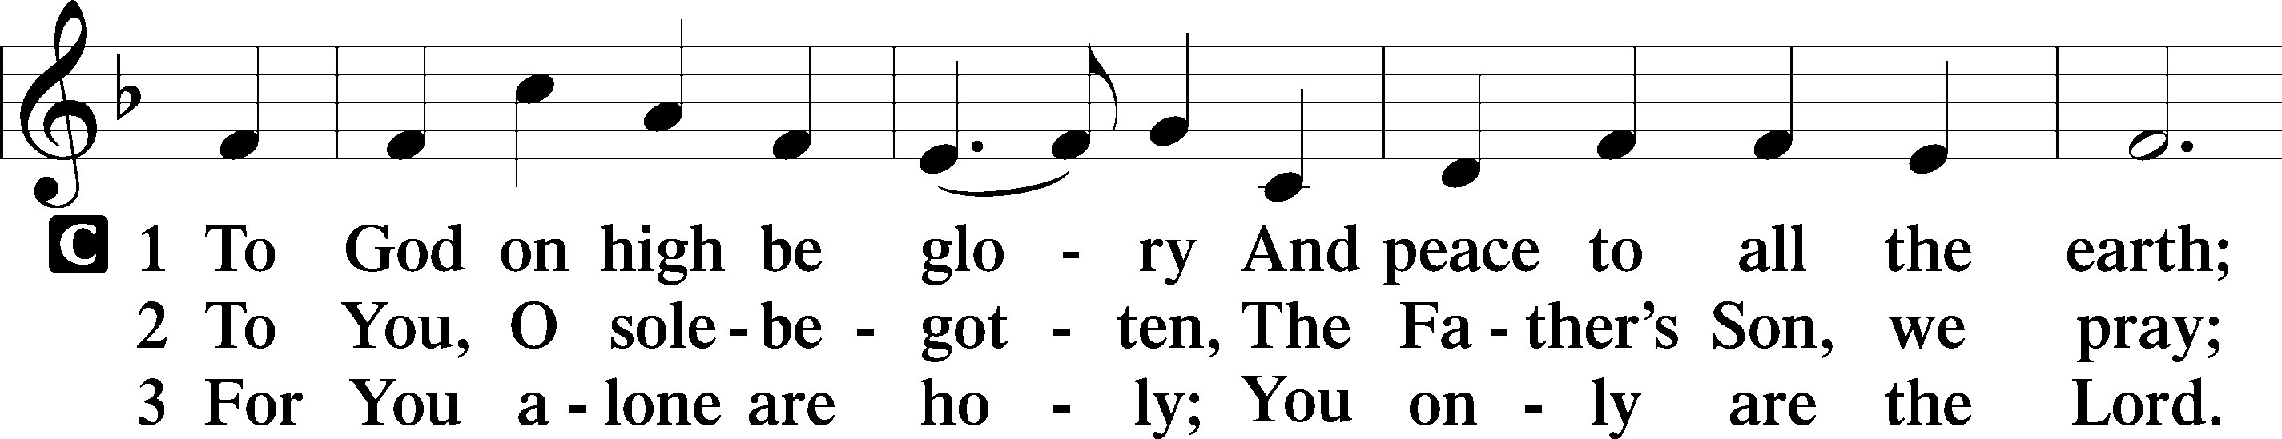
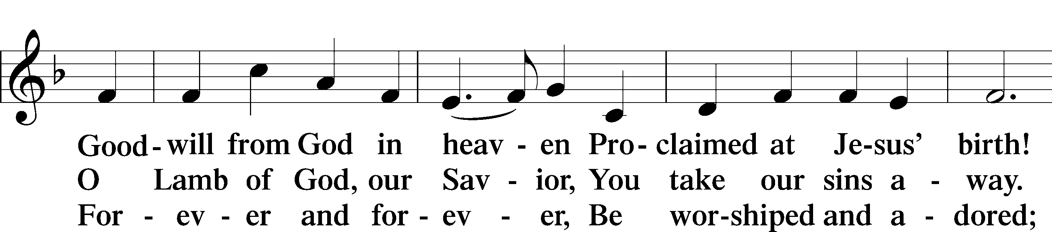
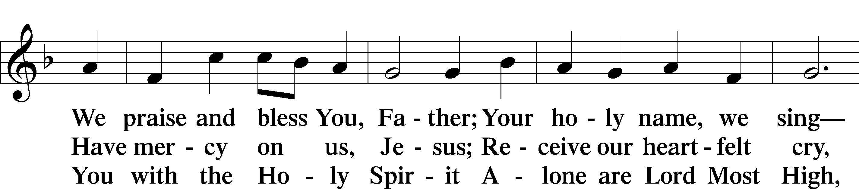
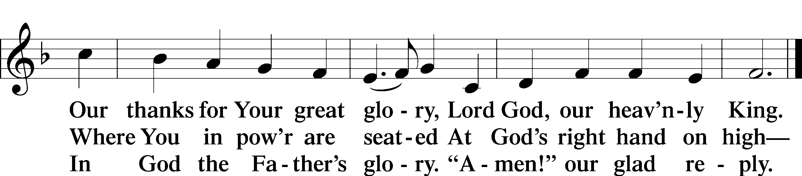

Salutation and Collect of the Day
P The Lord be with you.
C And also with you.

P Let us pray.
O God, through the humiliation of Your Son You raised up the fallen world. Grant to Your faithful people, rescued from the peril of everlasting death, perpetual gladness and eternal joys; through Jesus Christ, our Lord, who lives and reigns with You and the Holy Spirit, one God, now and forever.

C Amen.

Sit
First Reading Acts 2:14a, 36–41
14Peter, standing with the eleven, lifted up his voice and addressed them, . . .
36Let all the house of Israel therefore know for certain that God has made him both Lord and Christ, this Jesus whom you crucified.”
37Now when they heard this they were cut to the heart, and said to Peter and the rest of the apostles, “Brothers, what shall we do?” 38And Peter said to them, “Repent and be baptized every one of you in the name of Jesus Christ for the forgiveness of your sins, and you will receive the gift of the Holy Spirit. 39For the promise is for you and for your children and for all who are far off, everyone whom the Lord our God calls to himself.” 40And with many other words he bore witness and continued to exhort them, saying, “Save yourselves from this crooked generation.” 41So those who received his word were baptized, and there were added that day about three thousand souls.

A This is the Word of the Lord.
C Thanks be to God.

Epistle 1 Peter 1:17–25
17If you call on him as Father who judges impartially according to each one’s deeds, conduct yourselves with fear throughout the time of your exile, 18knowing that you were ransomed from the futile ways inherited from your forefathers, not with perishable things such as silver or gold, 19but with the precious blood of Christ, like that of a lamb without blemish or spot. 20He was foreknown before the foundation of the world but was made manifest in the last times for your sake, 21who through him are believers in God, who raised him from the dead and gave him glory, so that your faith and hope are in God.
22Having purified your souls by your obedience to the truth for a sincere brotherly love, love one another earnestly from a pure heart, 23since you have been born again, not of perishable seed but of imperishable, through the living and abiding word of God; 24for “All flesh is like grass and all its glory like the flower of grass. The grass withers, and the flower falls, 25but the word of the Lord remains forever.” And this word is the good news that was preached to you.

A This is the Word of the Lord.
C Thanks be to God.

Stand
Alleluia and Verse
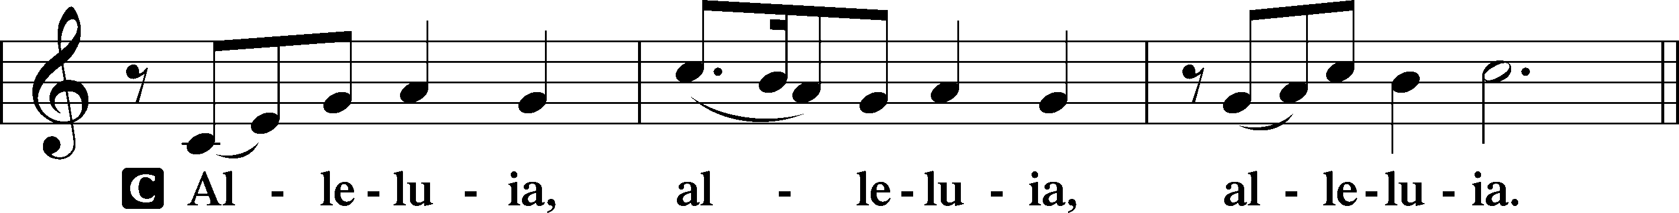

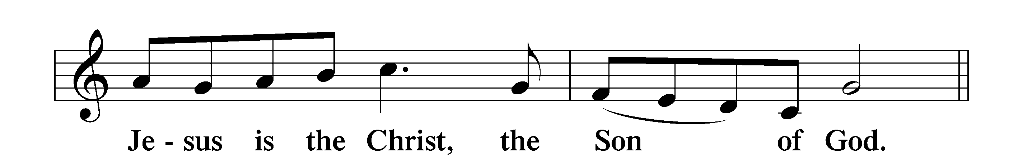
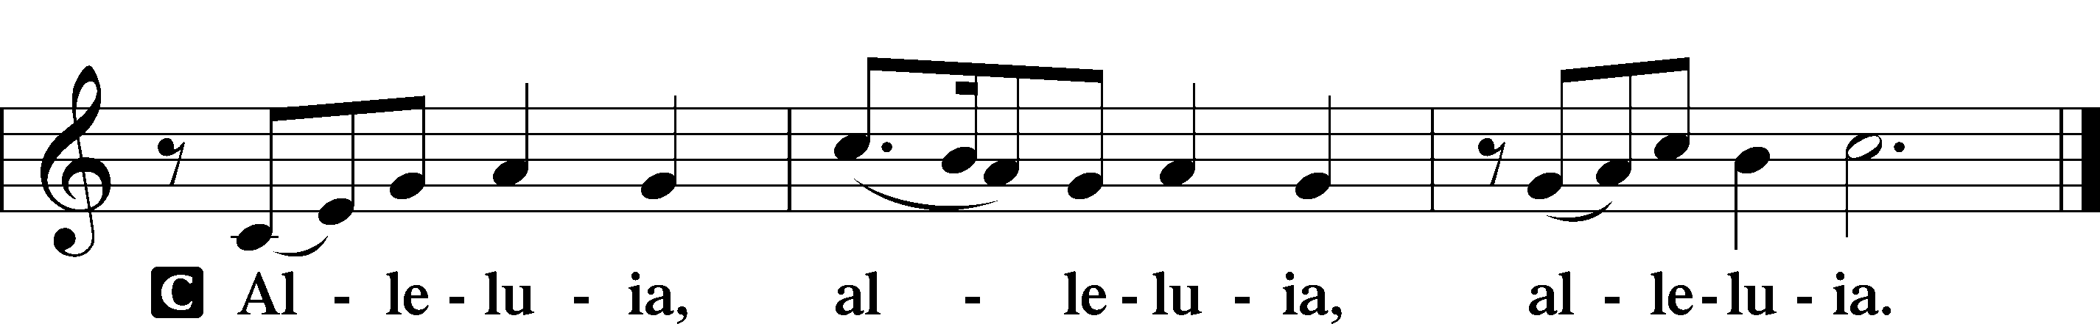

Holy Gospel Luke 24:13–35
P The Holy Gospel according to St. Luke, the twenty-fourth chapter.
C Glory to You, O Lord.

13That very day two of them were going to a village named Emmaus, about seven miles from Jerusalem, 14and they were talking with each other about all these things that had happened. 15While they were talking and discussing together, Jesus himself drew near and went with them. 16But their eyes were kept from recognizing him. 17And he said to them, “What is this conversation that you are holding with each other as you walk?” And they stood still, looking sad. 18Then one of them, named Cleopas, answered him, “Are you the only visitor to Jerusalem who does not know the things that have happened there in these days?” 19And he said to them, “What things?” And they said to him, “Concerning Jesus of Nazareth, a man who was a prophet mighty in deed and word before God and all the people, 20and how our chief priests and rulers delivered him up to be condemned to death, and crucified him. 21But we had hoped that he was the one to redeem Israel. Yes, and besides all this, it is now the third day since these things happened. 22Moreover, some women of our company amazed us. They were at the tomb early in the morning, 23and when they did not find his body, they came back saying that they had even seen a vision of angels, who said that he was alive. 24Some of those who were with us went to the tomb and found it just as the women had said, but him they did not see.” 25And he said to them,
“O foolish ones, and slow of heart to believe all that the prophets have spoken! 26Was it not necessary that the Christ should suffer these things and enter into his glory?” 27And beginning with Moses and all the Prophets, he interpreted to them in all the Scriptures the things concerning himself.
28So they drew near to the village to which they were going. He acted as if he were going farther, 29but they urged him strongly, saying, “Stay with us, for it is toward evening and the day is now far spent.” So he went in to stay with them. 30When he was at table with them, he took the bread and blessed and broke it and gave it to them. 31And their eyes were opened, and they recognized him. And he vanished from their sight. 32They said to each other, “Did not our hearts burn within us while he talked to us on the road, while he opened to us the Scriptures?” 33And they rose that same hour and returned to Jerusalem. And they found the eleven and those who were with them gathered together, 34saying, “The Lord has risen indeed, and has appeared to Simon!” 35Then they told what had happened on the road, and how he was known to them in the breaking of the bread.

P This is the Gospel of the Lord.
C Praise to You, O Christ.

Apostles’ Creed
C I believe in God, the Father Almighty,
maker of heaven and earth.
And in Jesus Christ, His only Son, our Lord,
who was conceived by the Holy Spirit,
born of the virgin Mary,
suffered under Pontius Pilate,
was crucified, died and was buried.
He descended into hell.
The third day He rose again from the dead.
He ascended into heaven
and sits at the right hand of God the Father Almighty.
From thence He will come to judge the living and the dead.

I believe in the Holy Spirit,
the holy Christian Church,
the communion of saints,
the forgiveness of sins,
the resurrection of the body,
and the life T everlasting. Amen.
Sit

476 Who Are You Who Walk in Sorrow

Sermon

Offering. We generously give our offerings to the LORD out of thanksgiving for His generosity of forgiveness, life, and salvation in Christ (2 Corinthians 9:8). We believe that our offerings are not only to support the proclamation of the Gospel here and around the world, but also to help us all grow in faith and trust in Him (2 Corinthians 9:7). We have placed an offering plate in the narthex so you are able to freely give back to Him as you are able. To Him be all the glory!

Stand

Prayer of the Church

Lord’s Prayer

Benedicamus
A Let us bless the Lord.
C Thanks be to God.

Benediction
P The Lord bless you and keep you.
The Lord make His face shine on you and be gracious to you.
The Lord look upon you with favor and T give you peace.

C Amen.

878 Abide with Me

Announcements
Join us for Spring Clean-Up! Saturday, April 25th from 9:00 a.m.-noon.
There will be inside and outside work.
Please bring rakes, leaf blowers and a trailer if you have one available.

Online Giving
We have added another option for online giving which will hopefully be easier to use for many people. It is through tithe.ly and can be found on our website messiahsartell.com please share any feedback or ask questions if you need assistance.

