21st Sunday After Pentecost
October 18th, 2026

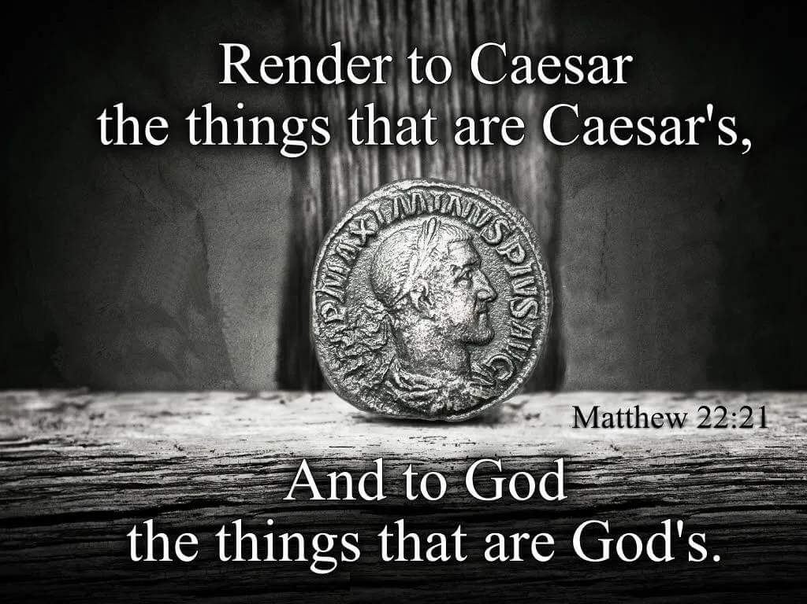

Messiah Lutheran Church
Sartell, MN
www.messiahsartell.com
320-252-5883
Prayer Before Entering
Please take this time to focus on our purpose in gathering and join in prayer before our service begins. Blessed Lord, You have caused all Holy Scriptures to be written for our learning. Grant that we may so hear them, read, mark, learn, and inwardly digest them that, by patience and comfort of Your holy Word, we may embrace and ever hold fast the blessed hope of everlasting life; through Jesus Christ, our Lord.

As We Gather
In today's Gospel reading (Matthew 22:15–22), the Pharisees try to trap Jesus with a question about paying taxes to Caesar. They expect that any answer He gives can be turned against Him. Jesus isn't caught. He answers, "Render to Caesar the things that are Caesar's, and to God the things that are God's," and His questioners leave amazed. We still face hard questions and challenges to our faith today, and sometimes it feels like we're walking into a trap. But Jesus has already overcome every snare of the devil, even death itself, when He rose on Easter morning. We may not always have the perfect answer, but God does. As we hear His Word and think on it, He gives us a firm foundation and the confidence that in Christ, the victory is already ours. May you leave today encouraged and strengthened in Him.

850 God of Grace and God of Glory

Stand

The sign of the cross may be made by all in remembrance of their Baptism.

P In the name of the Father and of the T Son and of the Holy Spirit.
C Amen.

P Our help is in the name of the Lord,
C who made heaven and earth.

P If You, O Lord, kept a record of sins, O Lord, who could stand?
C But with You there is forgiveness; therefore You are feared.

P Since we are gathered to hear God’s Word, call upon Him in prayer and praise, let us first consider our unworthiness and confess before God and one another that we have sinned in thought, word, and deed, and that we cannot free ourselves from our sinful condition. Together as His people let us take refuge in the infinite mercy of God, our heavenly Father, seeking His grace for the sake of Christ, and saying:
C God, be merciful to me, a sinner.

Silence for reflection on God’s Word and for self-examination.

C Almighty God, have mercy upon us, forgive us our sins, and lead us to everlasting life. Amen.

P Almighty God in His mercy has given His Son to die for you and for His sake forgives you all your sins. As a called and ordained servant of Christ, and by His authority, I therefore forgive you all your sins in the name of the Father and of the T Son and of the Holy Spirit.

C Amen.

Introit Psalm 121:1–4, 7–8; antiphon: v. 5
P The Lord is your keeper;
the Lord is your shade on your right hand.
C I lift up my eyes to the hills.
From where does my help come?
P My help comes from the Lord,
who made heaven and earth.
C He will not let your foot be moved;
he who keeps you will not slumber.
P Behold, he who keeps Israel
will neither slumber nor sleep.
C The Lord will keep you from all evil;
he will keep your life.
P The Lord will keep your going out and your coming in
from this time forth and forevermore.
All: Glory be to the Father and to the Son
and to the Holy Spirit;
as it was in the beginning,
is now, and will be forever. Amen.
P The Lord is your keeper;
the Lord is your shade on your right hand.

Kyrie
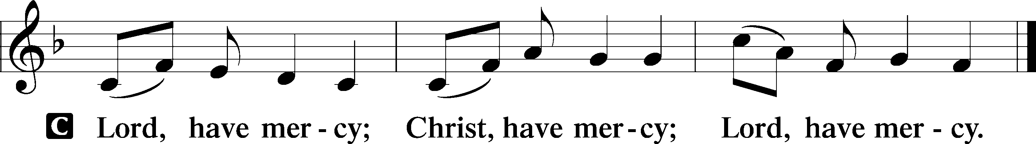

Gloria in Excelsis
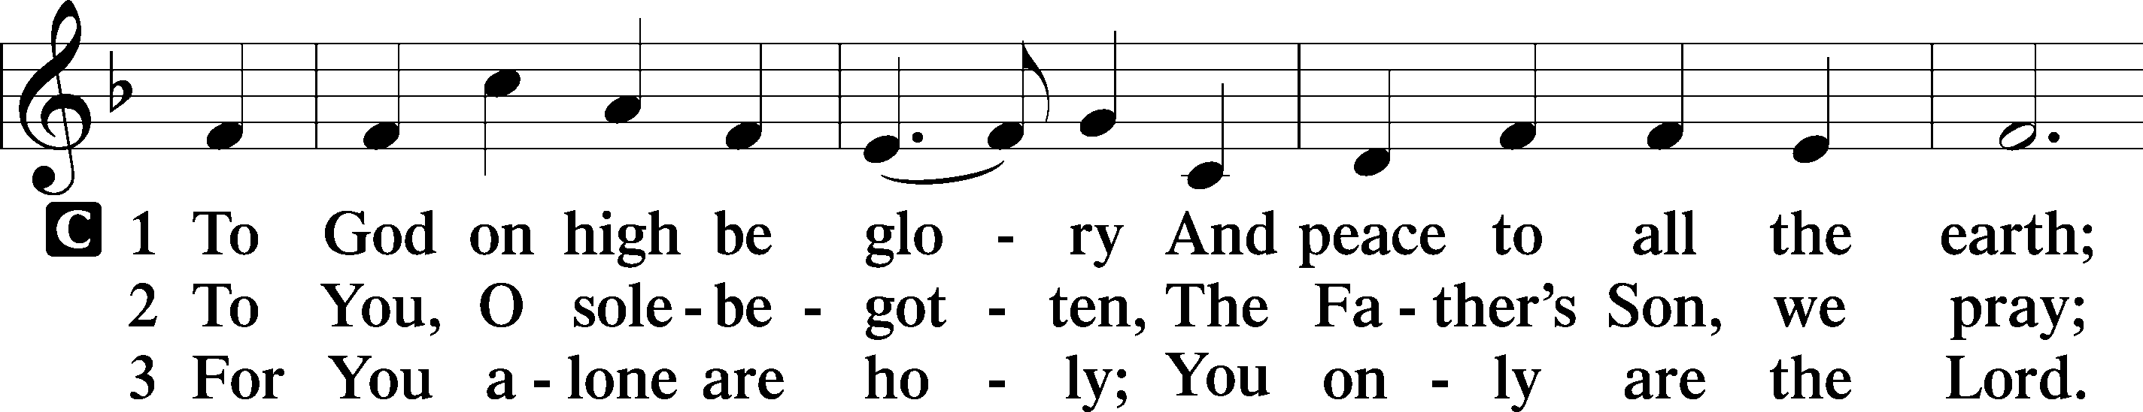
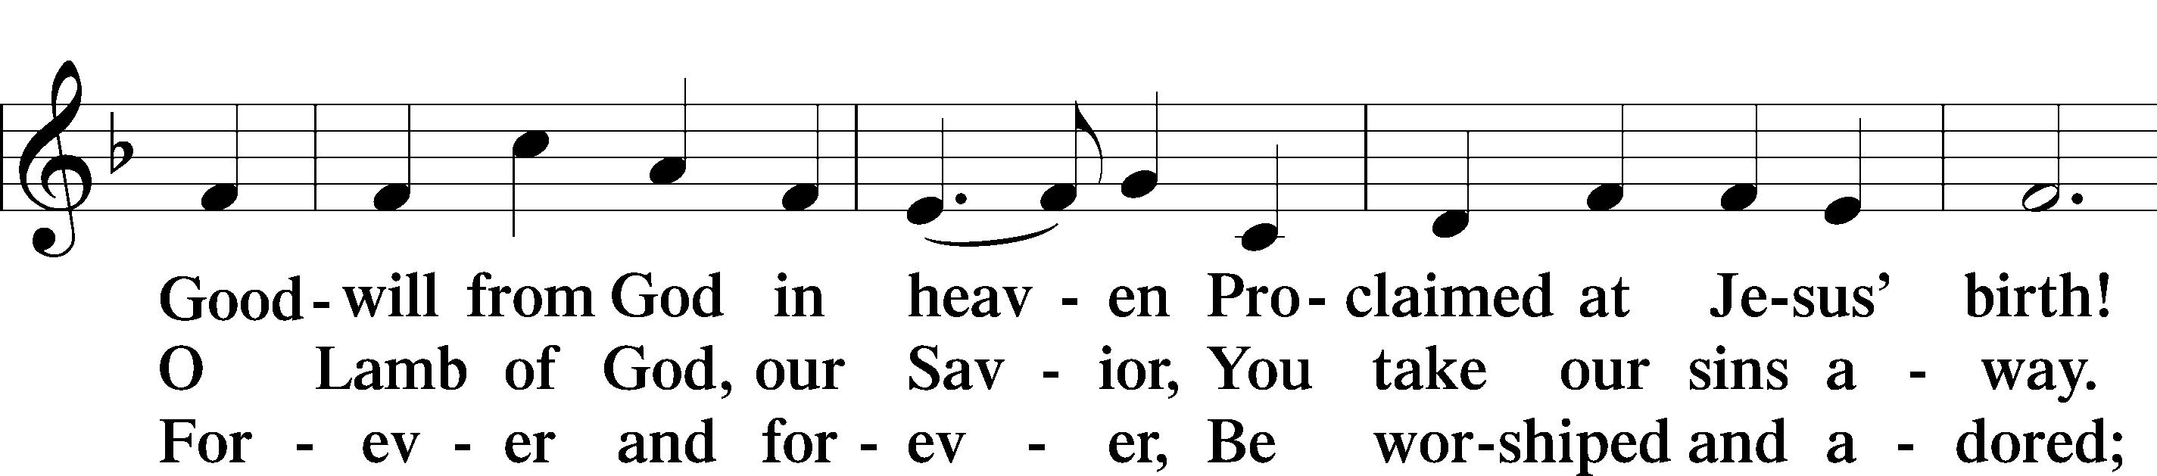
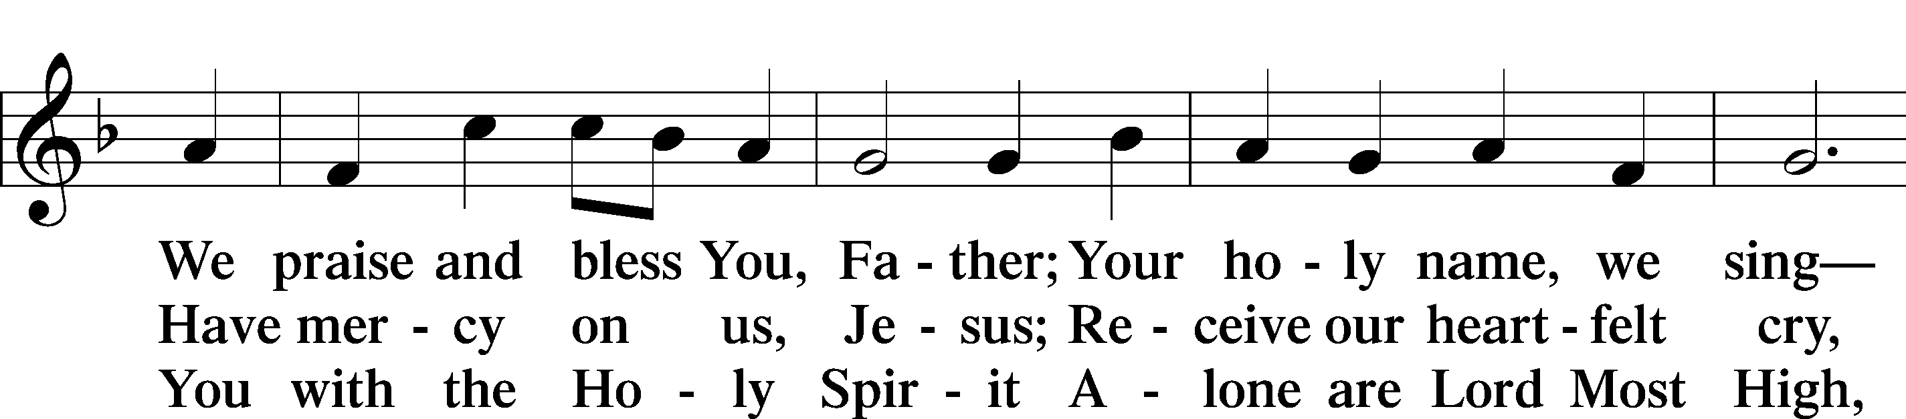
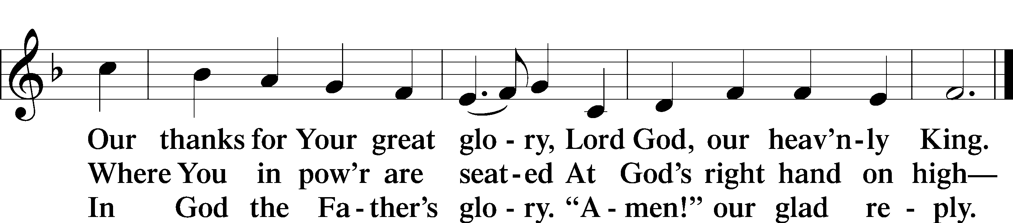

Salutation and Collect of the Day
P The Lord be with you.
C And also with you.

P Let us pray.
O God, the protector of all who trust in You, have mercy on us that with You as our ruler and guide we may so pass through things temporal that we lose not the things eternal; through Jesus Christ, Your Son, our Lord, who lives and reigns with You and the Holy Spirit, one God, now and forever.

C Amen.

Sit

Old Testament Reading Isaiah 45:1–7
1Thus says the Lord to his anointed, to Cyrus,
whose right hand I have grasped,
to subdue nations before him
and to loose the belts of kings,
to open doors before him
that gates may not be closed:
2“I will go before you
and level the exalted places,
I will break in pieces the doors of bronze
and cut through the bars of iron,
3I will give you the treasures of darkness
and the hoards in secret places,
that you may know that it is I, the Lord,
the God of Israel, who call you by your name.
4For the sake of my servant Jacob,
and Israel my chosen,
I call you by your name,
I name you, though you do not know me.
5I am the Lord, and there is no other,
besides me there is no God;
I equip you, though you do not know me,
6that people may know, from the rising of the sun
and from the west, that there is none besides me;
I am the Lord, and there is no other.
7I form light and create darkness,
I make well-being and create calamity,
I am the Lord, who does all these things.”

A This is the Word of the Lord.
C Thanks be to God.
Epistle 1 Thessalonians 1:1–10
1Paul, Silvanus, and Timothy, To the church of the Thessalonians in God the Father and the Lord Jesus Christ: Grace to you and peace.
2We give thanks to God always for all of you, constantly mentioning you in our prayers, 3remembering before our God and Father your work of faith and labor of love and steadfastness of hope in our Lord Jesus Christ. 4For we know, brothers loved by God, that he has chosen you, 5because our gospel came to you not only in word, but also in power and in the Holy Spirit and with full conviction. You know what kind of men we proved to be among you for your sake. 6And you became imitators of us and of the Lord, for you received the word in much affliction, with the joy of the Holy Spirit, 7so that you became an example to all the believers in Macedonia and in Achaia. 8For not only has the word of the Lord sounded forth from you in Macedonia and Achaia, but your faith in God has gone forth everywhere, so that we need not say anything. 9For they themselves report concerning us the kind of reception we had among you, and how you turned to God from idols to serve the living and true God, 10and to wait for his Son from heaven, whom he raised from the dead, Jesus who delivers us from the wrath to come.

A This is the Word of the Lord.
C Thanks be to God.

Stand

Alleluia and Verse
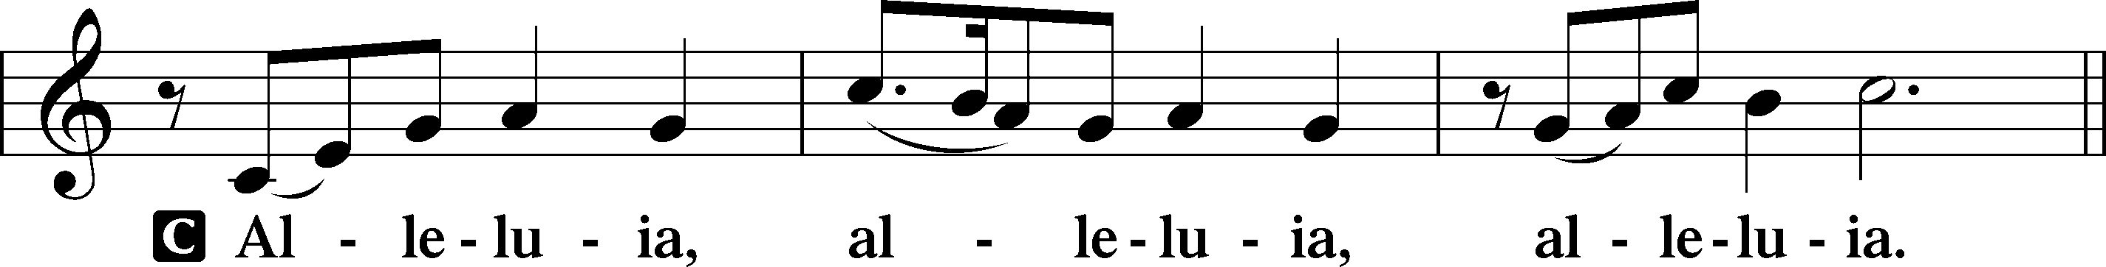
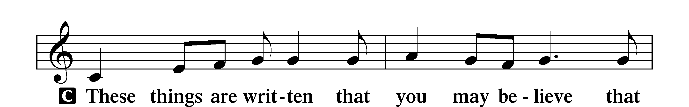
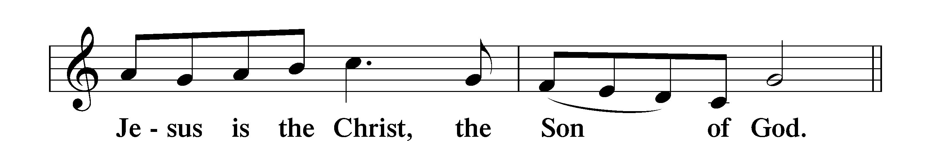
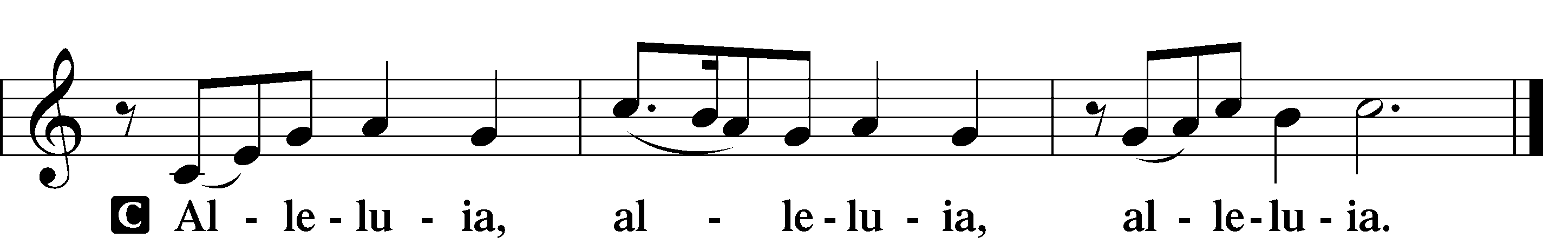
Holy Gospel Matthew 22:15–22
P The Holy Gospel according to St. Matthew, the twenty-second chapter.
C Glory to You, O Lord.

15Then the Pharisees went and plotted how to entangle [Jesus] in his talk. 16And they sent their disciples to him, along with the Herodians, saying, “Teacher, we know that you are true and teach the way of God truthfully, and you do not care about anyone’s opinion, for you are not swayed by appearances. 17Tell us, then, what you think. Is it lawful to pay taxes to Caesar, or not?” 18But Jesus, aware of their malice, said, “Why put me to the test, you hypocrites? 19Show me the coin for the tax.” And they brought him a denarius. 20And Jesus said to them, “Whose likeness and inscription is this?” 21They said, “Caesar’s.” Then he said to them, “Therefore render to Caesar the things that are Caesar’s, and to God the things that are God’s.” 22When they heard it, they marveled. And they left him and went away.

P This is the Gospel of the Lord.
C Praise to You, O Christ.

Apostles’ Creed
C I believe in God, the Father Almighty,
maker of heaven and earth.
And in Jesus Christ, His only Son, our Lord,
who was conceived by the Holy Spirit,
born of the virgin Mary,
suffered under Pontius Pilate,
was crucified, died and was buried.
He descended into hell.
The third day He rose again from the dead.
He ascended into heaven
and sits at the right hand of God the Father Almighty.
From thence He will come to judge the living and the dead.
I believe in the Holy Spirit,
the holy Christian Church,
the communion of saints,
the forgiveness of sins,
the resurrection of the body,
and the life T everlasting. Amen.

Sit

781 We Give Thee But Thine Own

Sermon

Offering. We generously give our offerings to the LORD out of thanksgiving for His generosity of forgiveness, life, and salvation in Christ (2 Corinthians 9:8). We believe that our offerings are not only to support the proclamation of the Gospel here and around the world, but also to help us all grow in faith and trust in Him (2 Corinthians 9:7). We have placed an offering plate in the narthex so you are able to freely give back to Him as you are able. To Him be all the glory!

Stand

Prayer of the Church

Lord’s Prayer

Benedicamus
A Let us bless the Lord.
C Thanks be to God.

Benediction
P The Lord bless you and keep you.
The Lord make His face shine on you and be gracious to you.
The Lord look upon you with favor and T give you peace.
C Amen.

851 Lord of Glory, You Have Bought Us

