15th Sunday After Pentecost
September 6th, 2026

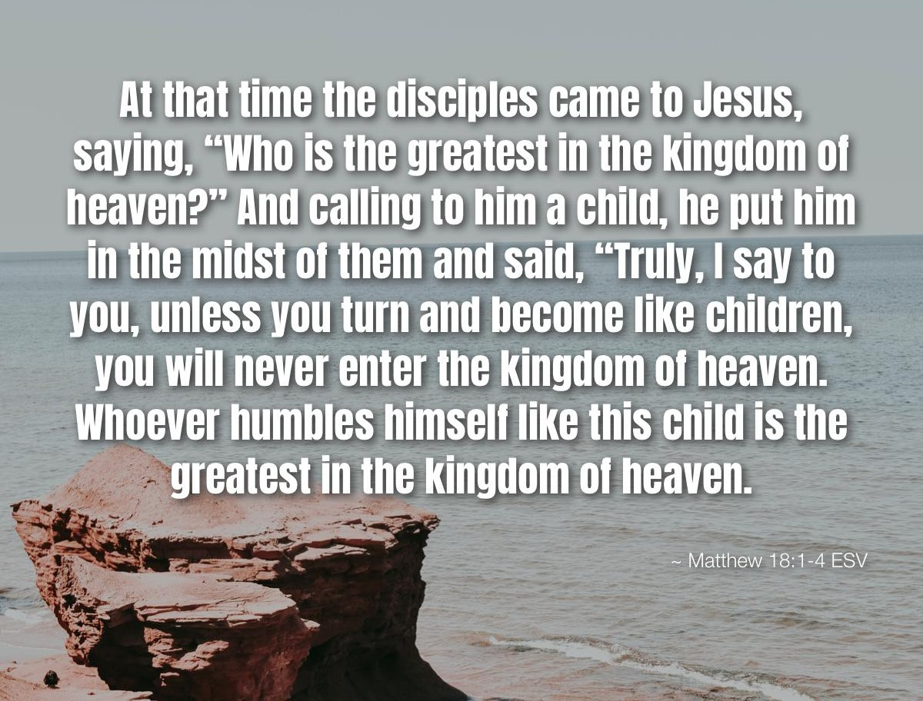

Messiah Lutheran Church
Sartell, MN
www.messiahsartell.com
320-252-5883
Prayer Before Entering
Please take this time to focus on our purpose in gathering and join in prayer before our service begins. Blessed Lord, You have caused all Holy Scriptures to be written for our learning. Grant that we may so hear them, read, mark, learn, and inwardly digest them that, by patience and comfort of Your holy Word, we may embrace and ever hold fast the blessed hope of everlasting life; through Jesus Christ, our Lord.

As We Gather
Matthew 18 invites us to hear Jesus’ loving call to humility, care, and grace. When the disciples ask who is greatest in the kingdom of heaven, Jesus places a child before them and reminds us that true greatness is not found in status or pride, but in humble trust and love for the “little ones” God has placed in our lives.

As we gather for worship, we are reminded that pride can sometimes get in the way of loving others, seeking the wandering, and receiving correction with grace. But the good news is that Jesus, the truly greatest One, humbled Himself for us. He comes after His wandering sheep, forgives our sins, and rejoices to bring us home. Let us set aside our pride and come before our Lord as humble children together.

605 Father Welcomes

Stand

The sign of the cross may be made by all in remembrance of their Baptism.

P In the name of the Father and of the T Son and of the Holy Spirit.
C Amen.

P Our help is in the name of the Lord,
C who made heaven and earth.

P If You, O Lord, kept a record of sins, O Lord, who could stand?
C But with You there is forgiveness; therefore You are feared.

P Since we are gathered to hear God’s Word, call upon Him in prayer and praise, let us first consider our unworthiness and confess before God and one another that we have sinned in thought, word, and deed, and that we cannot free ourselves from our sinful condition. Together as His people let us take refuge in the infinite mercy of God, our heavenly Father, seeking His grace for the sake of Christ, and saying:
C God, be merciful to me, a sinner.

Silence for reflection on God’s Word and for self-examination.

C Almighty God, have mercy upon us, forgive us our sins, and lead us to everlasting life. Amen.

P Almighty God in His mercy has given His Son to die for you and for His sake forgives you all your sins. As a called and ordained servant of Christ, and by His authority, I therefore forgive you all your sins in the name of the Father and of the T Son and of the Holy Spirit.

C Amen.

Introit Psalm 92:1–4; antiphon: v. 5
P How great are your works, O Lord!
Your thoughts are very deep!
C It is good to give thanks to the Lord,
to sing praises to your name, O Most High;
P to declare your steadfast love in the morning,
and your faithfulness by night,
C to the music of the lute and the harp,
to the melody of the lyre.
P For you, O Lord, have made me glad by your work;
at the works of your hands I sing for joy.
All: Glory be to the Father and to the Son
and to the Holy Spirit;
as it was in the beginning,
is now, and will be forever. Amen.
P How great are your works, O Lord!
Your thoughts are very deep!

Kyrie
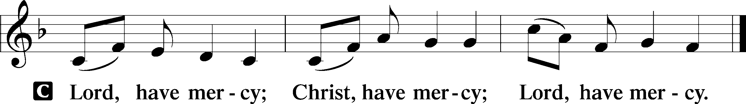

Gloria in Excelsis
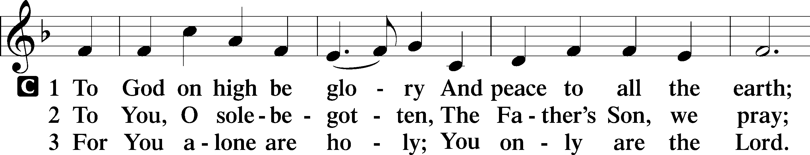
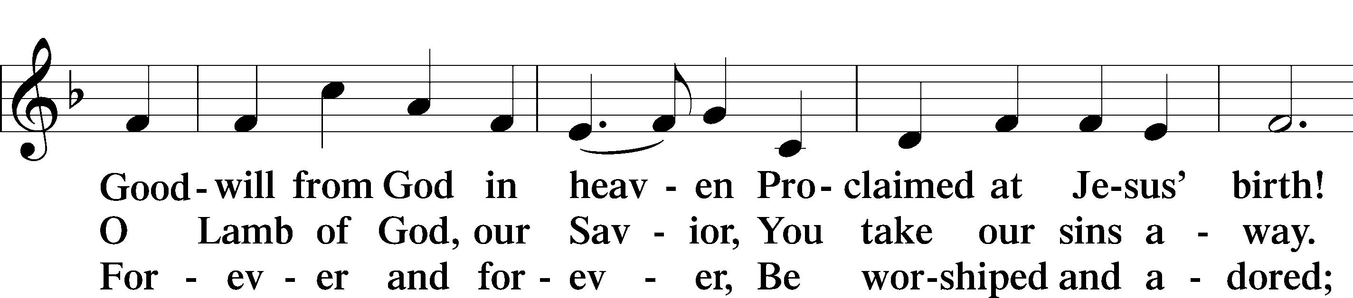
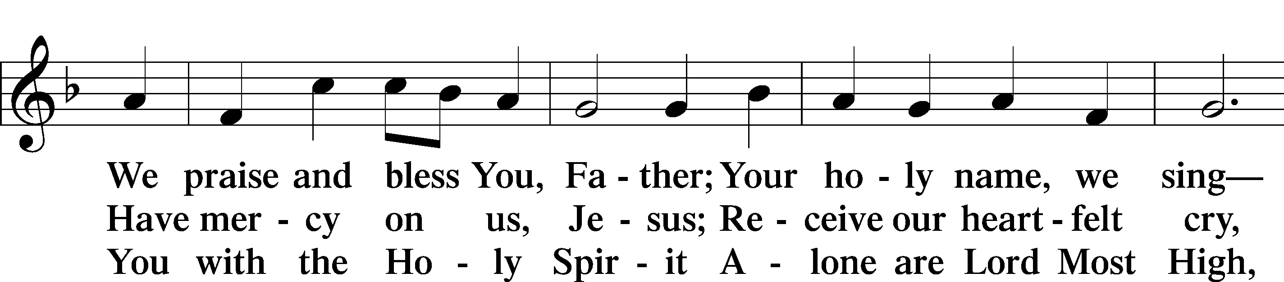
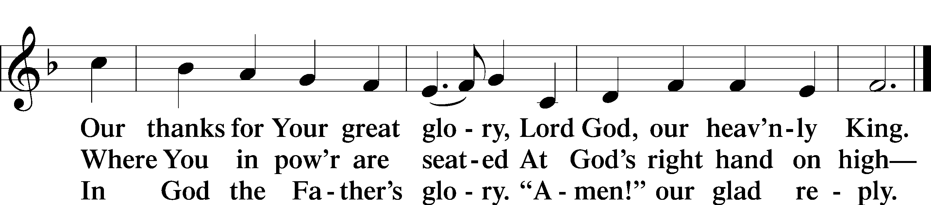

Salutation and Collect of the Day
P The Lord be with you.
C And also with you.

P Let us pray. O God, from whom all good proceeds, grant to us, Your humble servants, Your holy inspiration, that we may set our minds on the things that are right and, by Your merciful guiding, accomplish them; through Jesus Christ, Your Son, our Lord, who lives and reigns with You and the Holy Spirit, one God, now and forever.
C Amen.
Sit

Old Testament Reading Ezekiel 33:7–9
7“So you, son of man, I have made a watchman for the house of Israel. Whenever you hear a word from my mouth, you shall give them warning from me. 8If I say to the wicked, O wicked one, you shall surely die, and you do not speak to warn the wicked to turn from his way, that wicked person shall die in his iniquity, but his blood I will require at your hand. 9But if you warn the wicked to turn from his way, and he does not turn from his way, that person shall die in his iniquity, but you will have delivered your soul.”

A This is the Word of the Lord.
C Thanks be to God.

Epistle Romans 13:1–10
1Let every person be subject to the governing authorities. For there is no authority except from God, and those that exist have been instituted by God. 2Therefore whoever resists the authorities resists what God has appointed, and those who resist will incur judgment. 3For rulers are not a terror to good conduct, but to bad. Would you have no fear of the one who is in authority? Then do what is good, and you will receive his approval, 4for he is God’s servant for your good. But if you do wrong, be afraid, for he does not bear the sword in vain. For he is the servant of God, an avenger who carries out God’s wrath on the wrongdoer. 5Therefore one must be in subjection, not only to avoid God’s wrath but also for the sake of conscience. 6For the same reason you also pay taxes, for the authorities are ministers of God, attending to this very thing. 7Pay to all what is owed to them: taxes to whom taxes are owed, revenue to whom revenue is owed, respect to whom respect is owed, honor to whom honor is owed.
8Owe no one anything, except to love each other, for the one who loves another has fulfilled the law. 9The commandments, “You shall not commit adultery, You shall not murder, You shall not steal, You shall not covet,” and any other commandment, are summed up in this word: “You shall love your neighbor as yourself.” 10Love does no wrong to a neighbor; therefore love is the fulfilling of the law.

A This is the Word of the Lord.
C Thanks be to God.

Stand

Alleluia and Verse
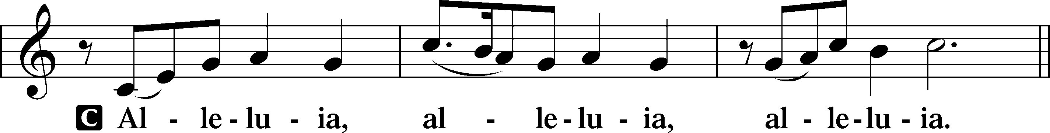
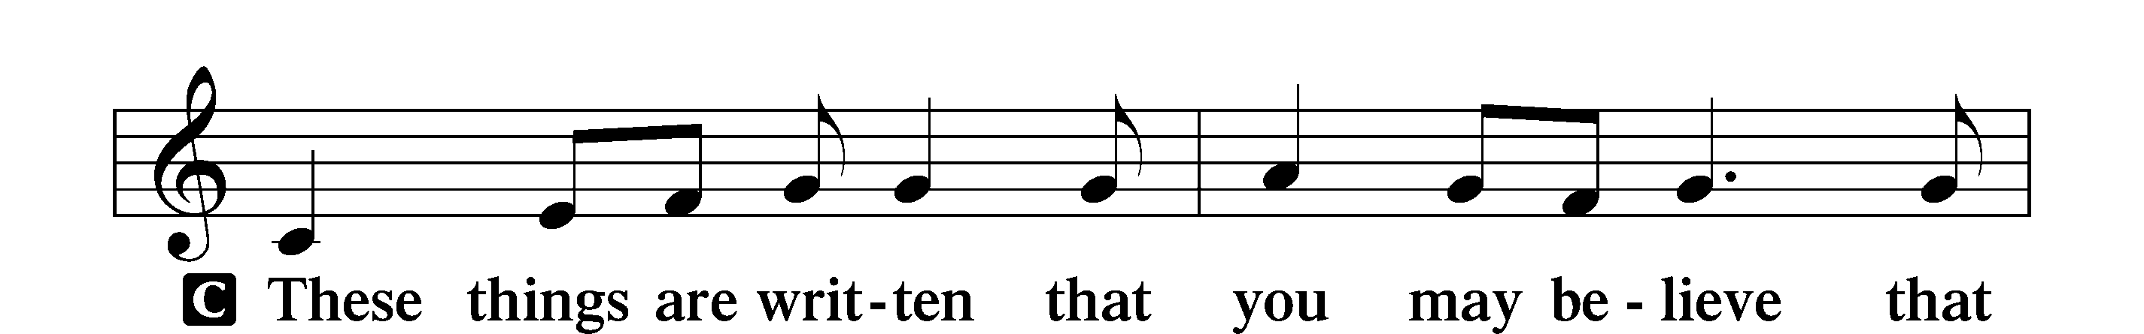
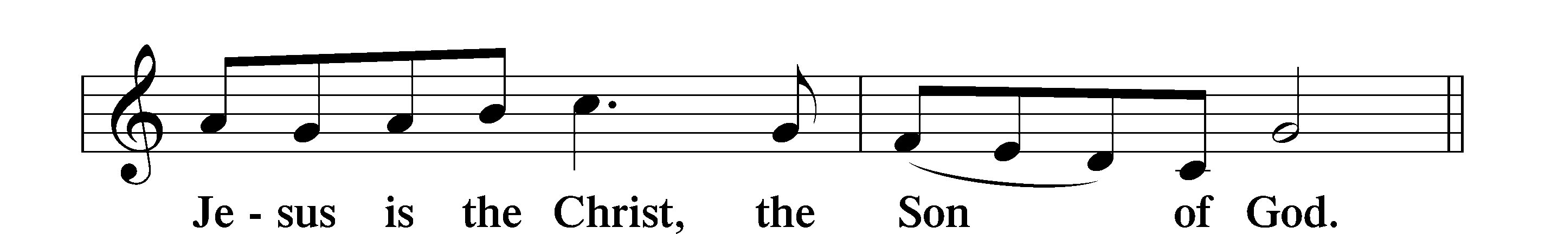
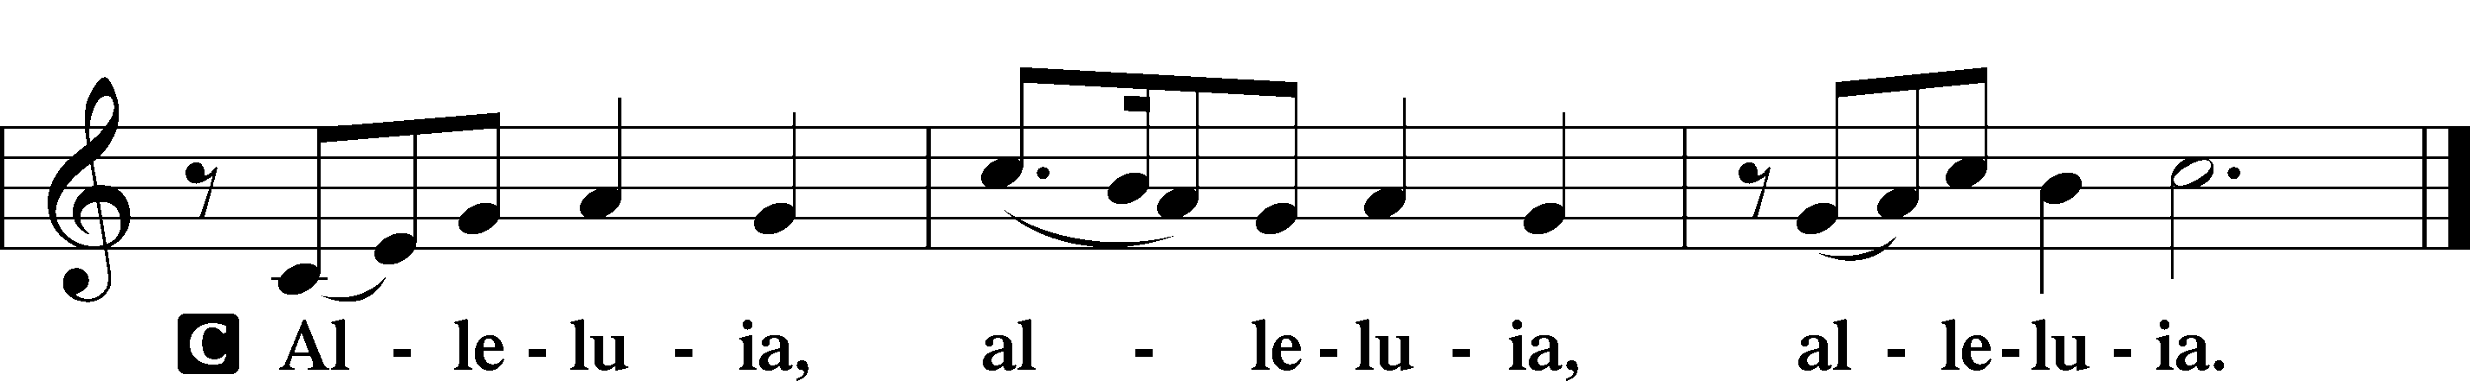

Holy Gospel Matthew 18:1–20
P The Holy Gospel according to St. Matthew, the eighteenth chapter.
C Glory to You, O Lord.

1At that time the disciples came to Jesus, saying, “Who is the greatest in the kingdom of heaven?” 2And calling to him a child, he put him in the midst of them 3and said, “Truly, I say to you, unless you turn and become like children, you will never enter the kingdom of heaven. 4Whoever humbles himself like this child is the greatest in the kingdom of heaven.
5“Whoever receives one such child in my name receives me, 6but whoever causes one of these little ones who believe in me to sin, it would be better for him to have a great millstone fastened around his neck and to be drowned in the depth of the sea.
7“Woe to the world for temptations to sin! For it is necessary that temptations come, but woe to the one by whom the temptation comes! 8And if your hand or your foot causes you to sin, cut it off and throw it away. It is better for you to enter life crippled or lame than with two hands or two feet to be thrown into the eternal fire. 9And if your eye causes you to sin, tear it out and throw it away. It is better for you to enter life with one eye than with two eyes to be thrown into the hell of fire.
10“See that you do not despise one of these little ones. For I tell you that in heaven their angels always see the face of my Father who is in heaven. 11For the Son of Man came to save the lost. 12What do you think? If a man has a hundred sheep and one of them has gone astray, does he not leave the ninety-nine on the mountains and go in search of the one that went astray? 13And if he finds it, truly, I say to you, he rejoices over it more than over the ninety-nine that never went astray. 14So it is not the will of my Father who is in heaven that one of these little ones should perish.
15“If your brother sins against you, go and tell him his fault, between you and him alone. If he listens to you, you have gained your brother. 16But if he does not listen, take one or two others along with you, that every charge may be established by the evidence of two or three witnesses. 17If he refuses to listen to them, tell it to the church. And if he refuses to listen even to the church, let him be to you as a Gentile and a tax collector. 18Truly, I say to you, whatever you bind on earth shall be bound in heaven, and whatever you loose on earth shall be loosed in heaven. 19Again I say to you, if two of you agree on earth about anything they ask, it will be done for them by my Father in heaven. 20For where two or three are gathered in my name, there am I among them.”

P This is the Gospel of the Lord.
C Praise to You, O Christ.

Apostles’ Creed
C I believe in God, the Father Almighty,
maker of heaven and earth.
And in Jesus Christ, His only Son, our Lord,
who was conceived by the Holy Spirit,
born of the virgin Mary,
suffered under Pontius Pilate,
was crucified, died and was buried.
He descended into hell.
The third day He rose again from the dead.
He ascended into heaven
and sits at the right hand of God the Father Almighty.
From thence He will come to judge the living and the dead.
I believe in the Holy Spirit,
the holy Christian Church,
the communion of saints,
the forgiveness of sins,
the resurrection of the body,
and the life T everlasting. Amen.
Sit

864 Shepherd of Tender Youth

Sermon

Offering. We generously give our offerings to the LORD out of thanksgiving for His generosity of forgiveness, life, and salvation in Christ (2 Corinthians 9:8). We believe that our offerings are not only to support the proclamation of the Gospel here and around the world, but also to help us all grow in faith and trust in Him (2 Corinthians 9:7). We have placed an offering plate in the narthex so you are able to freely give back to Him as you are able. To Him be all the glory!

Stand

Prayer of the Church

Lord’s Prayer

Benedicamus
A Let us bless the Lord.
C Thanks be to God.

Benediction
P The Lord bless you and keep you.
The Lord make His face shine on you and be gracious to you.
The Lord look upon you with favor and T give you peace.
C Amen.

725 Children of the Heavenly Father

Announcements

Fellowship Cookout!!! Next Sunday, Sept. 13: Hotdogs and Burgers will be provided, but please bring salads or desserts to share! Free-will offering!

Calling all noodle helpers! We’ll be mixing, rolling, cutting, and hanging noodles on Mondays, Sept. 14 and 28, and Oct. 12 at 12:30 p.m. Whether you’re a noodle pro,
a first-timer, or just coming for coffee and fellowship, we’d love to have you.
All helping hands are welcome as we prepare for the
Sartell Area Churches’ Craft and Bake Sale on Oct. 31.

2026 Mental Health Walk by NAMI, will be held Saturday, Sept. 12 at Wilson Park, 625 Riverside Dr. NE, St Cloud. Registration is at 9 a.m. Walk begins at 10 a.m. It is free to participate, and donations are welcomed. Presented by Gary Vieth, President of NAMI. All are welcome!

